Photodegradation, DFT and electrochemical studies of carbon nanohorns modified BiSbO₄/BiSbS₃ heterostructure for an endocrine disrupting agent pentachlorophenol

Maria Batool, Muhammad Nadeem Zafar*

Department of Chemistry, University of Gujrat, Gujrat 50700, Pakistan

*Corresponding author emails: nadeem.zafar@uog.edu.pk, znadeempk@gmail.com; ORCID ID: 0000-0002-2109-7601 (MN Zafar)

Supporting information

S1. Crystal structure determination of BiSbO₄ by using Vesta software

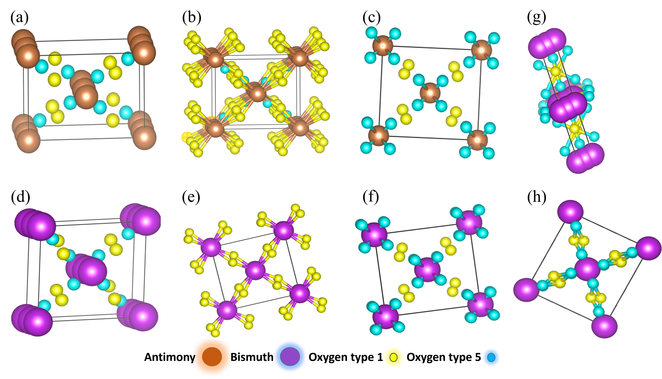
Figure S1. Structural representation of BiSbO₄ nanocomposite (a) atomic positions of BiSbO₄ without Bismuth (b) bonding of Sb and (type 1) oxygen (c) bonding of Sb and (type 5) oxygen (d) atomic positions of elements in BiSbO₄ composite with Bismuth (e) bonding of Bismuth and (type 1) oxygen (f) bonding of bismuth and (type 5) oxygen (g) lateral view of bonding of (type 1) and (type 5) oxygen atoms (h) front view of bonding (type 1) and (type 5) oxygen atoms

S2. Crystal structure determination of BiSbS₃ by using Vesta software

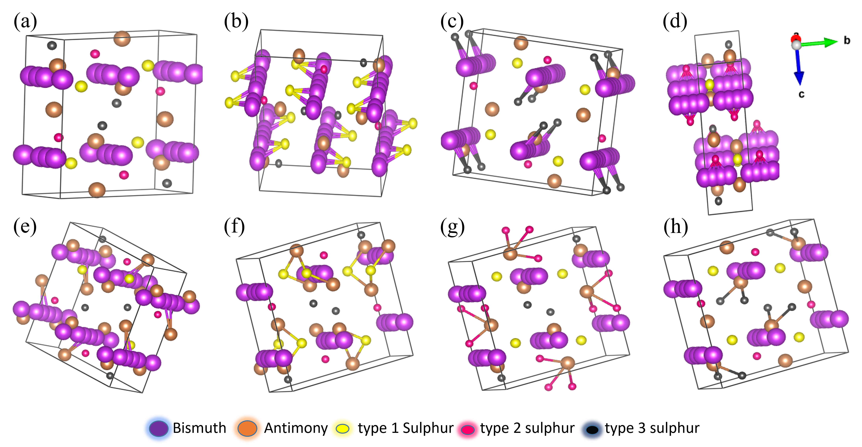
Figure S2. Structural representation of BiSbS₃ (a) positions of atoms in BiSbS₃ composite (b) bonding of (type 1) sulphur with Bismuth (c) bonding of (type 3) sulphur with bismuth (d) bonding of (type 2) sulphur with bismuth (e) bonding of Bismuth and antimony (f) bonding of (type 1) sulphur with antimony (g) bonding of (type 2) sulphur with antimony (h) bonding of (type 3) sulphur with antimony

Figure S3. (a) Effect of BiSbO₄, BiSbS₃ and BiSbO₄/BiSbS₃/CNHs dosage and (b) effect of PCP concentration on degradation of PCP onto BiSbO₄, BiSbS₃ and heterostructure BiSbO₄/BiSbS₃/CNHs

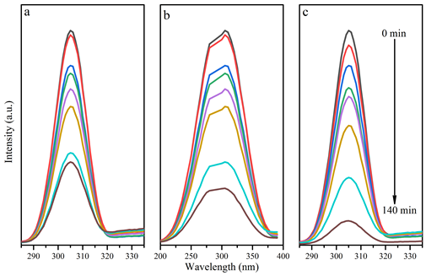
Figure S4. (a) Time study of (a) BiSbS₄ (b) BiSbO₃ and (c) heterostructure BiSb O₄/BiSbS₃/CNHs at optimum conditions for degradation of PCP

Figure S5. Tauc Plot–Optical band gap energy estimation of BiSbO₄ and BiSbS₃

Figure S6. (a) Effect of other pollutants and (b) effect of scavengers on efficiency of heterostructure BiSbO₄/BiSbS₃/CNHs for degradation of PCP

Figure 7. Time vs. potential plots of (a) heterostructure BiSbO₄/BiSbS₃/CNHs, (b) BiSbO₄ and (c) BiSbS₃

Figure S8. Current density versus scan rate for BiSbO₄, BiSbS₃ and heterostructure BiSbO₄/BiSbS₃/CNHs

