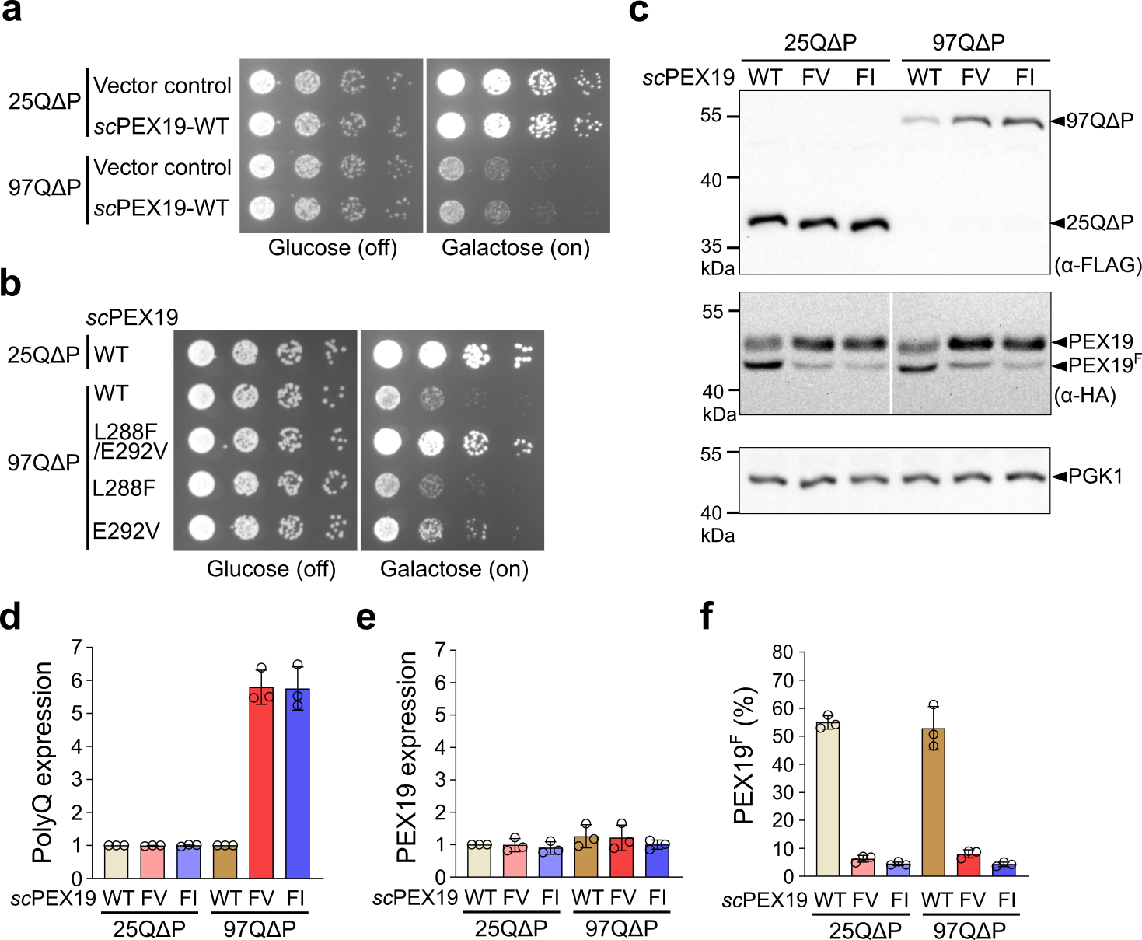
Extended Data Fig. 1. A scPEX19 double mutation (L288F/E292V) is necessary to prevent the cellular toxicity of Httex1-97QΔP-GFP in yeast.
a, b, Growth test of Httex1-25QΔP-GFP- and Httex1-97QΔP-GFP-integrated yeast cells expressing empty vector control, scPEX19-WT, scPEX19-FV (L288F/E292V), scPEX19-L288F or scPEX19-E292V. An overnight culture of the cells in the selective media containing 2% raffinose and 0.1 % glucose was diluted to an OD₆₀₀ of 0.1. The 5-fold serial diluted cells were spotted on plates containing galactose or glucose.
c-f, Representative images of western blot analysis monitoring the expression levels of Httex1-25QΔP-GFP, Httex1-97QΔP-GFP, scPEX19, and PGK1 are shown in c. Total yeast cell extracts were prepared using the NaOH-SDS lysis method as described in STAR Methods. The protein expression levels of N-terminally Flag-tagged PolyQ and HA-tagged scPEX19 proteins were quantified and shown in d and e, respectively. (f) Relative expression levels of the farnesylated PEX19 (denoted as PEX19^{F}) were calculated as (Intensity of PEX19^{F} band/Total intensity of PEX19 and PEX19^{F} bands)*100. All data in (D-F) are shown as mean ± SD, with three biological replicates (n=3).
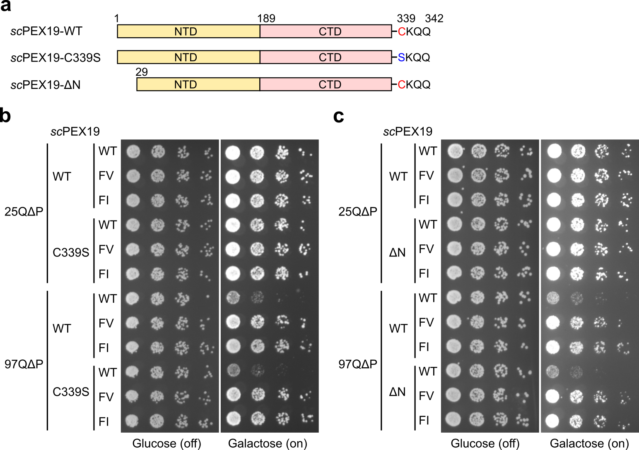
Extended Data Fig. 2. PEX3 binding and farnesylation on scPEX19 variants are dispensable for suppressing the cellular toxicity of Httex1-97QΔP-GFP.
a, Schematic of the domain organization of scPEX19-WT and its mutants. scPEX19-C339S removes the C-terminal farnesylation site, while scPEX19-ΔN (29-342 aa) lacks residues needed for PEX3 interaction. Either C339S or ΔN mutations were introduced into scPEX19-WT, scPEX19-FV, and scPEX19-FI.
b, c, Growth test of Httex1-25QΔP-GFP or Httex1-97QΔP-GFP cells expressing the scPEX19-WT and indicated scPEX19 mutants. Addition of the above mutations to scPEX19-FV and scPEX19-FI did not alter their ability to rescue the yeast cell death caused by Httex1-97QΔP-GFP expression.

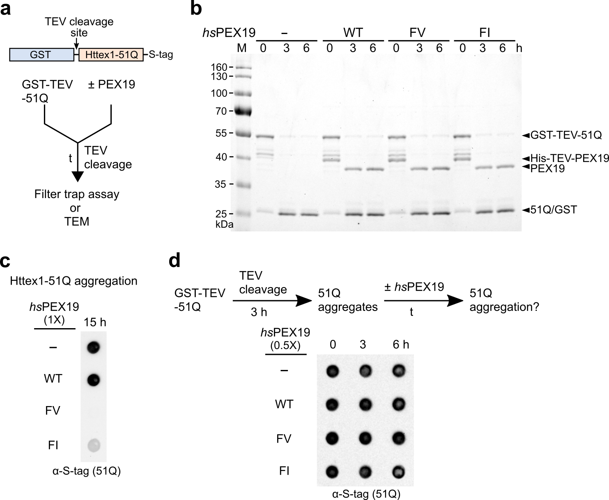
Extended Data Fig. 3. hsPEX19 variants act as a holdase that prevents the aggregation of Httex1-51Q.
a, Schematic showing the in vitro aggregation assays used to measure SDS-insoluble Httex1-51Q aggregates or Httex1-51Q fibrils in the absence and presence of PEX19 proteins. TEV protease was added to GST-TEV-Httex1-51Q in the absence and presence of PEX19 (t=0). Upon adding TEV protease, the N-terminal GST tag of GST-TEV-Httex1-51Q was removed, and Httex1-51Q aggregation was initiated. The reactions were carried out in the absence and presence of PEX19-WT and its variants. At the indicated time, samples were taken and further processed for either filter trap assays or TEM measurements. The C-terminal S-tag enables the detection of Httex1-51Q proteins in the filter trap assay.
b, SDS-PAGE analysis to monitor the TEV cleavage efficiency of Httex1-51Q. The same samples collected from Fig. 2d were used for SDS-PAGE analysis. The hsPEX19 proteins also contain the N-terminal His-tag with TEV protease cleavage site. The presence of hsPEX19 proteins in the reactions does not perturb the TEV cleavage efficiency.
c, In vitro aggregation assay of Httex1-51Q in the absence and presence of hsPEX19 proteins. 3 μM of GST-TEV-Httex1-51Q and 3 μM of PEX19 proteins were incubated in the presence of TEV protease at 30°C for 15 h. After quenching the reactions, samples were analyzed using filter trap assay.
d, In vitro aggregation assay to monitor the disaggregase activity of PEX19 proteins. 3 μM of GST-TEV-Httex1-51Q was preincubated with TEV protease at 30°C. After 3 h incubation with TEV protease, either hsPEX19-WT or its variants were added to a final concentration of 1.5 μM and further incubated for 3 and 6 h. Samples were then subjected to the filter trap assay.

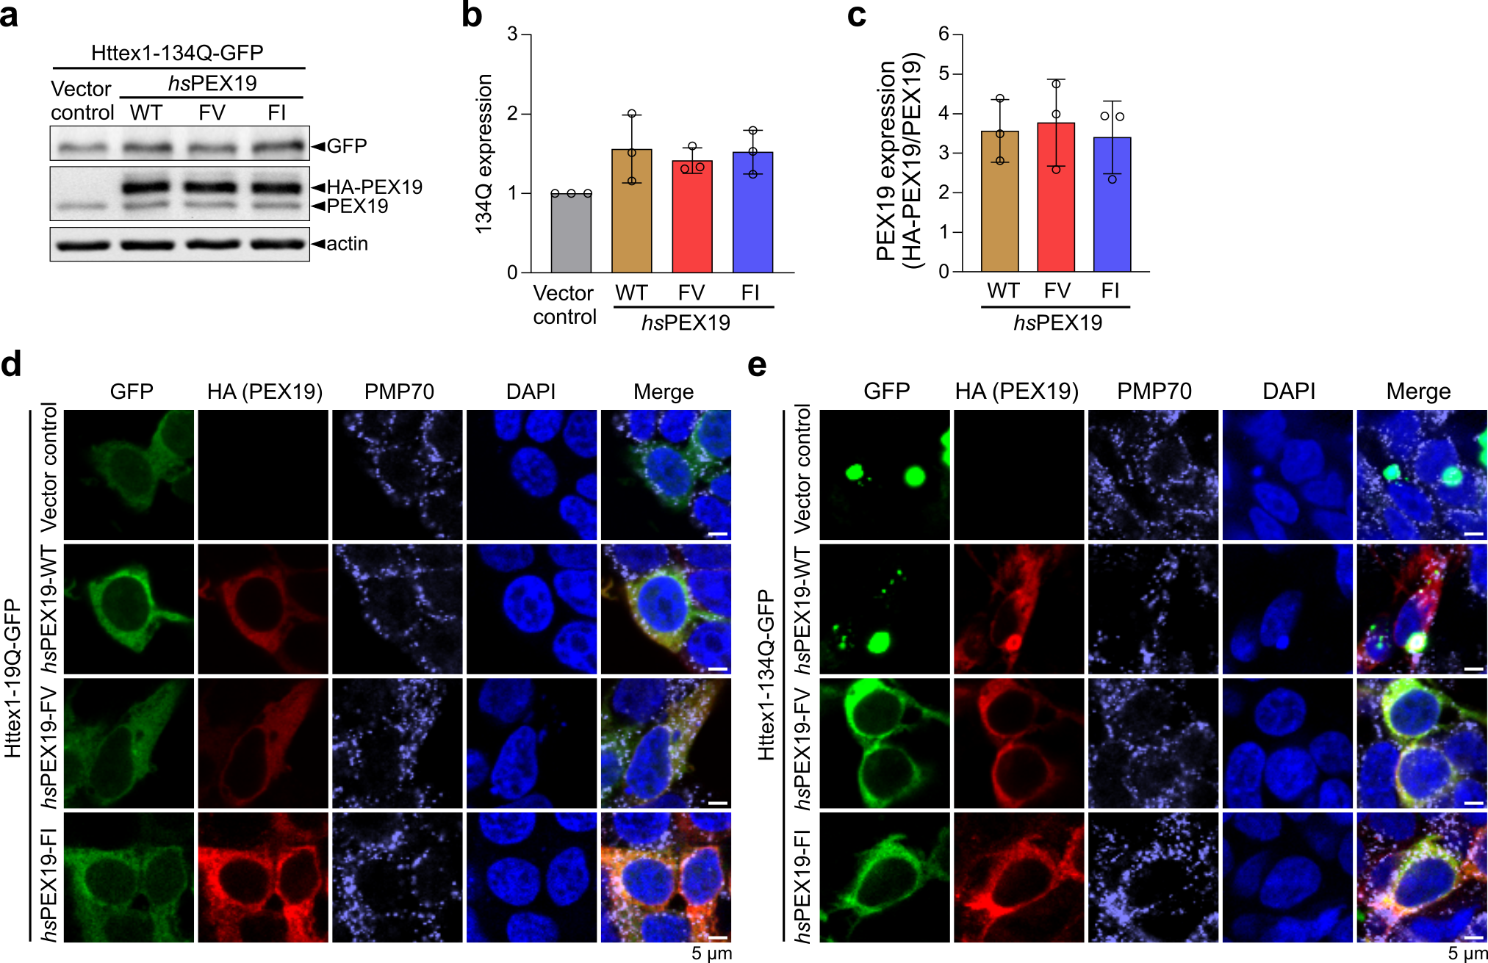
Extended Data Fig. 4. hsPEX19 variants reduce the cytosolic aggregation of Httex1-134Q in HEK293T cells.
a-c, (a) Representative western blot images showing protein levels of Httex1-134Q-GFP and hsPEX19 co-expressed in HEK293T cells. (b) and (c), Quantification of the data in a. Both expression levels of Httex1-134Q-GFP in b and hsPEX19 in c were normalized by β-actin. Data in b and c are shown as mean ± SD, with three biological replicates (n=3).
d, e, Confocal microscopy images of HEK293T cells coexpressing Httex1-19Q-GFP or Httex1-134Q-GFP and hsPEX19. HA-hsPEX19 and PMP70 were stained using HA and PMP70 antibodies, respectively.

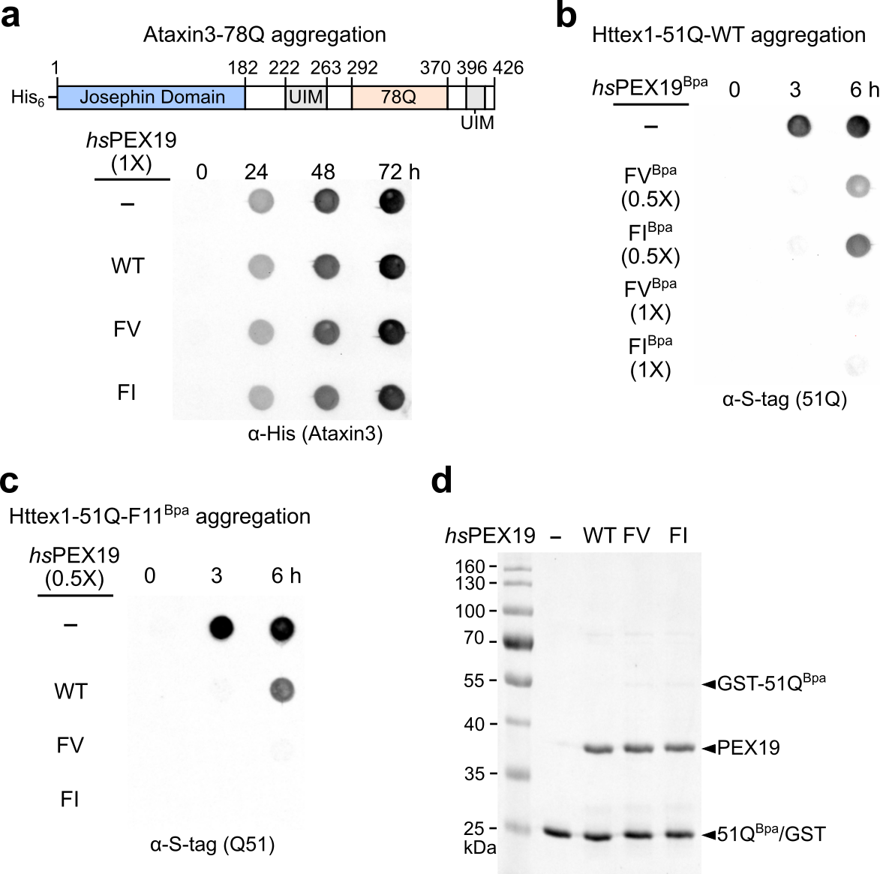
Extended Data Fig. 5. hsPEX19 variants cannot suppress the aggregation of another polyQ repeat protein, Ataxin3.
a, Schematic illustration of His₆-tagged Ataxin3-78Q and in vitro aggregation assay to monitor Ataxin3-78Q aggregation in the absence and presence of hsPEX19 proteins. Ataxin3 consists of an N-terminal Josephin domain, several ubiquitin-interacting motifs (UIMs), and a polyQ repeat domain. 30 µM of Ataxin3-78Q was incubated with 30 µM of hsPEX19 proteins at 37°C. After indicated time points, samples were quenched and applied to filter trap assay as described in STAR Methods. SDS-insoluble and heat-stable Ataxin-3-78Q aggregates were detected with a His-tag antibody.
b, In vitro aggregation assay to monitor the chaperone activity of hsPEX19-FV^{Bpa} and hsPEX19-FI^{Bpa} toward Httex1-51Q-WT. 3 µM of Httex1-51Q-WT was incubated with 1.5 or 3 µM of hsPEX19-FV^{Bpa} or hsPEX19-FI^{Bpa} at 30°C. Since 3 µM of both hsPEX19-FV^{Bpa} and hsPEX19-FI^{Bpa} were sufficient to prevent the aggregation of Httex1-51Q-WT, we carried out the Bpa crosslinking assay with the same reaction conditions in Fig. 3d and 3e.
c, d, In vitro aggregation assay of Httex1-51Q-F11^{Bpa} was carried out with 1.5 µM of hsPEX19 protein in c. The same reaction samples at 3 h were applied for the SDS-PAGE analysis in d.
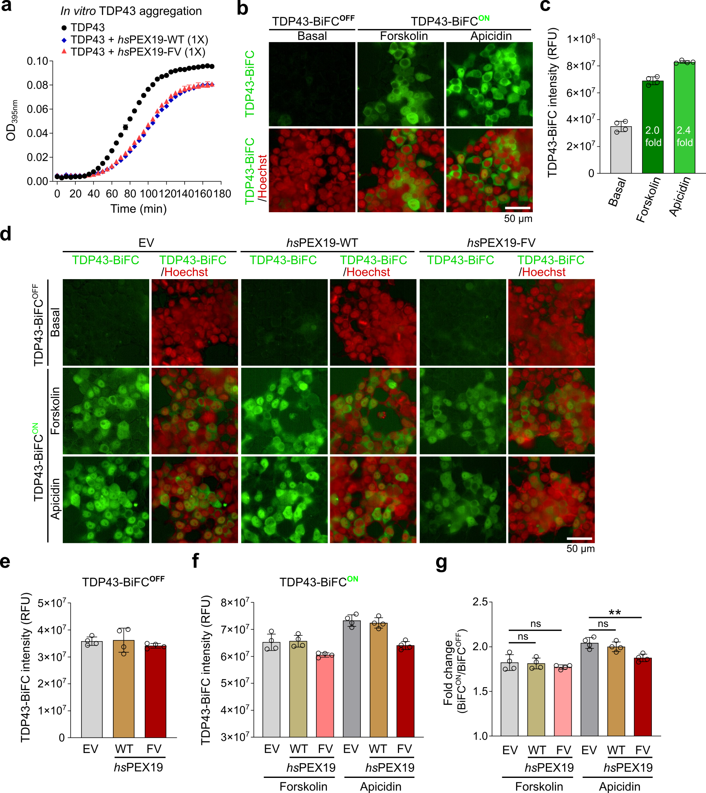
Extended Data Fig. 6. hsPEX19 variants do not efficiently prevent TDP43 aggregation in vitro and in mammalian cells.
a, In vitro TDP43 aggregation assay. TDP43 aggregation was initiated by adding TEV protease in the reactions containing TDP43-TEV-MBP-His₆ and hsPEX19 proteins, and the turbidity caused by TDP43 aggregation was monitored at the optical density of 395 nm as described in STAR Methods. Data in a are shown as mean ± SEM, with n=2. Error bars are shown but may not be visible in some cases.
b, c, Activation of TDP-43 oligomerization in HEK293 TDP43-BiFC cells. Representative microscopic images of Forskolin- and Apicidin-activated TDP43-BiFC cells are shown in b. The fluorescence intensities of TDP43-BiFC in b and its replicates were quantified in c. Intensity fold changes of Forskolin- and Apicidin-activated TDP43-BiFC are approximately 2.0 and 2.4, respectively.
d-g, The hsPEX19-transfected TDP43-BiFC cells were treated with Forskolin and Apicidin, and the representative microscopic images are shown in d. The fluorescence intensities of TDP43-BiFC^{OFF} and reagent-activated TDP43-BiFC^{ON} are quantified in e and f, respectively. The intensity fold changes are also summarized in g.
All data in c, e, f, and g are shown as mean ± SD, with n=4. Pairwise comparisons are shown as indicated, where ∗∗p < 0.01 by the ordinary one-way ANOVA with Tukey post-hoc test.

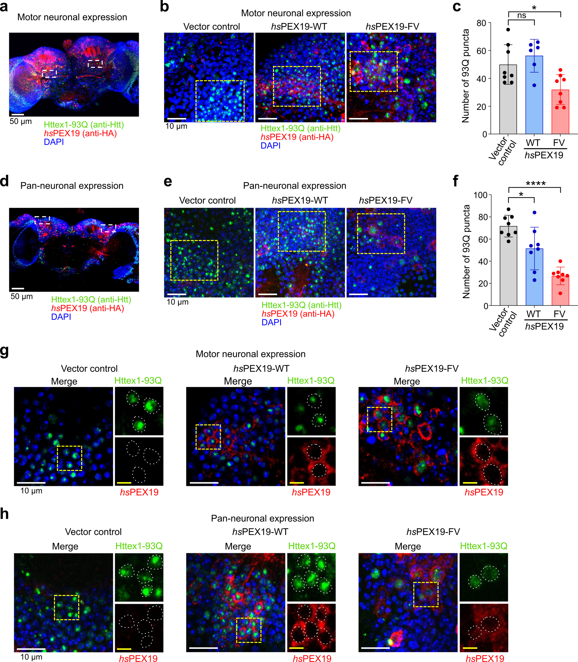
Extended Data Fig. 7. Overexpression of hsPEX19-FV reduced the nuclear puncta formation of Httex1-93Q in both motor- and pan-neurons.
a, Representative whole merged image of fly adult brain coexpressing Httex1-93Q and hsPEX19-WT in motor neurons at day 12 after pupal eclosion (APE). The N-terminally HA-tagged hsPEX19 and Httex1-93Q proteins were stained using HA and Htt (mEM48) antibodies, respectively. The white dashed squares represent the regions used for the analysis of the Httex1-93Q puncta number. Scale bar: 50 μm.
b, c, (b) Representative images of motor neurons coexpressing Httex1-93Q and vector control, hsPEX19-WT or hsPEX19-FV at day 12 APE. The same size of areas (yellow dashed squares) was used to quantify the number of Httex1-93Q puncta in c. Scale bar: 10 μm. (c) Quantification of Httex1-93Q puncta number. The data in c are shown as mean ± SEM, with n = 6-8 motor neuron regions from 3-4 adult fly brains for each condition. Statistical significance was evaluated using the ordinary one-way ANOVA with Tukey post-hoc test. *p<0.05, ns=not significant.
d, Representative whole merged image of fly adult brain coexpressing Httex1-93Q and hsPEX19-WT in pan-neurons at day 10 APE. The white dashed squares represent the regions used for the analysis of the Httex1-93Q puncta number within Kenyon cell somata. Scale bar: 50 μm.
e, f, (e) Representative images of pan-neurons coexpressing Httex1-93Q and vector control, hsPEX19-WT or hsPEX19-FV at day 10 APE. (f) Quantification of Httex1-93Q puncta number. The data in f are shown as mean ± SEM, with 8 kenyon cell somata (n = 8) from 4 adult fly brains for each condition. Statistical significance was evaluated using the ordinary one-way ANOVA with Tukey post-hoc test. *p<0.05, ****p<0.0001.
g, h, Representative images of expressing Httex1-93Q and vector control, hsPEX19-WT or hsPEX19-FV in motor neurons (g) at day 12 APE or pan-neurons (h) at day 10 APE. Scale bar (white solid line), 10 μm; Inset images (yellow dashed squares) are 2-fold enlarged, and the white dashed lines indicate the nucleus. Scale bar (yellow solid line): 5 μm.

