Supplementary material belonging to the manuscript:
Uveal Melanoma zebrafish xenograft models illustrate the mutation status dependent-effect of compound synergism or antagonism
Quincy C. C. van den Bosch^{1,2}, Emine Kilic^{1 ‡}, Erwin Brosens^{2 ‡*}
¹Department of Ophthalmology and ²Clinical Genetics Erasmus MC Cancer Institute, Erasmus MC, Rotterdam, The Netherlands, ‡contributed equally, *corresponding author
Corresponding author: Erwin Brosens, e.brosens@erasmusmc.nl

Contents:
Supplementary table 1: Copy number variations and mutation status of cell lines used in this manuscript.
Supplementary figure 1: Single nucleotide polymorphism array of dermal melanocytes.
Supplementary figure 2: Visual representation of quantifying zebrafish xenografts.
Supplementary figure 3: Overview of tumor volume and detected disseminated cells per inoculation site for each cell line
Supplementary figure 4: Toxicity screen on zebrafish larvae
Supplementary methods: Scripts to quantify zebrafish xenografts.

Copy number variations and mutation status of cell lines used in this manuscript.

Cell line | Origin | Driver Mutation  (GNAQ/GNA11) | Secundary Mutation  (BSE) | Chr. 3 | Chr. 6 | Chr. 8 | BAP1 protein | Study | RRID
GM21807 | Infant Skin | - | - | Disomy 3 | Disomy 6 | Disomy 8 | - | - | CVCL_H988
CRL4059 | Adult Skin | - | - | Disomy 3 | Disomy 6 | Disomy 8 | - | - | N/A
92.1 | Primary | GNAQ Q209L c.626A>T | EIF1AX c. 17G/A | Disomy 3 | Gain 6p | Gain 8q | Yes | [1] | CVCL_8607
Mel202 | Primary | GNAQ Q209L c.626A>T | SF3B1 c.1793 C>T | Disomy 3 | Gain 6p, Loss 6q | Gain 8q | Yes | [1] | CVCL_C301
MP38 | Primary | GNAQ Q209L c.626A>T | BAP1 c.68-9_72del | Monosomy 3 | Gain 6p, Loss 6q | Gain 8q, Loss 8p | No | [2] | CVCL_4D11
MP46 | Primary | GNAQ Q209L c.626A>T | WT | Disomy 3, LOH | Gain 6p, Loss 6q | Gain 8q, Loss 8p | No | [2] | CVCL_4D13
MM28 | Liver Metastasis | GNA11 Q209L c.626 A>T | BAP1 c.1881 C>A | Loss 3q | Gain 6p, Loss 6q | Gain 8q, Loss 8p | No | [2] | CVCL_4D15
Supplementary Table 1: Overview of molecular status of the used cell lines in this manuscript.

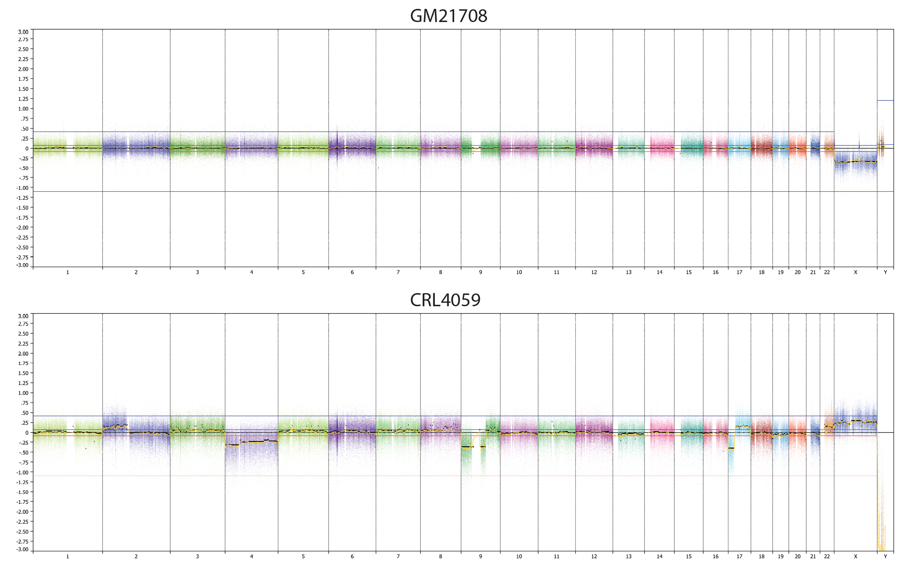
Supplementary Figure 1: Single nucleotide polymorphism array of dermal melanocytes
Neonatal melanocytes (GM21708) illustrate a normal chromosomal pattern; whereas hTERT-dermal melanocytes (CRL4059) demonstrate chromosomal aberration in chr.2, chr. 4, chr. 9 and chr.17

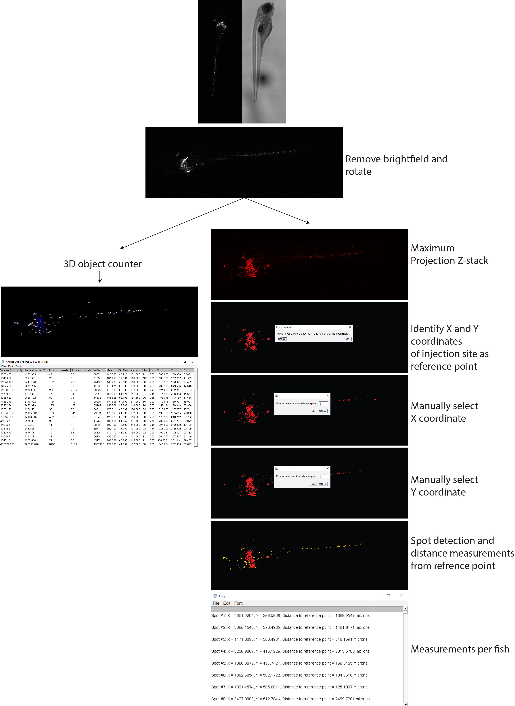
Supplementary Figure 2: Visual representation of quantifying zebrafish xenografts
Visual representation of quantifying zebrafish xenografts illustrating data acquirement in a step-by-step fashion.
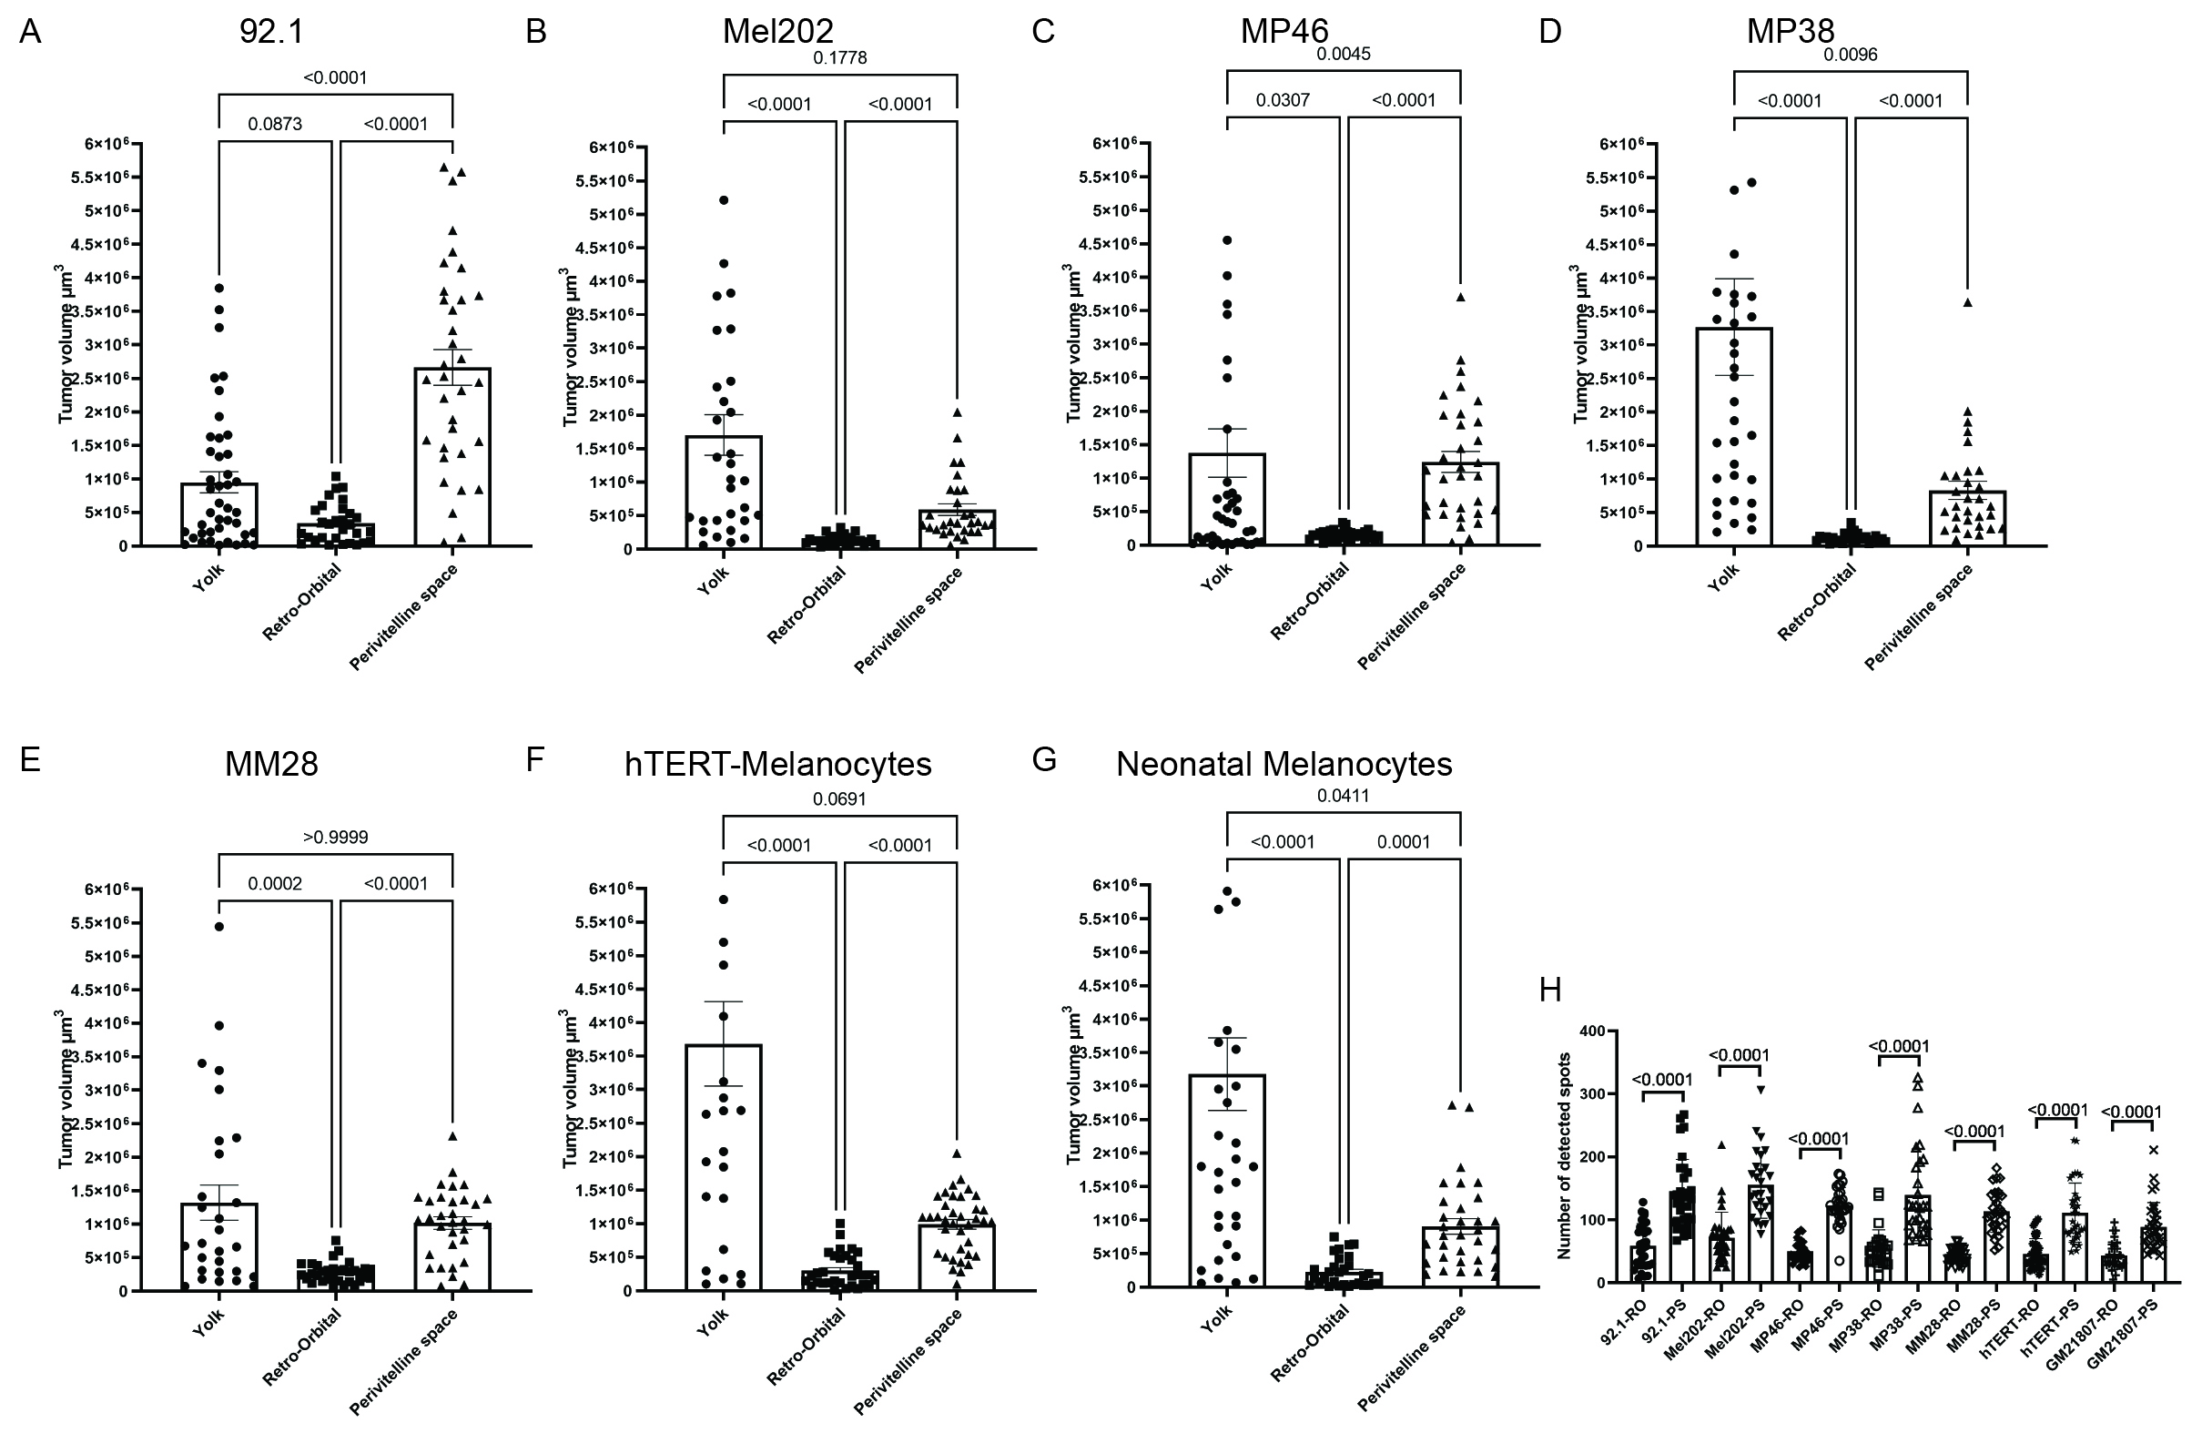
Supplementary Figure 3: Overview of tumor volume and detected disseminated cells per inoculation site for each cell line
Comparison of tumor volumes between yolk sac, retro-orbital and perivitilline space injections illustrated the differences between injection site (A-G). H) comparison of the detected number of spots between retro-orbital and perivitilline space inoculations.

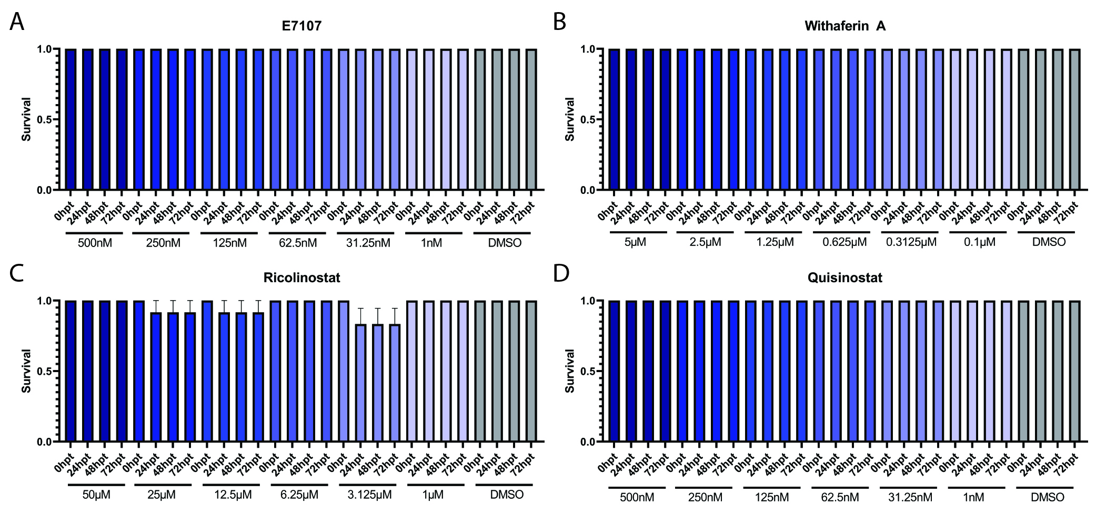
Supplementary Figure 4: Toxicity tolerance of zebrafish larvae
Each compound was evaluated for toxicity based on the effective concentrations found by in vitro screenings of UM cell lines.

Supplementary Methods: Scripts to quantify zebrafish xenografts.
Script to quantify tumor volume (Can be copy and pasted into the macro-manager of FIJI)
//splits all channels.
run("Split Channels");
//Closes brightfield image. Adjust 'C2-*' to whatever channel you want to remove from analysis
close('C2-*');
//transform image to get the right orientation. This might differ depending on how the zebrafish is positioned under the microscope.
run("Rotate 90 Degrees Right")
//measure tumor spots in cubic micron.
run("3D Objects Counter", "threshold=90 slice=1 min.=10 max.=10000000 exclude_on_edges surfaces_numbered statistics");
//Saves measurements in text file.
saveAs("text");
//Closes analysed image.
close("C1-*");
//Closes measurements.
close("*.txt");

Script to quantify number of disseminated cells and their migration distance (Can be copy and pasted into the macro-manager of FIJI)
// Splits all channels
run("Split Channels");
// Close channel 2
close("*C2*");
// Rotate image 90 degrees to the right. This might differ depending on how the zebrafish is positioned under the microscope.
run("Rotate 90 Degrees Right");
// Max-intensity Z projection without keeping the stack
run("Z Project...", "projection=[Max Intensity]");
zProjID = getImageID();
saveAs("Tiff", "zProj.tif");
// Threshold image and obtain mask.
setThreshold(90, 255);
run("Create Mask");
maskID = getImageID();
saveAs("Tiff", "mask.tif");
// Multiply z-projected image with mask using image calculator to obtain binary thresholded image.
imageCalculator("Multiply", "zProj.tif", "mask.tif");
//Selects image which will be analysed.
selectImage("zProj.tif");

//Identify x and y coordinates of injection spot
waitForUser("Hover over the reference point and remember the coordinates.");
// Manually enter the x and y coordinates of the reference point
xRef = getNumber("Enter x-coordinate of the reference point:", 0);
yRef = getNumber("Enter y-coordinate of the reference point:", 0);
// Set parameters for spot detection.
minSize = 20; // minimum spot size in pixels
maxSize = 5000; // maximum spot size in pixels
threshold = 20; // detection threshold
// Find spots using the Find Maxima function
run("Find Maxima...", "noise=" + threshold + " output=[Point Selection] exclude");
// Filter spots by size
run("Analyze Particles...", "size=" + minSize + "-" + maxSize + " circularity=0.00-1.00 show=Masks add");
// Get the number of spots and their x and y coordinates
nSpots = nResults();
for (i = 0; i < nSpots; i++) {
x = getResult("X", i);
y = getResult("Y", i);
// Calculate the distance between the spot and the reference point
distance = sqrt(pow(x - xRef, 2) + pow(y - yRef, 2)); // convert distance to microns
// Write the spot's x and y coordinates and the distance to the reference point to the output file
print("Spot #" + (i+1) + ": X = " + x + ", Y = " + y + ", Distance to reference point = " + distance + " microns\n");
}
//Selects the measurements window
selectWindow("Log");
//Saves measurements as text file.
saveAs("Text");
//String of commands to close and reset all parameters and images used to obtain measurements without closing stacks that are still to be analyzed.
print("\\Clear");
run("Clear Results");
roiManager("Reset");
run("Close");
close("C*");
close("zProj.tif");
close("mask.tif");
close("Mask of zProj.tif");

References
1. Jager, M.J., et al., Uveal Melanoma Cell Lines: Where do they come from? (An American Ophthalmological Society Thesis). Trans Am Ophthalmol Soc, 2016. 114: p. T5.
2. Amirouchene-Angelozzi, N., et al., Establishment of novel cell lines recapitulating the genetic landscape of uveal melanoma and preclinical validation of mTOR as a therapeutic target. Mol Oncol, 2014. 8(8): p. 1508-20.

