Supplementary Materials
for
SegPhase : Development of arrival time picking models for Japan’s seismic network using the hierarchical vision transformer
Author #1: Shinya Katoh, Earthquake Research Institute, The University of Tokyo, 1-1-1 Yayoi, Bunkyo-ku, Tokyo 113-0032, Japan, shinya-k@eri.u-tokyo.ac.jp
Author #2: Yoshihisa Iio, Disaster Prevention Research Institute, Kyoto University, Gokasho Uji, Kyoto 611-0011, Japan, iio.yoshihisa.56n@st.kyoto-u.ac.jp
Author #3: Hiromichi Nagao, The University of Tokyo, 1-1-1 Yayoi, Bunkyo-ku, Tokyo 113-0032, Japan, nagaoh@eri.u-tokyo.ac.jp
Author #4: Hirochi Katao, Disaster Prevention Research Institute, Kyoto University, Gokasho Uji, Kyoto 611-0011, Japan, katao.hiroshi.2v@kyoto-u.jp
Author #5: Masayo Sawada, Disaster Prevention Research Institute, Kyoto University, Gokasho Uji, Kyoto 611-0011, Japan, sawada.masayo.8s@kyoto-u.ac.jp
Author #6: Kazuhide Tomisaka, Disaster Prevention Research Institute, Kyoto University, Gokasho Uji, Kyoto 611-0011, Japan, tomisaka.kazuhide.6c@kyoto-u.ac.jp

Text S1
The PhaseNet models were trained under consistent conditions to facilitate a fair comparison with the SegPhase model. Both models utilized a batch size of 32 and a learning rate of 0.001, with RAdam as the optimization algorithm and categorical cross-entropy loss as the loss function. Early stopping was employed for both models, ensuring that the only difference between the SegPhase and PhaseNet models lies in their architectural structure.

The objective of this analysis is to compare model architectures rather than optimize performance through hyperparameter tuning. By using RAdam, we aimed to minimize the influence of hyperparameters and concentrate on the differences in model performance. After testing various batch sizes and learning rates, we evaluated the mean and standard deviation of the arrival time residuals between the predicted and true travel times on the test data (Fig. S3). The results indicated that the selected learning rate and batch size were effective, confirming that applying the same settings for both PhaseNet and SegPhase would not introduce any issues.

The original PhaseNet model architecture was designed for three-component, 100 Hz sampling waveforms. Consequently, adjustments were required to accommodate three-component, 250 Hz sampling waveforms and vertical component, 100 Hz sampling waveforms. For the three-component, 250 Hz sampling waveforms, we modified the padding value within the convolutional layers. This adjustment does not affect the number of trainable parameters, thereby preserving the model's representational capability. For the vertical component, 100 Hz sampling waveforms, we altered the number of input and output channels, setting the input channel to 1 and the output channels to 2. Meanwhile, for the three-component, 100 Hz sampling waveforms, the original PhaseNet model structure was maintained.

Text S2
We calculated precision, recall, and F1 scores based on the standards set by Zhu and Beroza (2019). Outputs were classified as positive if their probability values exceeded a specified threshold, while those that fell below the threshold were labeled as false negatives (FN). Among the positives, outputs with a time difference of less than 0.1 s between model predictions and human annotations were classified as true positives (TP), whereas those with a greater difference were considered false positives (FP).

Figs. S4 and S5 compare the performance of SegPhase and PhaseNet. In terms of the F1 score, SegPhase consistently demonstrates superior performance across the models (250 Hz, 100 Hz, and M01). It maintains high F1 scores across a broad range of thresholds, achieving peak values that surpass those of PhaseNet. This result indicates that SegPhase effectively balances precision (accuracy) and recall (detection rate), leading to better overall performance. Moreover, the optimal thresholds at which the F1 score reaches its maximum yield higher F1 scores for SegPhase than for PhaseNet, confirming the model’s enhanced performance even under balanced detection conditions.

The precision-recall curves further illustrate the advantages of SegPhase. Unlike PhaseNet, SegPhase maintains high precision even as recall increases, highlighting its ability to reduce false positives while sustaining a high detection rate. Additionally, the precision-recall curves for SegPhase consistently sit above those of PhaseNet across all models, demonstrating the model’s robustness and stability under varying conditions.

Importantly, SegPhase performs consistently well in both P-wave and S-wave picking tasks. Across all models (250 Hz, 100 Hz, and M01), the model exhibits a high level of adaptability, with particularly pronounced advantages in S-wave detection. This confirms that SegPhase’s design is effective for detecting both types of seismic waves.

Furthermore, we applied SegPhase and PhaseNet to continuous waveforms, comparing the number of detected seismic sources using the thresholds that maximize F1 scores for P-waves and S-waves (for detailed application methods, please refer to Section 4.1 of the main text). While there was no significant difference in the spatial distribution of detected earthquakes between the SegPhase and PhaseNet models (Fig. S6), a notable difference was observed in the total number of detected events. SegPhase detected 23,627 earthquakes, surpassing the 20,582 earthquakes identified by PhaseNet. Additionally, an analysis of the frequency distribution of detected earthquakes by magnitude revealed that SegPhase exhibited superior detection capability for small earthquakes, particularly those with a magnitude of M0.6 or less, in comparison to PhaseNet (Fig. S7). These results suggest that SegPhase may be more effective in detecting small-magnitude earthquakes.

These findings indicate that SegPhase achieves superior performance in seismic wave picking and detection. Its ability to maintain high precision and recall, coupled with consistent performance in both P-wave and S-wave detection, underscores its reliability and versatility. These characteristics make SegPhase a robust tool for improving the accuracy of seismic wave arrival time detection and demonstrate its potential for practical applications in observational seismology.

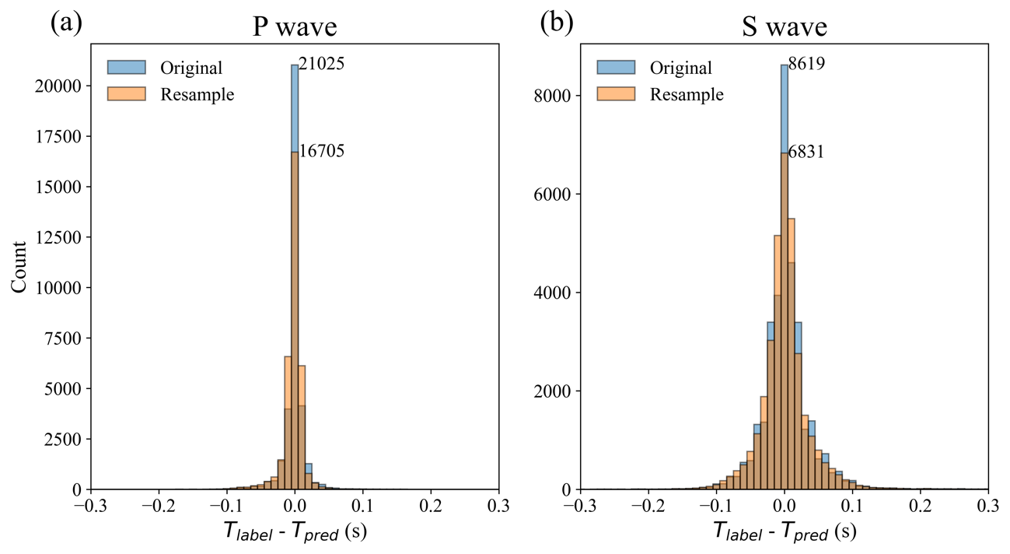
Fig. S1 Difference in model inference results due to sampling frequency
This histogram shows the residuals between the arrival times predicted by the model and the true arrival times. The same test dataset, sampled at 250 Hz, is used for the analysis. ‘Original’ refers to the inference results from the model trained on 250 Hz data, while ‘Resample’ refers to the inference results from the model trained on data downsampled from 250 Hz to 100 Hz. During inference with the Resample model, the test dataset is also downsampled to 100 Hz. (Refer to the main text for details on the models and data.)

Fig. S2 Example of data augmentation through the synthesis of seismic waves along the time axis
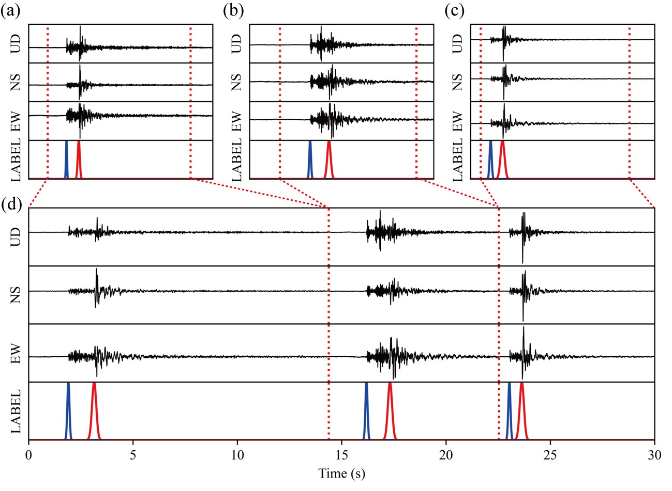
Panels (a), (b), and (c) show individual seismic waveforms used for synthesis. The signal range (enclosed by the red dashed line) is sampled randomly between 0.5 and 1 second before the P-wave arrival time and extends to the point where the signal-to-noise ratio reaches 2. Panel (d) displays the result of synthesizing these seismic waves.

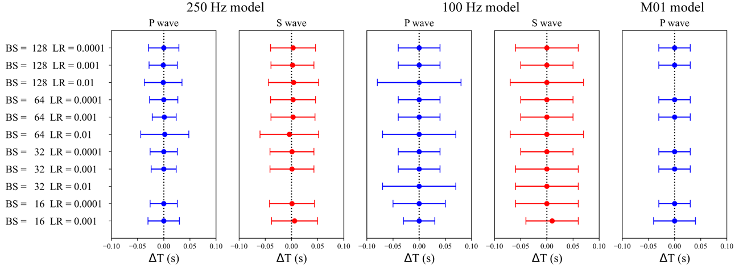
Fig. S3 Mean and standard deviation of travel time residuals with varying model hyperparameters
This figure illustrates the effect of different hyperparameters (Batch size (BS) and Learning rate (LR)) on model inference performance using the RAdam optimization algorithm to train PhaseNet. BS values of 16, 32, 64, and 128, and LR values of 0.01, 0.001, and 0.0001 were used, with each combination listed on the vertical axis. The horizontal axis represents the travel time residuals, with the mean for each model plotted as circles and the standard deviation shown as error bars. Blank spaces indicate combinations where model training did not succeed.

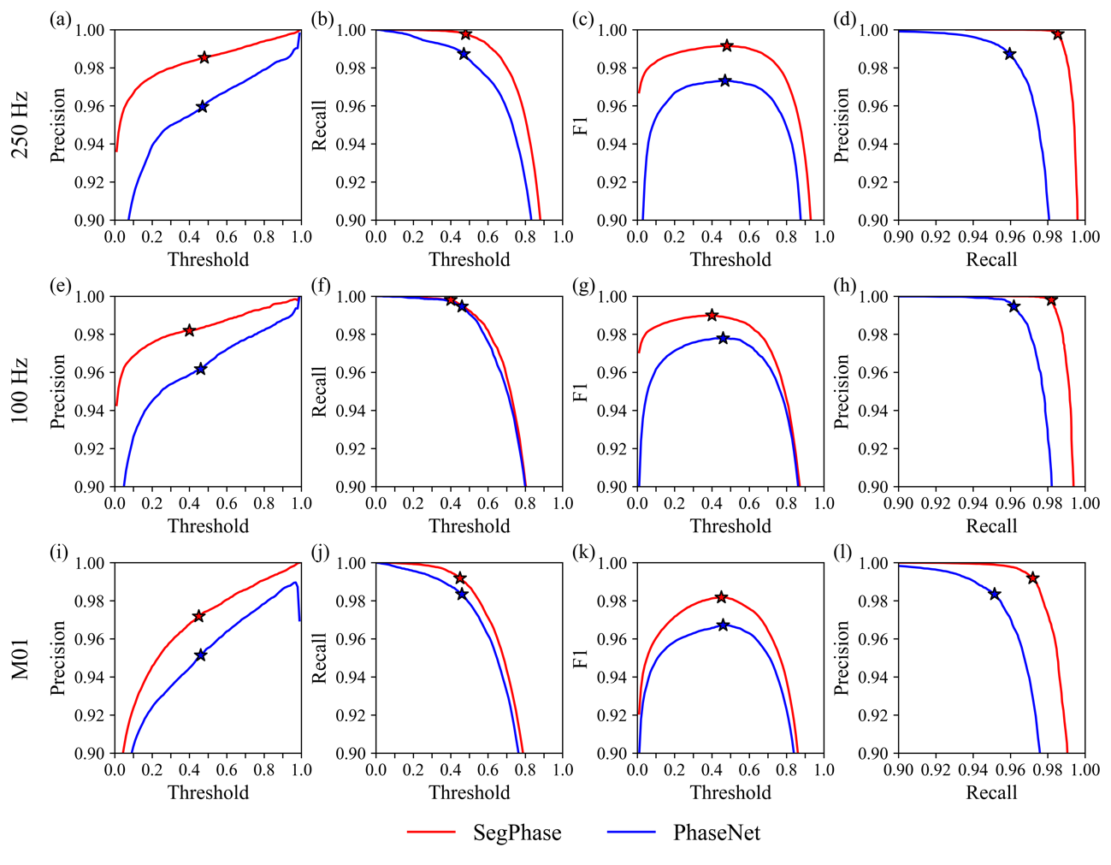
Fig. S4 Comparison of metrics for P-wave arrival time picking between SegPhase and PhaseNet
The graphs show precision, recall, F1 scores, and Precision-Recall curves for P-wave arrival time picking using SegPhase (in red) and PhaseNet (in blue) across different thresholds for three models: 250 Hz (a, b, c, and d), 100 Hz (e, f, g, and h), and M01 (i, j, k, and l). The x-axis represents threshold values. Red (SegPhase) and blue (PhaseNet) star markers indicate the thresholds at which the F1 score is maximized.

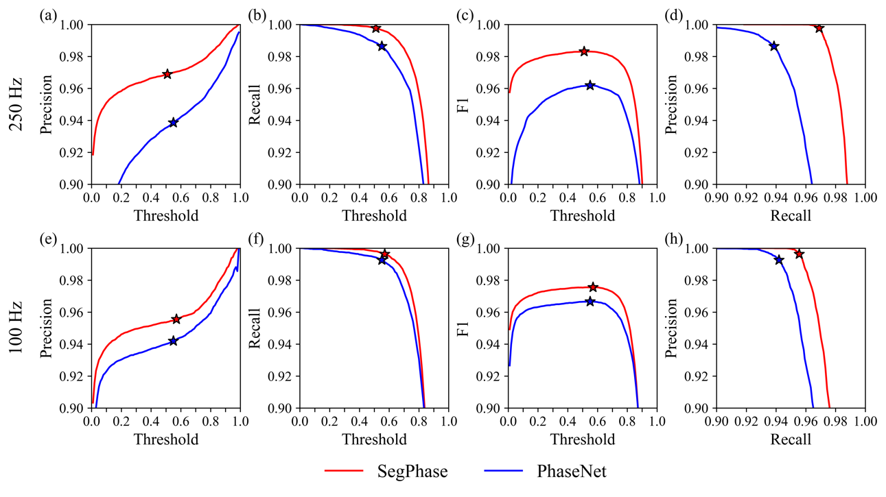
Fig. S5 Comparison of metrics for S-wave arrival time picking between SegPhase and PhaseNet
The graphs show precision, recall, F1 scores, and Precision-Recall curves for S-wave arrival time picking. Other details are the same as in Fig. S2.

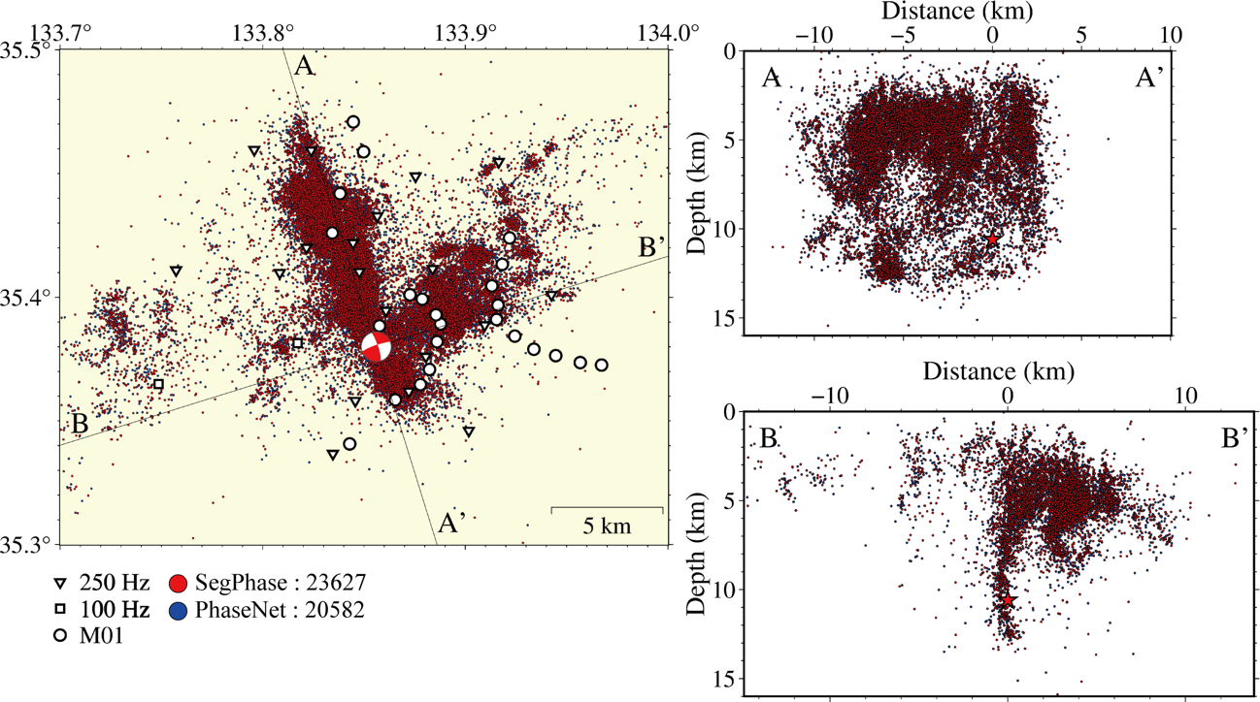
Fig. S6 Comparison of the distribution of hypocenters determined by SegPhase and PhaseNet using optimal thresholds.
White reversal triangle, square, and circle are 3-component 250 Hz sampling stations, 3-component 100 Hz sampling stations, and 1-component (vertical motion) 100 Hz sampling seismic stations, respectively. The focal mechanism of the MJ 6.6 central Tottori Prefecture earthquake is shown. The red stars in the cross sections of lines AA' and BB' are the hypocenter locations of the mainshock. The horizontal axis of the cross section is the horizontal distance from the epicenter. Red and Blue circles are hypocenters detected SegPhase and PhaseNet, respectively.

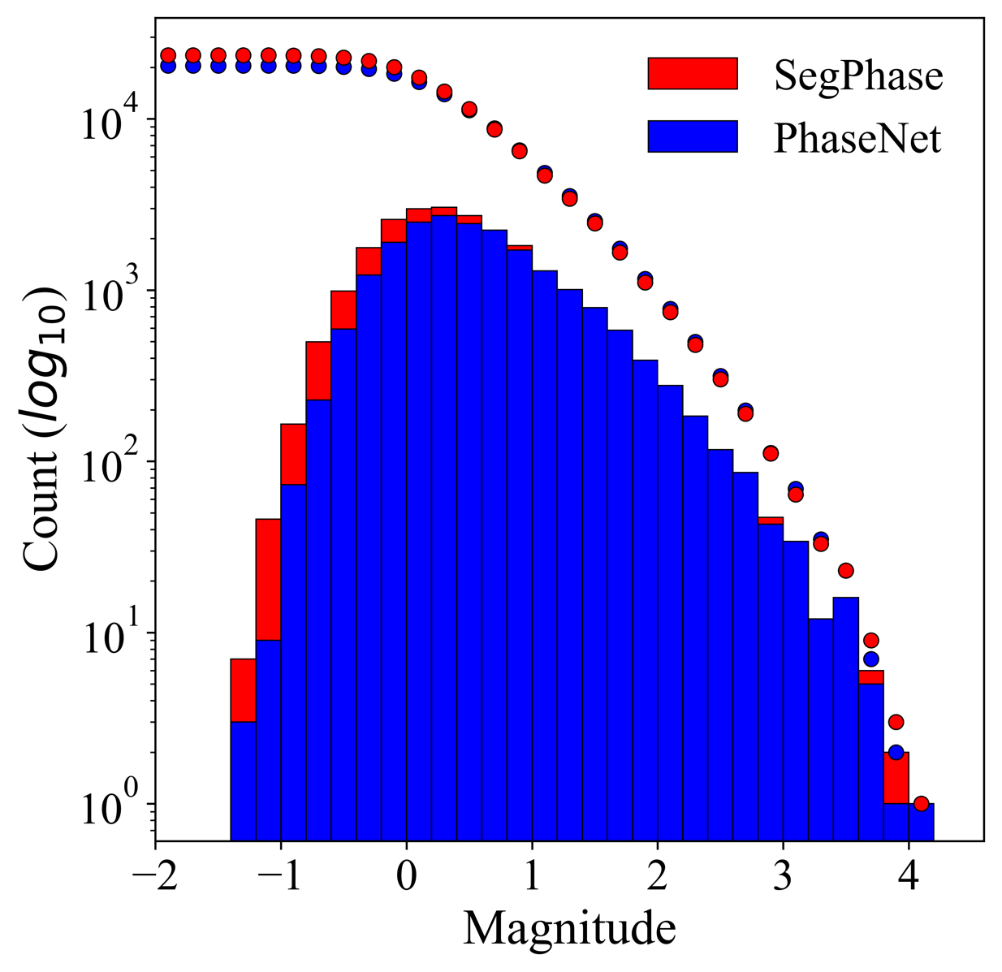
Fig. S7 Frequency distribution of earthquakes by magnitude detected by SegPhase and PhaseNet.
This figure shows the frequency-magnitude distribution of the earthquake catalogs by the SegPhase (Red) models and PhaseNet (Blue).

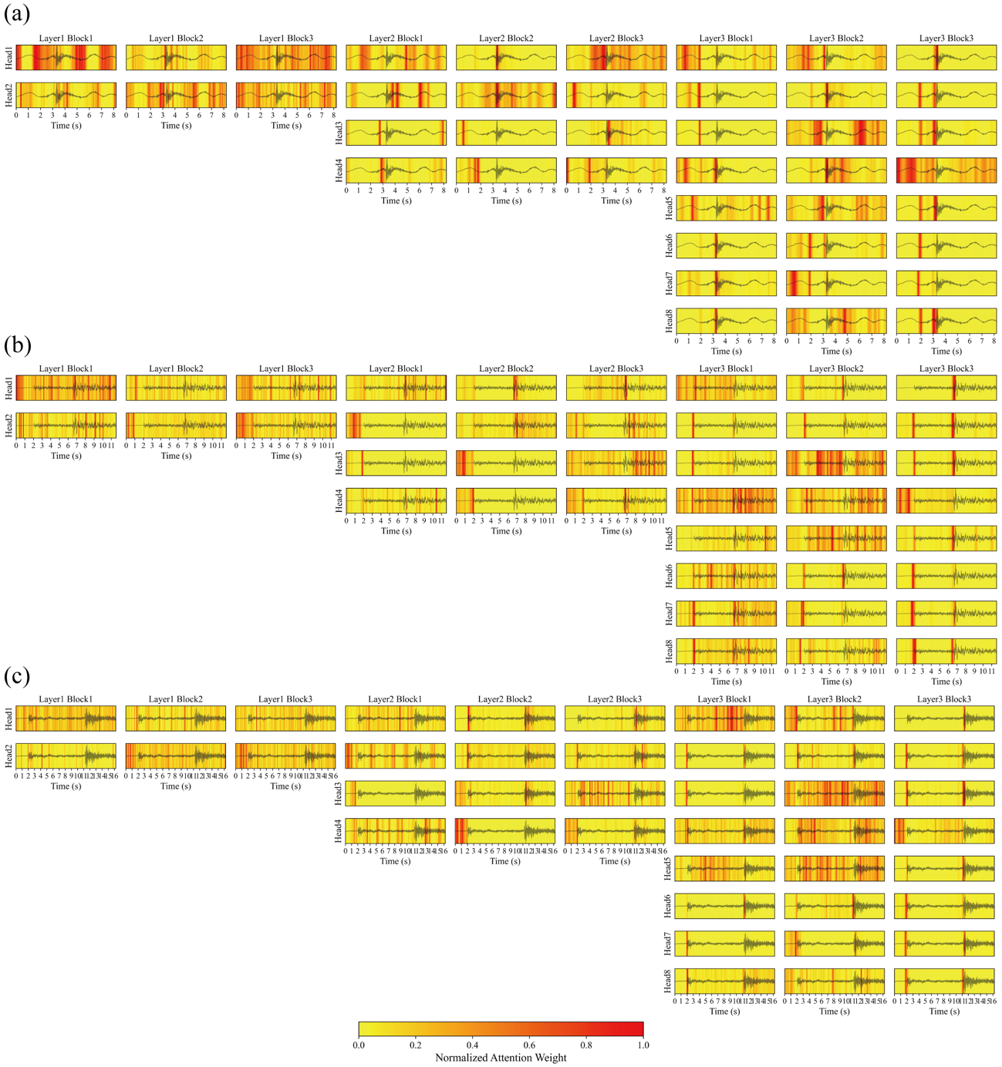
Fig. S8 Attention maps for all heads in the 100 Hz model
The format is the same as in Fig. 3.

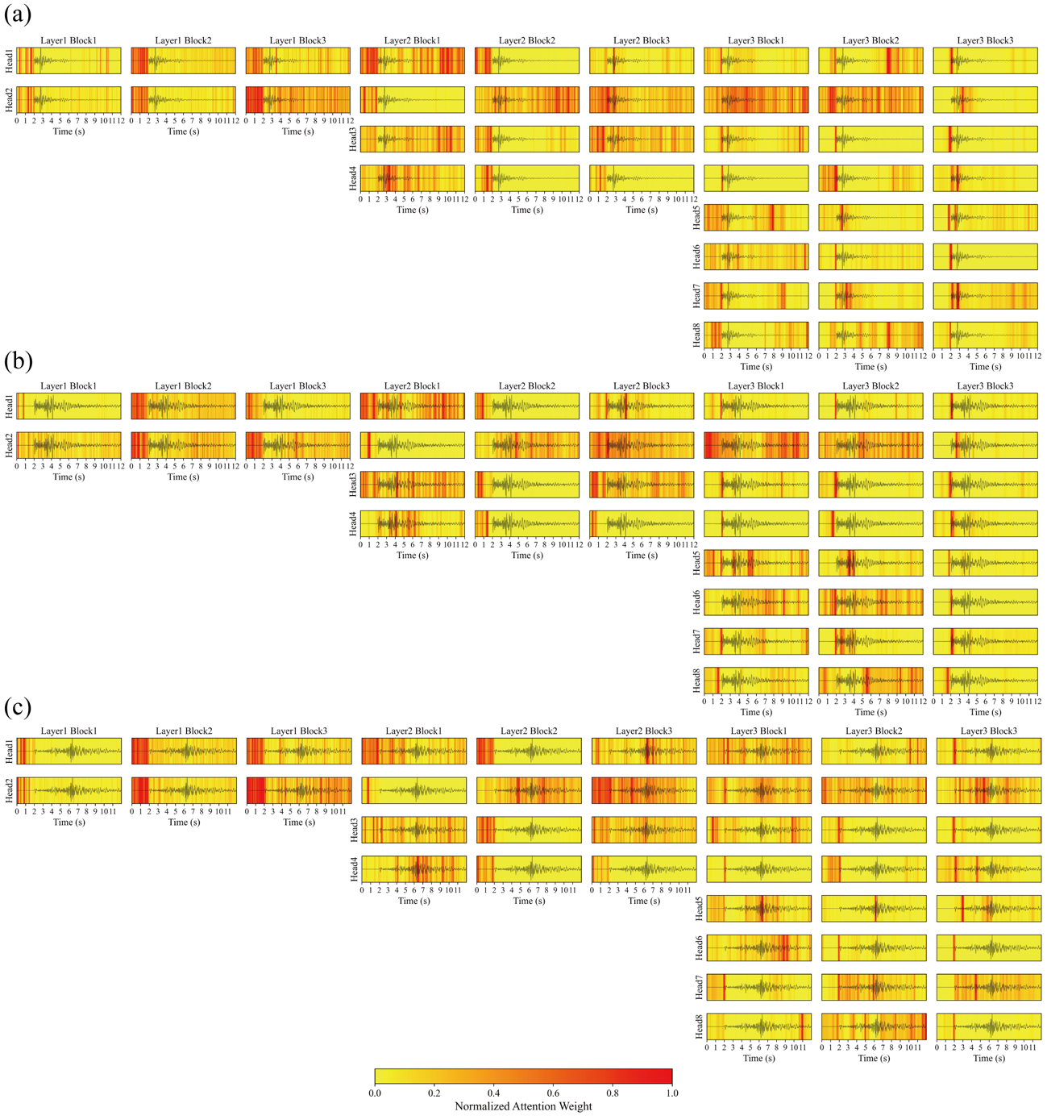
Fig. S9 Attention maps for all heads in the M01 model
The format is the same as in Fig. 3.

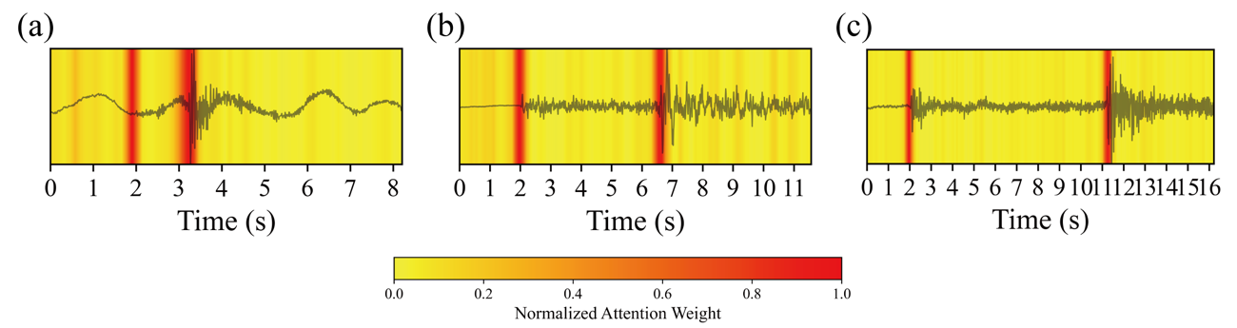
Fig. S10 Rollout attention maps for the 100 Hz model
The format is the same as in Fig. 4. Panels (a), (b), and (c) display results for different input data, corresponding to those in Fig. S6.

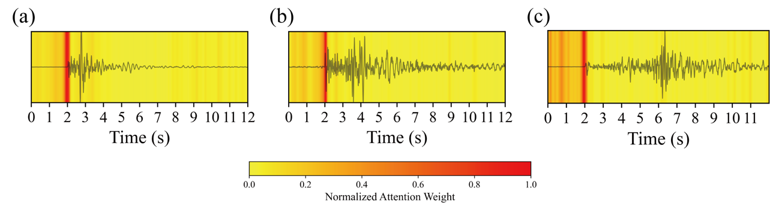
Fig. S11 Rollout attention maps for the M01 model
The format is the same as in Fig. 4. Panels (a), (b), and (c) show the results of different input data, corresponding to the data in Fig. S10.

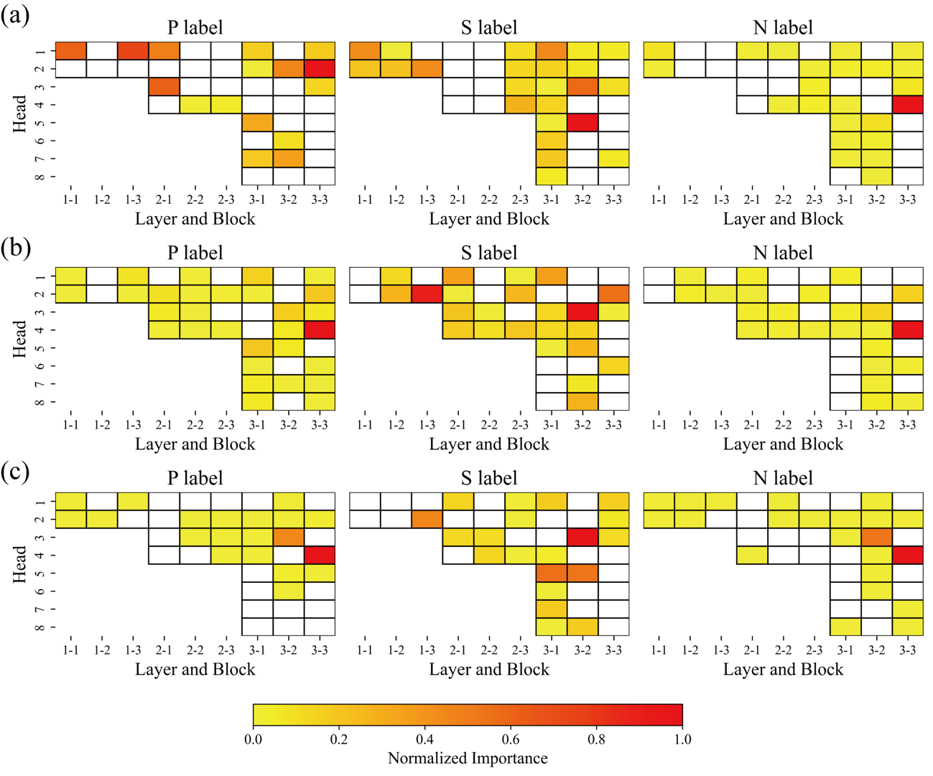
Fig. S12 Importance heatmaps for the 100 Hz model
The format is the same as in Fig. 5. Panels (a), (b), and (c) display results for different input data, corresponding to those in Fig. S6.

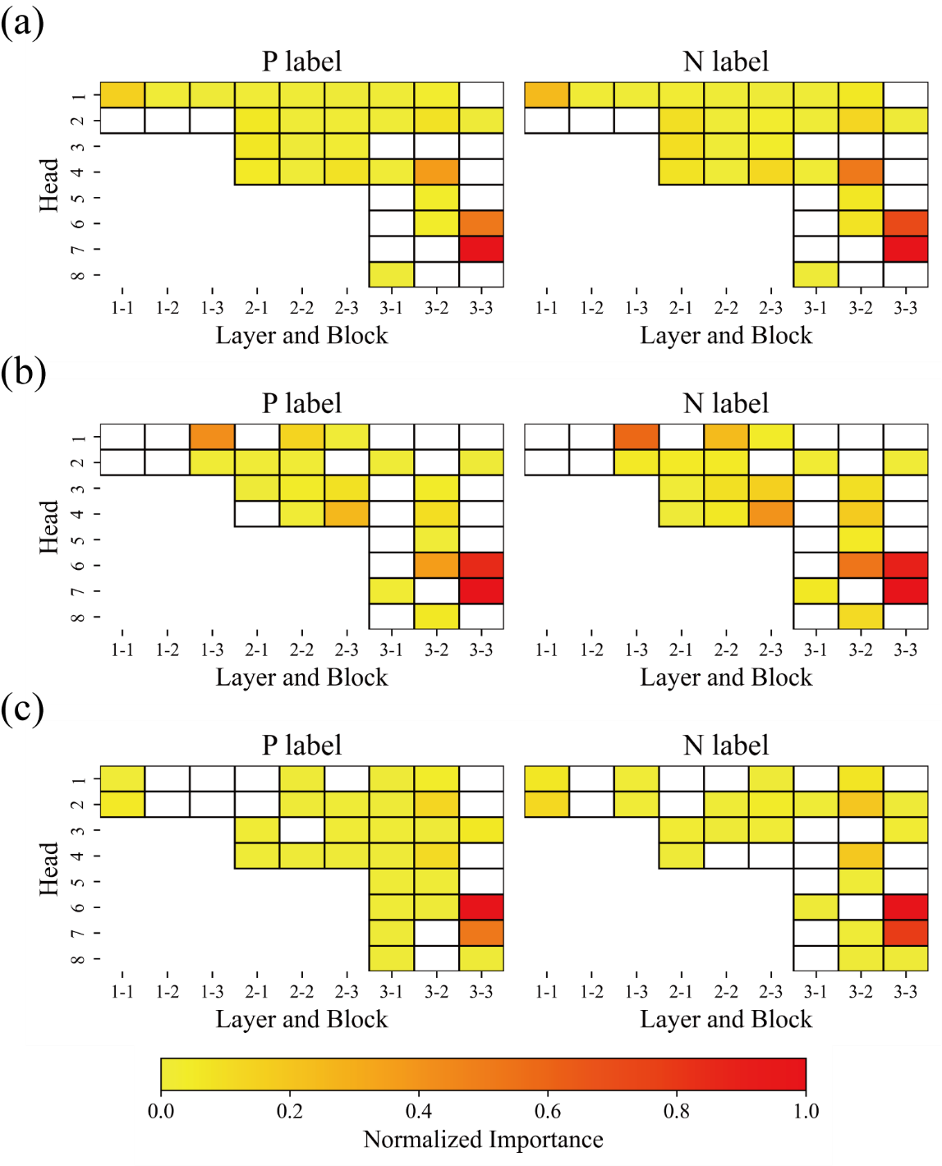
Fig. S13 Importance heatmaps of M01 model
The format is the same as in Fig. 5. Panels (a), (b), and (c) present results for different input data, corresponding to the data in Fig. S10.

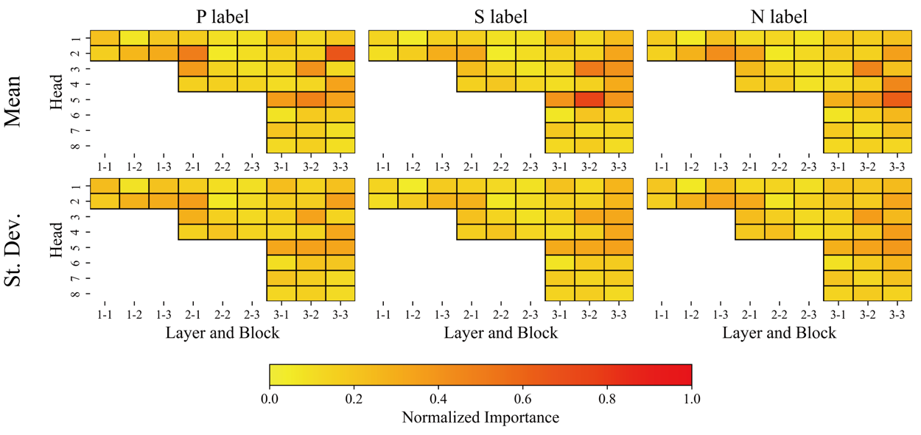
Fig. S14 Mean and standard deviation importance heatmaps for the 100 Hz model
The format is the same as in Fig. 6.

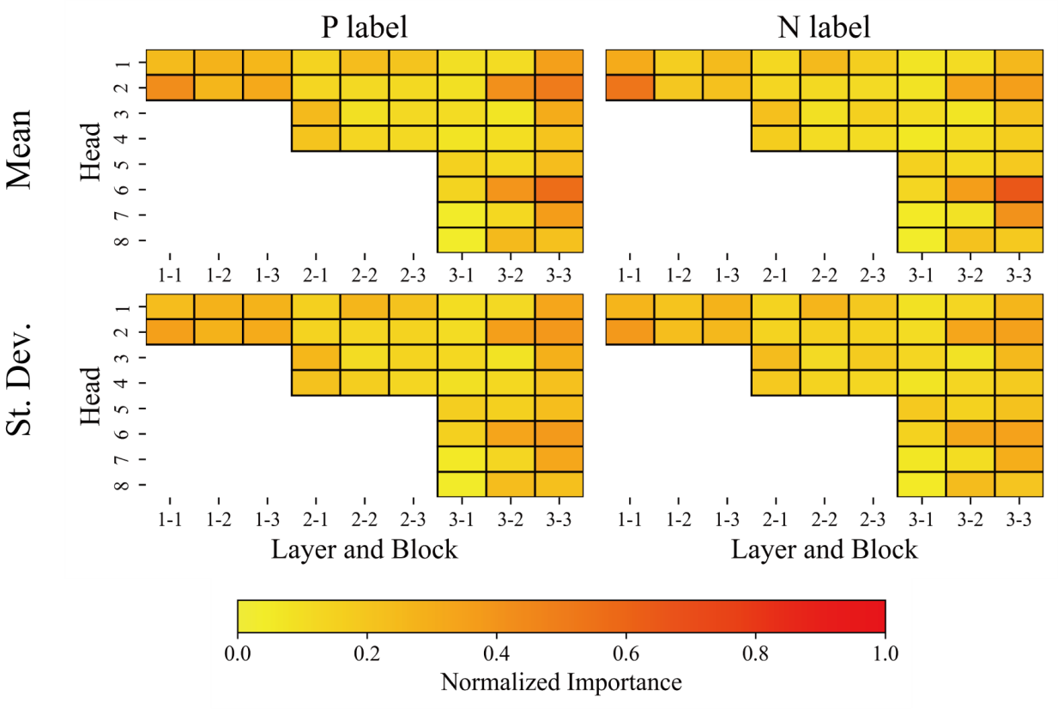
Fig. S15 Mean and standard deviation importance heatmaps for the M01 model
The format is the same as in Fig. 6.

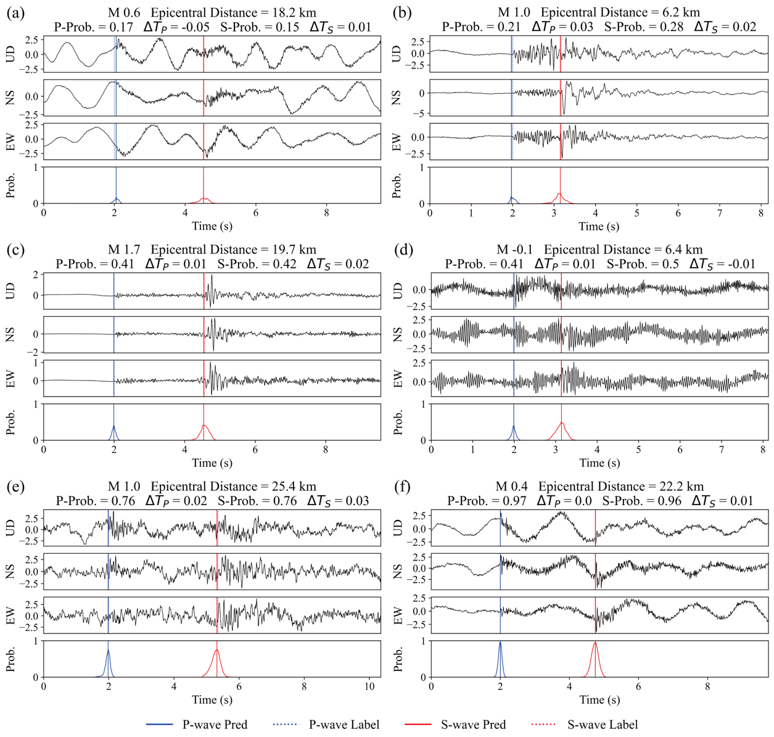
Fig. S16 Results showing close matches between 100 Hz model predictions and labeled data
The explanation is the same as in Fig. 4.

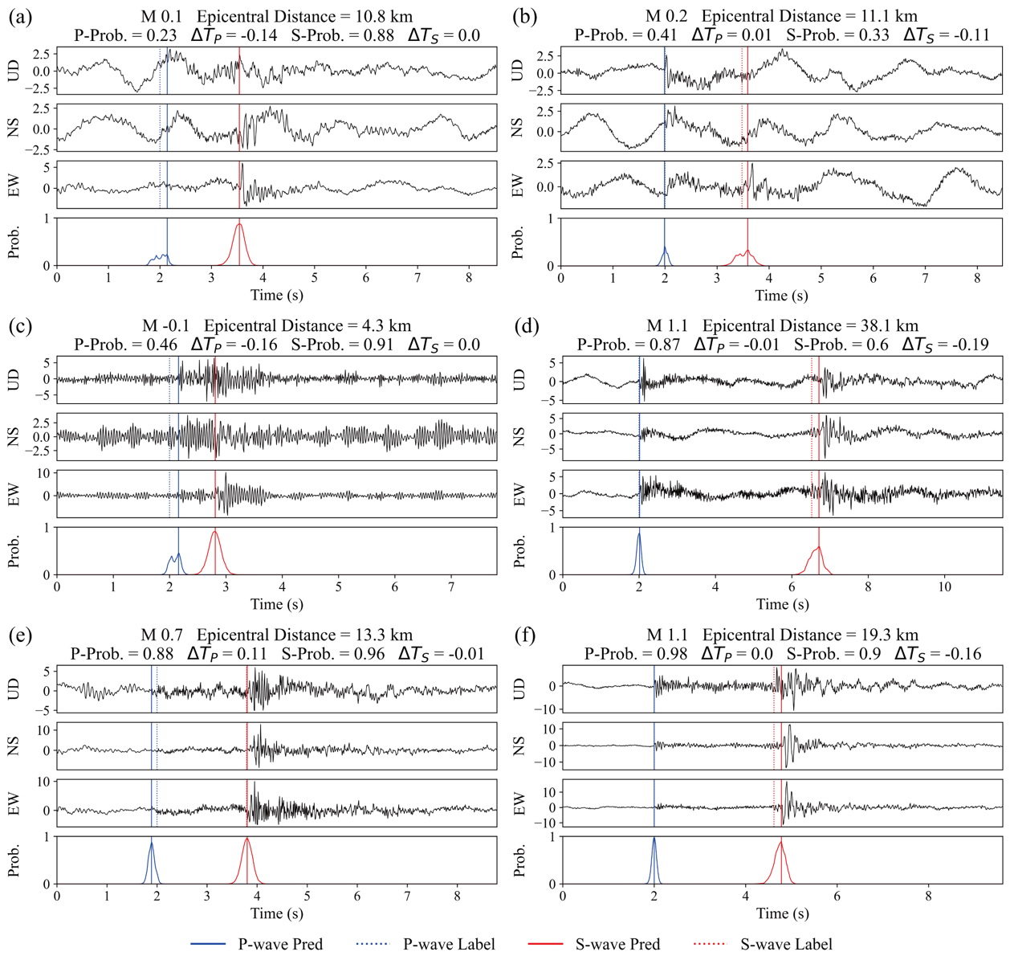
Fig. S17 Results indicating discrepancies in arrival times between 100 Hz model predictions and labeled data
The explanation is the same as in Fig. 4.

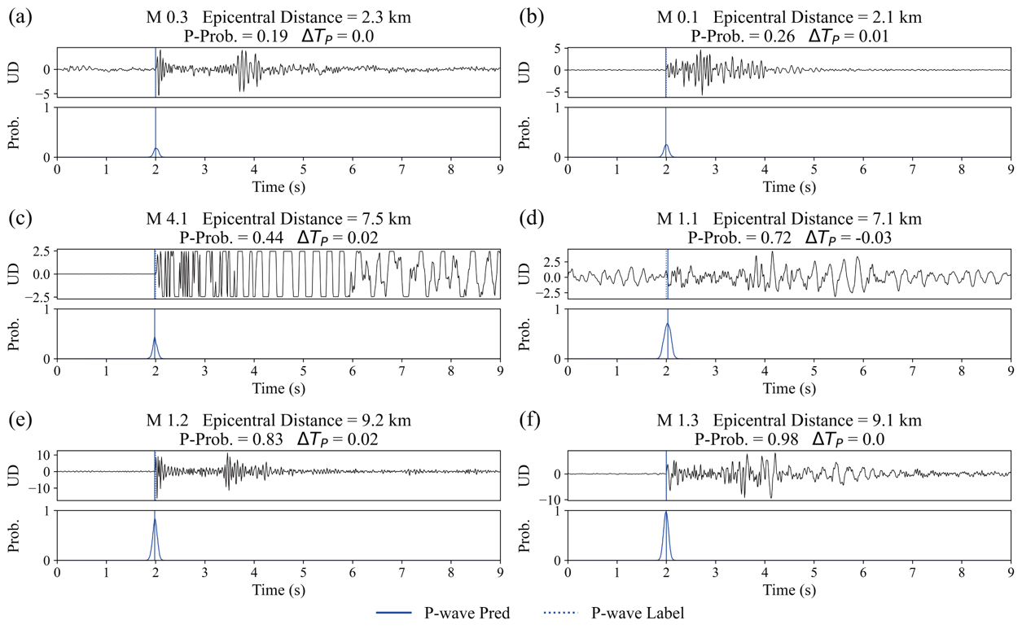
Fig. S18 Results showing close matches between M01 model predictions and labeled data
The top panel displays the waveforms of the UD components, while the bottom panel shows the output probability distributions from the model. Arrival times picked by humans and models are indicated by vertical lines: solid lines represent model predictions (Pred.) and dashed lines represent human determinations (Label), with P-waves shown in blue. Each panel also includes the magnitude, epicentral distance, P-wave output probability, and P-wave arrival time residual at the top.

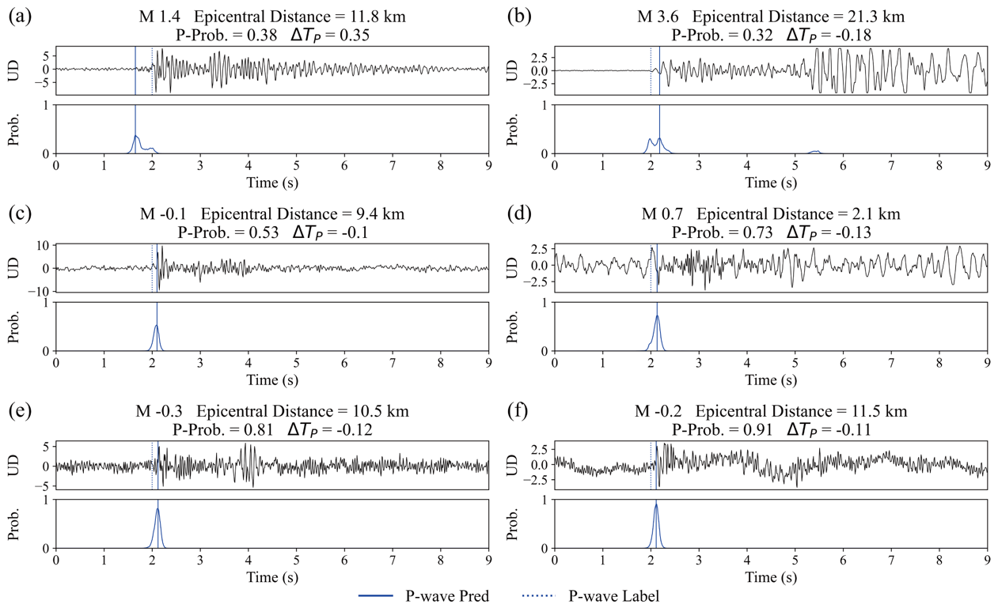
Fig. S19 Results indicating discrepancies in arrival times between M01 model predictions and labeled data
The explanation is the same as in Fig. S5.

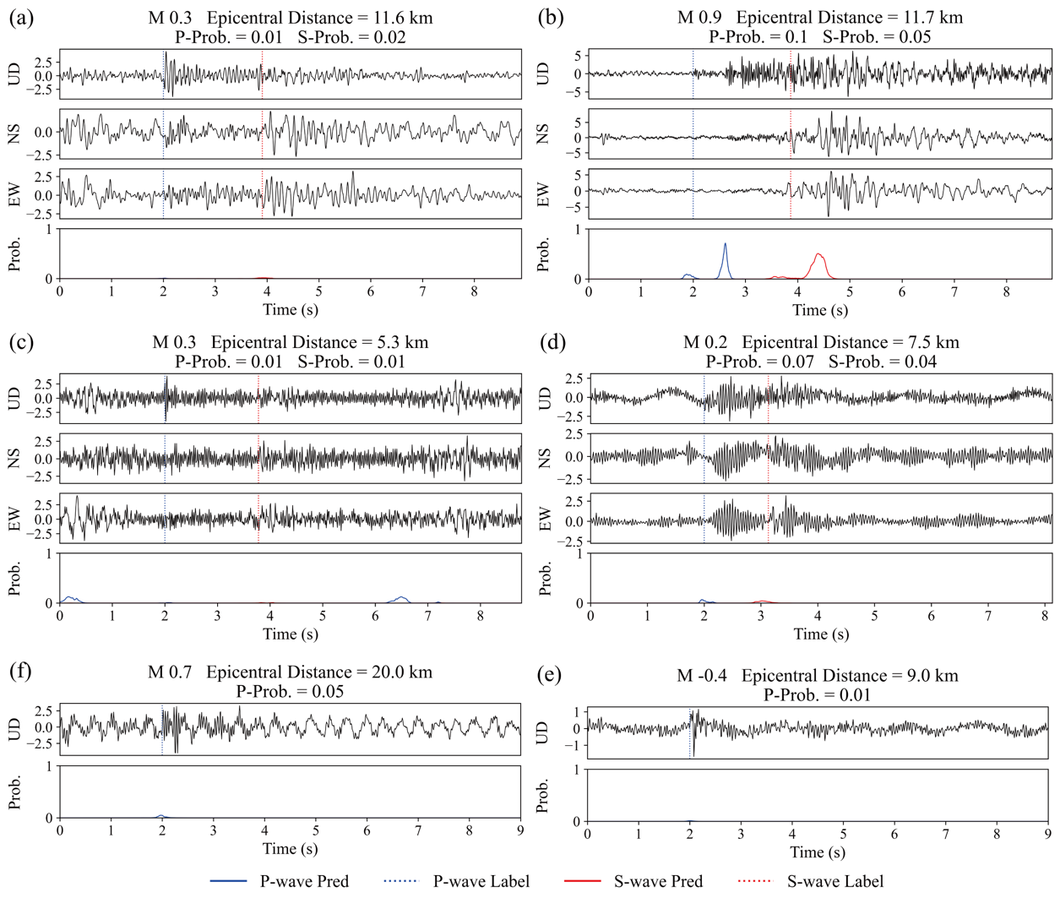

Fig. S20 Examples of waveforms not detected by the model
These examples illustrate cases where the model failed to detect the arrival time (output probability less than 0.1). Panels (a) and (b) show results for the 250 Hz model, panels (c) and (d) show results for the 100 Hz model, and panels (e) and (f) show results for the M01 model. Other explanations are the same as in Fig. 4.

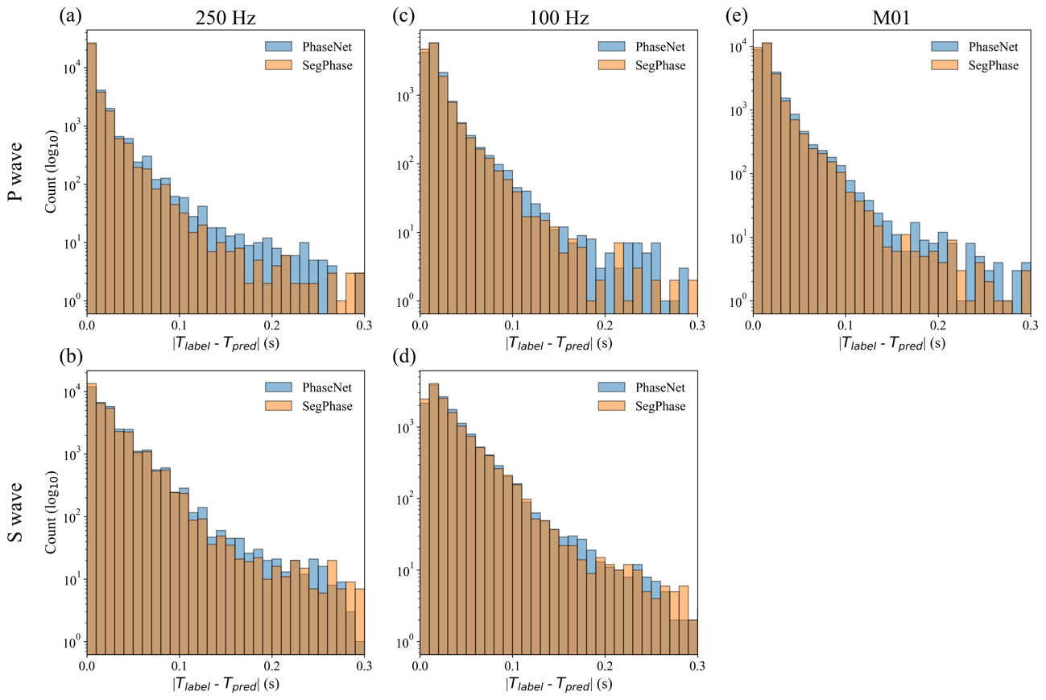
Fig. S21 Histogram of absolute arrival time residual value for each model
(a) and (b) are absolute arrival time residual value histograms for the 250 Hz model and (c) and (d) for the 100 Hz model. The bin width is 0.01 s. Light blue and orange are the results of the SegPhase and PhaseNet models, respectively. The color of the histograms for each model is transparent and is a mixture of light blue and orange in the area where the bin is common.

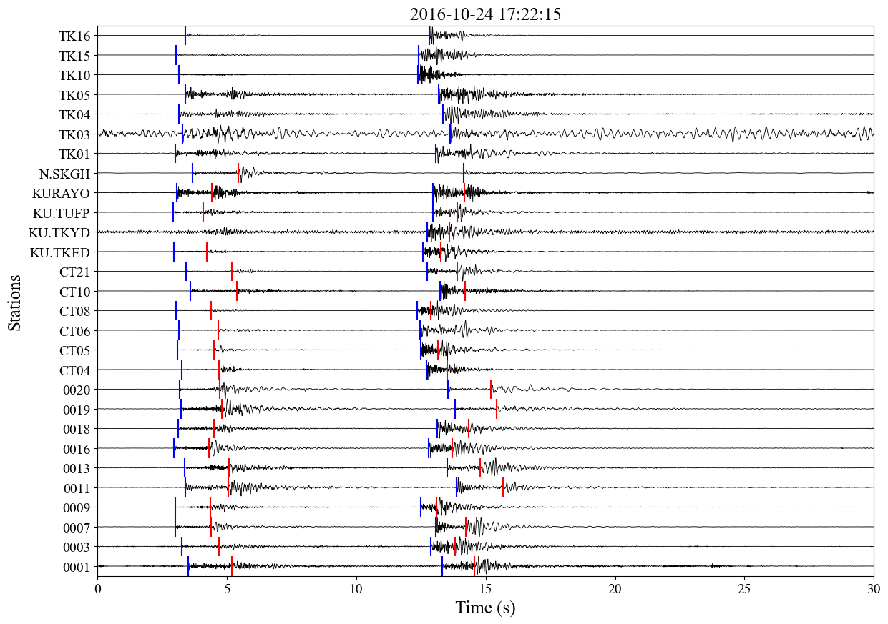
Fig. S22 Results of continuous waveform picking
This figure shows waveforms observed at each observation point for 30 seconds from 17:22:15 on October 24, 2016, recorded by the aftershock observation network in the source region of the 2016 Central Tottori Earthquake. Each waveform from three-component observation points is a stacked representation of UD, NS, and EW components. The vertical axis lists the observation points from bottom to top, where points 0001 to KU.TUFP are 250 Hz sampling points, KURAYO and N.SKGH are 100 Hz sampling points, and TK01 to TK16 are 100 Hz sampling points for the UD component only. Blue and red vertical lines indicate the P-wave and S-wave arrival times estimated by the SegPhase model, respectively.

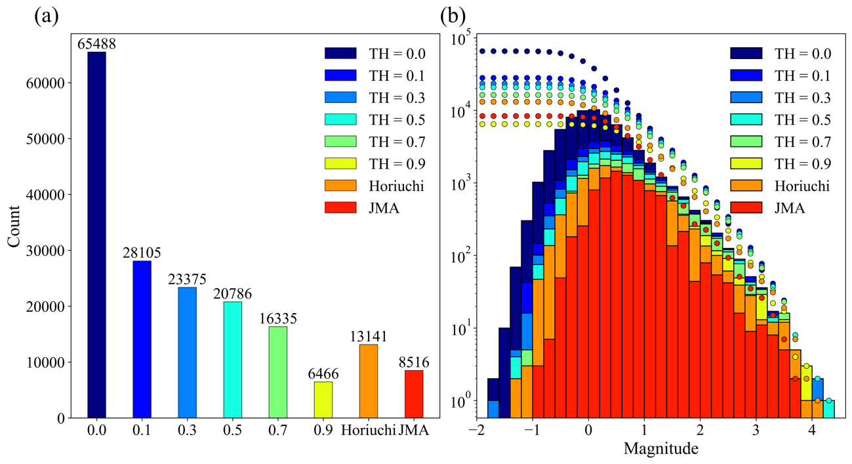
Fig. S23 Number of earthquake detections and frequency-magnitude distribution detected by PhaseNet
The explanation is the same as in Fig. 11.

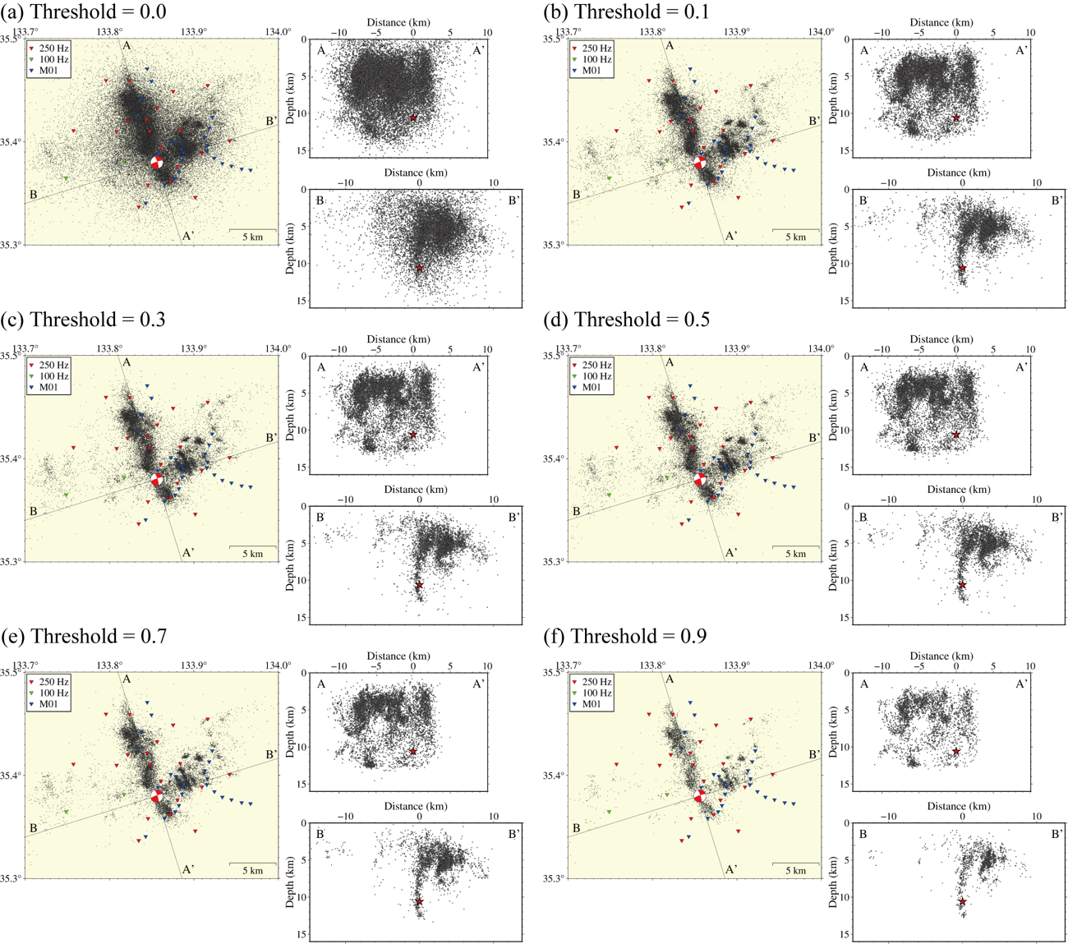
Fig. S24 Distribution of hypocenters for different thresholds of output probability values using PhaseNet models
The explanation is the same as in Fig. 9.

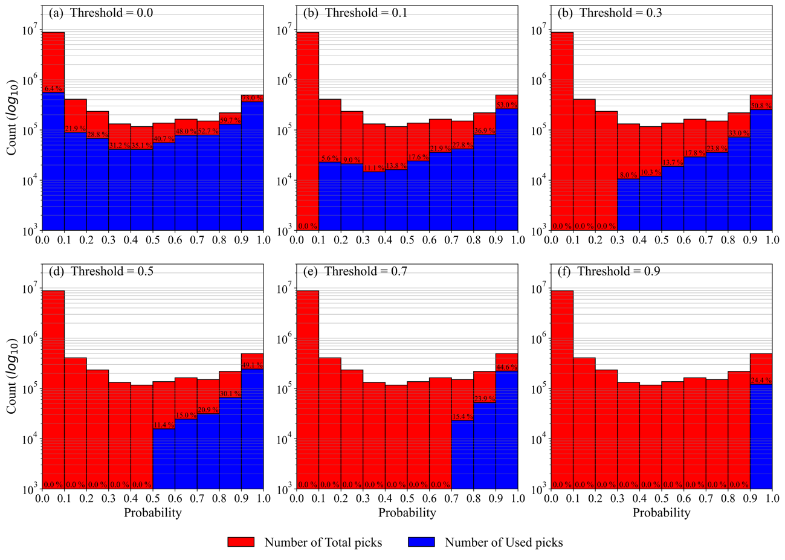
Fig. S25 Ratio of P-wave arrival times detected by PhaseNet to those used for hypocenter determination
This figure shows the ratio of P-wave arrival times detected by PhaseNet to those used for hypocenter determination. The explanation is the same as in Fig. 13.

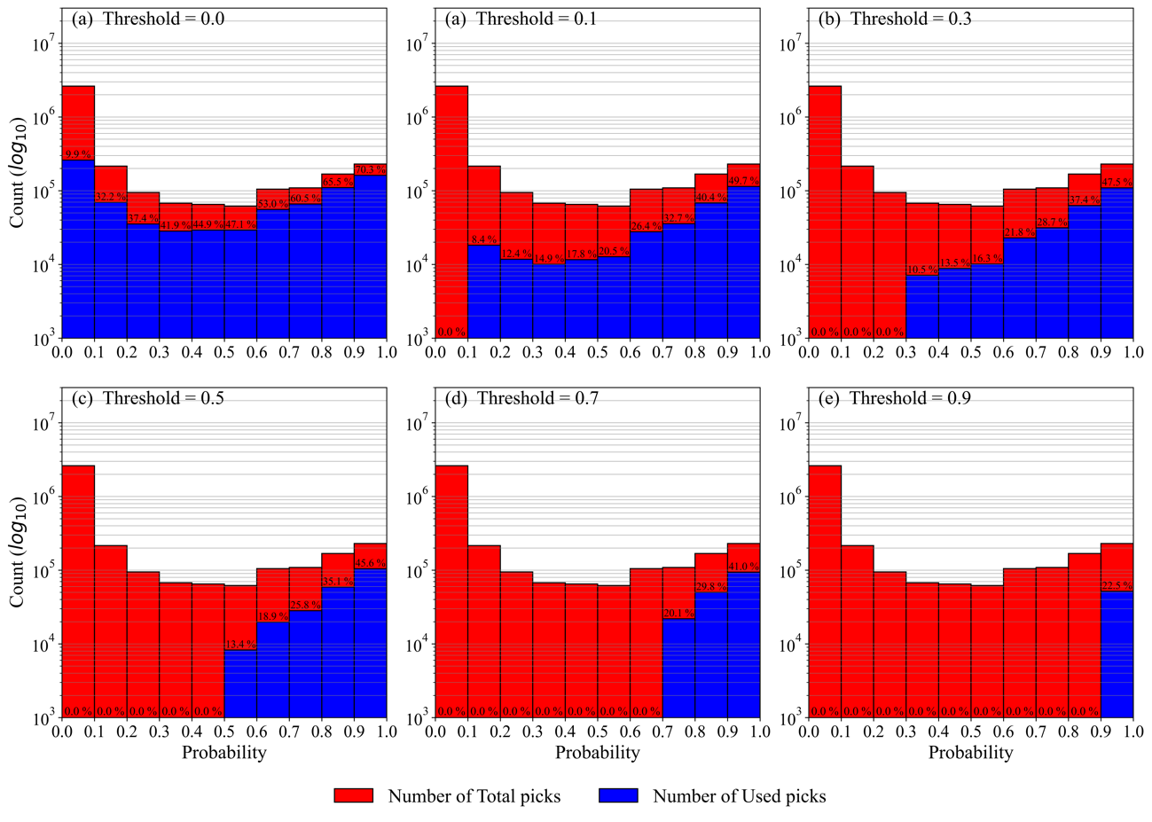
Fig. S26 Ratio of S-wave arrival times detected by PhaseNet to those used for hypocenter determination
This figure shows the ratio of S-wave arrival times detected by PhaseNet to those used for hypocenter determination. The explanation is the same as in Fig. 13.

