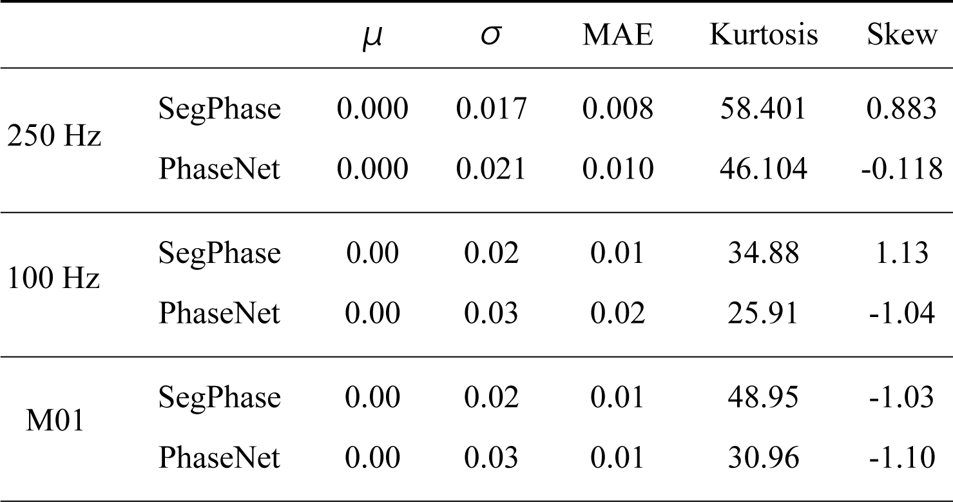
Table 1 μ, σ, MAE, Kurtosis and Skew of P-wave arrival time residual distribution

Table 2 μ, σ, MAE, Kurtosis and Skew of S-wave arrival time residual distribution
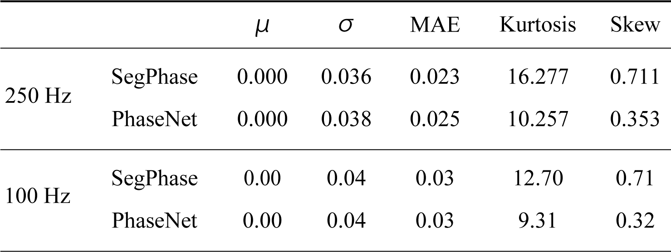

Table 3 O-C and hypocenter error
