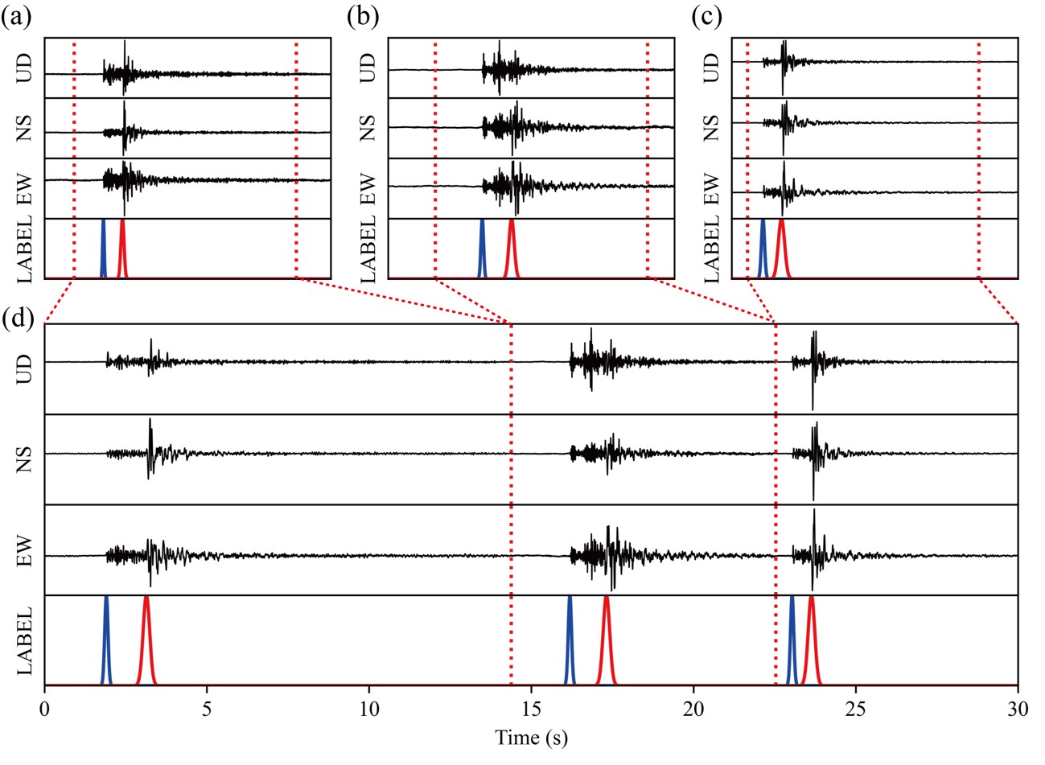
Figure S 1 Example of data augmentation through the synthesis of seismic waves along the time axis.
(a), (b) and (c) are individual seismic waveforms used for synthesis. This signal range (area enclosed by red dashed line) is from a random sampling point between 0.5 and 1 second before the P-wave arrival time to the point where the signal-to-noise ratio reached 2. (d) is the result of the synthesis of seismic waves.

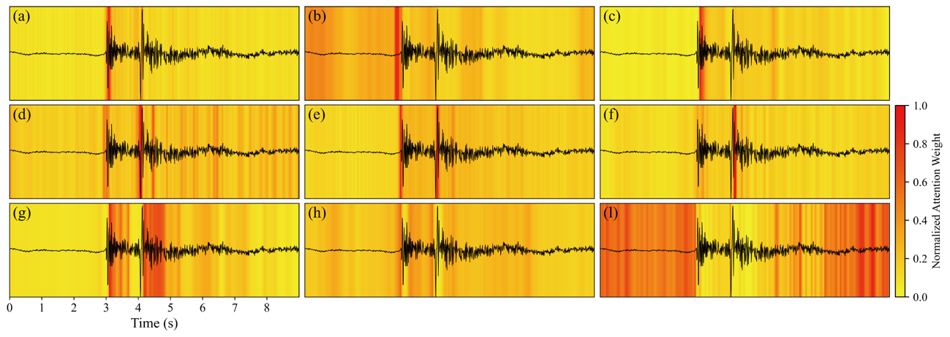
Figure S 2 Attention maps of 100 Hz model
The explanation is the same as Figure 2.

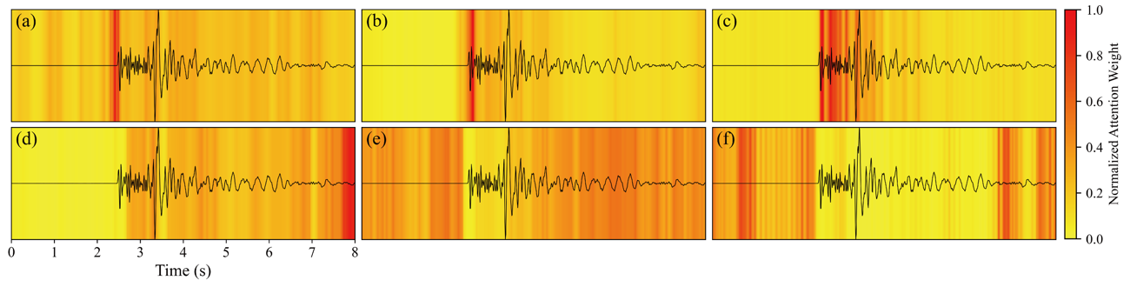
Figure S 3 Attention maps of M01 model
This is the result showing where the model focused on seismic waves shown by a black line. Locations where the model paid attention are shown in deep red. (a), (b), and (c) shows the model pays attention to the direct P-wave and (d), (e), and (f) to other than the direct P- and S-waves.

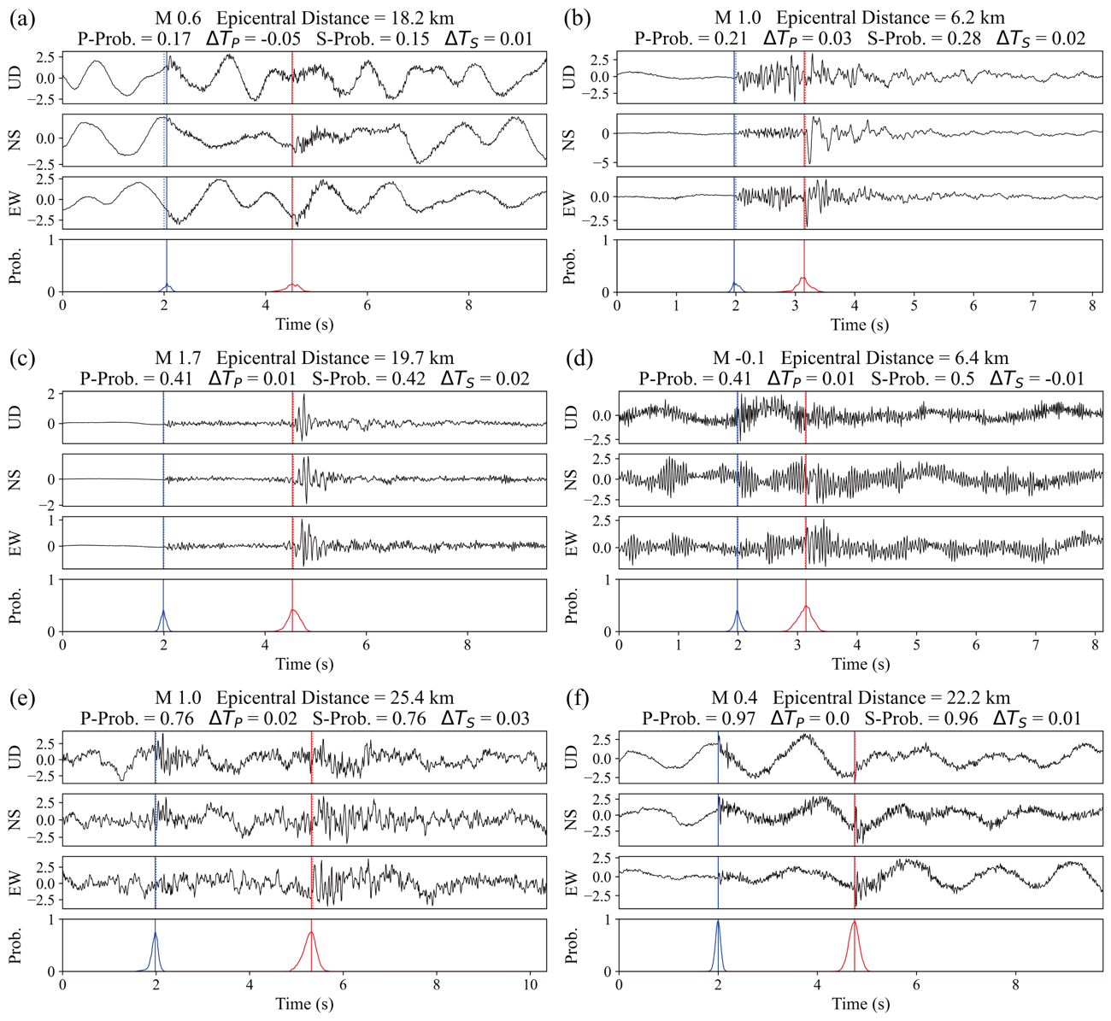
Figure S 4 Results indicating almost match in arrival times between 100 Hz model predictions and labeled data
The explanation is the same as Figure 4.

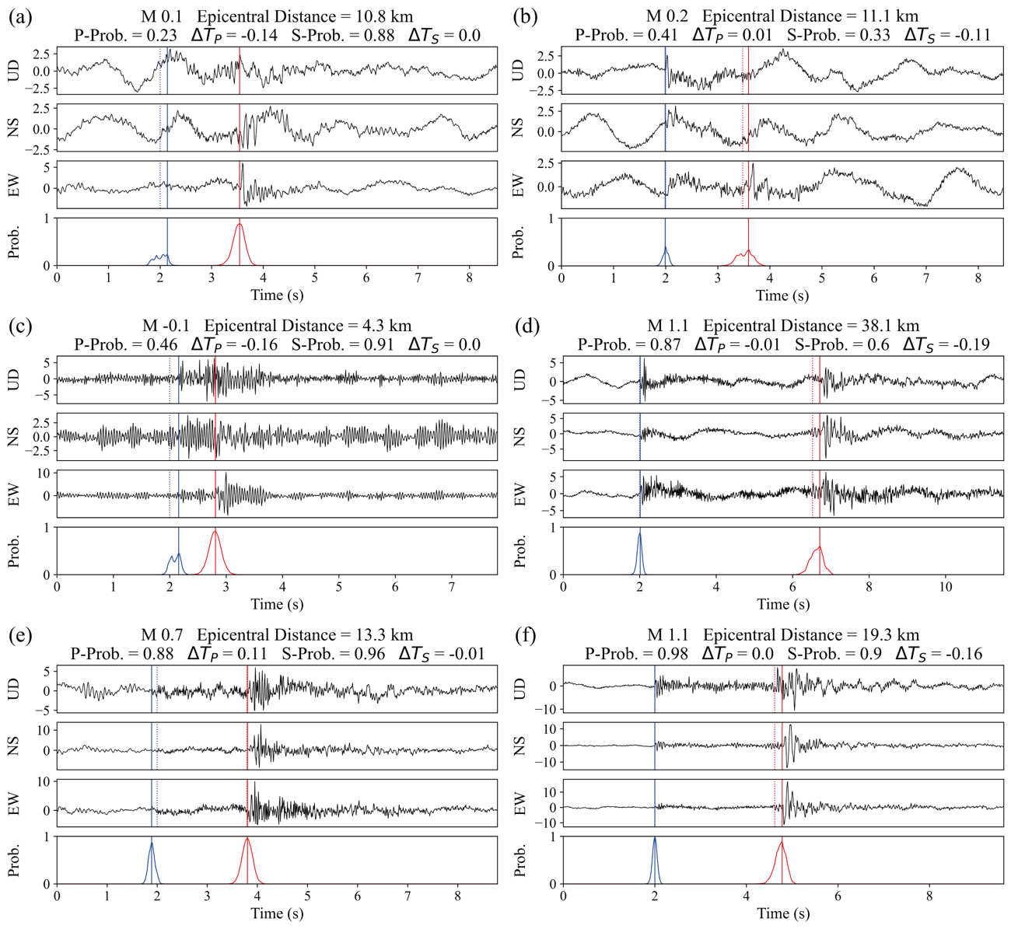
Figure S 5 Results indicating discrepancies in arrival times between 100 Hz model predictions and labeled data
The explanation is the same as Figure 4.

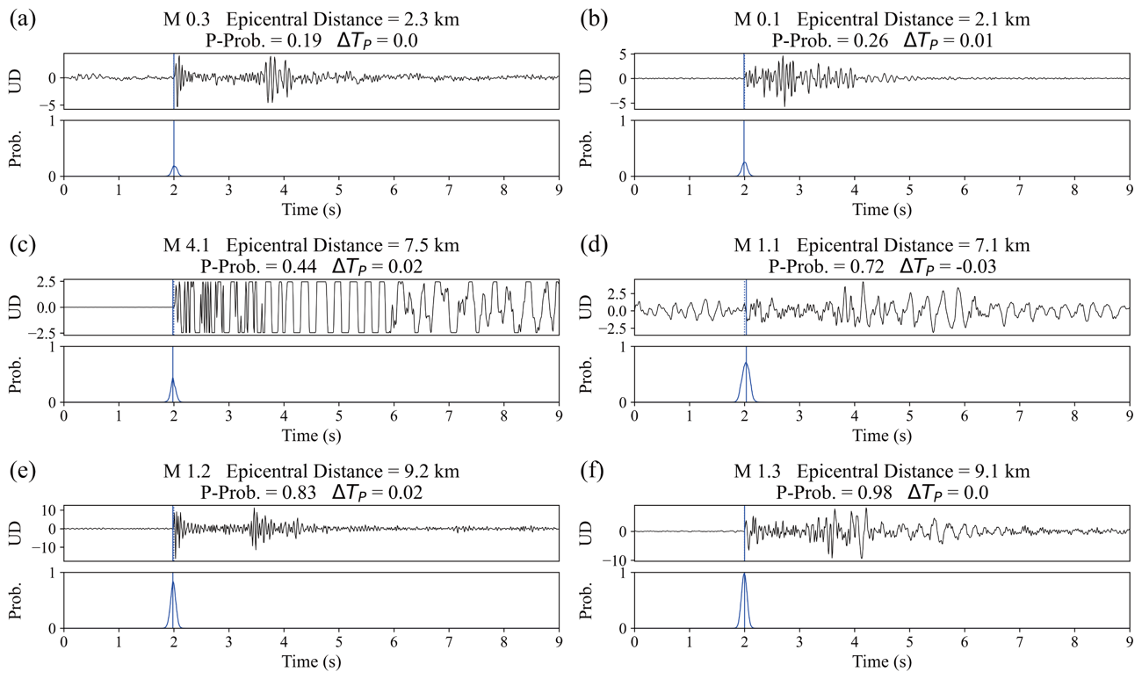
Figure S 6 Results indicating almost match in arrival times between M01 model predictions and labeled data
Waveforms of the UD components are shown from the top panel, and output probability distributions by the model are shown in the bottom panel. Arrival times picked by humans and models are shown as vertical lines: solid for model predictions (Pred.) and dashed for human determinations (Label), with P-waves in blue. The magnitude, epicentral distance, P-wave output probability, P-wave arrival time residual are also shown at the top of each panel.

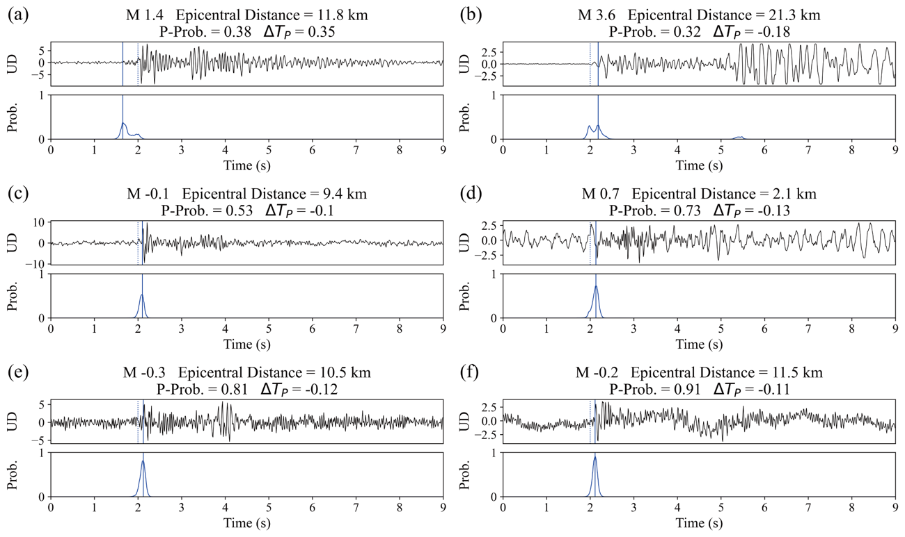
Figure S 7 Results indicating discrepancies in arrival times between M01 model predictions and labeled data
The explanation is the same as Figure S5.

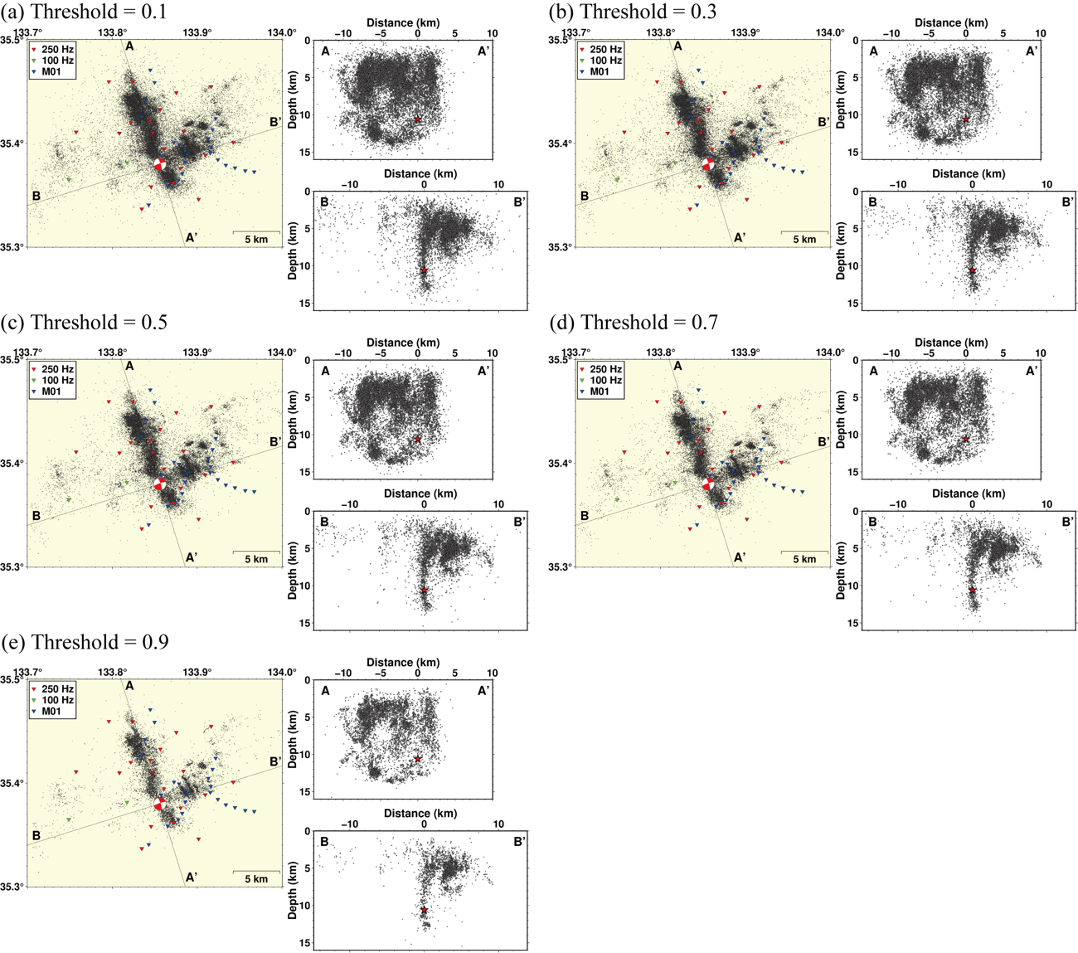
Figure S 8 Distribution of hypocenters for different thresholds of output probability values by PhaseNet models
The explanation is the same as Figure 9.

