Supplementary data

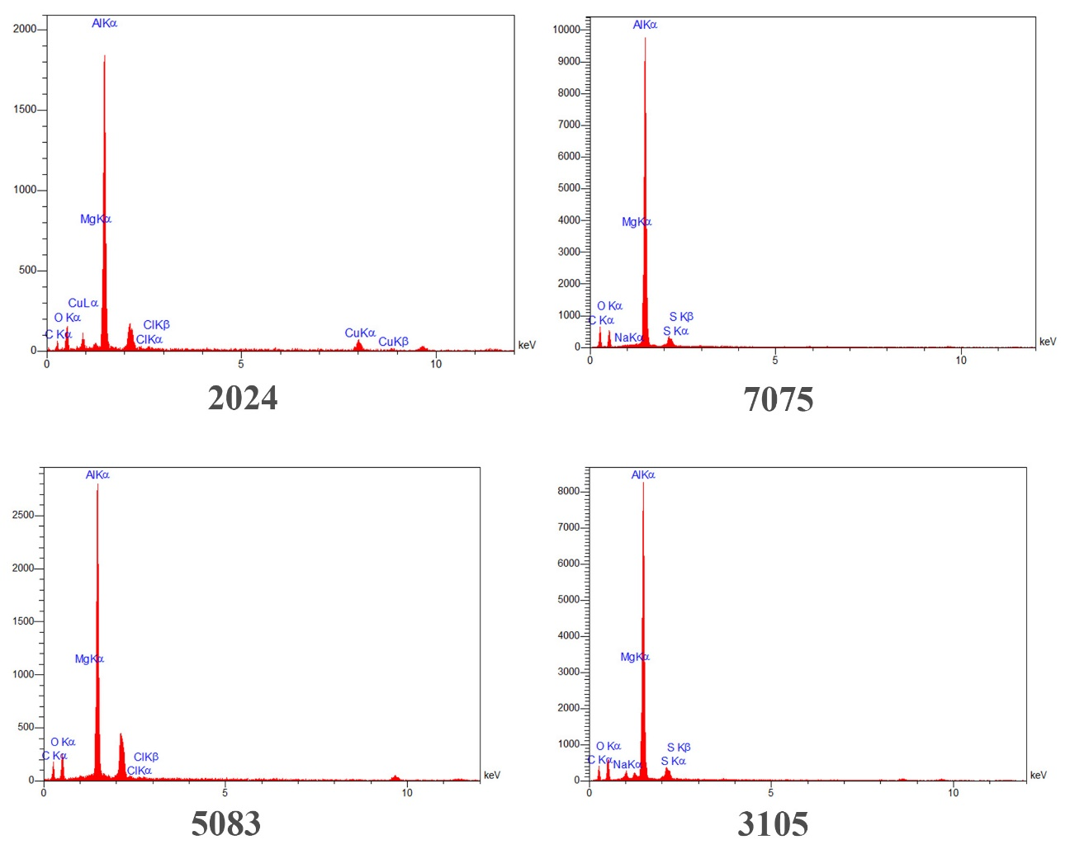
ementary data
Figure S1. EDS analysis charts per unit counts per second

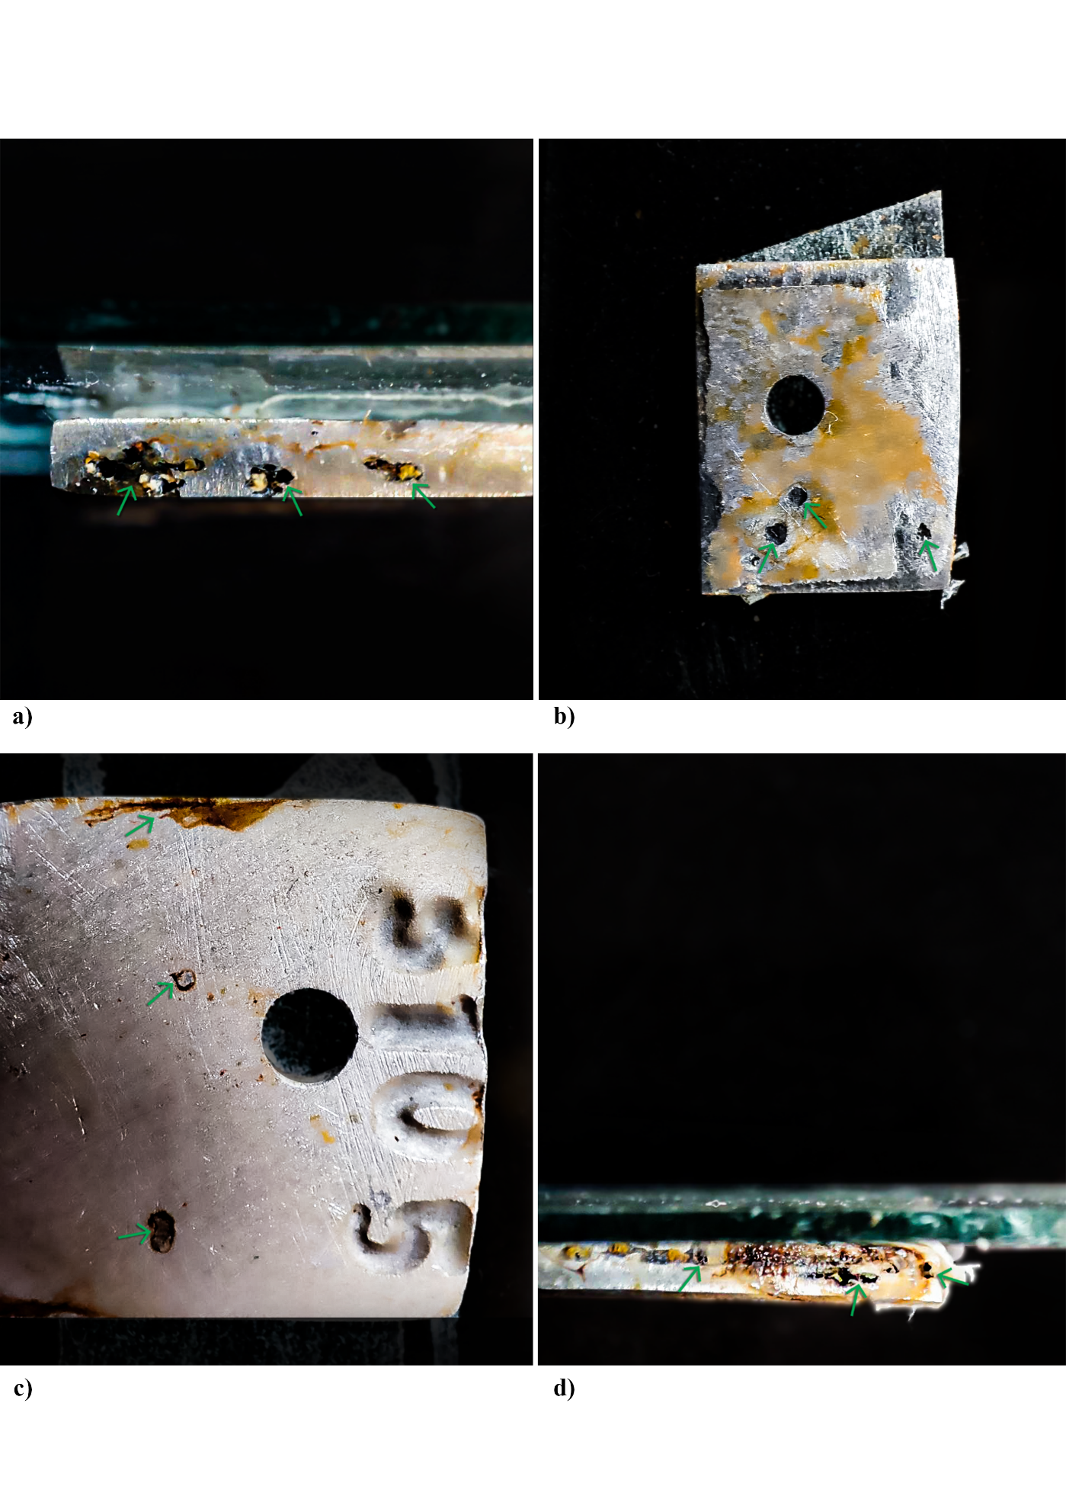
Figure S2. The real pictures of aluminum alloys after passing 75 days of corrosion test.
a) 2024 alloy b) 5083 alloy c) 3105 alloy d) 7075 alloy. Arrows indicate pitting corrosion.

