Supplemental Materials
Supplemental Figure S1. Flowchart of analytic sample
Supplemental Table S1. Comparisons of baseline characteristics of participants with and without loss to follow-up
Supplemental Table S2. Comparisons of baseline characteristics of participants with and without baseline CCR and symptomatic KOA data
Supplemental Table S3. Associations of CCR and incident symptomatic KOA after multiple imputation
Supplemental Table S4. Associations of CCR and incident symptomatic KOA after excluding participants with eGFR<60ml/(min.1.73m²) (N=4020)
Supplemental Table S5. Associations of CCR and incident symptomatic KOA after excluding participants with eGFR<90ml/(min.1.73m²) (N=2600)
Supplemental Table S6. Associations of CCR and incident symptomatic KOA after excluding participants with kidney disease at baseline (N=3964)

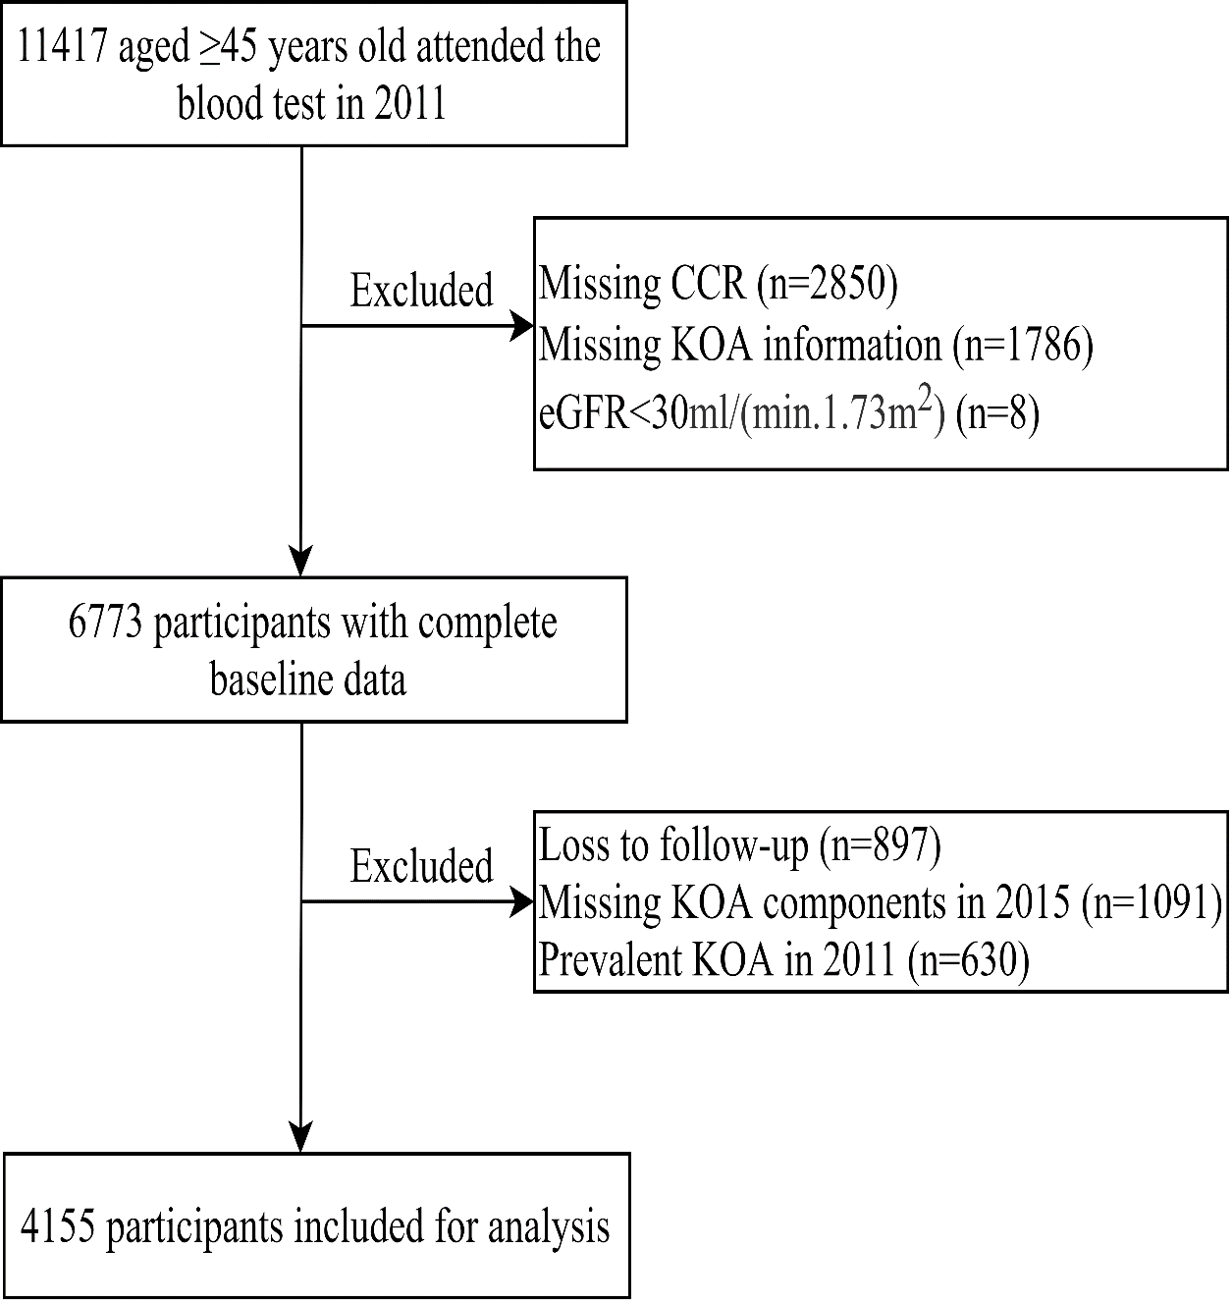
Supplemental Figure S1. Flowchart of analytic sample

Supplemental Table S1. Comparisons of baseline characteristics of participants with and without loss to follow-up
Characteristics | Loss (n=1988) |  | No loss(n=4785) | P
CCR, median (IQR) | 75.3 (64.7, 88.7) |  | 77.7 (67.6, 90.0) | <0.001
Age, year, mean (SD) | 62.2 (11.2) |  | 59.4 (9.3) | <0.001
Female (%) | 1049 (52.8) |  | 2419 (50.6) | 0.103
Rural living, n (%) | 1159 (58.3) |  | 3025 (63.2) | <0.001
Married, n (%) | 1526 (76.8) |  | 3993 (83.4) | <0.001
Education level, n (%) |  |  |  | <0.001
Elementary school and below | 1454 (73.1) |  | 3235 (67.6)
Secondary school | 310 (15.6) |  | 1001 (20.9)
High school and above | 224 (11.3) |  | 549 (11.5)
Smoking behavior, n (%) |  |  |  | 0.038
Never | 1201 (62.3) |  | 2818 (59.8)
Past | 182 (9.4) |  | 412 (8.7)
Current | 545 (28.3) |  | 1480 (31.4)
Drinking behavior, n (%) |  |  |  | 0.106
Never | 1195 (61.3) |  | 2758 (58.9)
Past | 170 (8.7) |  | 397 (8.5)
Current | 583 (29.9) |  | 1525 (32.6)
BMI, kg/m², mean (SD) |  | 23.1 (4.1) | 23.6 (3.9) | <0.001
Poor self-rated health, n (%) | 1602 (80.6) |  | 3548 (74.2) | <0.001
Fall history, n (%) | 322 (17.3) |  | 695 (15.0) | 0.019
Fracture history, n (%) | 30 (1.6) |  | 63 (1.4) | 0.498
Depression, n (%) | 723 (39.6) |  | 1503 (32.6) | <0.001
ADL/IADL difficulties, n (%) | 619 (31.2) |  | 1159 (24.2) | <0.001
Hypertension, n (%) | 883 (44.4) |  | 1896 (39.6) | <0.001
Diabetes, n (%) | 345 (17.4) |  | 756 (15.8) | 0.123
Heart diseases, n (%) | 253 (12.8) |  | 568 (11.9) | 0.348
Stroke, n (%) | 77 (3.9) |  | 104 (2.2) | <0.001
Chronic lung disease, n (%) | 216 (10.9) |  | 448 (9.4) | 0.067
Kidney disease, n (%) | 118 (6.0) |  | 255 (5.4) | 0.349
Notes: CCR, creatinine to cystatin c ratio; BMI, body mass index; ADL, activities in daily living; IADL, instrumental activities in daily living.

Supplemental Table S2. Comparisons of baseline characteristics of participants with and without baseline CCR and symptomatic KOA data
Characteristics | Missing (n=4636) | Complete (n=6781) | P
Age, year, mean (SD) | 57.5 (8.4) | 60.2 (9.9) | <0.001
Female (%) | 2547 (54.9) | 3472 (51.2) | <0.001
Rural living, n (%) | 3063 (66.1) | 4187 (61.7) | <0.001
Married, n (%) | 3884 (83.8) | 5526 (81.5) | 0.001
Education level, n (%) |  |  | 0.014
Elementary school and below | 3206 (69.2) | 4693 (69.2)
Secondary school | 969 (20.9) | 1315 (19.4)
High school and above | 461 (9.9) | 773 (11.4)
Smoking behavior, n (%) |  |  | 0.059
Never | 2823 (62.7) | 4022 (60.5)
Past | 386 (8.6) | 597 (9.0)
Current | 1290 (28.7) | 2027 (30.5)
Drinking behavior, n (%) |  |  | 0.752
Never | 2691 (60.3) | 3958 (59.6)
Past | 385 (8.6) | 570 (8.6)
Current | 1388 (31.1) | 2108 (31.8)
BMI, kg/m², mean (SD) | 23.6 (3.9) | 23.5 (3.9) | 0.183
Poor self-rated health, n (%) | 3756 (81.9) | 5158 (76.1) | <0.001
Fall history, n (%) | 789 (17.9) | 1019 (15.7) | 0.002
Fracture history, n (%) | 85 (1.9) | 93 (1.4) | 0.051
Depression, n (%) | 1900 (43.4) | 2228 (34.6) | <0.001
ADL/IADL difficulties, n (%) | 1393 (30.4) | 1782 (26.3) | <0.001
Hypertension, n (%) | 1823 (39.7) | 2786 (41.1) | 0.132
Diabetes, n (%) | 681 (14.7) | 1104 (16.3) | 0.024
Heart diseases, n (%) | 593 (13.0) | 823 (12.2) | 0.206
Stroke, n (%) | 136 (3.0) | 182 (2.7) | 0.403
Chronic lung disease, n (%) | 458 (10.0) | 665 (9.8) | 0.741
Kidney disease, n (%) | 297 (6.5) | 378 (5.6) | 0.046
Notes: CCR, creatinine to cystatin c ratio; KOA, knee osteoarthritis; BMI, body mass index; ADL, activities in daily living; IADL, instrumental activities in daily living.

Supplemental Table S3. Associations of CCR and incident KOA after 10-time multiple imputations
Category | Total population |  |  | Male |  |  | Female
Category | OR (95% CI) | P |  | OR (95% CI) | P |  | OR (95% CI) | P
Lowest | Reference |  |  | Reference |  |  | Reference
Middle | 0.86(0.67,1.11) | 0.257 |  | 1.05(0.70,1.56) | 0.810 |  | 0.75(0.54,1.04) | 0.084
Highest | 0.67(0.51,0.89) | 0.005 |  | 0.70(0.26,0.72) | 0.001 |  | 0.82(0.58,1.16) | 0.258
Per-SD | 0.83(0.73,0.94) | 0.004 |  | 0.72(0.58,0.90) | 0.005 |  | 0.89(0.76,1.04) | 0.130
Notes: CCR, creatinine to cystatin c ratio; KOA, knee osteoarthritis; Boldface indicates significance.

Supplemental Table S4. Associations of CCR and incident symptomatic KOA after excluding participants with eGFR<60ml/(min.1.73m²) (N=4020)
Category | Total population |  |  | Male |  |  | Female
Category | OR (95% CI) | P |  | OR (95% CI) | P |  | OR (95% CI) | P
Lowest | Reference |  |  | Reference |  |  | Reference
Middle | 0.89(0.63,1.18) | 0.419 |  | 1.17(0.75,1.83) | 0.482 |  | 0.74(0.52,1.07) | 0.109
Highest | 0.70(0.51,0.97) | 0.029 |  | 0.49(0.27,0.87) | 0.015 |  | 0.86(0.58,1.27) | 0.433
Per-SD | 0.84(0.73,0.97) | 0.018 |  | 0.76(0.59,0.98) | 0.034 |  | 0.89(0.75,1.06) | 0.196
Notes: CCR, creatinine to cystatin c ratio; KOA, knee osteoarthritis; eGFR, estimated glomerular filtration rate; Boldface indicates significance.

Supplemental Table S5. Associations of CCR and incident symptomatic KOA after excluding participants with eGFR<90ml/(min.1.73m²) (N=2600)
Category | Total population |  |  | Male |  |  | Female
Category | OR (95% CI) | P |  | OR (95% CI) | P |  | OR (95% CI) | P
Lowest | Reference |  |  | Reference |  |  | Reference
Middle | 0.76(0.54,1.09) | 0.137 |  | 0.91(0.52,1.61) | 0.757 |  | 0.67(0.42,1.07) | 0.092
Highest | 0.63(0.41,0.96) | 0.031 |  | 0.39(0.18,0.84) | 0.017 |  | 0.82(0.48,1.39) | 0.465
Per-SD | 0.86(0.71,1.04) | 0.114 |  | 0.74(0.53,1.04) | 0.084 |  | 0.92(0.72,1.16) | 0.474
Notes: CCR, creatinine to cystatin c ratio; KOA, knee osteoarthritis; eGFR, estimated glomerular filtration rate; Boldface indicates significance.

Supplemental Table S6. Associations of CCR and incident symptomatic KOA after excluding participants with kidney disease at baseline (N=3964)
Category | Total population |  |  | Male |  |  | Female
Category | OR (95% CI) | P |  | OR (95% CI) | P |  | OR (95% CI) | P
Lowest | - |  |  | - |  |  | -
Middle | 0.89(0.67,1.18) | 0.137 |  | 1.13(0.72,1.78) | 0.586 |  | 0.74(0.51,1.07) | 0.108
Highest | 0.65(0.47,0.89) | 0.031 |  | 0.44(0.24,0.79) | 0.006 |  | 0.78(0.53,1.17) | 0.228
Per-SD | 0.81(0.70,0.94) | 0.005 |  | 0.72(0.56,0.94) | 0.014 |  | 0.85(0.71,1.02) | 0.077
Notes: CCR, creatinine to cystatin c ratio; KOA, knee osteoarthritis; Boldface indicates significance.

