Supplementary Information and Data

Spirulina platensis peptide-loaded nanoliposomes alleviate hepatic lipid accumulation in Male Wistar Rats by influencing redox homeostasis and lipid metabolism via the AMPK signaling pathway

Katayoon Karimzadeh ^{1,2*}, Suraj Unniappan ¹, Asgar Zahmatkesh ³

S.1.1.Total phenolic content

Total phenolic content (TPC) was measured using Folin–Ciocalteu reagents as previously described (Karimzadeh et al., 2023). A total of 300 μL aliquot of samples were mixed with 1875 μL distilled water following the addition of a 125 μL aliquot of reagent. Then, the sample was shaken for 10 min at ambient temperature. Next, sodium carbonate solution (250 μL) was added and incubated in a water bath (45°C) for 30 min. The absorbance of the samples was measured at 765 nm with a UV-vis spectrophotometer. The gallic acid (GA) standard curve (0–250 μL/mL) was used and results were expressed as milligrams of gallic acid equivalence (GAE) per gram of dry weight (DW). The SP amount in each sample was calculated using the following equation:
Y = 0.105X + 0.005, (R2 = 0.996).

S.1.2. Storage stability

The storage stability of each liposomal formulation was also determined by keeping them at 4°C and 25°C for 24 days (Mohammadi et al., 2023). The changes in EE, size, zeta potential, and antioxidant activity were detected at the designated time points during storage. All experiments were developed in triplicate.

Supplementary Table S1.1. Composition of the experimental diets (g/kg diet)
Ingredients | Standard chow diet | High-fat diet
Corn starch | 479.5 | 339.5
Casein | 200 | 200
Sucrose | 150 | 150
Lard | 30 | 160
Cellulose | 50 | 50
L-Cysteine | 3 | 3
Soybean | 40 | 40
Cholesterol | - | 10
Minerals | 35 | 35
Vitamins | 10 | 10
Choline bitartrate | 2.5 | 2.5
Tert-Butylhydroquinone | 0.01 | 0.01
Α-Lipoic acid | - | -
Total (g) | 1000 | 1000
Energy (Kcal) | 4,159.9 | 4,859.9
Fat % (Calories) | 15.1 | 38.9

Supplementary Table S1.2. Primer sequences used in reverse transcriptionquantitative PCR.
Gene | Forward primer (5'3') | Reverse primer (5'3')
FAS | GTGTGGTAGGCTTGGTGAACTGTC | GTGAGATGTGCTGCTGAGGTTGG
SREBP-1c | TTCTGCCTTGTGCGGTATGTTGAG | TCTGCTCCTGAGTGGACCATGATC
PPARα | CTGAGGAAGCCATTCTGCGACATC | GCGTCTGACTCGGTCTTCTTGATG
PPARγ | AGGACATCCAAGACAACCTGCTG | GTGCTCTGTGACAATCTGCCTGAG
ACCα | TGGTGAGGATGGCGGCTCTG | GGTGGTGTGAAGGCGTTGTCC
HMGCR | TGTGGGAACGGTGACACTTA | CTTCAAATTTTGGGCACTCA
CYP7A1 | CCTCCTGGCCTTCCTAAATC | AGACCTGGTCCCTCACACAC
ABCA1 | GGTAGTGTGGCCACTTTCGT | TCTGGGCCTGATGAAAAATC
AOX1 | TCGGGCAAGTGAGGCGCATT | AGCAACAGCATTGGGGCGGA
AMPKα1 | ATCCGCAGAGAGATCCAGAA | GTCGACTCTCCTTTTCGTC
ACC | GCCTCTTCCTGACAAACGAG | TCCATACGCCTGAAACATGA
CPT-1 | GAGAAGGGAGGACAGAGACT | GCTCAGACAATACCTCCTTC
SIRT | CCAGATTTCAAGGCTGTTGGTTCC | CCACAGGAACTAGAGGATAAGGCGT
B-actin | ATTGCTGACAGGATGCAGAA | TAGAGCCACCAATCCACACAG

All primers used here are based on rat sequences. FAS, Fatty acid synthase; SREBP-1c, Sterol regulatory element-binding protein 1; PPARα, Peroxisome proliferator-activated receptor alfa; PPARγ, Peroxisome proliferator-activated receptor gamma; ACCα, acetyl‐coenzyme A carboxylase alpha; HMGCR, 3-hydroxy-3-methylglutaryl coenzyme A reductase ABCA1, ATP-binding cassette subfamily A member-1; AOX1 Aldehyde Oxidase 1 : acyl-CoA oxidase 1; CYP7A1, cytochrome P450 7A1; HMGCR, 3-hydroxy-3-methylglutaryl coenzyme A reductase; SREBP1c : sterol regulatory element binding protein-1c; AMPKα1, AMP-activated protein kinase; ACC, acetyl-CoA carboxylase ;CPT-1,carnitine palmitoyltransferase-1; SIRT1, silent information regulating factor1.

Supplementary Results

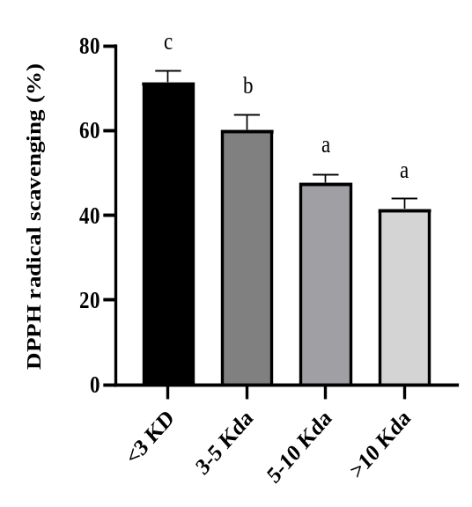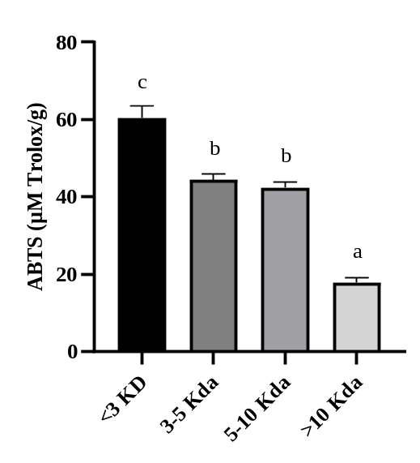

Supplementary Fig. S2.1 Antioxidant activities of the alcalase hydrolysates of Spirulina platensis peptides. (A) DPPH radical scavenging activity of the four different molecular weights of Spirulina platensis peptides (B) ABTS radical scavenging activity of the three different molecular weights of Spirulina platensis peptides. Data are presented as the mean ± SEM (n = 3). Results were statistically analyzed using one-way ANOVA followed by Tukey's multiple-comparison test, and values with different labels (a-c) are significantly different (p < 0.05).The fraction with <3KD revealed higher antioxidant activity and its applied for liposomal formula prepration.

S2.1.Physical stability study

The study of stability is an essential concern for the development and evaluation of nanoliposome formulation. The characterization analysis of nanostructure particles such as size diameter, zeta potential, and also entrapment efficiency during the storage period provide some information regarding the use of those vesicles as drug carriers. The unchangeable values of those indices during storage period indicated the high potential nanocarrier for warrants drug retention.
The stability study of the nanoliposome formulation was evaluated at two different temperatures (4°C, and 25°C) for 24 days, and results are summarized in Table S2.2. The SP-Ch-LP was statable at refrigerated temperature and did not have any significant difference between the values for particles size zeta potential, and antioxidant activity in terms of ABST, but the reduction of about 16.15% was significantly observed (p < 0.05) in encapsulation efficiency value after 24 days with respect to the result at first day. With the increase in temperature, the size of vesicle of SP-Ch-LP increased from 131.82±3.34 nm to194.46±6.23 nm, and PDI significantly changed (p < 0.05) from 0.32±0.02 mV to 0.46±0.03 mV.

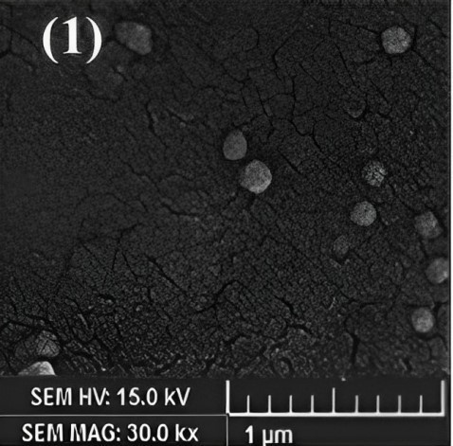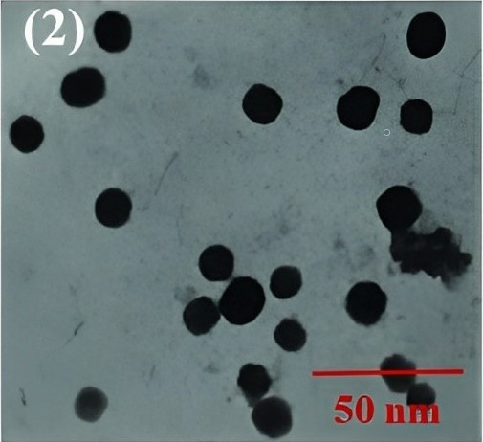
Supplementary Fig. S2.2. (1) Scanning electron microscopy (SEM) and (2) transmission electron microscopy (TEM) of Spirulina platensis peptide-loaded nano liposomes coated with chitosan (SP-Ch-LP) which showed the presence of the spherical nanoparticles with a smooth surface in the nanosized range (130.76±2.34 nm)

Supplementary Table S2.1. Zeta potential, average diameter, polydispersity index, encapsulation efficiency percentage (EE%), 2,2-Diphenyl-1-picrylhydrazyl(DPPH Inhibition)2,2c-Azino-Bis 3-Ethylbenzothiazoline-6-Sulfonic Acid (ABTS), and total phenol content of unloaded liposome nanoparticles (UN-LP), peptide-loaded liposomes (SP- LP) and peptide-loaded liposomes coated with chitosan (SP-Ch-LP).
Indices | UN-LP | SP-LP | SP-Ch-LP
Zeta Potential  (mV) | -41.27±1.45ª | -24.43±1.12^{b} | 26.68±1.12^{c}
Size (nm) | 144.83±4.50^{c} | 87.47±1.86ª | 130.76±2.34^{b}
Poly-Dispersity  Index (PDI) | 0.26±0.02ª | 0.32±0.02^{b} | 0.41±0.03^{c}
Encapsulation  Efficiency (EE%) | - | 83.36±1.55ª | 88.17±2.70ª
%DPPH  Inhibition | 41.47±0.40ª | 71.13±0.85^{c} | 66.56±0.23^{b}
ABTS (µM Trolox/g) | 28.66±0.32ª | 58.22±0.76^{c} | 54.38±0.54^{b}
Total phenol content  (mg GAE/g) | - | 143.82±2.46ª | 148.16±2.78ª
Results were reported as mean ± SD, n = 3 (repeat per sample). Different letters within the same row in each treatment indicate a significant difference (P <0.05).

Supplementary Table S2.2. Visual appearance and physicochemical stability of peptide-loaded chitosomes (SP-Ch-LP) under different storage temperatures (4, and 25 °C). Poly-Dispersity Index (PDI); Encapsulation Efficiency (EE%).

Physicochemical stability
 | Day1 |  | Day8 |  | Day16 |  | Day24
 | 4°C | 25°C | 4°C | 25°C | 4°C | 25°C | 4°C | 25°C
Size (nm) | 131.53±3.11ª | 131.82±3.34ª | 134.16±2.86ª | 135.78±3.57^{b} | 134.38±2.61ª | 158.28±5.16^{c} | 134.63±2.38ª | 194.46±6.23 ^{d}
(PDI) | 0.32±0.02ª | 0.32±0.02ª | 0.33±0.01ª | 0.37±0.03^{b} | 0.32±0.02ª | 0.41±0.02^{c} | 0.32±0.02ª | 0.46±0.03^{d}
(EE%) | 88.46±2.70^{c} | 88.75±2.70^{d} | 84.17±2.70^{b} | 54.17±2.70^{c} | 81.17±2.70^{b} | 48.17±2.70^{b} | 74.17±2.70ª | 44.17±2.70ª
ABTS (µM Trolox/g) | 54.46±0.85ª | 54.61±0.37^{d} | 54.21.22±0.34ª | 50.47±0.13^{c} | 54.22±0.11^{c} | 44.38±0.25^{b} | 54.18±0.14ª | 41.64±0.43ª
Results were reported as mean ± SD, n = 3 (repeat per sample). Different letters within the same raw in each temperature indicate a significant difference (P <0.05).

