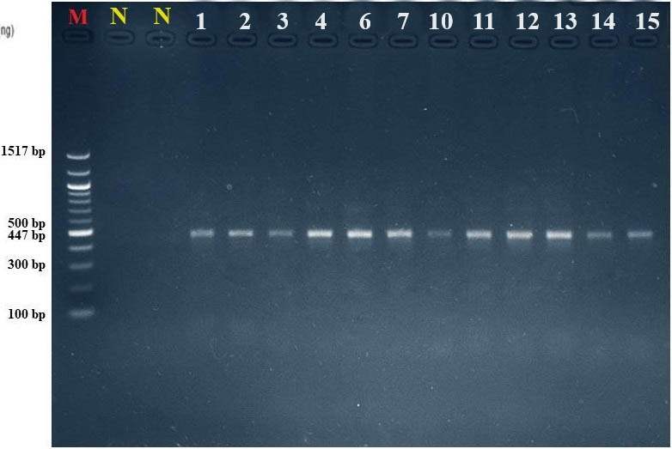
The Meloidogyne incognita PCR product (447 bp) with marker ladder 100–1517 bp.

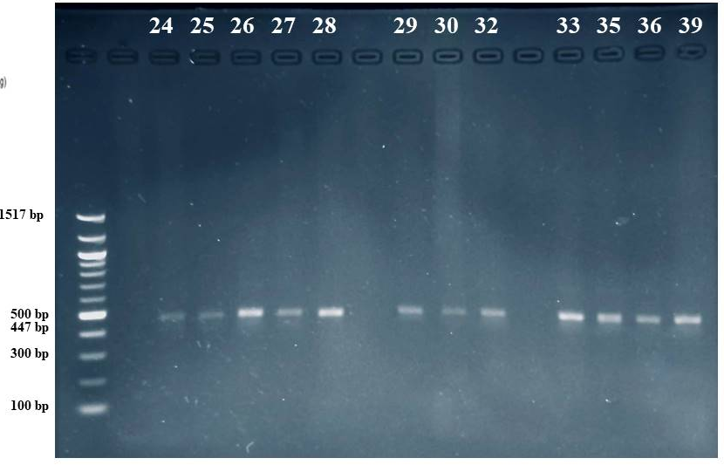
The Meloidogyne incognita PCR product (447 bp) with marker ladder 100–1517 bp.

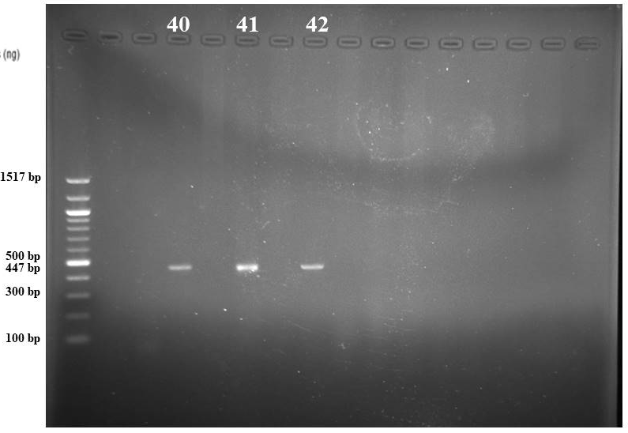

The Meloidogyne incognita PCR product (447 bp) with marker ladder 100–1517 bp.
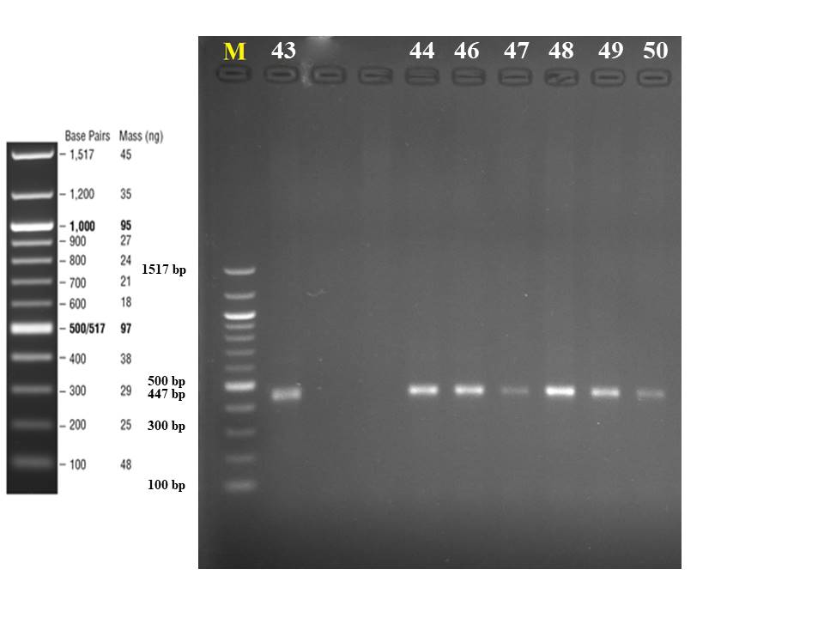

The Meloidogyne incognita PCR product (447 bp) with marker ladder 100–1517 bp.

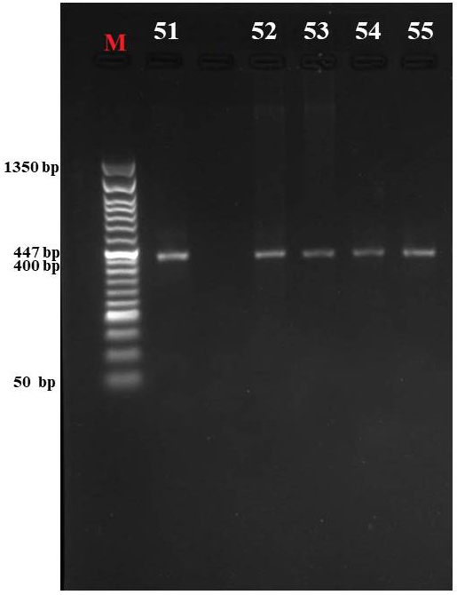

The Meloidogyne incognita PCR product (447 bp) with marker ladder 50–1350 bp.
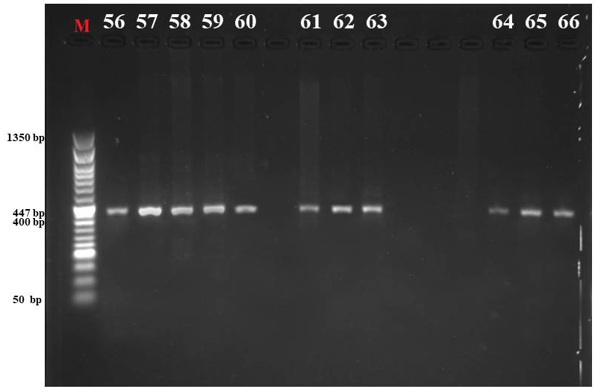
The Meloidogyne incognita PCR product (447 bp) with marker ladder 50–1350 bp.
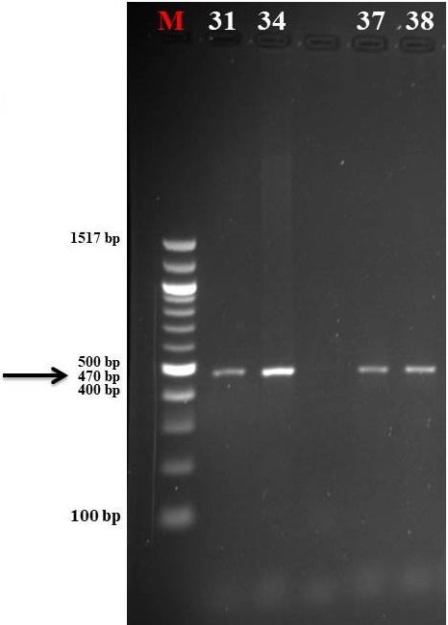

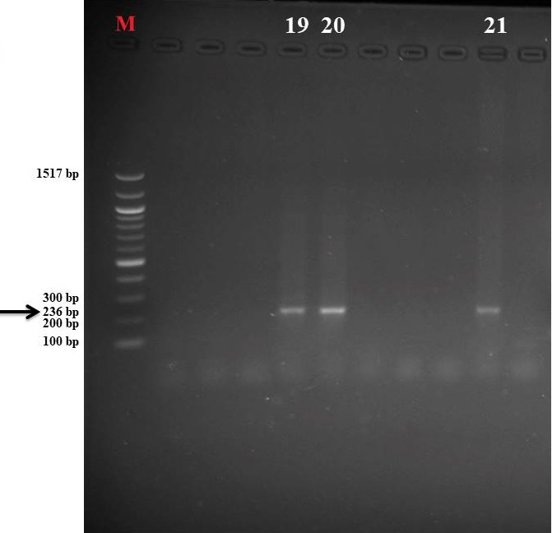
The Meloidogyne hapla PCR product (470 bp) with marker ladder 100–1517 bp.

The Meloidogyne enterolobii PCR product (236 bp) with marker ladder 100–1517 bp.
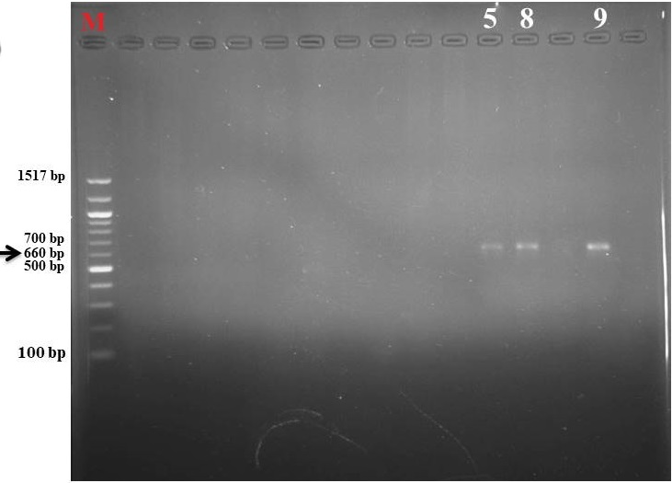

The Meloidogyne javanica PCR product (660 bp) with marker ladder 100–1517 bp.
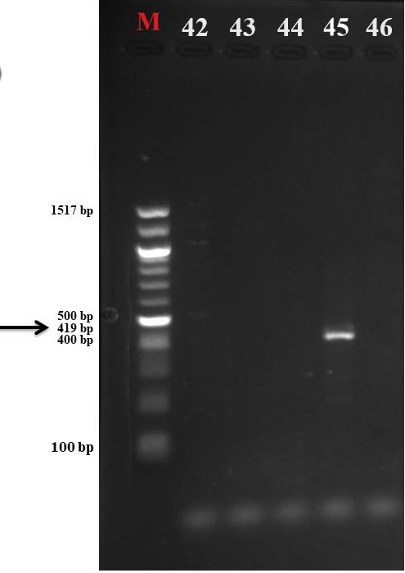

The Meloidogyne arenaria PCR product (419 bp) with marker ladder 100–1517 bp.

