Pupil-linked arousal reflects intracranial aperiodic neural activity in the human auditory cortex.

Madaline Mocchi^{1,2}, Eleonora Bartoli¹, John Magnotti³, Jan Willem DeGee⁴, Brian Metzger¹, Bailey Pascuzzi¹, Raissa Mathura¹, Suhrutha Pulapaka¹, Wayne Goodman⁵, Sameer Sheth¹, Matthew McGinley², Kelly Bijanki^{1*}

¹Baylor College of Medicine Department of Neurosurgery
²Baylor College of Medicine Department of Neuroscience
³University of Pennsylvania Department of Neurosurgery
⁴University of Amsterdam Department of Cognitive and Systems Neuroscience
⁵Baylor College of Medicine Department of Psychiatry

* Corresponding author
E-mail: bijanki@bcm.edu (KB)
Supplemental Table 1. Demographics, Coverage, and Electrode Distribution
Subject | Sex | Age (years) | Number of Blocks  Total(Valid) | pSTG Electrodes  Total(Valid) | Total Trials Across Runs and Electrodes  Standard/Oddball
Subject 1 | F | 53 | 4(3) | 4(4) | 78/31
Subject 2 | F | 25 | 7(2) | 4(4) | 119/44
Subject 3 | M | 41 | 4(2) | 17(16) | 164/41
Subject 4 | M | 60 | 5(3) | 5(5) | 292/71
Subject 5 | F | 44 | 2(2) | 8(8) | 80/9
Subject 6 | F | 46 | 2(2) | 10(10) | 91/22
Subject 7 | M | 42 | 2(2) | 6(0)* | -
Subject 8 | M | 25 | 2(2) | 11(11) | 171/45
Subject 9 | M | 30 | 2(0)* | 7(7) | -
Subject 10 | F | 44 | 2(2) | 8(8) | 153/28
Number of blocks reflects the total number of test blocks collected while the patient was in the epilepsy monitoring unit (EMU) for their inpatient stay. Valid blocks are those which showed adequate pupil data quality (see Methods). Total pSTG electrodes are all electrodes identified within the posterior supratemporal gyrus, and valid electrodes are all electrodes that met inclusion criteria for adequate data quality (see Methods). Total Trials across runs are trials that were not considered outliers on either pupil or neural data sets (see Methods). Stars denote when a patient is excluded from analyses due to non-responsive pSTG electrodes (Subject 7), or poor pupil data quality (Subject 9).

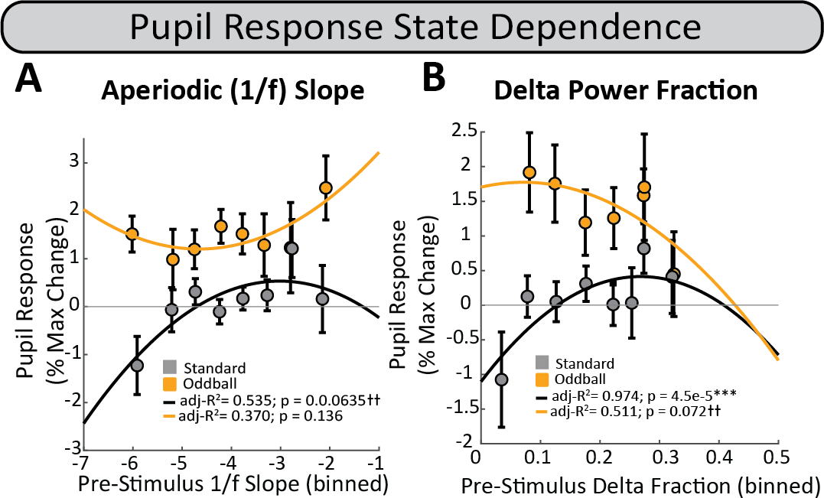
Supplemental Figure 1. Pupil Response State Dependence (Pre-Stimulus Window). Pupil phasic responses show no clear state-dependent relationship with A) aperiodic 1/f slope, but for B) delta power fraction bins, there is an inverted u-shaped relationship for standard trials.

Supplemental Table 2. Pupil Response State Dependence (Pre-stimulus Window)
Model | Model Coefficients | Fixed Effect | Estimate | P-Value
Aperiodic Slope | P ~ (S + I(S^2))*C + (1|Sub) | (Intercept) | 0.40570 | 0.7842
Aperiodic Slope | P ~ (S + I(S^2))*C + (1|Sub) | Slope | -0.02311 | 0.9758
Aperiodic Slope | P ~ (S + I(S^2))*C + (1|Sub) | (Slope)^2 | -0.02471 | 0.8004
Aperiodic Slope | P ~ (S + I(S^2))*C + (1|Sub) | Condition | 5.86154 | 0.0684
Aperiodic Slope | P ~ (S + I(S^2))*C + (1|Sub) | Slope*Condition | 1.58868 | 0.3514
Aperiodic Slope | P ~ (S + I(S^2))*C + (1|Sub) | (Slope^2)*Condition | 0.14154 | 0.5236
Delta Fraction | P ~ (D + I(D^2))*C + (1|Sub) | (Intercept) | -0.8252 | 0.4324
Delta Fraction | P ~ (D + I(D^2))*C + (1|Sub) | Delta Fraction | 10.3787 | 0.2075
Delta Fraction | P ~ (D + I(D^2))*C + (1|Sub) | (Delta Fraction)^2 | -23.8236 | 0.2300
Delta Fraction | P ~ (D + I(D^2))*C + (1|Sub) | Condition | 4.0135 | 0.0074 **
Delta Fraction | P ~ (D + I(D^2))*C + (1|Sub) | Delta*Condition | -23.0747 | 0.1896
Delta Fraction | P ~ (D + I(D^2))*C + (1|Sub) | Delta^2*Condition | 53.0218 | 0.1828
Statistical significance (after correction for multiple comparisons): *P<0.05, **P<0.01, ***P<0.001. Critical P-values after FDR correction for multiple correction (Benjamini-Hochberg) are reported. Asterisks have been removed if no longer significant after correction. Estimates reflect the modeled differences between factors within each fixed effect: P = Pupil Response Size (% of Max Change), Condition (Oddball – Standard), S = Aperiodic 1/f-like slope estimate, D = Delta Power Fraction, Sub = subject identifier, I = polynomial constant.

Supplemental Table 3. Cortical Response Summary Statistics for Early Response Period.
Frequency band by Condition |  | Mean(SD) | Signed Rank | Z | Adj. P-Value
High Gamma
 | Standard | 32.96(17.69) | 171 | 3.72 | 0.0013**
 | Oddball | 67.10(32.10) | 171 | 3.72 | 0.0013**
 | Matched Difference (Odd-Std) | 147.94(172.99) | 665 | 5.25 | 0.00***
Low Gamma
 | Standard | 39.98(14.88) | 171 | 3.72 | 0.0013**
 | Oddball | 62.85(25.51) | 171 | 3.72 | 0.0013**
 | Matched Difference (Odd-Std) | 99.15(134.94) | 635 | 4.74 | 0.00***
High Beta
 | Standard | 19.67(16.83) | 167 | 3.55 | 0.0018**
 | Oddball | 23.74(22.82) | 164 | 3.42 | 0.0026**
 | Matched Difference (Odd-Std) | 22.16(117.71) | 321 | -0.19 | 2.21
Low Beta
 | Standard | 25.44(29.00) | 167 | 3.55 | 0.0018**
 | Oddball | 19.93(39.77) | 130 | 1.94 | 0.1711
 | Matched Difference (Odd-Std) | -44.60(125.53) | 163 | -2.67 | 0.045*
Alpha
 | Standard | 44.15(36.82) | 170 | 3.68 | 0.0013**
 | Oddball | 37.62(46.31) | 155 | 3.03 | 0.0087**
 | Matched Difference (Odd-Std) | -68.26(125.53) | 225 | -1.70 | 0.41
Theta
 | Standard | 39.80(32.82) | 170 | 3.68 | 0.0013**
 | Oddball | 39.70(51.20) | 162 | 3.33 | 0.0033**
 | Matched Difference (Odd-Std) | -52.10(257.99) | 299 | -0.53 | 2.15
Delta
 | Standard | 38.69(22.09) | 171 | 3.72 | 0.0013**
 | Oddball | 40.75(31.06) | 171 | 3.72 | 0.0013**
 | Matched Difference (Odd-Std) | -10.51(208.04) | 346 | 0.20 | 2.21

Supplemental Table 4. Cortical Response Summary Statistics for Late Response Period.
Frequency band by Condition |  | Mean(SD) | Signed Rank | Z | Adj. P-Value
High Gamma
 | Standard | 7.45(6.47) | 164 | 3.42 | 0.0036**
 | Oddball | 16.40(10.95) | 171 | 3.72 | 0.0022**
 | Matched Difference (Odd-Std) | 40.78(70.55) | 609 | 4.34 | 0.0001***
Low Gamma
 | Standard | 11.88(6.09) | 171 | 3.72 | 0.0022**
 | Oddball | 20.08(9.94) | 171 | 3.72 | 0.0022**
 | Matched Difference (Odd-Std) | 33.75(72.83) | 513 | 2.83 | 0.0121*
High Beta
 | Standard | 10.03(9.62) | 158 | 3.15 | 0.0081**
 | Oddball | 0.017(13.30) | 86 | 0.22 | 3.20
 | Matched Difference (Odd-Std) | -43.18(100.98) | 114 | -3.44 | 0.0021**
Low Beta
 | Standard | 22.14(14.44) | 169 | 3.64 | 0.0025**
 | Oddball | -10.81(14.79) | 30 | -2.42 | 0.065
 | Matched Difference (Odd-Std) | -151.03(208.01) | 2.00 | -5.20 | 0.000***
Alpha
 | Standard | 39.77(27.08) | 168 | 3.59 | 0.0025*
 | Oddball | 1.48(35.22) | 91 | 0.24 | 2.84
 | Matched Difference (Odd-Std) | -217.11(352.99) | 87.00 | -3.86 | 0.0006***
Theta
 | Standard | 40.78(33.45) | 166 | 3.51 | 0.0030*
 | Oddball | -1.15(43.87) | 76 | -0.41 | 2.58
 | Matched Difference (Odd-Std) | -257.35(469.52) | 117 | -3.39 | 0.0021**
Delta
 | Standard | 57.21(18.89) | 171 | 3.72 | 0.0022**
 | Oddball | 19.34(26.23) | 147 | 2.68 | 0.0337*
 | Matched Difference (Odd-Std) | -214.85(415.78) | 90 | -3.82 | 0.0005***

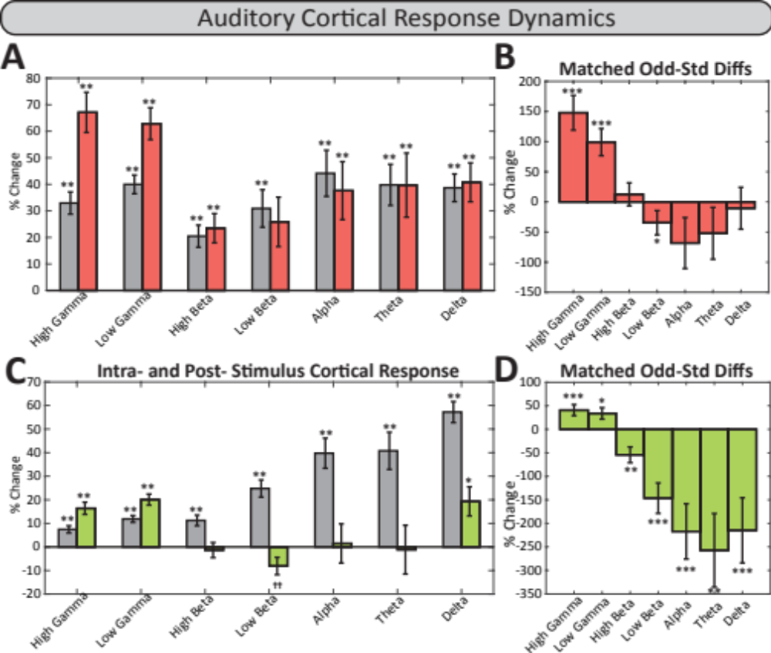
Supplemental Figure 2. Early and Late Auditory Cortical Responses across each canonical frequency band. In A) the early (0-350 ms) time window, both conditions (standard, grey bars; oddball, red bars) show a significant increase in power from pre-stimulus baseline. B) Within-run matched differences between conditions (Oddball – Standard) show significantly larger increases in high and low gamma power for oddball stimuli compared to standard stimuli, and a significantly smaller increase in low beta power for oddball compared to standard stimuli. C) The late (250-750 ms) time window shows significant increases in power from baseline for all frequency bands in the standard condition (grey bars), and significant increases in power for high gamma, low gamma, and delta power bands in the oddball condition (green bars), with no change from baseline seen for all other power bands in the oddball condition. D) Within-run matched differences between condition (Oddball – Standard) show significantly larger increases in high and low gamma for oddball stimuli compared to standard stimuli, and significantly smaller increases in power (larger suppressions of power) for all frequency bands in the oddball condition compared to the standard condition. Early high gamma and low gamma bars, as well as late window high beta – delta bars, are recapitulated in main text (Figure 4).

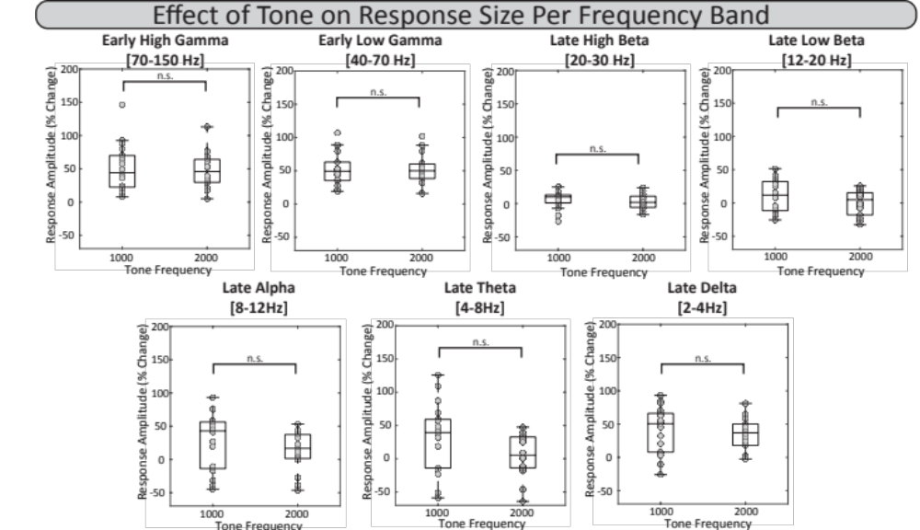
Supplemental Figure 3. Response differences are not due to the spectral qualities of the stimulus. Each bar plot pair shows no significant difference in response size for any frequency band when average between-subjects responses are grouped by tone frequency instead of stimulus condition.

Supplemental Table 5. Response size difference by tone for each frequency band.
 |  | Ranks |  | Test Statistics
Frequency Band | Tone Frequency (Hz) | N | Mean Rank | Chi-square | df | P-Value
High Gamma | 1000 | 18 | 18.61 | 0.004 | 1 | 0.9495
High Gamma | 2000 | 18 | 18.39 | 0.004 | 1 | 0.9495
Low Gamma | 1000 | 18 | 18.33 | 0.009 | 1 | 0.9244
Low Gamma | 2000 | 18 | 18.67 | 0.009 | 1 | 0.9244
High Beta | 1000 | 18 | 20.28 | 1.025 | 1 | 0.3113
High Beta | 2000 | 18 | 16.72 | 1.025 | 1 | 0.3113
Low Beta | 1000 | 18 | 20.72 | 1.602 | 1 | 0.2057
Low Beta | 2000 | 18 | 16.28 | 1.602 | 1 | 0.2057
Alpha | 1000 | 18 | 21.06 | 2.118 | 1 | 0.1456
Alpha | 2000 | 18 | 15.94 | 2.118 | 1 | 0.1456
Theta | 1000 | 18 | 21.72 | 3.367 | 1 | 0.0665
Theta | 2000 | 18 | 15.28 | 3.367 | 1 | 0.0665
Delta | 1000 | 18 | 20.39 | 1.157 | 1 | 0.2821
Delta | 2000 | 18 | 16.61 | 1.157 | 1 | 0.2821

