Transcriptomics extraction the key chromium resistance genes of Cellulomonas
Yongdong Li¹, Shengchao Gao², Hongmei Sun³, Lianbin Cao³, Tong Li³, Wentong Li³, Tongbiao Li³, Mingchneg Wang³, Enzhong Li³, Hongxia Ni¹, Yi Chen^{1*}, Ying Liu^{2*}
¹Ningbo Municipal Center for Disease Control and Prevention, Ningbo Key Laboratory of Virus Research, Ningbo 315010, P. R. China
²Shaanxi Key Laboratory of Agricultural and Environmental Microbiology, College of Life Sciences, Northwest A&F University, No. 22 Xinong Road, Yangling 712100, Shaanxi, People’s Republic of China
³College of Biological and Food Engineering, Huanghuai University, No.76 Kaiyuan Road, Zhumadian 463000, Henan, People’s Republic of China

∗ Corresponding author. Current address: Ningbo Municipal Center for Disease Control and Prevention, Ningbo Key Laboratory of Virus Research, Ningbo 315010, P. R. China, E-mail: 30279068@qq.com.
Current address: Shaanxi Key Laboratory of Agricultural and Environmental Microbiology, College of Life Sciences, Northwest A&F University, No. 22 Xinong Road, Yangling, Shaanxi Province, PR China, 712100. E-mail address: liuy0512@hotmail.com.

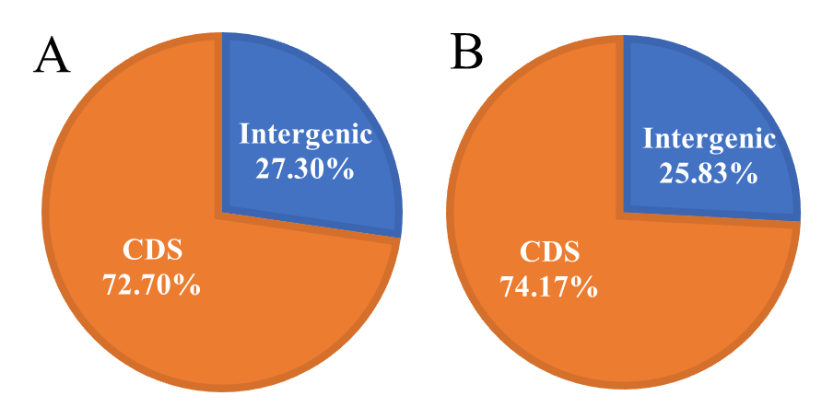

Fig. S1 The distribution of sequencing reads in different regions of the genome, A represents the control group with a Cr (VI) concentration of 0 mM, B represents the experimental group with a Cr (VI) concentration of 0.5 mM.
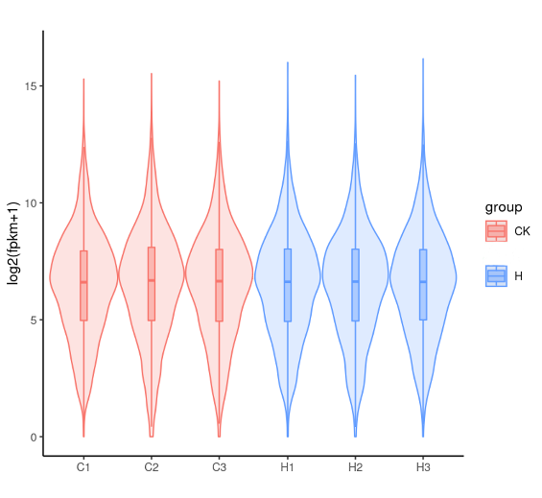

Fig. S2 The distribution of gene expression levels, C1, C2, and C3 are control groups with a Cr(VI) concentration of 0 mM, and H1, H2, and H3 are experimental groups with a Cr(VI) concentration of 0.5 mM.
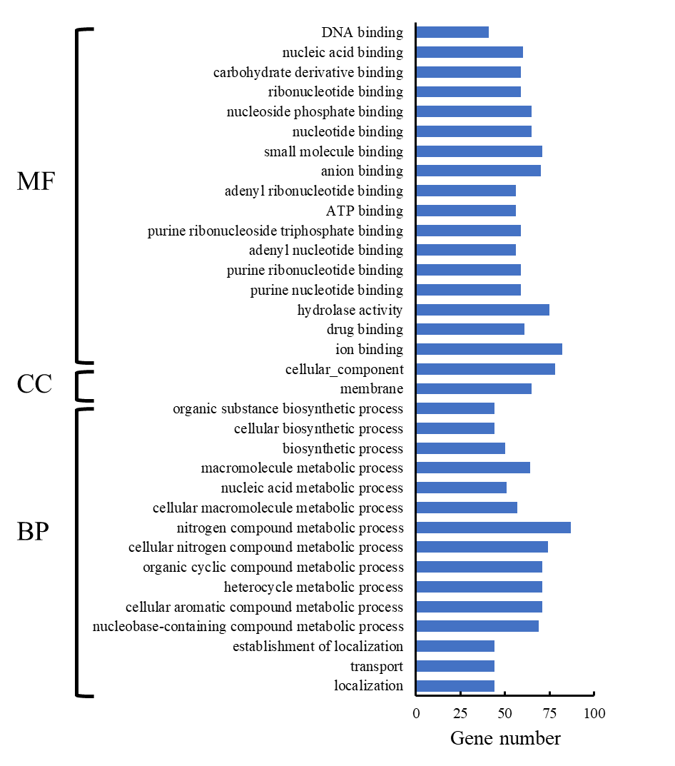

Fig. S3 GO enrichment categories for the up-regulated genes in C. fimi Clb-11 under 0.5 mM Cr(VI) stress.

Table S1 Quality translation of sample sequencing data
样品 | Raw reads | Clean reads | 平均Q20(%) | 平均Q30(%) | 平均GC含量(%)
C1 | 8542856 | 8396030 | 97.30 ± 0.097 | 92.65 ± 0.16 | 71.35 ± 0.38
C2 | 7870844 | 7699450 | 97.30 ± 0.097 | 92.65 ± 0.16 | 71.35 ± 0.38
C3 | 7846744 | 7600894 | 97.30 ± 0.097 | 92.65 ± 0.16 | 71.35 ± 0.38
H1 | 7956742 | 7806830 | 97.38 ± 0.061 | 92.76 ± 0.11 | 71.86 ± 0.17
H2 | 8612608 | 8478230 | 97.38 ± 0.061 | 92.76 ± 0.11 | 71.86 ± 0.17
H3 | 7547812 | 7410976 | 97.38 ± 0.061 | 92.76 ± 0.11 | 71.86 ± 0.17
Note: C1, C2, and C3 are control groups with a Cr(VI) concentration of 0 mM; H1, H2, and H3 are experimental groups with a Cr(VI) concentration of 0.5 mM.

Table S2 Differential gene statistical results
compare | all | up | down | threshold
HvsCK | 1234 | 654 | 580 | DESeq2 padj<=0.05 |log2FoldChange|>=0.0
Note: CK is control groups with a Cr(VI) concentration of 0 mM; H is experimental groups with a Cr(VI) concentration of 0.5 mM.

