Supplemental Information 1

Table S1 Categorization of migrants
 | Capture occasion
 | Migrant trap survey | Migrant trap survey &  early spring capture survey | Total
Bill-shaped predation-caused wound | 41 | 10 | 51
Tooth-shaped predation-caused wound | 22 | 2 | 24
Non-identified predation-caused wound | 24 | 7 | 31
Handling-caused wound | 154 | 32 | 186
Tooth-shaped predation-caused wound & handling-caused wound | 0 | 0 | 0
Bill-shaped predation-caused wound & handling-caused wound | 0 | 1 | 1
Bill-shaped predation-caused wound & tooth-shaped predation-caused wound | 4 | 0 | 4
Non identified predation-caused wound & handling-caused wound | 0 | 0 | 0
No wound (unscathed) | 214 | 67 | 281
Total | 459 | 119 | 578

Confirmation of the accuracy of the wound type
The identification of the wound type based on the scar characteristics is difficult because scar patterns are sometimes unclear. This raises the concern that our categorization of the wound type might be incorrect. To confirm this plausible problem is not in our case, we investigated the consistency of occurrence patterns between predation- and handling- caused wounds. If our categorization was incorrect, the occurrence pattern should be correlated between the predation- and handling-caused wounds. Specifically, we assessed whether frequency of the predation- and handling- caused wounds was positively affected by the date of capture in migrant trap, because effects of the date of capture in migrant trap on the frequency of predation-caused wound was positive (see Results). Logistic regression was employed to assess whether the frequency of the handling-caused wound at the migrant trap was positively affected by the date of capture in migrant trap and size (fork length) at migrant trap. Interaction term between date of capture at migrant trap and fork length was not included in the model because of non-significant effects observed in preliminary analyses using full models.
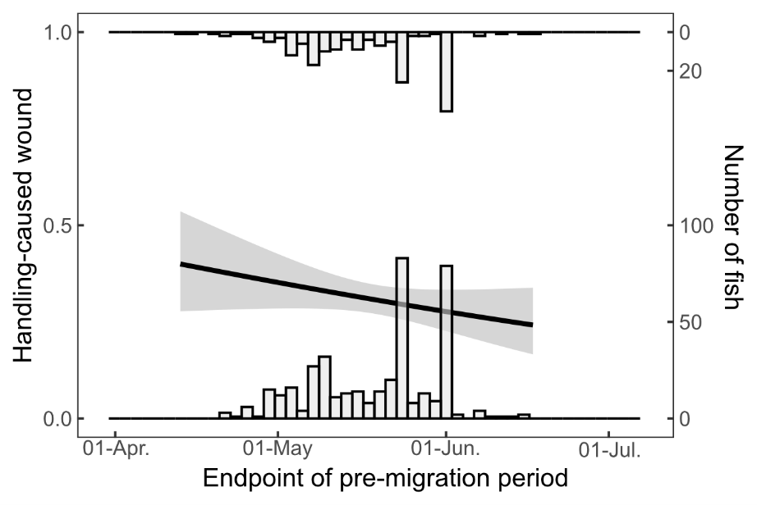
The frequency of migrants with handling-caused wound was negatively affected by the date of capture at migrant trap (χ² = 4.30, P = 0.038) (Fig. S1) (Table S2) and positively affected by fork length at migrant trap (χ² = 6.40, P = 0.011) (Table S2). This indicates that the relationship between migration timing and the frequency of handling-caused wound was negative, which contrasts to predation-caused wound (see Results). This inconsistency between the occurrence patterns of predation- and handling- caused wounds suggest our concerns regarding classification accuracy are warranted. The negative relationship between frequency of the handling-caused wound and timing of start of migration may be due to our improved skill and/or the smaller processing samples of the caught migrants in the later survey period, which allowed us to handle the fish more carefully.
Table S2 Results of the logistic regression model predicting frequency of handling-caused wound
Model formulae | Independent variable | Estimates | Std. Error | χ² value | P
Frequency of handling-caused wound ~ Intercept + Pre-migration period + Fork length
 | Intercept | -1.75 | 1.57
 | Pre-migration period | -1.56 × 10⁻² | 7.55 × 10⁻³ | 4.30 | 0.038
 | Fork length | 2.40 × 10⁻² | 9.64 × 10⁻³ | 6.40 | 0.011
Fig. S1 The frequency of handling-caused wound in relation to date of capture in migrant trap (end point of pre-migration period). Regression line was predicted by logistic regression (see Table S1 for estimates). The shaded area represents the 95 % confidence interval of the fitted regression line. The second Y-axis shows the number of individuals with wound (y = 1) and without wound (y = 0).

