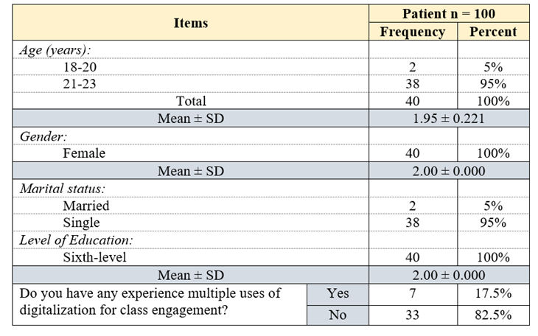
Table (1) Socio-demographic characteristics of the nursing students included in the study

Table (2) Students Knowledge and perceptions about Word wall game in class teaching in (pre-test and post-test)
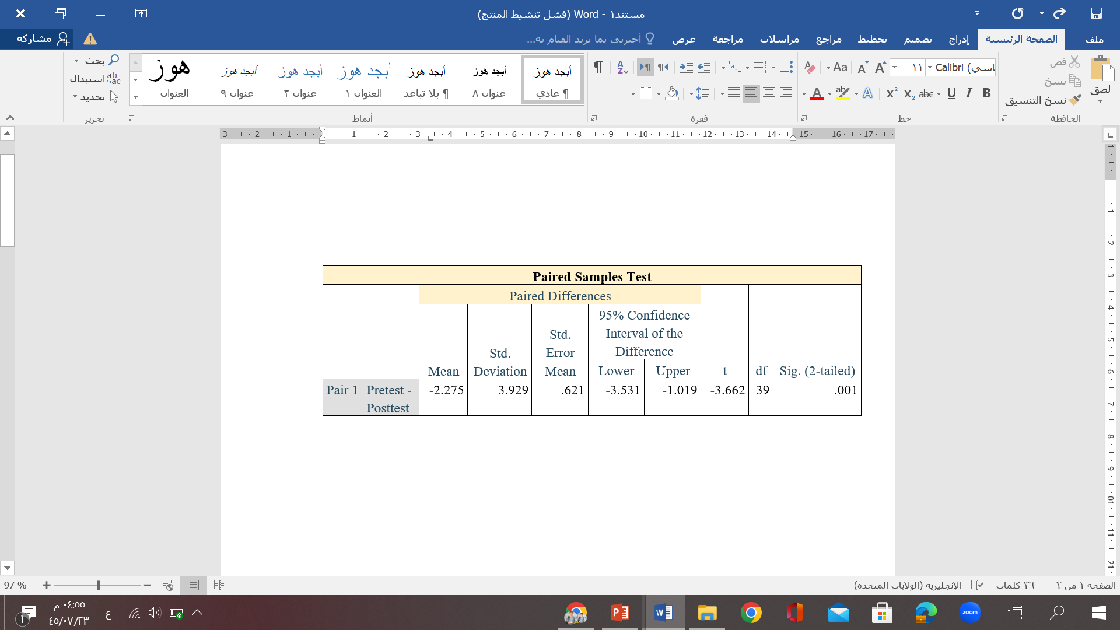

Table (3) Pre-test and post-test analysis for participants
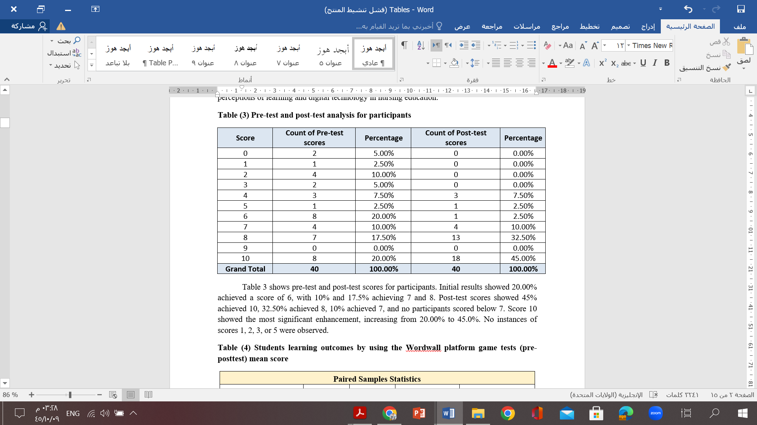
Table (4) Students learning outcomes by using the Wordwall platform game tests (pre-posttest) mean score
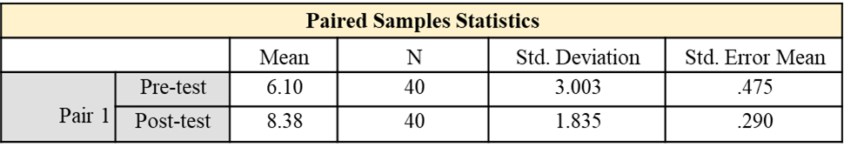
Table (5) Association between Wordwall platform game tests (pre-post-test)
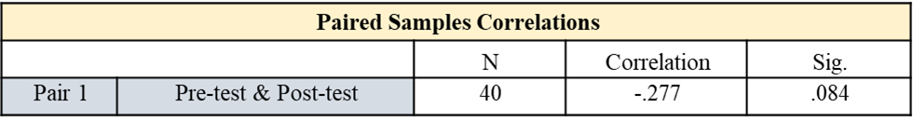

Table (6) Students' attitudes toward using Wordwall " games" as a teaching method for motivation.
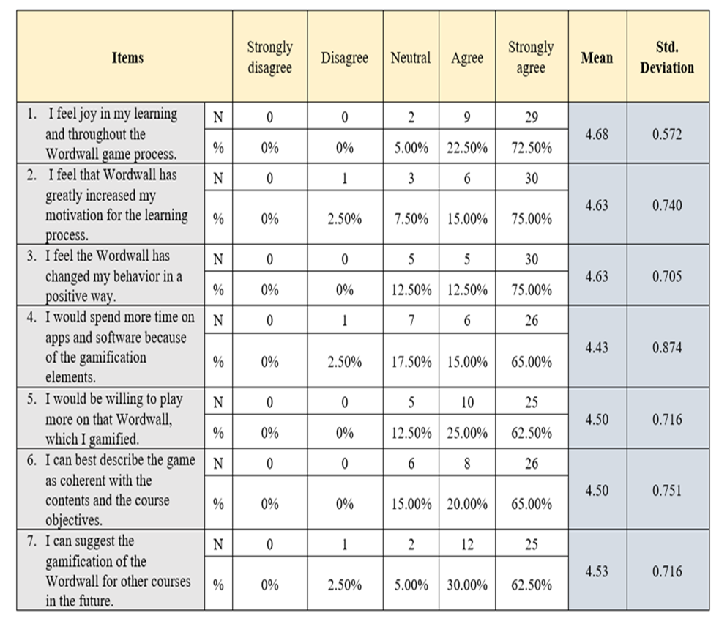

Table (7) Students’ attitudes toward using Padlet platform “Recorded Lecture Presentation” as an effective method in learning and students’ engagement
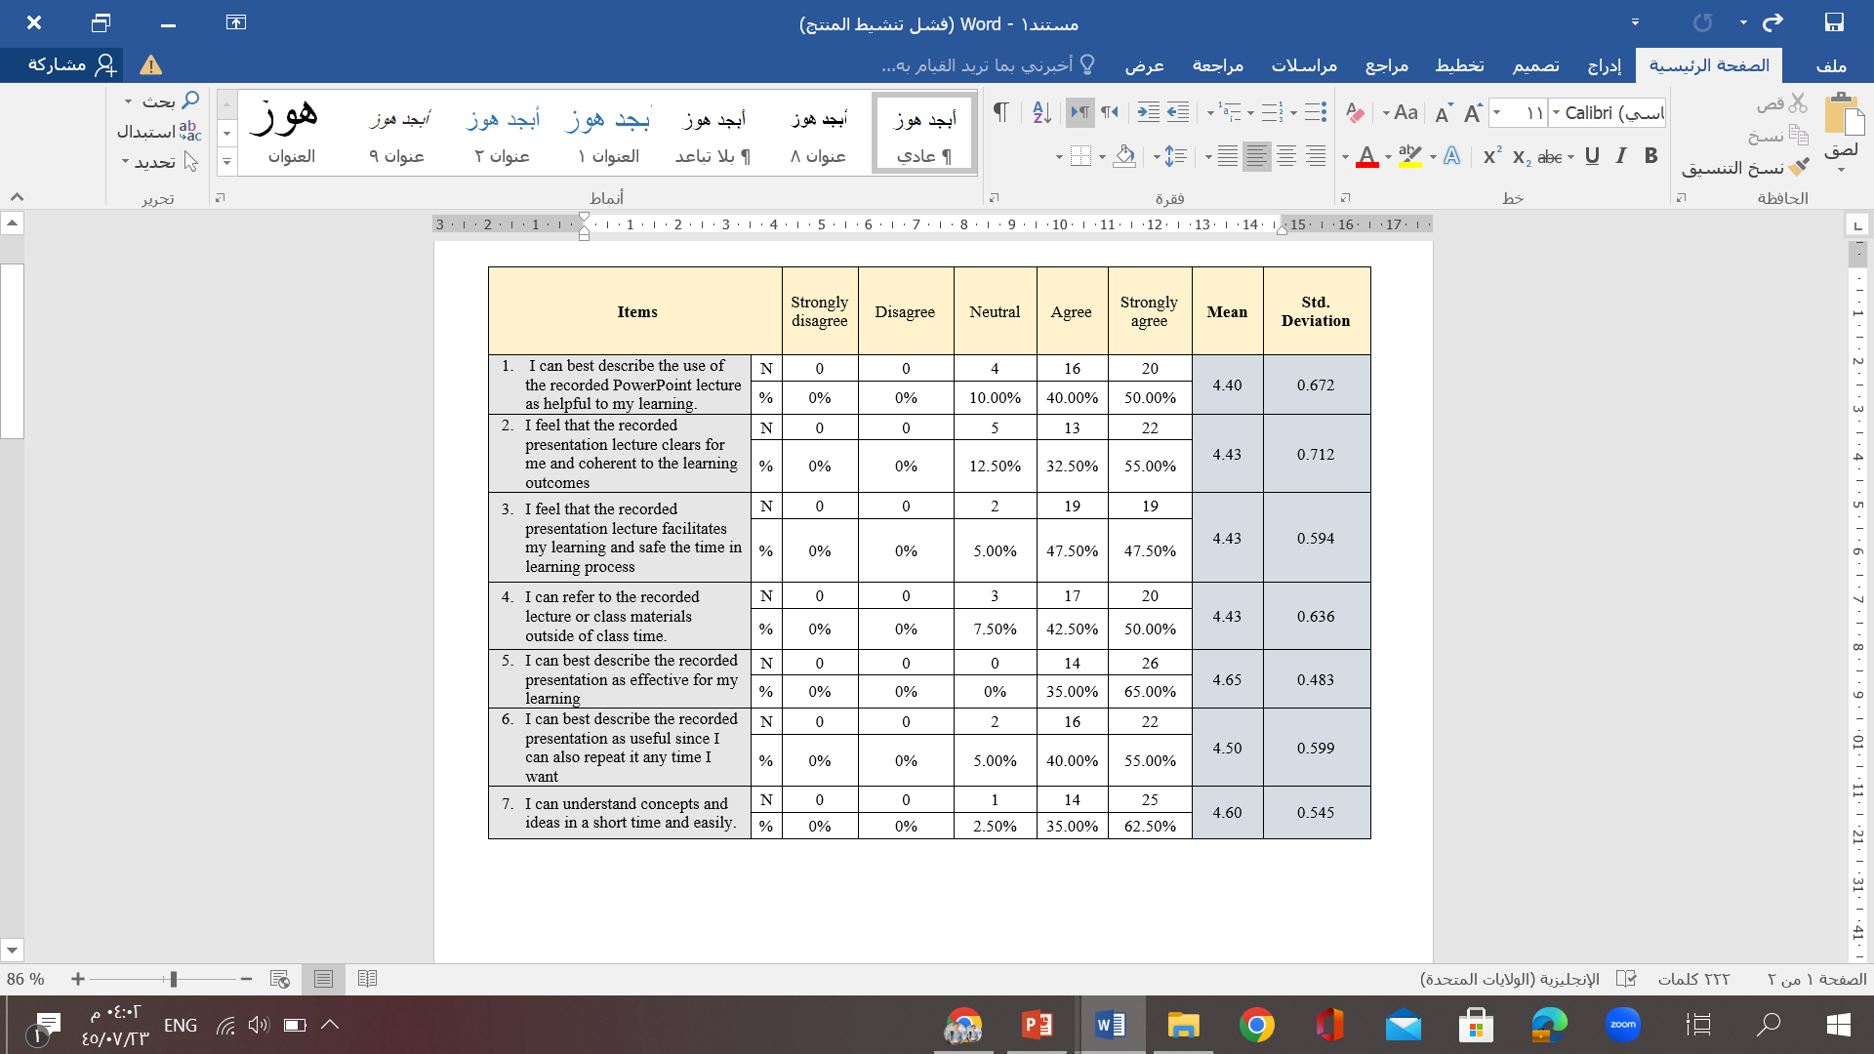

Table (8) Students' attitudes toward using Padlet platform “Recorded Lecture Presentation” as an effective method for communication and collaboration in learning
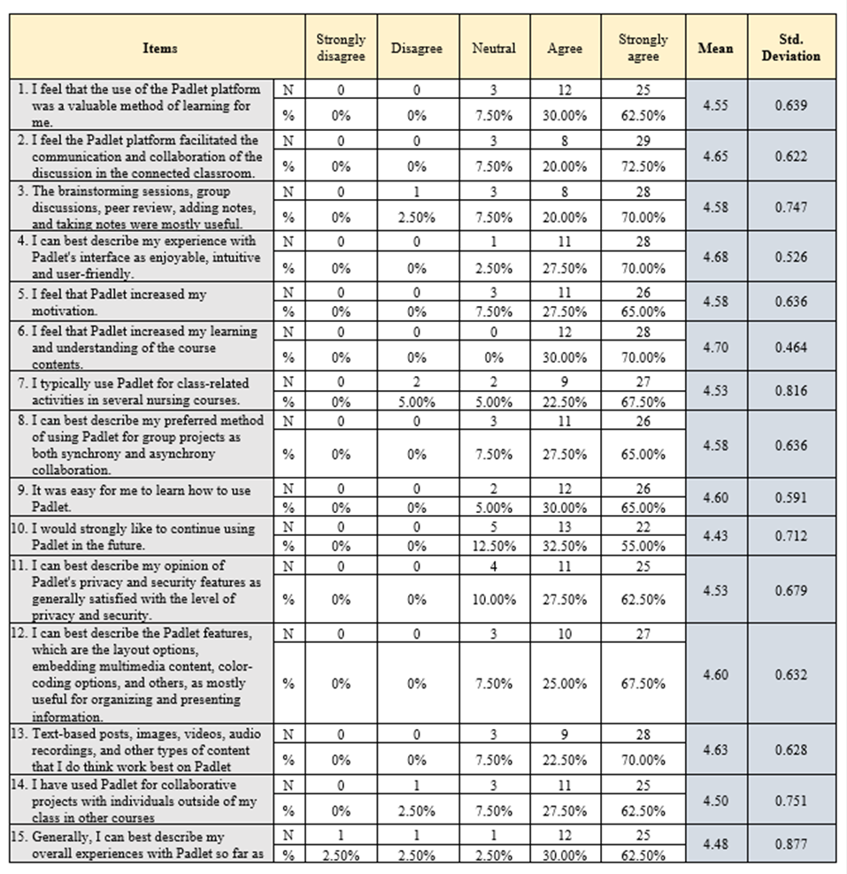

Table (9) Students' attitudes toward using videos in nursing education.
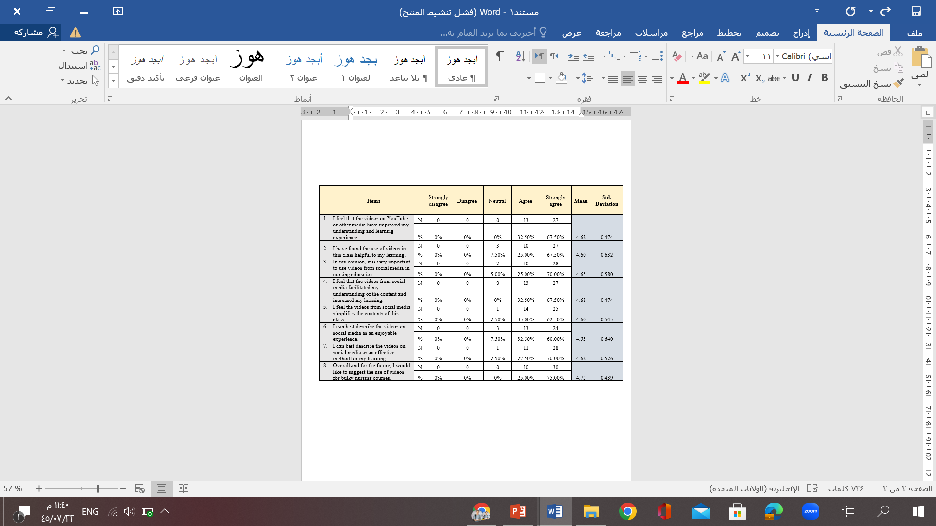
Table (10) Overall students' attitudes toward using technologies in the connected classroom
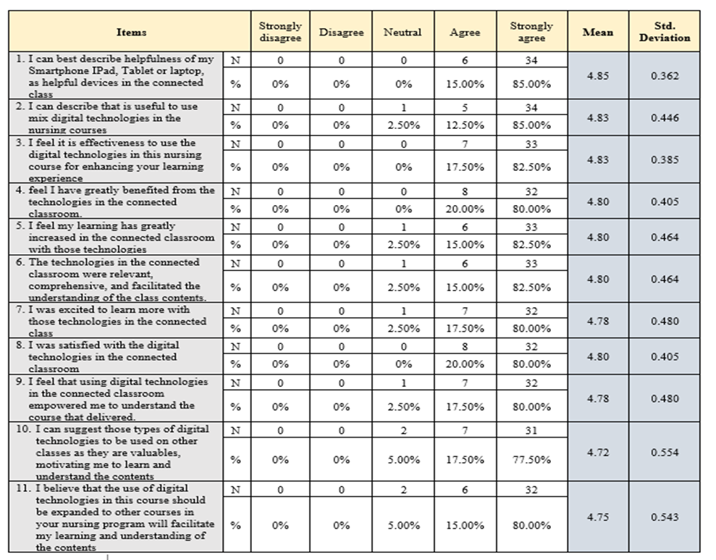

Table (11) Student satisfaction regarding using multiple teaching methods used in the class
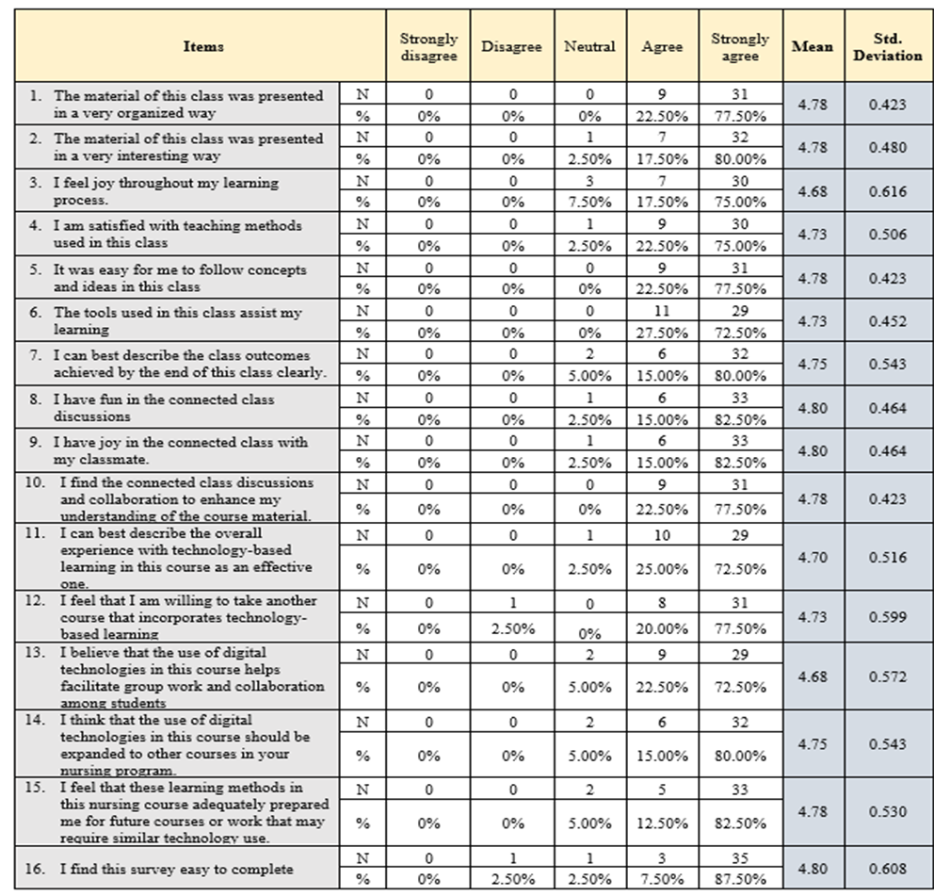
Table (12) The Scoring system table: Standard opinion direction domains of the five-point Likert scale.
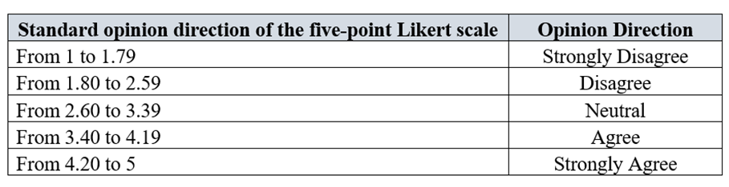
Table (13) Combined technologies means, direction, standard deviation, and variance
