Supplemental Information:
The Effect of Assist Gas Type on Nitinol Microsecond Laser Cut Edges: A Study on the Use of Oxygen, Argon, Nitrogen, Helium, and Compressed Air
Cory R. Otto, Alireza Doroudi, Majid Vaseghi, & Keivan Davami*

Specimen Preparation

Specimen Mounting
The specimens were cold cast mounted in 32 mm diameter potting puck. Buehler SamplKwick quick set acrylic was used as the mounting resin. Atmospheric conditions were used when pouring the acrylic resin into the mold. A vacuum chamber was used for 1-minute after pouring to reduce air bubbles and promote edge adhesion. Specimens were mounted longitudinally with the tube laying tangent to the bottom of the mold. Shown in Figure SI.1 is an illustration of the mounting orientation and polishing to produce two flats for quantitative analysis.
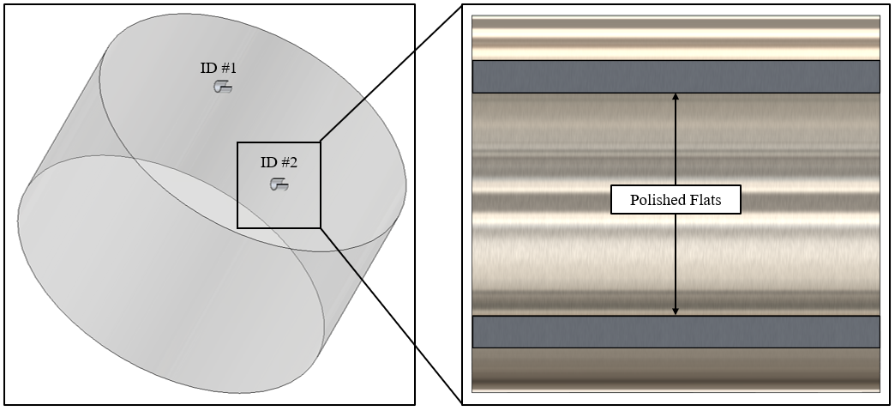
Figure SI.1. - Longitudinal specimen mounting for cross-sectioning and polishing.

Specimen Grinding / Polishing
Specimens were ground and polished using a Buehler EcoMet30 semi-automatic polisher to produce flats for analysis on the specimen. Shown in Table SI.1 is the procedure that was followed for preparation of the specimens.
Table SI.1 - Specimen preparation steps, Buehler products used and polisher parameters.
Abrasive  Type |  | Surface Disk / Cloth | Load  (N) | Base Speed  (RPM) | Head Speed  (RPM) | Relative Rotation | Time (min:sec)
45-micron SiC Water Cooled |  | CarbiMet | 15 | 300 | 50 | Same | 2:00
9μm MetiDi Supreme Diamond |  | MicroFloc | 15 | 150 | 50 | Opposite | 5:00
3μm MetiDi Supreme Diamond |  | VerduTex | 15 | 150 | 50 | Same | 5:00
0.2μm MasterMet 2 Colloidal Silica |  | ChemoMet | 15 | 150 | 50 | Same | 5:00

- Abrasive: media used for grinding and/or polishing.
- Surface Disk/Cloth: pad used for grinding and/or polishing.
- Load: downward force used to hold specimens against the abrasive.
- Base Speed: rotational speed of the polisher base.
- Head Speed: rotational speed of the polisher holder.
- Relative Rotation: direction of rotation of base compared to head.
- Time: cycle time of the grinding and/or polishing step.

Specimen Etching
After polishing the specimens were etched for microstructural analysis. Three 10-second cycles were used for etching. Specimens were swabbed with an HF acid etchant and then immediately rinsed with deionized water. The following section will show the progression of the chemical reaction as the number etching cycles increases. A custom mixed hydrofluoric-nitric acid solution was determined to provide the best etching results for Nitinol. Provided in Table SI.2 is the chemical composition of the etchant that was used for analysis and the commonly used Kroll’s reagent.
Table SI.2 - Nitinol HF-Based Custom Mixed Etchant versus Kroll’s Reagent
HF (mL) | H₂O (mL) | HNO₃ (mL) | Total (mL) | HF Percentage | Notes
3 | 132 | 15 | 150 | 2.00% | Custom Composition
3 | 138 | 9 | 150 | 2.00% | Kroll’s Reagent
Shown in Figure SI.2 is the progression of surface etching based on the number of 10-second cycles that the specimen was swabbed with a custom mixed 2% HF acid etchant. The results were similar to those obtained with Kroll’s reagent, with a slightly crisper resolution of grain morphology.
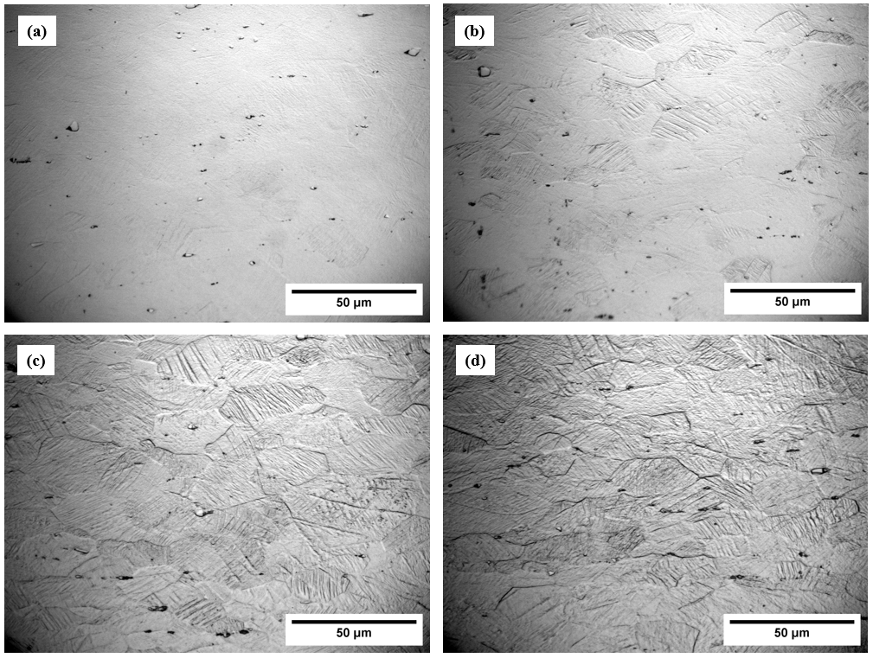
Figure SI.2. - 2-percent HF etching (a) one 10-second cycle (b) two 10-second cycles (c) three 10-second cycles (d) four 10-second cycles.

Dross Analysis

Oxygen Dross Comparison
Shown in Figure SI.3 are the dross analysis samples that were cut with an oxygen assist gas at varying cut rates. As the cut rate increased, the amount of dross present on the inner diameter of the tubes decreased.
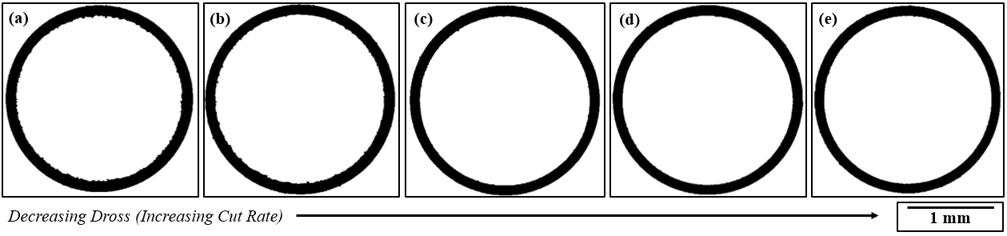
Figure SI.3. - Oxygen μs laser cuts (a) 4.23 mm/s, (b) 12.70 mm/s, (c) 21.17 mm/s, (d) 29.63 mm/s, and (e) 38.10 mm/s.

Argon Dross Comparison
Shown in Figure SI.4 are the dross analysis samples that were cut with an argon assist gas at varying cut rates. It can be noted that there was significantly more dross when comparing to the specimens cut with an oxygen assist gas.
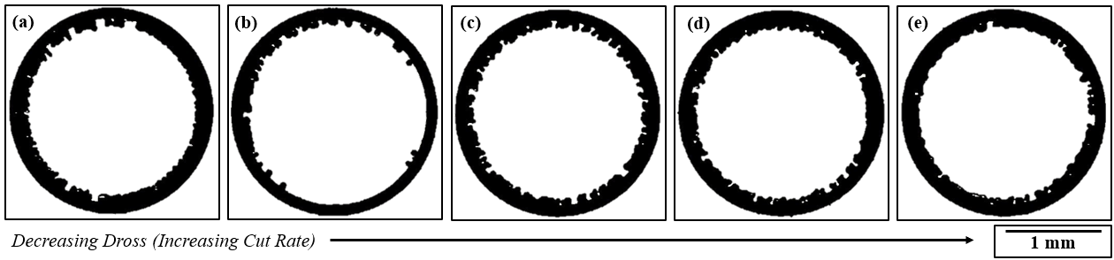
Figure SI.4. - Argon μs laser cuts (a) 4.23 mm/s, (b) 12.70 mm/s, (c) 21.17 mm/s, (d) 29.63 mm/s, and (e) 38.10 mm/s.

Nitrogen Dross Comparison
Shown in Figure SI.5 are the dross analysis samples that were cut with a nitrogen assist gas at varying cut rates. Observations were made that the dross was brittle and separated from the laser cut edge during handling.
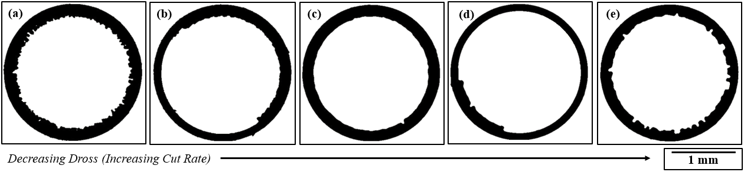
Figure SI.5. – Nitrogen μs laser cuts (a) 4.23 mm/s, (b) 12.70 mm/s, (c) 21.17 mm/s, (d) 29.63 mm/s, and (e) 38.10 mm/s.

Compressed Air Dross Comparison
Shown in Figure SI.6 are the dross analysis samples that were cut with a compressed air assist gas at varying cut rates. The dross was intermittent and appeared to have sections similar to the oxygen assist gas specimens.
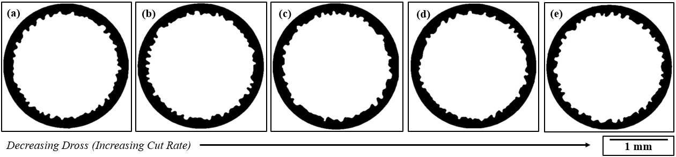
Figure SI.6. – Compressed air μs laser cuts (a) 4.23 mm/s, (b) 12.70 mm/s, (c) 21.17 mm/s, (d) 29.63 mm/s, and (e) 38.10 mm/s.

Helium Dross Comparison
Shown in Figure SI.7 are the dross analysis samples that were cut with a helium assist gas at varying cut rates. The dross adhered to the laser cut wall and was not able to be easily removed.
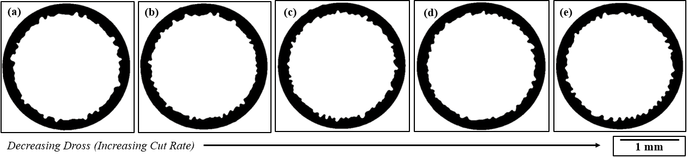
Figure SI.7. – Helium μs laser cuts (a) 4.23 mm/s, (b) 12.70 mm/s, (c) 21.17 mm/s, (d) 29.63 mm/s, and (e) 38.10 mm/s.

Surface Roughness Analysis
Provided in Table SI.3 are the measurements that were collected on the Keyence WI-001 laser-based sensor for the average arithmetic mean surface roughness measurements. The specimens cut with oxygen were shown to have the lowest surface roughness value.
Table SI.3 - Surface roughness raw data measurements from Keyence WI-001 laser sensor.
Oxygen |  |  |  |  | Argon
Cut Rate  (mm/s) | Measurement | Low  (μm) | High  (μm) | Average  (μm) | Cut Rate  (mm/s) |  | Measurement |  | Low  (μm) |  | High  (μm) | Average  (μm)
4.23 | Sa | 0.48 | 0.54 | 0.51 | 4.23 |  | Sa |  | 1.04 |  | 1.08 | 1.06
12.70 | Sa | 0.49 | 0.55 | 0.52 | 12.70 |  | Sa |  | 0.76 |  | 0.80 | 0.78
21.17 | Sa | 0.44 | 0.50 | 0.47 | 21.17 |  | Sa |  | 0.83 |  | 0.89 | 0.86
29.63 | Sa | 0.43 | 0.49 | 0.46 | 29.63 |  | Sa |  | 0.92 |  | 0.98 | 0.95
38.10 | Sa | 0.43 | 0.47 | 0.45 | 38.10 |  | Sa |  | 0.57 |  | 0.61 | 0.59
Nitrogen |  |  |  |  | Helium
Cut Rate  (mm/s) | Measurement | Low  (μm) | High  (μm) | Average  (μm) | Cut Rate  (mm/s) |  | Measurement |  | Low  (μm) |  | High  (μm) | Average  (μm)
4.23 | Sa | 1.96 | 2.04 | 2.00 | 4.23 |  | Sa |  | 1.18 |  | 1.22 | 1.20
12.70 | Sa | 1.73 | 1.77 | 1.75 | 12.70 |  | Sa |  | 1.23 |  | 1.27 | 1.25
21.17 | Sa | 1.50 | 1.56 | 1.53 | 21.17 |  | Sa |  | 1.24 |  | 1.30 | 1.27
29.63 | Sa | 1.06 | 1.10 | 1.08 | 29.63 |  | Sa |  | 1.32 |  | 1.38 | 1.35
38.10 | Sa | 1.03 | 1.07 | 1.05 | 38.10 |  | Sa |  | 1.42 |  | 1.50 | 1.46
Compressed Air
Cut Rate  (mm/s) | Measurement | Low  (μm) | High  (μm) | Average  (μm)
4.23 | Sa | 1.10 | 1.14 | 1.12
12.70 | Sa | 0.85 | 0.89 | 0.87
21.17 | Sa | 1.04 | 1.08 | 1.06
29.63 | Sa | 0.97 | 1.03 | 1.00
38.10 | Sa | 0.95 | 1.01 | 0.98

SEM Analysis

Oxygen Cut SEM Overview
Shown in Figure SI.8 is an SEM overview of the Nitinol laser cut specimen that was produced with an oxygen assist gas at a cut rate of 38.10 mm/s. The specimen was observed to have little to no dross, a low surface roughness, and an even striation pattern on the laser cut surface. A depiction of the whole perimeter of the laser cut surface is provided, as well as a zoomed in SEM image of the laser cut edge. Overall, the specimen cut with oxygen at the fastest cut rate was shown to provide the highest quality cut. It was assumed that the combustion reaction with oxygen aided in removal of the melt pool, hence leading to a higher quality cut.
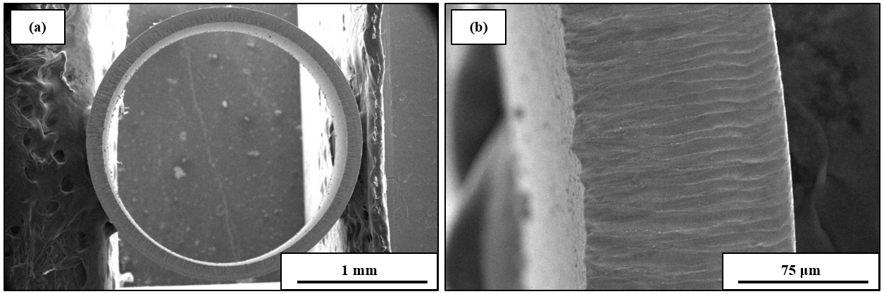
Figure SI.8. – SEM oxygen cut Nitinol specimen: (a) 35x magnification and (b) 500x magnification.

Argon Cut SEM Overview
Shown in Figure SI.9 is an SEM overview of the Nitinol laser cut specimen that was produced with an argon assist gas at a cut rate of 38.10 mm/s. The specimen was observed to have significant dross, a 2x increase surface roughness, and an even striation pattern on the laser cut surface. An occasional re-solidification of melted material was found on the striation pattern. Overall, the specimen cut with argon at the fastest cut rate was shown to provide a high-quality cut edge, besides the presence of significant dross. It was assumed that the lack of a combustion reaction resulted in more dross present on the laser cut surface.
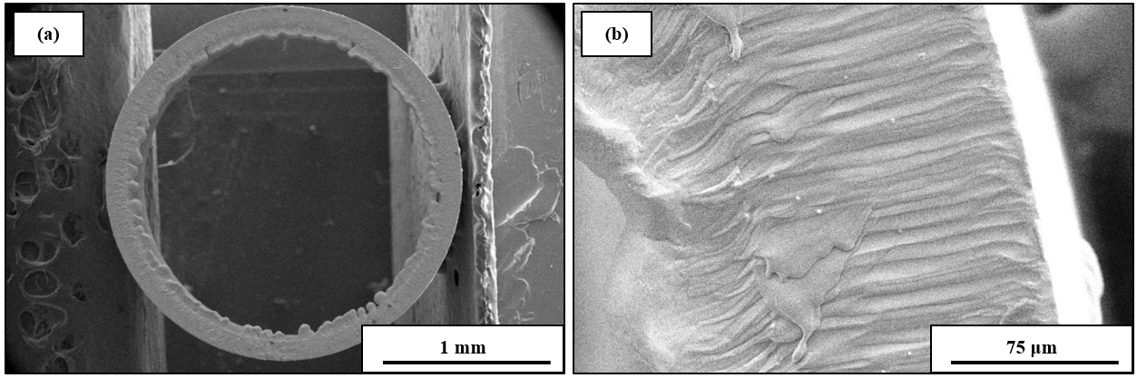
Figure SI.9. – SEM argon cut Nitinol specimen: (a) 35x magnification and (b) 500x magnification.

Nitrogen Cut SEM Overview
Shown in Figure SI.10 is an SEM overview of the Nitinol laser cut specimen that was produced with a nitrogen assist gas at a cut rate of 38.10 mm/s. The specimen was observed to have significant dross, a high surface roughness, and an uneven striation pattern on the laser cut surface. Overall, the specimen cut with nitrogen at the fastest cut rate was shown to provide a mid-range quality cut edge, besides the presence of significant dross and an increased surface roughness.
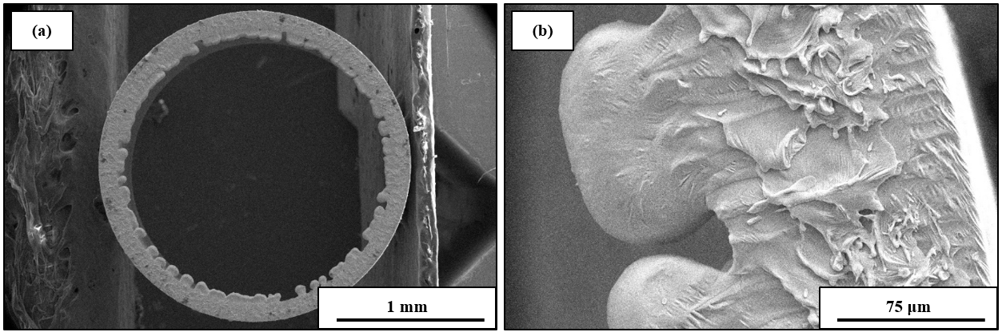
Figure SI.10. – SEM nitrogen cut Nitinol specimen: (a) 35x magnification and (b) 500x magnification.

Helium Cut SEM Overview
Shown in Figure SI.11 is an SEM overview of the Nitinol laser cut specimen that was produced with a helium assist gas at a cut rate of 38.10 mm/s. The specimen was observed to have significant dross, a high surface roughness, and an uneven even striation pattern on the laser cut surface. Significant re-solidification of melted material was found on the striation pattern. Overall, the specimen cut with helium at the fastest cut rate was shown to provide a low-quality cut edge. It was assumed that the poor cut quality was attributed to the 2x lower assist gas pressure that was used for the helium specimen.
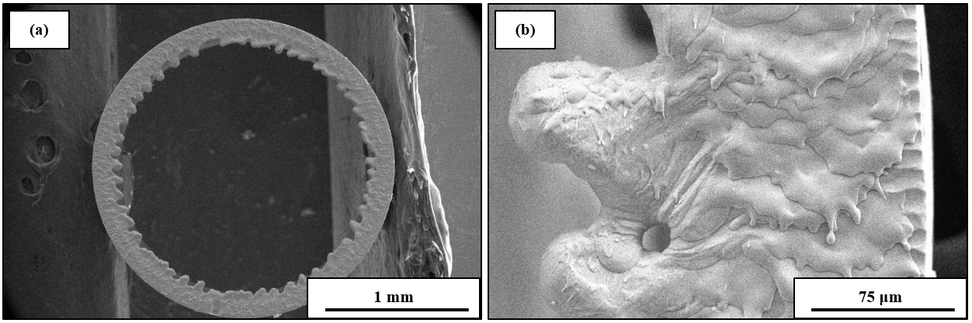
Figure SI.11. – SEM helium cut Nitinol specimen: (a) 35x magnification and (b) 500x magnification.

Compressed Air Cut SEM Overview
Shown in Figure SI.12 is an SEM overview of the Nitinol laser cut specimen that was produced with a compressed air assist gas at a cut rate of 38.10 mm/s. The specimen was observed to have significant dross, a high surface roughness, and an uneven even striation pattern on the laser cut surface. Significant re-solidification of melted material was found on the striation pattern. Overall, the specimen cut with compressed air had the worst cut quality when compared to the other assist gas types. It was also assumed that the poor cut quality was attributed to the 2x lower assist gas pressure that was used for the compressed air specimen.
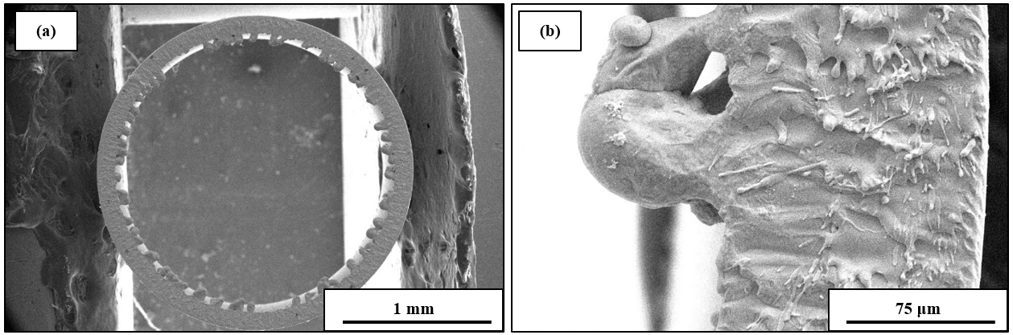
Figure SI.12. – SEM compressed air cut Nitinol specimen: (a) 35x magnification and (b) 500x magnification.

Nanoindentation Hardness Analysis

Raw Data
Nanoindentation analysis demonstrated that the laser cut specimens did not experience a change in hardness near the laser cut edge. Conclusions were drawn that the selected laser cutting parameters were able to produce negligible HAZ. The raw data for the average of 4 hardness tests is shown in Table SI.4.
Table SI.4 - Average Hardness Testing Data for Specimens Cut at 38.10 mm/s.
Distance from Edge (μm) | Oxygen Average | Argon Average | Nitrogen Average | Helium Average | Compressed Air Average
Distance from Edge (μm) | Hardness HIT (GPa)
5 | 3.740 | 3.539 | 3.803 | 4.393 | 4.360
25 | 3.672 | 3.547 | 3.816 | 3.875 | 4.070
45 | 3.892 | 3.792 | 3.708 | 3.872 | 3.720
65 | 3.947 | 3.664 | 3.463 | 3.526 | 3.753
85 | 3.835 | 3.756 | 4.007 | 3.690 | 3.772
10 | 3.620 | 3.937 | 3.877 | 3.704 | 3.769
30 | 3.626 | 3.756 | 3.713 | 3.919 | 3.457
50 | 3.788 | 3.579 | 3.725 | 3.826 | 3.705
70 | 3.778 | 3.927 | 3.670 | 3.735 | 3.996
90 | 3.967 | 3.793 | 3.838 | 3.652 | 3.828
15 | 3.665 | 3.644 | 3.932 | 3.979 | 3.836
35 | 3.924 | 3.974 | 3.776 | 4.045 | 3.710
55 | 3.837 | 3.658 | 3.825 | 3.934 | 3.757
75 | 3.808 | 3.938 | 3.875 | 4.020 | 3.761
95 | 3.839 | 3.681 | 3.812 | 4.283 | 3.634
20 | 3.887 | 3.762 | 3.700 | 4.111 | 3.688
40 | 3.857 | 3.959 | 3.783 | 3.998 | 3.694
60 | 3.980 | 3.679 | 3.896 | 3.946 | 3.778
80 | 4.017 | 3.516 | 3.822 | 4.140 | 3.820
100 | 3.922 | 3.743 | 3.832 | 3.964 | 3.752

Hardness Plots
Shown in Figure SI.13 is the hardness testing up to 100 μm away from the laser cut edge. No deviations in hardness were observed. It was concluded that the tested assist gases can produce negligible HAZ penetration depths with the selected laser parameters and avoid inducing microstructural grain recrystallization.
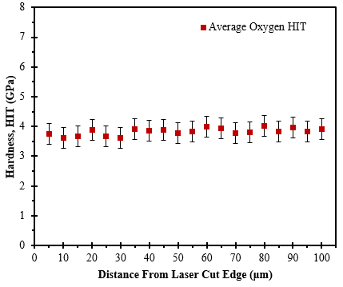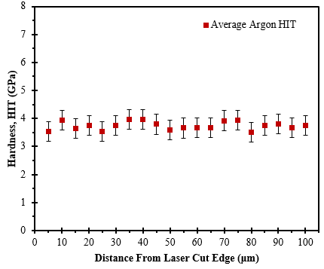
(b)
(a)
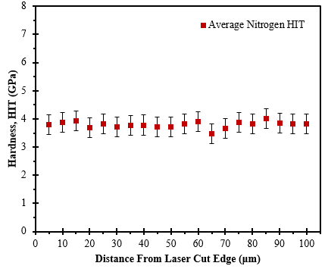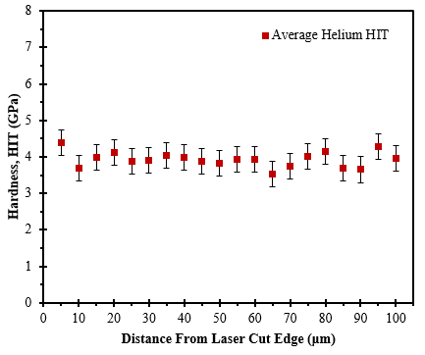
(e)
(d)
(c)
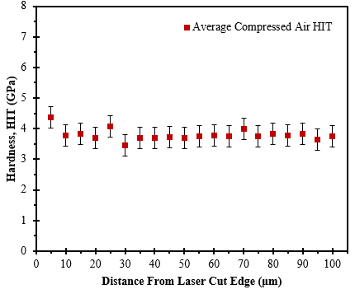
Figure SI.13. - Hardness testing of Nitinol specimen laser cut at rate of 38.10 mm/s with: (a) oxygen, (b) argon, (c) nitrogen, (d) helium, and (e) compressed air.

EDX Elemental Composition Analysis

Raw Data
Provided in Table SI.5 is the elemental composition measured with EDX at varying distances from the laser cut edge.
Table SI.5 – Raw data for the elemental composition at varying distances from the laser cut edge.
Oxygen Assist Gas (at% Chemical Composition)
Distance from Laser Cut Edge | N | O | Ar | Ti | Ni
0.5 | 18.9 | 46.1 | 0 | 14.6 | 13.5
2.5 | 4.3 | 5.8 | 0.2 | 44.1 | 43.8
5 | 5 | 3.3 | 0.1 | 44.9 | 44.6
7.5 | 5.3 | 4 | 0.2 | 44.7 | 44.1
10 | 3.2 | 2.5 | 0.1 | 46.8 | 46.1
12.5 | 4.3 | 3.3 | 0.2 | 45.2 | 44.9
15 | 3.6 | 2.9 | 0.2 | 45.8 | 45.6
17.5 | 2.4 | 2.8 | 0.2 | 46.5 | 46.3
Argon Assist Gas (at% Chemical Composition)
Distance from Laser Cut Edge | N | O2 | Ar | Ti | Ni
0.5 | 3.4 | 3.8 | 0.2 | 45.3 | 44.7
2.5 | 6.2 | 5 | 0.1 | 43 | 43.3
5 | 4.8 | 5.1 | 0 | 44 | 43.9
7.5 | 5.6 | 6.8 | 0.1 | 42.7 | 42.4
10 | 4.4 | 5.6 | 0.1 | 43.7 | 43.6
12.5 | 1.1 | 3.8 | 0.2 | 46.3 | 45.8
15 | 4.5 | 4.5 | 0.1 | 44.6 | 44.2
17.5 | 5.8 | 4.2 | 0.2 | 44.1 | 43.7
Nitrogen Assist Gas (at% Chemical Composition)
Distance from Laser Cut Edge | N | O2 | Ar | Ti | Ni
0.5 | 7.5 | 17.7 | 0 | 35.9 | 36.3
2.5 | 3.9 | 8.7 | 0.2 | 42.5 | 42.4
5 | 4.5 | 4.7 | 0.1 | 44.1 | 43.6
7.5 | 2.8 | 3 | 0.1 | 46.2 | 45.8
10 | 2.6 | 3.5 | 0.1 | 45.5 | 45.4
12.5 | 1.5 | 2.3 | 0.1 | 47 | 46.6
15 | 2.1 | 3.2 | 0.2 | 45.9 | 45.7
17.5 | 3.8 | 4.4 | 0.1 | 44.6 | 44.4
Helium Assist Gas (at% Chemical Composition)
Distance from Laser Cut Edge | N | O2 | Ar | Ti | Ni
0.5 | 3 | 5.1 | 0.2 | 44.3 | 44.1
2.5 | 1.5 | 3 | 0.1 | 46.6 | 46.4
5 | 1.6 | 2.6 | 0.1 | 46.8 | 46.4
7.5 | 1.6 | 3.5 | 0.2 | 46.1 | 45.9
10 | 1.5 | 3 | 0.1 | 46.1 | 46.2
12.5 | 0.8 | 3.7 | 0.1 | 46.2 | 46.3
15 | 1.7 | 3.1 | 0.1 | 46.4 | 46.1
17.5 | 2 | 3.1 | 0.2 | 46.3 | 45.8
Compressed Air Assist Gas (at% Chemical Composition)
Distance from Laser Cut Edge | N | O2 | Ar | Ti | Ni
0.5 | 1.7 | 19.2 | 0.1 | 33.7 | 39.6
2.5 | 0.5 | 4.9 | 0.4 | 42.3 | 46.2
5 | 1.3 | 5.9 | 0.2 | 43.4 | 45.5
7.5 | 3.9 | 6.7 | 0.1 | 42.7 | 43.9
10 | 5.8 | 7.3 | 0.1 | 41.2 | 42.4
12.5 | 6.9 | 7.7 | 0.1 | 40.6 | 41.5
15 | 7.6 | 8.3 | 0.2 | 40 | 41.1
17.5 | 6.9 | 7.7 | 0.1 | 40.6 | 41.5

EDX Plots
Shown in Figure SI.14 is the elemental composition analyzing the penetration depth of the specimens cut with the different assist gas types at varying distances from the laser cut edge.
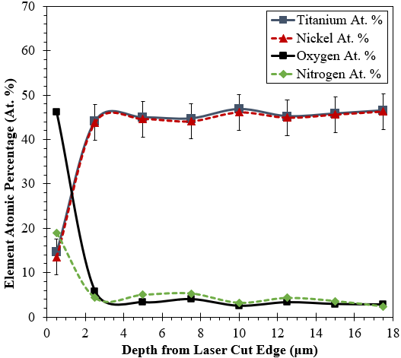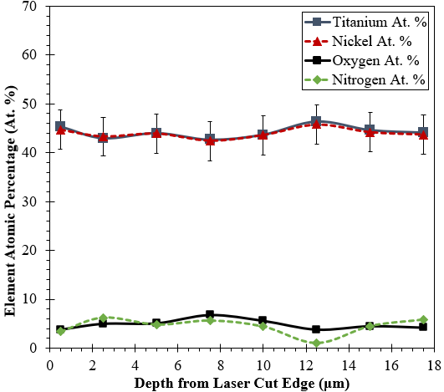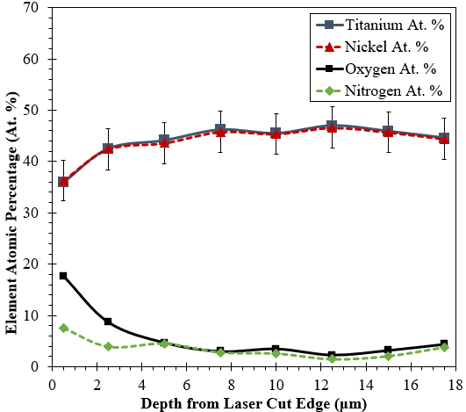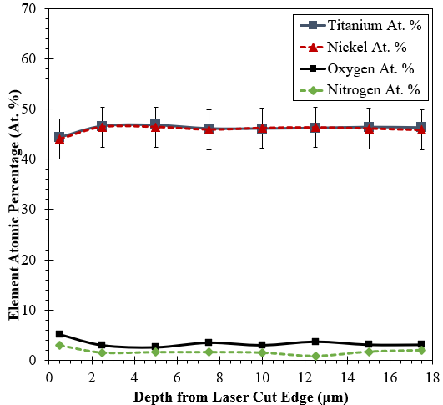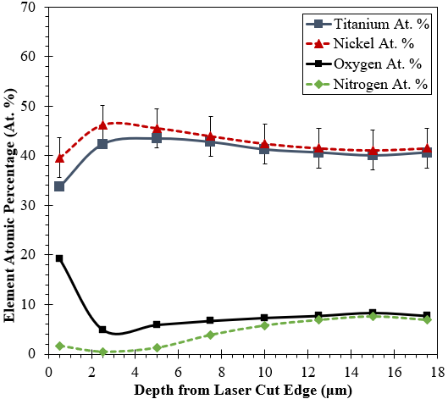
(e)
(d)
(c)
(a)
(b)
Figure SI.14. - Elemental composition of Nitinol specimen at varying distances from the laser cut edge. Specimen cut at a rate of 38.10mm/s (a) oxygen, (b) argon, (c) nitrogen, (d) helium, and (e) compressed air.

Recast Layer Thickness Analysis

Raw Data
The specimens were mounted, cross-sectioned, and polished for recast layer thickness analysis. Provided in Table SI.6 is the raw data for the five measurements that were taken for each assist gas type. Overall, the recast layer thickness was observed to be relatively small, with the largest thickness only averaging 1.5 μm thick.
Table SI.6 - Raw data for recast layer thickness measurements for specimens cut at a rate of 38.10 mm/s.
Recast Layer Thickness (μm)
Measurement | Oxygen | Argon | Nitrogen | Helium | Comp. Air
Meas-1 | 1.525 | 0.745 | 1.110 | 0.731 | 0.892
Meas-2 | 1.460 | 0.960 | 1.638 | 0.944 | 1.252
Meas-3 | 1.470 | 0.505 | 1.667 | 0.869 | 1.427
Meas-4 | 1.446 | 0.585 | 1.042 | 0.865 | 1.144
Meas-5 | 1.842 | 0.463 | 1.841 | 0.962 | 1.135
Average Thickness (μm): | 1.549 | 0.652 | 1.460 | 0.874 | 1.170

Image of Recast Layer
Provided in Figure SI.15a is an SEM image of the thin recast layer that was found to be present on all of the microsecond laser processed specimens. Shown in Figure SI.15b is an optical microscope image of the grain structure that highlights the presence of the thin recast layer. Both figures are of a specimen cut with oxygen which was shown to have the largest measurement for recast layer thickness.
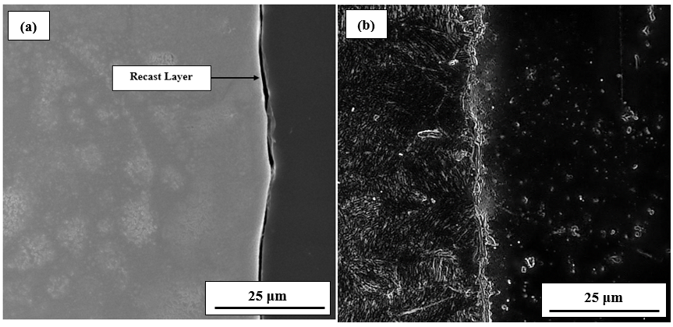
Figure SI.15. - Image of Nitinol recast layer for specimen cut with an oxygen assist gas at 38.10 mm/s (a) polished SEM view and (b) etched optical microscopy view.

Application of Oxygen Process to Stent Strut Geometry
Provided in Figure SI.16 is a representation of applying the reactive assist gas cutting process to a 125 μm thick Nitinol tube with a stent strut width of 190 μm. It was demonstrated that a dross-free cut was possible when using a long-pulse laser cutting process paired with an oxygen assist gas. Furthermore, a 3x expansion of the diameter of the tube was possible with no cracking/breakage and without any chemical post-processing or electropolishing. A hydrofluoric-nitric acid (HF) cleaning operation demonstrated that any residual cutting debris could easily be removed.

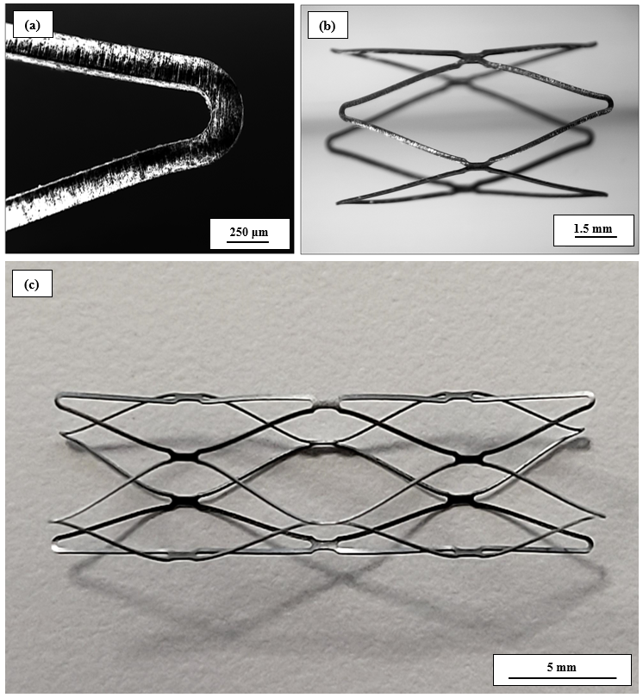
Figure SI.16. – (a) as cut Nitinol laser cut strut at a rate of 4.23 mm/s on a microsecond laser demonstrating a near dross-free cut, (b) 3x expansion of diameter after 505˚C heat setting, and (c) 3x expansion of the diameter and HF cleaning procedure.

Ejection Temperature Distribution Analysis
Provided in Figure SI.17 is an analysis of the temperature distribution for the various assist gas types used for cutting. With oxygen, the thermal gradient is more localized and with an inert assist gas the thermal field is more dispersed.
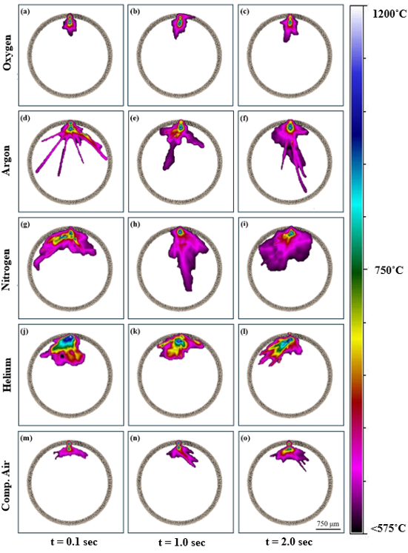
Figure SI.17. – Nitinol laser tube cutting in-situ thermal data superimposed on a scaled tube cross section to demonstrate the difference between laser cutting assist gas types: (a-c) oxygen, (d-f) argon, (g-i) nitrogen, (j-l) helium, and (m-o) compressed air, where “t” is the time since the start of cutting.

