Supplemental Materials
Article title: The association between peripheral sensitivity of thyroid hormones and contrast-induced acute kidney injury: a retrospective study on euthyroid patients underwent coronary angiography
Journal name: Endocrine
Author names: Yuan Fang; Hao Chen; Zijie Wang; Jingyi Lv; Zhenni Zhao; Danan Wang; Duanbin Li; Guosheng Fu; Wenbin Zhang
Corresponding authors: Guosheng Fu and Wenbin Zhang,
Affiliation: Department of Cardiology, Sir Run Run Shaw Hospital affiliated with Zhejiang University School of Medicine; Key Laboratory of Cardiovascular Intervention and Regenerative Medicine of Zhejiang Province, Hangzhou 310000, Zhejiang, People's Republic of China.
Address: Department of Cardiology, Sir Run Run Shaw Hospital, School of Medicine, Zhejiang University, 3 East Qingchun Road, Hangzhou 310000, Zhejiang Province, People's Republic of China.
E-mail: 3313011@zju.edu.cn

Figures
Figure S1. ROC analysis between FT3 and CI-AKI
Figure S2. ROC analysis between FT4 and CI-AKI
Figure S3. Subgroup analysis between FT3 and CI-AKI
Figure S4. Subgroup analysis between FT4 and CI-AKI

Tables
Table S1. Multivariable linear regression models on Scr elevation
Table S2. Multivariable linear regression models on Scr elevation (with additional adjustment for premedication)
Table S3. Multivariable logistic regression models on CI-AKI
Table S4. Multivariable logistic regression models on CI-AKI (with additional adjustment for premedication)

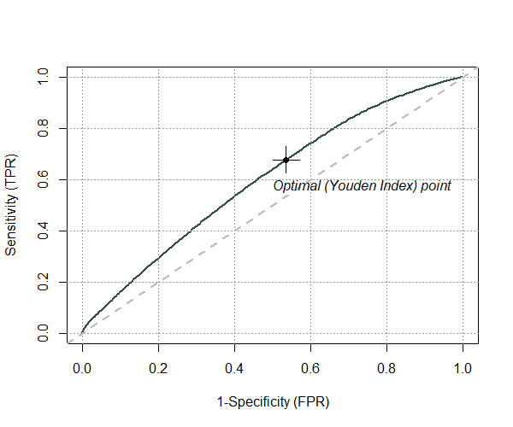
Figure S1. ROC analysis between FT3 and CI-AKI. The optimal cut-off point is marked with a cross. ROC, Receiver operating characteristic; other abbreviations refer to Fig. 1.
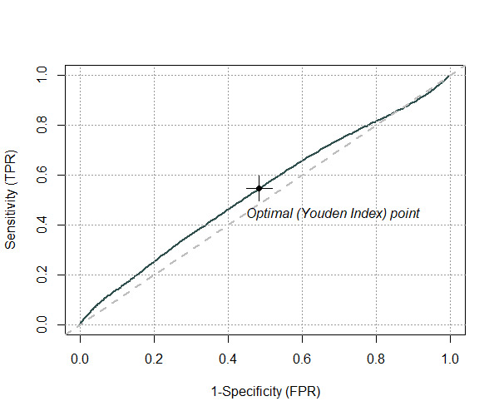
Figure S2. ROC analysis between FT4 and CI-AKI. The optimal cut-off point is marked with a cross. ROC, Receiver operating characteristic; other abbreviations refer to Fig. 1.
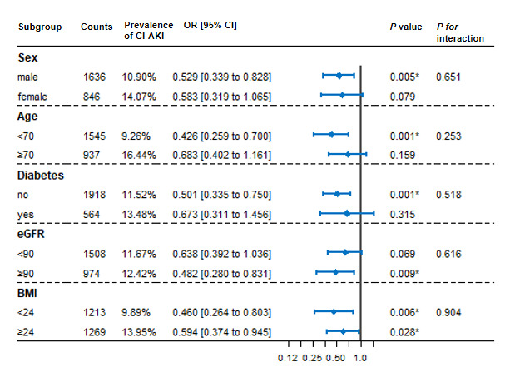
Figure S3. Subgroup analysis between FT3 and CI-AKI according to gender (male/female), age (<70/≥70 years), diabetes (with/without), eGFR (<90/≥90 ml/min/1.73m²) and BMI (<24/≥24kg/m²). Multivariable logistic regression analysis was conducted. The interaction P value (P for interaction) between PSTH and each subgroup was calculated through the likelihood ratio test. eGFR, estimated glomerular filtration rate; BMI, body mass index. Other abbreviations refer to Fig. 1. *P<0.05
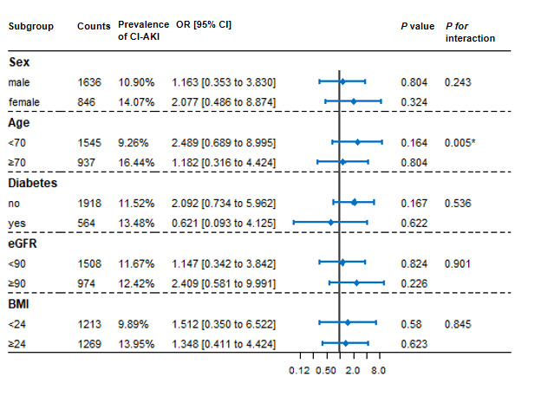
Figure S4. Subgroup analysis between FT4 and CI-AKI according to gender (male/female), age (<70/≥70 years), diabetes (with/without), eGFR (<90/≥90 ml/min/1.73m²) and BMI (<24/≥24kg/m²). Multivariable logistic regression analysis was conducted. The interaction P value (P for interaction) between PSTH and each subgroup was calculated through the likelihood ratio test. eGFR, estimated glomerular filtration rate; BMI, body mass index. Other abbreviations refer to Fig. 1. *P<0.05

Table S1. Multivariable linear regression models on Scr elevation
 | FT3/FT4 |  |  | FT3 |  |  | FT4
 | Coefficient β | P value |  | Coefficient β | P value |  | Coefficient β | P value
Thyroid hormone | -3.201 [-5.951 to -0.451] | 0.023* |  | -4.122 [-7.366 to -0.879] | 0.013* |  | 2.409 [-6.382 to 11.200] | 0.591
Age, per 10 years | 5.327 [-59.124 to 68.779] | 0.871 |  | 5.870 [-58.563 to 70.303] | 0.858 |  | 5.993 [-58.528 to 70.514] | 0.856
Male | 0.281 [-2.427 to 2.989] | 0.839 |  | 0.092 [-2.600 to 2.784] | 0.947 |  | -0.012 [-2.719 to 2.695] | 0.993
Diabetes | 0.854 [-2.137 to 3.844] | 0.576 |  | 0.788 [-2.204 to 3.781] | 0.606 |  | 1.245 [-1.728 to 4.219] | 0.412
Average SBP, mmHg | 2.399 [-18.619 to 23.417] | 0.823 |  | 1.940 [-19.069 to 22.948] | 0.856 |  | 1.714 [-19.065 to 23.015] | 0.854
eGFR, ml/min/1.73 m² | 2.111 [0.902 to 3.321] | 0.001* |  | 2.081 [0.874 to 3.288] | 0.001* |  | 2.009 [0.800 to 3.217] | 0.001*
Ejection fraction, % | -1.660 [-5.153 to 1.832] | 0.352 |  | -1.989 [-5.466 to 1.488] | 0.262 |  | -1.917 [-5.425 to 1.591] | 0.284
Hemoglobin, g/L | -8.200 [-11.790 to -4.610] | <0.001* |  | -7.987 [-11.584 to -4.390] | <0.001* |  | -8.339 [-11.934 to -4.745] | <0.001*
C-reactive protein, mg/L | 8.071 [4.562 to 11.579] | <0.001* |  | 8.087 [4.593 to 11.581] | <0.001* |  | 8.810 [5.357 to 12.263] | <0.001*
Volume of contrast agent, mg | -1.622 [-5.109 to 1.864] | 0.362 |  | -1.817 [-5.309 to 1.676] | 0.308 |  | -1.465 [-4.948 to 2.035] | 0.414
Isotonic agent (vs. hypotonic) | -2.093 [-4.804 to 0.618] | 0.130 |  | -2.149 [-4.860 to 0.563] | 0.121 |  | -2.240 [-4.742 to 0.684] | 0.143
CI indicates confidence interval; other abbreviations refer to Table. 1. *P<0.05

Table S2. Multivariable linear regression models on Scr elevation (with additional adjustment for premedication)
 | FT3/FT4 |  |  | FT3 |  |  | FT4
 | Coefficient β | P value |  | Coefficient β | P value |  | Coefficient β | P value
Thyroid hormone | -3.061 [-5.791 to -0.331] | 0.028* |  | -4.346 [-7.569 to -1.124] | 0.008* |  | 1.068 [-7.684 to 9.819] | 0.811
Age, per 10 years | 12.995 [-51.019 to 77.010] | 0.691 |  | 13.541 [-50.438 to 77.521] | 0.678 |  | 13.788 [-50.295 to 77.871] | 0.673
Male | 0.716 [-1.977 to 3.409] | 0.602 |  | 0.552 [-2.125 to 3.229] | 0.686 |  | 0.396 [-2.296 to 3.088] | 0.773
Diabetes | 1.546 [-1.432 to 4.524] | 0.309 |  | 1.441 [-1.538 to 4.420] | 0.343 |  | 1.935 [-1.026 to 4.896] | 0.200
Average SBP, mmHg | -0.551 [-21.432 to 20.330] | 0.959 |  | -1.023 [-21.889 to 19.843] | 0.923 |  | -1.032 [-21.935 to 19.870] | 0.923
eGFR, ml/min/1.73m² | 1.882 [0.708 to 3.055] | 0.002* |  | 2.101 [0.897 to 3.304] | 0.001* |  | 2.005 [0.800 to 3.209] | 0.001*
Ejection fraction, % | -1.039 [-4.535 to 2.456] | 0.560 |  | -1.312 [-4.792 to 2.169] | 0.460 |  | -1.337 [-4.845 to 2.171] | 0.455
Hemoglobin, g/L | -7.898 [-11.463 to -4.332] | <0.001* |  | -7.654 [-11.226 to -4.082] | <0.001* |  | -8.015 [-11.585 to -4.445] | <0.001*
C-reactive protein, mg/L | 8.180 [4.697 to 11.663] | <0.001* |  | 8.121 [4.654 to 11.588] | <0.001* |  | 8.926 [5.498 to 12.354] | <0.001*
Volume of contrast agent, mg | -0.108 [-3.610 to 3.394] | 0.952 |  | -0.300 [-3.806 to 3.207] | 0.867 |  | 0.031 [-3.475 to 3.537] | 0.986
Isotonic agent (vs. hypotonic) | -1.717 [-4.414 to 0.980] | 0.212 |  | -1.783 [-4.479 to 0.914] | 0.195 |  | -1.654 [-4.353 to 1.045] | 0.230
statin | -11.897 [-15.679 to -8.116] | <0.001* |  | -12.101 [-15.882 to -8.321] | <0.001* |  | -11.947 [-15.737 to -8.156] | <0.001*
ACEI | -0.263 [-3.665 to 3.138] | 0.879 |  | -0.132 [-3.531 to 3.268] | 0.939 |  | -0.199 [-3.605 to 3.207] | 0.909
ARB | -0.479 [-3.165 to 2.208] | 0.727 |  | -0.290 [-2.978 to 2.398] | 0.833 |  | -0.478 [-3.172 to 2.215] | 0.728
CI indicates confidence interval; other abbreviations refer to Table. 1. *P<0.05

Table S3. Multivariable logistic regression models on CI-AKI
 | FT3/FT4 |  |  | FT3 |  |  | FT4
 | OR [95% CI] | P value |  | OR [95% CI] | P value |  | OR [95% CI] | P value
Thyroid hormone
Quintile 1 | 1 (reference) |  |  | 1 (reference) |  |  | 1 (reference)
Quintile 2 | 0.805[0.568 to 1.140] | 0.356 |  | 0.629[0.448 to 0.884] | 0.008* |  | 0.662[0.438 to 1.002] | 0.051
Quintile 3 | 0.613[0.388 to 0.968] | 0.016* |  | 0.564[0.387 to 0.821] | 0.003* |  | 0.754[0.488 to 1.165] | 0.204
Quintile 4 | 0.471[0.160 to 1.389] | 0.012* |  | 0.326[0.558 to 0.976] | 0.003* |  | 0.901[0.511 to 1.590] | 0.719
Age, per 10 years | 2.718 [0.000 to Inf] | 0.999 |  | 1.812 [0.000 to Inf] | 1.000 |  | 1.549 [0.000 to Inf] | 1.000
Male | 0.758 [0.572 to 1.004] | 0.054 |  | 0.738 [0.558 to 0.976] | 0.033* |  | 0.728 [0.550 to 0.965] | 0.027*
Diabetes | 1.138 [0.833 to 1.554] | 0.417 |  | 1.139 [0.835 to 1.555] | 0.411 |  | 1.195 [0.877 to 1.627] | 0.260
Average SBP | 2.026 [0.227 to 18.093] | 0.528 |  | 1.866 [0.204 to 17.051] | 0.580 |  | 1.687 [0.190 to 14.980] | 0.639
eGFR | 1.242 [1.087 to 1.419] | 0.001* |  | 1.244 [1.089 to 1.421] | 0.001* |  | 1.219 [1.067 to 1.392] | 0.004*
Ejection fraction | 0.911 [0.649 to 1.280] | 0.592 |  | 0.862 [0.615 to 1.207] | 0.387 |  | 0.881 [0.627 to 1.236] | 0.463
Hemoglobin | 0.677 [0.482 to 0.952] | 0.025* |  | 0.708 [0.503 to 0.997] | 0.048* |  | 0.671 [0.478 to 0.943] | 0.021*
C-reactive protein | 2.041 [1.479 to 2.815] | <0.001* |  | 1.993 [1.444 to 2.751] | <0.001* |  | 2.230 [1.623 to 3.063] | <0.001*
Volume of contrast agent | 0.661 [0.443 to 0.987] | 0.043* |  | 0.651 [0.435 to 0.973] | 0.036* |  | 0.911 [0.679 to 1.221] | 0.533
Isotonic agent (vs. hypotonic) | 0.736 [0.548 to 0.989] | 0.042* |  | 0.734 [0.546 to 0.986] | 0.040* |  | 0.742 [0.553 to 0.995] | 0.046*

CI indicates confidence interval; other abbreviations refer to Table. 1. *P<0.05

Table S4. Multivariable logistic regression models on CI-AKI (with additional adjustment for premedication)
 | FT3/FT4 |  |  | FT3 |  |  | FT4
 | OR [95% CI] | P value |  | OR [95% CI] | P value |  | OR [95% CI] | P value
Thyroid hormone
Quintile 1 | 1 (reference) |  |  | 1 (reference) |  |  | 1 (reference)
Quintile 2 | 0.868[0.611 to 1.234] | 0.431 |  | 0.637[0.452 to 0.896] | 0.010* |  | 0.659[0.434 to 0.999] | 0.049*
Quintile 3 | 0.592[0.382 to 0.916] | 0.019* |  | 0.554[0.379 to 0.811] | 0.002* |  | 0.735[0.474 to 1.139] | 0.168
Quintile 4 | 0.265[0.091 to 0.770] | 0.015* |  | 0.341[0.170 to 0.681] | 0.002* |  | 0.854[0.482 to 1.513] | 0.588
Age, per 10 years | 3.328 [0.000 to Inf] | 0.999 |  | 2.650 [0.000 to Inf] | 0.999 |  | 2.242 [0.000 to Inf] | 0.999
Male | 0.771 [0.581 to 1.022] | 0.070* |  | 0.751 [0.567 to 0.994] | 0.046* |  | 0.743 [0.560 to 0.986] | 0.039*
Diabetes | 1.194 [0.870 to 1.638] | 0.272 |  | 1.194 [0.871 to 1.636] | 0.271 |  | 1.258 [0.920 to 1.721] | 0.151
Average SBP | 1.657 [0.184 to 14.893] | 0.652 |  | 1.524 [0.165 to 14.051] | 0.710 |  | 1.368 [0.153 to 12.232] | 0.779
eGFR | 1.250 [1.093 to 1.430] | 0.001* |  | 1.252 [1.095 to 1.432] | 0.001* |  | 1.224 [1.071 to 1.400] | 0.003*
Ejection fraction | 0.944 [0.670 to 1.331] | 0.742 |  | 0.898 [0.639 to 1.263] | 0.537 |  | 0.912 [0.647 to 1.285] | 0.599
Hemoglobin | 0.689 [0.489 to 0.969] | 0.032* |  | 0.723 [0.513 to 1.019] | 0.064 |  | 0.685 [0.487 to 0.963] | 0.030*
C-reactive protein | 2.075 [1.501 to 2.868] | <0.001* |  | 2.022 [1.462 to 2.795] | <0.001* |  | 2.262 [1.644 to 3.114] | <0.001*
Volume of contrast agent | 0.734 [0.488 to 1.104] | 0.137 |  | 0.725 [0.481 to 1.092] | 0.124 |  | 0.759 [0.505 to 1.141] | 0.184
Isotonic agent (vs. hypotonic) | 0.753 [0.559 to 1.013] | 0.061 |  | 0.747 [0.555 to 1.005] | 0.054 |  | 0.760 [0.566 to 1.022] | 0.069
statin | 0.474 [0.332 to 0.677] | <0.001* |  | 0.465 [0.326 to 0.665] | <0.001* |  | 0.474 [0.331 to 0.677] | <0.001*
ACEI | 1.070 [0.750 to 1.526] | 0.709 |  | 1.072 [0.751 to 1.532] | 0.702 |  | 1.092 [0.766 to 1.557] | 0.628
ARB | 1.001 [0.744 to 1.347] | 0.993 |  | 1.024 [0.761 to 1.379] | 0.875 |  | 0.993 [0.739 to 1.336] | 0.965

CI indicates confidence interval; other abbreviations refer to Table. 1. *P<0.05

