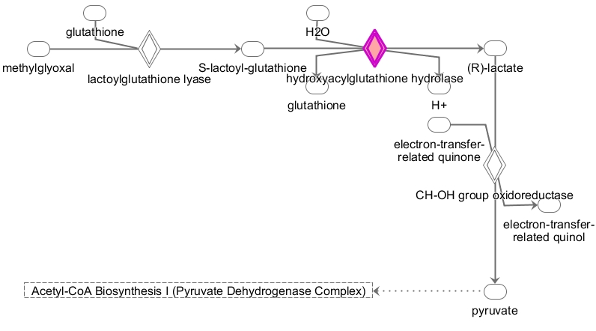
Supplementary Figure S1a. Figure showing pathway diagram of Methylglyoxal Degradation I pathway and found to be involved in early stage breast cancer with p-value= 9.84E-03.
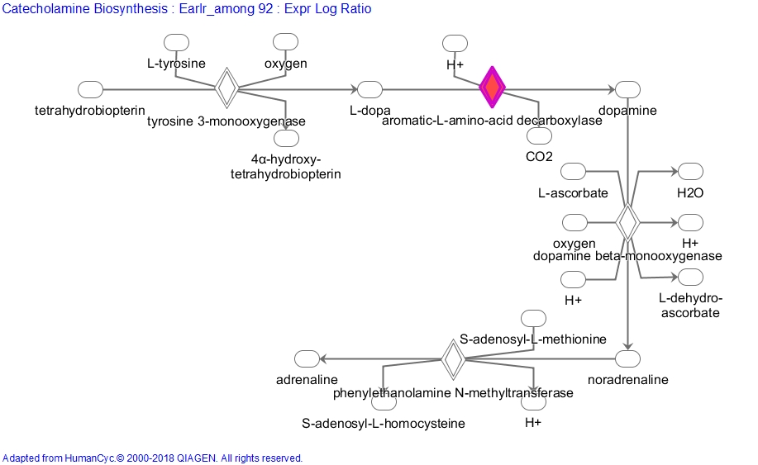

Supplementary Figure S1b. Figure showing pathway diagram of Catecholamine biosynthesis pathway and found to be involved in early stage breast cancer with p-value= 1.31E-02.

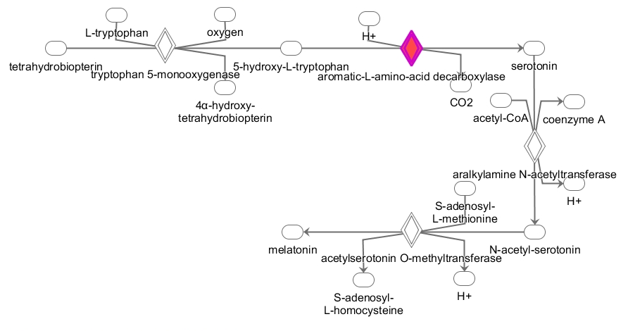
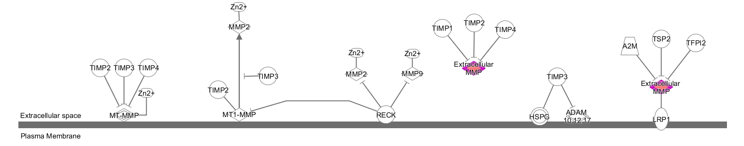

Supplementary Figure S1c. Figure showing pathway diagram of Serotonin and Melatonin biosynthesis pathway and found to be involved in early stage breast cancer with p-value= 1.96E-02.

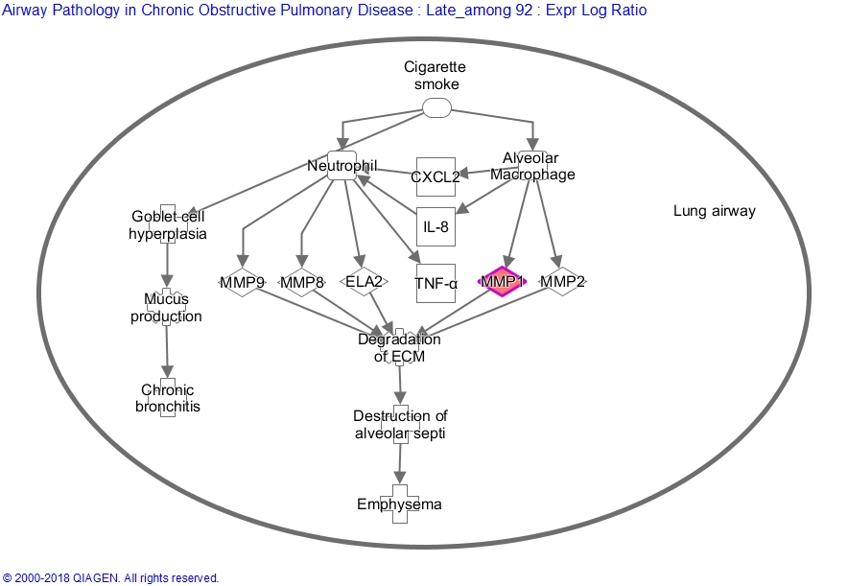
Supplementary Figure S1d. Figure showing pathway diagram of Airway pathology in COPD pathway and found to be involved in late stage breast cancer with p-value= 1.67E-02.

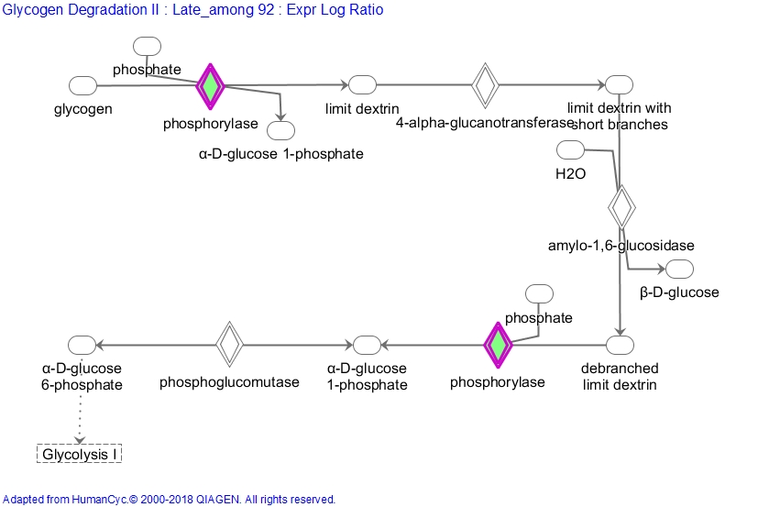

Supplementary Figure S1e. Figure showing pathway diagram of Glycogen degradation II pathway and found to be involved in late stage breast cancer with p-value= 2.7E-02.

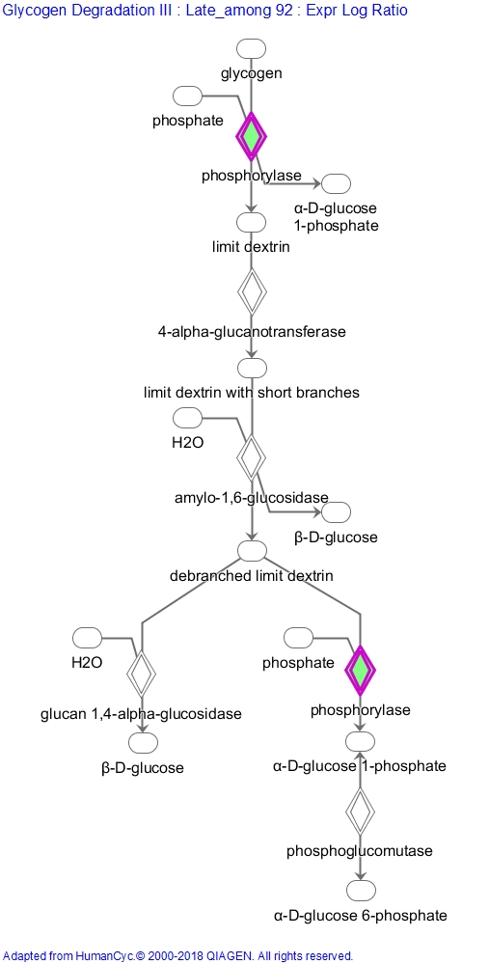
Supplementary Figure S1f. Figure showing pathway diagram of Glycogen degradation III pathway and found to be involved in late stage breast cancer with p-value= 3.11E-02.

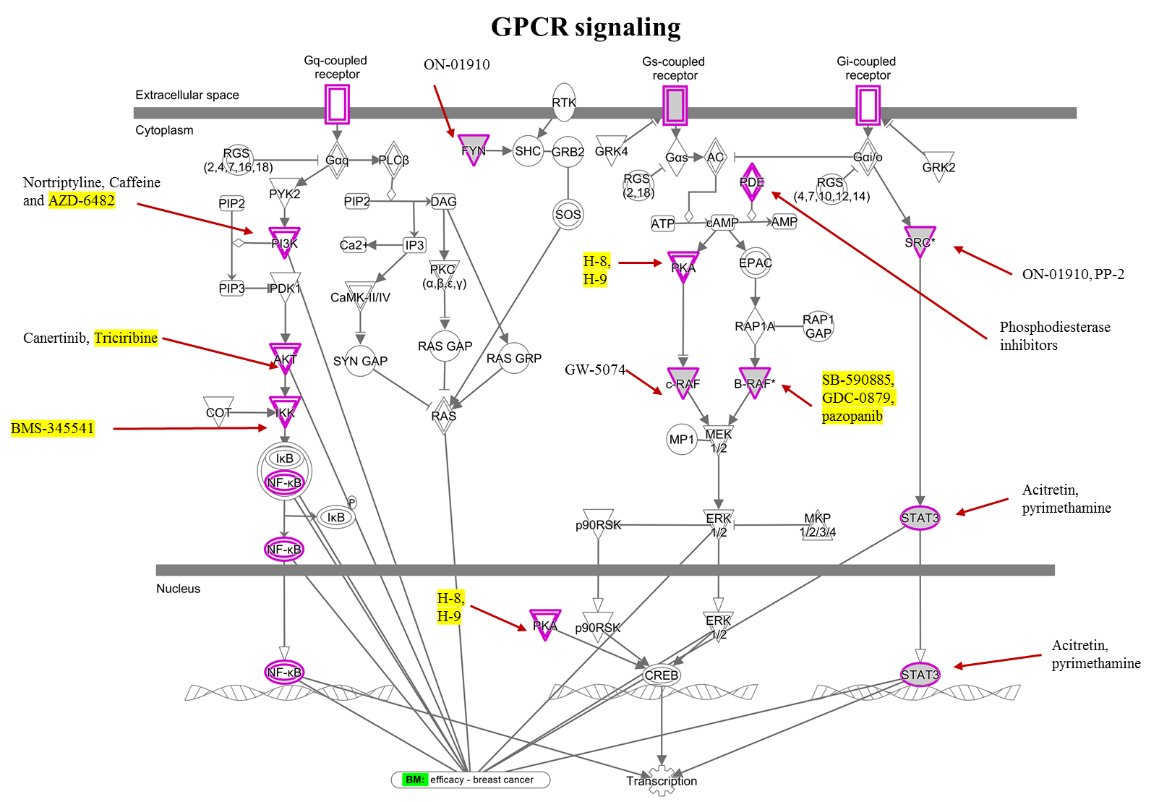
Supplementary Figure S2a. Figure showing pathway diagram of GPCR signalling pathway (-log(p-value)= 92.100) alongwith the drugs targeting the genes of the pathway.

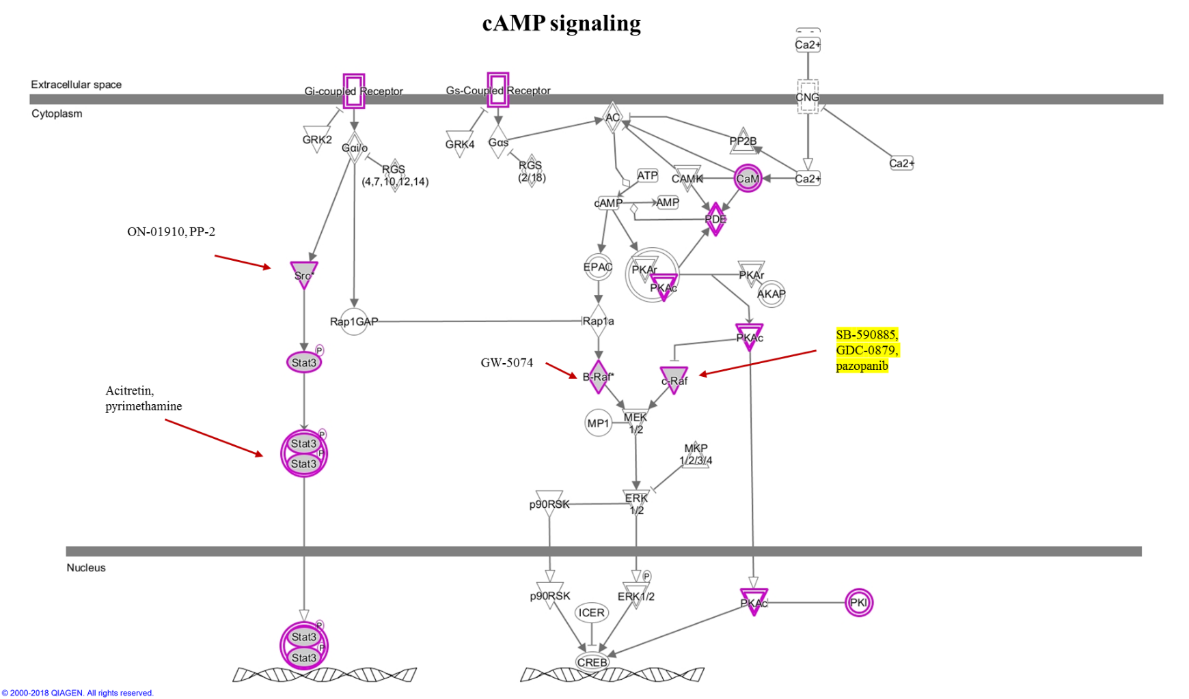

Supplementary Figure S2b. Figure showing pathway diagram of cAMP signalling pathway (-log(p-value)= 70.000) alongwith the drugs targeting the genes of the pathway.

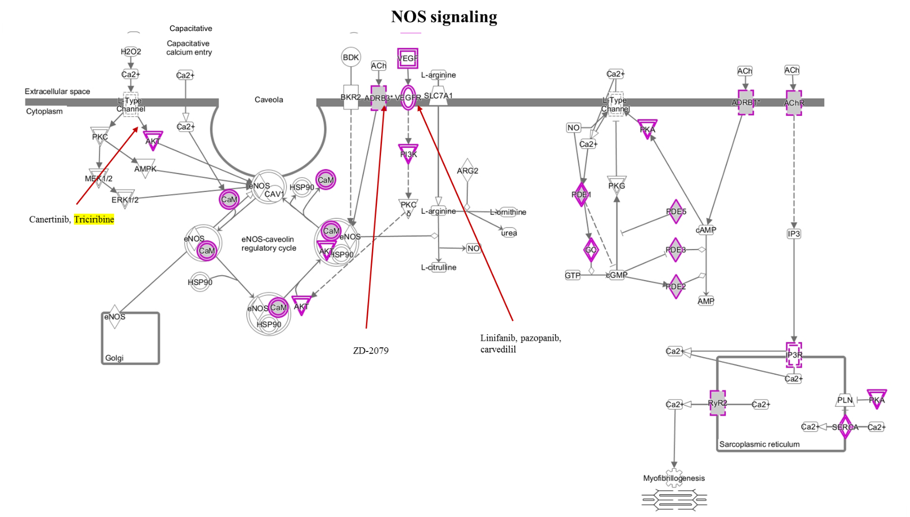
Supplementary Figure S2c. Figure showing pathway diagram of NOS signalling pathway (-log(p-value)= 29.000) alongwith the drugs targeting the genes of the pathway.

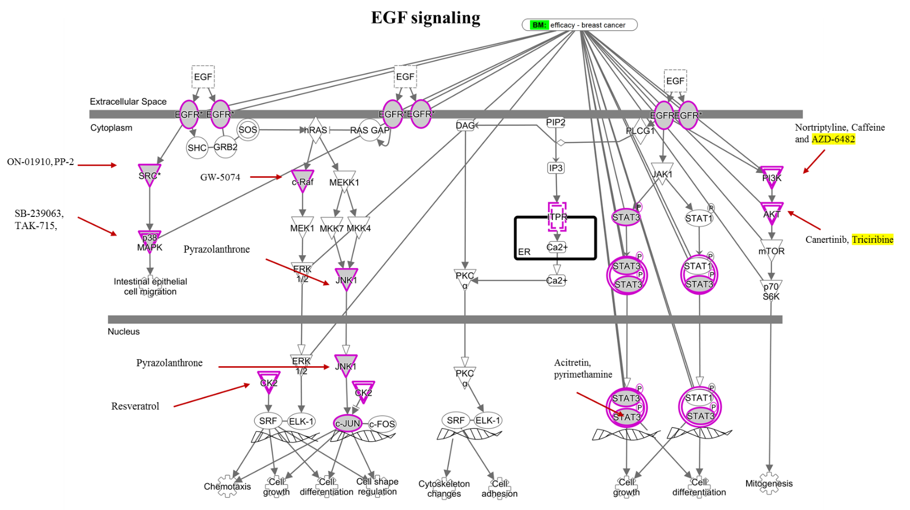
Supplementary Figure S2d. Figure showing pathway diagram of EGF signalling pathway (-log(p-value)= 22.5) alongwith the drugs targeting the genes of the pathway.

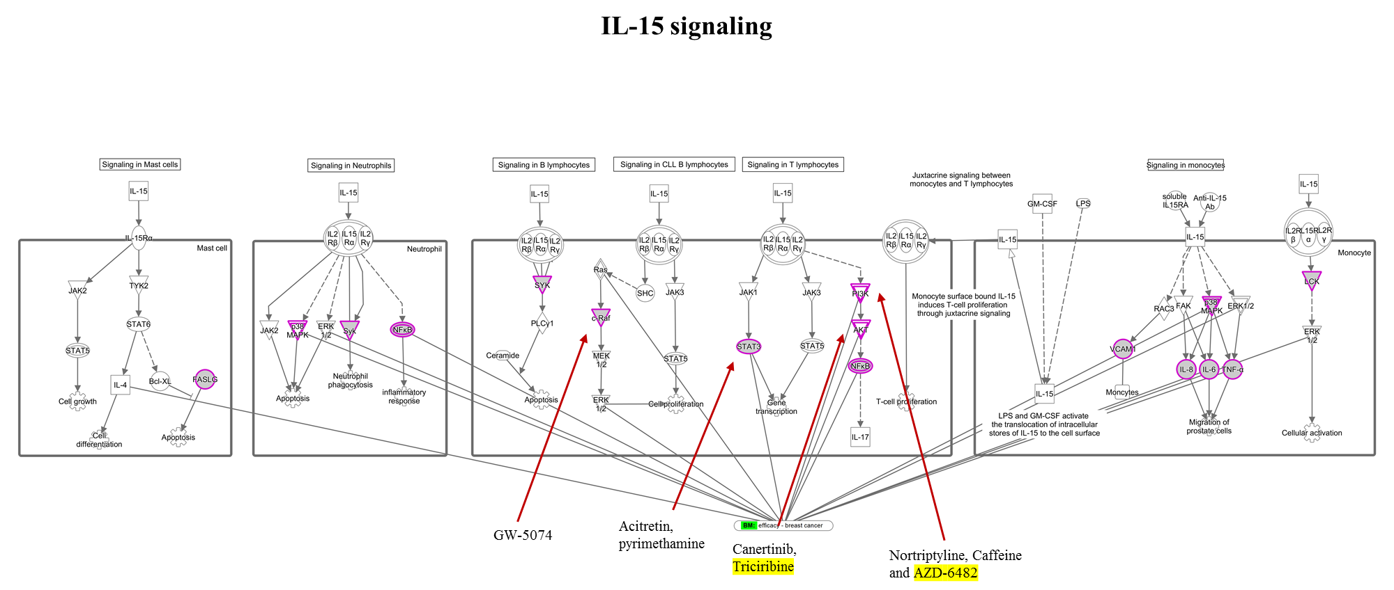
Supplementary Figure S2e. Figure showing pathway diagram of IL-15 signalling pathway (-log(p-value)= 21.200) alongwith the drugs targeting the genes of the pathway.

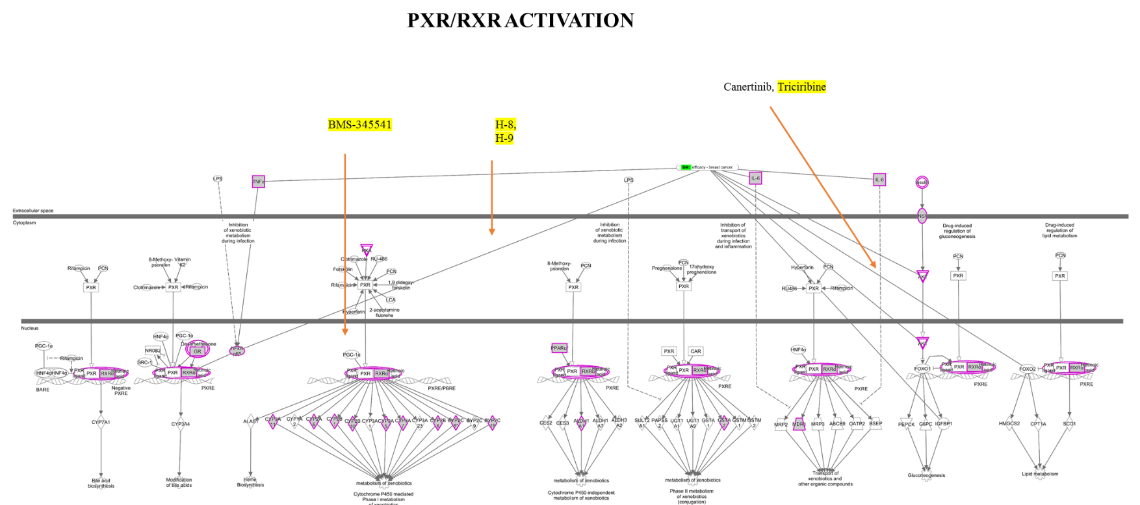

Supplementary Figure S2f. Figure showing pathway diagram of PXR/RXR activation pathway (-log(p-value)= 20.400) alongwith the drugs targeting the genes of the pathway.

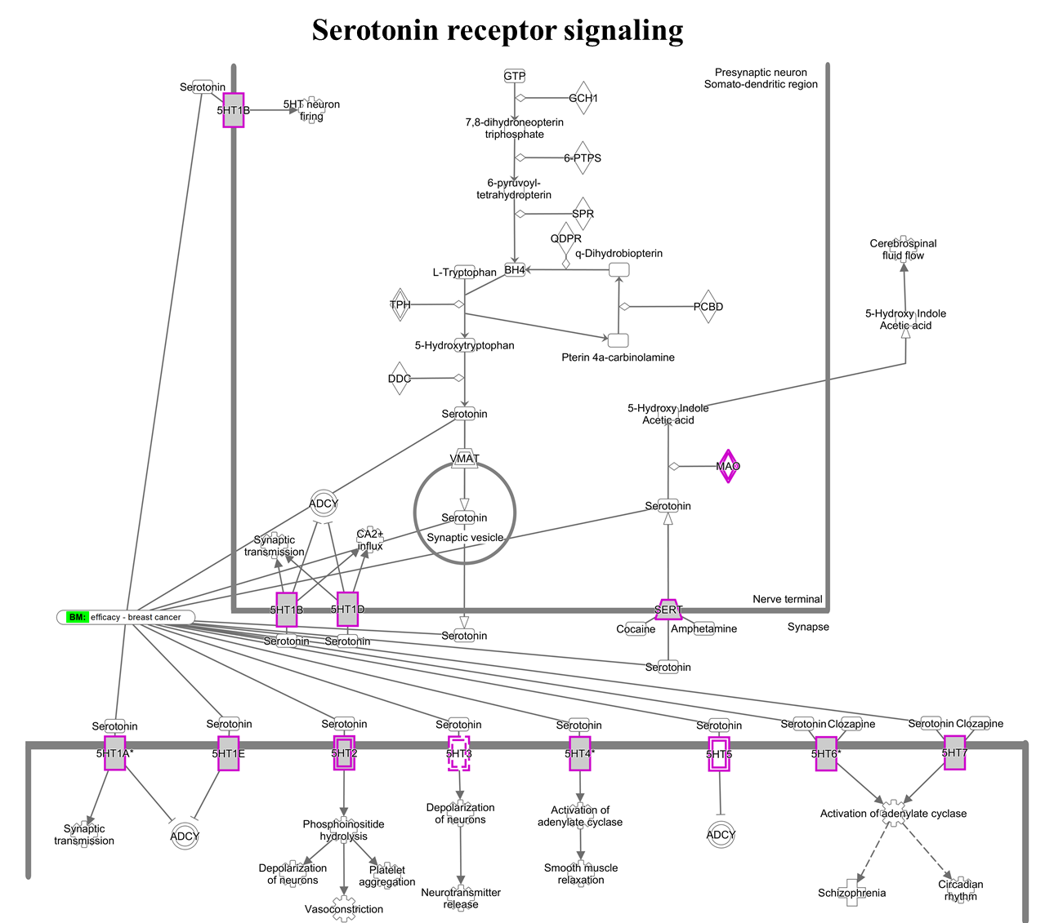
Supplementary Figure S2g. Figure showing pathway diagram of serotonin receptor signaling
(-log(p-value)= 16.800) alongwith the drugs targeting the genes of the pathway.

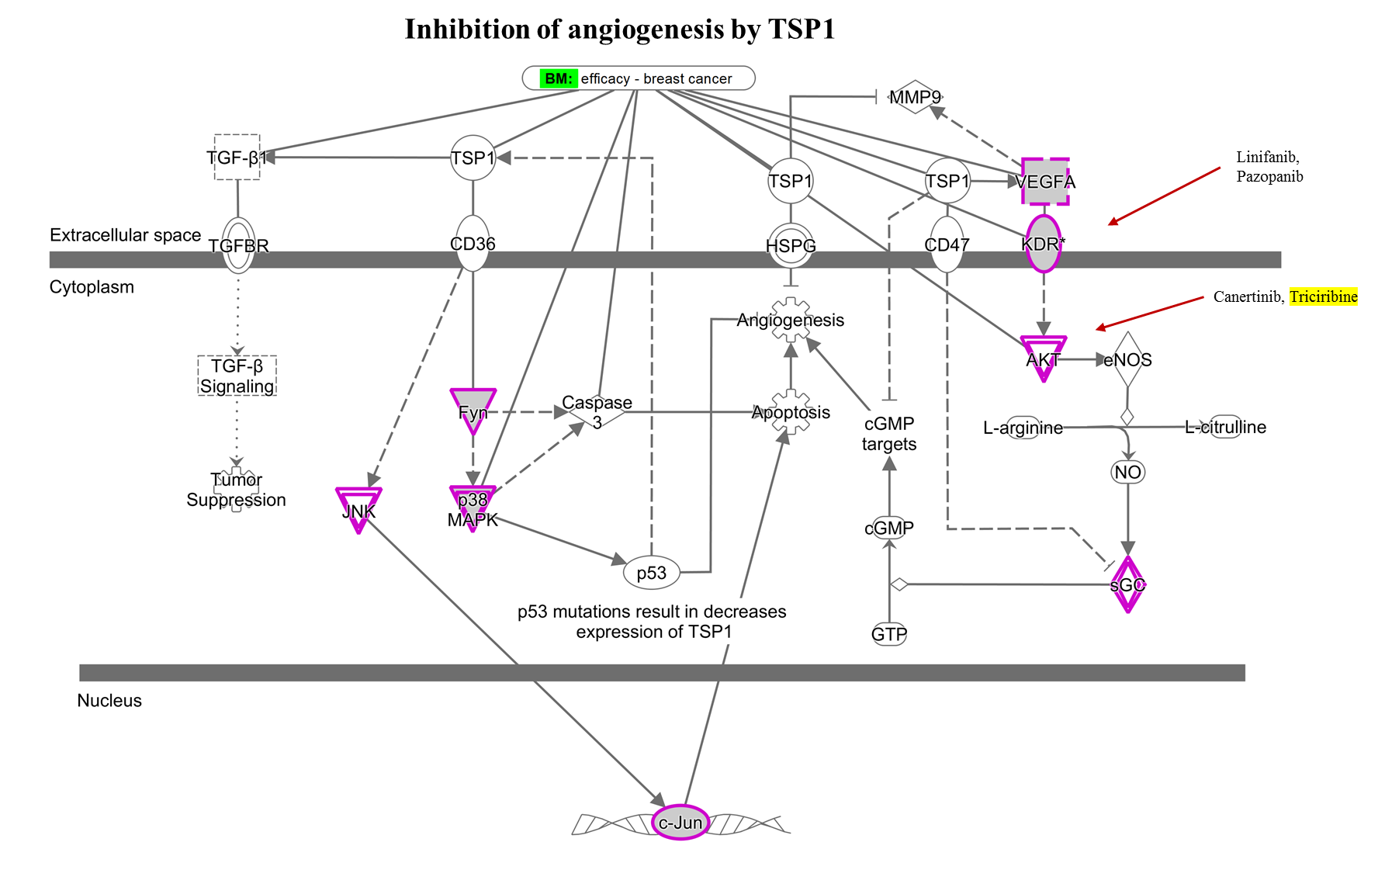
Supplementary Figure S2h. Figure showing pathway diagram of inhibition of angiogenesis by TSP1 (-log(p-value)= 14.100) alongwith the drugs targeting the genes of the pathway.

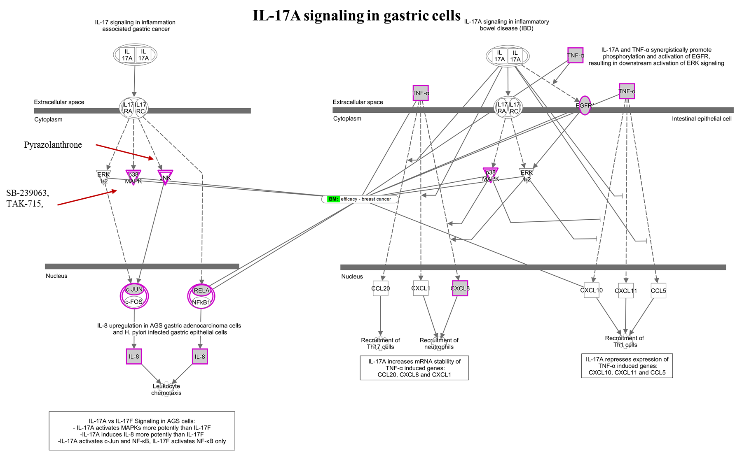
Supplementary Figure S2i. Figure showing pathway diagram of IL-17A signalling in gastric cells (-log(p-value)= 10.900) alongwith the drugs targeting the genes of the pathway.

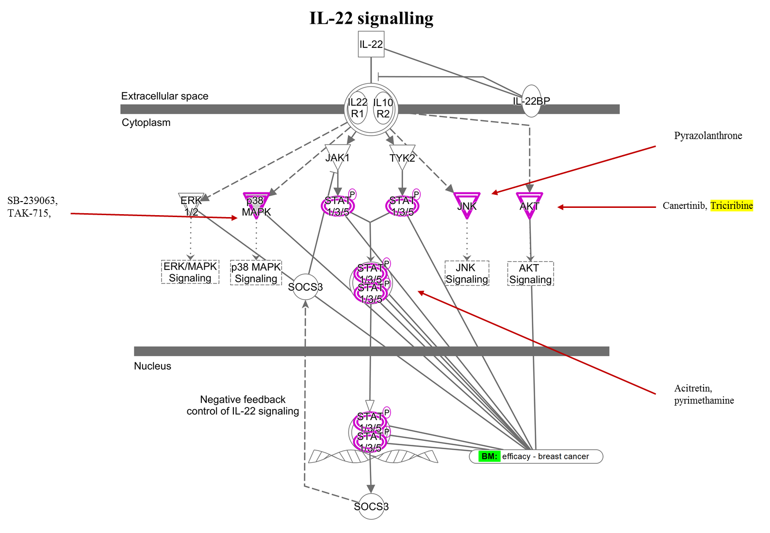
Supplementary Figure S2j. Figure showing pathway diagram of IL-22A signalling in gastric cells (-log(p-value)= 9.580) alongwith the drugs targeting the genes of the pathway.

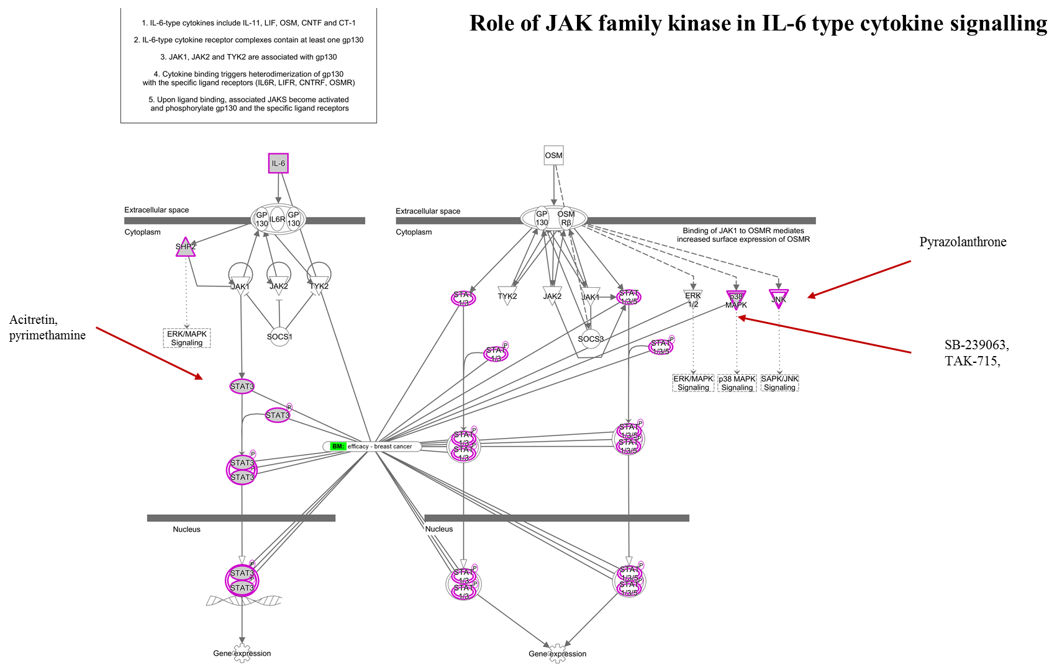
Supplementary Figure S2k. Figure showing pathway diagram of role of JAK family kinase in IL-6 type cytokine signlling (-log(p-value)= 7.940) alongwith the drugs targeting the genes of the pathway.

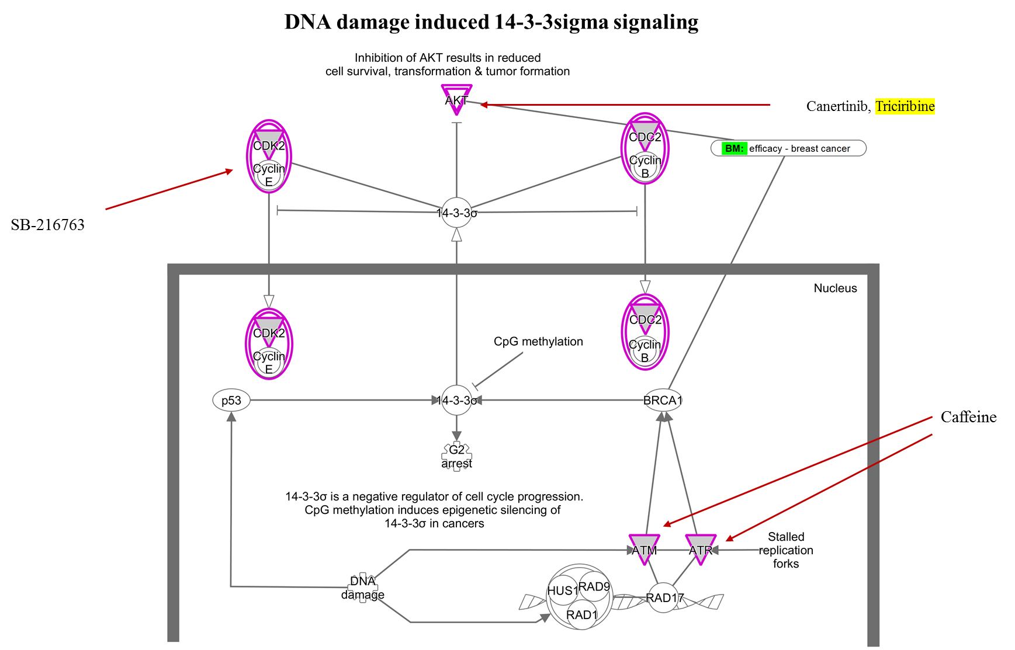
Supplementary Figure S2l. Figure showing pathway diagram of role of DNA damage induced 14-3-3 sigma signalling (-log(p-value)= 7.500) alongwith the drugs targeting the genes of the pathway.

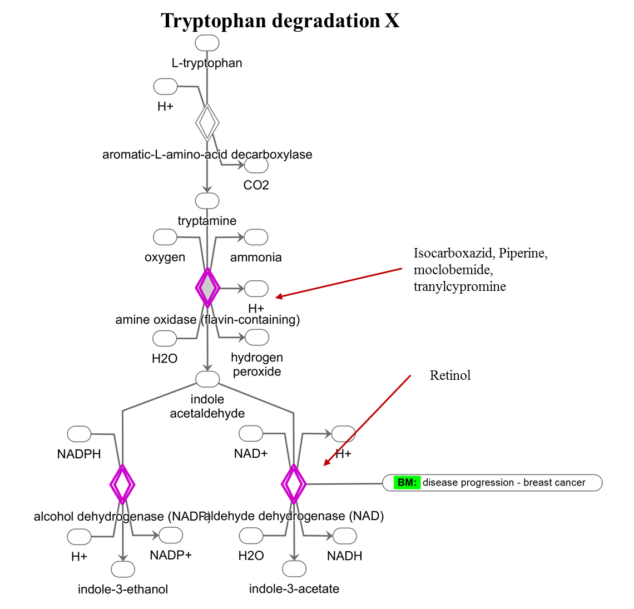
Supplementary Figure S2m. Figure showing pathway diagram of role of Tryptophan degradation X (-log(p-value)= 5.890) alongwith the drugs targeting the genes of the pathway.

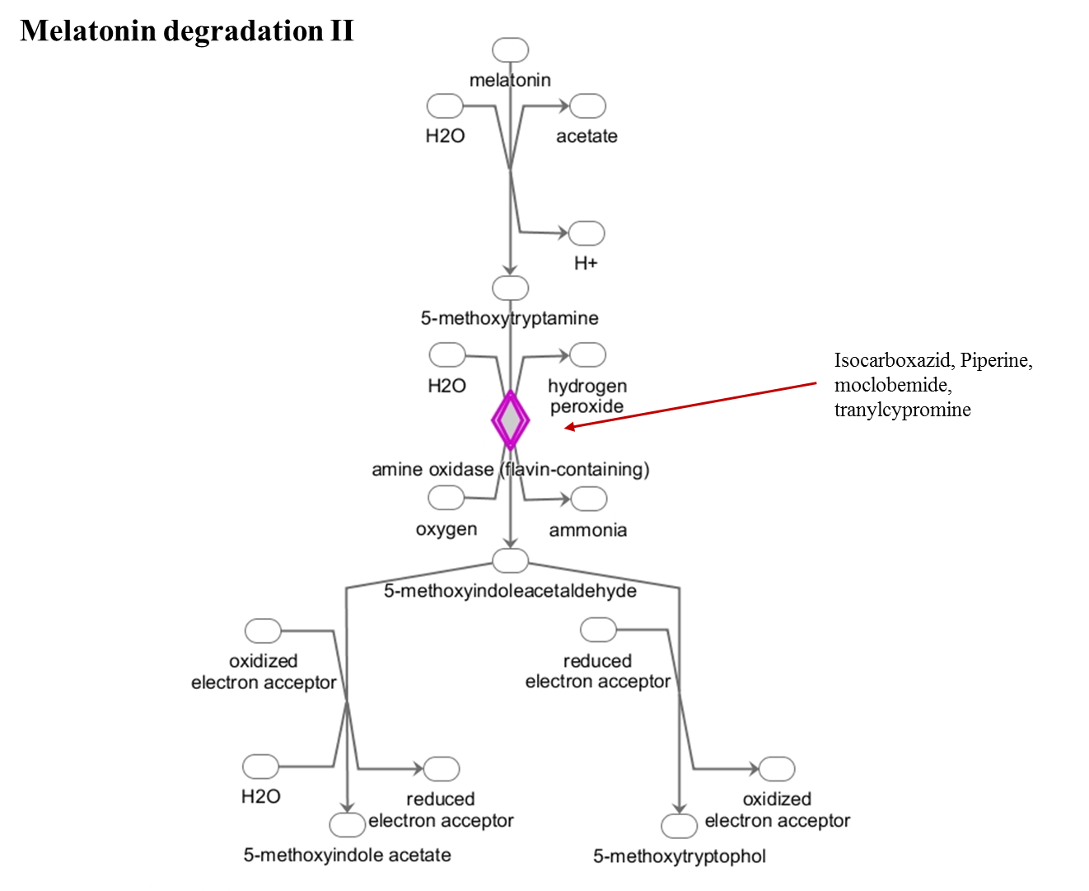

Supplementary Figure S2n. Figure showing pathway diagram of role of Melatonin degradation II (-log(p-value)= 2.690) alongwith the drugs targeting the genes of the pathway.

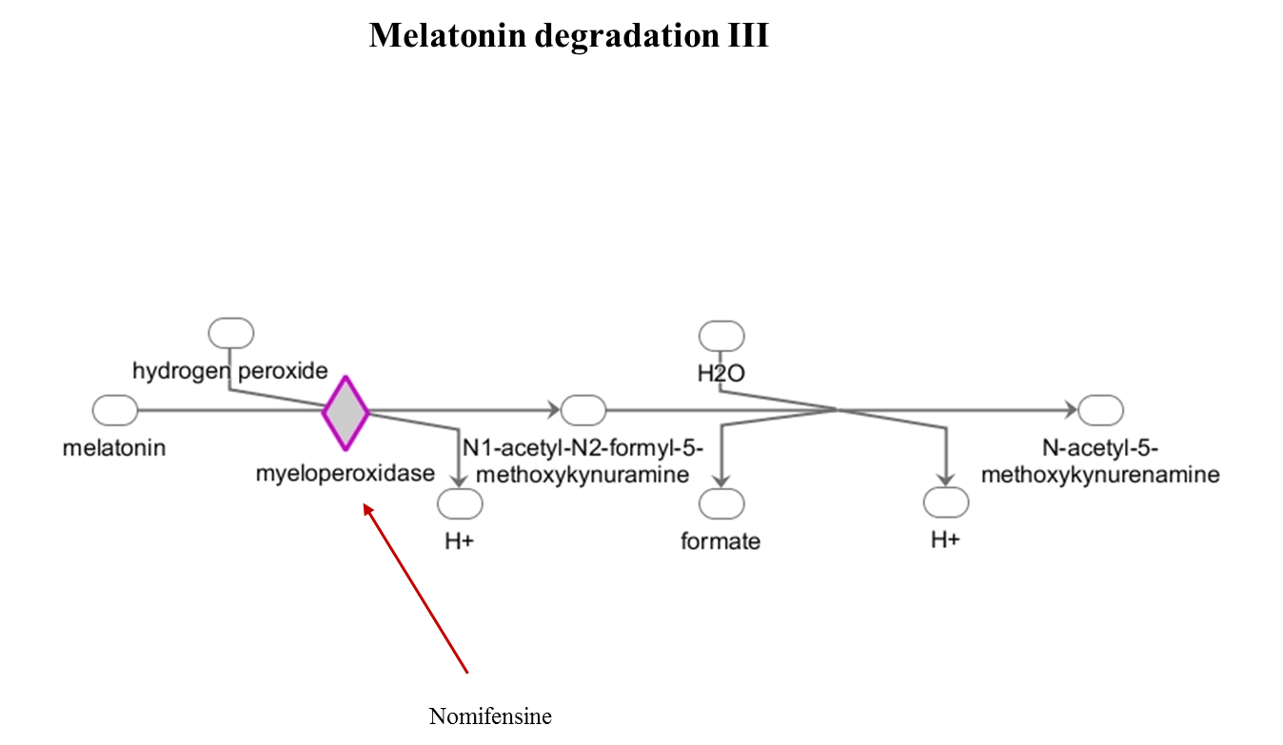
Supplementary Figure S2o. Figure showing pathway diagram of role of Melatonin degradation III (-log(p-value)= 1.730) alongwith the drugs targeting the genes of the pathway.

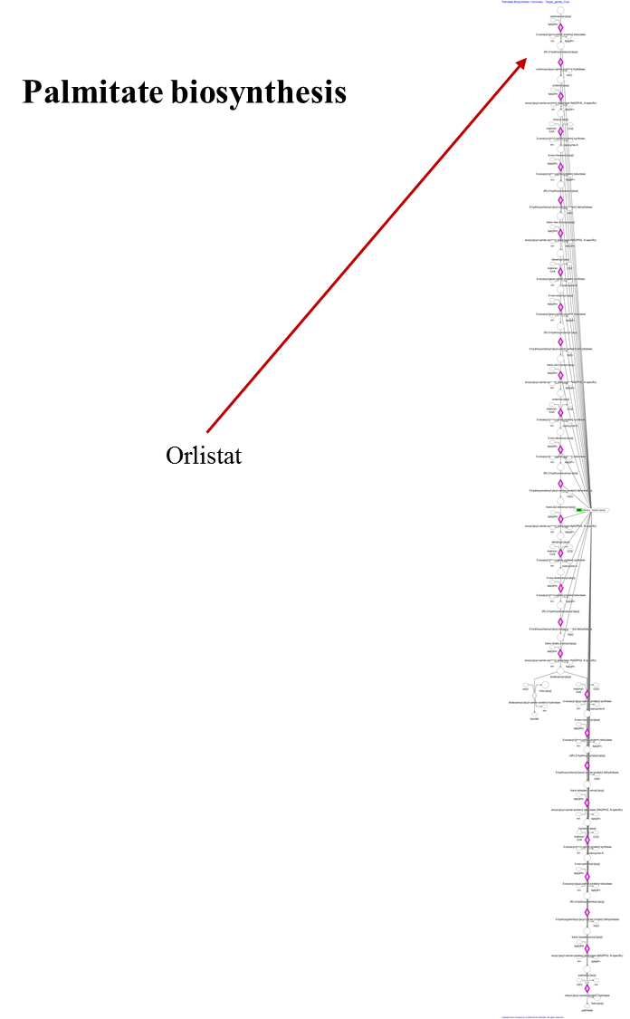
Supplementary Figure S2p. Figure showing pathway diagram of role of Palmitate biosynthesis (-log(p-value)= 1.430) alongwith the drugs targeting the genes of the pathway.

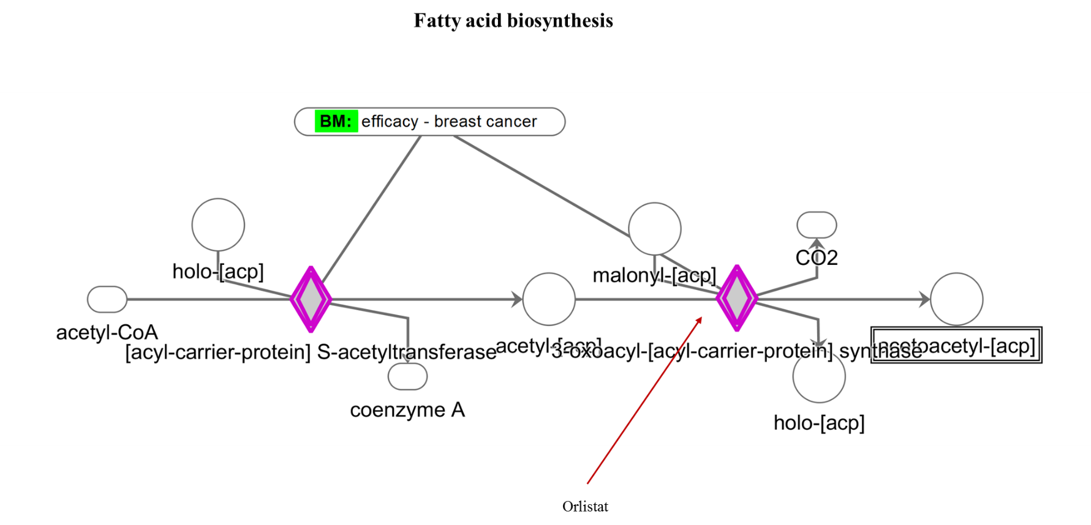
Supplementary Figure S2q. Figure showing pathway diagram of role of Fatty acid biosynthesis (-log(p-value)= 1.430) alongwith the drugs targeting the genes of the pathway.

