Supplemental Information for:

Biomass loss caused by selective logging elevates
topsoil water regime in tropical lowland rainforests

Table of Contents:
Fig. S1 | Page 1
Fig. S2 | Page 2
Fig. S3 | Page 3
Fig. S4 | Page 4
Fig. S5 | Page 5
Fig. S6 | Page 6
Table S1 | Page 7
Table S2 | Page 8

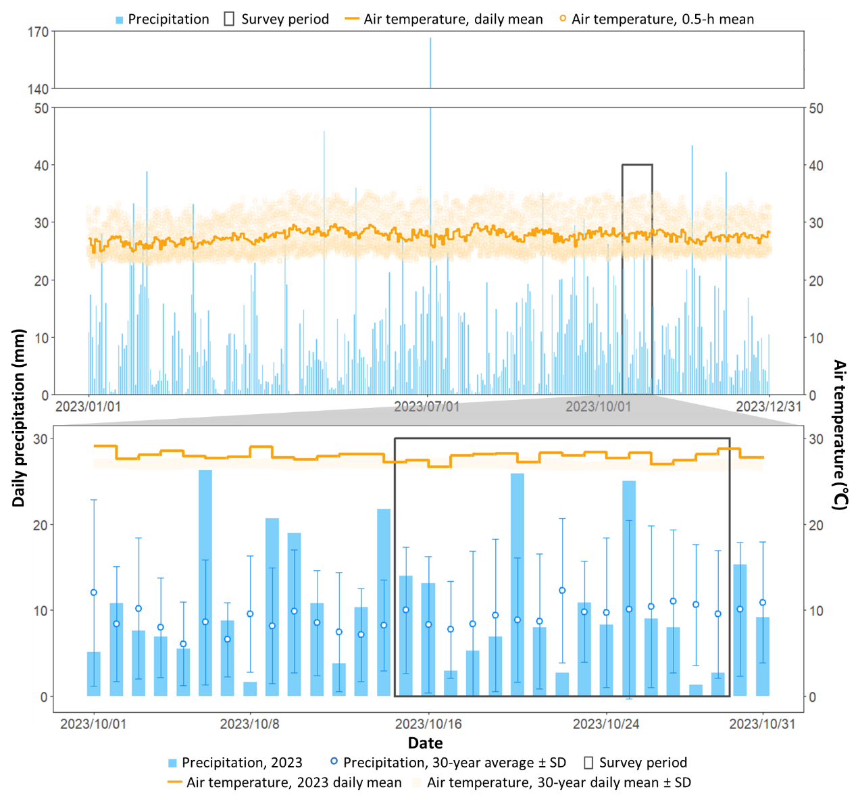
Fig. S1 ERA5T simulation of daily total precipitation (bars) and mean air temperature (solid line; 2 m above ground) basing on meteorological data monitored at Sandakan International Airport. The figure above shows annual precipitation and air temperature dynamics in year 2023; the figure below zooms to October 2023, and compared daily precipitation and mean air temperature with 30-year averages (1993 to 2023). The period of field survey is marked in grey.

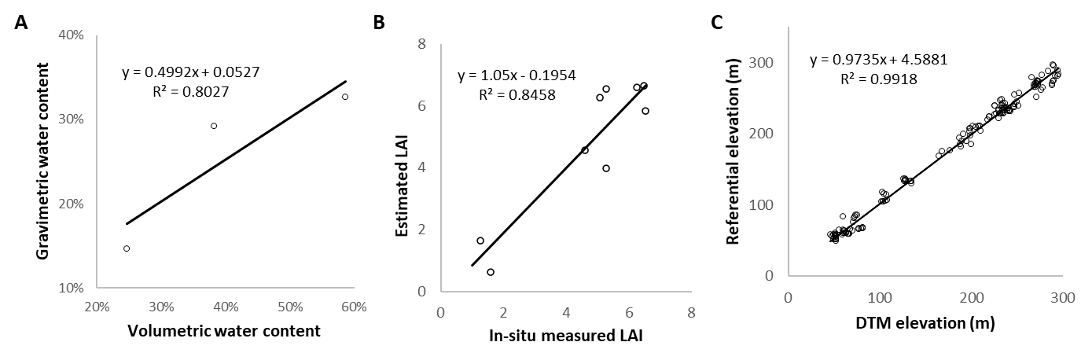
Fig. S2 (A) Comparing in-situ measurement with experimental measurement of soil moisture (n=3). Gravimetric water content was measured with air-dried soil samples collected at different sampling sites; (B) Validation of in-situ measurement with allometric-estimation of LAI (n=9). The estimation was basing on tree census data (e.g., diameter at breast height) collected in 2018 and 2019, following the allometries proposed by Yamakura et al. (1986) using tree census data from Aoyagi et al., 2017 and Sawada et al., 2022; (C) Accuracy assessment of DTM using elevation collected from a referential map provided by the Deramakot Forest Management Department at ground control points within the area of interest, i.e., transect belts (n=158). A simple linear regression was fitted to each plot.

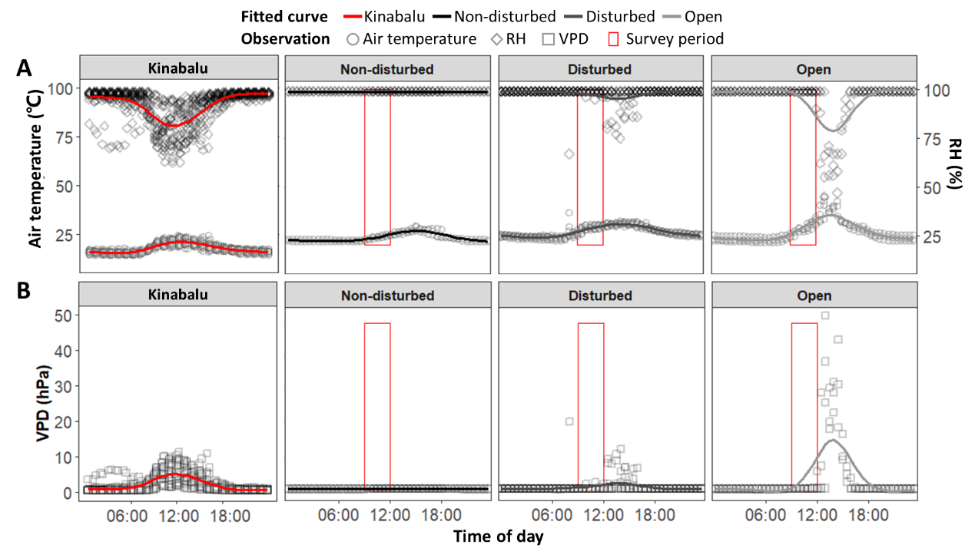
 | Non-disturbed | Disturbed | Open | Kinabalu
Measuring Period | 10/26 – 10/29 | 10/17 – 10/23 | 10/26 – 10/29 | 10/17 – 10/29
Air temperature_{mean} (℃) | 24.31 | 26.97 | 26.98 | 17.79
RH_{mean} (%) | 99.00 | 98.11 | 94.75 | 91.21
VPD_{max} (hPa) | 0.42 | 20.41 | 52.09 | 11.31
CHM_{mean} (m) | 39.10 | 13.90 | 3.85 | –
Gap rate (%) | 0 | 4.42 | 68.56 | –
Year of disturbance | – | 1991 | 1996 | –
ΔNBR | – | 0.28 | 0.46 | –
Fig. S3 (A) Air temperature (℃) and relative humidity (RH, %) measured at Mont. Kinabalu meteorological station (1560 m), non-disturbed site, disturbed canopy site, and open canopy site at Deramakot and Tangkulap Forest Reserves. Air temperature was measured every 0.5 h. Survey period was marked with red box (9 am to 12 pm). (B) VPD (vapor pressure deficit, hPa) measured at Mont. Kinabalu meteorological station (1560 m) and calculated for non-disturbed site, disturbed canopy site, and open canopy site at Deramakot and Tangkulap Forest Reserves. Canopy structural traits within a 20-m buffer and historical disturbances were summarized in the table below. VPD_{max} denotes the highest value over the entire measurement for each site.

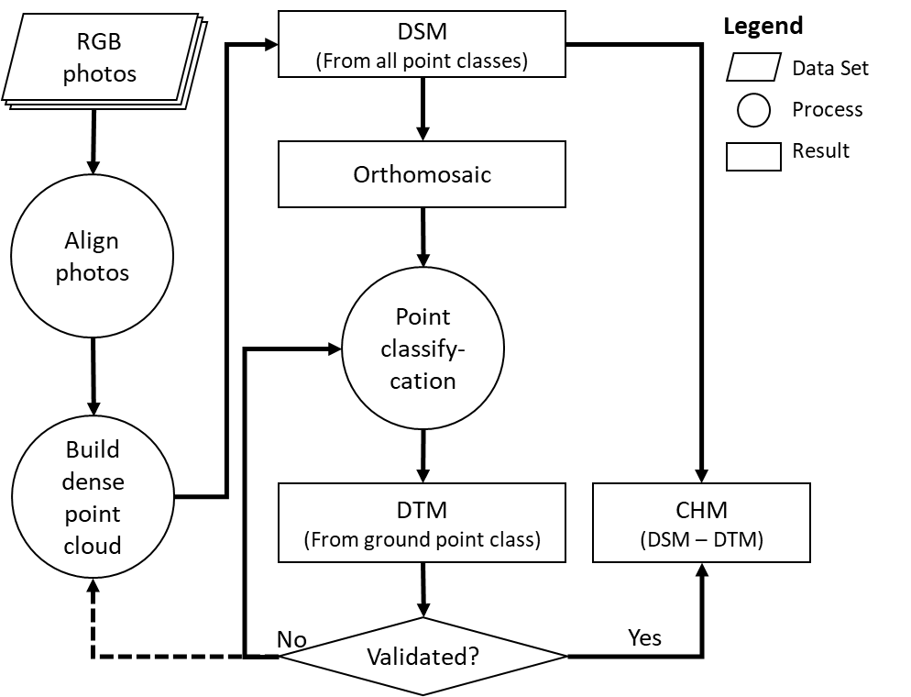
Fig. S4 Workflow for generating CHM from UAV imagery using Agisoft Metashape. During the validation process, elevation extracted from the DTM was compared to the referential elevation at ground control points. The predefined threshold of difference between the two was 10%.

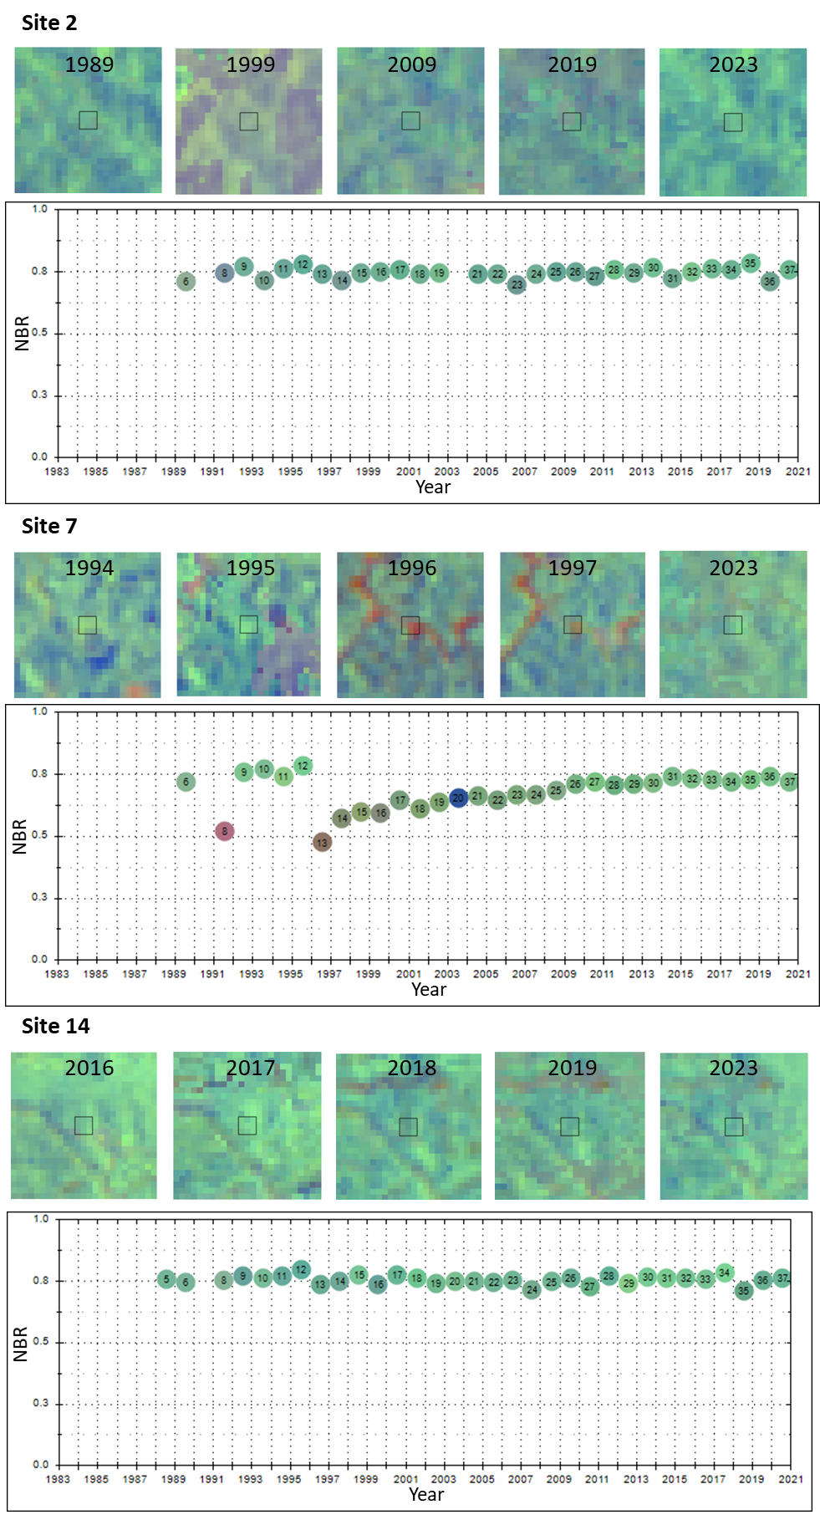
Fig. S5 Example of photointerpretation of logging events basing on NBR (normalized burn ratio) time series generated from Landsat annual mosaic imageries (1988 – 2023): (A) Site 2, non-disturbed forest, (B) Site 7, selective logging (conventional) detected in 1996, (C) Site 14, selective logging (reduced-impact logging) in 2018 confirmed by the forest manager and field observation. Satellite imageries showed annual NBR of the years pre and- post-disturbance as well as 2023. The centered square in each scene were 90×90 m², within which target transects located.
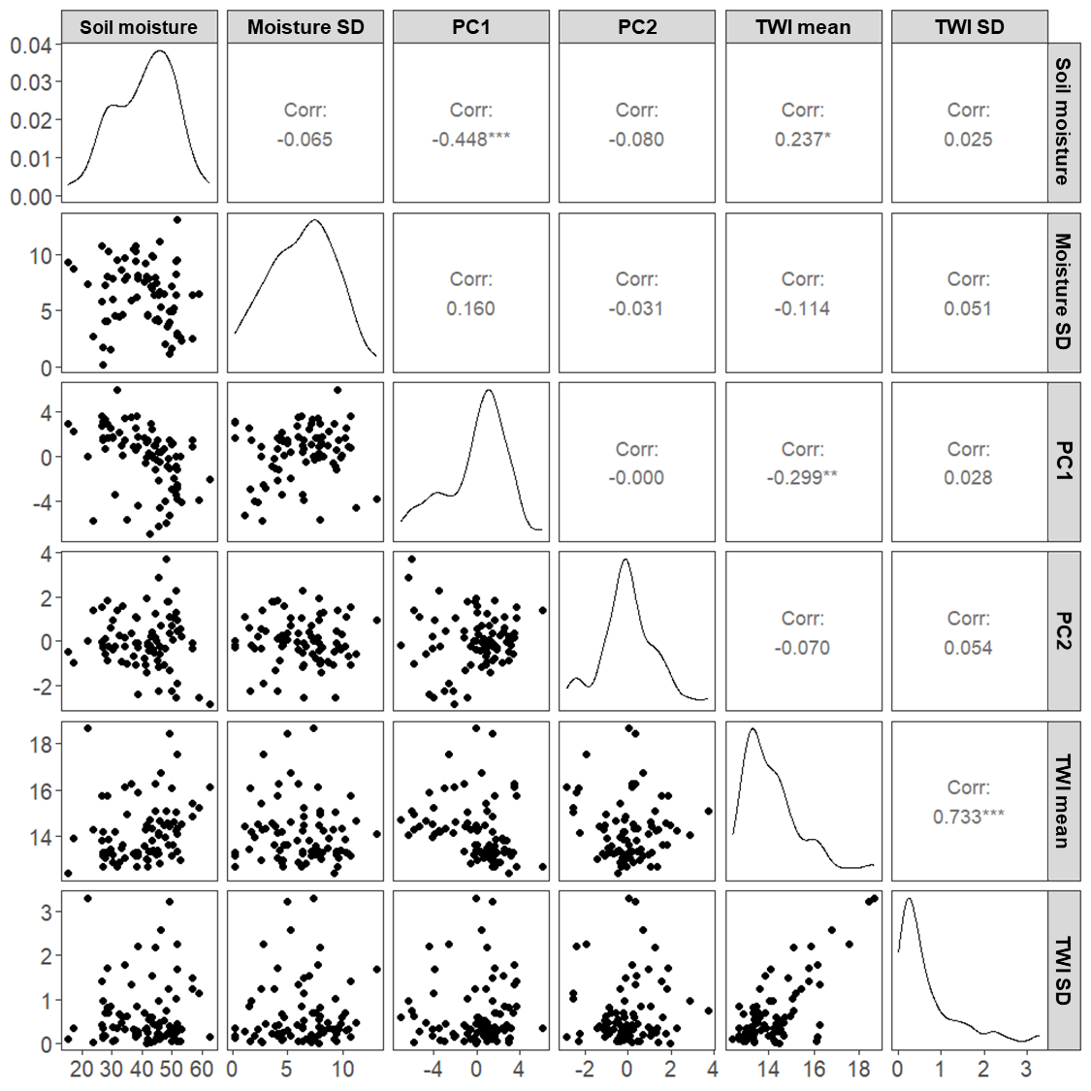
Fig. S6 Scatter plot matrix for the GAM dataset. The diagnose showed distribution density.

Table S1 Information of UAV survey, Landsat time series and LAI measurement at each site.
Site ID | Number of transects | UAV survey |  |  | Landsat time series ^{(a)} |  | LAI measurement
Site ID | Number of transects | Area (ha) | Date | Time | Disturbance year | ΔNBR | Total readings | Bad readings ^{(c)}
1 | 1 | 9.45 | 10/15 | 12:21 | – | – | 10 | 0
2 | 11 | 11.02 | 10/21 | 12:15 | – | – | 100 | 0
3 | 5 | 7.23 | 10/17 | 12:32 | 1995 | 0.40 | 40 | 15
4 | 6 | 6.84 | 10/19 | 12:06 | 1988 | 0.29 | 48 | 21
5 | 4 | 7.99 | 06/12 | 13:19 | 1996 | 0.17 | 32 | 2
6 | 5 | 7.74 | 06/13 | 13:59 | 1996 | 0.03 | 40 | 5
7 | 7 | 11.98 | 06/09 | 14:59 | 1996 | 0.05 | 56 | 1
8 | 4 | 10.44 | 06/07 | 12:56 | 1996 | 0.39 | 32 | 7
9 | 1 | 11.02 | 06/07 | 13:12 | 1996 | 0.38 | 8 | 7
10 | 6 | 8.24 | 06/13 | 13:30 | 1998 | 0.23 | 48 | 11
11 | 9 | 9.18 | 10/24 | 11:04 | 2018 | 0.12 | 72 | 0
12 | 6 | 3.82 | 10/22 | 11:27 | 2017 | 0.18 | 48 | 10
13 | 7 | 8.26 | 10/24 | 11:26 | 2018 | 0.02 | 56 | 0
14 | 5 | 12.89 | 10/28 | 11:56 | 2018 | 0.11 | 40 | 0
15 | 7 | 10.75 | 10/28 | 10:51 | 2022 | – ^{(b)} | 56 | 4

^{(a)} Data listed here represents the most recent and significant disturbance detected at one of the transects within a certain site. Not every transects of this site were disturbed or under the same disturbance intensity.
^{(b)} We ignored ΔNBR at this site as only 1 value of post-disturbance NBR (year 2023) could be used for calculation, which may give erroneous results.
^{(c)} In paired readings, those with below-canopy brightness greater than the above-canopy brightness are bad readings. These readings were removed when calculating LAI.

Table S2 Dataset used for fitting semivariogram models. Dist.: distance; #: number of pared observations.
All sites |  | Non-disturbed canopy |  | Open canopy |  | Disturbed canopy
Dist. (m) | # | Dist. (m) | # | Dist. (m) | # | Dist. (m) | #
5.2 | 480 | 6.8 | 42 | 6.3 | 73 | 5.4 | 309
15.2 | 1290 | 16.8 | 108 | 16.3 | 162 | 15.4 | 810
25.2 | 1624 | 26.8 | 156 | 26.3 | 194 | 25.4 | 1092
35.2 | 1672 | 36.8 | 132 | 36.3 | 224 | 35.4 | 1141
45.2 | 1422 | 46.8 | 119 | 46.3 | 177 | 45.4 | 974
55.2 | 1264 | 56.8 | 80 | 56.3 | 146 | 55.4 | 823
65.2 | 1044 | 66.8 | 54 | 66.3 | 119 | 65.4 | 618
75.2 | 894 | 76.8 | 51 | 76.3 | 82 | 75.4 | 520
85.2 | 780 | 86.8 | 54 | 86.3 | 52 | 85.4 | 454
95.2 | 718 | 96.8 | 63 | 96.3 | 35 | 95.4 | 387
105.2 | 668 | 106.8 | 48 | 106.3 | 18 | 105.4 | 342
115.2 | 588 | 116.8 | 41 | 112.3 | 56 | 115.4 | 305
125.2 | 430 | 126.8 | 46 |  |  | 125.4 | 240
135.2 | 342 | 136.8 | 46 |  |  | 135.4 | 209
141.2 | 640 | 142.8 | 68 |  |  | 141.4 | 418

