SUPPORTING INFORMATION
Title: Multigram-scale Synthesis of Volasertib, an Inhibitor of Polo-like Kinases in Clinical Evaluation
Author(s): Kang Wang, Dong Zhao, Mingli Jin, Yuan Li, Lei Sun, Yanli Zhu, Chen Wang, Shuang Liª, Yu Wang, Qianying Miao, Xiao Chen, Yanfang Zhao*, Yunlei Hou*

¹H NMR, ¹³C NMR and HPLC Spectra

Table of contents
¹H Spectra of 3-Methoxy-4-nitro-N-(4-oxocyclohexyl)benzamide (W-3) 2
¹H Spectra of N-[trans-4-[4-(Cyclopropylmethyl)-1-piperazinyl]cyclohexyl]-3-methoxy-4-nitrobenzamide (W-4) 2
¹H Spectra of 4-amino-N-{4-[4-(cyclopropylmethyl)piperazin-1-yl]cyclohexyl}-3-methoxybenzamide (W-5) 3
¹H Spectra of (2R)-2-aminobutanoate hydrochloride (W-7) 3
¹H Spectra of Methyl (2R)-2-[(2-chloro-5-nitro-4-pyrimidinyl)(1-methylethyl)amino]butanoate (W-9) 4
¹H Spectra of (7R)-2-Chloro-7-ethyl-7,8-dihydro-8-(1-methylethyl)-6(5H)-pteridinone (W-10) 4
¹H Spectra of (7R)-2-Chloro-7-ethyl-7,8-dihydro-5-methyl-8-(1-methylethyl)-6(5H)-pteridinone (W-11) 5
¹H Spectra of (Volasertib) 5
¹³C NMR and Infrared Spectra of (Volasertib) 6
HPLC Spectra of Volasertib 7

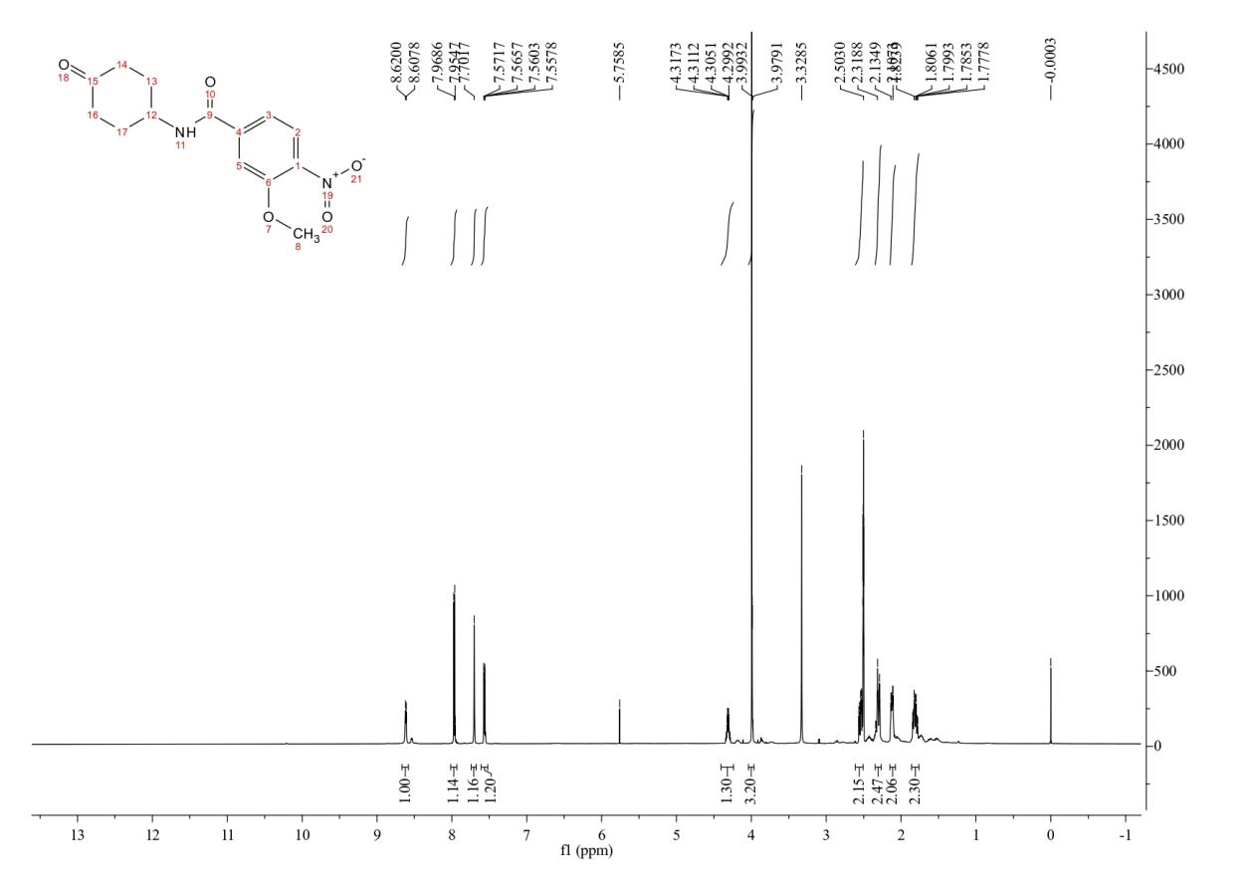
Fig. S1 ¹H NMR Spectra of 3-Methoxy-4-nitro-N-(4-oxocyclohexyl)benzamide (W-3) 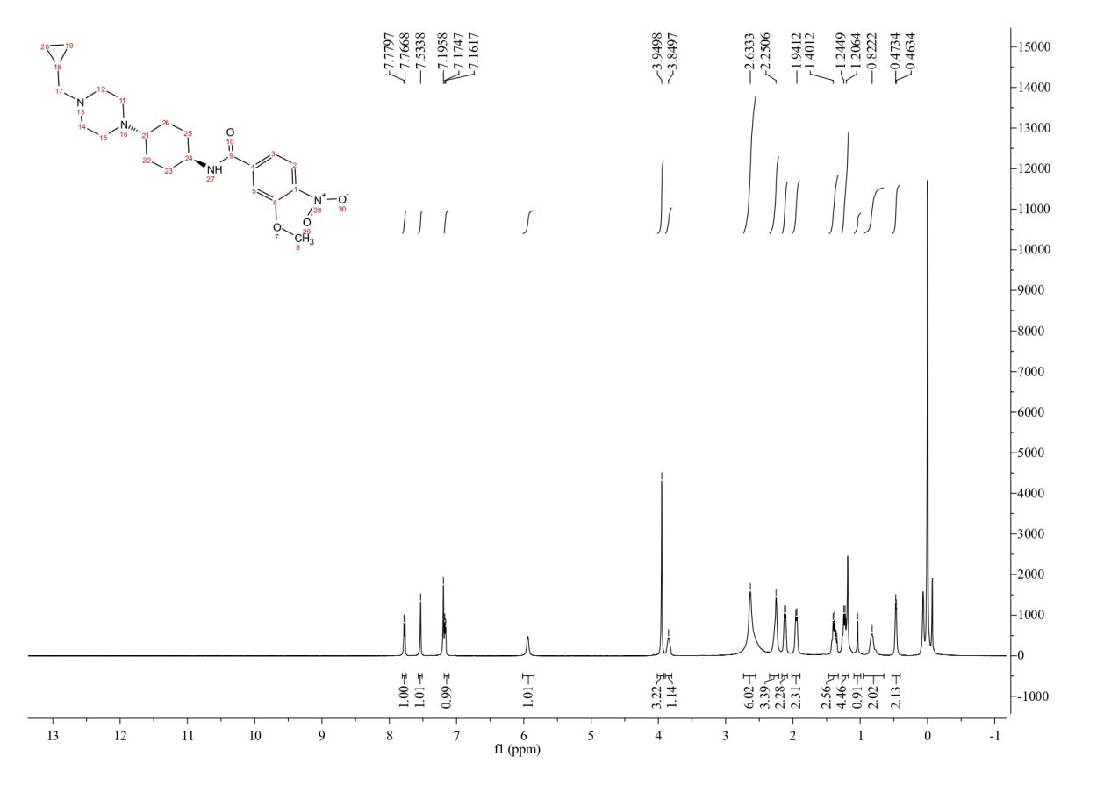
Fig. S2 ¹H NMR Spectra of N-[trans-4-[4-(Cyclopropylmethyl)-1-piperazinyl]cyclohexyl]-3-methoxy-4-nitrobenzamide (W-4)
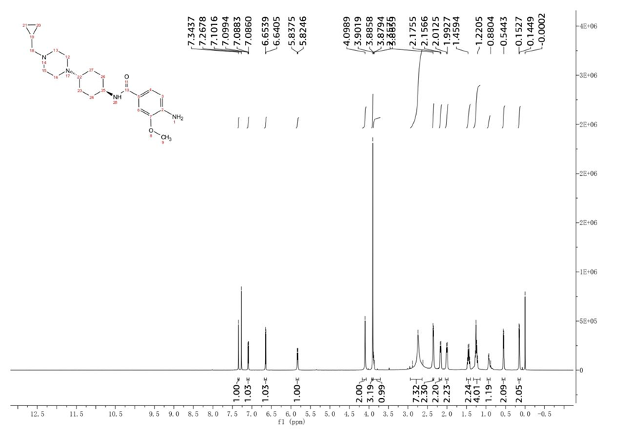
Fig. S3 ¹H Spectra of 4-amino-N-{4-[4-(cyclopropylmethyl)piperazin-1-yl]cyclohexyl}-3-methoxybenzamide (W-5) 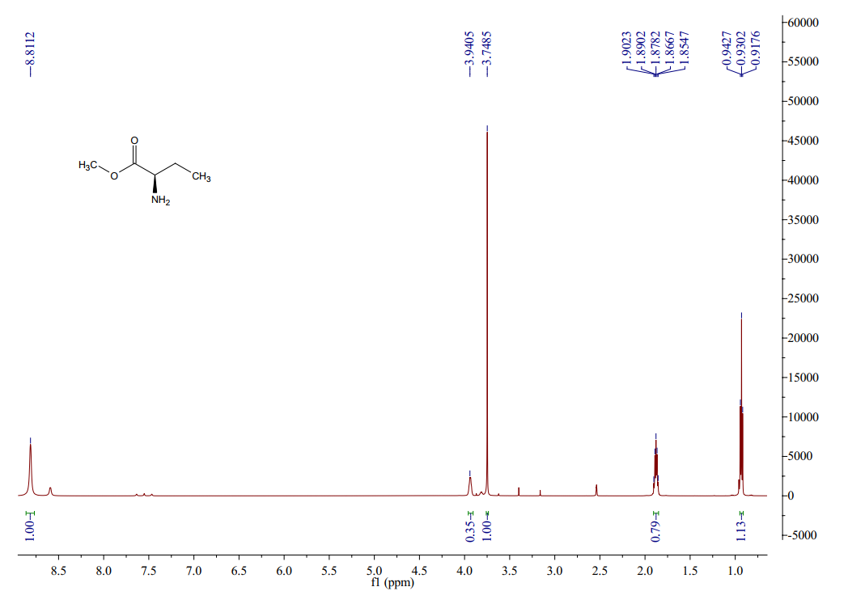Fig. S4 ¹H Spectra of (2R)-2-aminobutanoate hydrochloride (W-7)

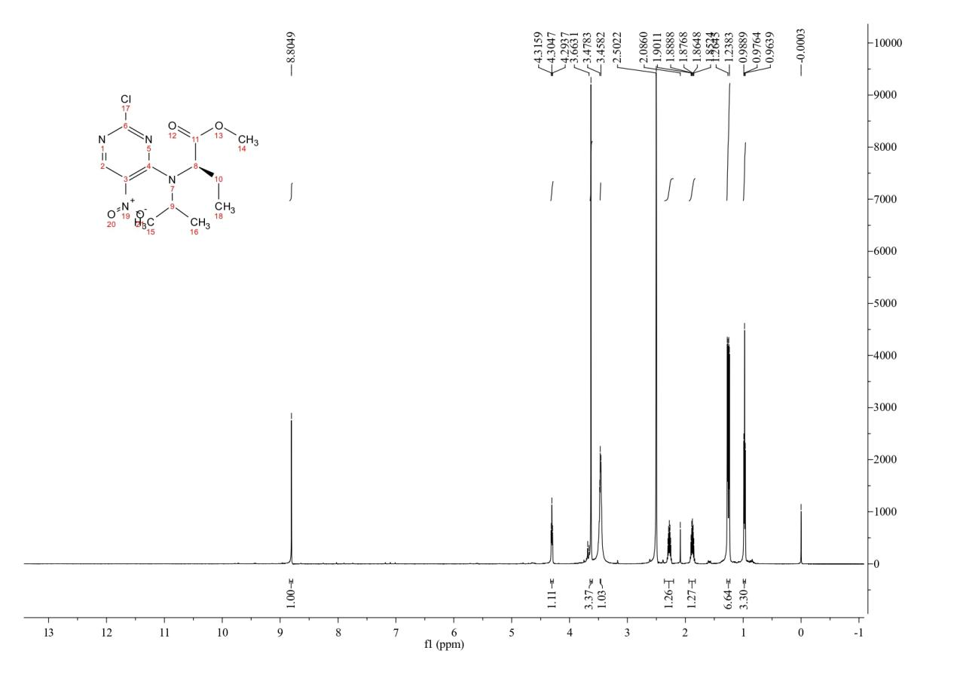Fig. S5 ¹H Spectra of Methyl (2R)-2-[(2-chloro-5-nitro-4-pyrimidinyl)(1-methylethyl)amino]butanoate (W-9)
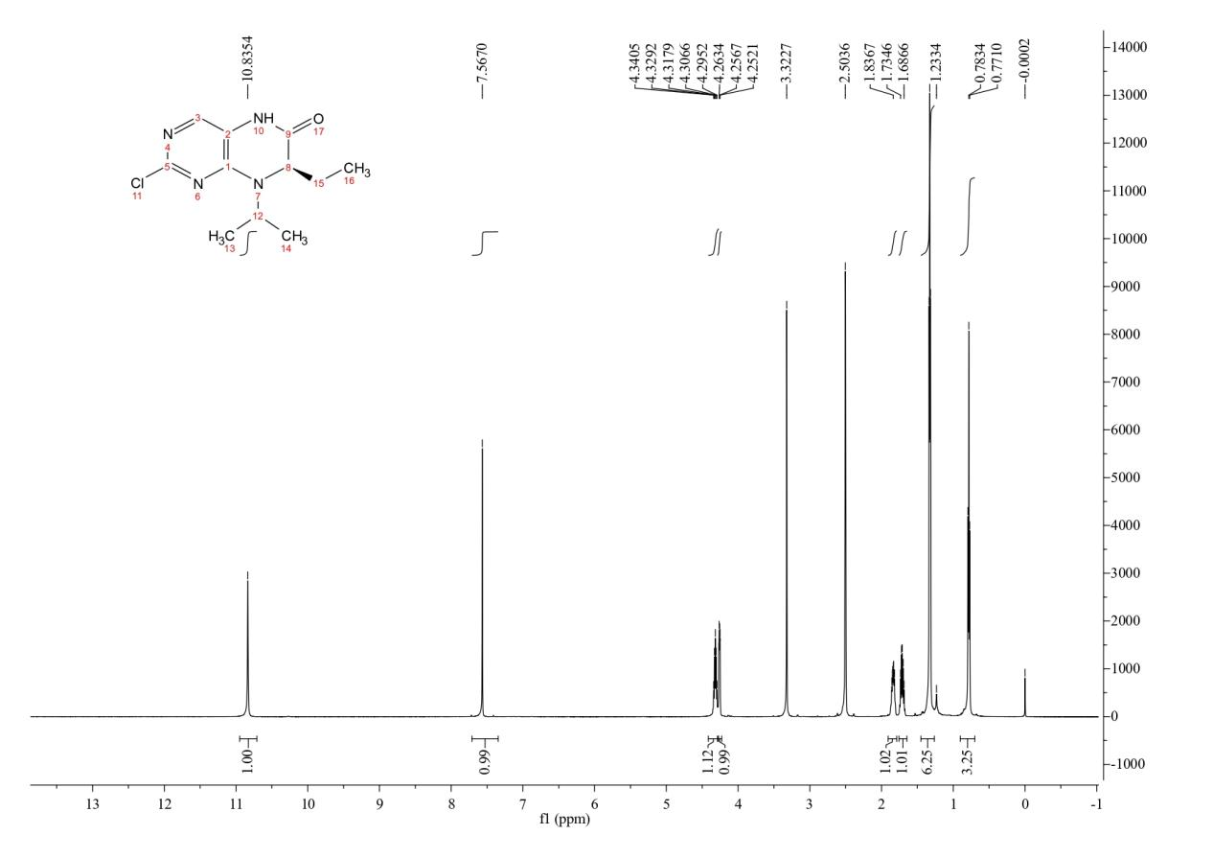Fig. S6 ¹H Spectra of (7R)-2-Chloro-7-ethyl-7,8-dihydro-8-(1-methylethyl)-6(5H)-pteridinone (W-10)
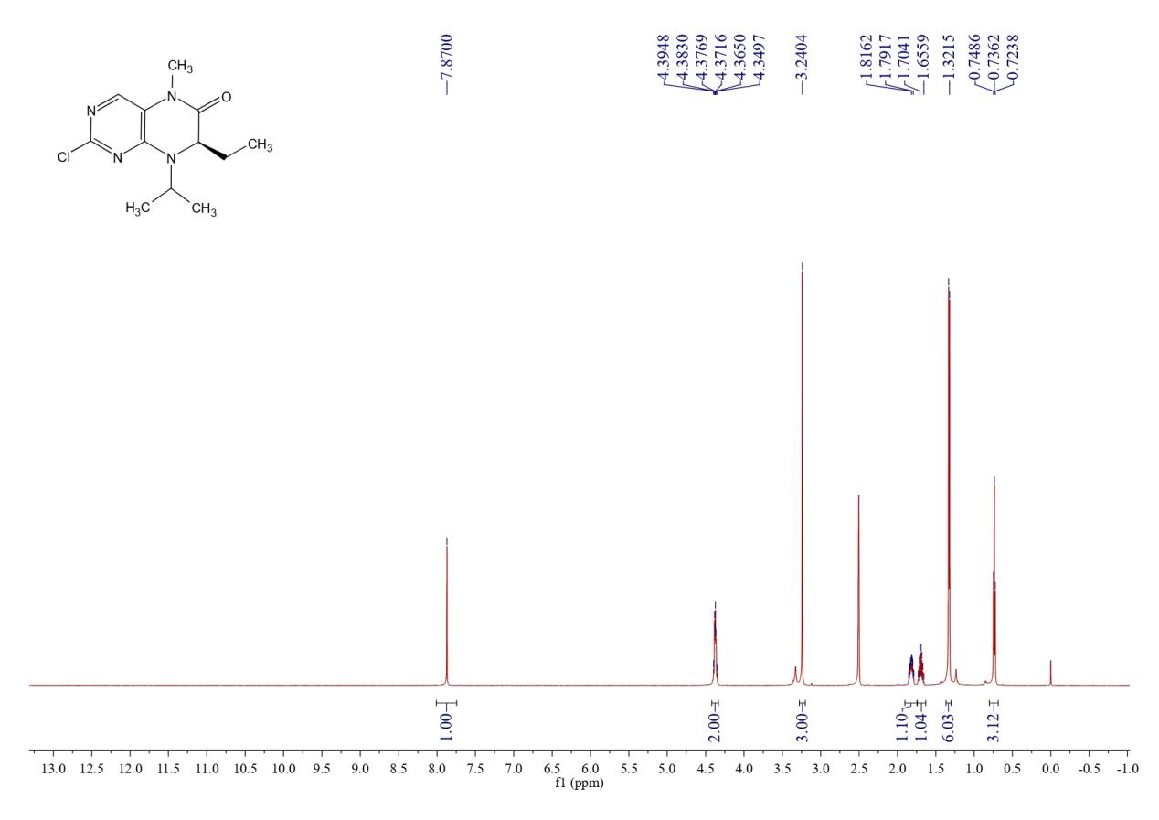Fig. S7 ¹H Spectra of (7R)-2-Chloro-7-ethyl-7,8-dihydro-5-methyl-8-(1-methylethyl)-6(5H)-pteridinone (W-11) 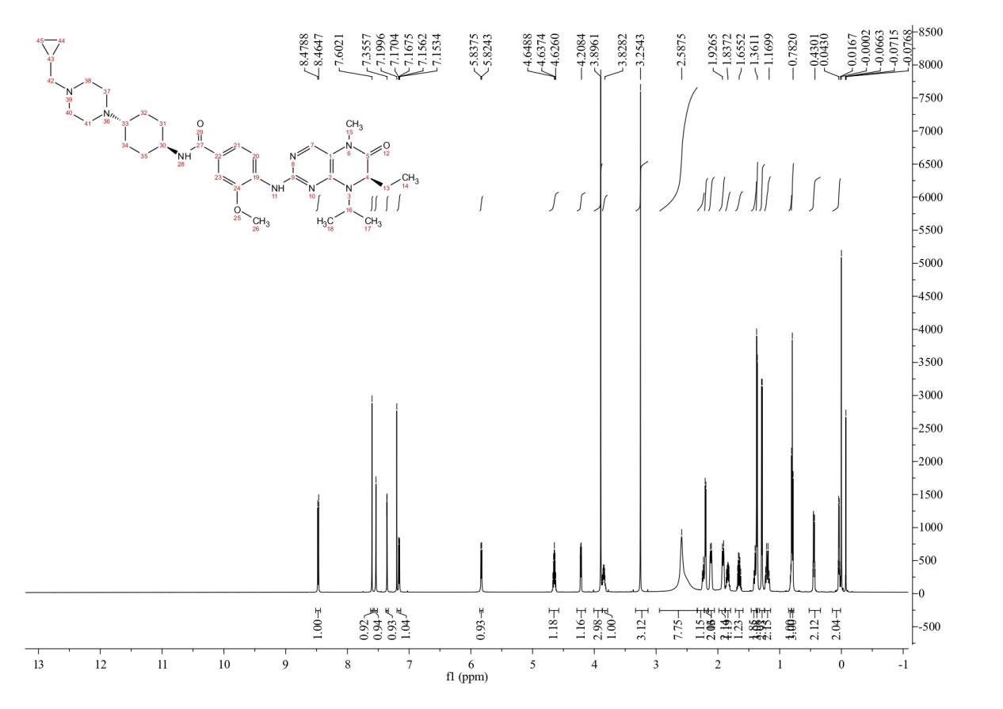Fig. S8 ¹H Spectra of (Volasertib)

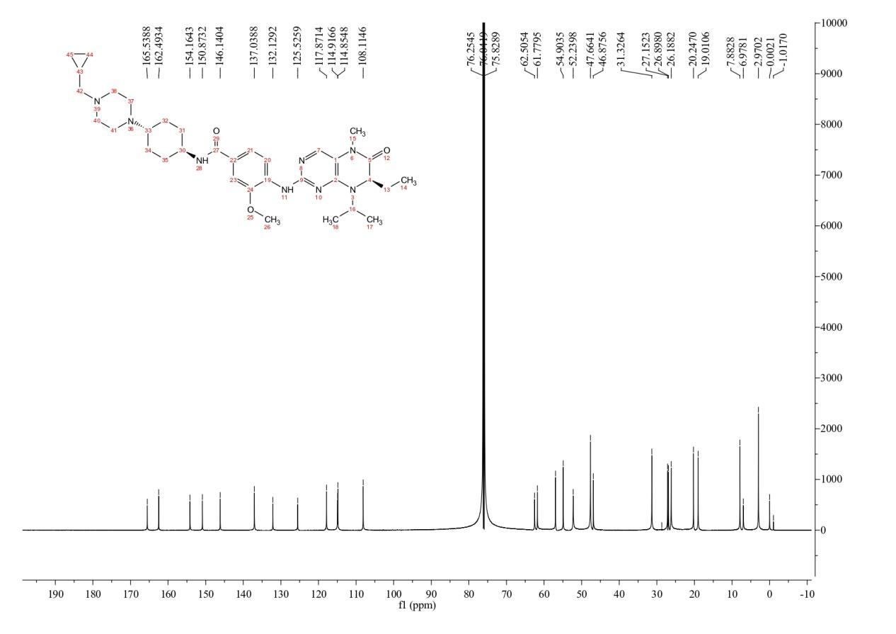Fig. S9 ¹³C NMR Spectra of (Volasertib)
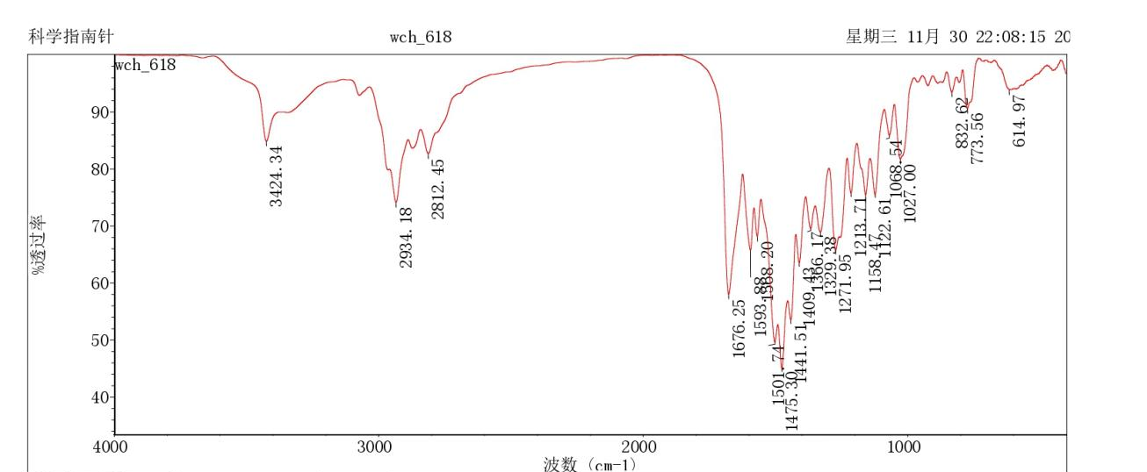Fig. S10 Infrared Spectra of Volasertib

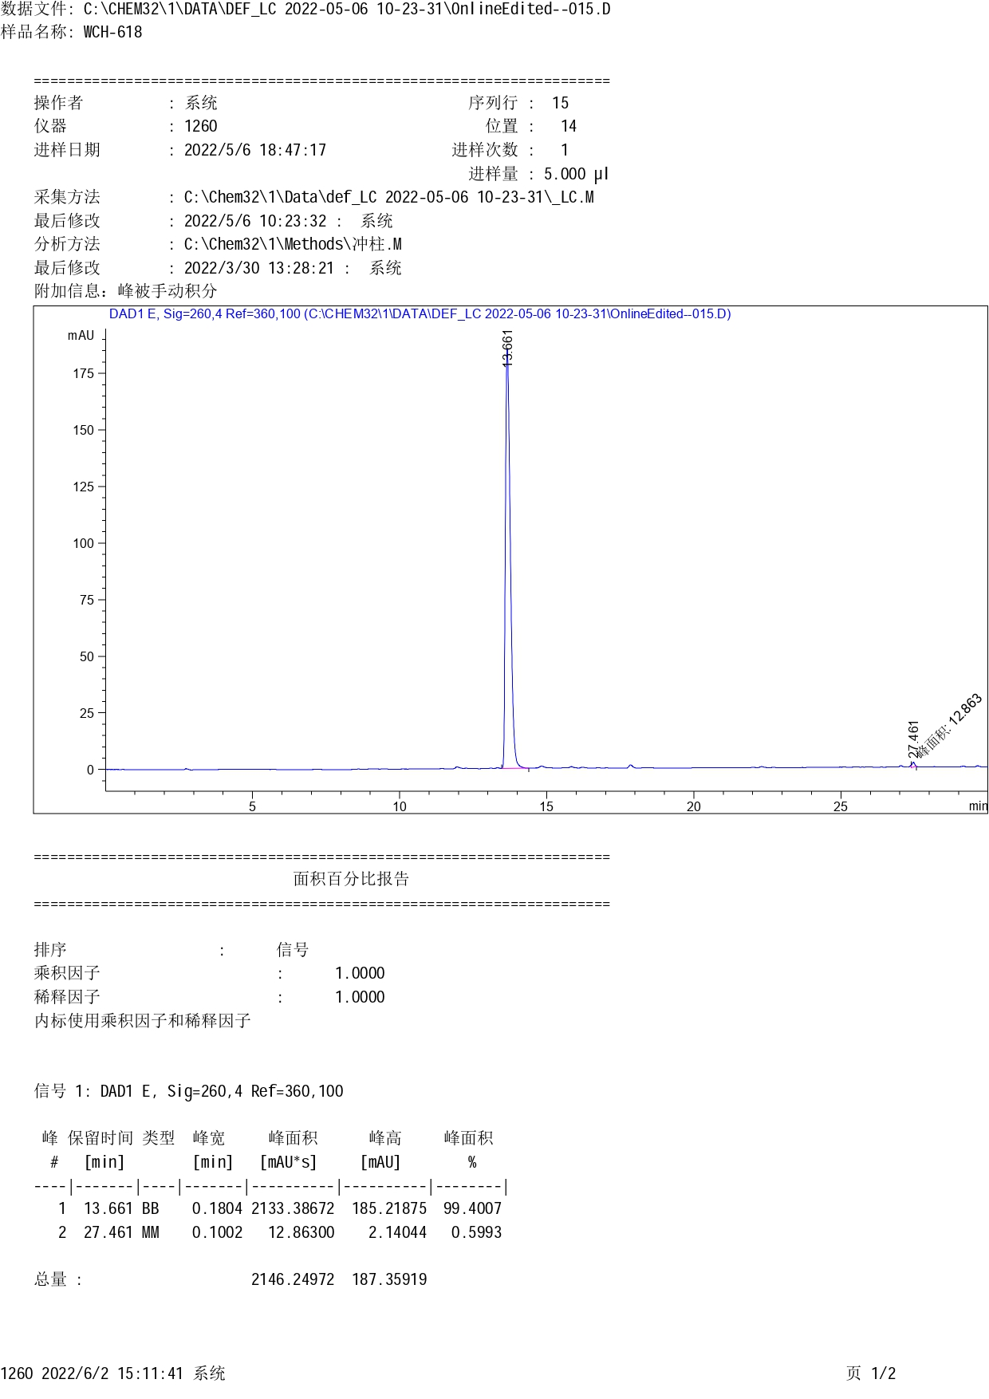
Fig. S15 HPLC Spectra of Volasertib

