Supporting information

Vanadium Dissolution Eliminate the Lattice Distortion of Co-O octahedron during Oxygen Evolution for Promoted Water Splitting

Zhijian Liang, Di Shen, Yao Wei, Fanfei Sun, Yin Xie, Lei Wang* and Honggang Fu*
Dr. Z. Liang, Dr. D. Shen, Prof. Y. Xie, Prof. L. Wang, Prof. H. Fu
Key Laboratory of Functional Inorganic Material Chemistry Ministry of Education of the People’s Republic of China
Heilongjiang University
Harbin 150080 (China)
E-mail: wanglei0525@hlju.edu.cn, fuhg@hlju.edu.cn, fuhg@vip.sina.com
Dr. Y. Wei, Prof. F. Sun
Shanghai Institute of Applied Physics
Chinese Academy of Sciences
Shanghai 201204 (China)
Shanghai Synchrotron Radiation Facility, Shanghai Advanced Research Institute
Chinese Academy of Sciences
Shanghai 201204 (China)

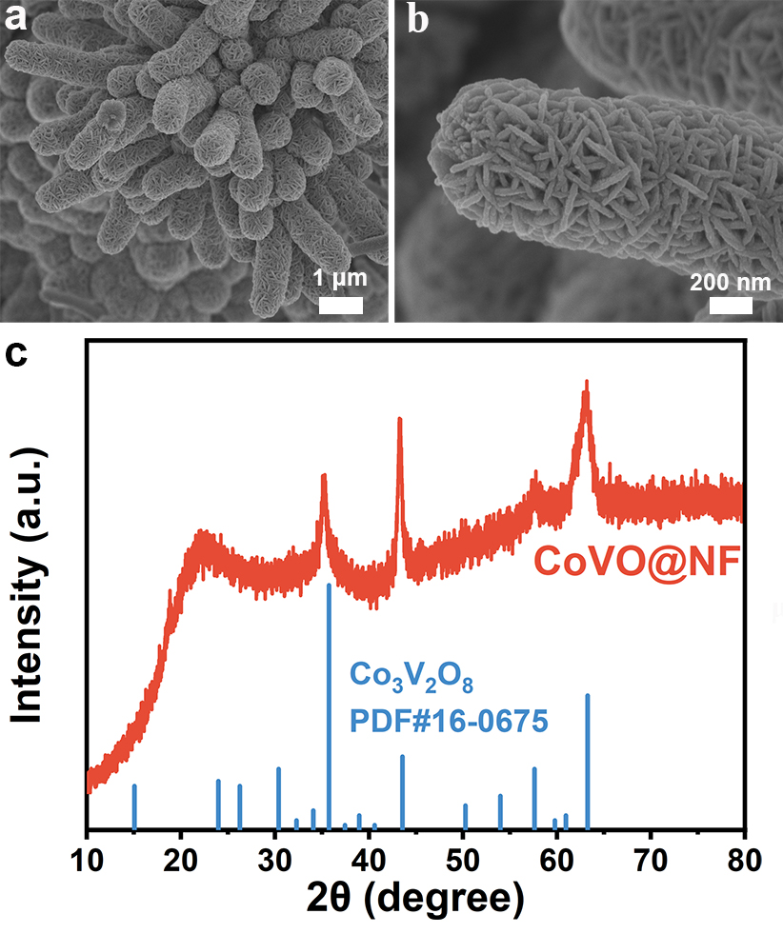
Supplementary Fig. 1. (a, b) SEM images and (c) XRD pattern of CoVO@NF.

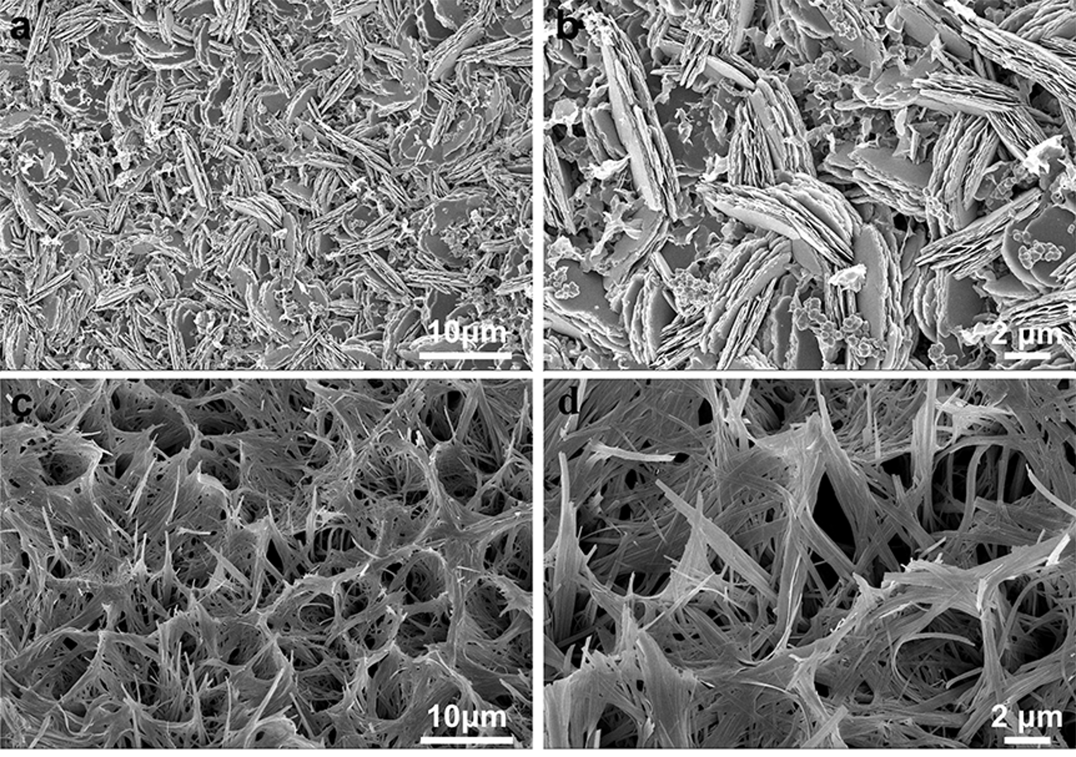
Supplementary Fig. 2. SEM images of (a, b) CoO@NF and (c, d) VO@NF.

Supplementary Fig. 3. FTIR spectrum of P-CoVO@NF.

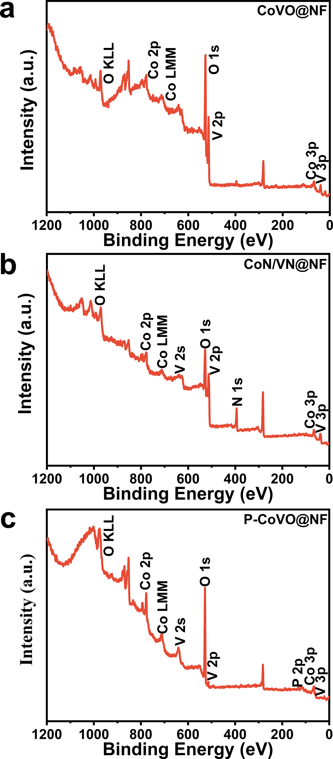
Supplementary Fig. 4. XPS survey spectra of (a) CoVO@NF, (b) CoN/VN@NF and (c) P-CoVO@NF.

Supplementary Fig. 5. XPS spectra of O 2p for CoVO@NF (top) and P-CoVO@NF (bottom).

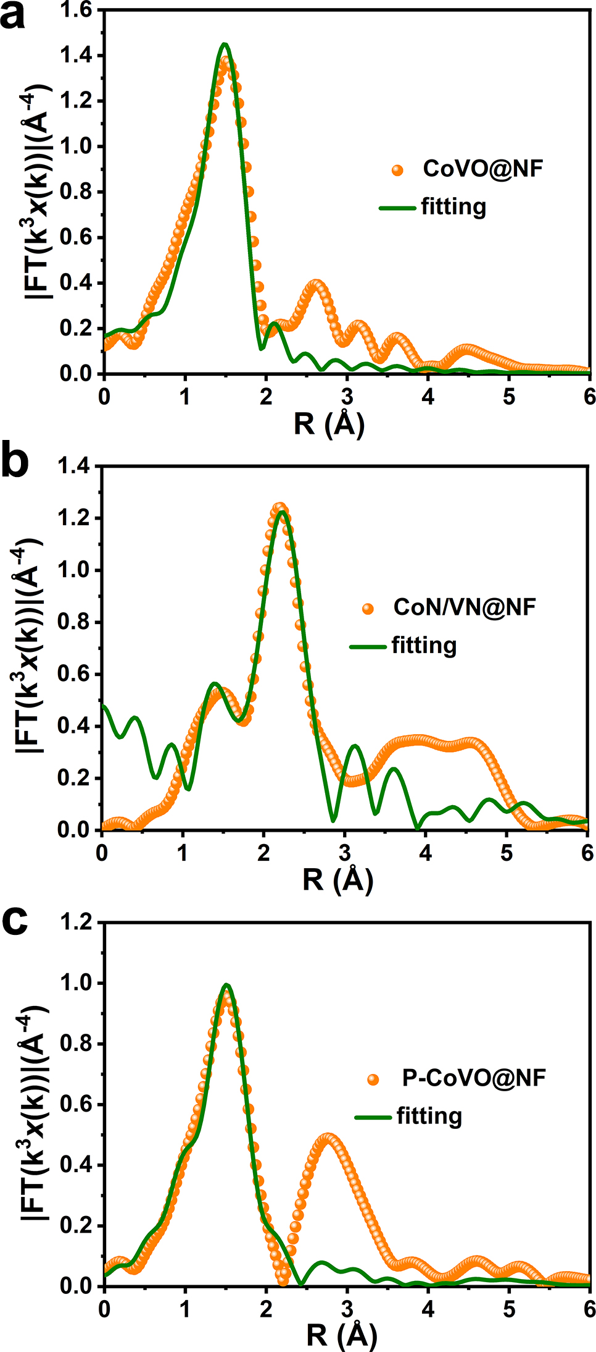
Supplementary Fig. 6. Co K-edge EXAFS fitting analyses of (a) CoVO@NF, (b) CoN/VN@NF and (c) P-CoVO@NF.

Supplementary Table 1. EXAFS fitting data results of Figure 2(d-f) and Supplementary Fig. 6.
Catalyst | Path | N^{[a]} | R (Å)^{[b]} | σ² (10⁻³)^{[c]} | E₀ (eV)^{[d]} | R-factor
CoVO@NF | Co‒O | 4.32 | 2.02 | 6.17 | ‒5.25 | 0.01
CoN/VN@NF | Co‒O | 0.74 | 2.02 | 4.79 | ‒1.15 | 0.01
CoN/VN@NF | Co‒N | 0.67 | 2.14 | 15.19 | 5.75 | 0.01
CoN/VN@NF | Co‒Co | 1.34 | 2.45 | 0.49 | 8.08 | 0.01
P-CoVO@NF | Co‒O | 2.34 | 1.96 | 9.17 | ‒7.14 | 0.01
P-CoVO@NF | Co‒P | 0.38 | 2.07 | 6.29 | ‒4.80 | 0.01
P-CoVO@NF | Co‒Co | 3.81 | 2.97 | 9.90 | 6.66 | 0.01
[a] N: coordinated number. [b] R: Bond distance. [c] σ²: Debye–Waller factor to account for both thermal and structural disorders. [d] E₀: inner potential correction. All the R–factors for the fitted results are within 0.02, indicating the goodness of the fit.

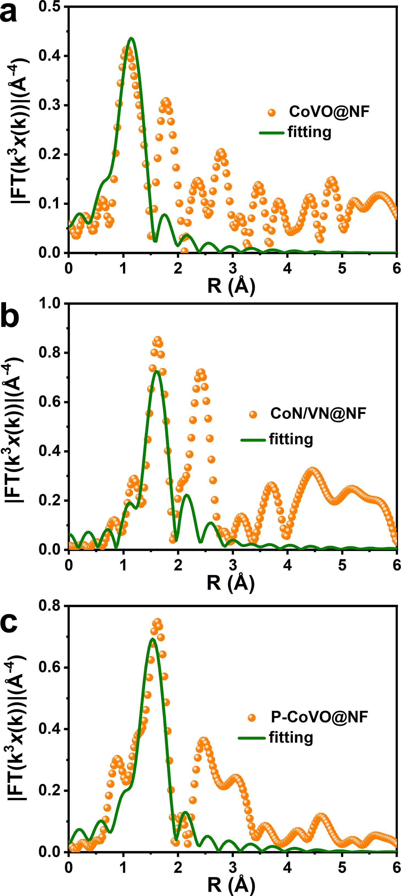
Supplementary Fig. 7. V K-edge EXAFS fitting analyses of (a) CoVO@NF, (b) CoN/VN@NF and (c) P-CoVO@NF.

Supplementary Table 2. EXAFS fitting data results of Figure 2(h-j) and Supplementary Fig. 7.
Catalyst | Path | N^{[a]} | R (Å)^{[b]} | σ² (10⁻³)^{[c]} | E₀ (eV)^{[d]} | R-factor
CoVO@NF | V‒O  V‒V | 3.54  1.1 | 1.62  3.84 | 1.69  2.52 | ‒6.45  0.003 | 0.01
CoN/VN@NF | V‒O | 2.05 | 2.16 | 12.20 | ‒0.71 | 0.01
CoN/VN@NF | V‒N  V‒V | 1.17  1.00 | 2.07  2.62 | 2.69  1.16 | 11.67  0.01 | 0.01
P-CoVO@NF | V‒O  V‒V | 3.14  1.10 | 2.00  3.06 | 0.82  2.51 | 3.17  0.02 | 0.01
[a] N: coordinated number. [b] R: Bond distance. [c] σ²: Debye–Waller factor to account for both thermal and structural disorders. [d] E₀: inner potential correction. All the R–factors for the fitted results are within 0.02, indicating the goodness of the fit.

Supplementary Table 3. Comparison of the HER performance of CoN/VN@NF with other reported electrocatalysts.
Catalysts | η₁₀ in 1.0 M KOH  (mV) | Tafel slope  (mV dec^{‒1}) | References
NiCo₂S₄/ReS₂ | 85 | 78.3 | Adv. Funct. Mater. 2023, 33, 2210072
H-Mo₂C/NG | 63 | 48 | Nat. Commun. 2022, 13, 7225
MoO₂/Mo₃P/Mo₂C | 69 | 60.4 | Small 2023, 19, 2206472
S-NiFe₂O₄ | 61 | 80 | Angew. Chem. Int. Ed. 2021, 60, 14117
Mo_{0.6}V_{0.4}Se₂ | 157 | 76 | ACS Nano 2021, 15, 14672-14682
Ni₂P/Zn-Ni-P-0.1 | 61 | 128 | J. Mater. Chem. A 2023, 11, 2191-2202
6B-Fe₇S₈/FeS₂/CC | 113 | 57.4 | Adv. Funct. Mater. 2022, 32, 2107802
Co/CoP@HOMC | 120 | 78 | Adv. Energy Mater. 2021, 11, 2102134
CoN/VN@NF | 55 | 53 | This work
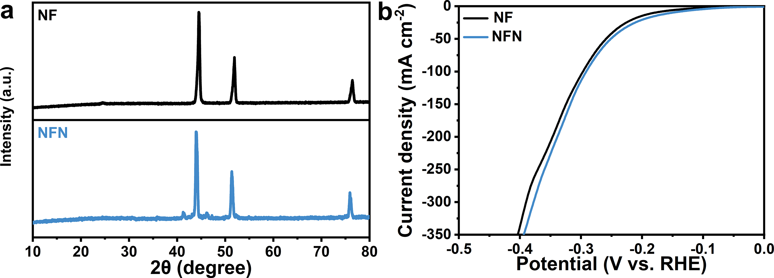
Supplementary Fig. 8. (a) XRD patterns of NF and NFN. (b) HER polarization curves of NF and NFN with a scan rate of 5 mV s^{‒1} in 1.0 M KOH.

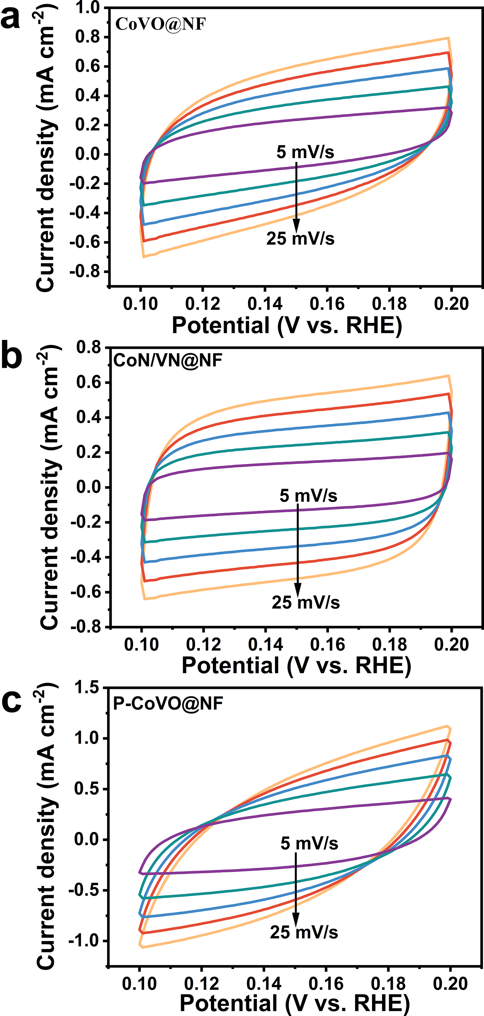
Supplementary Fig. 9. CV curves of (a) CoVO@NF, (b) CoN/VN@NF and (c) P-CoVO@NF at different scan rates in 1.0 M KOH.

Supplementary Fig. 10. HER polarization curves of CoVO@NF, CoN/VN@NF and P-CoVO@NF after normalizing by ECSA values.

Supplementary Fig. 11. The calculated TOF curves of CoVO@NF, CoN/VN@NF and P-CoVO@NF for HER.

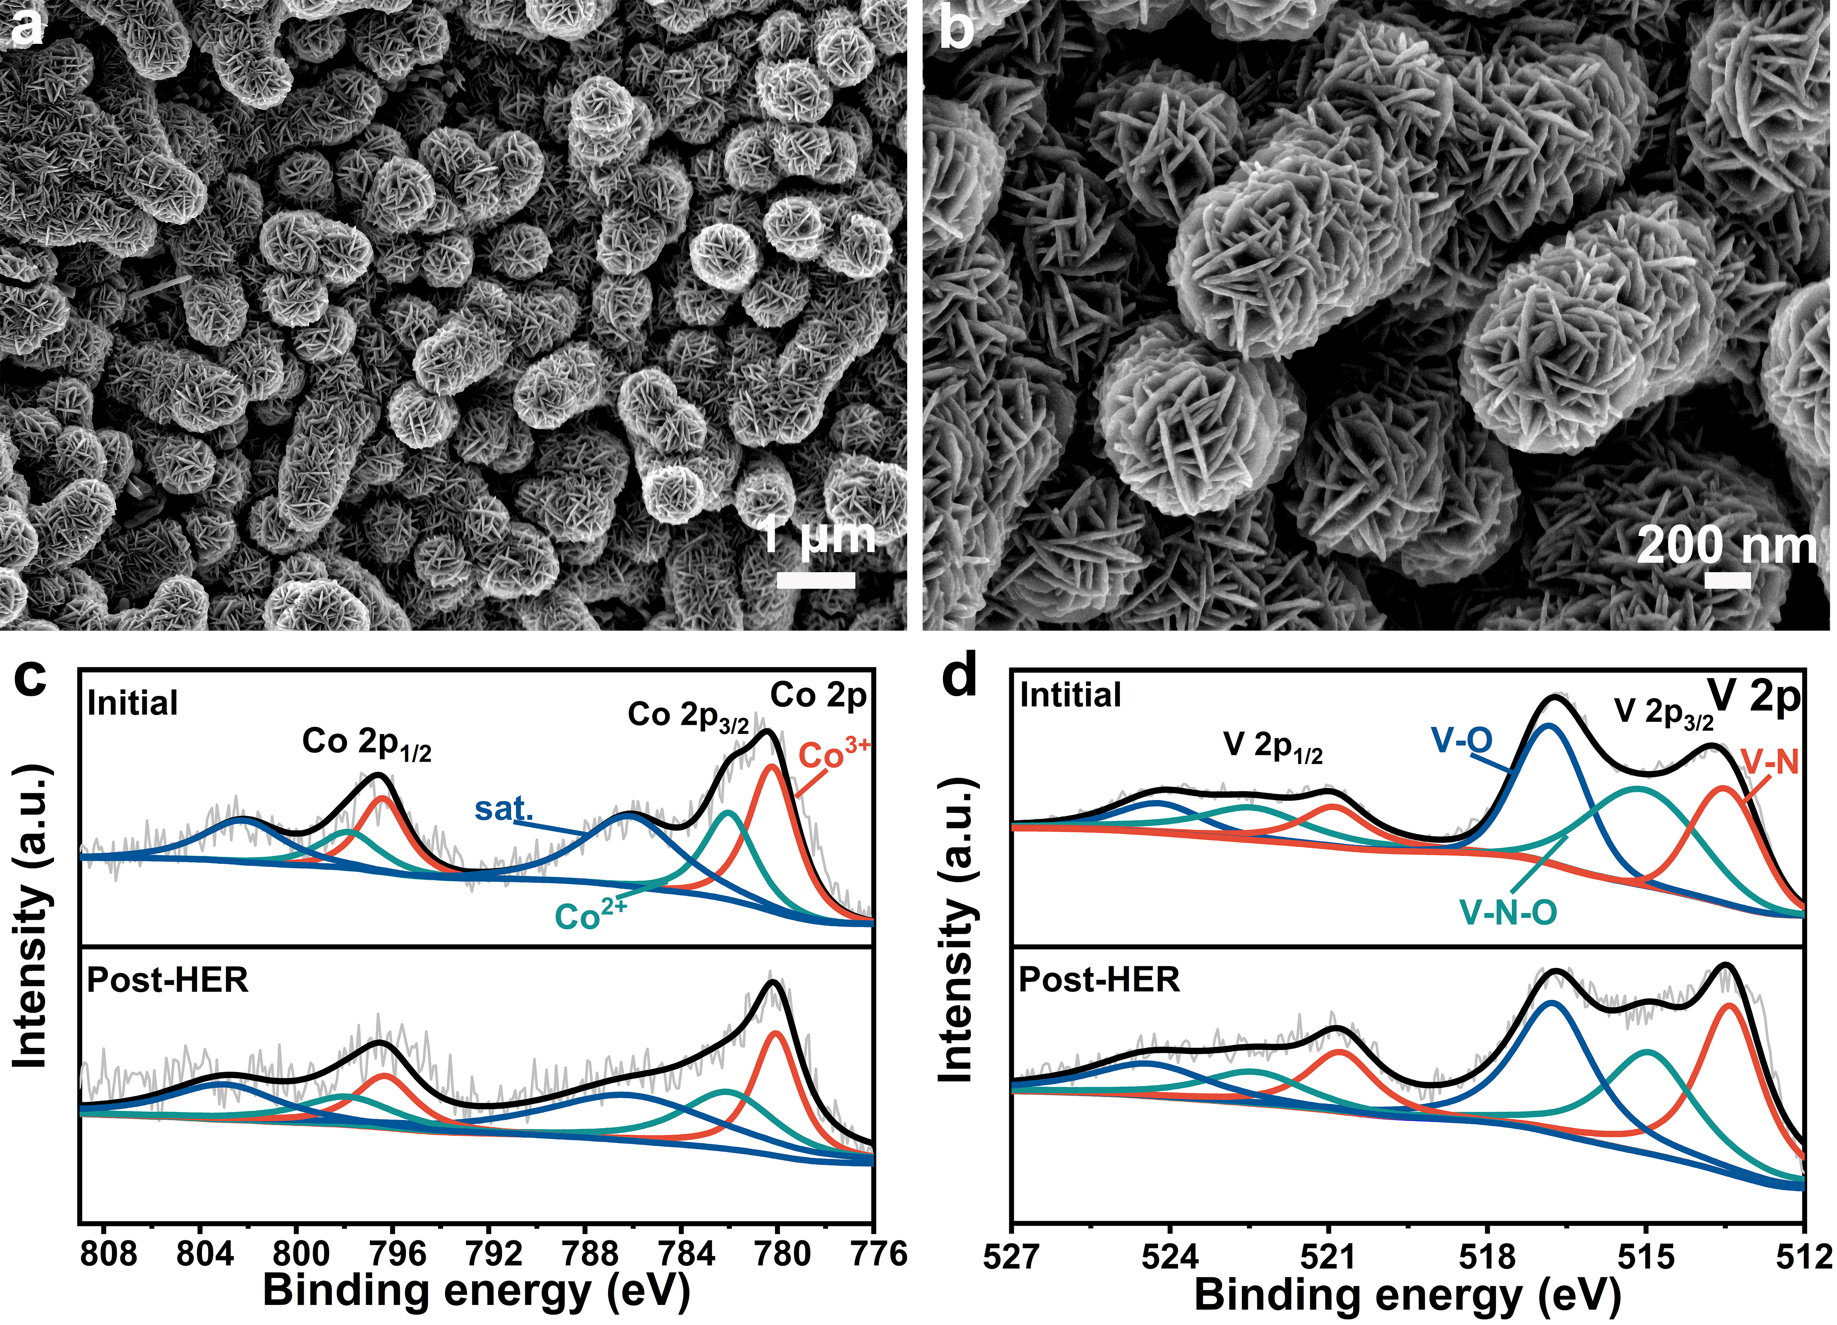
Supplementary Fig. 12. (a, b) SEM images, XPS spectra of (c) Co 2p and (d) V 2p of CoN/VN@NF after HER chronoamperometry test.

Supplementary Table 4. Comparison of the OER performance of P-CoVO@NF with other reported electrocatalysts.
Catalysts | η₁₀₀ in 1 M KOH^{[a]} (mV) | Tafel slope (mV dec⁻¹) | References
CoO@S-CoTe | 362 | 56 | Adv. Sci. 2023, 10, 2206204
S-NiSe₂/NiFe₂O₄ | 370 | 46 | Small 2023, 2310266
ZnCo₂O_{4-x}F/CNTs | 521 | 59.2 | ACS Catal. 2022, 12, 10808-10817
FeCoNiMo HEA/C | 318 | 48.02 | Angew. Chem. Int. Ed. 2021, 60, 14117
(NiFeCoMn)₃S₄ | 423 | 75.6 | Adv. Funct. Mater. 2023, 33, 2208170
MoCoP-NPC | 400 | 49 | Small 2023, 13, 2206472
Fe₃Co₃Ni₂-(oxy)hydroxide | 421.48 | 49 | ACS Catal. 2023, 13, 601-611
Co/CoP@HOMC | 480 | 151 | Adv. Energy Mater. 2021, 11, 2102134
P-CoVO@NF | 317 | 77 | This work
[a] Values of current densities were read from the LSV curves in the corresponding references.

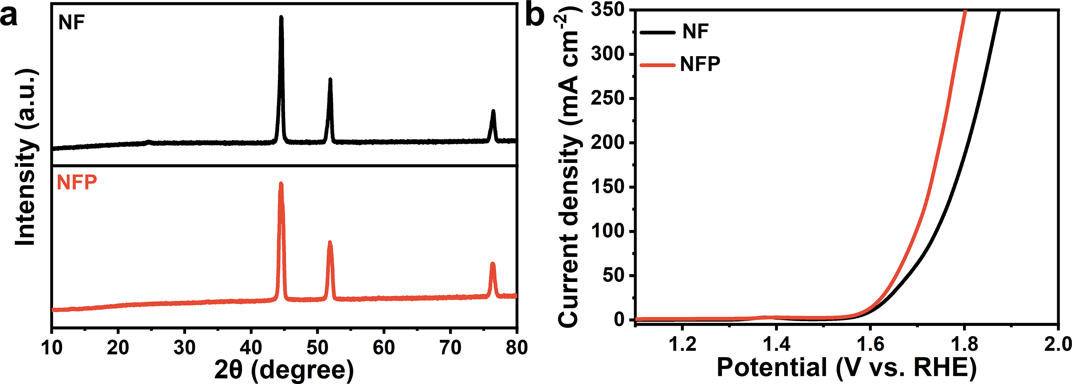
Supplementary Fig. 13. (a) XRD patterns of NF and NFP (after phosphating). (b) OER Polarization curves of NF and NFP at a scan rate of 5 mV s^{‒1} in 1.0 M KOH.

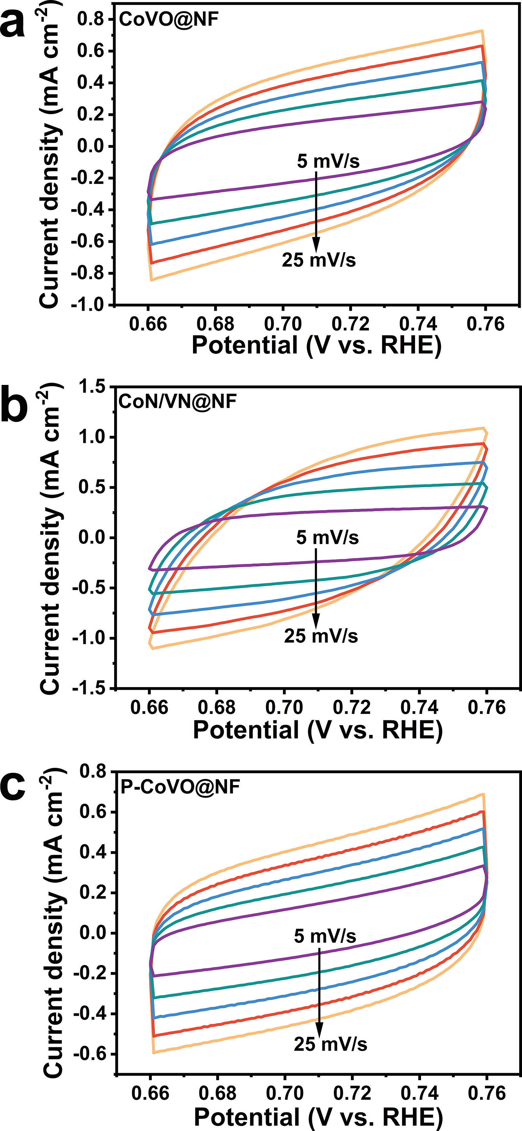
Supplementary Fig. 14. CV curves of (a) CoVO@NF, (b) CoN/VN@NF and (c) P-CoVO@NF at different scan rates in 1.0 M KOH.

Supplementary Fig. 15. OER polarization curves with normalized by ECSA of CoVO@NF, CoN/VN@NF and P-CoVO@NF.

Supplementary Fig. 16. The calculated TOF curves of CoVO@NF, CoN/VN@NF and P-CoVO@NF towards OER.

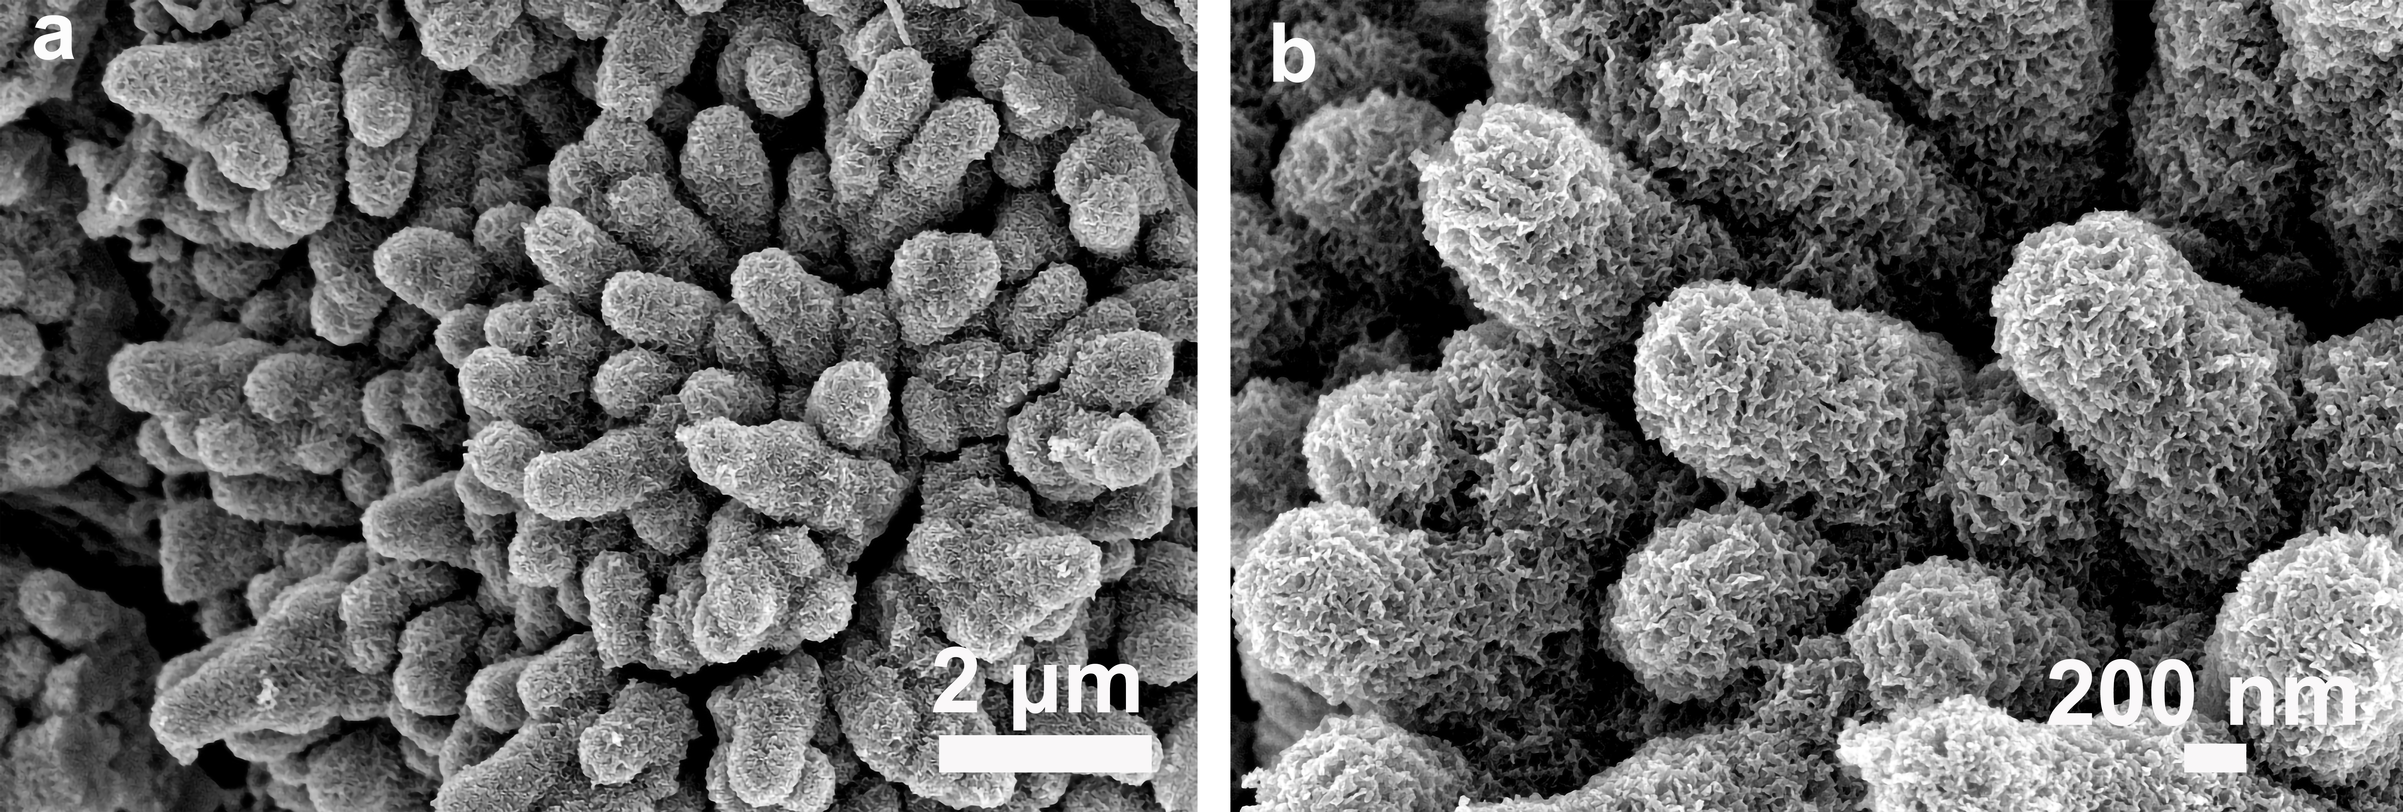
Supplementary Fig. 17. SEM images of P-CoVO@NF after OER stability test.
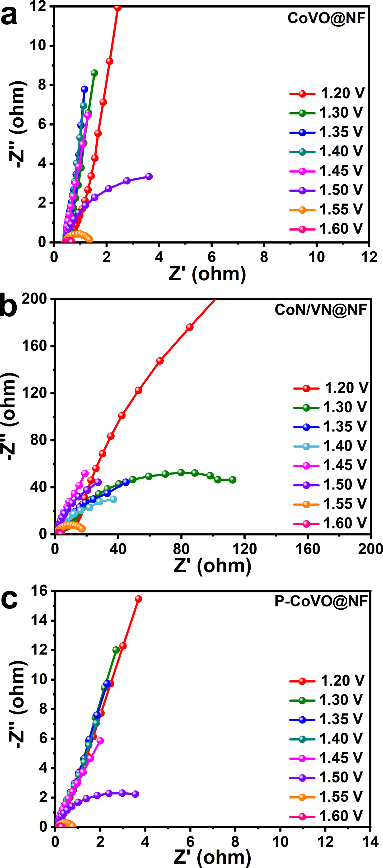
Supplementary Fig. 18. Nyquist plots of (a) CoVO@NF, (b) CoN/VN@NF and (c) P-CoVO@NF tested in 1.0 M KOH.

Supplementary Table 5. Fitting results of the operando Nyquist plot under different applied potential.
Catalyst | Potential (V) | R_{s} (Ω) | R_{CEOR} (Ω) | R_{OER} (Ω)
CoVO@NF | 1.20 | 0.440 | 0.08 | 417.70
CoVO@NF | 1.30 | 0.427 | 1.01 | 131.50
CoVO@NF | 1.35 | 0.418 | 1.07 | 71.04
CoVO@NF | 1.40 | 0.415 | 1.11 | 73.42
CoVO@NF | 1.45 | 0.420 | 1.24 | 63.00
CoVO@NF | 1.50 | 0.433 | 0.06 | 6.44
CoVO@NF | 1.55 | 0.424 | 0.05 | 0.87
CoVO@NF | 1.60 | 0.431 | 0.11 | 0.18
CoN/VN@NF | 1.20  1.30  1.35  1.40  1.45  1.50  1.55  1.60 | 0.619  0.647  0.626  0.629  0.581  0.594  0.500  0.626 | 4.15  1.75  0.07  3.39  0.07  0.05  1.74  0.54 | 565.20  126.3  55.58  50.30  128.50  86.46  16.97  2.92
P-CoVO@NF | 1.20  1.30  1.35  1.40  1.45  1.50  1.55  1.60 | 0.145  0.150  0.149  0.146  0.144  0.143  0.144  0.146 | 0.02  0.09  0.05  0.05  0.05  0.05  0.02  0.05 | 351.90  103.80  68.79  56.35  35.59  4.60  0.59  0.10

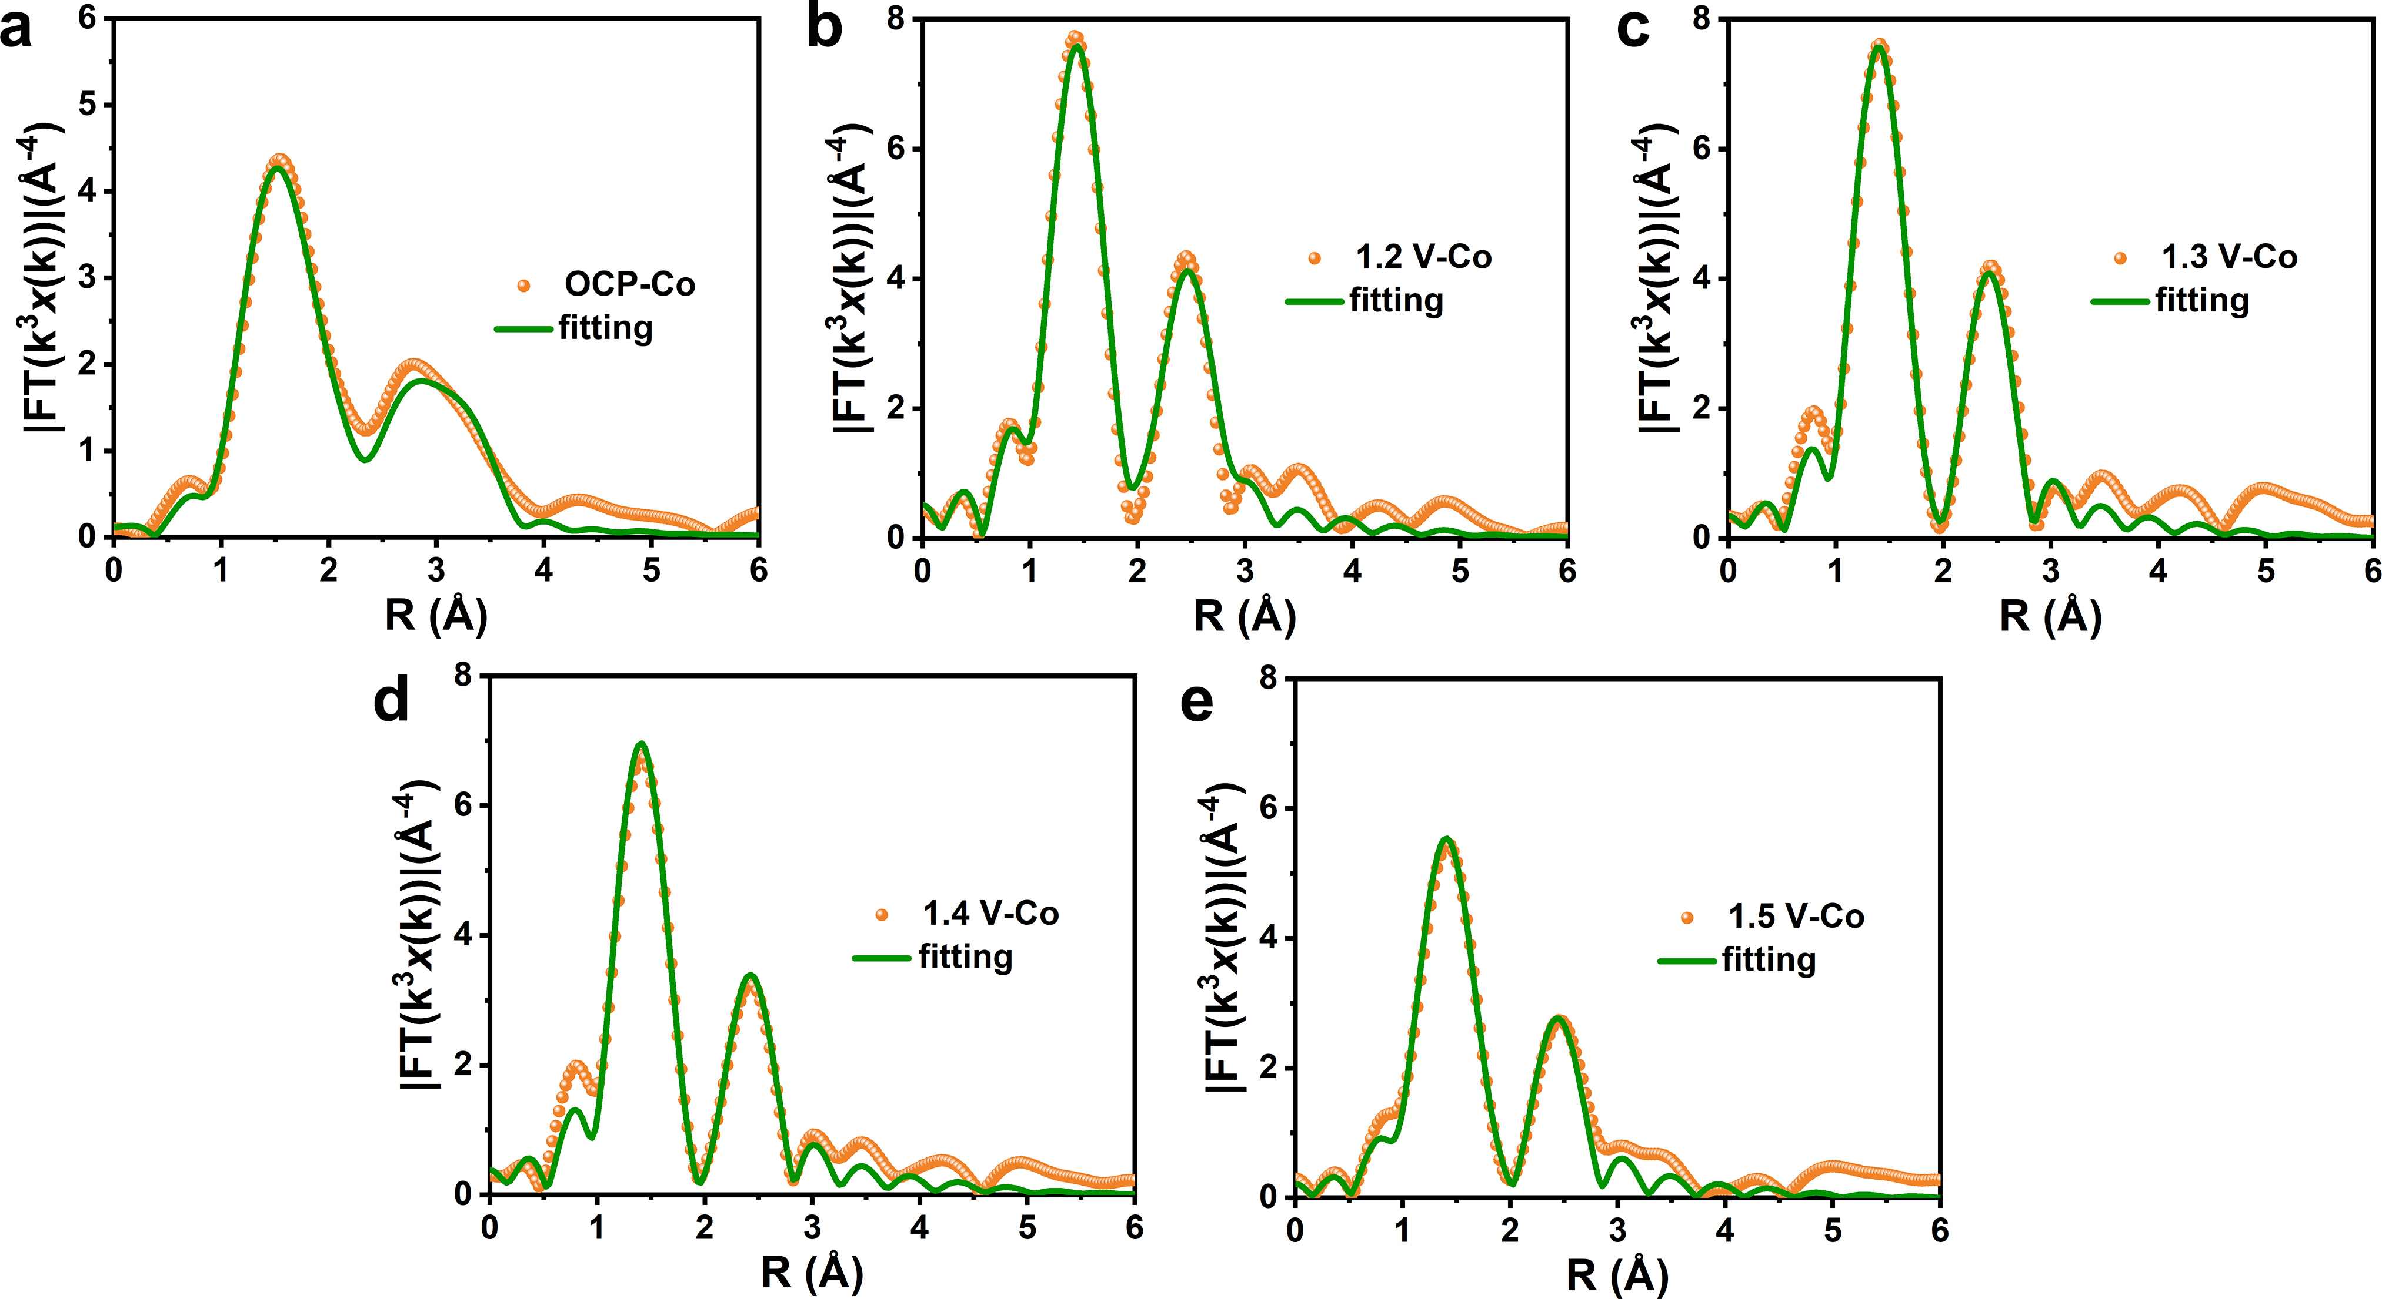
Supplementary Fig. 19. The corresponding fitting curves of Co K-edge at the applied potentials of (a) OCP, (b) 1.2 V, (c) 1.3 V, (d) 1.4 V and (e) 1.5 V.

Supplementary Table 6. Co K-edge FT-EXAFS fitting data results from Supplementary Fig. 19.
Potentials | Path | N^{[a]} | R (Å)^{[b]} | σ² (10⁻³)^{[c]} | E₀ (eV)^{[d]} | R-factor
OCP | Co‒O  Co‒P  Co‒Co  Co‒Co | 4.18  0.89  1.35  3.69 | 1.95  2.37  3.09  3.51 | 11.67  10.85  8.95  10.00 | ‒7.53  9.78  7.91  7.91 | 0.01
1.2 V | Co‒O | 5.20 | 1.90 | 6.89 | ‒4.33 | 0.01
1.2 V | Co‒Co | 3.03 | 2.85 | 8.52 | ‒5.31 | 0.01
1.3 V | Co‒O | 4.63 | 1.91 | 11.00 | ‒3.89 | 0.01
1.3 V | Co‒Co | 2.45 | 2.93 | 14.00 | 6.67 | 0.01
1.4 V | Co‒O | 4.59 | 1.89 | 6.00 | ‒6.17 | 0.01
1.4 V | Co‒Co | 2.75 | 2.85 | 7.00 | -4.52 | 0.01
1.5 V | Co‒O | 4.13 | 1.90 | 8.41 | ‒5.21 | 0.01
1.5 V | Co‒Co | 2.04 | 2.89 | 14.00 | -4.78 | 0.01
[a] N: coordinated number. [b] R: Bond distance. [c] σ²: Debye–Waller factor to account for both thermal and structural disorders. [d] E₀: inner potential correction. All the R–factors for the fitted results are within 0.02, indicating the goodness of the fit.
Supplementary Fig. 20. XPS spectra of Co 2p of P-CoVO@NF before and after OER test.

Supplementary Fig. 21. XPS spectra of P 2p (top) and O1s (bottom) of P-CoVO@NF before and after OER test.

Supplementary Table 7. XPS analyses of P-CoVO@NF before and after OER test.
Mass ratio | Initial (wt %) | After test (wt %)
Co | 25.35 | 25.96
V | 29.5 | 17.52
O | 30.08 | 31.08
P | 10.6 | 3.45

Supplementary Table 8. ICP-MS analyses of Co, V and P content in solution after OER test.
Element | The content in solution (μg L⁻¹)
Co | 0.2942
V  P | 7512.8835  2732.9133

Supplementary Table 9. The electronic charge distribution of CoVO@NF, CoN/VN@NF and P-CoVO@NF models.
Models | Co | V | O | N | P
CoVO@NF | 0.85 e | 1.12 e | −0.53 e | − | −
CoN/VN@NF | 0.23 e | 0.64 e | − | −0.66 e | −
P-CoVO@NF | 0.80 e | 1.10 e | −0.65 e | − | 2.21 e

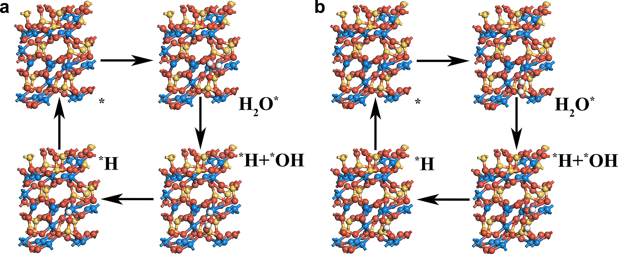
Supplementary Fig. 22. Models of HER intermediates on (a) Co side (b) V side of CoVO@NF, where cyan, yellow, red and white spheres represent Co, V, O and H atoms, respectively.

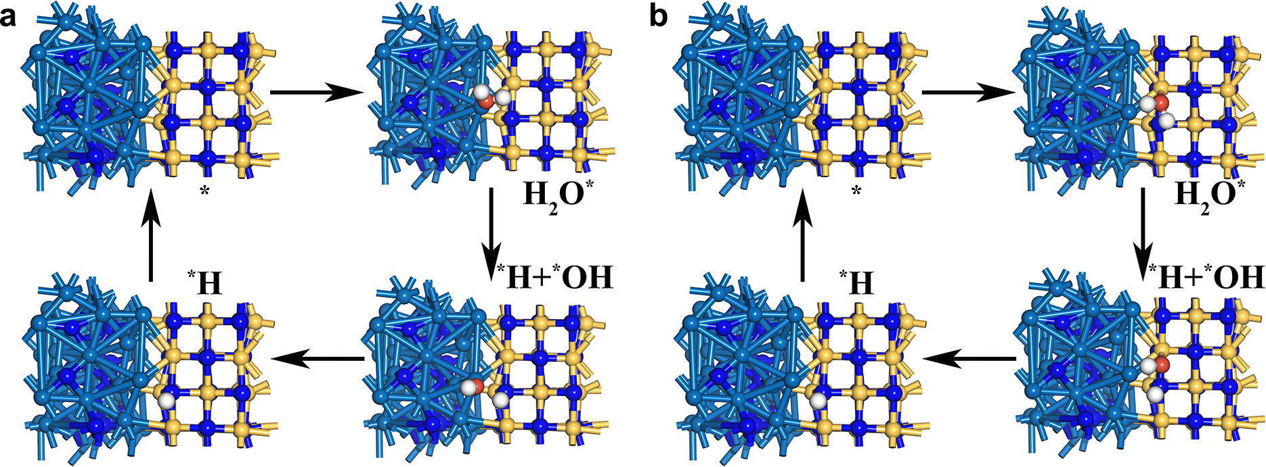
Supplementary Fig. 23. Models of HER intermediates on (a) Co/N sides (b) V/N sides of CoN/VN@NF, where cyan, yellow, blue, red and white spheres represent Co, V, N, O and H atoms, respectively.

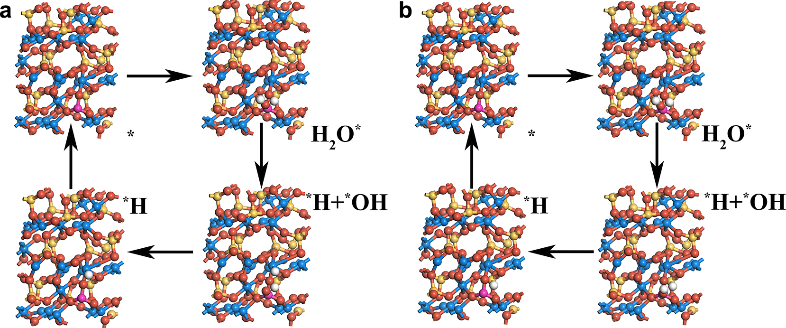
Supplementary Fig. 24. Models of HER intermediates on (a) Co/P sides (b) V/P sides of P-CoVO@NF, where cyan, yellow, pink, red and white spheres represent Co, V, P, O and H atoms, respectively.

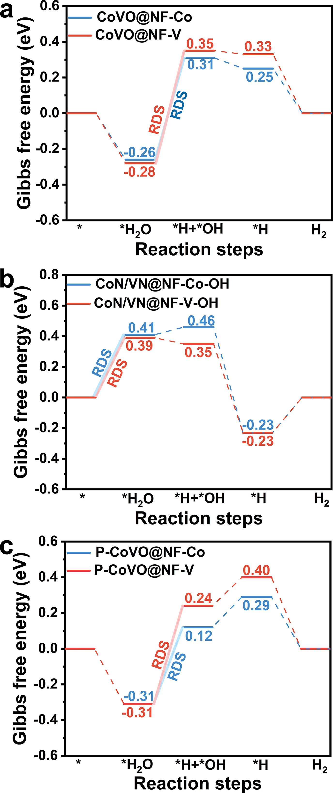
Supplementary Fig. 25. Free energy diagrams of HER process on different sites for (a) CoVO@NF, (b) CoN/VN@NF and (c) P-CoVO@NF.

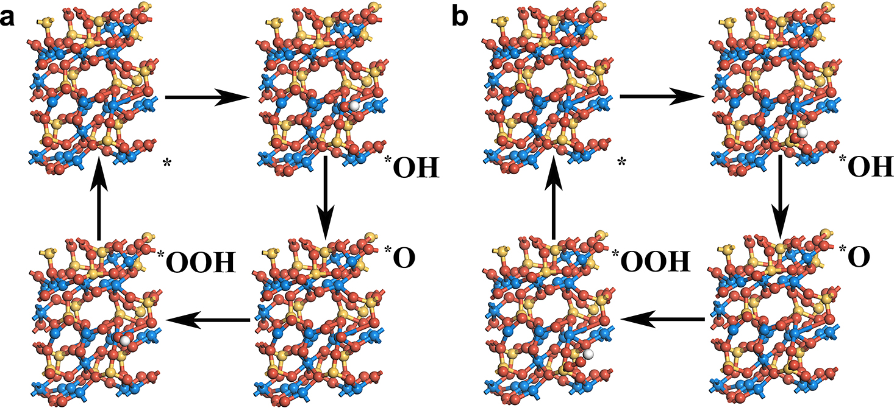
Supplementary Fig. 26. Models of OER intermediates on (a) Co side and (b) V side of CoVO@NF, where cyan, yellow, red and white spheres represent Co, V, O and H atoms, respectively.

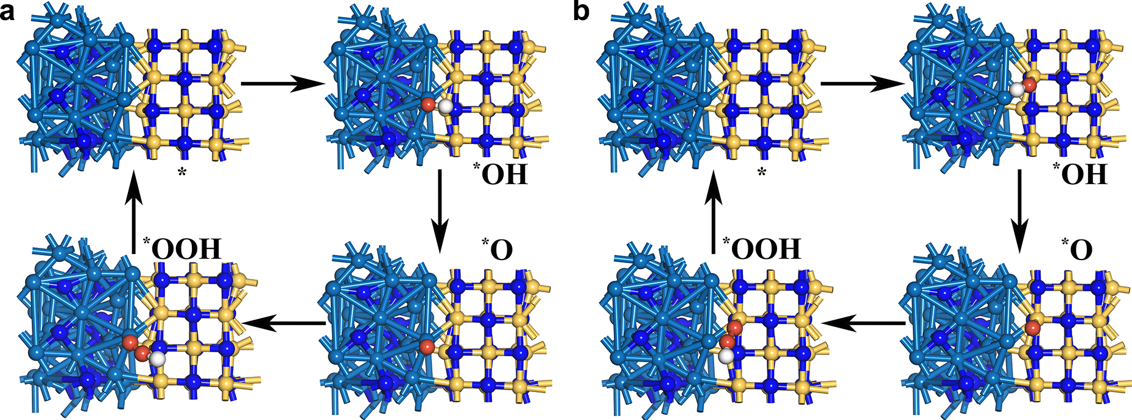
Supplementary Fig. 27. Models of OER intermediates on (a) Co side and (b) V side of CoN/VN@NF, where cyan, yellow, blue, red and white spheres represent Co, V, N, O and H atoms, respectively.

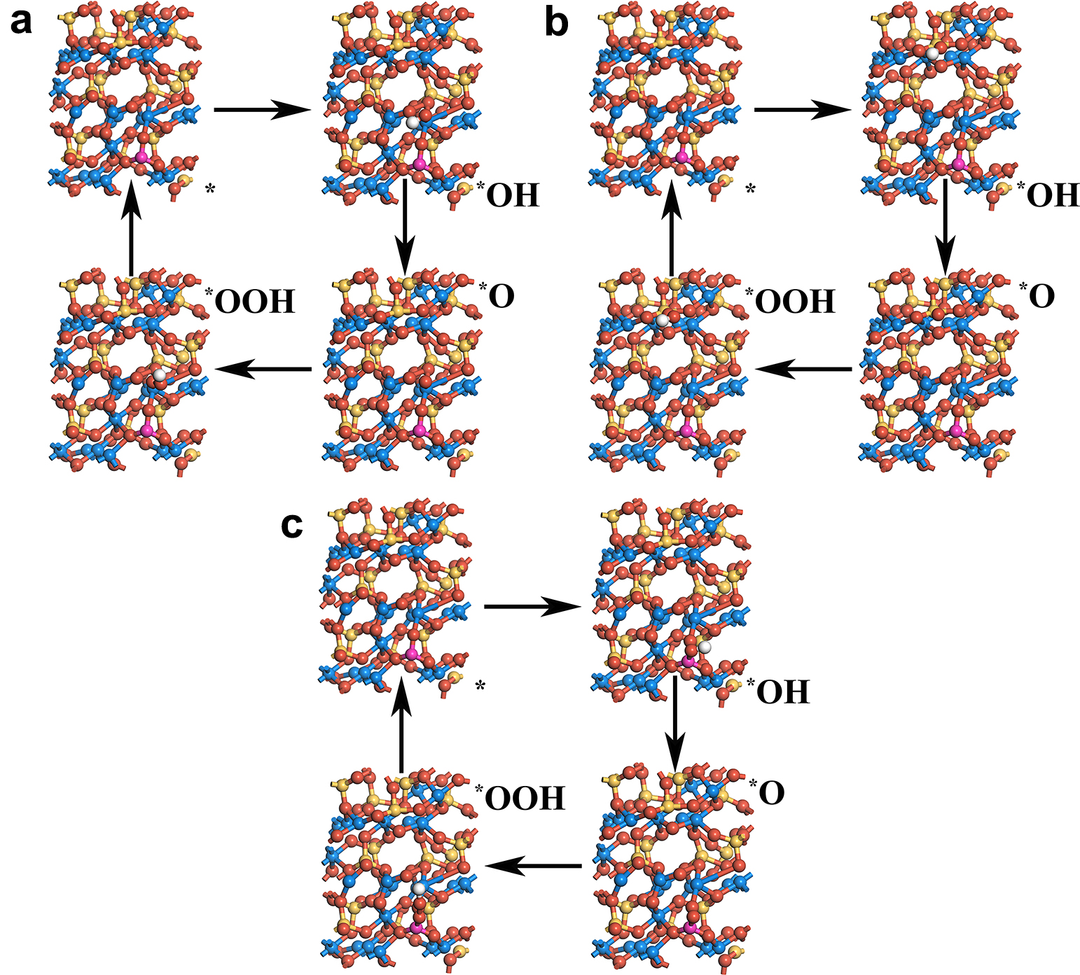
Supplementary Fig. 28. Models of OER intermediates on (a) Co side, (b) V side, and (c) P side of P-CoVO@NF, where cyan, yellow, pink, red and white spheres represent Co, V, P, O and H atoms, respectively.

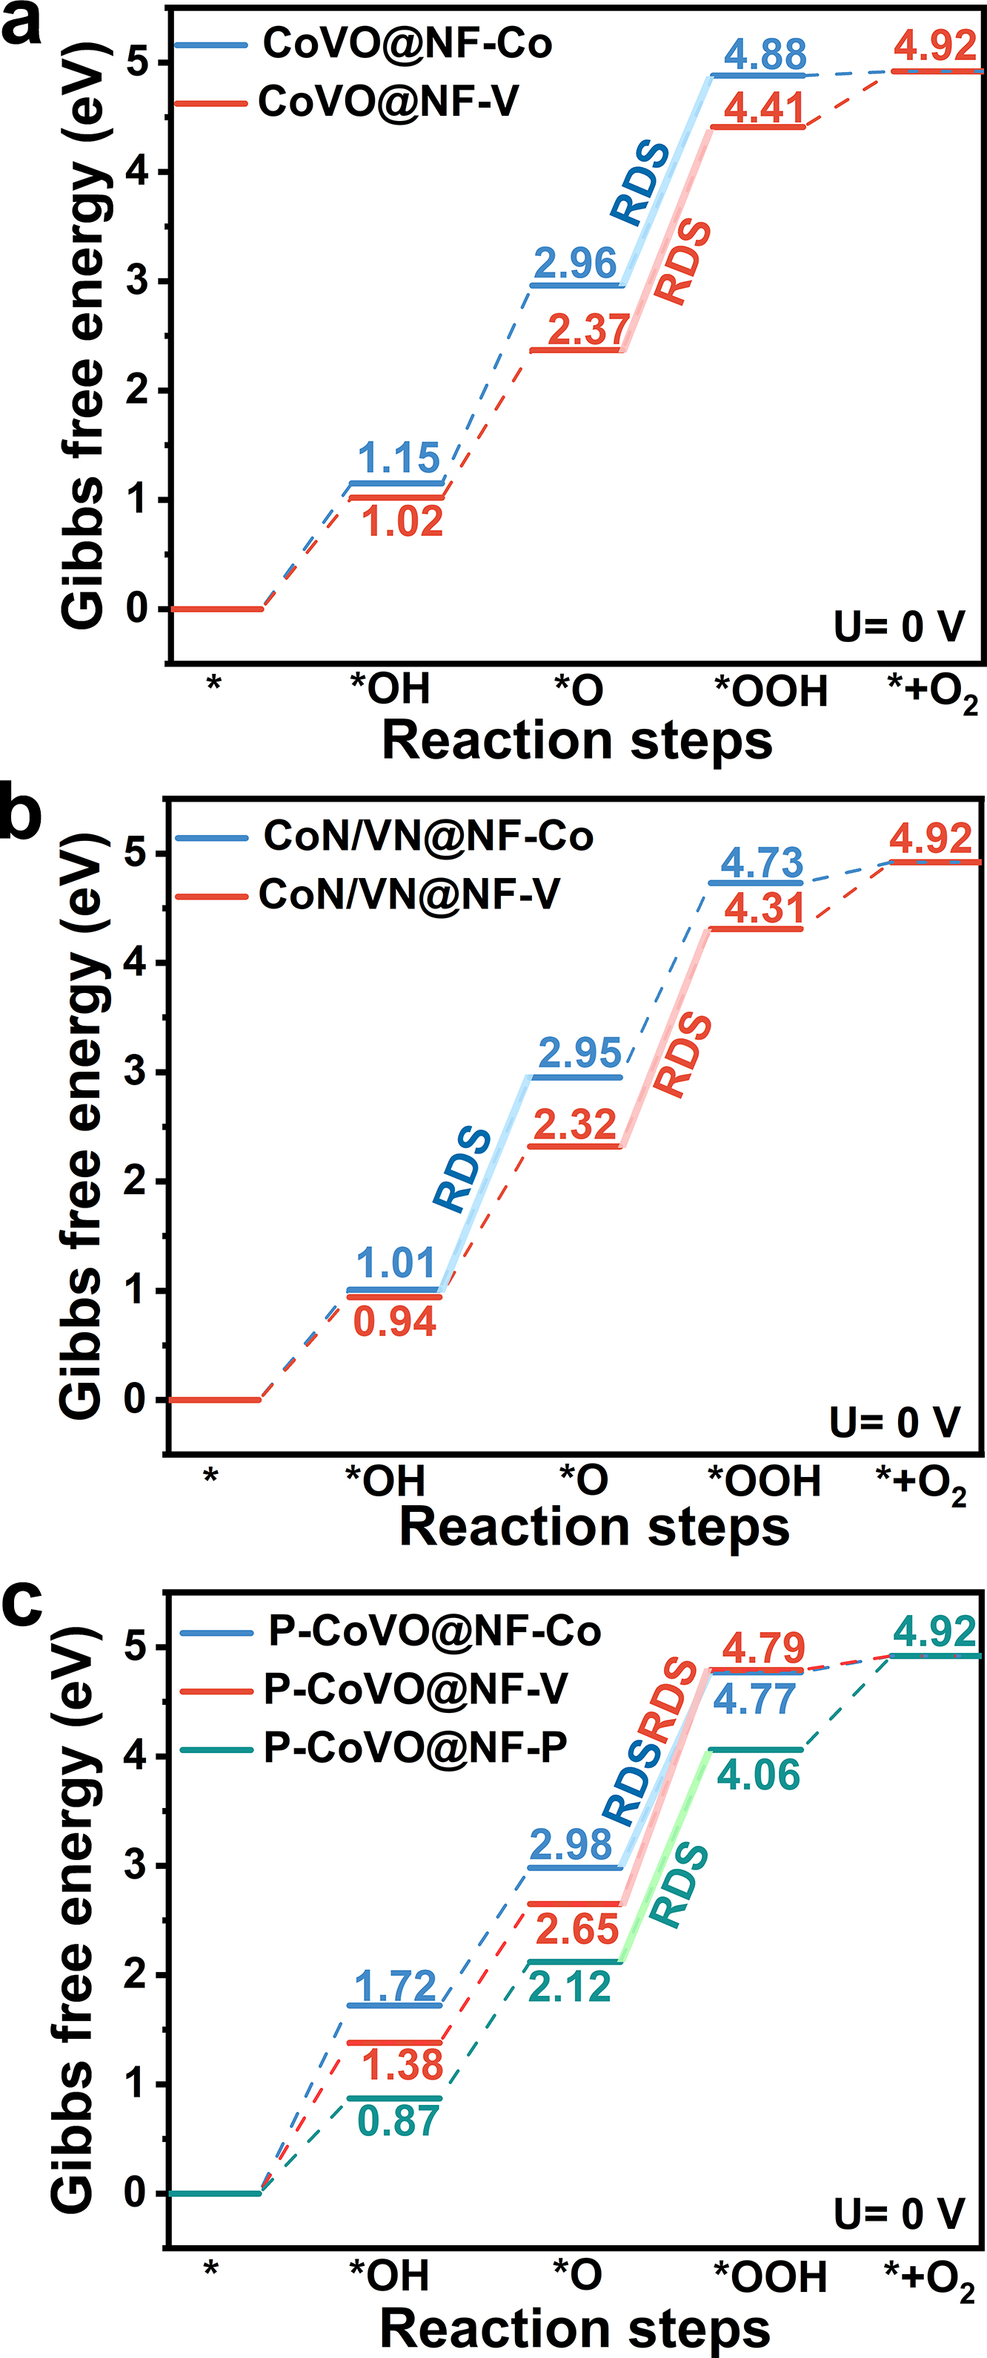
Supplementary Fig. 29. Free energy diagram of OER process on different sites for (a) CoVO@NF, (b) CoN/VN@NF and (c) P-CoVO@NF.

As shown in Figure S29, the change in Gibbs free energy of the OER intermediates (*OH, *O, *OOH) in the primitive step is depicted at an applied voltage of 0 V. The calculations conducted for the V sites reveal that the RDS occur during the conversion of *O to *OOH. Conversely, calculations for the Co site indicate that the crucial step for CoN/VN@NF is the generation process of *O, with the RDS for the Co site consistently smaller than that for the V site in all catalysts. These findings propose that the Co site could potentially serve as the active site with superior catalytic activity.

Supplementary Fig. 30. Partial density of state for Co in P-CoOOH@NF.

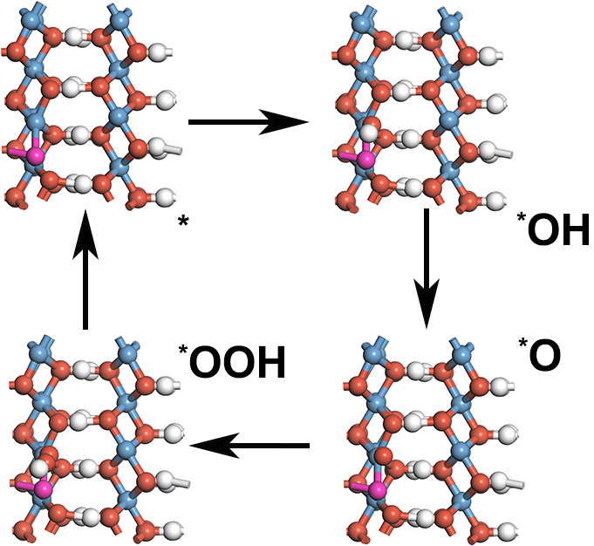
Supplementary Fig. 31. Models of OER intermediates on Co side of P-CoOOH@NF, where Co, P, O, and H atoms are represented by cyan, pink, red, and white spheres, respectively.

Supplementary Table 10. The comparison of the over water splitting cell voltage of this work with other reported electrocatalysts.
Catalyst | η₁₀ and η₁₀₀ in 1 M KOH^{[a]} (V) | Reference
Ni₃N-CeO₂/NF // Ni₃N-CeO₂/NF | 1.515, — | Adv. Funct. Mater. 2023, 33, 2306786
Co₇Fe₃/Co-600 // Co₇Fe₃/Co-600 | 1.50, 2.00 | Adv. Sci. 2023, 10, 2301961
Co₂P-Ni₃S₂/NF // Co₂P-Ni₃S₂/NF | 1.54, 1.89 | Small 2023, 19, 2304081
P-Mo-Co₃O₄@CC // P-Mo-Co₃O₄@CC | 1.54, 1.62 | Carbon Energy. 2023, 5, e279
CuNi@NiFeCu/CP // CuNi@NiFeCu/CP | 1.51, 1.81 | Appl. Catal. B Environ 2021, 5, 120600
V-CoP // V-CoP | 1.59, 1.82 | Adv. Energy Mater. 2021, 11, 2101758
Ni₅P_{4-x}I_{x}/Ni₂P NF // Ni₅P_{4-x}I_{x}/Ni₂P NF | 1.46, 1.77 | Adv. Sci. 2023, 10, 2205605
Ni_{x}S_{y}@MnO_{x}H_{y}/NF // Ni_{x}S_{y}@MnO_{x}H_{y}/NF | 1.530, 1.829 | Nano-Micro Lett. 2022, 14, 120
P-CoVO@NF // CoN/VN@NF | 1.43，1.75 | This work
[a] Values of current densities were read from the LSV curves in corresponding literature.

Supplementary Fig. 32. Polarization curves of RuO2@NF(+)||PtC@NF(‒) and P-CoVO@NF(+)||CoN/VN@NF(‒) systems in a H-type electrolytic cell.

Supplementary Fig. 33. Photos of gases collected by the drainage method at different time.

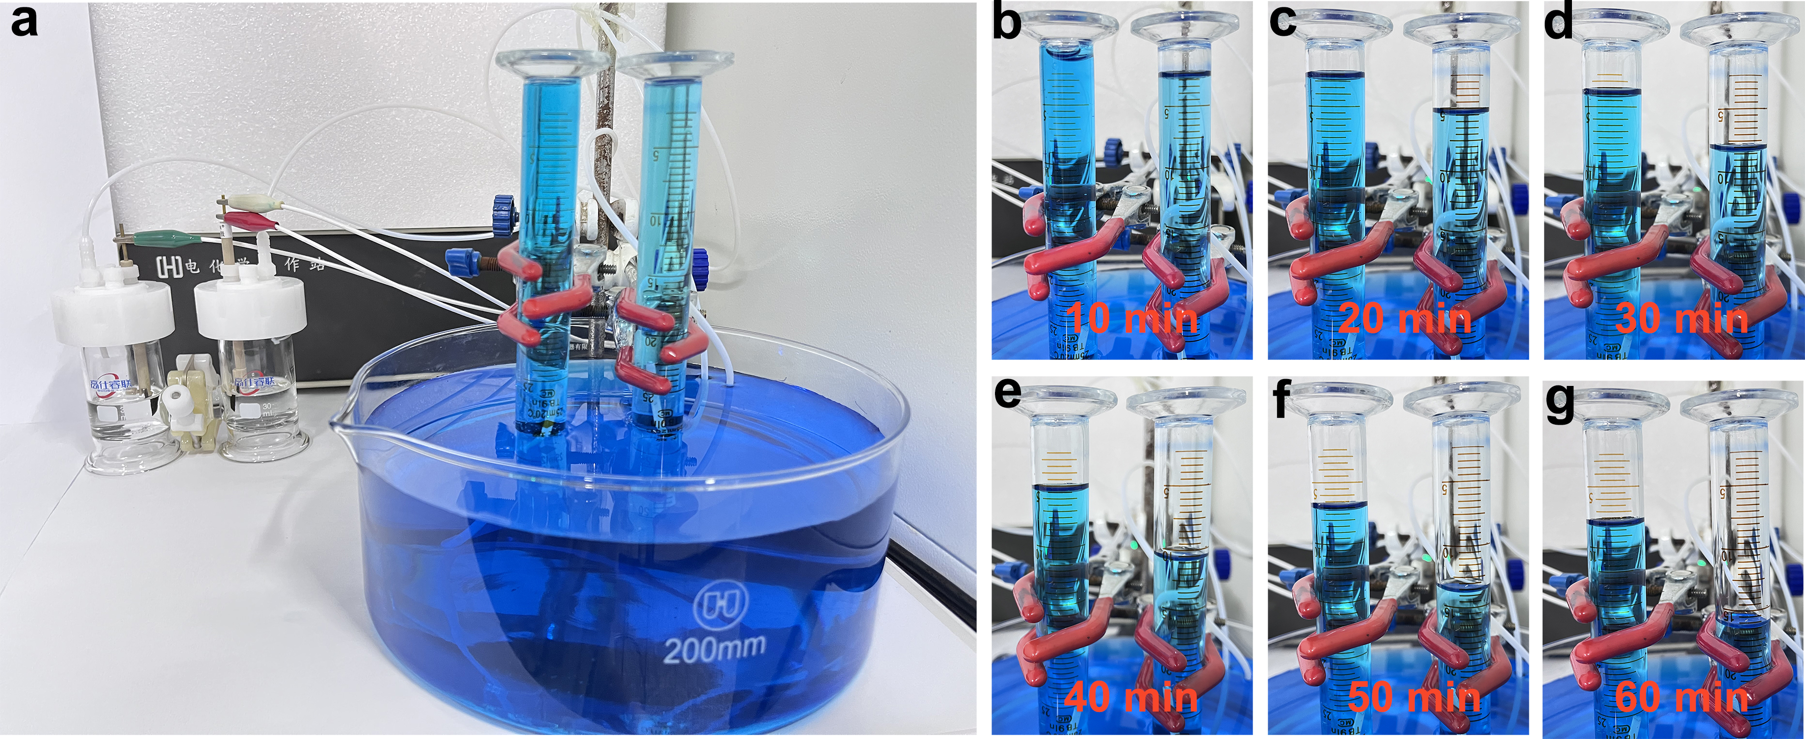
Supplementary Fig. 34. Chronoamperometric curve of P-CoVO@NF(+)||CoN/VN@NF(‒) system at 1.75 V.

Supplementary Fig. 35. The experimental and theoretical yield of H₂ and O₂ at a current density of 40 mA cm^{‒2} for calculating Faradaic efficiency of P-CoVO@NF(+)||CoN/VN@NF(‒) system.
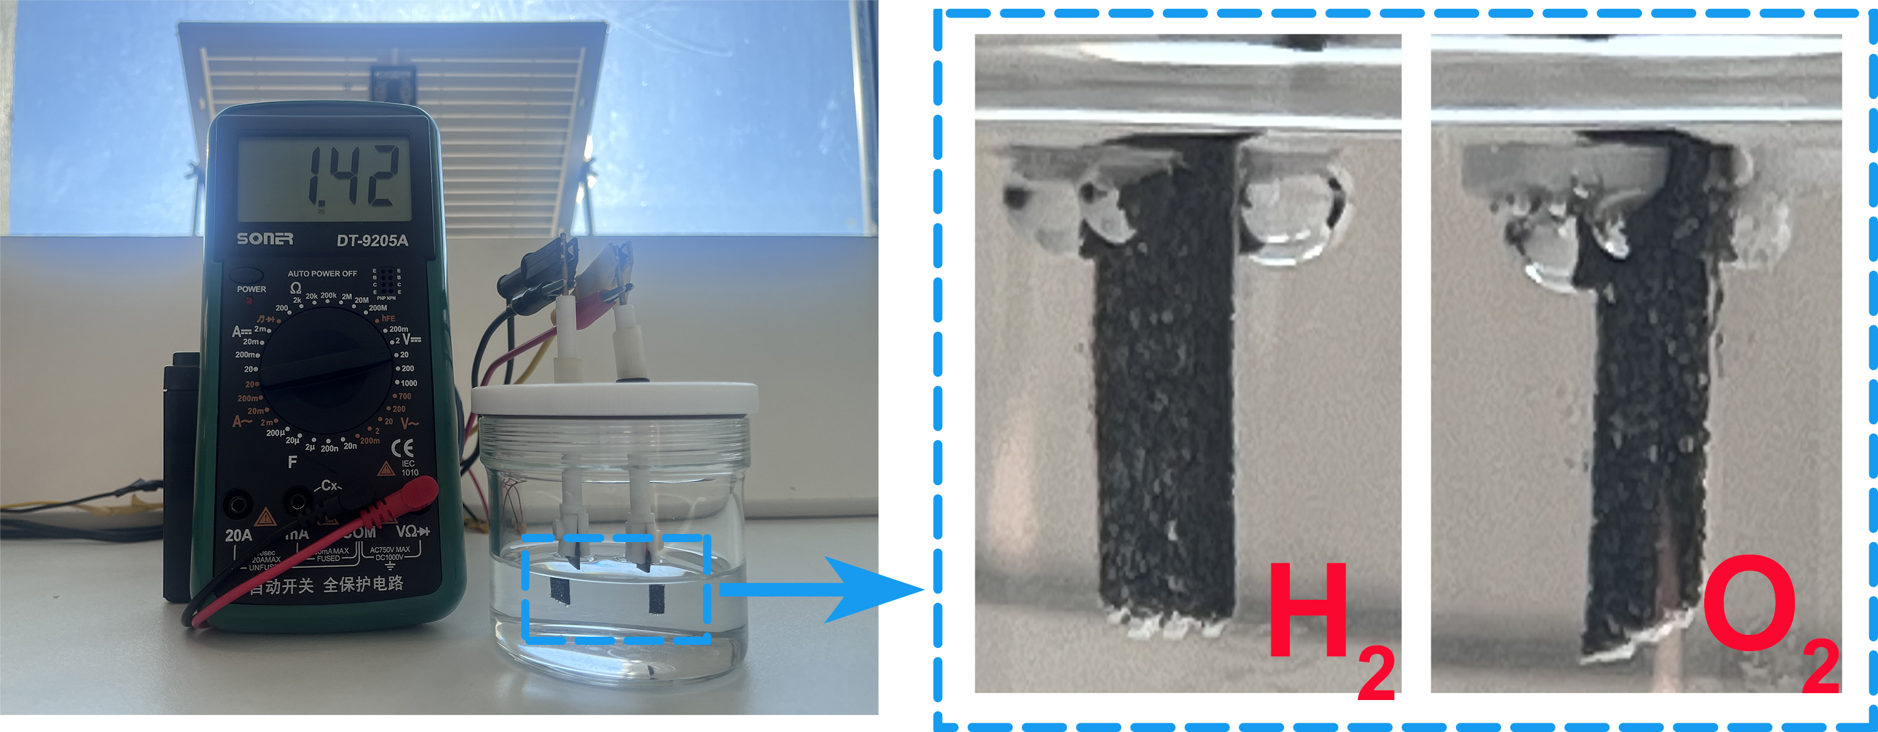
Supplementary Fig. 36. Photograph of P-CoVO@NF(+)||CoN/VN@NF(‒) system in a single electrolytic cell for overall water splitting driven by solar energy.

