Table S1. Details of the selected populations including fenced and unfenced patches.

Species | Population | Code | Altitude (m.a.s.l.) | Fencing  year | Total N ind. | N fenced ind.
Erodium cazorlanum | Puerto de Lezar | Ec_Lezar | 1898 | 1999 | 200 | 100
 | Valdeazores | Ec_Valde | 1560 | 2004 | 661 | 302
Hormathophylla baetica | Puerto Llano | Hb_Pllano | 1809 | 2005 | 360 | 234
 | Valdeazores | Hb_Valde | 1560 | 2004 | 887 | 400
Solenanthus reverchonii | Cabrilla Alta | Sr_Cabr | 1770 | 1983 | 240 | 62
Table S2. Summary of the linear mixed model for density of focal species (ind/m²). Significant differences at p<0.05 in bold. (Model= density ~ population*fenced, random= ~transect/population). Abbreviations for species and populations: Ec_Lezar=Erodium cazorlanum-Puerto de Lezar, Ec_Valde=Erodium cazorlanum-Valdeazores, Hb_PLlano=Hormathophylla baetica-Puerto Llano, Hb_Valde=Hormathophylla baetica-Valdeazores, and Sr_Cabr= Solenanthus reverchonii-Cabrilla Alta.

 | Response=density
Predictors | Estimates | CI | p
(Intercept) | 0.78 | 0.51 – 1.04 | <0.001
population [Ec_Valde] | -0.17 | -0.54 – 0.21 | 0.370
population [Hb_PLlano] | -0.40 | -0.77 – -0.03 | 0.037
population [Hb_Valde] | -0.51 | -0.89 – -0.14 | 0.009
population [Sr_Cabr] | -0.44 | -0.81 – -0.07 | 0.023
fenced [yes] | 0.46 | 0.09 – 0.84 | 0.017
population [Ec_Valde] *fenced [yes] | -0.46 | -0.99 – 0.07 | 0.087
population [Hb_PLlano] * fenced [yes] | -0.45 | -0.98 – 0.08 | 0.093
population [Hb_Valde] * fenced [yes] | 0.12 | -0.41 – 0.65 | 0.650
population [Sr_Cabr] * fenced [yes] | -0.68 | -1.21 – -0.15 | 0.014
N _{tr} | 50
Observations | 50

Model AIC= 55.45826.
Model Rsquare= 0.5896519
Random effects: StdDev Intercept: 0.2745345; StdDev Residual: 0.1029504

Table S3. Summary of the ANOVA performed after the lineal mixed model for density (table S2) of focal species (ind/m²). Significant differences at p<0.05 in bold. (Model= density ~ population*fenced, random= ~transect/population).

Source | numDF | denDF | F-value | p-value
(Intercept) | 1 | 40.00 | 180.57 | 0.00
population | 4 | 40.00 | 10.00 | 0.00
fenced | 1 | 40.00 | 4.22 | 0.05
population:fenced | 4 | 40.00 | 3.32 | 0.02

Figure S1. Partial view of sheep fence installed to protect Erodium cazorlanum at Valdeazores population (see table S1).

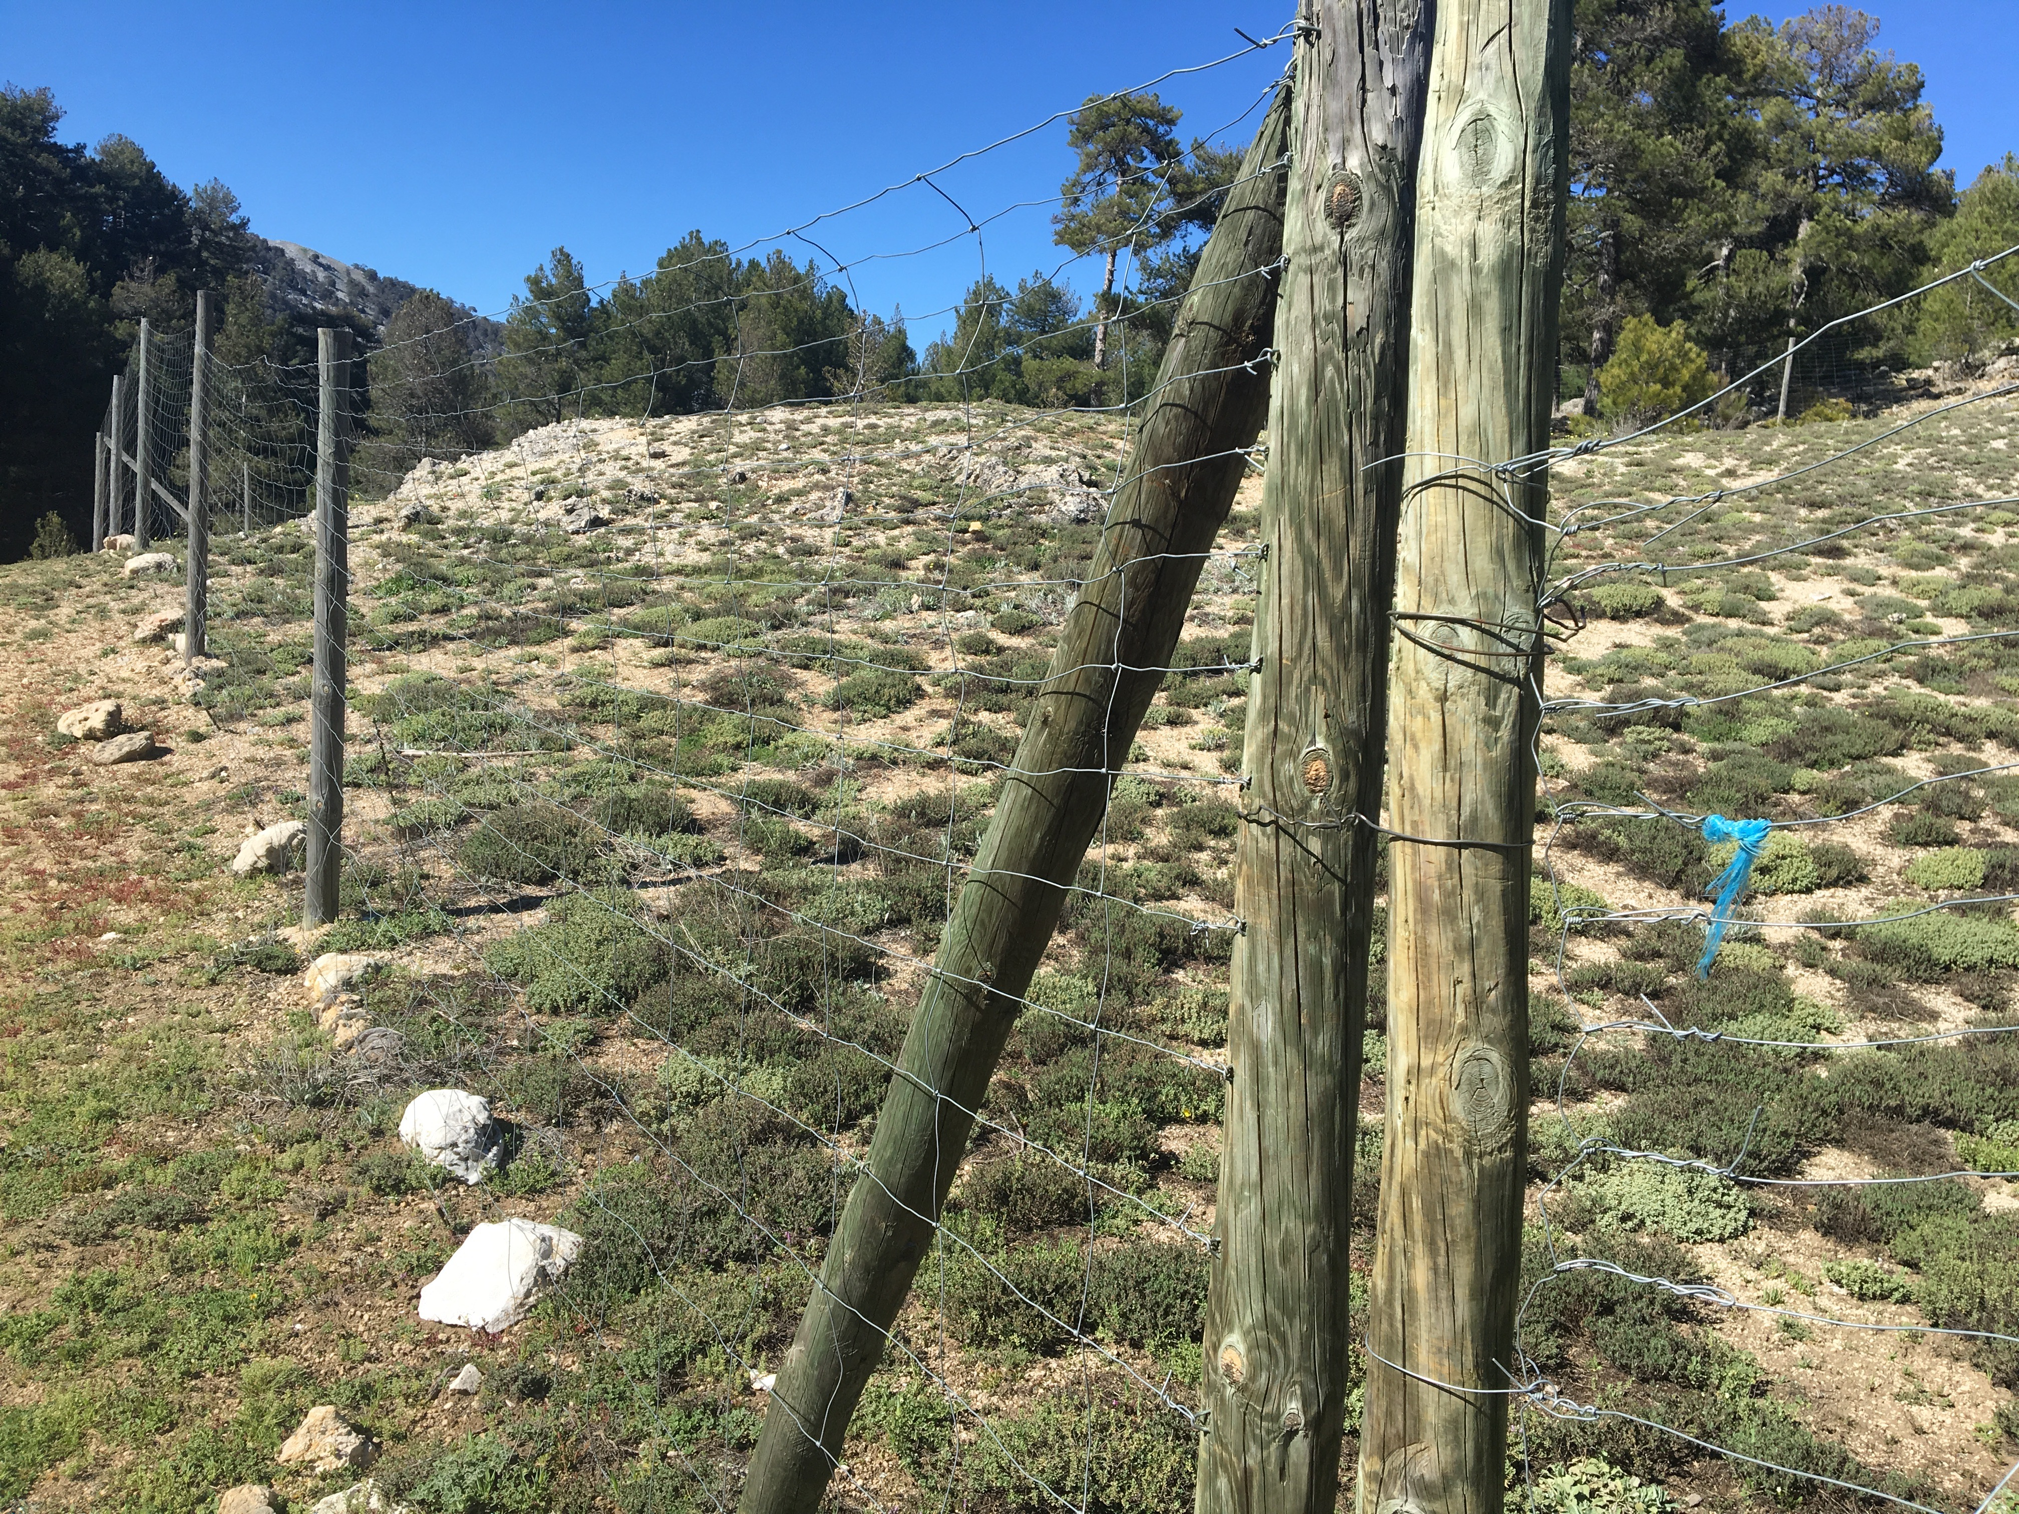

Figure S2. Relative percentage of vegetative (veg.) vs. reproductive (rep) for fenced (yes) and unfenced (no) individuals of the target species per population (Ec_Lezar=Erodium cazorlanum-Puerto de Lezar, Ec_Valde=Erodium cazorlanum-Valdeazores, Hb_PLlano=Hormathophylla baetica-Puerto Llano, Hb_Valde=Hormathophylla baetica-Valdeazores, and Sr_Cabr= Solenanthus reverchonii-Cabrilla Alta). n=30 in all cases.

