SUPPLEMENTARY FIGURES

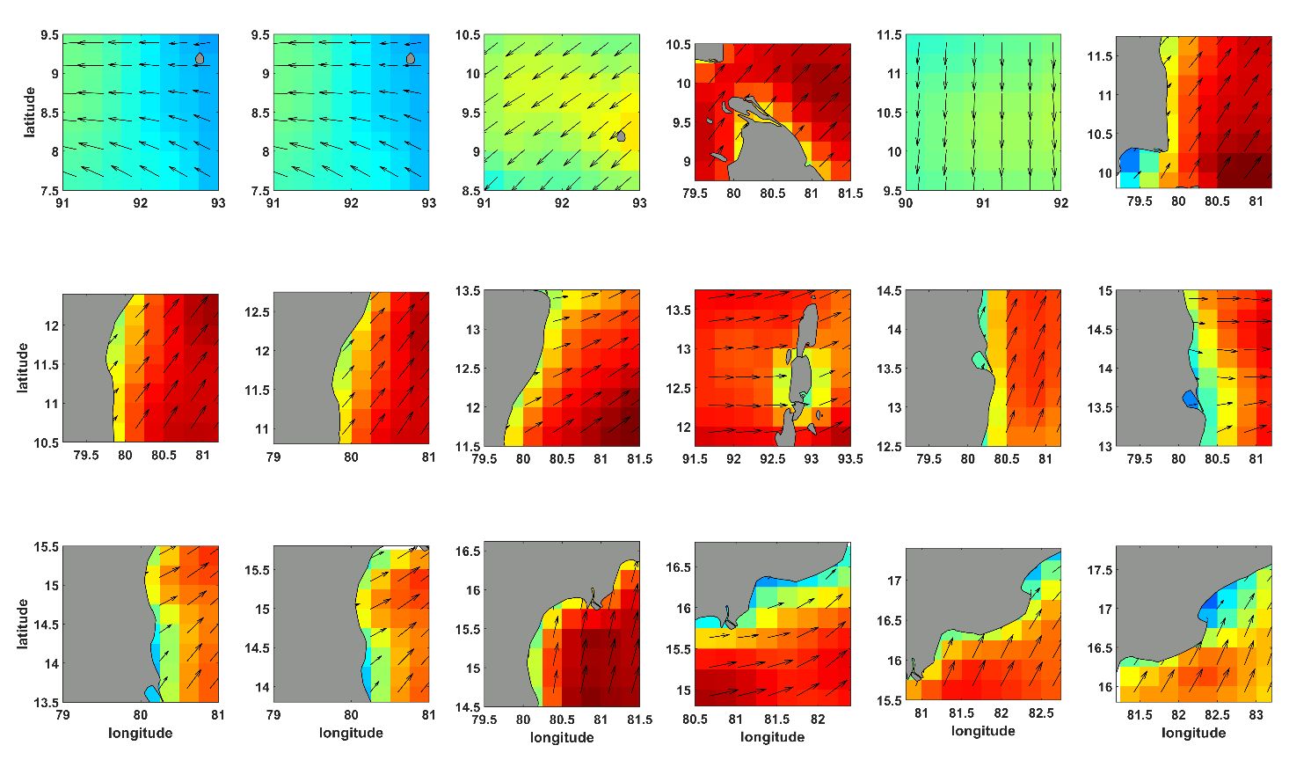
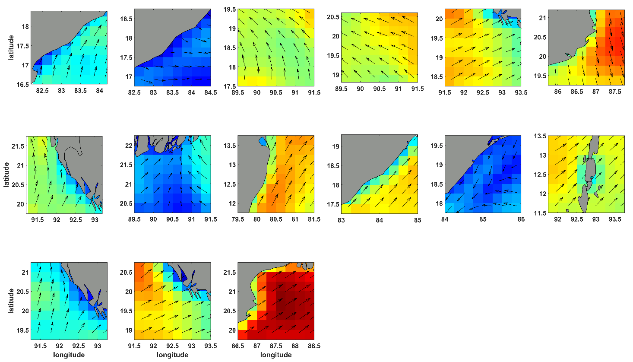
Supplementary Figure 1. The wind speed and direction maps for the respective SAR images.

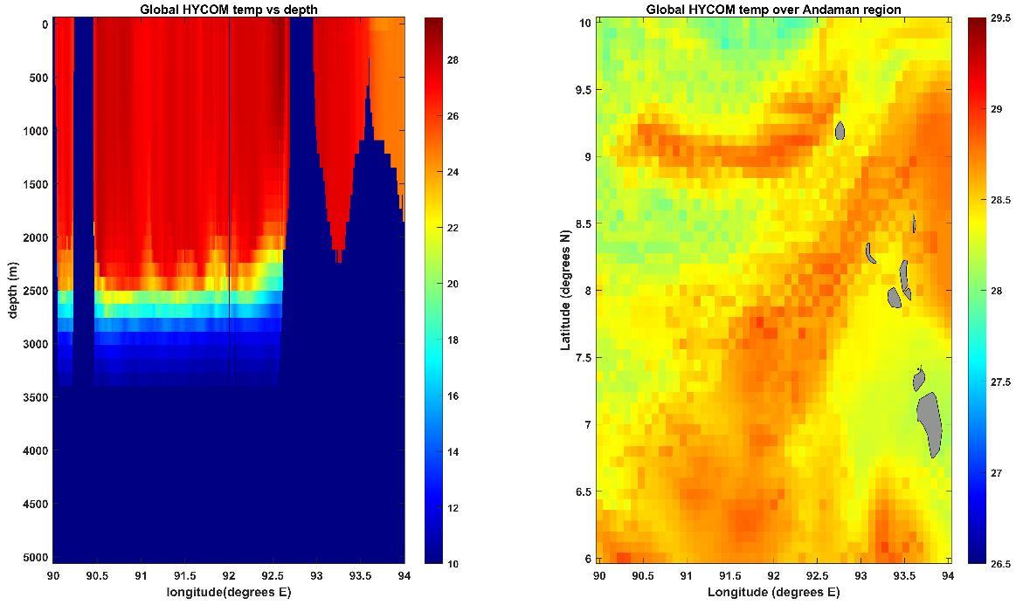
Supplementary Figure 2. The daily Global Open Hycom model simulations of sea surface temperature (°C) along the transect at 8.5° latitude and spatial plot on 11th Feb 2009 showing temperature fluctuations representing internal wave signatures.

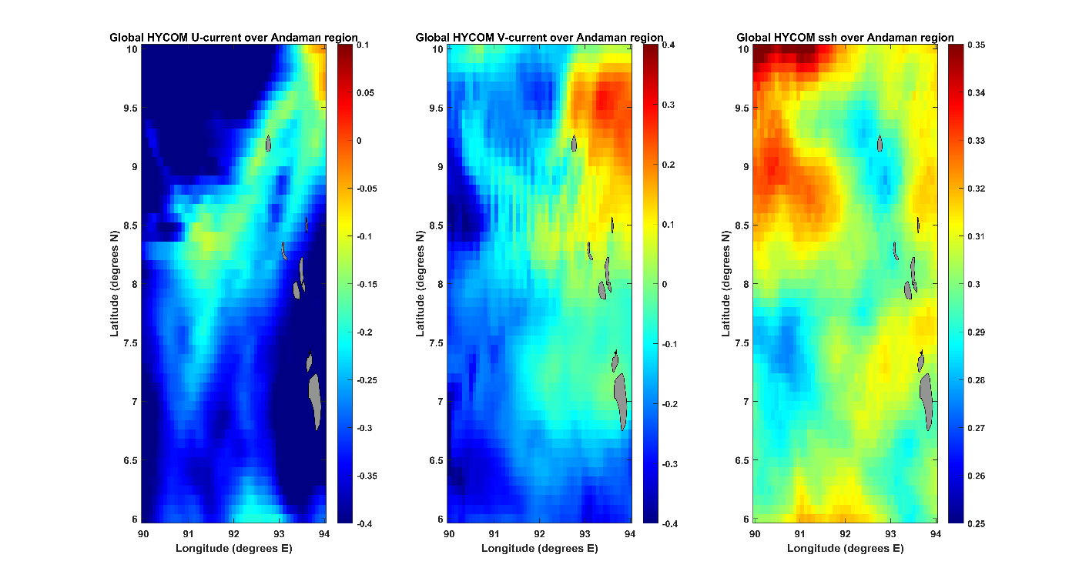

Supplementary Figure 3. The daily Global Open Hycom model simulations of U–current, V–current, and SWS data on 11th Feb 2009.

