SUPPLEMENTARY MATERIALS
Sundaixanthone A from the stem bark of Calophyllum sundaicum P. F. Stevens
Mas Atikah Lizazman¹, Vivien Jong Yi Mian^{1,*}
¹Faculty of Applied Sciences, Universiti Teknologi MARA, Kota Samarahan, Sarawak, Malaysia
*E-mail: vivien@uitm.edu.my

Abstract: Sundaixanthone A, a new compound from the class of xanthone was isolated from Calophyllum sundaicum collected in Sarawak, Malaysia. The compound was characterized using NMR techniques, and identified as 12-(2,3-dihydroxy-3-methylbutyl)-5,10-dihydroxy-2,2-dimethyl-2H,6H-pyrano [3,2-b] xanthen-6-one.
Keywords: sundaixanthone A, Calophyllum sundaicum, NMR characterization.


The structure of sundaixanthone A.

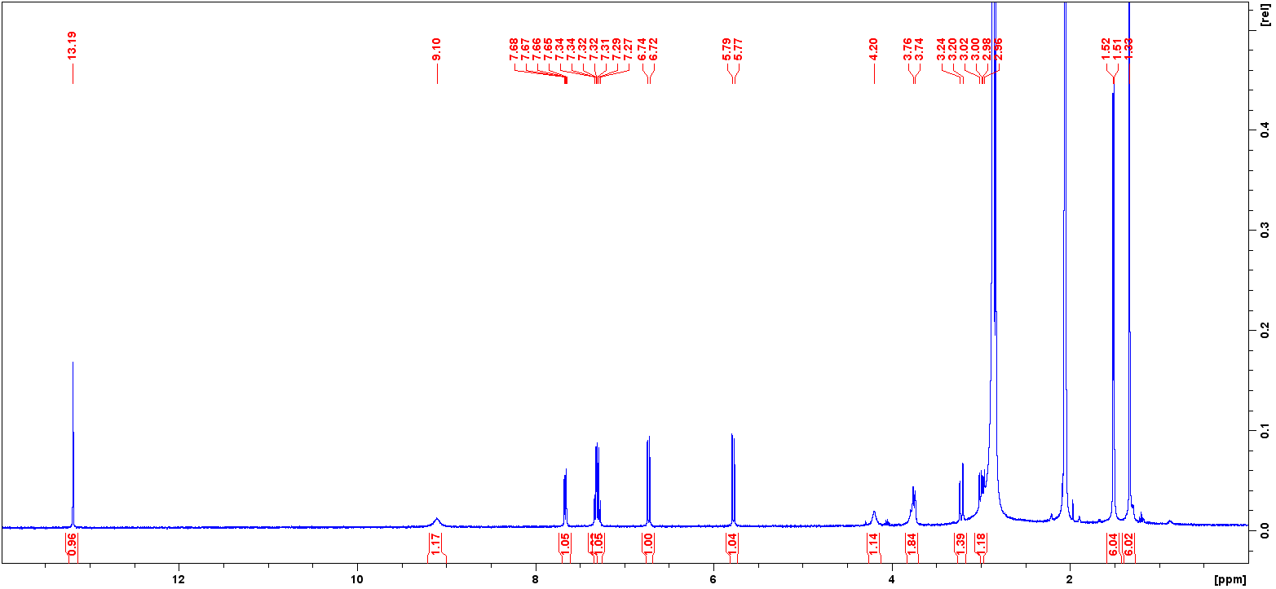
Figure S1. 1D (¹H) NMR spectrum (400 MHz, acetone-d₆) of sundaixanthone A.

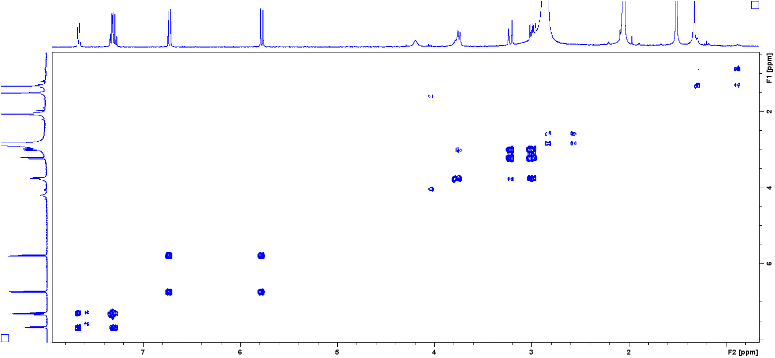
Figure S2. 2D (COSY) NMR spectrum (400 MHz, acetone-d₆) of sundaixanthone A.

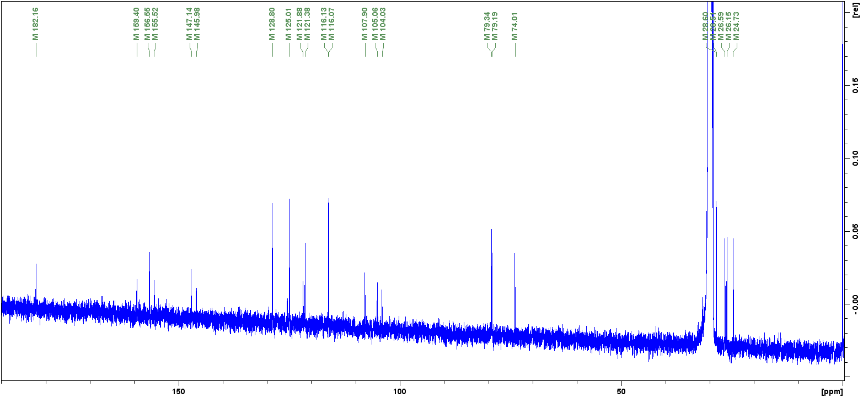
Figure S3. 1D (¹³C) NMR spectrum (100 MHz, acetone-d₆) of sundaixanthone A.

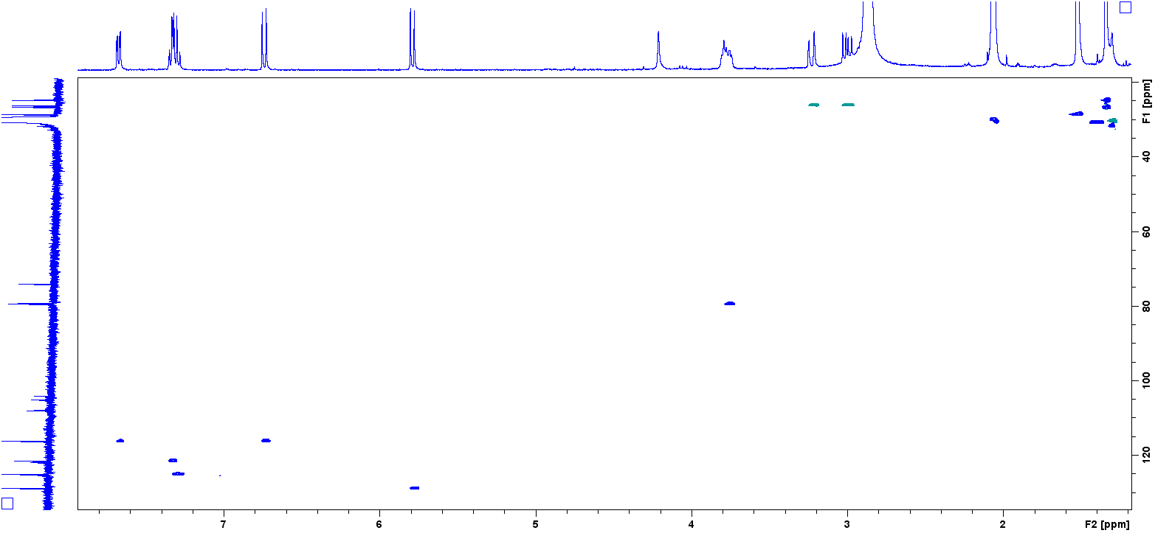
Figure S4. 2D (HSQC) NMR spectrum (400 MHz, acetone-d₆) of sundaixanthone A.

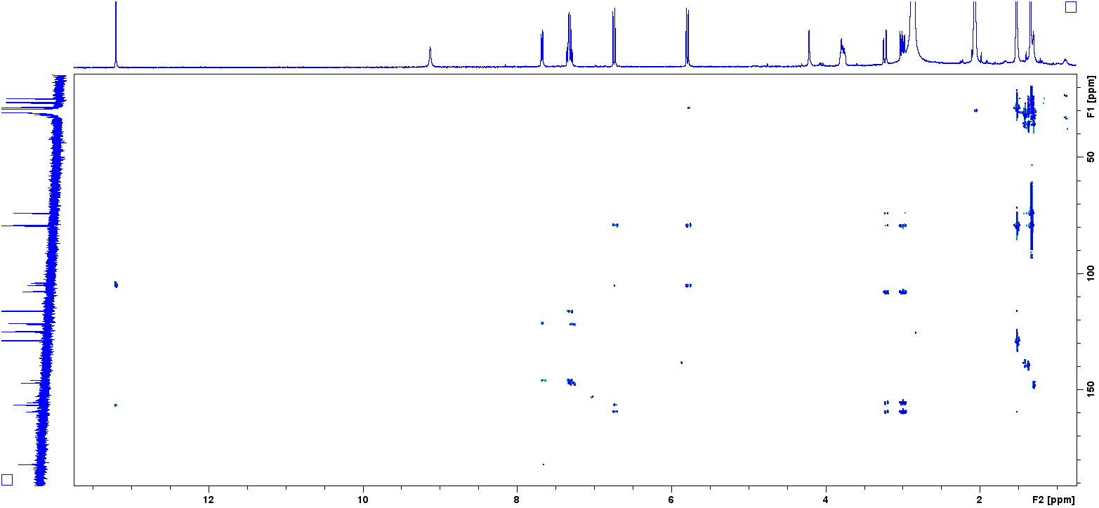
Figure S5. 2D (HSQC) NMR spectrum (400 MHz, acetone-d₆) of sundaixanthone A.

