Supplementary appendix

Supplement to: Y Qi, H Li, K Qi, et al. Clinical outcomes and microenvironment profiling of relapsed/refractory extramedullary disease of multiple myeloma patients with anti-BCMA CAR T cell-based therapy

Supplementary appendix
contents
Supplemental Methods 1
1. Study design and procedures 1
1.1 Inclusion and exclusion criteria 1
1.2 Definition of extramedullary disease in multiple myeloma 2
1.3 Representativeness of study participants 2
1.4 Clinical procedures 2
1.5 CAR T-cell manufacturing 3
2. Assessment of BCMA expression pre- and post-infusion 4
3. Peripheral CAR T-cell expansion and persistence 4
4. Risk management and risk assessment 5
4.1 Possible adverse events during cell infusion and its prevention and treatment 5
4.2 Adverse events after cell infusion and their prevention and treatment 5
5. Multiplex immunofluorescence (mIF) 6
Supplemental Figures 7
Figure S1. Consort diagram. 7
Figure S2. Subgroup analysis of ORR in R/R MM patients with EMD. 8
Figure S3. Survival analyses according to the status of best response and the presence of EMD. 9
Figure S4. Correlation of L-CRS with the occurrence and severity of systemic CRS, and timeline of systemic and local CRS. 10
Figure S5. Representative immunofluorescence images about BCMA expression at the time of medullary/EMD progression. 12
Figure S6. Distribution of infiltrating immune cell subsets in pre-treatment EMD biopsies according to tumor and normal tissue areas. 13
Figure S7. CAR T cell detection in the pleural effusion of select patients with pleural infiltration and clinically detectable localized inflammatory reactions at the early stage of CAR T-treatment. 14
Supplemental Tables 15
Table S1. Characteristics of patients receiving bridging therapy and re-assessment. 15
Table S2. Factors related to survival outcomes. 17
Table S3. Characteristics of R/R MM patients with EMD and without EMD 18
Table S4. Factors related to occurrence of L-CRS 19
Table S5. EMD response and toxicity of CAR T-cell therapy in patients experiencing L-CRS 20
Table S6. Comparison of plasma cell membrane BCMA expression level between baseline and progression/relapse in bone marrow/EMD 21
Table S7. Characteristics of baseline EMD biopsy specimens analyzed in immune microenvironment analysis 22
Table S8. Summary of primary antibodies and secondary antibody used for immunofluorescence 23
References 24

Supplemental Methods

1. Study design and procedures
This study design was approved by the institutional ethical review boards of The Affiliated Hospital of Xuzhou Medical University, Zhenjiang First People's Hospital, Affiliated Hospital of Nantong University, Yancheng First People's Hospital, Changzhou First People's Hospital. Clinical trial was registered at www.chictr.org.cn as #ChiCTR-OIC-17011272. The recruitment period for this study cohort was between May 1, 2017, and September 1, 2023.

1.1 Inclusion and exclusion criteria
Inclusion criteria
1. Male or female participants aged 18-70 years at time of enrollment.
2. Life expectancy > 12 weeks.
3. Participants must have a confirmed diagnosis of multiple myeloma.
4. Refractory or relapsed multiple myeloma patients
5. ALT/AST<3 × institutional upper limit of normal.
6. Total bilirubin ≤2.0mg/dl.
7. Performance status (Karnofsky≥50%).
8. Voluntarily participated in the trial of CAR-T for the treatment of multiple myeloma.
9. Blood was collected intravenously and no other contraindications for apheresis.
10. Informed Consent/Assent: All subjects have the ability to understand and the willingness to sign a written informed consent.
11. Participants must have at least one histologically confirmed EMD resulting from hematogenous spread involving different organs, skin, and lymph nodes; with no relationship to the adjacent bone lesions at screening.
Exclusion criteria
1. Pregnant or lactating women, or female with a pregnancy plan within six months.
2. Infectious diseases (e.g., HIV, active tuberculosis, etc.).
3. Active hepatitis B or hepatitis C.
4. Evaluation screening showed that the transfected lymphocytes were less than 10% or proliferation< 5 times under the co-stimulation of CD3/CD28.
5. Pregnant or lactating women, or female with a pregnancy plan within six months.
6. Active hepatitis B or hepatitis C.
7. Abnormal vital signs and failure to cooperate with the examination.
8. Any mental or psychological illnesses that could, in the investigator's opinion, potentially interfere with the completion of treatment.
9. Highly allergic constitution or history of severe allergies, especially to IL-2.
10. Systemic or severe local infections require anti-infective treatment.
11. Evidence of current uncontrolled dysfunction of heart, lung, brain, and other important organs.
12. Active and severe auto-immune disease.
13. Other conditions that are not eligible for the trial in the judgment of the principal investigator.

1.2 Definition of extramedullary disease in multiple myeloma
Extramedullary disease (EMD) is a less frequent manifestation of multiple myeloma, where myeloma cells become independent of bone marrow microenvironment, infiltrate other organs/tissues and/or circulate freely in the blood (1). The definitions of EMD vary greatly in multiple myeloma patients. In this study, we have used a more stringent definition inclusive of extra-osseous plasmacytomas resulting from hematogenous spread involving different organs, skin, and lymph nodes; with no relationship to the adjacent bone lesions (2, 3). Evidence of extramedullary involvement was confirmed by either multiparameter flow cytometry of specimens of pleural effusion, and cerebrospinal fluid, or by immunohistochemistry of formalin-fixed paraffin-embedded tumor tissues (e.g., soft-tissue plasmacytoma biopsies), or by radiographic imaging at extramedullary sites.

1.3 Representativeness of study participants
Table 1 Study representativeness table
Cancer type(s) / subtype(s) / stage(s) / condition | Relapsed/refractory multiple myeloma (R/R MM) with extramedullary disease (EMD)
Considerations related to:
Sex | According to a review of the Swedish registry, extramedullary plasmacytoma occurs with a predicted incidence of 0.063/100,000 in females and 0.078/100,000 in males. Bone-related plasmacytoma occurs with a predicted incidence of 0.090/100,000 in females and 0.191/100,000 in males (4). A longitudinal study comprising 1003 MM patients treated in one center between 1971 and 2007, EMD was associated with younger age and higher prevalence in males (5).
Age | The median age at diagnosis of MM is approximately 65 years (2), while it occurs at a median age of 55 in R/R MM patients with EMD. Further, the median age for patients with bone-related plasmacytoma is higher as compared to patients with extramedullary plasmacytoma (71 vs 60.5 years) (2; 3).
Race/ethnicity | It is more than twice as common among African Americans with an incidence of  16.5/100,000 among African American men and 12.0/100,000 among African American women (6). Asians and Pacific Islanders were at a decreased risk, at 5.0 and 3.2 for men and women, respectively (6).
Geography | Incidence of EMD at diagnosis ranges between 6% and 10%, while later in the course of the disease this increases to 13%-26%, with a 32-35% peak in case of relapse after allogeneic stem cell transplantation (3; 7). In the final stage of the disease, and bone-independent involvement is observed in approximately 70% of cases studied with autopsy, 7 with a peculiar involvement of visceral sites (7).
Other considerations | Patients in ISS stage III had an increased risk for EMD progression (8).  EMD is associated with high-risk features, such as high LDH levels, high-risk cytogenetics, or high-risk gene expression profiles such as del(17p) aberration (8).
Overall representativeness of study | The age distribution of our study is in line with the average age distribution of R/R MM patients with EMD in the literature, median age of 55 years.  Our study consisted of a greater number of male patients (54.8%) than female patients (45.2%) which is consistent with previous reports showing a greater incidence of EMD in male patients than in female patients.  ISS stage III was more common in this study population (48.4%), followed by ISS stage I (22.6%) and II (29.0%), which is similar with the constituent ratio reported previously.  A higher prevalence of p53 deletion was observed in this study population (32.3%), which is consistent with the prior data.  The majority patients in this study presented with elevated LDH level at the time of screening, which is consistent with the prior data.  It should be acknowledged that this was a small cohort (n=31), thus impacting the potential representativeness of the R/R MM patients with EMD.

1.4 Clinical procedures
After providing written informed consent, all eligible patients would undergo apheresis. All included patients are given fludarabine (30 mg/m²/d, day -5 to -3) and cyclophosphamide (750mg/m²/d, day -5) for lymphodepletion chemotherapy. Patients with high disease burden at screening in bone marrow (e.g., at least 50% bone marrow clonal plasma cells) or in EMD (e.g., involvement of vital mediastinal structures/organs/central nervous system, or with severe compressive pain, or with bulky plasmacytomas) are permitted to have bridging chemotherapy during the manufacturing interval between apheresis and lymphodepletion at the discretion of the treating physician. After bridging therapy, a EMD re-assessment is required after bridging therapy, and before CAR T-cell infusion. Procedures are demonstrated in figure 1.
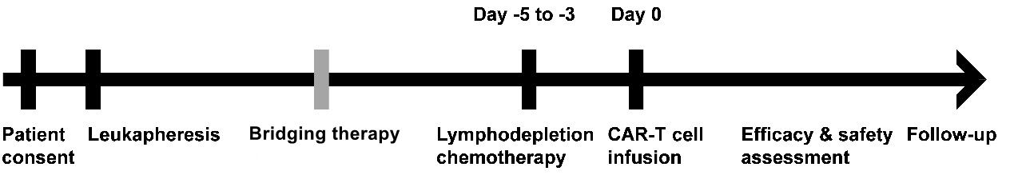
Figure 1. Schematic diagram of study procedures.
CAR T cells are infused two days after the end of lymphodepletion chemotherapy. Patients received sequential anti-BCMA and anti-CD19 CAR T cells at a dose of 1 × 10⁶ cells/kg on day 0. During the entire infusion process, the patient's vital signs should be closely monitored. 30 to 60 minutes before CAR T-cell infusion, patients are given 325 to 650 mg of acetaminophen to prevent infusion-related reactions.
The response was assessed according to the International Myeloma Working Group (IMWG) criteria (9). Re-evaluation of the response was performed two weeks, 1 month, 2 months, 3 months, 6 months, and one year after CAR T-cell infusion. Patients were followed up for analysis of progression and survival outcomes to the data cutoff of May 1, 2023. We collected clinical data regarding general information at enrollment, clinical manifestations, laboratory examinations and diagnostic imaging at diagnosis, treatment, and follow-up. Assessment of EMD included imaging techniques (MRI, CT, or ¹⁸F-FDG PET-CT), physical examination, and biopsy of involved tissues for pathological examination when necessary. Patients should be reassessed and given salvage therapy under the condition of disease progression or relapse at any time.
The metabolic tumor volume in the whole body (WB MTV) determined by ¹⁸F-FDG PET/CT was used to assess extramedullary disease burden at screening based on imaging (10). The MTV of each lesion was calculated using an automated contouring program based on the standardized uptake value and developed with a threshold of 40% of the maximum standardized uptake value. The WB MTV of each patient was defined as the sum of metabolic volume of all focal lesions.

1.5 CAR T-cell manufacturing
Chimeric antigen receptors targeting CD19 and BCMA were synthesized and subcloned into lentivirus expression vector Lenti-EF1a-puro. The expression vectors targeting CD19 lentivirus are as follows (figure 2):
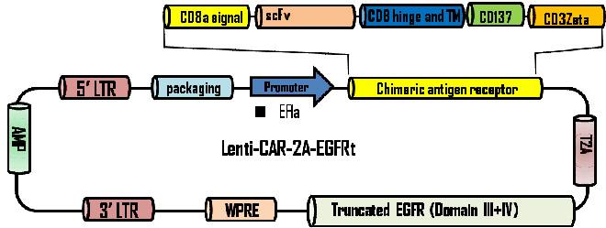
CD19
Figure 2. Structure of a targeted CD19 lentiviral expression vector
The scFv used in humanisedCD19-CAR-T removes the heterologous protein sequence, while retaining the affinity and specificity of the parent mouse antigen, reducing the possibility of HAMA reaction to the lowest level and effectively prolonging CAR-T cells persistence in vivo.
The expression vectors targeting BCMA lentivirus are as follows (figure 3):
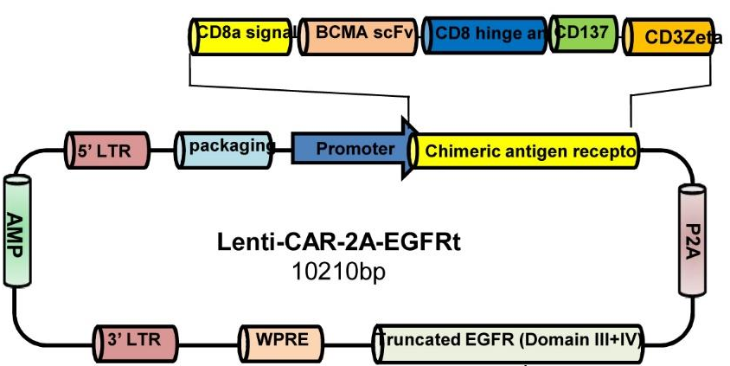
Figure 3. Structure of a targeted BCMA lentiviral expression vector
PBMC was isolated from peripheral blood of patients and CD3⁺ T cells were separated by magnetic beads. After activation, T cells were infected with recombinant lentivirus carrying anti-BCMA CAR construct, and CAR-T cells were expanded. The expression of EGFRt on the surface of recombinant CAR-T cells was detected by flow cytometry.

2. Assessment of BCMA expression pre- and post-infusion
Bone marrow aspirate, pleural effusion, and cerebrospinal fluid was collected for MRD detection. MRD was detected according to EuroFlow antibody panels for plasma cell disorders. In order to clarify the expression of BCMA in different patients before and after treatment, we added anti-BCMA antibody on the basis of panel. Multiple myeloma Flow-MRD antibody panel:
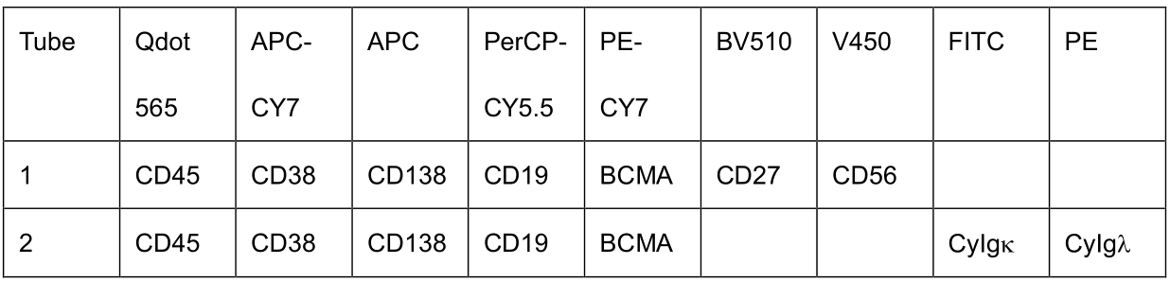
Multiparameter flow cytometry analysis was performed on fresh specimens and isotype control antibody was used in each sample for normalization. Plasma cells were gated according to the expression of CD45 and CD38. Phenotype of plasma cells was defined as low level of CD45 and intermediate-to-high level of CD38, which was abbreviated as CD45^{low}CD38^{int/hi} thereafter. MRD-negativity was defined as the absence of phenotypically aberrant clonal plasma cells with a minimum sensitivity of 10⁻⁵ monoclonal myeloma cells among mononuclear cells. Plasma cells were further analyzed for BCMA expression density, quantified by proportion of BCMA⁺ cells in malignant plasma cells, or by mean fluorescence intensity of BCMA expression. No less than 1.0×10⁵ cells were acquired in multiparameter flow cytometry analysis for each sample.
For detection of BCMA expression in extramedullary plasmacytoma, immunofluorescence of formalin-fixed paraffin-embedded tumor tissue was conducted in needle or excisional biopsy samples obtained under imaging guidance. BCMA expression (Proteintech Group, Inc, Cat No. 27724-1-AP) density was assessed by calculating the proportion of BCMA⁺ cells in CD138⁺ (Abcam, ab226108) tumor cells.
In this study, BCMA positive status was defined as conditions with at least one of the following characteristics: (1) BCMA expression detected in≥50% of malignant plasma cells by immunofluorescence, or (2) mean fluorescence intensity of BCMA expression≥1000 as determined by MFC. Because of lack of systematic quantification of antigen density, we use BCMA decrease/negative to include the case of partial or total BCMA loss.

3. Peripheral CAR T-cell expansion and persistence
The expansion and persistence of CAR T cells in patients’ peripheral blood, bone marrow, and cerebrospinal fluid was assessed by flowcytometry. Mononuclear cells isolated from patients’ samples collected per schedule post infusion were stained with Biotin labeled protein L antibody (GenScript, Nanjing, CHN) to detect the variable light chains (kappa chain) of exogenous CARs. The cells were then stained with Alexa Fluor 647‑conjugated Streptavidin (Jackson Immuno Research laboratories) and an anti-CD3 antibody. The percentage of peripheral blood CD3⁺ T lymphocytes that was CAR⁺ cells were determined by flowcytometry. The absolute number of CAR⁺ cells/μL of blood was determined by multiplying the percentage of CAR⁺ cells by the sum of blood CD3⁺ T lymphocytes/μL.

4. Risk management and risk assessment
In view of the safety of the subjects, possible AEs of the subjects should be closely monitored during the trial, and when adverse events occur, the investigator should determine whether it’s necessary to take measures quickly to ensure the safety of the subjects. Possible adverse events occurring to the subjects during the trial, and their prevention and treatment are described as follows:

4.1 Possible adverse events during cell infusion and its prevention and treatment
(1) Allergic reaction:
1) The non-autologous ingredients added during cell culture and manufacture may cause allergic reactions manifested as rash, laryngeal spasm, hypotension, and shock.
2) Rash: oral antihistamines.
3) Laryngeal spasm: intravenous adrenocortical hormone, fluid transfusion, and tracheotomy if necessary.
4) Hypotension and shock: Patients are treated with rapid intramuscular injection of Epinephrine, intravenous injection of Dexamethasone, fluid transfusion, and infusion of vasopressor drugs.
(2) Chill, fever, fatigue, anorexia, systemic pain, etc.
1) Although adequate washing is performed during the preparation of cell infusion, the cytokines in the supernatant of CAR T cells culture and a variety of allogeneic proteins mentioned above remain inevitably, causing these symptoms after infusion.
2) If the body temperature is greater than 39 ℃, give the antipyretic treatment such as Indometacin suppository or other antipyretic and analgesic drugs, Bupleurum and so on.

4.2 Adverse events after cell infusion and their prevention and treatment
(1) The most common adverse event after cell infusion is cytokine release syndrome, and its main manifestations and treatment principles are shown in table 1. The management of cytokine release syndrome and ICANS is based on ASTCT 2019 Consensus Grading for Cytokine Release Syndrome and Neurologic Toxicity Associated with Immune Effector Cells (11).
(2) Secondary infection due to low immunoglobulin: intravenous immunoglobulin, and corresponding antibiotic treatment according to the actual condition.
(3) Other complications caused by chemotherapy: according to the leukemia complications after chemotherapy treatment.

Table 2 Severe adverse events reaction and treatment
Clinical manifestation of severe adverse events | Clinical response to CRS
High fever | Antipyretic, TNF-α receptor blockers, Tocilizumab
Muscle pain | Nonsteroidal anti-inflammatory drugs
Vascular leakage syndrome: interstitial edema and hypotension | Vasopressors: Dopamine maintenance
ARDS (caused by acute pulmonary edema) | Continuous Positive Airway Pressure (CPAP)
Acute renal failure | Hemodialysis and so on
Acute heart failure | Diuresis and the cardiotonic agent
Abnormal liver function (abnormally elevated ALT/AST, and jaundice) | Liver protection, relieving jaundice, plasma exchange if necessary (artificial liver)
Pancytopenia | Protective isolation
Persistent hypo-fibrinogen (bleeding rarely occurring) | Replenish fibrinogen and plasma
ICANS, or other neurotoxicities | Dehydration, symptomatic treatment, hormone usage when necessary, self-limited
Hemophagocytic lymphohistiocytosis | Plasma exchange
Local-cytokine release syndrome | For patients without compression symptoms, continuous clinical observation and supportive care are recommended;  When compression symptoms occur, TNF-α receptor blockers and local intervention (if necessary), such as tracheotomy and drainage of serous effusion, should be implemented.

5. Multiplex immunofluorescence (mIF)
mIF was performed using the Opal multiplex system (Perkin Elmer, Waltham, MA) to visualize the expression of CD8, PD-1, TIM-3, LAG-3 (Panel 1); CD68, CD86, CD163 (Panel 2) in EMD tissues in two panels. The specimens were collected within 30min after tumor collection and fixed in formalin for 24-48h. Dehydration and paraffin embedding were performed using routine methods. Five consecutive sections (3µm-thick) were cut from paraffin blocks. One section was used for H&E staining. Two FFPE tumor slides were melted at 60°C for dehydration for 12 h. Paraffin sections were deparaffinized in xylene and re-hydrated in alcohol. Heat-induced antigen retrieval was performed in Tris/EDTA (pH 9.0) buffer. The sections were blocked with commercially available blocking buffer for 10 min. The primary antibodies used for each staining are listed in Supplementary Table S8. The concentration and staining order of the antibodies used in this study were optimized in advance. The slides were serially incubated with primary antibodies and horseradish peroxidase-conjugated secondary antibodies (Biolynx, Hangzhou, CHN) and subjected to tyramide signal amplification (TSA). Each round of TSA operation was followed by additional antigen retrieval and antibody stripping before the next round of staining. After all sequential staining reactions, sections were counter-stained with DAPI to visualize all cell nuclei.
Slides were scanned and digitalized by Zeiss AxioScanner Z.1 (Carl Zeiss AG) with ×20 objective magnification. The multi-spectral images were analyzed using the AP-TIME image analysis software (APiLab, Shanghai, CHN). Tissue-component segmentation of tumor and normal regions, cell phenotyping through quantification of individual and/or co-expressing markers, and spatial imaging analysis were performed.

Supplemental Figures

Figure S1. Consort diagram.
The diagram shows all participants’ courses from the time of enrolled in the study.
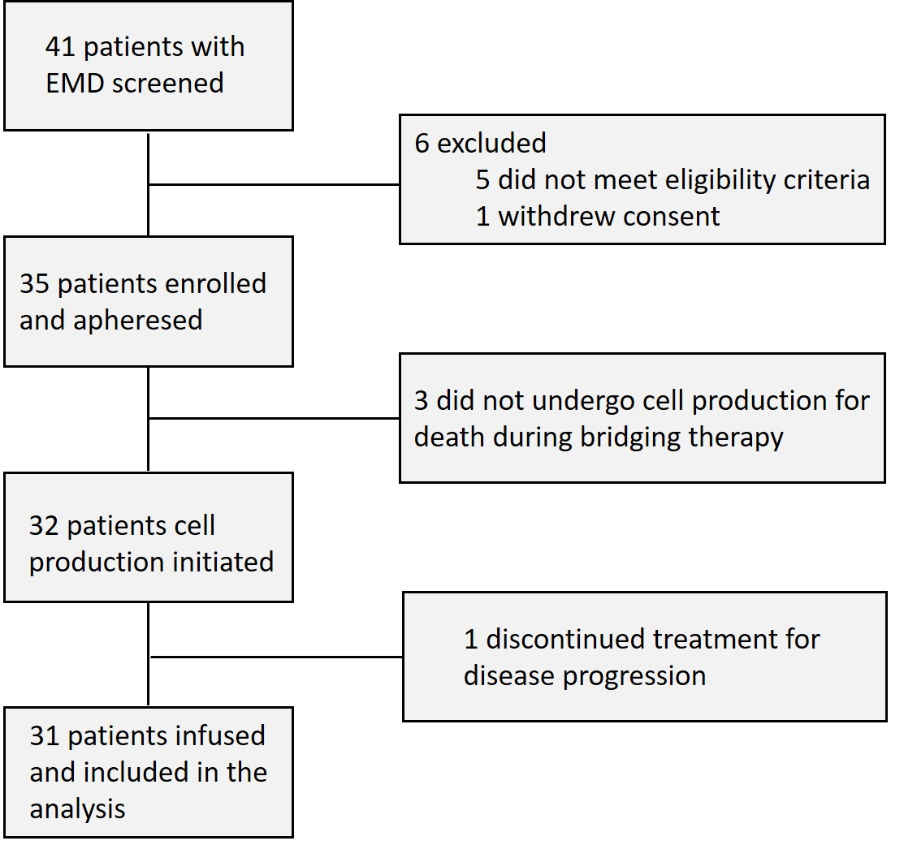

Figure S2. Subgroup analysis of ORR in R/R MM patients with EMD.
The forest plots showed the subgroup analyses of overall responses in medullary disease and EMD according to clinical characteristics at baseline. Plotted points represent the observed proportions, and the lines extending from the dots are the 95% CIs for these proportions. The 95% CI was calculated with the Clopper-Pearson method. Vertical dashed lines represent overall response rates of medullary disease and EMD in the 31 patients. Abbreviations: KPS=Karnofsky Performance score; R-ISS=Revised-International Staging System; LDH=lactic dehydrogenase; ASCT=autologous stem-cell transplantation.
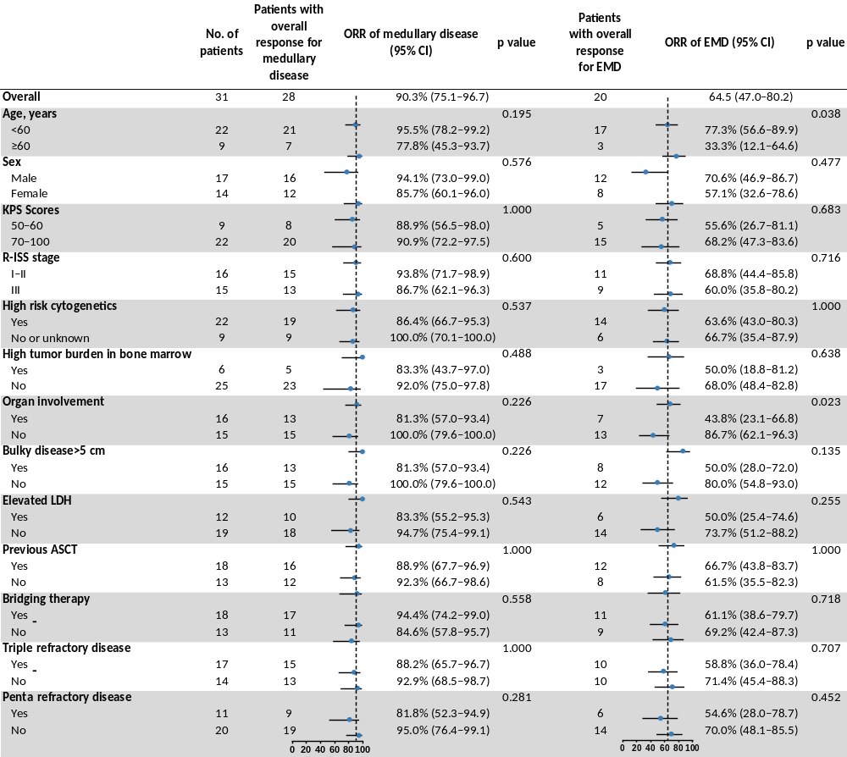

Figure S3. Survival analyses according to the status of best response and the presence of EMD.
Progression-free survival (PFS) (A) and overall survival (OS) (B) analyses between patients achieving best response of complete response (CR) or better and other responders; between patients with EMD and patients without EMD from the same clinical trials (C and D). Log-rank analysis was used across all groups.

Figure S4. Correlation of L-CRS with the occurrence and severity of systemic CRS, and timeline of systemic and local CRS.
(A) Colors on the swimmer plot indicate the highest grade of any systemic CRS recorded on each day for patients who developed local CRS (n=7) through the first 30 days after CAR T-cell infusion. The median onset time of systemic CRS (blue dotted line), L-CRS (purple dotted line), and kinetics of serum ferritin, IL-6, and CAR T cell levels are indicated. (B) Number of patients with each grade of systemic CRS and L-CRS. Spearman analysis showed a correlation of L-CRS with the occurrence and severity of systemic CRS (r=0.60 [95% CI 0.31-0.79]; p<0.001). CRS=cytokine release syndrome.
A
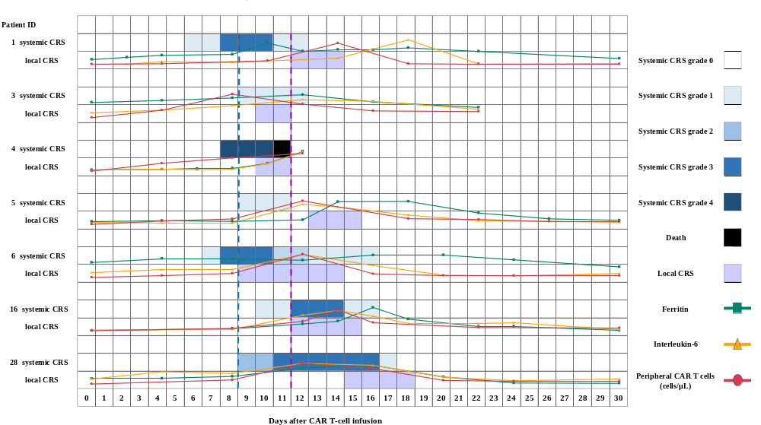
B
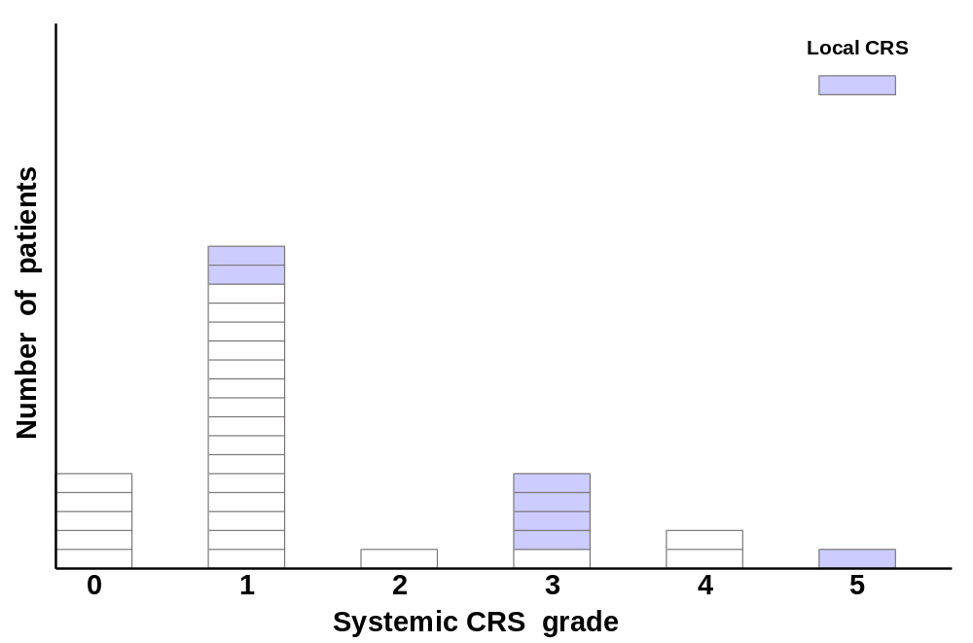

Figure S5. Representative immunofluorescence images about BCMA expression at the time of medullary/EMD progression.
(A-K) Representative immunofluorescence images of 10 patients experiencing post-infusion progression or relapse in EMD. Nine patients (A-I, high-power fields) presented with BCMA-positive progression, and 1 patients (J for high-power field and K for low-power field) presented with decreased or negative BCMA expression. (L) A patient experiencing combined medullary/EMD progression post-infusion presented with medullary/EMD-BCMA-double positive disease (left and right panels). (M) A patient experiencing combined medullary/EMD progression post-infusion presented with BCMA-decreased/negative disease solely in bone marrow (left panel).

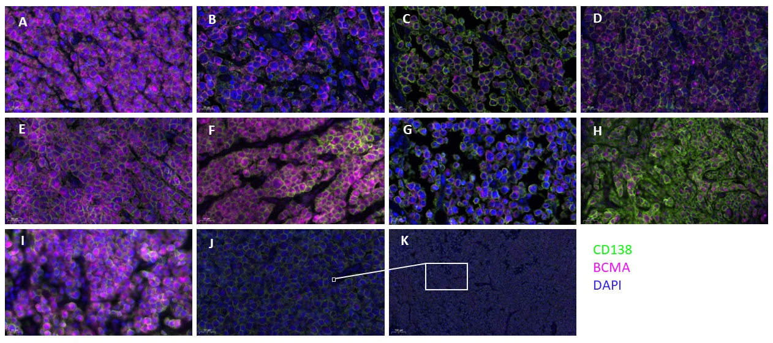
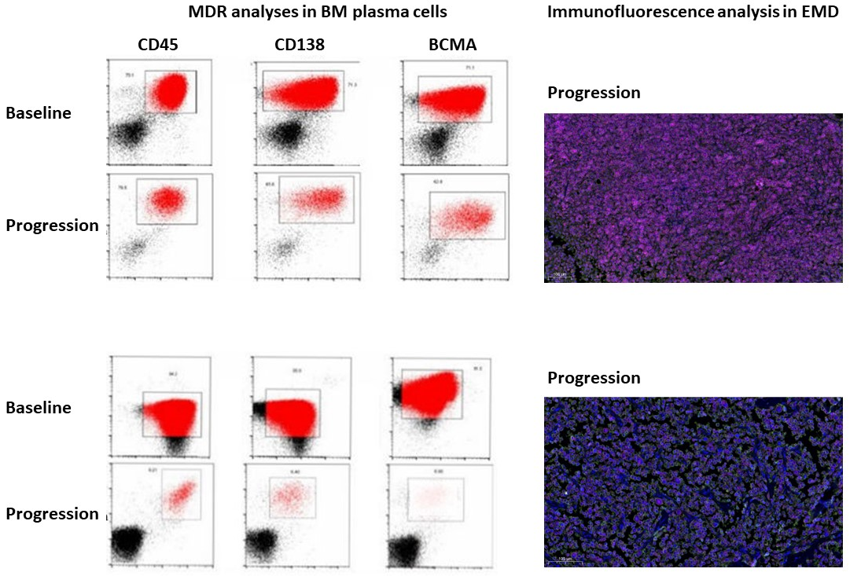
L
M

Figure S6. Distribution of infiltrating immune cell subsets in pre-treatment EMD biopsies according to tumor and normal tissue areas.
Infiltrating immune cell subsets proportions were measured by mIF panels including Panel 1 (CD8/PD-1/LAG-3/TIM-3/DAPI) (A), and Panel 2 (CD68/CD86/CD163/DAPI) (B), in pre-treatment EMD biopsies (n=16) and plotted according to tumor and peri-tumoral normal tissue areas. NA, not applicable, regardless of PD-1, LAG-3, TIM-3 expression.
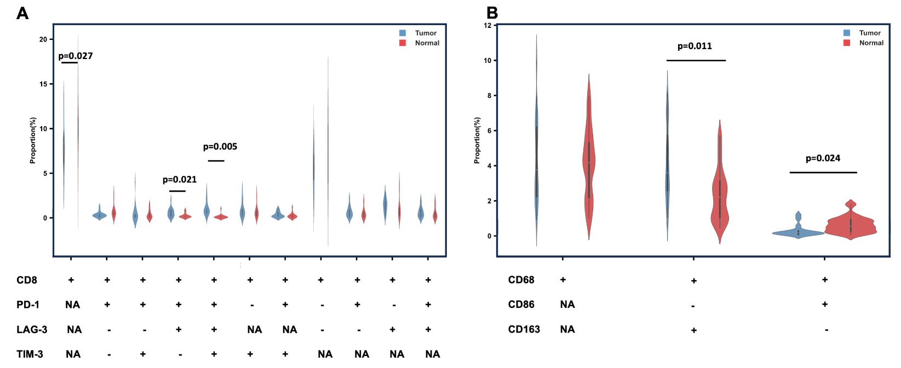

Figure S7. CAR T cell detection in the pleural effusion of select patients with pleural infiltration and clinically detectable localized inflammatory reactions at the early stage of CAR T-treatment.
In 2 patients (Patient 16 and 28) with pleural-based EMD at screening, clinically detectable localized inflammatory reaction (enlargement of localized pleural masses and new development of pleural effusion) was observed at the early stage of CAR T-cell treatment. CAR T cells were identified and amplified in the pleural effusion at the peak of L-CRS (day 12 and d16). CAR T cells decreased subsequently in the pleural effusion at the time of tumors regression (day 19 and day 20).
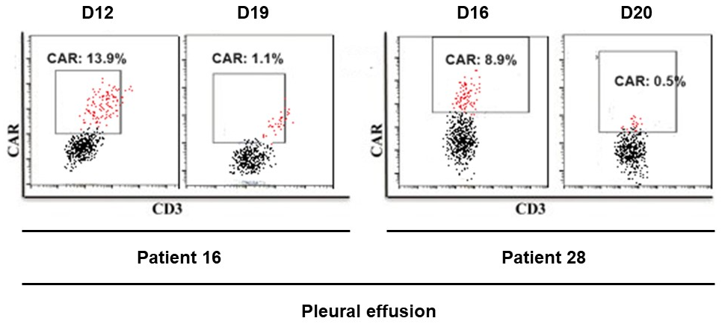

Supplemental Tables

Table S1. Characteristics of patients receiving bridging therapy and re-assessment.
Patient ID | Description of EMD | Bridging therapy | Re-assessment after bridging therapy
1 | Muscle mass | Focal radiotherapy | MR
6 | Pleura; splenic infiltration; subcutaneous nodules | VRD | SD
8 | Breast; pleura; subcutaneous nodules | DEPC | SD
9 | Chest wall infiltrations | DEPC | PD
11 | Maxillofacial infiltrations | Focal radiotherapy | MR
13 | Multiple subcutaneous nodules | FD | MR
14 | Intra-hepatic nodules; CNS | Dara-VRD | SD
18 | Axillary lymph nodes; testis; subcutaneous nodules | Dara-BKD | MR
19 | Subcutaneous tissue (single mass) | Dara-VRD | MR
20 | Muscle mass; pleura; subcutaneous nodules | Dara-VRD | SD
21 | Breast; gallbladder; intra-hepatic nodules; subcutaneous nodules | DARA-PD | PD
22 | Breast; gallbladder; pulmonary/intra-hepatic nodules | FC | MR
23 | CNS | KPD | SD
26 | Muscle mass; multiple subcutaneous nodules | BTK-CD | MR
27 | CNS | XPD | SD
28 | Muscle mass; mesenteric lymph nodes | Dara-CKD | MR
29 | Multiple subcutaneous nodules | DARA-KCD | MR
31 | Breast; intra-renal/-hepatic/pulmonary nodules; splenic infiltration; pleura | X-PVD | SD
Abbreviations:
VRD: Bortezomib, Lenalidomide, Dexamethasone
DEPC: Dexamethasone, Etoposide, Cyclophosphamide, Cisplatin
Dara-VRD: Daratumumab, Bortezomib, Lenalidomide, Dexamethasone
Dara-BKD: Daratumumab, Bendamustine, Carfilzomib, Dexamethasone
Dara-PD: Daratumumab, Pomalidomide, Dexamethasone
FC: Fludarabine, Cyclophosphamide
KPD: Carfilzomib, Pomalidomide, Dexamethasone
BTKi-CD: inhibitor of Bruton tyrosine kinase, Cyclophosphamide, Dexamethasone
XPD: Xpovio, Pomalidomide, Dexamethasone
Dara-CKD: Daratumumab, Cyclophosphamide, Carfilzomib, Dexamethasone
X-PVD: Xpovio, Pomalidomide, Bortezomib, Dexamethasone
MR, minimal response; SD, stable disease; PD, progressive disease.

Table S2. Factors related to survival outcomes.
Variables | Progression-free survival |  |  |  |  | Overall survival
Variables | Univariate analysis | Multivariate analysis¹ |  |  |  | Univariate analysis | Multivariate analysis¹
Variables | p value | Hazard  ratio | 95% CI | p value |  | p value | Hazard  ratio | 95% CI | p value
KPS | 0.092 | 2.16 | 1.19-8.28 | 0.151 |  | 0.087 | 2.61 | 2.10-9.23 | 0.092
50–60 versus 70–100
Organ involvement | 0.109 | 1.59 | 0.46-3.77 | 0.042 |  | 0.095 | 1.45 | 0.69-3.03 | 0.037
Bulky disease>5 cm | 0.092 | 1.48 | 0.76-2.86 | 0.265 |  | 0.184 | 1.39 | 0.62-3.09 | 0.729
Elevated LDH | 0.087 | 1.95 | 0.96-3.67 | 0.107 |  | 0.061 | 2.06 | 1.03-4.14 | 0.034
Bridging therapy | 0.022 | 1.45 | 0.64-3.24 | 0.302 |  | 0.010 | 1.46 | 0.56-3.79 | 0.245
Triple-refractory disease | 0.014 | – | – | – |  | 0.053 | – | – | –
Penta-refractory disease | 0.009 | 1.38 | 1.12-1.71 | 0.013 |  | 0.087 | 1.31 | 1.03-1.67 | 0.027
Abbreviations: KPS=Karnofsky Performance score; LDH=lactic dehydrogenase.
¹ Cox regression model was used for multivariate analysis. The variables in which p value was ≤0.1 by univariate analysis or the variables that may affect the results were included.

Table S3. Characteristics of R/R MM patients with EMD and without EMD
Characteristics | EMD (n=31) | non-EMD (n=110) | p value
Age (years), median (range) | 55 (31-70) | 55 (49-63) | 0.516
Sex, n (%) |  |  | 0.547
Male | 17 (54.8) | 53 (48.2)
Female | 14 (45.2) | 57 (51.8)
Myeloma type, n (%) |  |  | 0.270
IgG | 11 (35.5) | 48 (43.6)
IgA | 5 (16.1) | 27 (24.5)
IgM | 0 | 1 (0.9)
IgD | 7 (22.6) | 10 (9.1)
Light chain | 6 (19.4) | 21 (19.1)
Nonsecretory | 2 (6.5) | 3 (2.7)
R-ISS stage, n (%) |  |  | 0.838
I or II | 16 (51.6) | 61 (55.5)
III | 15 (48.4) | 49 (44.5)
Karnofsky Performance score, n (%) |  |  | 0.211
50-60 | 9 (29.0) | 20 (18.2)
70-100 | 22 (71.0) | 90 (81.8)
High tumor burden in bone marrow, n (%) | 6 (19.4) | 28 (25.5) | 0.636
High-risk cytogenetic profile, n (%) | 22/31 (71.0) | 63/105 (60.0) | 0.298
Prior lines of treatment, median (range) | 4 (3-12) | 4 (3-12) | 0.780
Triple-class refractory disease, n (%) | 17 (54.8) | 39 (35.5) | 0.063
Penta-drug refractory disease, n (%) | 11 (35.5) | 29 (26.4) | 0.369
Previous ASCT, n (%) | 18 (58.1) | 35 (31.8) | 0.059
Abbreviations: R-ISS=Revised-International Staging System; ASCT=autologous stem-cell transplantation.

Table S4. Factors related to occurrence of L-CRS
Variables | Local CRS
Variables | Univariate analysis |  |  |  | Multivariate analysis¹
Variables | Odds  ratio | 95% CI | p value |  | Odds  ratio | 95% CI | p value
High tumor burden in bone marrow | 0.76 | 0.14-4.08 | 0.745
Organ involvement | 0.99 | 0.27-3.63 | 0.971
Bulky disease > 5 cm | 2.90 | 0.78-10.78 | 0.066 |  | 2.13 | 0.57-9.83 | 0.043
Bridging therapy | 2.58 | 0.70-9.61 | 0.090
Elevated LDH | 1.58 | 0.42-5.78 | 0.517
Peak IL-6 (log₁₀ pg/mL)
< median | - | -
≥ median | 1.02 | 0.42-8.98 | 0.570
Peak Fer (log₁₀ ng/mL)
< median | -
≥ median | 2.71 | 0.64-10.51 | 0.071
Peak blood CAR⁺ cells (log₁₀ cells/μL) ²
< median | - | - |  |  | - | -
≥ median | 5.11 | 1.34-13.40 | 0.022 |  | 3.40 | 0.93-10.07 | 0.005
Abbreviations: LDH=lactic dehydrogenase; IL-6=Interleukin-6; Fer=Ferritin; CAR=chimeric antigen receptor.
¹ Binary logistic regression analysis was used to establish a mathematical model of the relationship between the variables and occurrence of L-CRS.

Table S5. EMD response and toxicity of CAR T-cell therapy in patients experiencing L-CRS
Among the 7 patients experiencing L-CRS, best response for EMD was evaluated as 3 (42.9%) with CR, 2 (28.6%) with VGPR, 1 (14.3%) with MR, and 1 (14.3%) died with concurrent systemic CRS.

Patient ID | Age, yr | gender | Organ involvement | Bulky disease > 5 cm | High tumor burden in BM | Bridging therapy | Systemic CRS grade | best response in EMD | time to first response in EMD
1 | 61 | Male | N | Y | N | Y | 3 | VGPR | 1 m
3 | 56 | Male | N | Y | N | N | 1 | CR | 1 m
4 | 70 | Female | Y | Y | N | N | 5 | Death | -
5 | 54 | Male | Y | N | N | N | 1 | CR | 1 m
6 | 59 | Male | Y | Y | Y | Y | 3 | MR | -
16 | 56 | Female | N | Y | Y | N | 3 | VGPR | 2 m
28 | 56 | Female | N | Y | N | Y | 3 | CR | 0.5 m
Abbreviations: Y=Yes; N=No; CR, complete response; VGPR, very good partial response; MR, minimal response; m=months.

Table S6. Comparison of plasma cell membrane BCMA expression level between baseline and progression/relapse in bone marrow/EMD
Patient ID | BCMA expression (MFI/proportion)¹
Patient ID | Baseline |  |  | Relapse/Progression
 | BM | EMD |  | BM | EMD
1 | 3137 | 34.4% |  | 1502 | 29.4%
3 | 53.5% | 67.2% |  | 8.8% | 71.1%
7 | NA | 70.0% |  | 3151 | 62.5%
10 | 2140 | NA |  | 2210 | 78.5%
13 | 21.5% | 40.1% |  | 20.6% | 37.7%
17 | 1987 | 69.4% |  | 1759 | 58.5%
Abbreviations: BM, bone marrow; NA, not available; MFI, mean fluorescence intensity.
¹ Among 6 patients experiencing combined medullary and extramedullary progression post-infusion with available paired tumor samples in bone marrow and EMD, 4 relapsed with medullary/EMD-double-positive disease (Patient 7, 10, 13, and 17), 2 with medullary-decreased/negative disease (Patient 1 and 3). BCMA expression was determined by flowcytometry of specimens of bone marrow aspirate, pleural effusion, and cerebrospinal fluid; or by CD138/BCMA-double stained immunofluorescence of tumor samples (e.g., bone marrow or extramedullary plasmacytoma biopsies). BCMA positive status was defined as conditions with at least one of the following characteristics: (1) BCMA expression detected in ≥ 50% of malignant plasma cells (CD138⁺) by immunofluorescence, and (2) MFI of BCMA expression ≥ 1000 as determined by cytometry. Because of lack of systematic quantification of antigen density, we use BCMA decreased/negative to include partial or total BCMA loss. Additional information about assessments of BCMA expression is provided in the Supplemental Methods.

Table S7. Characteristics of baseline EMD biopsy specimens analyzed in immune microenvironment analysis
Patient ID | Location of biopsy at EMD sites | Best EMD response | Outcome | PFS, m | OS, m
3 | Multiple subcutaneous nodules | CR | Ectopic PD (alive) | 18.1 | 34.7
4 | Breast mass | NA | Dead | 0.4 | 0.4
6 | Multiple subcutaneous nodules | MR | In situ PD (dead) | 1 | 6
7 | Thigh musscle mass | CR | Ectopic PD (dead) | 8.7 | 28.9
13 | Multiple subcutaneous nodules | PR | Ectopic PD (dead) | 3.5 | 8.5
16 | Multiple subcutaneous nodules | VGPR | Ectopic PD (dead) | 3.2 | 6
17 | Cervicical lymph nodes | PR | Ectopic PD (dead) | 21 | 22.3
18 | Axillary lymph nodes | MR | In situ PD (dead) | 3.5 | 9.7
19 | Subcutaneous nodules | CR | CR (alive) | 17 | 17
20 | Chest wall infiltrations | PD | In situ PD (dead) | 0.7 | 3
21 | Arm musscle mass | PD | In situ PD (dead) | 0.6 | 1.8
22 | Abdominal mass | MR | In situ PD (dead) | 2 | 5.5
23 | Spinal nerve | CR | CR (alive) | 9 | 9
25 | Breast mass | MR | In situ PD (alive) | 2 | 5
26 | Subcutaneous nodules | VGPR | In situ & ectopic PD (alive) | 12 | 14
31 | Pleural mass | VGPR | Ectopic PD (alive) | 5 | 9
Abbreviations: CR, complete response; VGPR, very good partial response; PR, partial response; MR, minimal response; PD, progressive disease; NA, not available; PFS, progression-free survival; OS, overall survival; m, month.

Table S8. Summary of primary antibodies and secondary antibody used for immunofluorescence
Reagent | Source | Identifier | Dilution
CD8 | Abcam | ab237709 | 1:100
PD-1 | Abcam | ab237728 | 1:50
LAG-3 | Abcam | ab209236 | 1:100
TIM-3 | Abcam | ab241332 | 1:500
CD68 | R&D | MAB20401 | 1:200
CD86 | Cell Signaling Technology | CST91882 | 1:200
CD163 | NOVUS | NBP1-30148 | 1:300
CD138 | Abcam | ab226108 | 1:500
BCMA | Cell Signaling Technology | CST88183 | 1:500
Horseradish-peroxidase-conjugated anti-rabbit and anti-mouse antibody | Biolynx | BX10001 | 1:3

References
- Bansal R, Rakshit S, Kumar S. Extramedullary disease in multiple myeloma. Blood Cancer J. 2021;11:161–69.
- Bladé J, Fernández de Larrea C, Rosiñol L, Cibeira MT, Jiménez R, Powles R. Soft-tissue plasmacytomas in multiple myeloma: incidence, mechanisms of extramedullary spread, and treatment approach. J Clin Oncol. 2011; 29:3805–12.
- Touzeau C, Moreau P. How I treat extramedullary myeloma. Blood. 2016;127:971–76.
- Pham A , Mahindra A. Solitary Plasmacytoma: a Review of Diagnosis and Management. Curr Hematol Malig Rep. 2019;14:63–69.
- M Varettoni, A Corso, G Pica, S Mangiacavalli, C Pascutto, M Lazzarino. Incidence, presenting features and outcome of extramedullary disease in multiple myeloma: a longitudinal study on 1003 consecutive patients. Ann Oncol. 2010;21:325–330.
- Sandeep Anand Padala, Adam Barsouk, Alexander Barsouk, Prashanth Rawla, Anusha Vakiti, Ravindra Kolhe, et al. Epidemiology, Staging, and Management of Multiple Myeloma. Med Sci (Basel). 2021;9:3.
- Vittorio Montefusco, Francesca Gay, Stefano Spada, Lorenzo De Paoli, Francesco Di Raimondo, Rossella Ribolla, et al. Haematologica. 2020;105:193–200.
- Sevcikova S, Minarik J, Stork M, Jelinek T, Pour L, Hajek R. Extramedullary disease in multiple myeloma-controversies and future directions. Blood Rev. 2019;36:32–39.
- Palumbo A, Rajkumar SV, San Miguel JF, et al. International Myeloma Working Group consensus statement for the management, treatment, and supportive care of patients with myeloma not eligible for standard autologous stem-cell transplantation. J Clin Oncol. 2014;32:587–600.
- Takahashi MES, Lorand-Metze I, de Souza CA, et al. Metabolic Volume Measurements in Multiple Myeloma. Metabolites. 2021;11:12.
- Lee DW, Santomasso BD, Locke FL, et al. ASTCT consensus grading for cytokine release syndrome and neurologic toxicity associated with immune effector cells. Biol Blood Marrow Transplant. 2019;25:625–38.

