Supplement to:

Stage dependence of Elton’s biotic resistance hypothesis of biological invasion

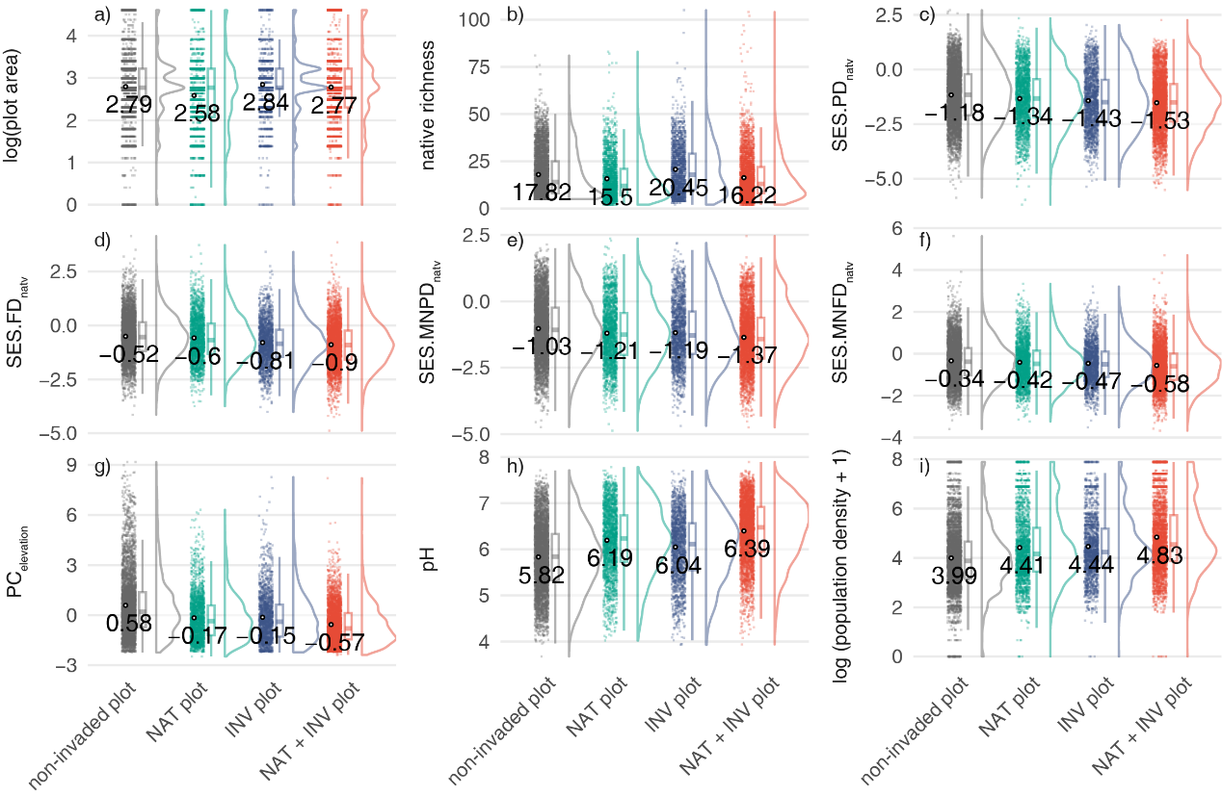
Fig. S1 The raincloud plots depict the distribution and variation of the nine variables used to predict alien species presence and richness across different plot types, namely, non-invaded plots, NAT plots (plots invaded by naturalized species), INV plots (plots invaded by invasive species), and NAT + INV plots (plots invaded by both naturalized and invasive species). See Table 1 in the main text for the detailed description of each variable. Each raincloud plot displays individual data points with overlaid means (left), a box plot indicating median and interquartile range (middle), and a density plot (right). Additionally, the mean of each variable for each plot type were marked.
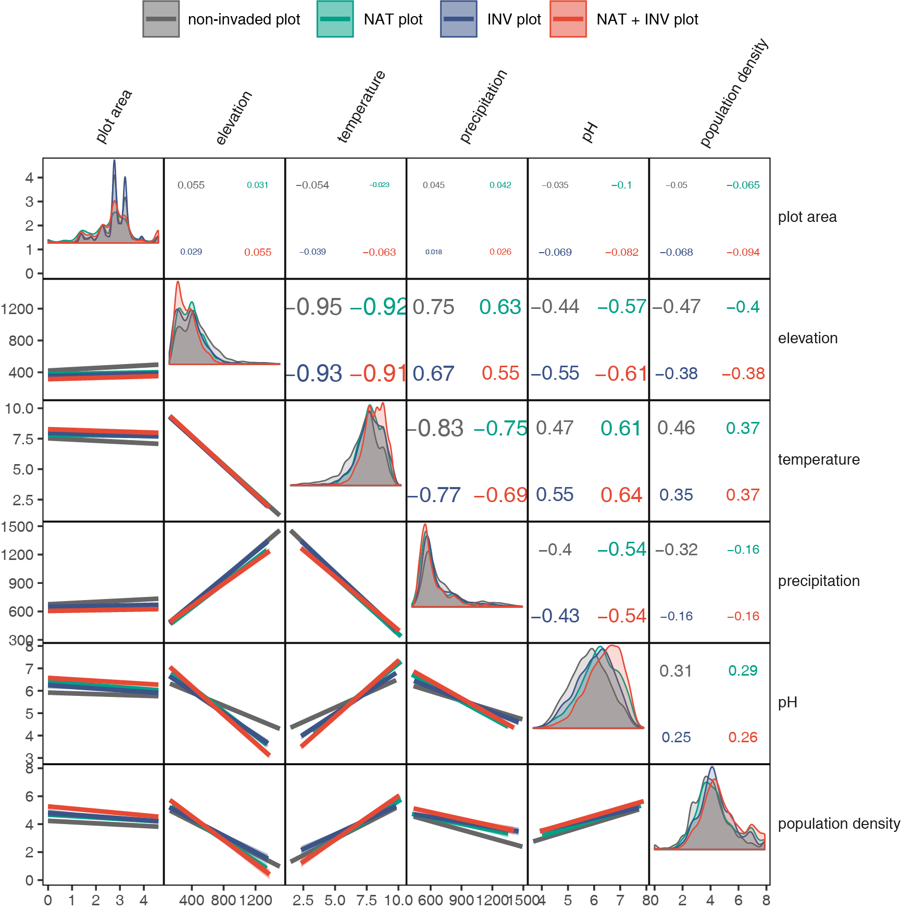Fig. S2 Correlogram showing the Pearson correlations among plot area (m², log-transformed), elevation (m), mean annual temperature (℃),total annual precipitation (mm), soil pH (pH) and population density (people/km², log(x+1)-transformed) across the four plot types, namely, non-invaded plots (n = 4,630), NAT plots (plots invaded by naturalized species, n = 2,157), INV plots (plots invaded by invasive species, n = 1,776), and NAT + INV plots (plots invaded by both naturalized and invasive species, n = 3493). The lower triangle of the figure shows the pairwise linear regression lines, while the upper triangle shows the Pearson correlation coefficients of each pair.
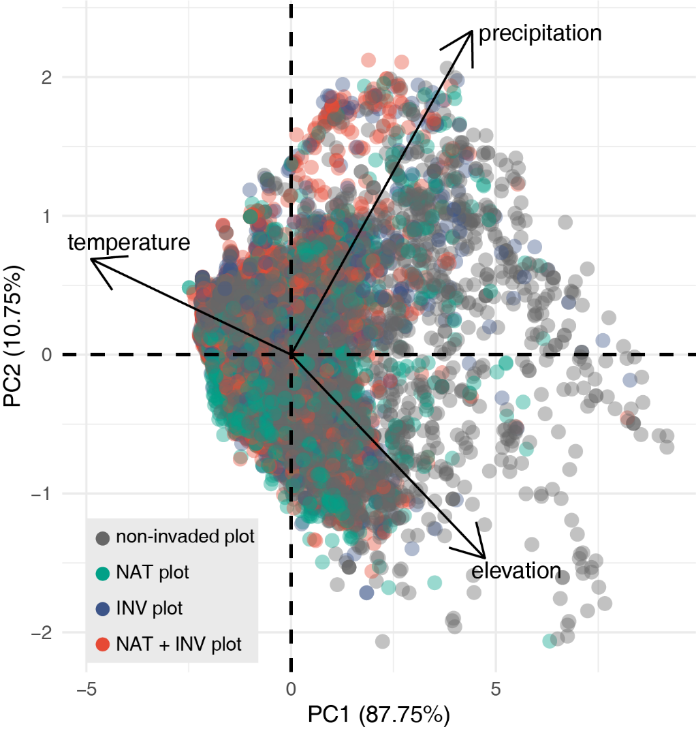
Fig. S3 Plot of the principal component analysis of mean annual temperature, total annual precipitation, and elevation using data of all 12,056 plots.
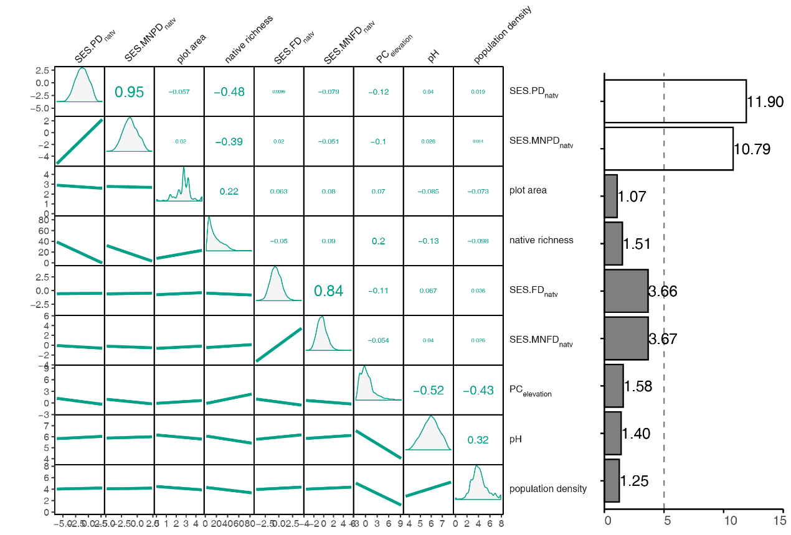
Fig. S4 Correlogram (left) and bar plot (right), respectively, showing the pairwise correlations and variance inflation factors (VIFs) of the nine variables used to predict alien species presence and richness for models (n = 7,187) focusing on NAT plots (plots invaded by naturalized species). See Table 1 in main text for the detailed description of these variables. In the correlogram, the lower triangle shows the pairwise linear regression lines, while the upper triangle shows the Pearson correlation coefficients of each pair. In the bar plot, the dashed line indicates the threshold of VIF = 5. Variables with VIFs exceeding this threshold are represented by unfilled bars, while those with VIF values lower than or equal to the threshold are depicted by black-filled bars. Additionally, variables with VIF >5 were excluded in related regressions.
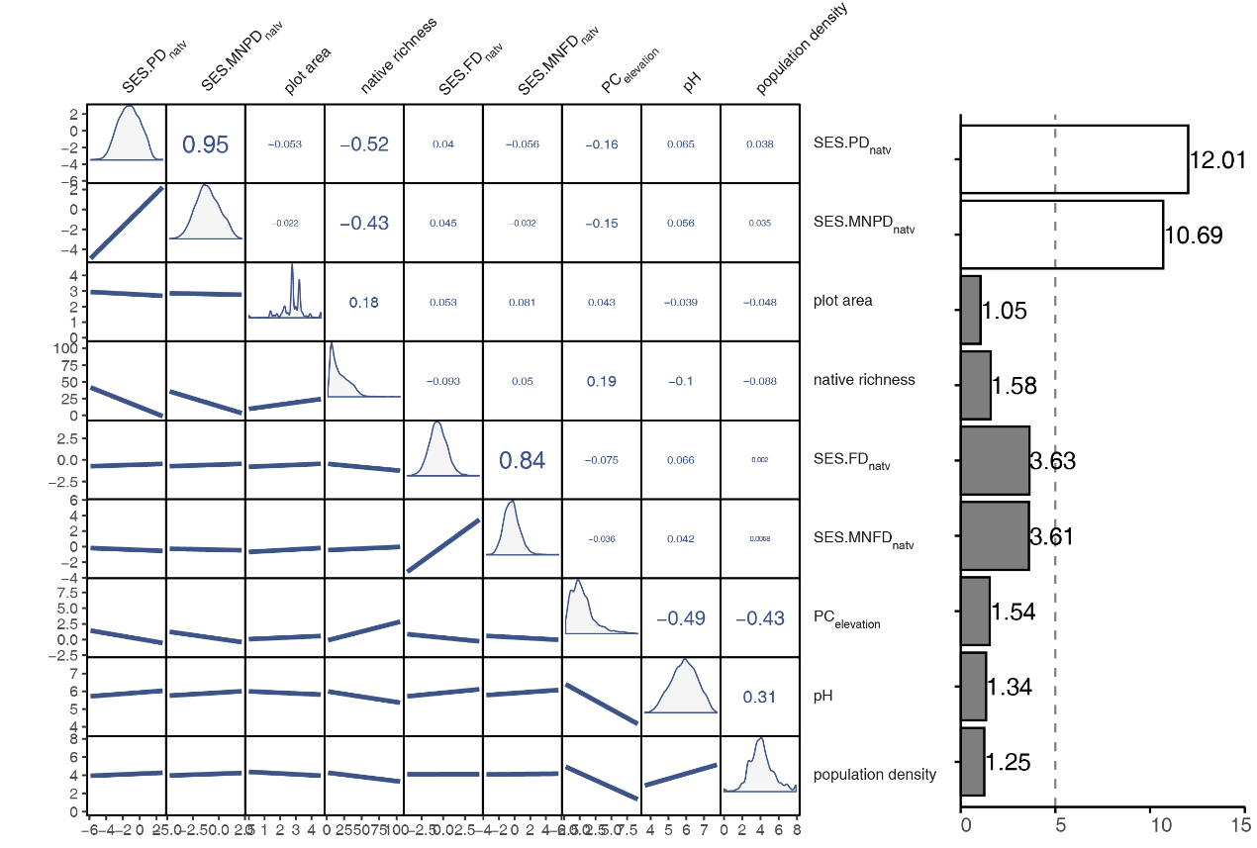
Fig. S5 Correlogram (left) and bar plot (right), respectively, showing the pairwise correlations and variance inflation factors (VIFs) of the nine variables used to predict alien species presence and richness for models (n = 6,460) focusing on INV plots (plots invaded by invasive species). See Table 1 in main text for the detailed description of these variables. In the correlogram, the lower triangle shows the pairwise linear regression lines, while the upper triangle shows the Pearson correlation coefficients of each pair. In the bar plot, the dashed line indicates the threshold of VIF = 5. Variables with VIFs exceeding this threshold are represented by unfilled bars, while those with VIF values lower than or equal to the threshold are depicted by black-filled bars. Additionally, variables with VIF >5 were excluded in related regressions.
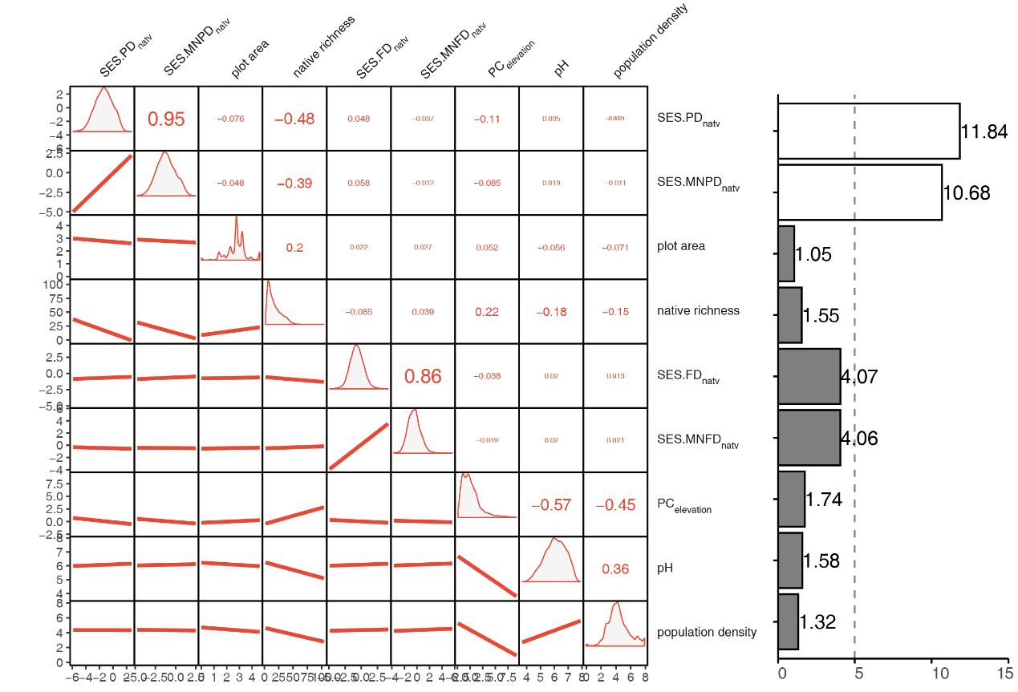
Fig. S6 Correlogram (left) and bar plot (right), respectively, showing the pairwise correlations and variance inflation factors (VIFs) of the nine variables used to predict alien species presence and richness for models (n = 8,123) focusing on NAT + INV plots (plots invaded by both naturalized and invasive species). See Table 1 in main text for the detailed description of these variables. In the correlogram, the lower triangle shows the pairwise linear regression lines, while the upper triangle shows the Pearson correlation coefficients of each pair. In the bar plot, the dashed line indicates the threshold of VIF = 5. Variables with VIFs exceeding this threshold are represented by unfilled bars, while those with VIF values lower than or equal to the threshold are depicted by black-filled bars. Additionally, variables with VIF >5 were excluded in related regressions.
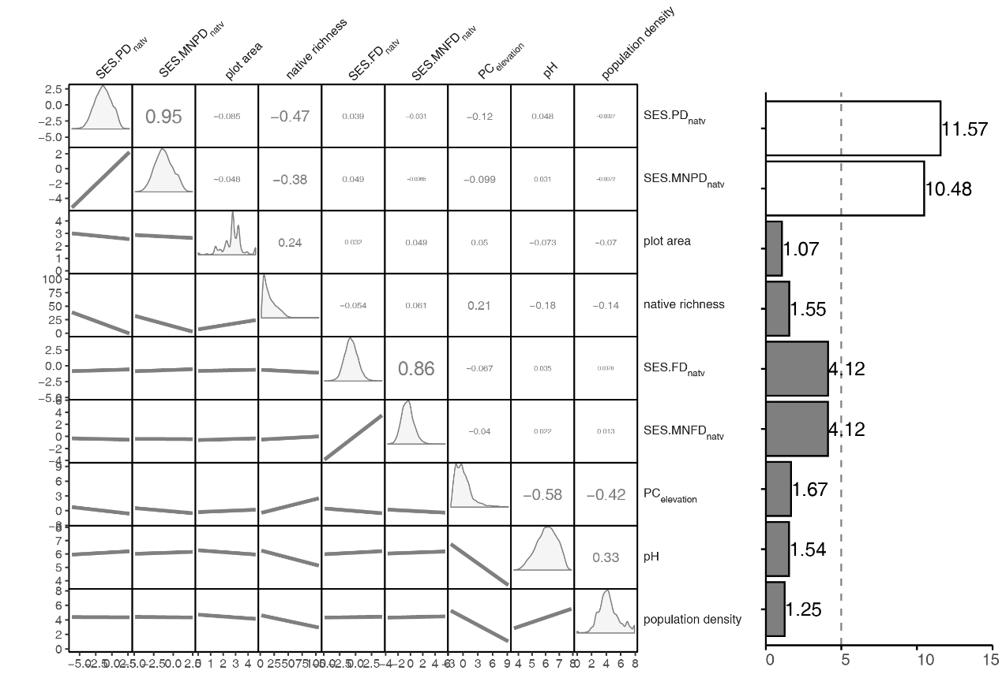
Fig. S7 Correlogram (left) and bar plot (right), respectively, showing the pairwise correlations and variance inflation factors (VIFs) of the nine variables used to predict alien species presence and richness for models (n = 12,056) focusing on alien plots (plots invaded by alien species regardless of their invasion stages). See Table 1 in main text for the detailed description of these variables. In the correlogram, the lower triangle shows the pairwise linear regression lines, while the upper triangle shows the Pearson correlation coefficients of each pair. In the bar plot, the dashed line indicates the threshold of VIF = 5. Variables with VIFs exceeding this threshold are represented by unfilled bars, while those with VIF values lower than or equal to the threshold are depicted by black-filled bars. Additionally, variables with VIF >5 were excluded in related regressions.

