The Healthy Diet Basket is a comparable global standard for the Cost of a Healthy Diet, meeting nutritional and environmental criteria

Anna W. Herforth^{1,4*}, Yan Bai^{2*} , Aishwarya Venkat¹, William A. Masters¹

Supplementary Information

Table S1. Average food group amounts recommended across FBDG scaled to meet a consistent dietary energy intake target (2 330 kcal)

Table S2. Food group proportions (by volume) depicted in plate-shaped Food Guides from all countries where they were available

Table S3. Healthy Diet Basket content by food group: Average food group amounts recommended across FBDG scaled to meet a consistent dietary energy intake target (2 330 kcal), translated into gram amounts by reference food items

Figure S1. Composition of the Healthy Diet Basket

Figure S2. Assessment of diet quality scores of least-cost diets by food-based dietary guideline (FBDG), across 159-172 countries

Table S1. Average food group amounts recommended across FBDG scaled to meet a consistent dietary energy intake target (2 330 kcal)
 | Starchy staples |  | Vegetables |  | Fruit |  | Protein-rich foods* |  | Oils
FBDG | kcal | grams | kcal | grams | kcal | grams | kcal | grams | kcal | grams
Argentina | 1 000 | 278 | 145 | 482 | 228 | 362 | 638 | 446 | 320 | 36
Benin | 1 216 | 338 | 133 | 443 | 167 | 266 | 462 | 323 | 352 | 40
China | 1 238 | 344 | 117 | 391 | 169 | 269 | 568 | 398 | 237 | 27
India | 1 009 | 280 | 123 | 409 | 110 | 175 | 809 | 566 | 279 | 32
Jamaica | 1 162 | 323 | 117 | 389 | 130 | 206 | 630 | 441 | 291 | 33
Malta | 1 343 | 373 | 112 | 375 | 148 | 234 | 572 | 400 | 155 | 18
Netherlands | 1 205 | 335 | 74 | 247 | 124 | 197 | 577 | 404 | 349 | 39
Oman | 942 | 262 | 101 | 337 | 370 | 587 | 335 | 234 | 583 | 66
United States of America | 1 038 | 288 | 89 | 297 | 187 | 297 | 753 | 527 | 263 | 30
Viet Nam | 1 165 | 324 | 92 | 307 | 166 | 263 | 640 | 447 | 267 | 30
Mean | 1 132 | 314 | 110 | 368 | 180 | 286 | 598 | 422 | 310 | 35
Median | 1 164 | 323 | 114 | 382 | 167 | 264 | 604 | 419 | 285 | 32
HDB | 1 160 | 322 | 110 | 367 | 160 | 254 | 600 | 420 | 300 | 34
Notes: Data shown are authors’ calculations from national government documents. An updated set of links to country websites is available from the FAO at https://www.fao.org/nutrition/education/food-dietary-guidelines. Few countries have quantified national FBDG, thus currently the analysis is guided by the quantified recommendations from these ten national FBDG, which represent a range of dietary recommendations articulated by countries in each region. Grams are based on kcal equivalent of all foods in the group to reference food items: egg for protein-rich foods and dry rice for starchy staples. Calories per gram of fruits and vegetables, respectively, are based on the average across all non-duplicate fruits (0.63 kcal/g) and vegetables (0.3 kcal/g) in the 2017 ICP dataset. HDB = Healthy Diet Basket.

*Protein-rich foods here combine dairy with other protein-rich foods, including meat, fish, egg, legumes, and/or nuts and seeds. The median amount for dairy across the 10 FBDG was 230 kcal, a food group present in all the selected FBDG except Jamaica’s. In some countries, protein-rich food group has sub-categories: Argentina: (a) meat, fish, egg; (b) dairy; Benin: (a) meat, fish, egg, legumes, nuts and seeds; (b) dairy; China: (a) meat, fish, egg; (b) dairy; (c) soy, nuts, seeds; India: (a) meat, fish, egg, legumes; (b) nuts and seeds; (c) dairy; Jamaica: (a) foods from animals including dairy; (b) legumes and nuts; Malta: (a) meat, fish, eggs, legumes, nuts and seeds; (b) dairy; Netherlands: (a) meat, fish, egg, legumes; (b) nuts and seeds; (c) dairy; Oman: (a) meat, fish, egg, nuts and seeds; (b) legumes; (c) dairy; United States of America: (a) meat, fish, egg, legumes, nuts and seeds; (b) dairy; Viet Nam: (a) meat, fish, egg, legumes; (b) dairy.

Table S2. Food group proportions (by volume) depicted in plate-shaped Food Guides from all countries where they were available
Country/year | Starchy staples | Vegetables | Fruits | Vegetables and fruits | Protein-rich foods* | Fats and oils | Total
Malta 2015 | 25 | 27 | 20 | 47 | 25 | 3 | 100
India 2018 | 27 |  |  | 50 | 20 | 3 | 100
Jamaica 2015 | 30 | 24 | 25 | 49 | 18 | 3 | 100
Argentina 2015 | 25 |  |  | 50 | 20 | 5 | 100
United States of America 2020 | 25 | 30 | 20 | 50 | 25 | 0 | 100
Oman 2009 | 34 | 15 | 15 | 30 | 36 | 0 | 100
Zambia 2021 | 34 | 15 | 18 | 33 | 33 | 0 | 100
Australia 2013 | 30 | 28 | 16 | 44 | 26 | 0 | 100
Canada 2019 | 25 |  |  | 50 | 25 | 0 | 100
Qatar 2015 | 27 | 25 | 13 | 38 | 35 | 0 | 100
Italy 2018 | 20 | 27 | 27 | 54 | 20 | 6 | 100
South Korea 2015 | 30 | 24 | 16 | 40 | 30 | 0 | 100
Uruguay 2016 | 28 | 30 | 20 | 50 | 16 | 6 | 100
Ecuador 2018 | 25 |  |  | 50 | 20 | 5 | 100
Malawi (unofficial) | 33 | 23 | 22 | 45 | 17 | 5 | 100
Pakistan 2018 | 33 | 19 | 15 | 34 | 27 | 6 | 100
Colombia 2015 | 30 |  |  | 27 | 38 | 5 | 100
Germany 2017 | 30 | 25 | 17 | 42 | 25 | 3 | 100
Chile 2013 | 15 | 30 | 20 | 50 | 30 | 5 | 100
United Kingdom of Great Britain and Northern Ireland 2016 | 37 |  |  | 37 | 24 | 2 | 100
Latvia 2008 | 25 |  |  | 50 | 25 | 0 | 100
Poland 2020 | 25 |  |  | 50 | 25 | 0 | 100
Portugal 2003 | 27 | 24 | 20 | 44 | 26 | 3 | 100
Switzerland 2011 | 40 |  |  | 40 | 20 | 0 | 100
Antigua and Barbuda 2013 | 39 | 14 | 14 | 28 | 28 | 5 | 100
Domenica 2007 | 28 | 25 | 17 | 42 | 25 | 5 | 100
Grenada 2006 | 47 | 10 | 10 | 20 | 27 | 6 | 100
Guyana 2018 | 33 | 15 | 15 | 30 | 30 | 7 | 100
Mexico 2015 | 33 | 16 | 16 | 32 | 35 | 0 | 100
Panama 2013 | 38 | 16 | 16 | 32 | 25 | 5 | 100
Peru 2019 | 36 | 16 | 16 | 32 | 27 | 5 | 100
Mean | 30.1 | 21.7 | 17.6 | 41.0 | 25.9 | 3.0 | 100
Median | 30.0 | 24.0 | 16.5 | 42.0 | 25.0 | 3.0 | 100
Mode | 25.0 | 24.0 | 20.0 | 50.0 | 25.0 | 0.0 | 100
HDB | 25.3% | 28.8% | 19.9% | 48.8% | 23.3% | 2.7% | 100%
Notes: Data shown are authors’ calculations, from visual inspection of food guides in the FAO compendium of FBDG accessed March 2022 at: https://www.fao.org/nutrition/education/food-based-dietary-guidelines.
* Protein-rich foods include dairy, other animal source foods, legumes, and sometimes nuts and seeds

A. proportion of dietary energy | B. proportion of volume (kcal dietary energy converted into grams of reference food items)* | C. proportion of the cost based on ICP 2017 global food retail prices
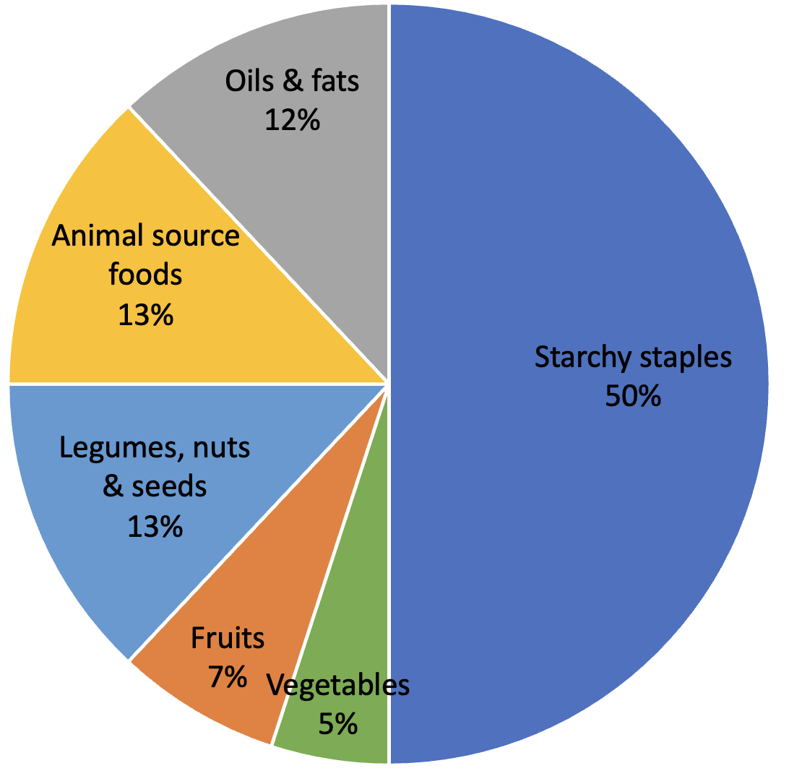 | 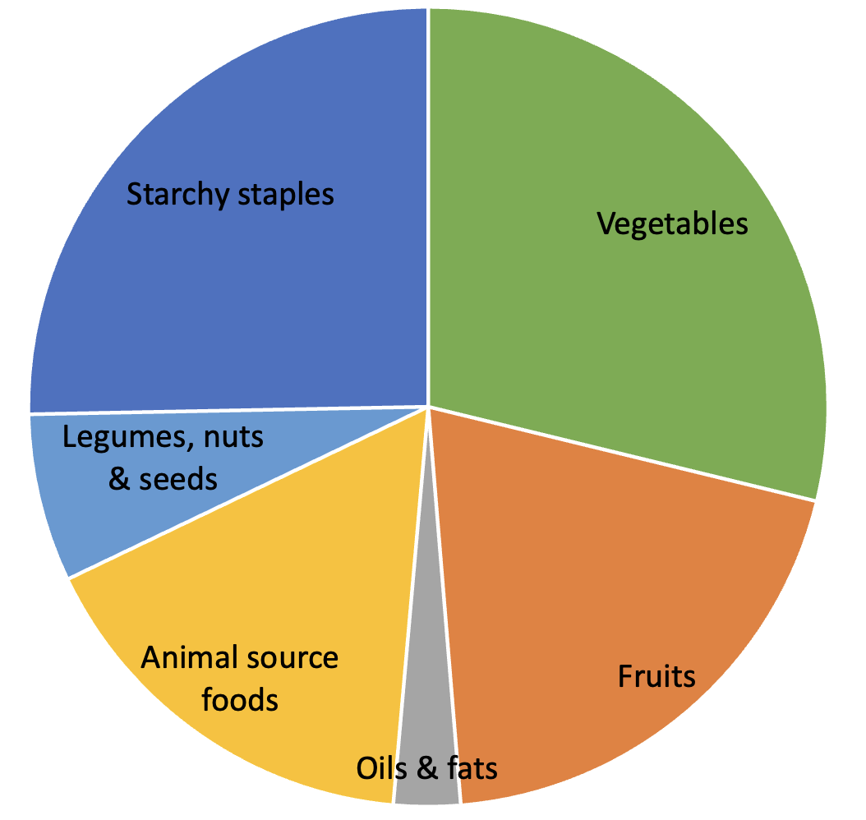 | 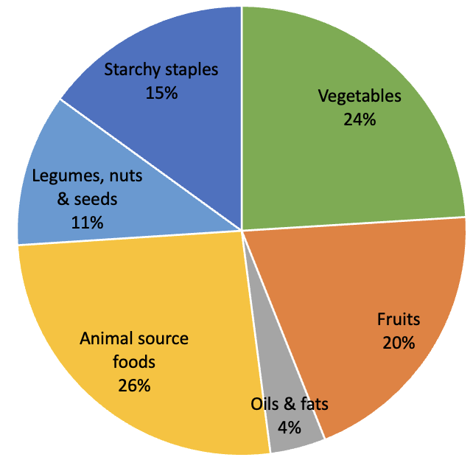
FigS1. Composition of the Healthy Diet Basket
*Different food items have different calories per gram. To equate calories and grams, the following reference food items were used: dry rice for starchy staples; egg for animal source foods; dry bean for legumes, nuts and seeds; and average kcal/g across all non-duplicate items in the 2017 ICP dataset for fresh fruits and vegetables.

Table S3. Healthy Diet Basket content by food group: Average food group amounts recommended across FBDG scaled to meet a consistent dietary energy intake target (2 330 kcal), translated into gram amounts by reference food items
Food group | Total energy content (kcal) | Equivalent gram content, by reference food* (edible portion)
Starchy staples | 1 160 | 322 g dry rice
Vegetables | 110 | 270–400 g vegetables
Fruits | 160 | 230–300 g fruits
Animal source foods | 300 | 210 g egg
Legumes, nuts & seeds | 300 | 85 g dry bean
Oils & fats | 300 | 34 g oil
*Different food items have different calories per gram. To equate calories and grams, the following reference food items were used: dry rice for starchy staples; egg for animal source foods; dry bean for legumes, nuts and seeds; and average kcal/g across all non-duplicate items in the 2017 ICP dataset for fresh fruits and vegetables.

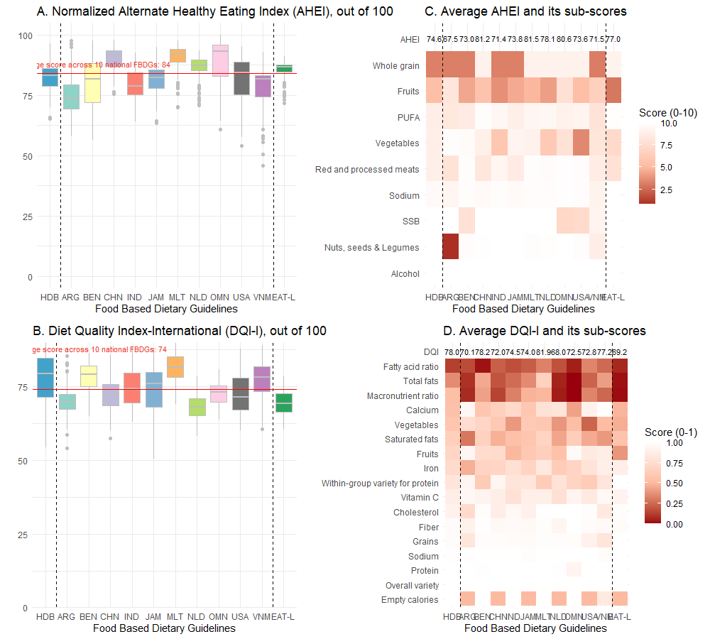Figure S2. Assessment of diet quality scores of least-cost diets by food-based dietary guidelines (FBDG) across 159-172 countries. (A) illustrates the distribution of the normalized Alternate Healthy Eating Index (AHEI) scores across various FBDG, represented through box plots. The AHEI is calculated based on nine dietary components, including fruits, vegetables, nuts & seeds & legumes, whole grains, sugar-sweetened beverages (SSBs), polyunsaturated fatty acids (PUFAs), red and processed meat, sodium, and alcohol. Each component's score ranges from 0 to 10, with higher scores indicating better adherence to healthy eating guidelines. Scores of all components are summed, and the total score is expressed as a percentage (score out of 100). (B) depicts the box plot distributions of the Diet Quality Index-International (DQI-I) scores across different FBDG. The DQI-I comprises four categories, encapsulating a total of 17 components. These categories are variety, adequacy, moderation, and overall balance, evaluating the diet's diversity, nutrient sufficiency, moderation in consumption of certain nutrients and foods, and balanced nutrient ratios. (C) presents a heatmap for assessing the scores of the AHEI's nine dietary components across the various FBDG. (D) features a heatmap for the DQI-I's 17 components, normalized between 0 and 1 for comparative purposes. The AHEI contained criteria that could not be analyzed from the level of specificity available in the food price data, including omega-3 fatty acids and trans fat.

