Removal of U(VI) from aqueous solution by Al⁰/Ni⁰ bimetallic material
Mengyue Ma¹; Weixuan Sang¹; Yishuo Zhang ^{1*}; Xiaoyan Li ^{1*}
(State Key Laboratory of Nuclear Resources and Environment,
East China University of Technology, Nanchang, Jiangxi 330013, China)

Fig. S1 N₂ adsorption–desorption isotherms of Al⁰/Ni⁰-BM

Fig. S1 showed the nitrogen adsorption-desorption curve of AlNi-NPs. The adsorption-desorption isotherm of AlNi-NPs material conformed to the IUPAC classification of Ⅳ curve and generated H3 hysteresis loop, which indicated that there were slit-type gaps between particles. According to nitrogen adsorption-desorption data, the relevant parameters were calculated by BET equation and BJH algorithm. The specific surface area of the composite AlNi-NPs was 47.498 m²/g, the pore volume was 0.303 cm³/g, average pore size was 25.523 nm, and the single-layer molecular adsorption capacity was 10.913 cm³.

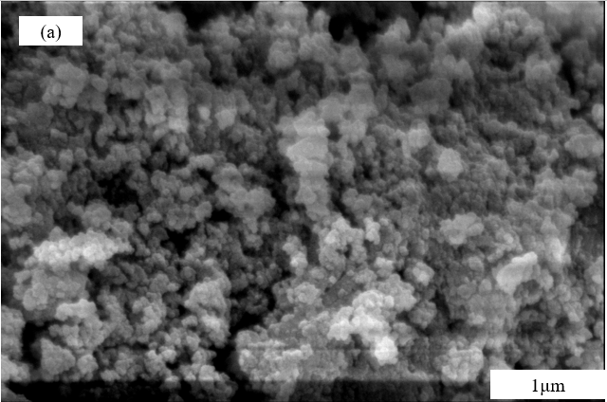 | 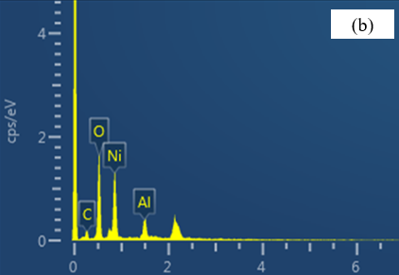
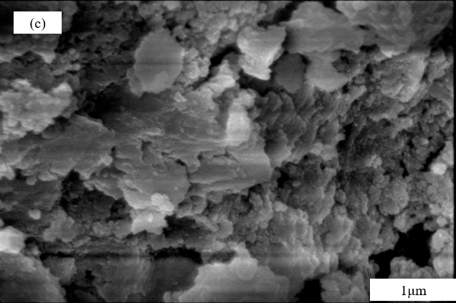 | 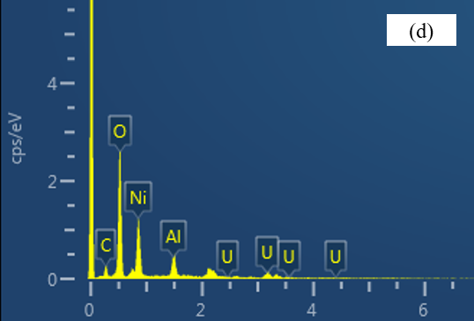
Fig. S2 SEM and EDS (a) (b) fresh Al⁰/Ni⁰-BM; (c) (d) reacted Al⁰/Ni⁰-BM.

Table S1 EDS parameters of Al⁰/Ni⁰-BM before and after reaction with U(Ⅵ)
Element | Before the reaction |  | After the reaction with U(Ⅵ)
Element | Wt (%) | Atomic (%) | Wt (%) | Atomic (%)
C | 6.13 | 14.33 | 5.06 | 12.05
O | 21.42 | 42.86 | 33.87 | 60.53
Ni | 57.41 | 27.45 | 38.41 | 18.71
Al | 15.04 | 15.36 | 6.37 | 6.75
U | 0 | 0 | 16.29 | 1.96

Table S2 Parameters for pseudo-first-order and pseudo-second-order kinetics
T/K | Pseudo-first-order kinetic |  |  |  | pseudo-second-order kinetic
T/K | Q_{e} (mg⋅g⁻¹) | k₁ (min⁻¹) | R² |  | Q_{e} (mg⋅g⁻¹) | k₂ (min⁻¹) | R²
288 | 60.72 | 0.0293 | 0.8481 |  | 109.89 | 0.00034 | 0.9920
293 | 62.08 | 0.0348 | 0.8542 |  | 113.38 | 0.00049 | 0.9920
298 | 64.61 | 0.0424 | 0.8693 |  | 115.74 | 0.00067 | 0.9947
303 | 64.81 | 0.0525 | 0.8802 |  | 120.63 | 0.00098 | 0.9964

Table S3 Reduction kinetic parameters
T/K | K_{obs} | R²
288 | 0.04579 | 0.95083
293 | 0.05292 | 0.95301
298 | 0.07289 | 0.95991
303 | 0.10255 | 0.97713

Table S4 Isotherms parameters for Langmuir and Freundlich models
T/K | Langmuir |  |  |  | Freundlich
 | Q_{m} (mg⋅g⁻¹) | K_{L} (L⋅mg⁻¹) | R² |  | K_{F} (L⋅g⁻¹) | 1/n | R²
293 | 153.85 | 0.1643 | 0.9484 |  | 79.38 | 0.1249 | 0.7489
298 | 167.50 | 0.1839 | 0.9600 |  | 87.80 | 0.1227 | 0.7811
303 | 186.21 | 0.1827 | 0.9410 |  | 98.71 | 0.1154 | 0.7365
308 | 211.42 | 0.1791 | 0.9245 |  | 111.40 | 0.1100 | 0.7145

