Human SMAD9
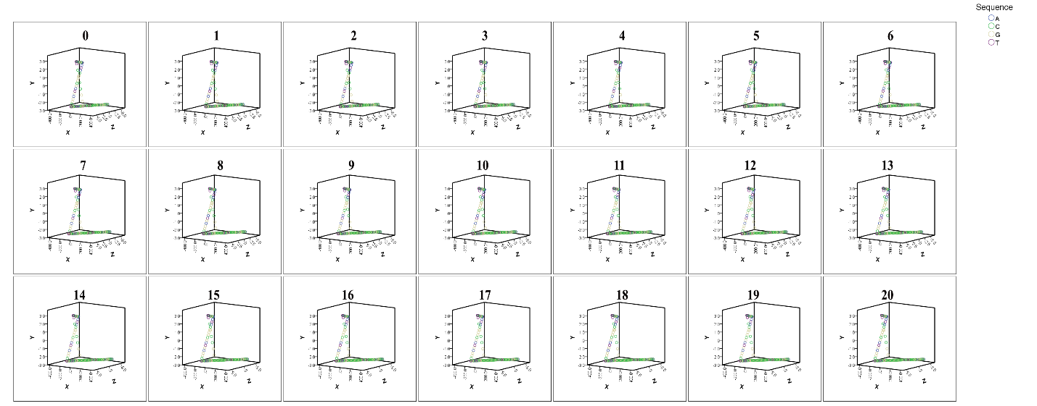
The GCC repeat in the 5’ UTR of the above gene resulted in the least divergence in the 3D structure of DNA for all repeats.

Human RASGEF1C
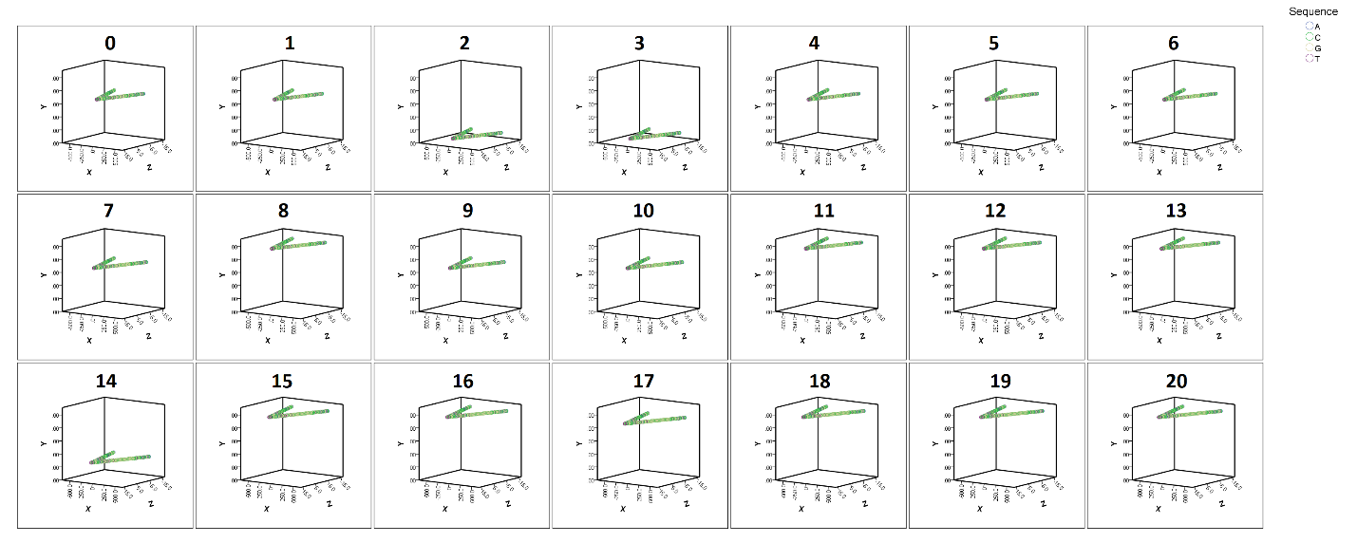
The GGC repeat in the 5’ UTR of the above gene resulted in the least divergence in the 3D structure of DNA for all repeats.

Capuchin PRKACB
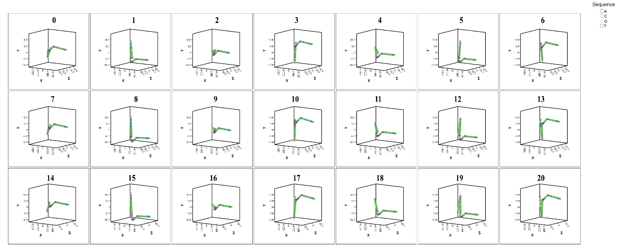
The GCC repeat in the 5’ UTR of a different species from human, which contained diverged flanking sequences resulted in similar results to human (least divergence effect on the 3D structure with 7-repeat additional or subtraction), indicating that the effect of GCC repeats is dominant to the effect of the flanking non-repeat sequences.

Human GPM6B
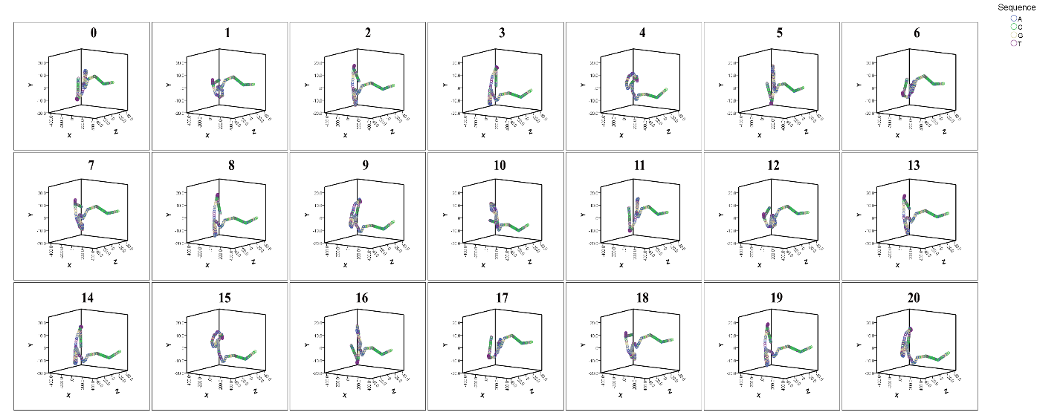
GA-repeats of all lengths exert significant effects on the 3D structure of the above gene.

