Enhanced virulence through genetic engineering of Beauveria bassiana blastospores by overexpression of a cuticle-degrading endochitinase

Gabriel Moura Mascarin^{1,2*}, Somraj Shrestha², Christopher A. Dunlap³, Jose Luis Ramirez³, Jeffrey J. Coleman²

¹ Laboratory of Environmental Microbiology, Brazilian Agricultural Research Corporation, Embrapa Environment, Rodovia SP 340, km 127.5, 13918-110 Jaguariúna, SP, Brazil.
² Department of Entomology and Plant Pathology, Auburn University, Auburn, AL 36849, USA.
³ Crop Bioprotection Research Unit, National Center for Agricultural Research, USDA, Peoria, IL 61604, USA

Supplementary material

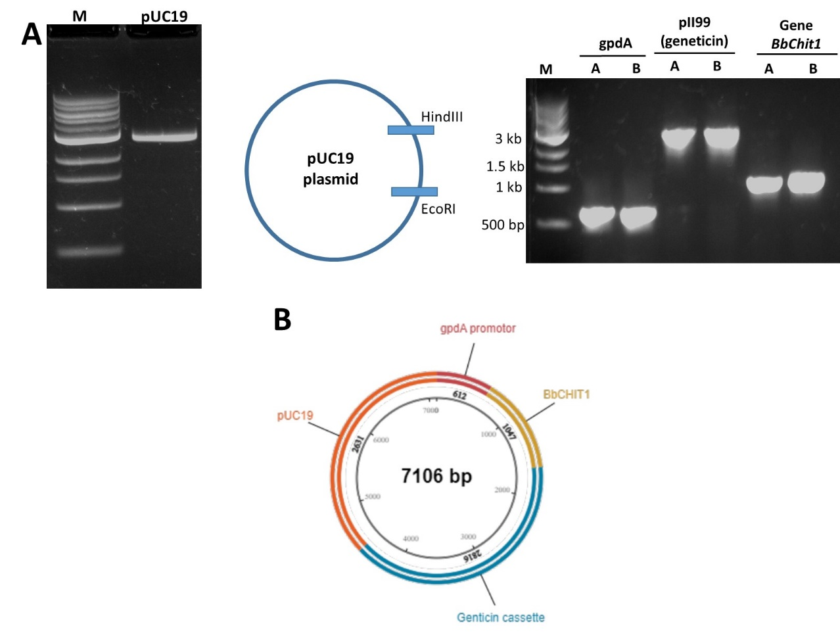
Fig. S1. Vector construction for overexpression of the endogenous chitinase gene BbChit1. (A) Ligation of plasmid pUC19 and gene sequences of geneticin (pII99), gpdA promotor, and chitinase gene (BbChit1). (B) Map of the vector constructed for use in generation of the BbChit1 overexpression strains.

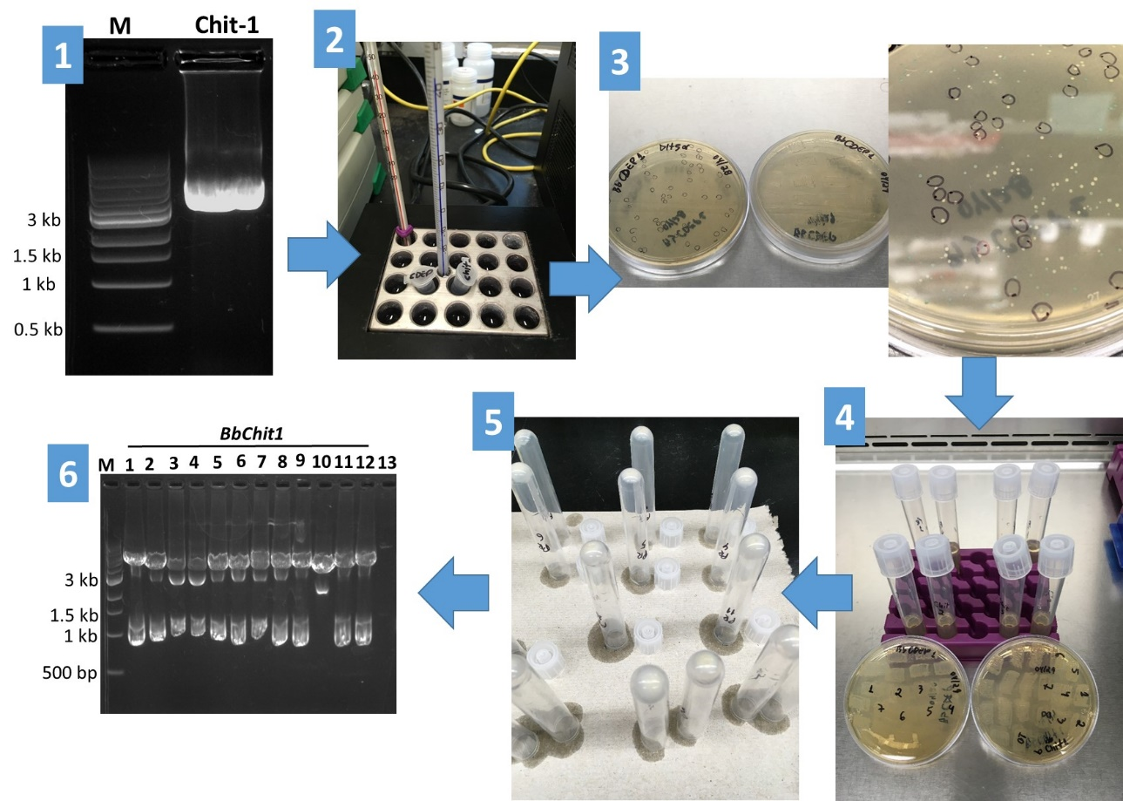
Fig. S2. Flowchart of E. coli transformation using heat-shock treatment with plasmids constructed with gpdA-BbChit1-geneticin cassette in pUC-19 as the backbone for overexpression of an endogenous chitinase from B. bassiana ARSEF 2860. 1) Agarose gel (0.8 w/v) of constructed plasmids with the target gene, BbChit1. 2) Heat shock treatment at 42 °C for 45 sec of competent E. coli cells in the presence of plasmidial constructs. 3) Selection of white recombinant bacterial colonies grown on selective medium based on XGal/IPTG. 4) Screening recombinant bacterial colonies on LB medium + 100 mg/mL ampicillin for 24 h. 5) Plasmid extraction and further digestion with the restriction enzyme EcoRI. 6) PCR analysis of E. coli colonies after transformation with plasmid constructs: Lines 1 to 12 are digested plasmids from E. coli transformed with the construct gpdA+BbChit1+geneticin. Positive mutants should appear with two bands on the 0.8% agarose gel after digestion only with EcoRI. More than 95% successful transformation in E. coli achieved with BbChit1.

