Unraveling the Role of Water in Mechanism Changes for Economically Viable Catalytic Plastic Upcycling
Taeeun Kwon ^{a,1}, Byeongchan Ahn ^{b,1}, Ki Hyuk Kang ^{c}, Wangyun Won ^{b,*}, Insoo Ro ^{a,*}
ª Department of Chemical and Biomolecular Engineering, Graduate School of Seoul National University of Science and Technology, Seoul, Republic of Korea
^{b} Department of Chemical and Biological Engineering, Korea University, Seoul, Republic of Korea
^{c} Chemical & Process Technology Division, Korea Research Institute of Chemical Technology (KRICT), Daejeon, Republic of Korea

¹ These authors contributed equally.
*Corresponding Authors:
Prof. W. Won (wwon@korea.ac.kr) and Prof. I. Ro (insoo@seoultech.ac.kr)

Supplementary Table 1 | LDPE depolymerization reaction results with different catalysts.
Entry | Catalyst | ª BAS/LAS ratio | Water/Catalyst weight ratio | Conversion (%) | ^{b} Yield (wt %)
 |  |  |  |  | Gas (Methane) | Gasoline | Jet fuel | Diesel | Lubricant
1 | 5% Ru/SiO₂ | 0.007 | 0.0 | 56.3 ± 0.6 | 5.8 (4.8) | 10.5 | 17.2 | 27.5 | 22.1
2 | 5% Ru/SiO₂ | 0.007 | 1.0 | 54.8 ± 0.7 | 3.2 (1.9) | 13.3 | 19.6 | 29.0 | 21.3
3 | 5% Ru/SBA-15 | 0.015 | 0.0 | 63.1 ± 1.2 | 3.0 (2.3) | 10.0 | 17.2 | 28.9 | 28.8
4 | 5% Ru/SBA-15 | 0.015 | 1.0 | 59.5 ± 0.5 | 7.4 (6.3) | 11.1 | 17.8 | 28.6 | 22.4
5 | 5% Ru/γ-Al₂O₃ | 0.000 | 0.0 | 49.1 ± 0.6 | 3.9 (3.0) | 8.2 | 13.7 | 22.8 | 21.5
6 | 5% Ru/γ-Al₂O₃ | 0.000 | 1.0 | 44.2 ± 0.7 | 8.0 (7.0) | 6.9 | 11.4 | 18.5 | 15.6
7 | 5% Ru/TiO₂ | 0.000 | 0.0 | 46.9 ± 0.9 | 0.9 (0.4) | 7.4 | 12.7 | 21.5 | 22.5
8 | 5% Ru/TiO₂ | 0.000 | 1.0 | 40.1 ± 0.6 | 4.0 (3.3) | 7.3 | 11.9 | 19.2 | 15.6
9 | 5% Ru/zeolite-Y | 0.410 | 0.0 | 80.6 ± 0.7 | 0.5 (0.3) | 9.7 | 19.4 | 35.6 | 41.5
10 | 5% Ru/zeolite-Y | 0.410 | 1.0 | 96.9 ± 0.2 | 1.4 (0.8) | 18.5 | 31.7 | 51.6 | 41.7
11 | Zeolite-Y | 0.398 | 0.0 | 27.3 ± 0.3 | 0.1 (0.0) | 1.2 | 2.8 | 8.2 | 17.2
12 | Zeolite-Y | 0.398 | 1.0 | 26.8 ± 0.4 | 0.0 (0.0) | 2.4 | 5.7 | 10.8 | 14.6
13 | ^{c} Blank | - | 0.0 | 5.8 ± 0.5 | 0.0 (0.0) | 0.3 | 0.7 | 1.8 | 3.7
14 | ^{c} Blank | - | ^{d} N.A. | 2.6 ± 0.2 | 0.1 (0.0) | 0.2 | 0.6 | 1.2 | 1.3
Reaction conditions: 250 °C, 3 h, 30 bar H₂ pressure (at 25°C), 1.70 g of LDPE (M_{n}: ~1,700, M_{w}: ~4,000), 50 mg of catalyst (Metal: 5wt%), and 50 mg of water (if needed), ª Brønsted acid site (BAS) per Lewis acid site (LAS) ratio estimated by Pyridine-adsorbed Fourier transform infrared (Py-IR) spectra, ^{b} Products were categorized by carbon number: Gas: C₁ - C₄, Gasoline: C₅ - C₁₂, Jet Fuel: C₈ - C₁₆, Diesel: C₉ - C₂₂, and Lubricant: C₂₀ - C₃₅, ^{c} no catalyst, ^{d} 50 mg of water was added. Detailed product distribution is shown in the Supplementary Fig. 1.

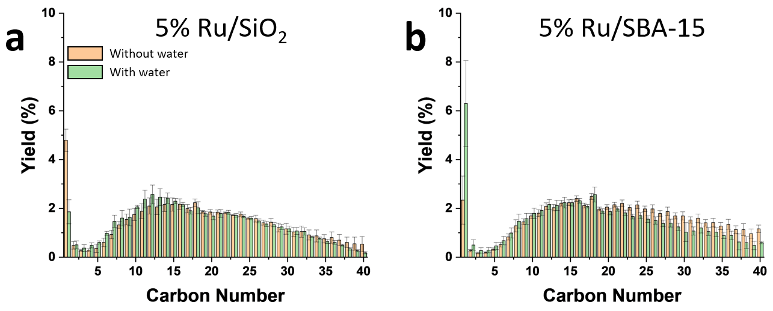
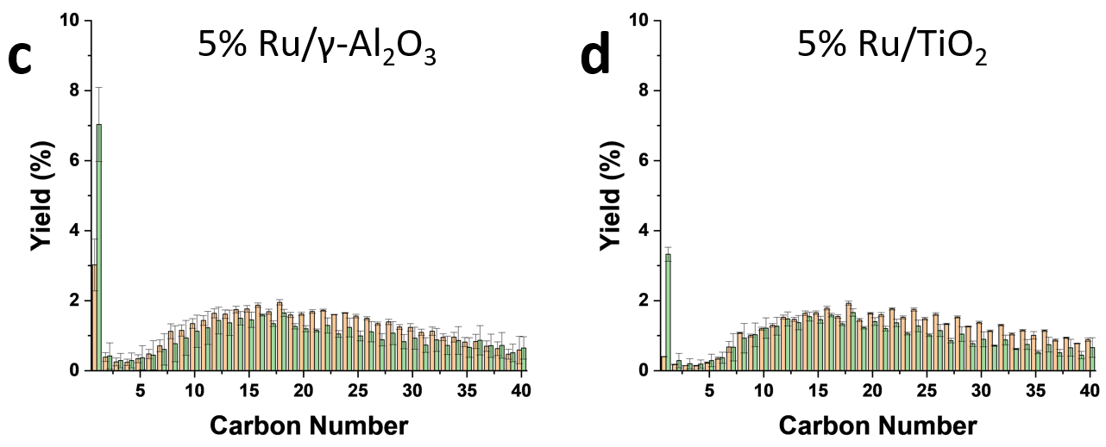
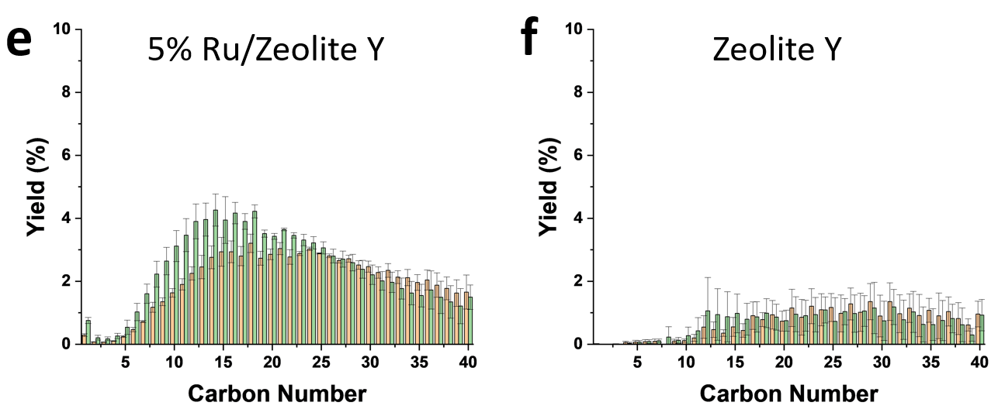
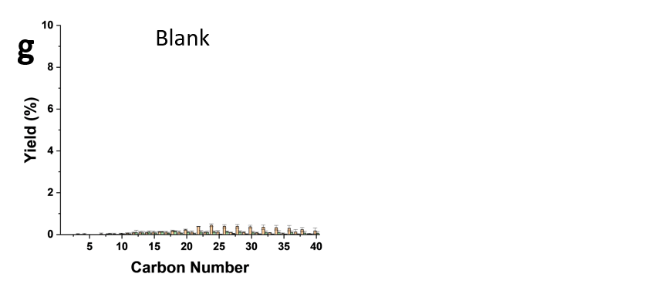
Supplementary Fig. 1 | Product distributions after LDPE depolymerization reaction. Reaction conditions: 250 °C, 3 h, 30 bar H₂ pressure (at 25°C), 1.70 g of LDPE (M_{n}: ~1,700, M_{w}: ~4,000), 50 mg of catalyst (Metal: 5wt%), The entries correspond to Supplementary Table 1. a. Ru/SiO₂ (entries 1, 2), b. Ru/SBA-15 (entries 3, 4), c. Ru/γ-Al₂O₃ (entries 5, 6), d. Ru/TiO₂ (entries 7, 8), e. 5% Ru/zeolite-Y (entries 9, 10), f. zeolite-Y (entries 11, 12), and g. Blank (entries 13, 14). Error bars = standard deviation. Source data are provided as a Source Data file.

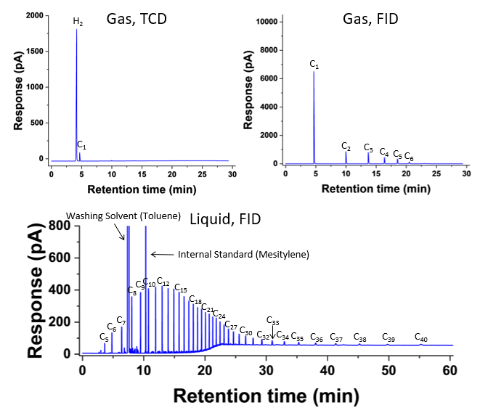
Supplementary Fig. 2 | GC-TCD and FID chromatograms of gas and liquid product from LDPE depolymerization reaction without water over Ru/zeolite-Y. Reaction conditions: 250 °C, 3 h, 30 bar H₂ pressure (at 25°C), 1.70 g of LDPE (M_{n}: ~1,700, M_{w}: ~4,000), 50 mg of Ru/zeolite-Y (metal: 5wt%). Source data are provided as a Source Data file.

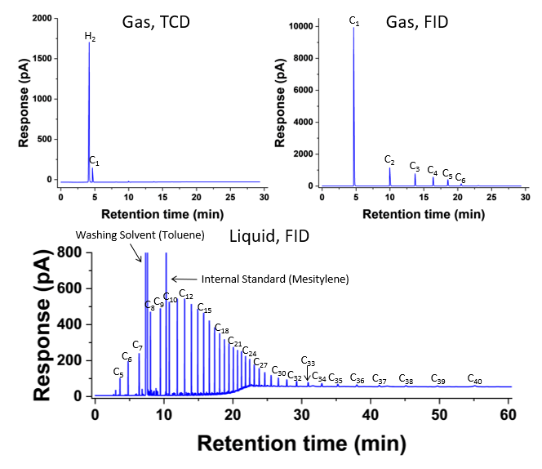
Supplementary Fig. 3 | GC-TCD and FID chromatograms of gas and liquid product from LDPE depolymerization reaction with water over Ru/zeolite-Y. Reaction conditions: 250 °C, 3 h, 30 bar H₂ pressure (at 25°C), 1.70 g of LDPE (M_{n}: ~1,700, M_{w}: ~4,000), 50 mg of Ru/zeolite-Y (metal: 5wt%), 50 mg of water. Source data are provided as a Source Data file.

Supplementary Table 2 | LDPE depolymerization reaction over Ru/zeolite-Y with different reaction conditions.
Entry | Reaction conditions |  |  | Water/Catalyst weight ratio | Conversion (%) | ^{b} Yield (%)
Entry | Time (h) | Temperature (°C) | ª Pressure (bar) | Water/Catalyst weight ratio | Conversion (%) | Gas (Methane) | Gasoline | Jet fuel | Diesel | Lubricant
1 | 0.5 | 250 | 30 | 0.0 | 35.3 ± 1.1 | 0.2 (0.1) | 2.4 | 5.7 | 12.5 | 21.7
2 | 0.5 | 250 | 30 | 1.0 | 45.4 ± 0.8 | 0.3 (0.2) | 3.4 | 7.5 | 15.6 | 25.5
3 | 1.5 | 250 | 30 | 0.0 | 51.0 ± 0.3 | 0.3 (0.2) | 4.8 | 10.2 | 20.7 | 31.9
4 | 1.5 | 250 | 30 | 1.0 | 82.4 ± 1.5 | 0.4 (0.2) | 7.6 | 16.1 | 31.6 | 44.7
5 | 3.0 | 250 | 30 | 0.0 | 80.6 ± 0.7 | 0.6 (0.3) | 9.9 | 18.9 | 34.6 | 41.4
6 | 3.0 | 250 | 30 | 1.0 | 96.9 ± 0.2 | 1.2 (0.7) | 17.8 | 27.4 | 48.0 | 44.8
7 | 6.0 | 250 | 30 | 0.0 | 99.4 ± 0.5 | 2.5 (1.4) | 23.1 | 35.1 | 52.3 | 35.8
8 | 6.0 | 250 | 30 | 1.0 | 100.0 ± 0.0 | 11.6 (6.6) | 45.5 | 42.9 | 52.5 | 20.8
9 | 1.5 | 250 | 30 | 0.5 | 76.6 ± 0.7 | 0.4 (0.2) | 7.1 | 15.1 | 30.1 | 42.7
10 | 1.5 | 250 | 30 | 2.0 | 69.1 ± 1.0 | 0.4 (0.3) | 5.8 | 13.1 | 26.9 | 38.7
11 | 1.5 | 250 | 20 | 0.0 | 40.9 ± 2.7 | 0.2 (0.1) | 2.7 | 6.4 | 14.1 | 25.6
12 | 1.5 | 250 | 20 | 1.0 | 70.5 ± 1.1 | 0.4 (0.3) | 5.6 | 12.7 | 25.8 | 40.2
13 | 1.5 | 250 | 40 | 0.0 | 57.2 ± 1.1 | 0.2 (0.1) | 3.8 | 9.3 | 20.3 | 33.4
14 | 1.5 | 250 | 40 | 1.0 | 85.5 ± 1.0 | 0.1 (0.1) | 2.9 | 9.5 | 24.6 | 50.8
15 | 1.5 | 200 | 30 | 0.0 | 24.6 ± 1.3 | 0.0 (0.0) | 0.5 | 1.6 | 5.1 | 14.6
16 | 1.5 | 200 | 30 | 1.0 | 29.4 ± 0.8 | 0.0 (0.0) | 0.6 | 2.1 | 6.3 | 17.6
17 | 1.5 | 300 | 30 | 0.0 | 91.2 ± 1.7 | 3.2 (2.0) | 37.9 | 47.2 | 59.0 | 19.9
18 | 1.5 | 300 | 30 | 1.0 | 99.0 ± 0.2 | 2.2 (1.0) | 28.8 | 41.5 | 59.1 | 33.3
Reaction conditions: 1.70 g LDPE (M_{n}: ~1,700, M_{w}: ~4,000), 50 mg of Ru/zeolite-Y (Metal: 5wt%), and rest of the reaction conditions were shown in the table, ª H₂ pressure at 25 °C, ^{b} Products were categorized by carbon number: Gas: C₁ - C₄, Gasoline: C₅ - C₁₂, Jet Fuel: C₈ - C₁₆, Diesel: C₉ - C₂₂, and Lubricant: C₂₀ - C₃₅.
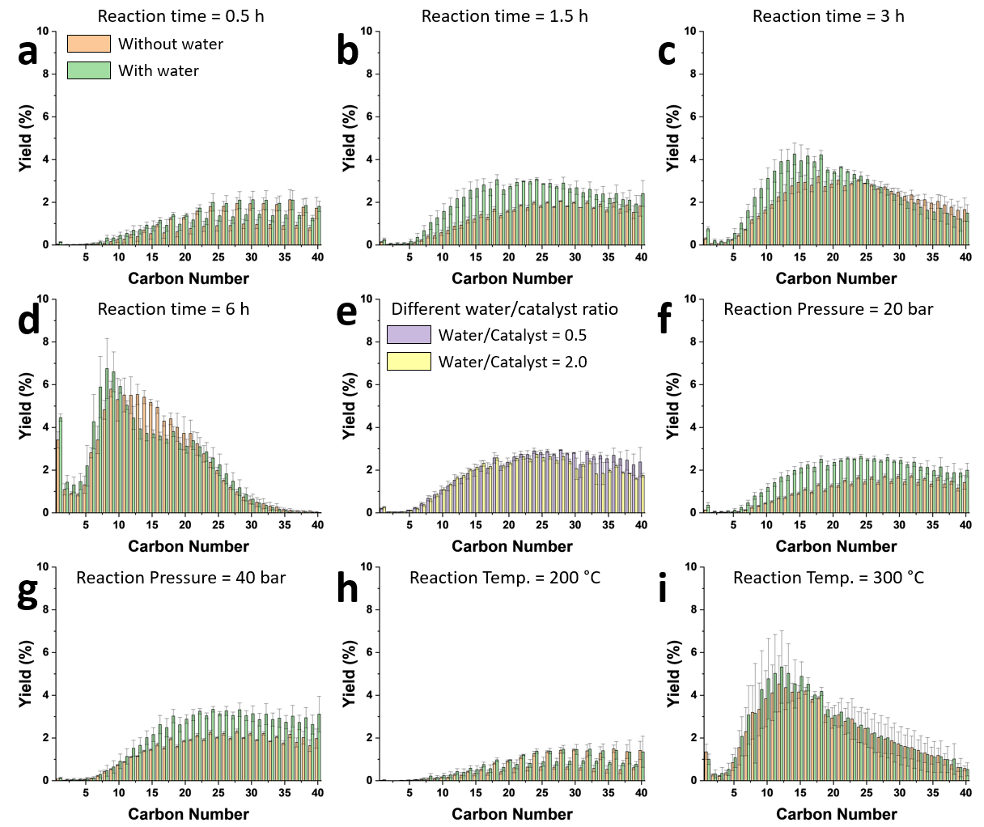
Supplementary Fig. 4 | Product distributions after LDPE depolymerization reaction over Ru/zeolite-Y with different reaction conditions. Unless otherwise mentioned, the reaction conditions are as follows: 250 °C, 1.5 h, 30 bar H₂ pressure (at 25°C), 1.70 g LDPE (M_{n}: ~1,700, M_{w}: ~4,000), 50 mg of Ru/zeolite-Y (Metal: 5wt%), and 50 mg of water (if needed), The entries correspond to Supplementary Table 1. a. Reaction time = 0.5 hours (entries 1, 2), b. Reaction time = 1.5 hours (entries 3, 4), c. Reaction time = 3 hours (entries 5, 6), d. Reaction time = 6 hours (entries 7, 8), e. Different water/catalyst ratio (entries 9, 10), f. Reaction pressure = 20 bar (entries 11, 12), g. Reaction pressure = 40 bar (entries 13, 14), h. Reaction temperature = 200 °C (entries 15, 16), and i. Reaction temperature = 300 °C (entries 17, 18). Error bars = standard deviation. Source data are provided as a Source Data file.

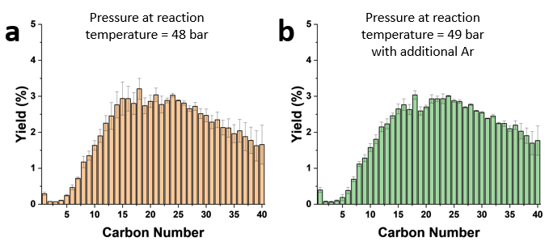
Supplementary Fig. 5 | Product distributions after LDPE depolymerization reaction with additional argon. Reaction conditions: 250 °C, 3 h, 1.70 g of LDPE (M_{n}: ~1,700, M_{w}: ~4,000), 50 mg of Ru/zeolite-Y (Metal: 5wt%), Pressure conditions: a. 30 bar H₂, b. 30 bar H₂ and 1 bar Ar (at 25 °C). Error bars = standard deviation. Source data are provided as a Source Data file.

In light of the difference in pressure between conditions without water (48 bar) and with water (49 bar) at a reaction temperature (250 °C), an additional experiment was conducted to investigate whether the observed reactivity enhancement resulted from a slight increase in reaction pressure. The introduction of additional Ar to achieve a reaction pressure of 49 bar yielded negligible difference in conversion and yields, suggesting that the increased reactivity is predominantly attributed to the presence of water rather than solely an escalation in reaction pressure.

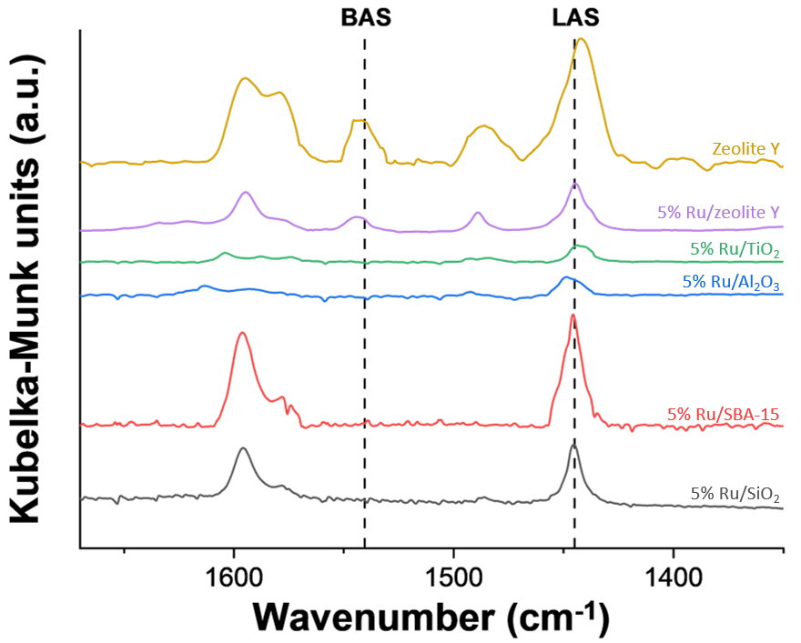
Supplementary Fig. 6 | Pyridine-IR spectra of Zeolite-Y and various Ru-based catalysts. Source data are provided as a Source Data file.

Supplementary Table 3 | Acid properties of Zeolite-Y and various Ru-based catalysts based on pyridine-DRIFTS analysis.
Catalyst | Integrated Absorbance (cm⁻¹) |  | Sample weight (mg) | Acidity by Pyridine-DRIFTS
Catalyst | BAS | LAS | Sample weight (mg) | BAS (%) | LAS (%) | BAS/LAS
5% Ru/SiO₂ | 0.01 | 2.86 | 10.1 | 0.7 | 99.3 | 0.007
5% Ru/SBA-15 | 0.06 | 5.85 | 17.5 | 1.5 | 98.5 | 0.015
5% Ru/Al₂O₃ | 0.00 | 1.31 | 11.1 | 0.0 | 100.0 | 0.000
5% Ru/TiO₂ | 0.00 | 0.99 | 10.7 | 0.0 | 100.0 | 0.000
5% Ru/zeolite-Y | 0.73 | 2.82 | 10.2 | 29.1 | 70.9 | 0.410
Zeolite-Y | 2.63 | 10.52 | 33.4 | 28.4 | 71.6 | 0.398
Radius of the catalyst disk was 0.63 cm.

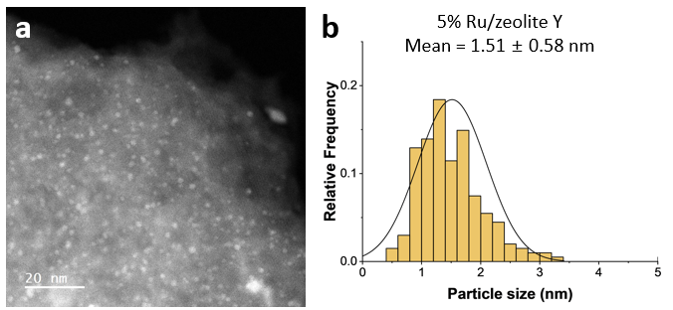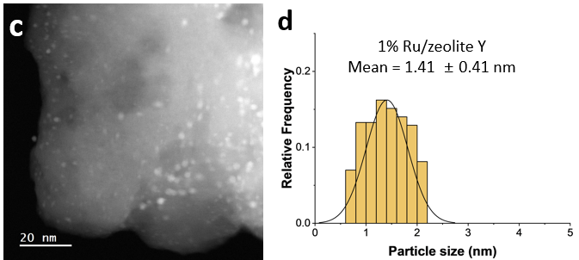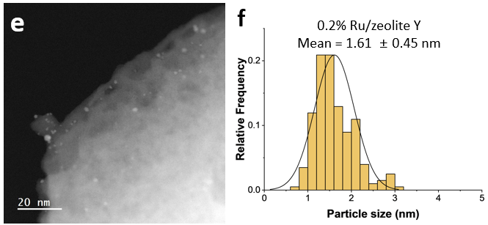
Supplementary Fig. 7 | Representative STEM image and Ru particle size distribution histogram of Ru/zeolite-Y. a, b. 5% Ru/zeolite-Y, c, d. 1% Ru/zeolite-Y, e, f. 0.2% Ru/zeolite-Y (Metal: 5wt%). Source data are provided as a Source Data file.

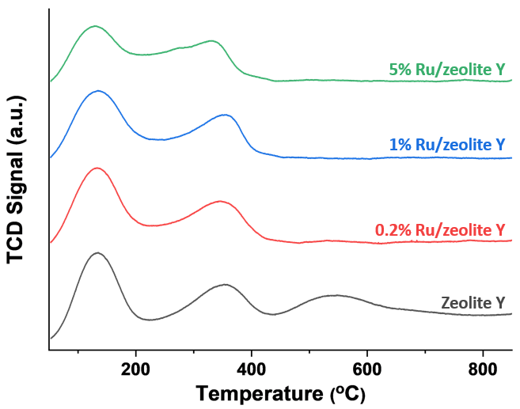
Supplementary Fig. 8 | Ammonia temperature-programmed desorption (NH₃-TPD) signal of different weight loading of Ru/zeolite-Y and zeolite-Y. Source data are provided as a Source Data file.

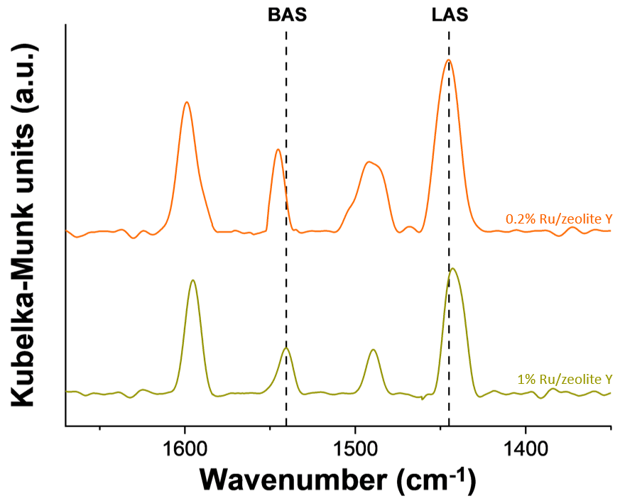
Supplementary Fig. 9 | Pyridine-IR spectra of Ru/zeolite-Y with different Ru loading. Source data are provided as a Source Data file.

Supplementary Table 4 | Acid properties of the Ru/zeolite-Y with different Ru loading based on pyridine-DRIFTS analysis.
Catalyst | Integrated Absorbance (cm⁻¹) |  | Sample weight (mg) | Acidity by Pyridine-DRIFTS
Catalyst | BAS | LAS | Sample weight (mg) | BAS (%) | LAS (%) | BAS/LAS
1% Ru/zeolite-Y | 1.01 | 3.79 | 18.2 | 29.8 | 70.2 | 0.425
0.2% Ru/zeolite-Y | 1.55 | 6.00 | 24.5 | 29.1 | 70.9 | 0.410
Radius of the catalyst disk was 0.63 cm.

Supplementary Table 5 | Catalytic properties of Ru/zeolite-Y
Catalyst | ª Particle size (nm) | ^{b} Acid site density (µmol/g) | ^{c} BAS/LAS ratio
5% Ru/zeolite-Y | 1.51 ± 0.58 | 636.3 | 0.410
1% Ru/zeolite-Y | 1.41 ± 0.41 | 602.5 | 0.425
0.2% Ru/zeolite-Y | 1.61 ± 0.45 | 609.3 | 0.410
ª Particle size was determined by STEM. ^{b} Acid site density was determined by NH₃-TPD. ^{c} Brønsted acid site (BAS) per Lewis acid site (LAS) ratio estimated by Pyridine-adsorbed Fourier transform infrared (Py-IR) spectra.

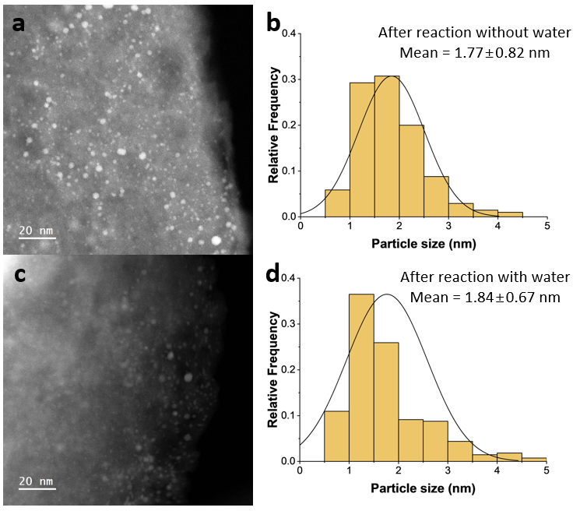
Supplementary Fig. 10 | a, c. Representative STEM images of spent Ru/zeolite-Y (Metal: 5wt%). b, d. Ru particle size distribution histograms of spent Ru/zeolite-Y (Metal: 5wt%). Source data are provided as a Source Data file.

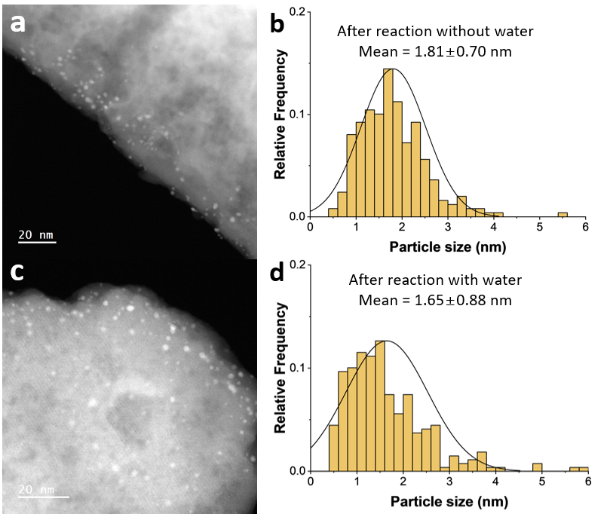
Supplementary Fig. 11 | a, c. Representative STEM images of spent Ru/zeolite-Y (Metal: 0.2wt%). b, d. Ru particle size distribution histograms of spent Ru/zeolite-Y (Metal: 0.2wt%). Source data are provided as a Source Data file.

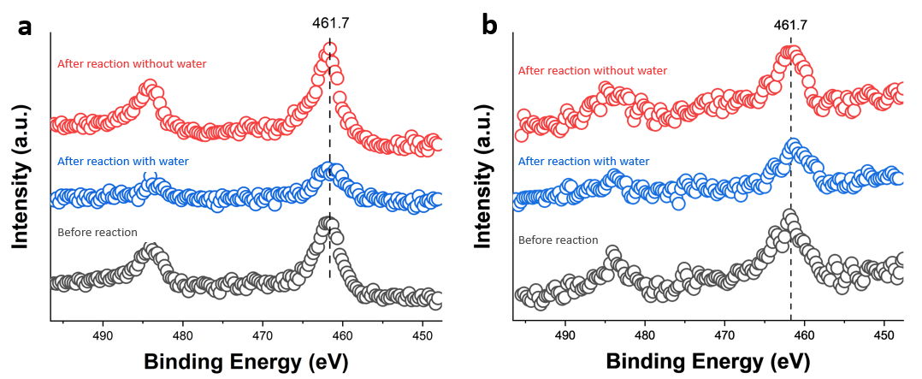
Supplementary Fig. 12 | X-ray photoelectron spectrum of Ru 3p_{3/2} of Ru/zeolite-Y before and after reaction with or without water a. 5% Ru/zeolite-Y, b. 0.2% Ru/zeolite-Y. Source data are provided as a Source Data file.

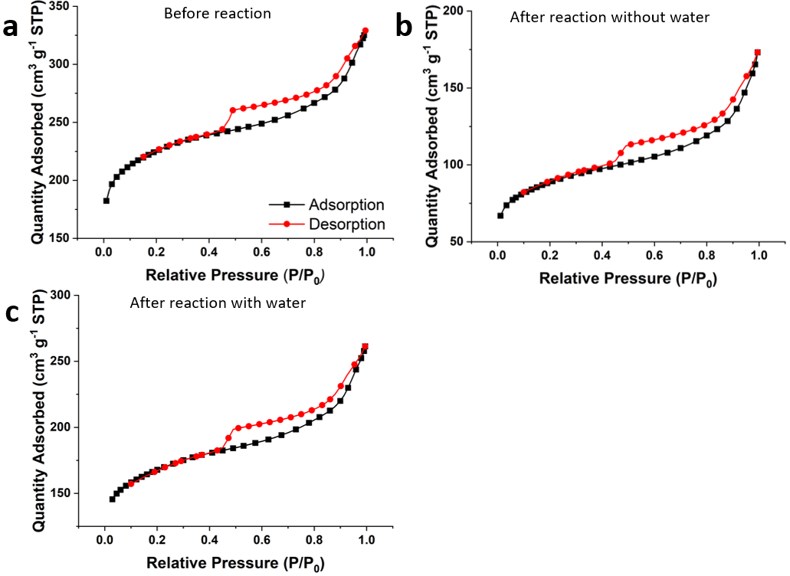
Supplementary Fig. 13 | N₂ adsorption-desorption isotherms a. Fresh Ru/Zeolite-Y, b. Ru/Zeolite-Y after reaction without water, and c. Ru/Zeolite-Y after reaction with water, (Metal: 5 wt %). Source data are provided as a Source Data file.

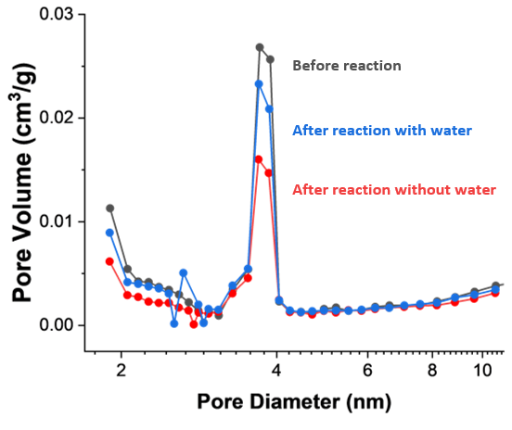
Supplementary Fig. 14 | Pore size distribution of fresh and spent Ru/Zeolite Y in the presence or absence of water based on the N₂ adsorption-desorption. Source data are provided as a Source Data file.

Supplementary Table 6 | Pore structure properties for fresh and spent catalyst, determined by BET.
Condition | Surface area  (m² g⁻¹) | Pore volume  (cm³ g⁻¹)
Before reaction | 855 | 0.509
After reaction without water | 327 | 0.268
After reaction with water | 635 | 0.404
Spent catalyst was obtained following conditions: 250 °C, 12 h, 30 bar H₂ pressure (at 25°C), 50 mg of Ru/zeolite-Y (Metal: 5wt%), 50 mg of water (if required). ª 1.70 g of LDPE (M_{n}: ~1,700, M_{w}: ~4,000) was added and ^{b} LDPE was not added.

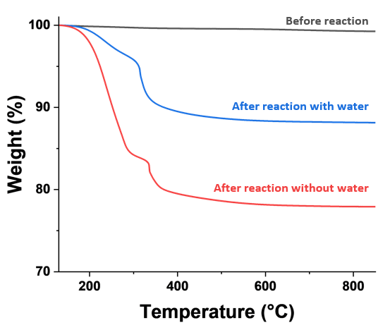
Supplementary Fig. 15 | TGA result of fresh and spent 5% Ru/zeolite-Y. Source data are provided as a Source Data file.

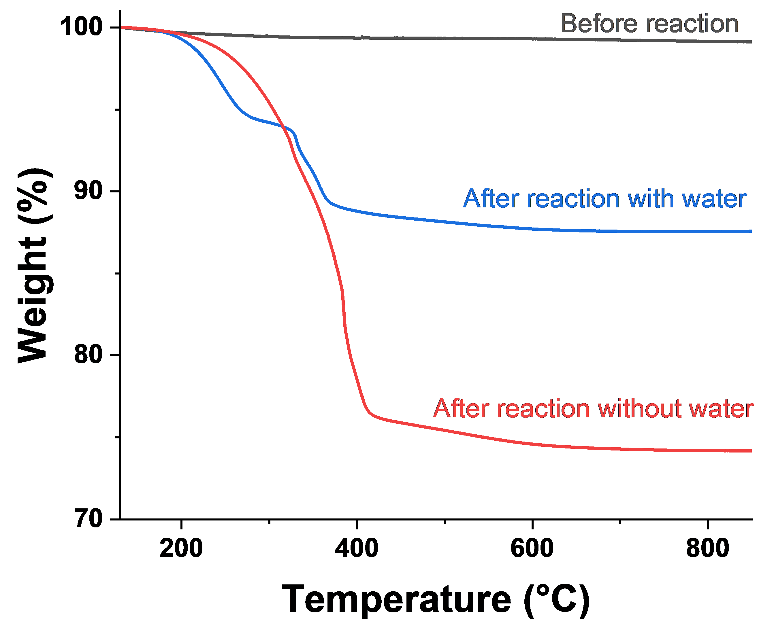
Supplementary Fig. 16 | TGA result of fresh and spent 0.2% Ru/zeolite-Y. Source data are provided as a Source Data file.

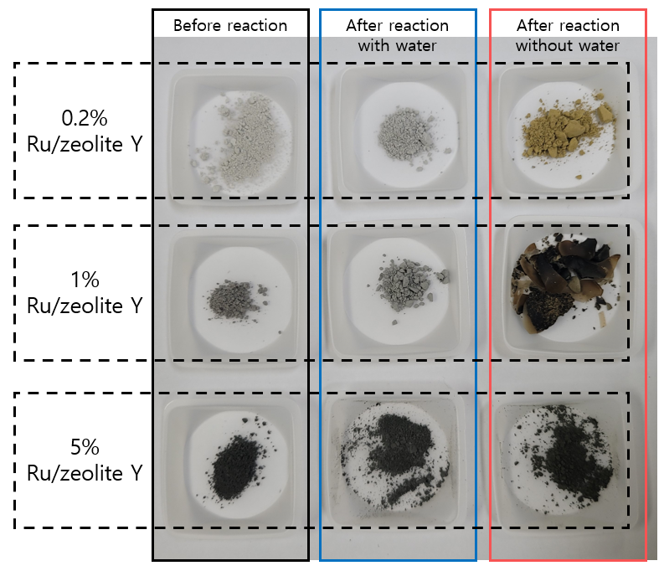
Supplementary Fig. 17 | Appearance of the catalyst before and after the reaction.

Supplementary Table 7 | Reusability results of LDPE depolymerization reaction over 5% Ru/zeolite-Y.
Entry | Catalyst condition | Water/Catalyst weight ratio | Conversion (%) | ª Yield (%)
 |  |  |  | Gas (Methane) | Gasoline | Jet fuel | Diesel | Lubricant
1 | 1st reuse with spent catalyst without water | 0.0 | 31.8 ± 1.3 | 0.1 (0.1) | 1.4 | 3.5 | 8.7 | 19.4
2 | 1st reuse with spent catalyst with water | 1.0 | 94.5 ± 0.4 | 0.5 (0.3) | 10.0 | 21.3 | 40.8 | 48.5
3 | 2nd reuse with spent catalyst without water | 0.0 | 24.1 ± 0.7 | 0.0 (0.0) | 0.3 | 1.0 | 4.5 | 15.4
4 | 2nd reuse with spent catalyst with water | 1.0 | 90.1 ± 0.6 | 0.3 (0.1) | 9.0 | 18.4 | 36.5 | 49.1
Reaction conditions: 250 °C, 3 h, 30 bar H₂ pressure (at 25°C), 1.70 g LDPE (M_{n}: ~1,700, M_{w}: ~4,000), 50 mg of spent Ru/zeolite-Y (Metal: 5wt%), and 50 mg of water (if needed). ª Products were categorized by carbon number: Gas: C₁ - C₄, Gasoline: C₅ - C₁₂, Jet Fuel: C₈ - C₁₆, Diesel: C₉ - C₂₂, and Lubricant: C₂₀ - C₃₅.
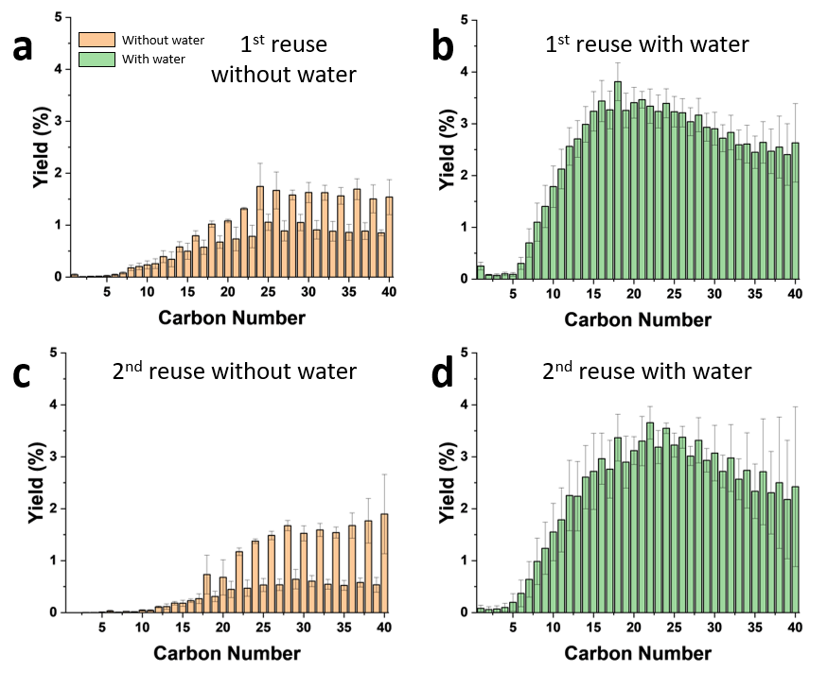
Supplementary Fig. 18 | Product distributions after LDPE depolymerization reaction for reuse test of Ru/zeolite-Y, the entries correspond to Supplementary Table 7, a. 1st reuse with spent catalyst without water (entry 1), b. 1st reuse with spent catalyst with water (entry 2), c. 2nd reuse with spent catalyst without water (entry 3), and d. 2nd reuse with spent catalyst with water (entry 4). Reaction conditions: 250 °C, 3 h, 30 bar H₂ pressure (at 25°C), 1.70 g of LDPE (M_{n}: ~1,700, M_{w}: ~4,000), 50 mg of spent catalyst (Metal: 5wt%), and 50 mg of water (if needed). Error bars = standard deviation. Source data are provided as a Source Data file.

Supplementary Table 8 | Acid properties of the spent 5% Ru/zeolite-Y based on pyridine-DRIFTS analysis.
Catalyst | Integrated Absorbance (cm⁻¹) |  | Sample weight (mg) | Acidity by Pyridine-DRIFTS
Catalyst | BAS | LAS | Sample weight (mg) | BAS (%) | LAS (%) | BAS/LAS
After reaction ª without water | 0.11 | 1.71 | 10.2 | 9.1 | 90.9 | 0.100
After reaction ª with water | 0.58 | 2.45 | 10.6 | 27.3 | 72.7 | 0.376
After controlled reaction ^{b}  without water | 0.59 | 2.68 | 9.8 | 25.9 | 74.1 | 0.350
After controlled reaction ^{b}  with water | 0.63 | 2.61 | 10.0 | 27.7 | 72.3 | 0.383
Radius of the catalyst disk was 0.63 cm. Spent catalyst was obtained following conditions: 250 °C, 12 h, 30 bar H₂ pressure (at 25°C), 50 mg of Ru/zeolite-Y (Metal: 5wt%), 50 mg of water (if required). ª 1.70 g of LDPE (M_{n}: ~1,700, M_{w}: ~4,000) was added and ^{b} LDPE was not added.

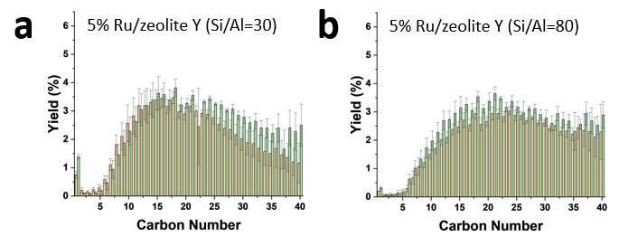
Supplementary Fig. 19 | Product distributions after LDPE depolymerization reaction over Ru/zeolite-Y with different Si/Al ratio. Reaction conditions: 250 °C, 3 h, 30 bar H₂ (at 25°C), 1.70 g of LDPE (M_{n}: ~1,700, M_{w}: ~4,000), 50 mg of catalyst, 50 mg of water (if needed). Error bars = standard deviation. Source data are provided as a Source Data file.

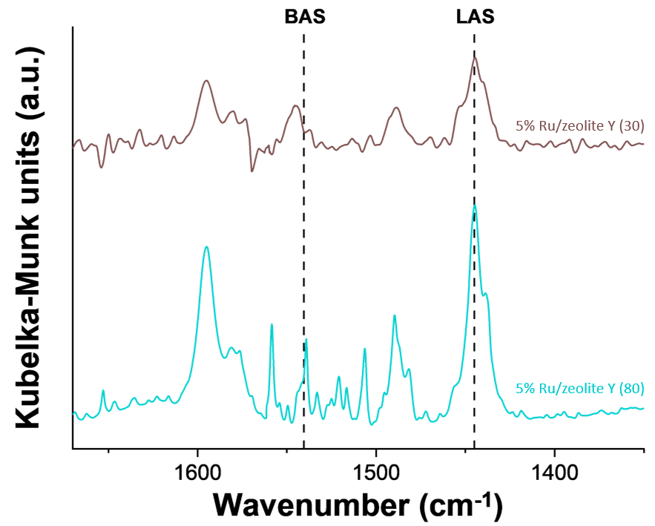
Supplementary Fig. 20 | Pyridine-IR spectra of Ru/zeolite-Y with different Si/Al ratio. Source data are provided as a Source Data file.
Supplementary Table 9 | PE depolymerization reaction over different content of Ru and acid site, and their proximity.
Entry | Catalyst | Ru content (mg) | Catalyst/Water weight ratio | Conversion (%) | ª Yield (%)
 |  |  |  |  | Gas | Gasoline | Jet fuel | Diesel | Lubricant
1 | 5% Ru/zeolite-Y (Si/Al=30) | 2.5 | 0.0 | 83.2 ± 1.2 | 1.3 | 14.5 | 25.8 | 42.7 | 37.6
2 | 5% Ru/zeolite-Y (Si/Al=30) | 2.5 | 1.0 | 96.5 ± 1.0 | 1.7 | 12.9 | 25.1 | 43.3 | 46.5
3 | 5% Ru/zeolite-Y (Si/Al=80) | 2.5 | 0.0 | 80.9 ± 0.4 | 0.4 | 8.6 | 17.2 | 32.7 | 42.7
4 | 5% Ru/zeolite-Y (Si/Al=80) | 2.5 | 1.0 | 96.2 ± 0.8 | 0.6 | 11.9 | 22.1 | 41.0 | 48.4
Reaction conditions: 250 °C, 3 h, 30 bar H₂ (at 25°C), 1.70 g of PE (M_{n}: ~1,700, M_{w}: ~4,000). ª Products were categorized by carbon number: Gas: C₁ - C₄, Gasoline: C₅ - C₁₂, Jet Fuel: C₈ - C₁₆, Diesel: C₉ - C₂₂, and Lubricant: C₂₀ - C₃₅.

Supplementary Table 10 | Acid properties of the Ru/zeolite-Y with different Si/Al ratio based on pyridine-DRIFTS analysis.
Catalyst | Integrated Absorbance (cm⁻¹) |  | Sample weight (mg) | Acidity by Pyridine-DRIFTS
Catalyst | BAS | LAS | Sample weight (mg) | BAS (%) | LAS (%) | BAS/LAS
5% Ru/zeolite-Y (Si/Al=30) | 1.04 | 2.48 | 10.4 | 39.9 | 60.1 | 0.664
5% Ru/zeolite-Y (Si/Al=80) | 0.81 | 5.05 | 10.3 | 20.4 | 79.6 | 0.256
Radius of the catalyst disk was 0.63 cm.

Supplementary Table 9 show comparable conversion enhancements in both Ru/zeolite-Y variants compared to our reference, suggesting the negligible influence of acid strength on conversion. However, interesting trends were found in product distribution related to acid strength. In the absence of water, decreasing Si/Al ratios led to a slight increase in gasoline yield and a minor reduction in lubricating oil yield (Supplementary Fig. 19). These findings align with pyridine-IR results (Supplementary Fig. 20 and Supplementary Table 10), showing a direct correlation between lower Si/Al ratios and higher proportions of Brønsted acid site, and thereby this suggests their pronounced contribution to the hydrocracking reaction. Conversely, in the presence of water, the reaction intermediates show no discernible trend linked to acid site density. This behavior arises from their ability to undergo protonation/deprotonation facilitated by water, as well as the increased influence of metal sites in the presence of water.

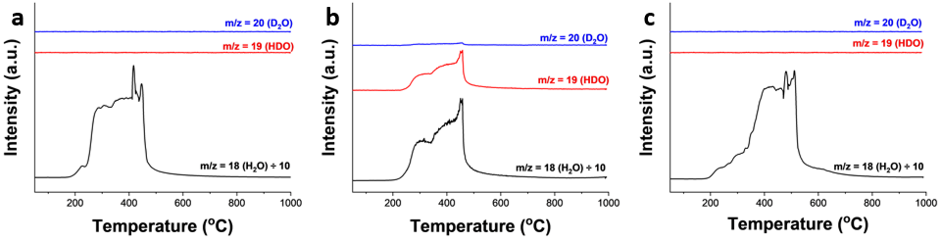
Supplementary Fig. 21 | Temperature-programmed oxidation coupled with mass spectrometry (TPO-MS) results for H₂O, HDO, and D₂O. a. After reaction with H₂O, b. After reaction with D₂O, and c. Controlled experiment with D₂O (reaction temperature was fixed at 25°C). Reaction conditions: 12 h, 30 bar H₂ (at 25°C), 50 mg of Ru/zeolite-Y (Metal: 5wt%), 1.70 g LDPE (M_{n}: ~1,700, M_{w}: ~4,000), and a. 250 °C, 50 mg of H₂O, b. 250 °C, 55.6 mg of D₂O, c. 25 °C, 55.6mg of D₂O. Source data are provided as a Source Data file.

To ascertain whether the observed HDO peak originates from the reaction rather than physically adsorbed D₂O, a control experiment was performed at a room temperature of 25 °C for 12 h. TPO-MS analysis demonstrated the absence of both D₂O and HDO after the control experiment, ruling out the possibility of physically adsorbed D₂O.

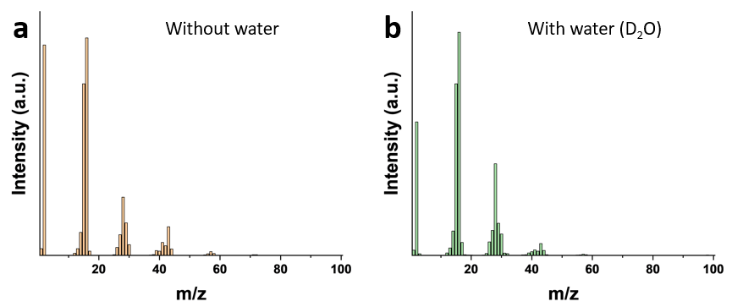
Supplementary Fig. 22 | MS spectra of gas products after reaction. a. without water b. with water (D₂O). Reaction conditions: 250 °C, 12 h, 30 bar H₂ pressure (at 25°C), 1.70 g LDPE (M_{n}: ~1,700, M_{w}: ~4,000), 50 mg of Ru/zeolite-Y (Metal: 5wt%), 55.6 mg of D₂O (if required). Source data are provided as a Source Data file.

Supplementary Table 11 | Depolymerization reaction results using PP, HDPE, commercial LDPE and LDPE bottle over Ru/zeolite-Y both with and without water.
Entry | Catalyst | Reactant | Reaction conditions | Conversion (%) | ª Yield (%)
 |  |  |  |  | Gas (Methane) | Gasoline | Jet fuel | Diesel | Lubricant
1 | 0.2% Ru/zeolite-Y | PP | (a) | 87.9 ± 2.5 | 23.8 (1.7) | 56.0 | 24.6 | 22.7 | 1.9
2 | 0.2% Ru/zeolite-Y | PP | (b) | 92.4 ± 0.1 | 2.2 (0.0) | 51.9 | 69.9 | 68.4 | 2.3
3 | 0.2% Ru/zeolite-Y | HDPE | (a) | 73.8 ± 1.6 | 50.1 (7.4) | 21.6 | 2.9 | 2.7 | 1.0
4 | 0.2% Ru/zeolite-Y | HDPE | (b) | 92.6 ± 0.7 | 56.9 (30.1) | 17.3 | 9.2 | 13.9 | 9.5
5 | 0.2% Ru/zeolite-Y | Commercial LDPE | (a) | 49.4 ± 1.7 | 32.2 (6.4) | 16.9 | 1.0 | 0.7 | 0.1
6 | 0.2% Ru/zeolite-Y | Commercial LDPE | (b) | 63.4 ± 1.5 | 2.5 (1.3) | 16.7 | 24.0 | 34.3 | 23.5
7 | 5% Ru/zeolite-Y | Commercial LDPE | (c) | 32.4 ± 0.5 | 6.8 (3.0) | 6.8 | 7.8 | 11.9 | 10.6
8 | 5% Ru/zeolite-Y | Commercial LDPE | (d) | 74.0 ± 1.5 | 2.7 (1.5) | 20.8 | 29.4 | 40.8 | 25.4
9 | 0.2% Ru/zeolite-Y | LDPE bottle | (a) | 43.6 ± 2.6 | 8.5 (1.6) | 34.1 | 15.0 | 9.2 | 0.2
10 | 0.2% Ru/zeolite-Y | LDPE bottle | (b) | 57.5 ± 1.0 | 4.4 (2.6) | 8.8 | 13.0 | 21.1 | 25.6
11 | 5% Ru/zeolite-Y | LDPE bottle | (c) | 74.5 ± 1.7 | 0.9 (0.5) | 11.1 | 20.3 | 34.9 | 36.1
12 | 5% Ru/zeolite- Y | LDPE bottle | (d) | 99.8 ± 0.3 | 11.0 (5.2) | 45.3 | 45.9 | 55.3 | 18.4
Reaction conditions: (a) 300 °C, 9 h, 30 bar H₂ (at 25°C), 1.70 g of reactant, 1.25g of catalyst, (b) 300 °C, 9 h, 30 bar H₂ (at 25°C), 1.70 g of reactant, 1.25g of catalyst, 1.25 g of water, (c) 250 °C, 6 h, 30 bar H₂ (at 25°C), 1.70 g of reactant, 50 mg of catalyst, (d) 250 °C, 6 h, 30 bar H₂ (at 25°C), 1.70 g of reactant, 50 mg of catalyst, 50 mg of water. ª Products were categorized by carbon number: Gas: C₁ - C₄, Gasoline: C₅ - C₁₂, Jet Fuel: C₈ - C₁₆, Diesel: C₉ - C₂₂, and Lubricant: C₂₀ - C₃₅.
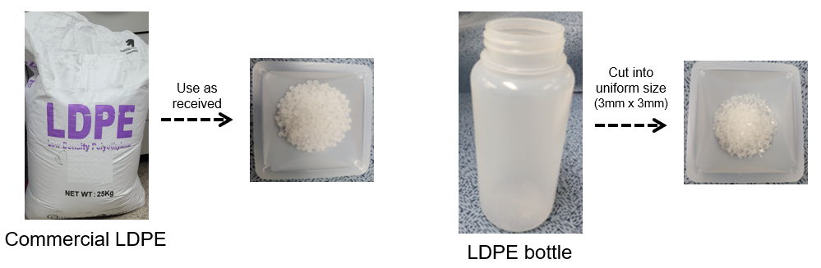
Supplementary Fig. 23 | Commercial LDPE and post-consumer LDPE bottle.

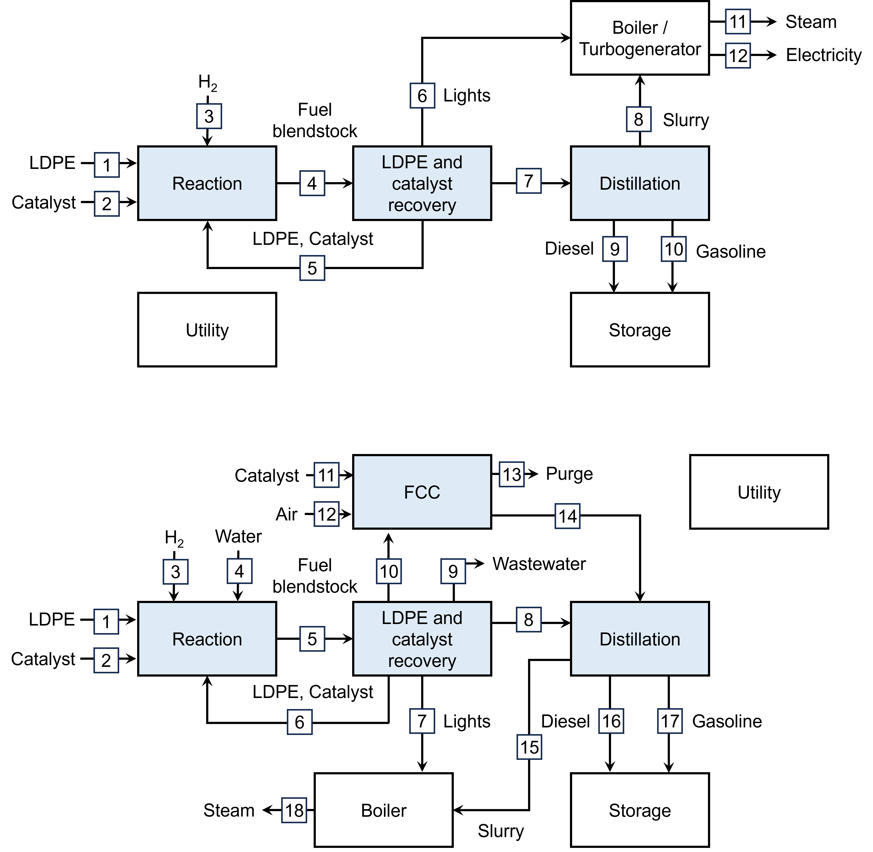
Supplementary Fig. 24 | Overall process block flow diagram of the process without and with water. Blue process steps correspond to inside battery limit (ISBL), and white process steps correspond to outside battery limit (OSBL).

Supplementary Table 12 | Mass and energy balances based on processing 240 tons/day of LDPE.
Major process step | Stream | Temp. (°C) | Pressure (bar) | Mass flow (tons/day) | Energy requirement (MW)
Process without water
Reaction | 1 | 25 | 1 | 264.6 | Heating: 6.4  Electricity: 0.3
Reaction | 3 | 25 | 70 | 5.1 | Heating: 6.4  Electricity: 0.3
Reaction | 4 | 250 | 46 | 500.3 | Heating: 6.4  Electricity: 0.3
LDPE and catalyst recovery | 6 | -19 | 1 | 26.1 | Cooling: 1.3
LDPE and catalyst recovery | 7 | 190 | 1 | 243.5 | Cooling: 1.3
Distillation | 9 | 247.9 | 1 | 32.2 | Heating: 0.3
Distillation | 10 | 123.8 | 1 | 200.9 | Heating: 0.3
Process with water
Reaction | 1 | 25 | 1 | 264.6 | Electricity:0.3
Reaction | 3 | 25 | 70 | 2.5 | Electricity:0.3
Reaction | 5 | 250 | 26 | 819.6 | Electricity:0.3
LDPE and catalyst recovery | 7 | 50 | 2 | 0.8 | Cooling:2.9
LDPE and catalyst recovery | 8 | 50 | 2 | 120.8 | Cooling:2.9
LDPE and catalyst recovery | 10 | 459 | 2 | 145.5 | Cooling:2.9
FCC | 14 | 140 | 2 | 145.5 | Heating: 2.2  Cooling: 0.6  Electricity: 0.6
Distillation | 16 | 251 | 1 | 106.5 | Heating: 1.1  Cooling:0.6
Distillation | 17 | 69 | 1 | 143.4 | Heating: 1.1  Cooling:0.6

Supplementary Table 13 | Energy requirements before and after heat integration.
Process | Energy required (MW) | Before | after
Without water | Heating | 8.1 | 6.7
Without water | Cooling | 2.8 | 1.3
With water | Heating | 9.7 | 3.3
With water | Cooling | 7.7 | 4.1

Supplementary Table 14 | List of economic parameters and assumptions.
Waste LDPE price ($ per ton)¹ |  | 600.0
Hydrogen price ($ per ton)² |  | 3,640.0
Decarbonized water price ($ per ton)³ |  | 10.0
Wastewater disposal price (cents per gal)⁴ |  | 7.2
FCC catalyst ($ per ton)⁵ |  | 2,000.0
Disposal of ash cost ($ per ton)⁶ |  | 37.6
Boiler chemicals ($ per ton) ⁶ |  | 6,126.0
Flue gas desulfurization lime price ($ per ton)⁶ |  | 262.0
Ammonia price ($ per ton)⁶ |  | 86.0
Cooling tower chemicals price ($ per ton)⁶ |  | 3,933.0
Electricity price (cents/kWh)⁷ |  | 6.7
Diesel price ($/gal)⁷ |  | 3.3
Internal rate of return (%)¹ |  | 20.0%
Tax rate (%)¹ |  | 21.0%
Depreciation period (years)¹ |  | 7.0
Assumptions:
- Capital investment is spread over 3 years at a rate of 8%, 60%, and 32% in the first, second, and third years, respectively.
- Working capital is 5% of fixed capital investment.
- Capital charge factor, calculated by discounted cash flow analysis, is 0.171.
Reference
¹ | Yadav, G., Singh, A., Dutta, A., Uekert, T., DesVeaux, J. S., Nicholson, S. R., ... & Beckham, G. T. Techno-economic analysis and life cycle assessment for catalytic fast pyrolysis of mixed plastic waste. Energy & Environmental Science, 16(9), 3638-3653 (2023). https://doi.org/10.1039/D3EE00749A.
² | https://data.csiro.au.
³ | Jang, D., Kim, J., Kim, D., Han, W. B., & Kang, S. Techno-economic analysis and Monte Carlo simulation of green hydrogen production technology through various water electrolysis technologies. Energy Conversion and Management, 258, 115499 (2022).
⁴ | https://www.statista.com
⁵ | Feedstock, E. W. Equipment design and cost estimation for small modular biomass systems, synthesis gas cleanup, and oxygen separation equipment. Nature Renew Energy Laboratory (2006).
⁶ | Davis, R. E., Grundl, N. J., Tao, L., Biddy, M. J., Tan, E. C., Beckham, G. T., ... & Roni, M. S. (2018). Process Design and economics for the conversion of lignocellulosic biomass to hydrocarbon fuels and coproducts: 2018 biochemical design case update; biochemical deconstruction and conversion of biomass to fuels and products via integrated biorefinery pathways (No. NREL/TP-5100-71949). National Renewable Energy Lab.(NREL), Golden, CO (United States). https://doi.org/10.2172/1483234.
⁷ | https://www.eia.gov/

Supplementary Table 15 | Capital and operating costs.
Subsystem | Capital cost (MM$) | Operating cost (MM$/yr)
Process without water
LDPE fractionation | 45.4 | 52.2
Drop-in fuel separation | 0.7 | -
Storage | 1.8 | -
Heat and power generation | 11.9 | 0.3
Utility | 0.3 | 0.0
Fixed cost | - | 8.3
Total installed equipment cost | 60.1 | -
Total capital investment | 114.7 | -
Total operating cost | - | 52.4
Process with water
LDPE fractionation | 42.5 | 49.2
FCC | 16.0 | 0.3
Drop-in fuel separation | 0.7 | 0.0
Storage | 1.9 | -
Heat and power generation | 6.6 | 0.1
Utility | 0.3 | 0.0
Fixed cost | - | 8.8
Total installed equipment cost | 68.1 | -
Total capital investment | 132.0 | -
Total operating cost | - | 49.6
- Capital cost is calculated using economic parameters (e.g. installation factors and discount rate) based on nth plant assumption. The formula is as follows:
$$Capital cost=Installed equipment cost+Total direct cost+Total indirect cost+Fixed capital investment+Total capital investment$$
- Operating cost of each subsystem includes raw material cost (e.g., waste LDPE, hydrogen), cooling utility cost (i.e., cooling water), wasteb disposal cost (e.g., ash disposal), and fixed cost (e.g., salaries, property insurance).

Supplementary Table 16 | Life-cycle impact assessment result. (functional unit: 1 GGE of gasoline)
 | Without water | With water | Conventional gasoline
GWP | -17% | -49% | 100%
SOD | -105% | -401% | 100%
IR | -382% | -459% | 100%
OF HH | -288% | -886% | 100%
FPMF | -50% | -114% | 100%
OF TE | -184% | -585% | 100%
TA | -31% | -98% | 100%
FWEu | 1126% | 999% | 100%
MEu | -42% | -43% | 100%
Tec | 4% | -49% | 100%
FWEc | 10279% | 5397% | 100%
MEc | 642% | 302% | 100%
HCT | 89783% | 55707% | 100%
HNCT | 3039% | 1458% | 100%
LU* | - | - | -
MRS | 22% | -463% | 100%
FRS | -15% | -78% | 100%
WC | 444% | -6664% | 100%
- Comparative result of LU is not shown because the LU of conventional gasoline is zero.

