Supporting Information for
Pacific Decadal Oscillation and ENSO Forcings of Northerly Low-level Jets on the Eastern Andes and Precipitation Extremes in South America
Ye Mu^{*1}, Charles Jones¹³, Leila Carvalho¹³, Lulin Xue², Changhai Liu², Qinghua Ding¹³
¹ Department of Geography, University of California Santa Barbara, CA 93106, USA.
² National Center for Atmospheric Research, Boulder, CO, USA
³ Earth Research Institute, University of California Santa Barbara, CA 93106, USA.

Contents of this file

Supplementary Figure 1

Supplementary Figure 2

Supplementary Figure 3

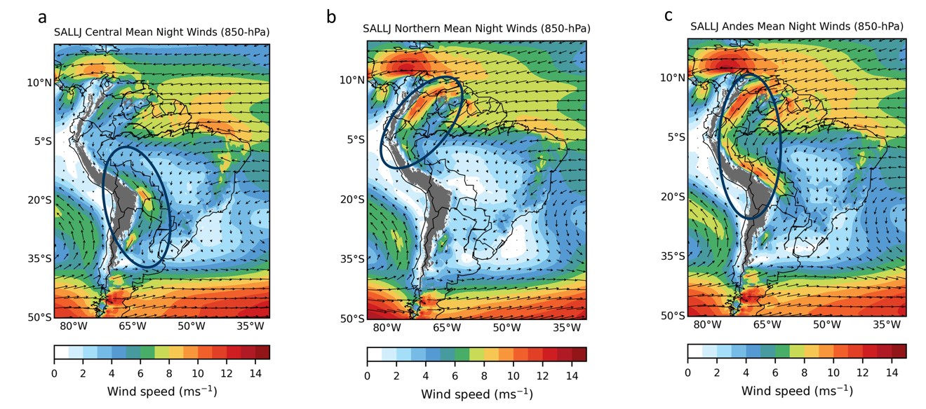

Supplementary Figure 1. Composites of 850hPa winds of SALLJ for (a) Central, (b) Northern and (c) Andes types. These three major types of SALLJ account for 99% of the LLJ cases from 1957 to 2022. Blue circles indicate the schematic location of the LLJ.

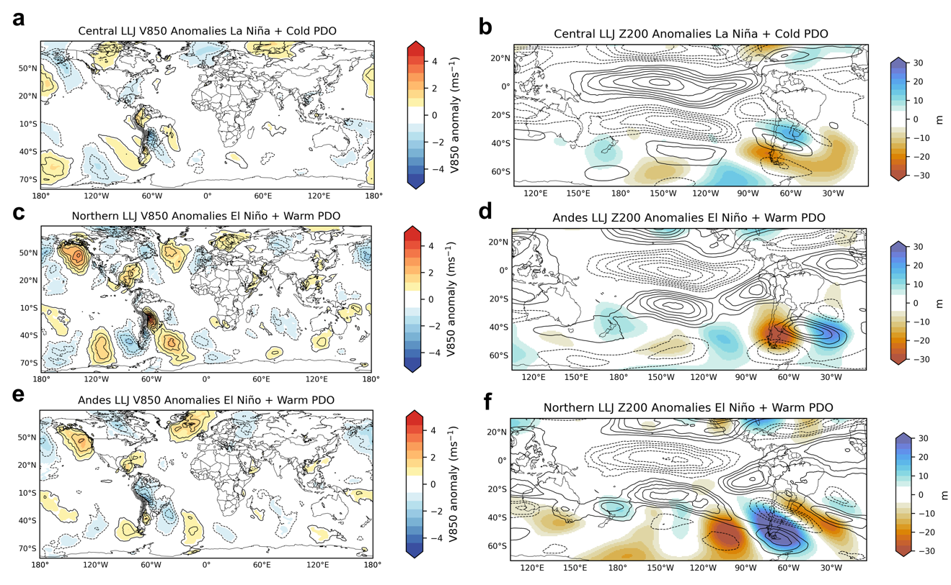

Supplementary Figure 2. Composites of wind anomalies and Rossby wave train during LLJ-unfavored ENSO-PDO phase. (a) 850-hPa meridional wind anomalies (ms-1) during Central LLJ in the La Niña + Cold PDO phase, and during (c) Northern and (e) Andes LLJ types in the El Niño and warm PDO phase. The left column (a, c, e) contours have 0.5 ms-1 intervals. The right column (b, d, f) shows geopotential height (m) (200-hPa, Z200) and zonal wind (200-hPa, U200) (1 ms-1 intervals) anomalies. All solid (dashed) contours indicate positive (negative) anomalies. Zero contour omitted.

Supplementary Figure 3. SESA wet season (NDJFM) precipitation from 1957 to 2021 from ERA5, CHIRPS and CPC daily data.

