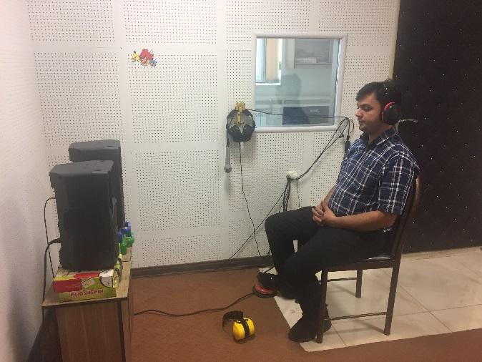
Fig. S1 The experiment set up of the current study.

Fig. S2 Comparison of the nominal and actual NRR of all types of the studied HPDs.

Fig. S3. The scatter plots of speech intelligibility values at S/N=0 compared with the S/N=+5

Fig. S4. The speech intelligibility values compared of earplugs' noise reduction (dB) at S/N=5

Fig. S5 The speech intelligibility values compared to of earplugs' noise reduction (dB) at S/N=0

