Supplemental Table 1: Follow up characteristics stratified by repeat prostate MRI

 | No Repeat Prostate MRI (n=282) | Repeat Prostate MRI  (n=52) | P value
Age  (median, IQR) | 63 (56, 68) | 58 (55, 65) | 0.2
Black race | 7.8%  22/282 | 19.2%  10/52 | 0.01
Insurance status | 62% Private, 38% Medicare/Medicaid | 71% Private, 29% Medicare/Medicaid | 0.2
CCI  (median, IQR) | 2  (1, 3) | 2  (1, 3) | >0.9
PSA category  <2 | 24 (8.5%) | 2 (3.8%) | 0.026
2-4 | 113 (40%) | 11 (21%)
4-10 | 131 (46%) | 33 (63%)
10-20 | 12 (4.3%) | 4 (7.7%)
PSAD (ng/mL/cc)  ≤0.10 | 220 (78%) | 23 (44%) | <0.001
0.1-≤0.15 | 46 (16%) | 21 (40%)
0.15-≤0.2 | 12 (4.3%) | 5 (9.6%)
>0.2 | 4 (1.4%) | 3 (5.8%)
PHI  0-26.9 | 88 (31%) | 7 (14%) | 0.01
27-35.9 | 61 (22%) | 10 (19%)
36-54.9 | 45 (16%) | 16 (31%)
≥55 | 7 (2.5%) | 0
Not obtained | 81 (29%) | 19 (36.5%)
PSA velocity (ng/mL/yr. median, IQR) | -0.11  (-0.62, 0.25) | 0.60  (-0.14, 1.27) | <0.001
PHI velocity (units/yr. median, IQR) | -1.29 (-4.49, 2.25) | 0.54  (-2.54, 3.74) | 0.006

Supplemental Table 2: AUCs at various cutoffs for PSA velocity for determining repeat prostate MRI or Biopsy
Threshold  (ng/mL/year) | AUC for Repeat MRI | AUC for Biopsy
-1.31 | 0.484 | 0.481
-0.69 | 0.490 | 0.487
-0.45 | 0.524 | 0.510
-0.23 | 0.566 | 0.569
-0.07 | 0.587 | 0.591
0.08 | 0.587 | 0.649
0.24 | 0.598 | 0.656
0.46 | 0.630 | 0.716
0.91 | 0.548 | 0.622
1.67 | 0.537 | 0.574

Supplemental Table 3: AUCs at various cutoffs for PHI velocity for determining repeat prostate MRI or Biopsy

Threshold  (units/year) | AUC for Repeat MRI | AUC for Biopsy
-8.73 | 0.591 | 0.588
-4.92 | 0.607 | 0.574
-3.43 | 0.642 | 0.632
-1.97 | 0.594 | 0.605
-0.90 | 0.549 | 0.667
0.40 | 0.546 | 0.647
1.80 | 0.466 | 0.628
3.62 | 0.513 | 0.591
5.78 | 0.523 | 0.568
8.56 | 0.560 | 0.592

Supplemental Figure 1: Number of Follow up PSA (a) and PHI measurements (b) after initial mpMRI PSA= Prostate-Specific Antigen, PHI= Prostate Health Index
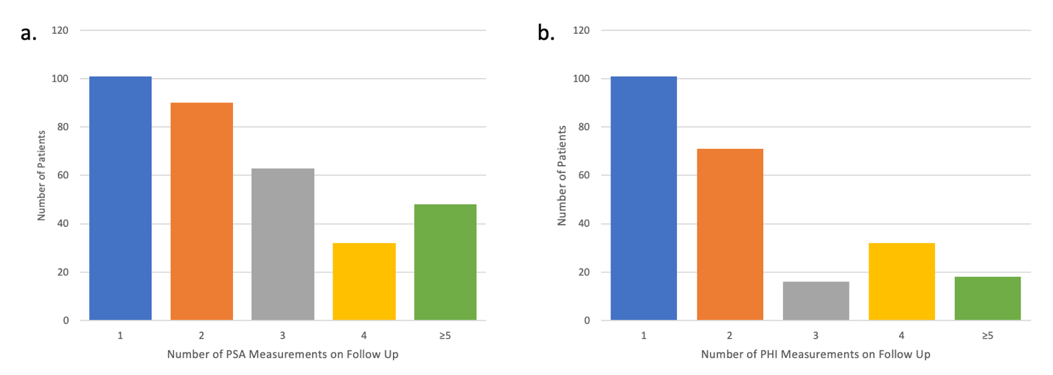

Supplemental Figure 2: Receiver Operator Curves for PSAV and PHIV Thresholds for repeat biopsy and MRI
