Supplement of
First Top-Down Diurnal Updates to NO_{x} Emissions Inventory in Asia Informed by the Geostationary Environment Monitoring Spectrometer (GEMS) Tropospheric NO₂ Columns

Table S1. Modeling setup.
Weather Research and Forecasting (WRF) model 3.8
Microphysics | Morrison two-moment scheme¹
Longwave and shortwave radiation | Rapid Radiative Transfer Model for GCMs (RRTMG)^{2,3}
Land surface model | Pleim-Xiu land surface model⁴
Surface layer | Pleim-Xiu surface layer⁵
Planetary boundary layer | ACM2 planetary boundary layer model^{6,7}
Cumulus parameterization | Kain-Fritch (new Eta) scheme⁸
Four-dimensional data assimilation | FDDA option for grid-nudging⁹
Initial and boundary conditions | National Centers for Environmental Prediction FNL (final) operational model global tropospheric analysis
CMAQ DDM-3D 5.2
Horizontal advection | YAMO
Vertical advection | WRF omega formula
Horizontal diffusion | Multiscale
Vertical diffusion | ACM2 vertical diffusion scheme^{6,7}
Chemical mechanism | Carbon Bond 5 (CB05)¹⁰
Aerosol processing module | The 6th generation CMAQ aerosol module (AERO6)¹¹
Dry deposition model | M3Dry¹²
Boundary condition | Profile (static)

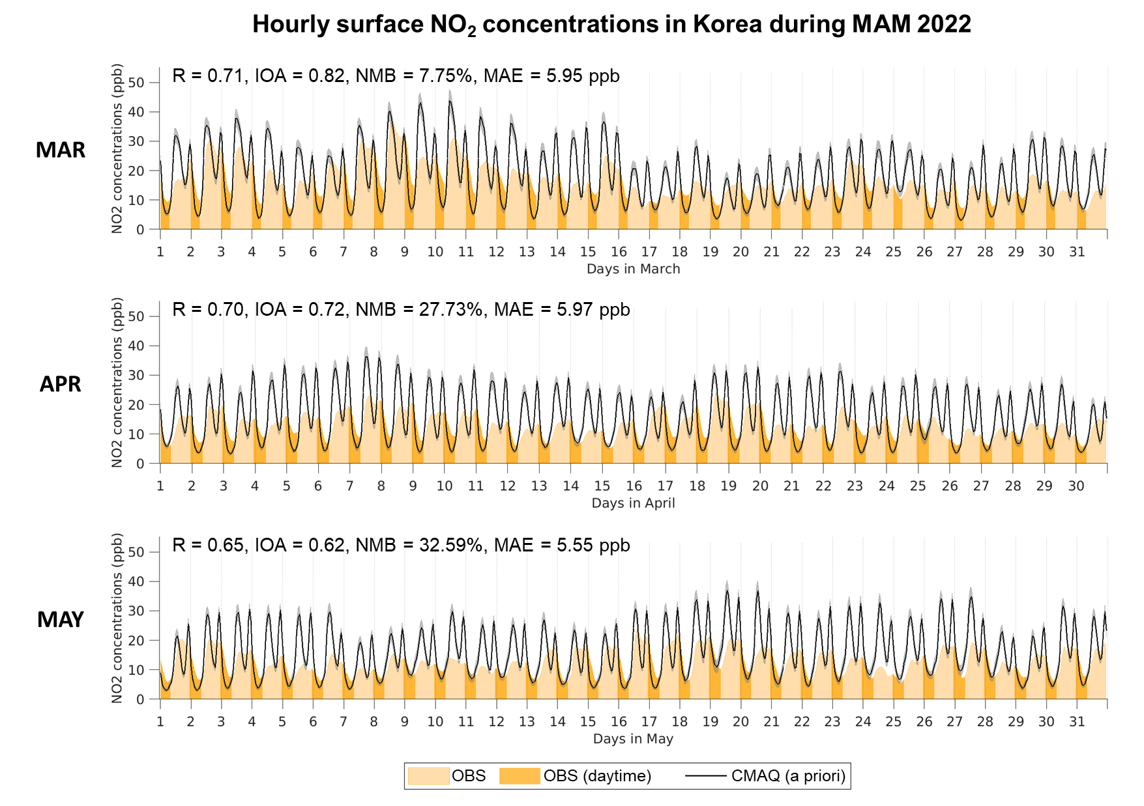
Figure S1. Time series of hourly surface NO₂ concentrations (ppb) observed and modeled at 459 AirKorea sites in Korea during MAM 2022. OBS: observed concentrations, OBS (daytime): observed concentrations during daylight hours (GEMS retrieval hours), and CMAQ (a priori): modeled concentrations using the a priori emissions. R: Pearson’s correlation coefficient, IOA: index of agreement, NMB: normalized mean bias (%), and RMSE: root mean square error (ppb). Shadings indicate the 95th percentile confidence interval.

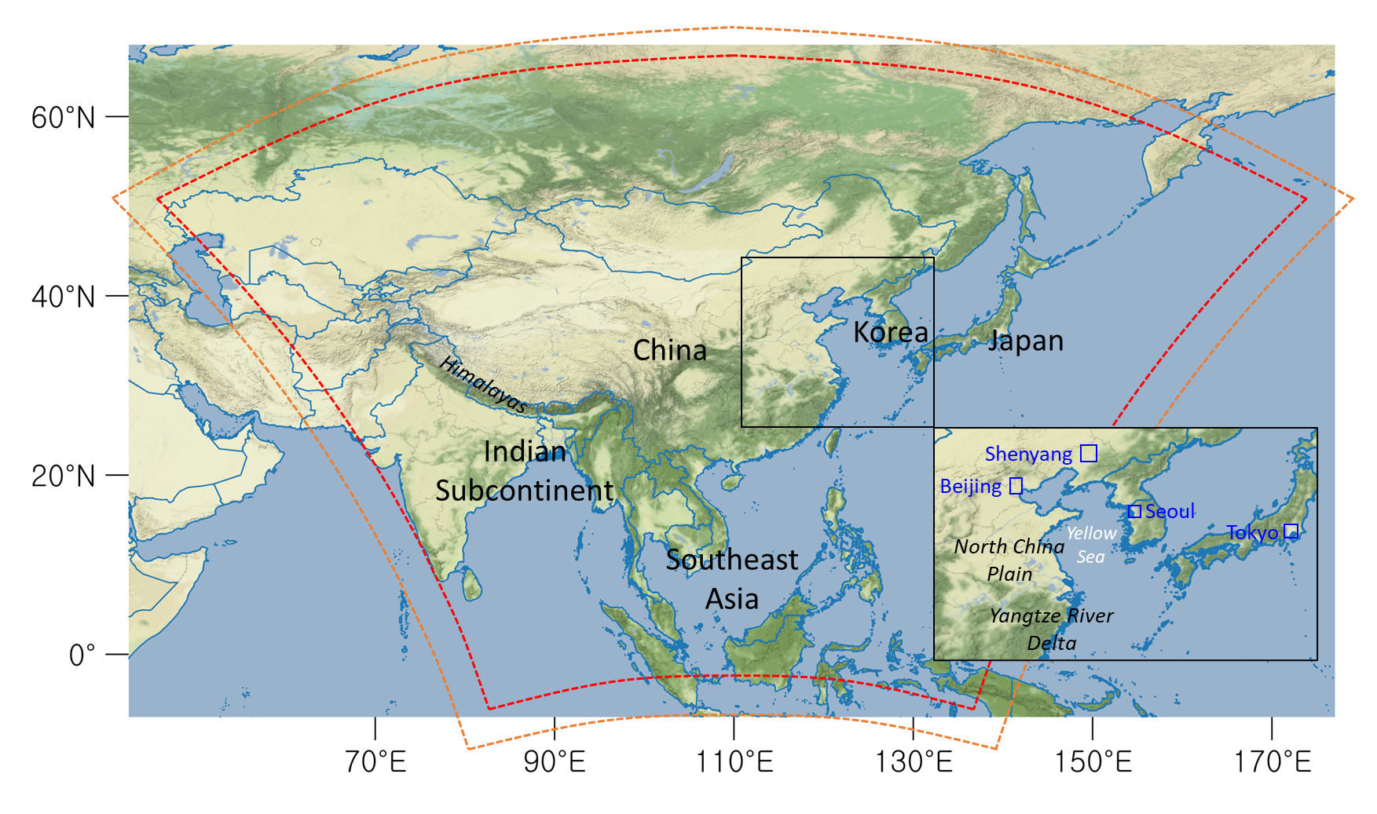
Figure S2. Modeling domain in Asia at a 27 km spatial resolution. The orange and red dotted lines indicate WRF and CMAQ modeling domains, respectively, in a 320 × 320 grid and a 300 × 300 grid.

Figure S3. Time series of the hourly surface meteorology observed and modeled at 95 weather stations in Korea during MAM 2022. (a) 2 m air temperature (°C), (b) 10 m wind U component (m/s), and (c) 10 m wind V component (m/s). The black and blue lines indicate the observed and WRF-simulated meteorology, respectively.

References
[1] Morrison, H., Thompson, G., & Tatarskii, V. (2009). Impact of Cloud Microphysics on the Development of Trailing Stratiform Precipitation in a Simulated Squall Line: Comparison of One- and Two-Moment Schemes. Monthly Weather Review, 137(3), 991–1007. https://doi.org/10.1175/2008MWR2556.1
[2] Clough, S. A., Shephard, M. W., Mlawer, E. J., Delamere, J. S., Iacono, M. J., Cady-Pereira, K., Boukabara, S., & Brown, P. D. (2005). Atmospheric radiative transfer modeling: A summary of the AER codes. Journal of Quantitative Spectroscopy and Radiative Transfer, 91(2), 233–244. https://doi.org/10.1016/j.jqsrt.2004.05.058
[3] Iacono, M. J., Delamere, J. S., Mlawer, E. J., Shephard, M. W., Clough, S. A., & Collins, W. D. (2008). Radiative forcing by long-lived greenhouse gases: Calculations with the AER radiative transfer models. Journal of Geophysical Research: Atmospheres, 113(D13). https://doi.org/10.1029/2008JD009944
[4] Xiu, A., & Pleim, J. E. (2001). Development of a Land Surface Model. Part I: Application in a Mesoscale Meteorological Model. Journal of Applied Meteorology and Climatology, 40(2), 192–209. https://doi.org/10.1175/1520-0450(2001)040<0192:DOALSM>2.0.CO;2
[5] Pleim, J. E. (2006). A Simple, Efficient Solution of Flux–Profile Relationships in the Atmospheric Surface Layer. Journal of Applied Meteorology and Climatology, 45(2), 341–347. https://doi.org/10.1175/JAM2339.1
[6] Pleim, J. E. (2007). A Combined Local and Nonlocal Closure Model for the Atmospheric Boundary Layer. Part I: Model Description and Testing. Journal of Applied Meteorology and Climatology, 46(9), 1383–1395. https://doi.org/10.1175/JAM2539.1
[7] Pleim, J. E. (2007). A Combined Local and Nonlocal Closure Model for the Atmospheric Boundary Layer. Part II: Application and Evaluation in a Mesoscale Meteorological Model. Journal of Applied Meteorology and Climatology, 46(9), 1396–1409. https://doi.org/10.1175/JAM2534.1
[8] Kain, J. S. (2004). The Kain–Fritsch Convective Parameterization: An Update. Journal of Applied Meteorology and Climatology, 43(1), 170–181. https://doi.org/10.1175/1520-0450(2004)043<0170:TKCPAU>2.0.CO;2
[9] Jeon, W., Choi, Y., Lee, H. W., Lee, S.-H., Yoo, J.-W., Park, J., & Lee, H.-J. (2015). A quantitative analysis of grid nudging effect on each process of PM2.5 production in the Korean Peninsula. Atmospheric Environment, 122, 763–774. https://doi.org/10.1016/j.atmosenv.2015.10.050
[10] Yarwood, G., Rao, S., Yocke, M., & Whitten, G. (2005). Updates to the carbon bond chemical mechanism: CB05. Final report to the US EPA, RT-0400675, 8, 13.
[11] Appel, K. W., Pouliot, G. A., Simon, H., Sarwar, G., Pye, H. O. T., Napelenok, S. L., Akhtar, F., & Roselle, S. J. (2013). Evaluation of dust and trace metal estimates from the Community Multiscale Air Quality (CMAQ) model version 5.0. Geoscientific Model Development, 6(4), 883–899. https://doi.org/10.5194/gmd-6-883-2013
[12] Pleim, J. E., Xiu, A., Finkelstein, P. L., & Otte, T. L. (2001). A Coupled Land-Surface and Dry Deposition Model and Comparison to Field Measurements of Surface Heat, Moisture, and Ozone Fluxes. Water, Air and Soil Pollution: Focus, 1(5), 243–252. https://doi.org/10.1023/A:1013123725860

