Supplementary Information: In-situ atomic observations unveil the aggregation growth and evolution of five-fold twin structures
Miao Song^{1, 2,✽}, Dingri Zhang¹, Dan Leng¹, Jaewon Lee³, Ziang Yang¹, Jiaxuan Chen¹, Dan Li¹, Lei Wang², Gang Zhou^{4,✽}, Rui Yang⁴, Kechao Zhou¹
¹ State Key Laboratory of Powder Metallurgy, Central South University, Changsha, Hunan 410083, China
² State Key Laboratory of Crystal Materials, Shandong University, Jinan, Shandong, 250100, China
³ Department of Mechanical and Aerospace Engineering, College of Engineering, University of Missouri, Columbia, MO 65203, USA
⁴ Shi-changxu Innovation Center for Advanced Materials, Institute of Metal Research, Chinese Academy of Sciences, Shenyang, Liaoning 110016, China

✽Corresponding author. Email: songmiao@csu.edu.cn; gzhou@imr.ac.cn
Supplementary sections:
Supplementary Note I. Configurations of Au nanoparticles (NPs)
Supplementary Note II. Various models of molecular dynamics (MD) simulation
Supplementary Note III. Force calculation
Supplementary Note IV. Growth and evolution dynamics after aggregation between 5-FT NP and SC NP
Supplementary Note V. Growth and evolution dynamics after aggregation between 5-FT NPs
Supplementary Note VI. van der Waals (vdW) interactions between 5-FT NP and various NPs
Supplementary Note I. Configurations of Au nanoparticles (NPs)
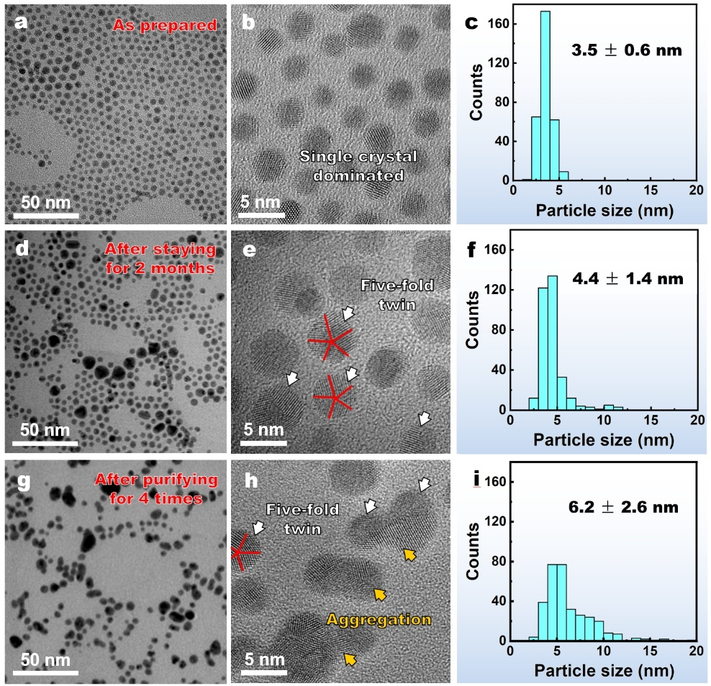
Supplementary Fig. 1. Configuration of Au NPs under various experimental process. (a), (d), and (g) Low magnification TEM bright-field images showing morphologies of Au NPs of the samples as-prepared, after standing for 2 months, and after purifying for 4 times, respectively. (b), (e), and (h) High-resolution TEM (HRTEM) images of the three samples, respectively. (c), (f), and (i) Size distribution of the three samples, respectively. Twin boundaries (TBs) are outlined by red lines. 5-FT NPs are highlighted by white arrows. Aggregated particles are highlighted by yellow arrows.

Supplementary Note II. Various models of molecular dynamics (MD) simulation
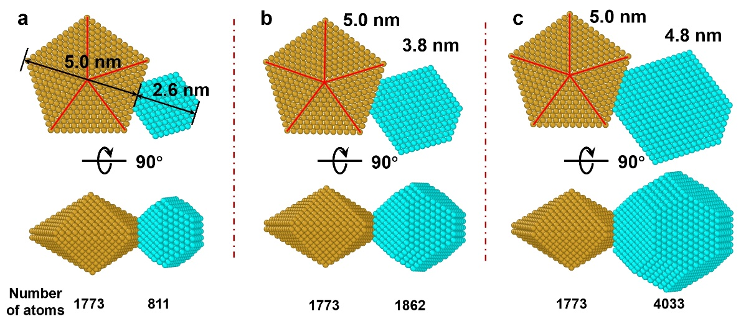
Supplementary Fig. 2. Top and side views of atomistic models of the aggregated Au NPs (5-FT: yellow, evolutionary single-crystals (SC): cyan) equilibrated with the conjugate gradient method. (a) Model 1-1: a 5.0 nm symmetrical 5-FT attached with a 2.6 nm SC. (b) Model 1-2: a 5.0 nm symmetrical 5-FT attached with a 3.8 nm SC. (c) Model 1-3: a 5.0 nm symmetrical 5-FT attached with a 4.8 nm SC. TBs are denoted by red lines.
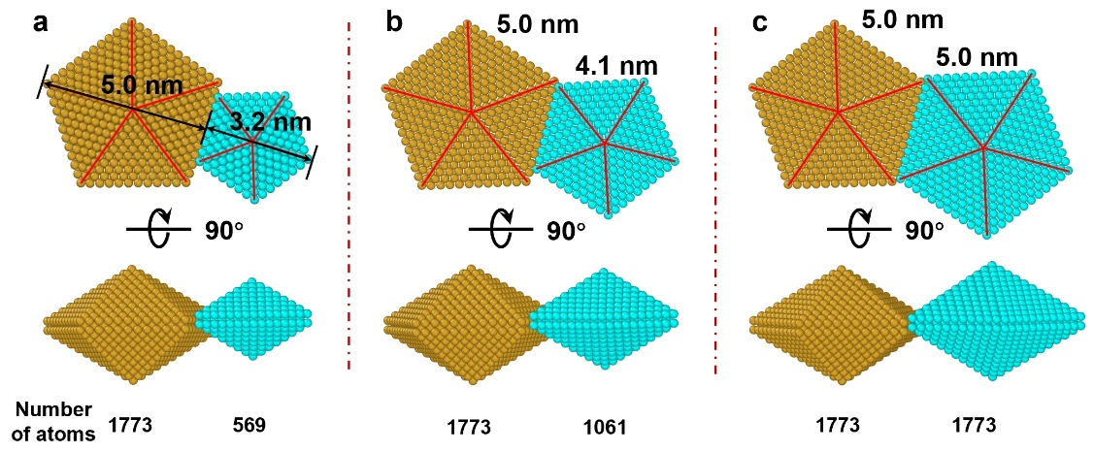
Supplementary Fig. 3. Top and side views of atomistic models of the aggregated Au NPs (5-FT: yellow, evolutionary 5-FT: cyan) equilibrated with the conjugate gradient method. (a) Model 2-1: a 5.0 nm symmetrical 5-FT (S5-FT) attached with a 3.2 nm S5-FT. (b) Model 2-2: a 5.0 nm S5-FT attached with a 4.1 nm symmetrical 5-FT. (c) Model 2-3: a 5.0 nm S5-FT attached with another 5.0 nm S5-FT. TBs are denoted by red lines.
Supplementary Table 1. Sizes and number of atoms of various simulated particles’ models.
Model 1 | Single-crystal | 5-FT | Size ratio | Model 2 | 5-FT | 5-FT | Size ratio
Model 1 | Size  (number of atoms) | Size  (number of atoms) | Size ratio | Model 2 | Size  (number of atoms) | Size  (number of atoms) | Size ratio
1-1 | 2.6 nm  (811) | 5.0 nm  (1773) | 0.52 | 2-1 | 3.2 nm  (569) | 5.0 nm  (1773) | 0.64
1-2 | 3.8 nm  (1862) | 5.0 nm  (1773) | 0.76 | 2-2 | 4.1 nm  (1061) | 5.0 nm  (1773) | 0.82
1-3 | 4.8 nm  (4033) | 5.0 nm  (1773) | 0.96 | 2-3 | 5.0 nm  (1773) | 5.0 nm  (1773) | 1.0

Supplementary Note III. Force calculation
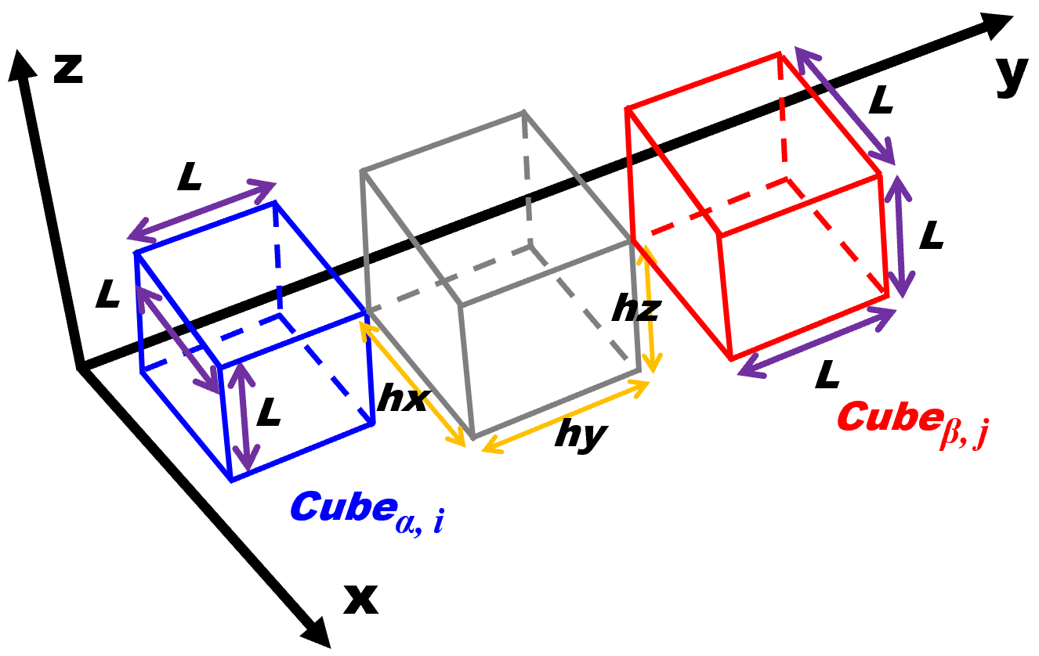
Supplementary Fig. 4. Parallel configuration of the small cube_{α, i} and the small cube_{β, j} with arbitrary separation distance hx, hy, and hz.
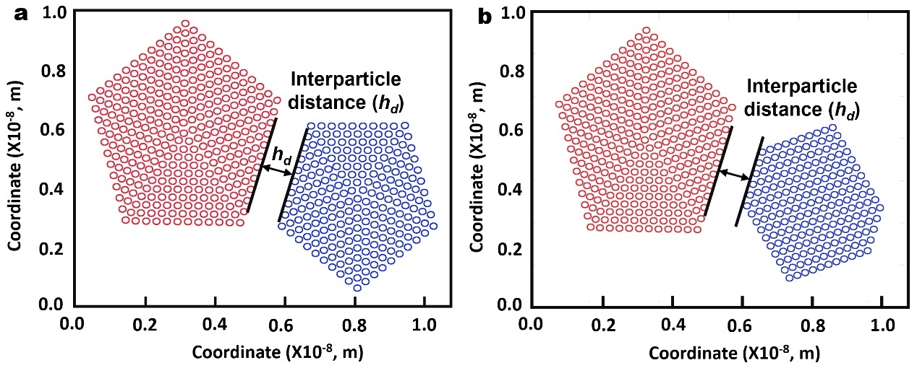
Supplementary Fig. 5. Scheme for NP configurations and coordinates. (a) 5-FT and 5-FT. (b) 5-FT and SC. The calculations were performed from h_{d} =0.1 nm to h_{d} =4.0 nm with 0.05 nm interval.

Supplementary Note IV. Growth and evolution dynamics after aggregation between 5-FT NP and SC NP
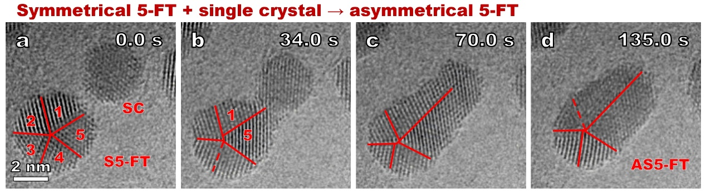
Supplementary Fig. 6. Atomic scale evolution process of a 3.5 nm SC NP aggregated with a 4.8 nm 5-FT NP with a size ratio of 0.73. (a-b) Orientation attachment process. (c-d) Surface diffusion dominated formation of an asymmetrical 5-FT (AS5-FT) NP. TBs are highlighted by red lines. Unclear TBs are highlighted by red dashed lines. Twin units are denoted by numbers ranging from 1 to 5.
Supplementary Fig. 7. MD simulation showing symmetrical surface diffusion dominated growth process after aggregation between a 5-FT NP with a SC NP with R=0.52 in Fig. 2. (a) 0.4 ns. (b) 2.0 ns. Red arrows show Au atoms diffusion directions along the big 5-FT NP surface.
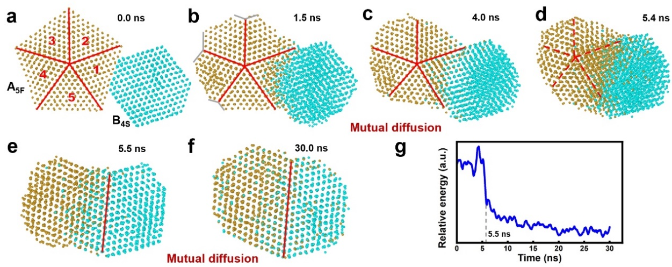
Supplementary Fig. 8. MD simulation of the aggregation growth between a 5.0 nm 5-FT NPs and a 3.8 nm SC NPs with R=0.76. (a-f) Detailed atomic evolution process after aggregation. (g) Variation of the relative energy of the simulated system from (a) to (f). The system energy decreases greatly resulted by de-twinning of 5-FT (5.4 ns to 5.5 ns). Twin units are denoted by numbers ranging from 1 to 5 in (a). TBs are highlighted by red lines. Unclear TBs are highlighted by red dashed lines. Re-entrant $\left\{111\right\}$ surfaces are highlighted by gray solid lines.

Supplementary Note V. Growth and evolution dynamics after aggregation between two 5-FT NPs
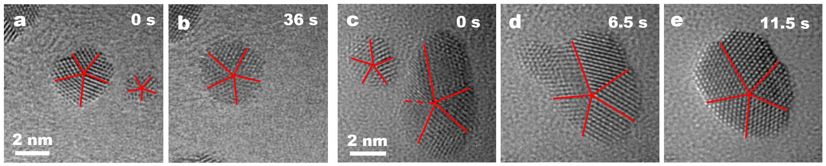
Supplementary Fig. 9. Aggregation growth between 5-FT NPs. (a-b) Formation of an S5-FT after aggregation between a 3.4 nm S5-FT and a 1.8 nm S5-FT with R=0.53. (c-e) Formation of a S5-FT after aggregation between a 2.6 nm S5-FT and a 5.5 nm AS5-FT with R=0.47. TBs are highlighted by red lines.
As presented in Supplementary Fig. 10a-b, aggregation between a relatively small (5.1 nm) S5-FT_{B1} NP and a 7.1 nm S5-FT_{A1} induces formation of a concave surface (denoted by the red arrow in Supplementary Fig. 10b) and a new zig-zag {200}B1/{111}A1 interface. The interface is formed by attachment between {200}B1 and {111}A1, and is severely strained due to a high theoretical lattice mismatch (13.4%) between {200} and {111}. Additionally, the interface is close to the twin pole of the B1 NP S5-FT, i.e., the size of the twin unit 4 (B1 S5-FT NP) is smaller than that of the twin unit 2 (A1 S5-FT NP), when the twin pole of the A1 NP S5-FT is overlapped (Supplementary Fig. 10b, c, and e). Nevertheless, the interface almost equals the twin units 4 and 2, when the twin pole of the A1 NP is split, which is introduced by migration of the TB between the twin units 1 and 2 (the A1 NP, Supplementary Fig. 10d and f). Lattice strain on both side of the {200}B1/{111}A1 interface significantly increases after the concave surface is filled by surface diffusion (highlighted by the red arrows, Supplementary Figs. 10b-c and 11) and almost released when the twin pole is close to the periphery of the B1 S5-FT NP (Supplementary Figs. 10f and 11). Beside the above interface, there is formation of a TB at the filled concave locations, i.e., the location between the twin unit 5 of the B1 S5-FT NP and the twin unit 1 of the A1 S5-FT NP (Supplementary Fig. 10c). Although the morphologies of the NPs vary significantly after attaching (highlighted by red arrows in Supplementary Fig. 10h), the yellow lines with the same length (Supplementary Fig. 10b and f) show there is no effective twin pole migration during the initial 185.0 s. This is also verified by countervailing TB migration of the B1 S5-FT NP (Supplementary Fig. 10b-f). Thereby, the surface diffusion determines the initial de-twinning process of the B1 S5-FT NP and the morphology variation of the system (Supplementary Fig. 10a-f). The morphology variation can be ignored from 185.0 s to 221.0 s, nevertheless, all of the TBs of the B1 S5-FT NP disappear, resulting in formation of a S5-FT (Supplementary Fig. 10f-h). This variation is dominated by TB migration determined de-twinning process, which happens when the twin pole is close to the periphery of the NP, such as 2 layers (Supplementary Fig. 10f). The phenomenon has also been detected in Fig. 1n-o and in our previous results [19]. TB migration is closely associated with nucleation and slip of partial dislocations on TBs, as highlighted in Supplementary Fig. 10c and p.
MD simulation of the aggregation growth process in Supplementary Fig. 10 is presented in Supplementary Fig. 12. Consistent with the experimental results, a new zig-zag {200}/{111} GB forms after aggregation, with formation of a new TB (highlighted by the short red line). Nevertheless, the small 5-FT transforms into amorphous state at 0.90 ns, and diffuses towards the big 5-FT NP, resulting in formation of a S5-FT. The energy exhibits a marked increase with the formation of the {200}/{111} GB and the new TB (Supplementary Fig. 12a-c). Then it decreases greatly after de-twinning of the small 5-FT (Supplementary Fig. 12d-e), followed by slow decrease with diffusion dominated surface modulation (Supplementary Fig. 12f-g).
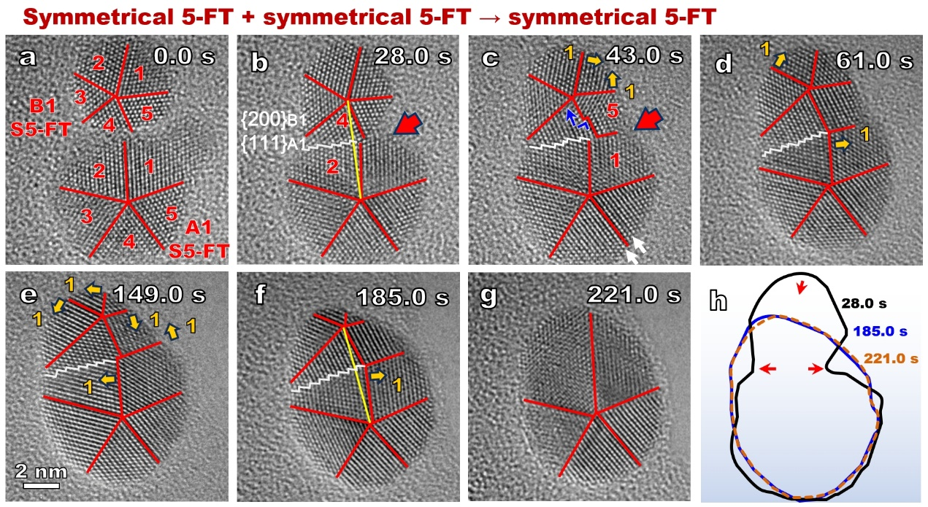
Supplementary Fig. 10. Configuration evolution after aggregation between a 5.1 nm 5-FT NP attached with a 7.1 nm 5-FT NP with R=0.72. (a-b) Aggregation induced formation of a {200}B1/{111}A1 grain boundary (GB). {200}B1/{111}A1 GB are denoted by white lines. (c) Surface diffusion dominated formation of a new TB (highlighted by red arrows). (d-f) TBs migration during evolution process. The yellows lines with the same length in (b) and (f) verify there is no effective twin pole migration from 28.0 s to 18.0 s. (f-g) De-twinning process of the B1 5-FT. (h) Outlines of the NPs at 28.0 s, 185.0 s, and 221.0 s, showing the surface diffusion dominates the initial configuration evolution from 28.0 s to 185.0 s and de-twinning happens when the 5-FT pole is close to the periphery (about 2-3 layers of {111}) of the new formed NP. Red arrows in (h) shows evolution directions of the NP’s outlines. Twin units are denoted by numbers ranging from 1 to 5. TBs are highlighted by red lines. Yellow arrows show migration directions of the TBs, compared with the immediate prior image. Partial dislocations are denoted by blue “└” and their slip directs are denoted by the blue arrows.
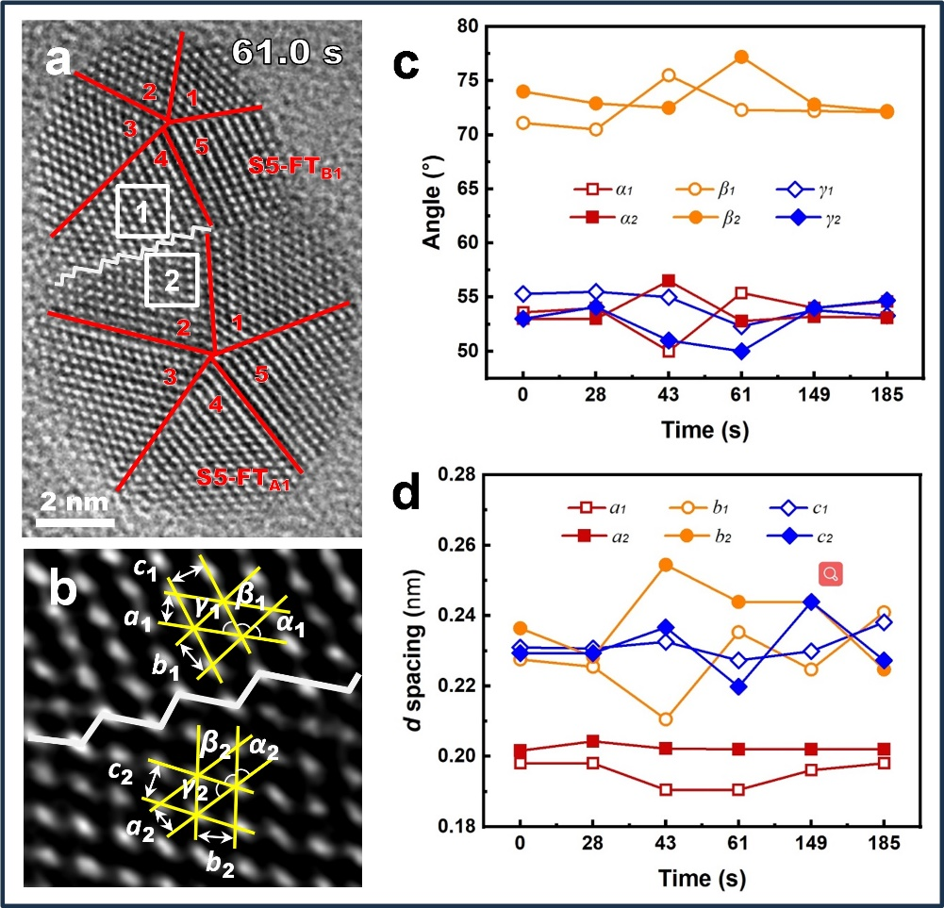
Supplementary Fig. 11. Strain evolution on both side of the {200}B1/{111}A1 interface in Supplementary Fig. 10. (a) HRTEM image showing selected regions (white-boxed locations 1 and 2) employed for strain analyses. (b) Enlarged {200}B1/{111}A1 interface showing parameters employed for strain analyses. (c) and (d) Variation of angles and lattice d-spacing with aggregation evolution durations. Lattice strain on both side of the {200}B1/{111}A1 interface significantly increases after the concave surface is filled by surface diffusion (highlighted by the red arrows in Supplementary Fig. 10b and c) and almost released when the twin pole is close to the periphery of the S5-FT_{B1} NP (see Supplementary Fig. 10f).
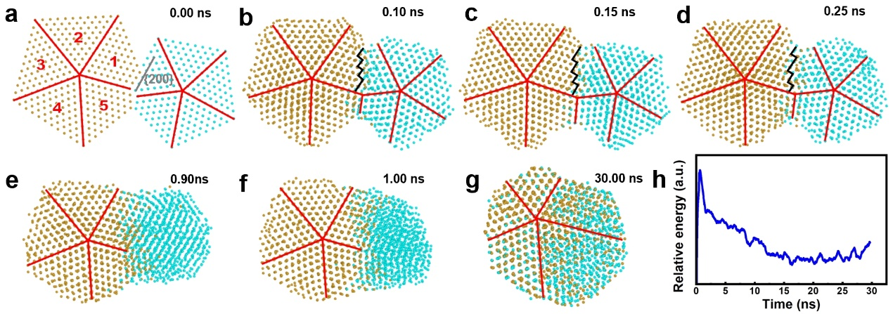
Supplementary Fig. 12. MD simulation of the aggregation growth process in Supplementary Fig. 10, i.e., {200} of the smaller 5-FT attaches with the {111} of the big 5-FT. (a) The initial configuration after aggregation between a 5.0 nm 5-FT NP and 3.9 nm 5-FT NP with R=0.78. (c) Formation of a stepped {200}/{111} GB (highlighted by dark solid lines) and a new TB (highlighted by the red line below the {200}/{111} GB). (c-d) Surface modulation. (e-f) Formation of amorphous structure of the small 5-FT. (g) Surface diffusion dominated formation of a relative AS5-FT NP. Twin units are denoted by numbers ranging from 1 to 5. TBs are highlighted by red lines. (h) Variation of the relative energy of the simulated system.
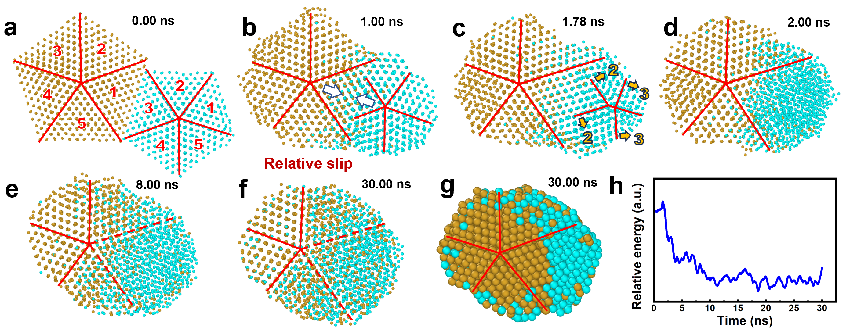Supplementary Fig. 13. MD simulation of the aggregation growth process between a 5.0 nm 5-FT NP and 4.1 nm 5-FT NP with R=0.82. (a-b) Relative slip after aggregation (highlighted by white arrows). (c) Aggregation induced TBs migration. (d-f) The initial smaller 5-FT evolves into amorphous state and diffusion towards the big 5-FT NP occurs, resulting in formation of a relative AS5-FT NP. (g) The biggest cross-sections perpendicular to the Z axes showing atomistic distribution of the initial 5-FT NPs. (h) Variation of the relative energies of the corresponding simulated systems. Twin boundaries are highlighted by red lines. Unclear TBs are highlighted by red dashed lines. Twin units are denoted by numbers ranging from 1 to 5. Slip directions and layers of the twin boundaries are denoted by yellow arrows and numbers, respectively.

Supplementary Note VI. van der Waals (vdW) interactions between 5-FT NP with various NPs
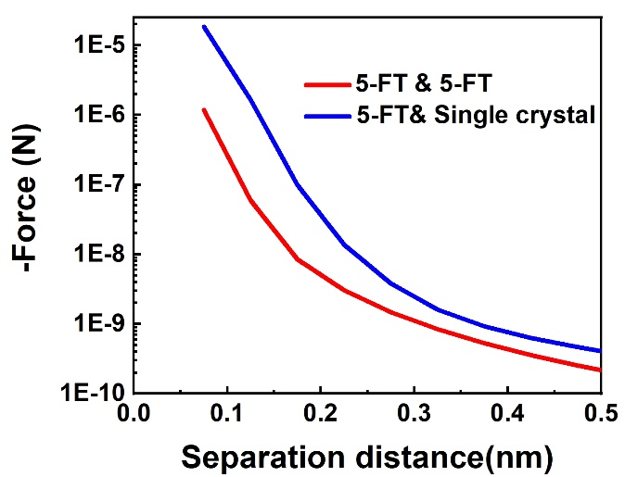
Supplementary Fig. 14. Calculated vdW interaction force between 5-FT and various NPs. The vdW interaction force between 5-FT and SC is stronger than that between the 5-FT and 5-FT NPs.

