Supporting information
D-dimer-based prediction model for flap loss in iliac bone transplantation
Zi-Li Yu^{1,2#}, Zhou-Yang Wu^{1#}, Ying Zhou², Si-Rui Ma^{1,2}, Jun Jia^{1,2*}
¹ State Key Laboratory of Oral & Maxillofacial Reconstruction and Regeneration, Key Laboratory of Oral Biomedicine Ministry of Education, Hubei Key Laboratory of Stomatology, School & Hospital of Stomatology, Wuhan University
² Department of Oral and Maxillofacial Surgery, School and Hospital of Stomatology, Wuhan University, 430079 Wuhan, China

# These authors contributed equally to this work as co-first authors.
* Correspondence: Jun Jia (junjia@whu.edu.cn)

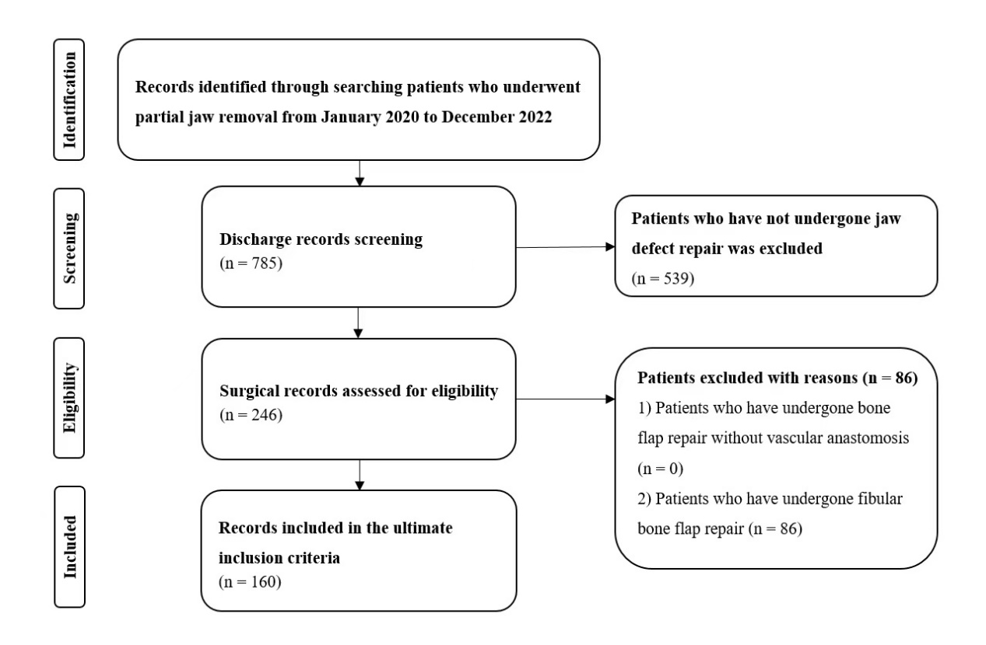
Figure S1. The flow diagram illustrating the case search and selection criteria.

Patient summary
The median age of the patients was 46 years, with an average age of 45.4 years (range 11-76 years); 105 were males (65.63%) and 55 were females (34.38%). The flaps were used to repair defects in mandible and maxilla. Among them, 103 patients were pathologically diagnosed with benign jaw lesions, including 58 cases of ameloblastoma,10 cases of ossifying fibroma and fibrous dysplasia, 18 cases of odontogenic cyst and tumour, and 4 cases of vascular anomalies. Additionally, 47 had malignant tumours, with 35 cases of squamous cell carcinoma (SCC), 2 cases of osteosarcoma, 3 cases of adenoid cystic carcinoma, and 2 cases of mucoepidermoid carcinoma. Furthermore, 4 patients had chronic osteomyelitis.

Table S1 Patient summary.
Characteristics | Total No. of patients | Rate (%)
Age (median age 46 years)
<46 | 81 | 50.63
≥46 | 79 | 49.38
Gender
Males | 105 | 65.63
Females | 55 | 34.38
Pathological diagnosis
Ameloblastoma | 58 | 36.25
Ossifying fibroma and fibrous dysplasia | 10 | 6.25
Odontogenic keratocyst | 9 | 5.63
Vascular anomalies | 4 | 2.50
Squamous cell carcinoma | 35 | 21.88
Osteosarcoma | 2 | 1.25
Adenoid cystic carcinoma | 3 | 1.88
Mucoepidermoid carcinoma | 2 | 1.25
Chronic osteomyelitis | 4 | 2.50
Others | 33 | 20.63
Prognosis
Normal | 143 | 89.38
Flap loss | 7 | 4.38
Titanium plate rejection | 9 | 5.63
Postoperative bleeding | 1 | 0.62

