
Weidian Zhou received Bachelor's degree from the School of Automation, Jiangnan University, Wuxi, China, in 2022. He is currently studying at the School of Automation, Southeast University, Nanjing, China.


Ru Hong received the M.E. degree from the School of electrical engineering, Southwest Jiaotong University, Chengdu, China, in 2018. He is currently pursuing the Ph.D. degree with Southeast University, Nanjing, China, with a focus on 3D computer vision, deep learning, pattern recognition.

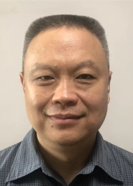
Feipeng Da received the PhD degree from the School of Automation, Southeast University, Nanjing, China, in 1998. He is currently a Professor with the School of Automation, Southeast University. He has published an academic monograph and authored or coauthored over 150 high quality articles, of which are retrieved by Science Citation Index (SCI), Engineering Index (El), and Index to Scientific and Technical Proceedings ISTP) more than 100 times. He has 40 authorized invention patents, one authorized patent for utility models, four software copyrights, and three international invention patents Patent Cooperation Treaty (PCT) applied. Professor Da also serves as a Reviewer for the journals from different areas, such as IEEE TRANSACTIONSON NEURAL NETWORKS AND LEARNING SYSTEMS, IEEE TRANSACTIONS ON CIRCUITS AND SYSTEMS-I: REGULARPAPERS, IEEE TRANSACTIONS ON CIRCUITS AND SYSTEMS-II: EXPRESS BRIEFS, Physics Letters A, Neural Networks, Pattern Recognition, Optics Express, Optics Letters, and Optics and Lasers in Engineering.

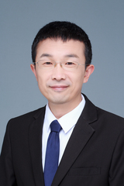
Shaoyan Gai He received his B.S., M.S. and Ph.D. degrees from the School of Automation in Southeast University, Nanjing, China from 1997 to 2008. His main research interests include computer vision, 3D measurement and image processing, and he has conducted in-depth research on visual measurement system modeling, calibration, dephasing, grating correction, 3D point cloud processing and pattern recognition.

