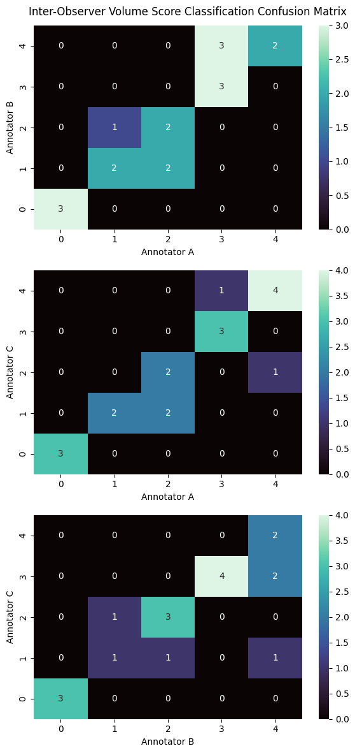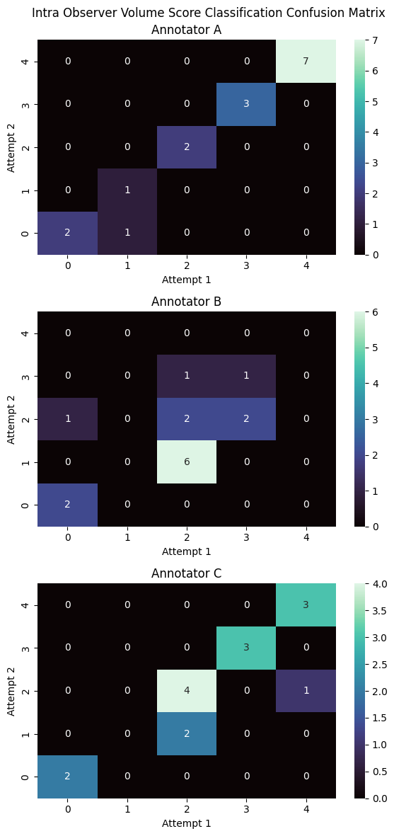
Supplementary Figure 1 : Volume Score Risk Cateogry Classification Confusion Matrices. Left: Inter-observer agreement. Right: Intra-observer agreement.

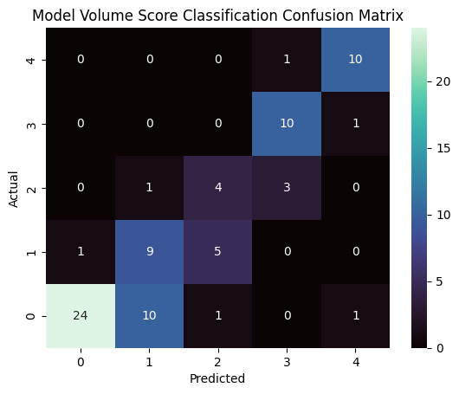
Supplementary Figure 2: Volume Score Risk Cateogry Classification Confusion Matrix for model-annotator agreement.
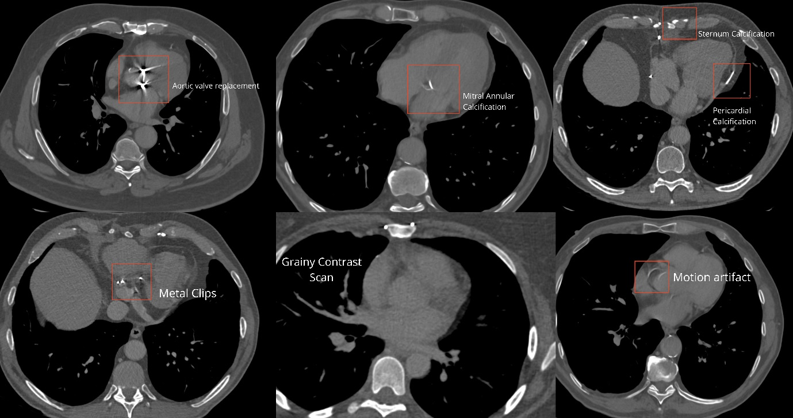
Supplementary Figure 3: Examples of artefacts present in the dataset, including artefacts due to foreign bodies, poor quality and grainy scans, motion artefacts, and brightness adjacent to the heart.

Artefact Type | Train/Validation | Test
Valves | 12 | 2
Pacemakers | 1 | 4
Stents | 5 | 3
Tubes | 0 | 2
Saphenous vein grafts (SVGs) | 2 | 1
Coronary artery bypass grafts (CABGs) | 6 | 4
LIMA (Left Internal Mammary Artery to LAD bypass) | 3 | 1
Wires | 1 | 1
Clips | 2 | 0
Lines | 5 | 3
EVAR (Endovascular Aneurysm Repair) | 1 | 0
Sternotomy | 9 | 1
Supplementary Table 1: Artefact type, and representation in train/validation, and test splits.
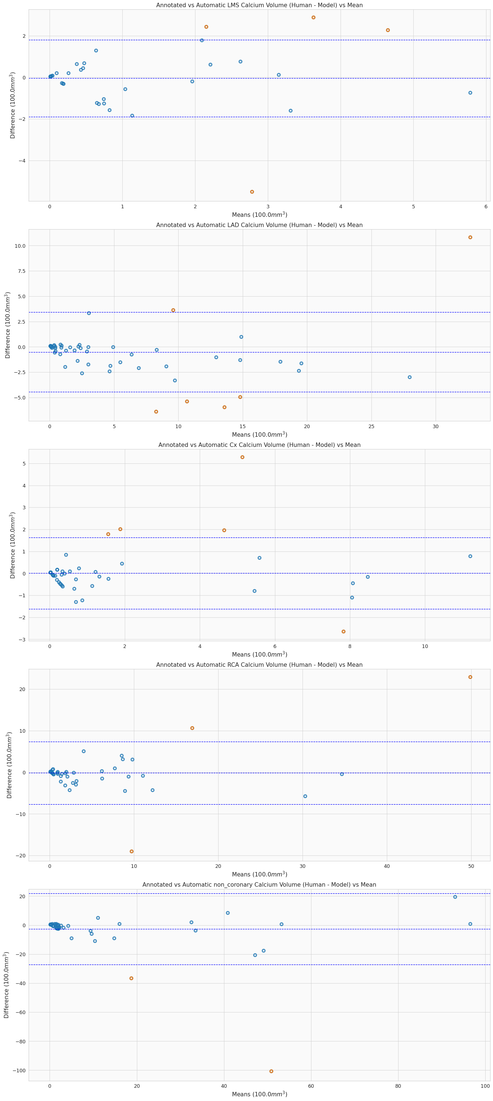
Supplementary Figure 4: Per-vessel Bland-Altman agreement plots between annotators and our automatic method. Outliers are shown as orange points.

Indication Type | Count (N=295)
Active Cancer Surveillance | 165 (56%)
Investigation of Lung Disease | 107 (36%)
Not Specified | 15 (5%)
Investigation of Weight Loss | 4 (1%)
Anaemia | 2 (< 1%)
Sepsis | 1 (< 1%)
Investigation of Aortic Disease | 1 (< 1%)
Supplementary Table 2: Indication summary for patients in our cohort.

