Supplementary Information
Biodiversity and Conservation

Climatic drivers of chytrid prevalence in the critically endangered Admirable Redbelly Toad
Mariana Retuci Pontes^{1,2*}, Michelle Abadie^{3,4}, Luisa P. Ribeiro^{1,2}, Guilherme Augusto-Alves^{1,2}, Márcio Borges-Martins², C. Guilherme Becker^{5,6} & Luís Felipe Toledo^{1,2}

¹Laboratório de História Natural de Anfíbios Brasileiros (LaHNAB), Departamento de Biologia Animal, Instituto de Biologia, Universidade Estadual de Campinas (UNICAMP), Campinas, São Paulo, Brasil.
²Programa de Pós-Graduação em Ecologia, Instituto de Biologia, Universidade Estadual de Campinas (UNICAMP), Campinas, São Paulo, Brasil.
³Centro Nacional de Pesquisa e Conservação de Répteis e Anfíbios do Instituto Chico Mendes de Conservação da Biodiversidade (RAN/ICMBio), Goiânia, Goiás, Brasil.
⁴Laboratório de Herpetologia, Departamento de Zoologia, Instituto de Biociências, Universidade Federal do Rio Grande do Sul (UFRGS), Porto Alegre, Rio Grande do Sul, Brasil.
⁵Department of Biology, and ⁶Center for Infectious Disease Dynamics, One Health Microbiome Center, The Huck Institutes of the Life Sciences, The Pennsylvania State University, Pennsylvania, USA.
*Corresponding author, e-mail address: maah.retuci@gmail.com

Table S1. Batrachochytrium dendrobatidis TaqMan Fast Master Mix Assays results. The lowest standard concentration with 95% or greater detection is: 0.1 copies per reaction (1.83 x 10⁻¹ GE/μL). Ct = cycle threshold.
Standard concentration | Replicates | Detected | Ct mean ± SD | Detection rate (%)
0.001 | 20 | 6 | 41.078 ± 1.196 | 30
0.01 | 20 | 17 | 40.191 ± 1.287 | 85
0.1 | 20 | 20 | 37.649 ± 1.519 | 100
1 | 20 | 20 | 33.950 ± 0.942 | 100
10 | 20 | 20 | 30.703 ± 0.831 | 100
100 | 20 | 20 | 27.316 ± 0.753 | 100
1000 | 20 | 20 | 23.974 ± 0.647 | 100
10000 | 20 | 20 | 20.566 ± 0.395 | 100
100000 | 20 | 20 | 18.068 ± 0.110 | 100

Table S2. Model selection for accumulated monthly rainfall, mean temperature of the 15 days prior to sampling date, and temperature and rainfall deviations metrics influencing Batrachochytrium dendrobatidis (Bd) prevalence and infection load in Melanophryniscus admirabilis in Brazil.
Model | AIC
Prevalence
Temperature deviation
YEAR, MONTH, TEMP, DEVTE3 | 277.4
YEAR, MONTH, TEMP, DEVTE1 | 278.6
YEAR, MONTH, TEMP, DEVTE2 | 279.8
Rainfall deviation
YEAR, MONTH, RAIN, DEVRF2 | 293.8
YEAR, MONTH, RAIN, DEVRF1 | 294.2
YEAR, MONTH, RAIN, DEVRF3 | 298.2
Infection load
Temperature deviation
YEAR, SEASON, TEMP, DEVTE2 | 133.7
YEAR, SEASON, TEMP, DEVTE3 | 133.9
YEAR, SEASON, TEMP, DEVTE1 | 136.2
Rainfall deviation
YEAR, SEASON, RAIN, DEVRF3 | 133.8
YEAR, SEASON, RAIN, DEVRF2 | 134.1
YEAR, SEASON, RAIN, DEVRF1 | 134.3
We employed a model selection approach based on Generalized Linear Models (GLMs) with binomial distribution and logit link function to screen for the strongest climatic anomaly metrics that potentially predict Bd prevalence, thereby reducing multicollinearity. Specifically, we included year, month, and mean temperature of the 15 days prior to sampling date (TEMP) as fixed variables in the temperature-models. Furthermore, we included temperature deviations of one, two, and three months prior to the sampling month. Additionally, to screen for the best rainfall anomaly metrics, we used year, month, and accumulated monthly rainfall from the month prior to sampling date (RAIN) as fixed effects, and we tested rainfall deviations of one, two, and three months prior to sampling. We additionally employed Gaussian GLMs with a log link function (using log10-transformed GE of Bd⁺ samples) as the response variable to screen for the strongest climatic anomaly variables of temperature and rainfall that potentially predict Bd infection loads. Specifically, the fixed variables included year, season (warm or cold), TEMP and RAIN, while we tested temperature and rainfall deviations of different periods, as described in the logistic model above. In the Bd prevalence model, best climatic anomaly metrics for temperature were temperature deviation subtracting the mean of the three months prior to sampling date from the historical temperature monthly mean (including 1-month lagged deviations) (DEVTE3), and rainfall deviation subtracting the mean of the two months prior to sampling date from the historical monthly rainfall mean (including 1-month lagged deviations (DEVRF2). For the Bd infection load model, the best climatic anomaly metrics were temperature deviation subtracting the mean of the two months prior to sampling date from the historical temperature monthly mean (including 1-month lagged deviations) (DEVTE2) and rainfall deviation subtracting the mean of the three months prior to sampling date from the historical monthly rainfall mean (including 1-month lagged deviations) (RAINRF3).

Table S3. Model selection for climatic variables influencing Batrachochytrium dendrobatidis (Bd) prevalence and infection load in Melanophryniscus admirabilis in Brazil.
Model | AIC |  | No. of variables |  | X²
Prevalence
YEAR, MONTH, DEVTE3, RAIN, DEVRF2 |  | 272.4 |  | 5 |  | 0.013
YEAR, MONTH, TEMP, DEVRF2 |  | 272.6 |  | 4 |  | 2.191
YEAR, MONTH, TEMP, RAIN, DEVRF2 |  | 273.5 |  | 5 |  | 1.158
YEAR, MONTH, TEMP, DEVTE3, DEVRF2 |  | 274.1 |  | 5 |  | 1.769
YEAR, MONTH, TEMP, DEVTE3, RAIN, DEVRF2 |  | 274.4 |  | 6 |  | 0.013
YEAR, MONTH, TEMP, DEVTE3, RAIN |  | 275.2 |  | 5 |  | 2.796
Infection load
YEAR, SEASON, TEMP, DEVTE2 |  | 133.7 |  | 4 |  | 0.234
YEAR, SEASON, DEVTE2 |  | 133.8 |  | 3 |  | 2.285
YEAR, SEASON, DEVRF2 |  | 133.8 |  | 3 |  | 2.358
YEAR, SEASON, RAIN, DEVRF3 |  | 133.8 |  | 4 |  | 0.274
YEAR, SEASON, RAIN |  | 134.2 |  | 3 |  | 2.730
YEAR, SEASON, TEMP |  | 134.5 |  | 3 |  | 2.777
We compared all possible models using Akaike Information Criterion (AIC); six best models are reported for Bd load and prevalence. Best predictors are: year of sampling date (YEAR), month of sampling date (MONTH), season of sampling (SEASON), mean temperature of the 15 days prior to sampling date (TEMP), accumulated monthly rainfall from the month prior to sampling date (RAIN), temperature deviation subtracting the mean of the three months prior to sampling date from the historical temperature monthly mean (including 1-month lagged deviations) (DEVTE3), temperature deviation subtracting the mean of the two months prior to sampling date from the historical temperature monthly mean (including 1-month lagged deviations) (DEVTE2), rainfall deviation subtracting the mean of the three months prior to sampling date from the rainfall historical monthly mean (including 1-month lagged deviations), (DEVRF3), rainfall deviation subtracting the mean of the three months prior to sampling date from the historical rainfall monthly mean (including 1-month lagged deviations) (DEVRF2)
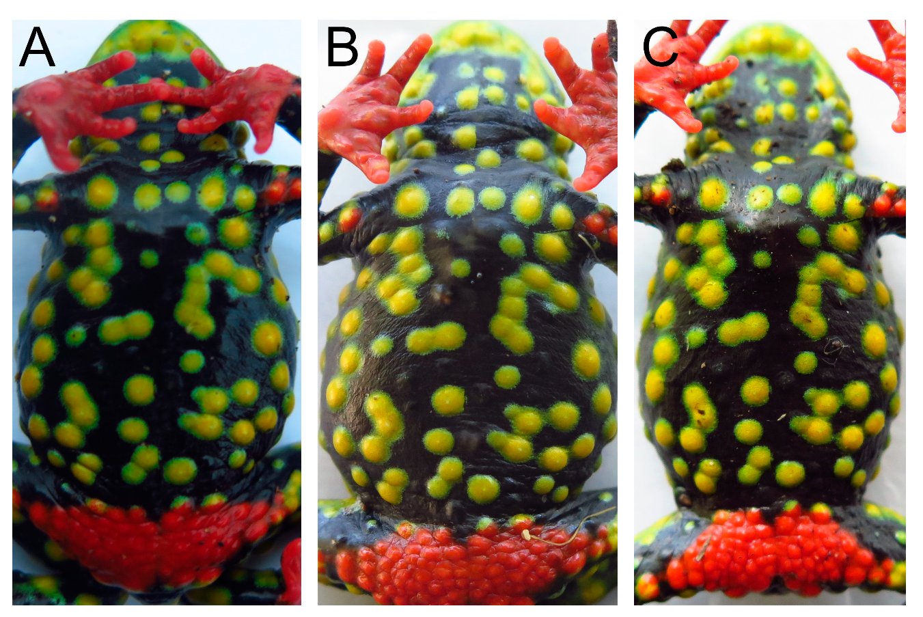Figure S1. Female Melanophryniscus admirabilis captured three times. We used a photo-identification as a mark recapture method, based on the natural spotted patterns of the toad’s belly. These photographs depict the same individual captured during three separate field expeditions: A) September 2019; B) November 2020; C) November 2022.
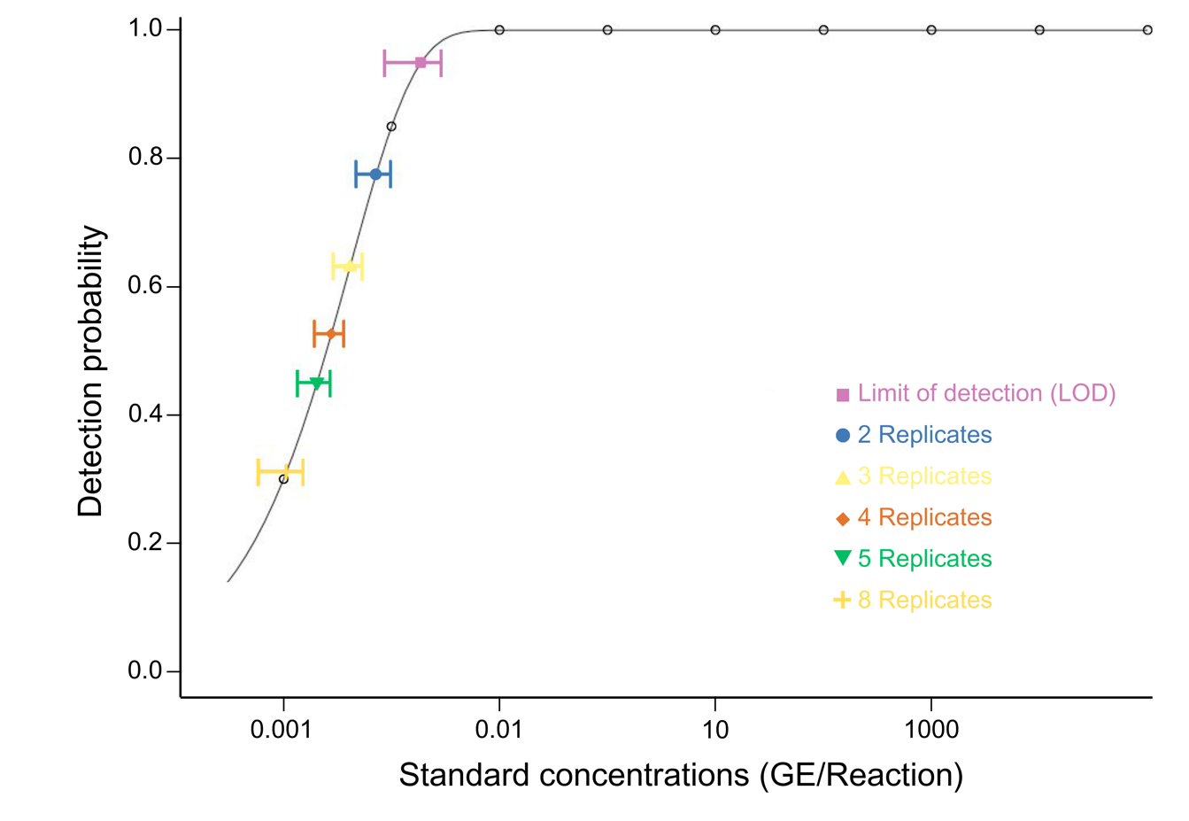Figure S2. Limit of detection (LOD) plot for Batrachochytrium dendrobatidis TaqMan Fast Master Mix Assays. Detection probability is on the y-axis and standard concentrations are on the x-axis. The lowest standard concentration with 95% or greater detection is: 0.1 copies per reaction (1.83 x 10⁻¹ GE/μL). Points are drawn with open circles for the detection rates of each standard tested, and the line represents the LOD model. Colored points with 95% confidence intervals are drawn to represent the LOD for multiple replicate analyses. We used a Weibull type II function to fit out data. Lack of fit test: p= 1.

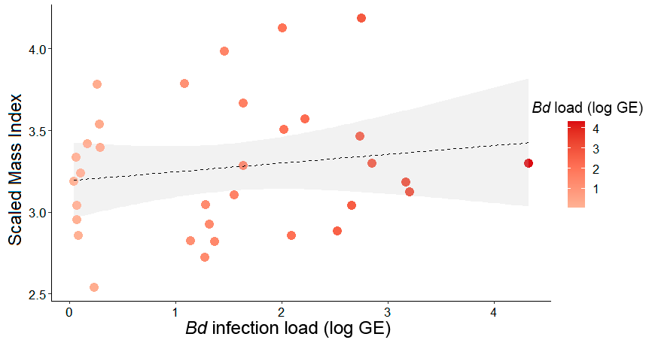Figure S3. Linear regression between Batrachochytrium dendrobatidis infection load (log GE) in infected males of Melanophryniscus admirabilis and the individual scaled mass index (n = 33, with a 95% confidence interval. Dashed line indicates the linear regression fit of a positive, non-significant trend.

