Table 1 Exercises of the active hamstring flexibility exercises with hip flexion mobilization
1st part
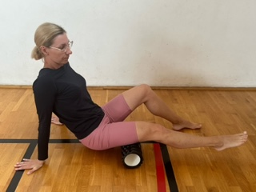 | Massage foam roller  Starting position: sit straight on the mat, place the massage tool between the back of the legs and the mat, and roll the legs front and back to massage the thighs between the buttock and the knee.
2nd part
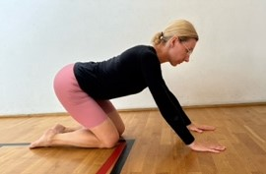  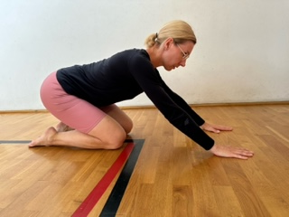 | Learning the pattern of flexion in the hip joints  Starting position: kneeling supported  - activation of the core muscles, awareness of setting the spine in the lumbar section and pelvis in a neutral position  - moving the hips towards the heels, keeping the spine in a neutral position.  Notes: keep the lower spine stable and the pelvis in an anterior tilt
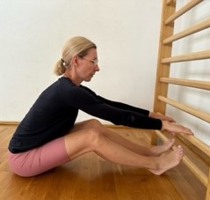  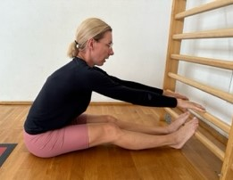 | Active mobilization of hamstrings with the development of the habit of correct hip flexion and extension technique  Starting position: sit straight, knees slightly bent  - hip flexion, knee extension.  - hold.  - knee flexion.  - hip flexion increase, knee extension.  Notes: keep the lower spine stable and the pelvis in an anterior tilt. The degree of flexion in the hips is adapted to the participant's abilities.
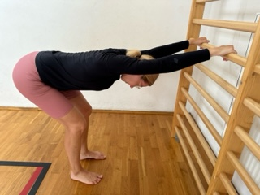  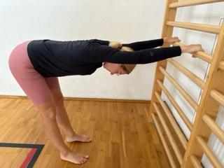 | Active mobilization of hamstrings with the development of the habit of correct hip flexion and extension technique  Starting position: standing, facing the wall, legs slightly bent at the knees  1. hip flexion, then knee extension  2. hold  3. knee flexion  4. hip flexion increase, knee extension  Notes: keep the lower spine stable and the pelvis in an anterior tilt. The degree of flexion in the hips is adapted to the participant's abilities.

Table 2 SPIRIT table of enrolment, intervention, and assessment
 | Enrollment | Before intervention | Randomization | Intervention
Timepoint | 1st month | 2nd month | 2nd month | 3rd, 4^{th,} and 5th months (12 weeks)
Enrollment
Eligibility pre-screening | +
Informed consent | +
Allocation |  |  | +
Interventions
Experimental and control group |  |  |  | +
Assessments
Pain intensity |  | + |  | +
Functional disability |  | + |  | +
Perceived musculoskeletal discomfort |  | + |  | +
The Global Perceived Improvement |  |  |  | +
Flexibility of the hamstring |  |  |  | +

