Supplementary Material
A new kind of hierarchical porous zirconium phosphonate: preparation and application on oxidation catalysis
Shan Fu^{1,†}, Yi Tian^{1,†}, Xin Long¹, Qian Shao¹, Kefeng Wang², Junyu Lei², Haijun Hao^{1,}*, Qinghong Xu^{1,}*
¹ College of Chemistry, Beijing University of Chemical Technology, Beijing, 100029, P.R. China
² Petrochemical Research Institute, PetroChina Company Limited, Beijing 100195, China
† The authors contribute equally to the paper
*Address all correspondence to the authors. e-mail: xuqh@mail.buct.edu.cn (Orcid: 0000-0002-6369-3540) and hjhao@mail.buct.edu.cn

Funding information
National Natural Science Foundation of China, Grant/Award Number: U1362113.
Content:
Fig. S1 NMR spectra of ¹H of DOTMP.
Fig. S2 EDS analysis for ZrDP.
Fig. S3 XPS analysis of Cu_{2p}, Fe_{2p}, Co_{2p}.

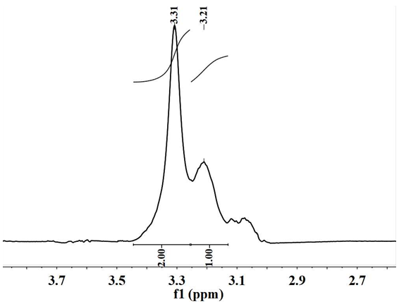
Fig. S1 NMR spectra of ¹H of DOTMP.
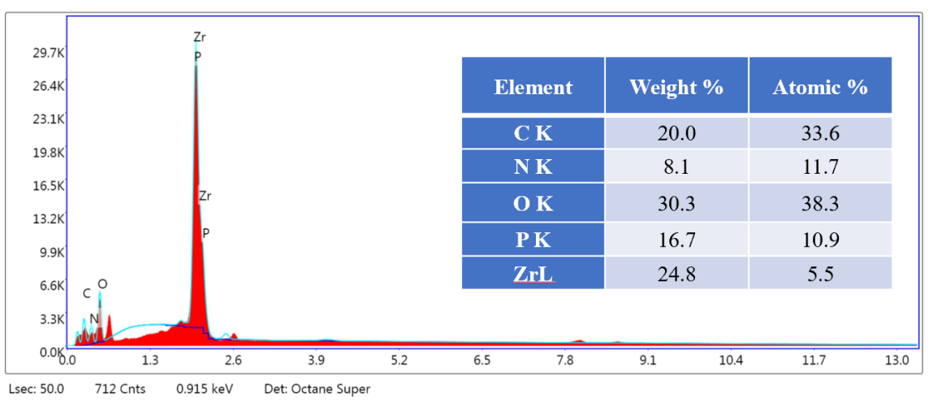
Fig. S2 EDS analysis for ZrDP.

Fig. S3 XPS analysis of Cu_{2p}, Fe_{2p}, Co_{2p}

