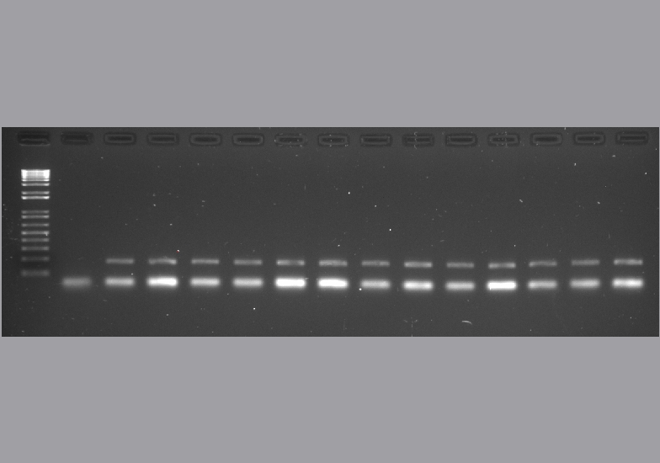
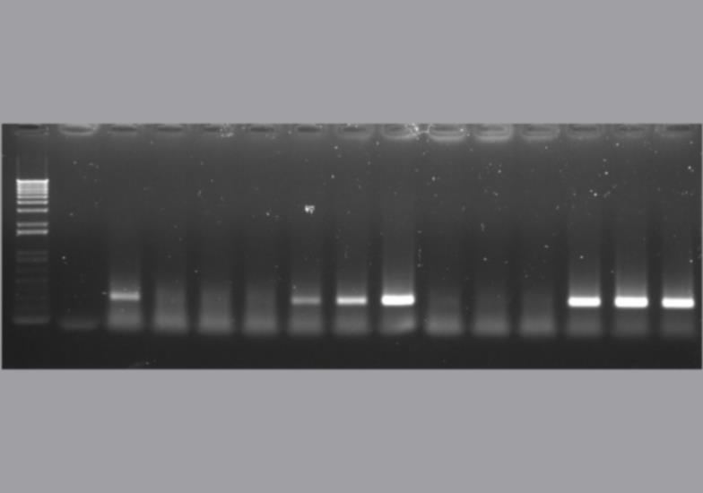
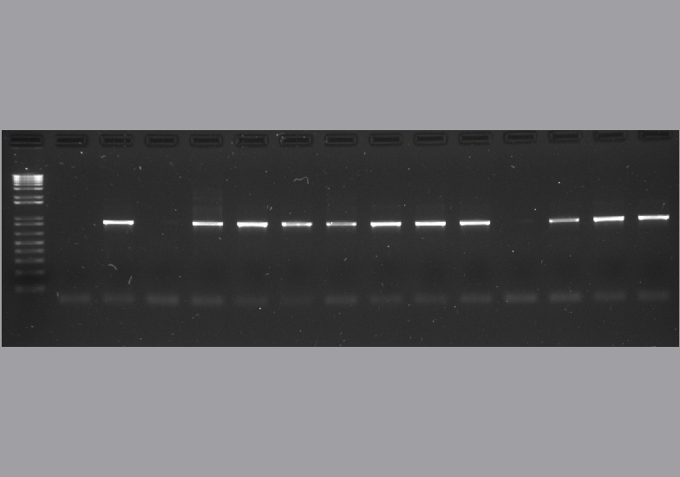
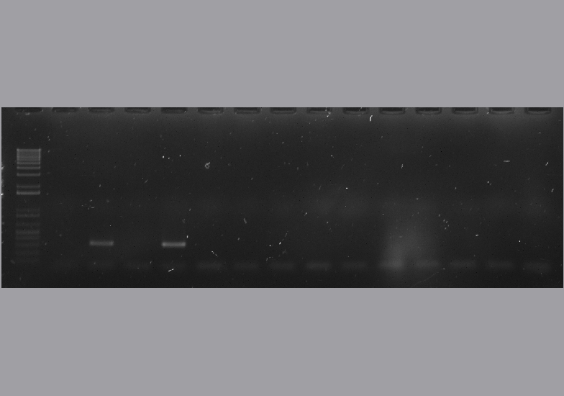
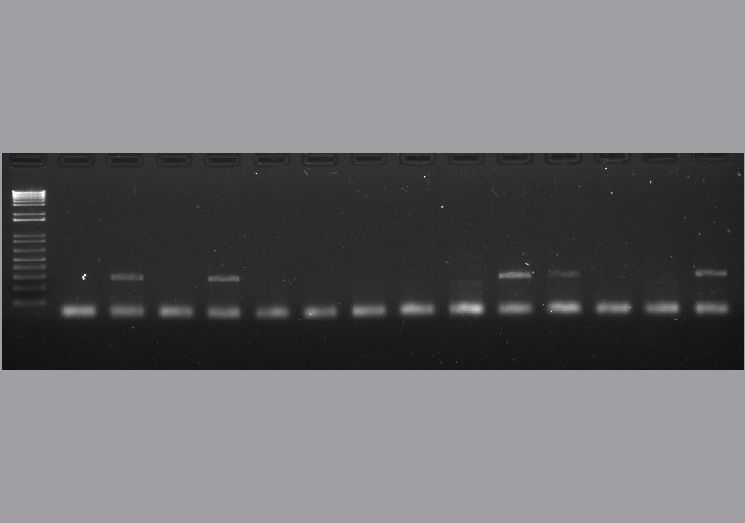
Figure S1.
M -ve +ve asymptomatic symptomatic asymptomatic symptomatic
c.v. Merlot
c.v. Syrah
NADH
GRBV
RSPV
GFLV
GSYV

