Additional file 2: Coverage probabilities from a small simulation study

Estimated coverage for the approximate confidence interval for the upper LOAM

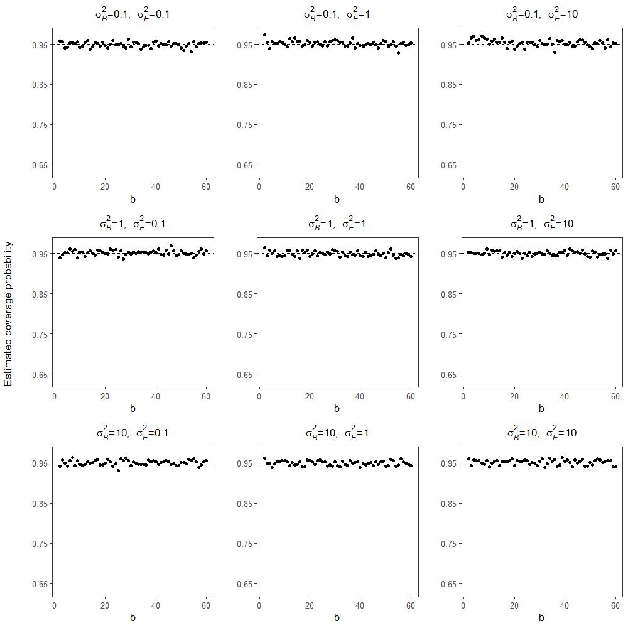
Figure 1. Estimated coverage probability for the approximate 95% confidence interval for the upper LOAM stated in Eq. (5) in the paper. The estimation is based on 1000 simulations from the two-way random effects model with $a=10, c=1, μ=0$, $σ_{A}^{2}=5$, while $b=2,…, 60$ and nine combinations of $σ_{B}^{2}$ and $σ_{E}^{2}$ are considered (see specific choices in the title of each plot). The estimated coverage probability is close to the wanted 95% for all the considered parameter values and all values of $b$.

Estimated coverage for the approximate confidence interval for $σ_{B}$
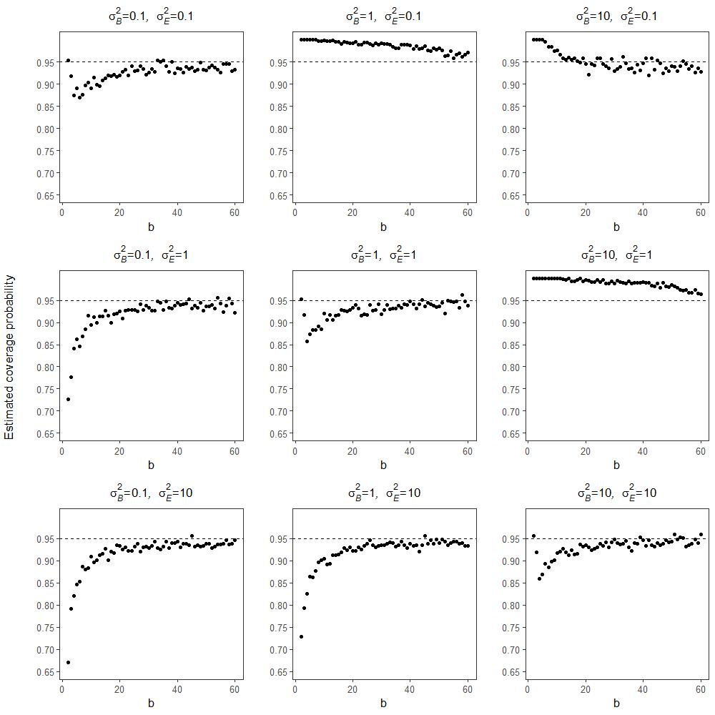
Figure 2. Estimated coverage probability for the approximate 95% confidence interval for $σ_{B}$ stated in Eq. (8) in the paper. The estimation is based on 1000 simulations from the two-way random effects model with $a=10, c=1, μ=0$, $σ_{A}^{2}=5$, while $b=2,…, 60$ and nine combinations of $σ_{B}^{2}$ and $σ_{E}^{2}$ are considered (see specific choices in the title of each plot). In general, for $b>20$ the estimated coverage probability is close to the wanted 95%, while the approximation may be poor for small values of $b$.

Estimated coverage for the approximate confidence interval for $σ_{E}$
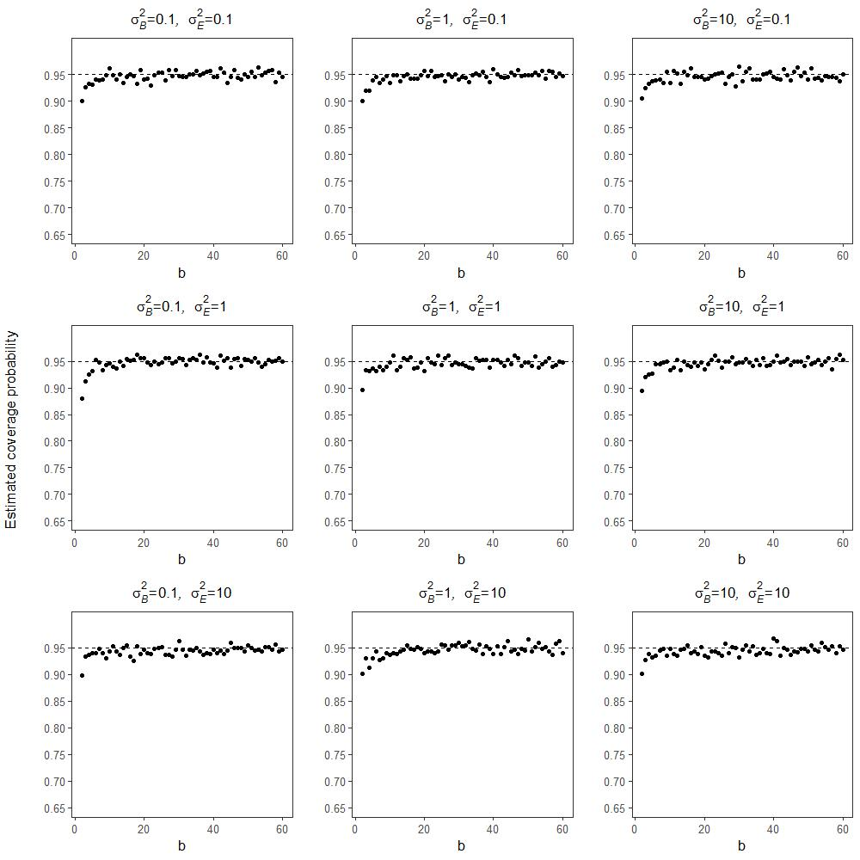
Figure 3. Estimated coverage probability for the symmetric and approximate 95% confidence interval for $σ_{E}$ [see Additional file 3]. The estimation is based on 1000 simulations from the two-way random effects model with $a=10, c=1, μ=0$, $σ_{A}^{2}=5$, while $b=2,…, 60$ and nine combinations of $σ_{B}^{2}$ and $σ_{E}^{2}$ are considered (see specific choices in the title of each plot). In general, the estimated coverage probability is close to the wanted 95%, perhaps except for small values of $b$ ($b<5)$. Note that an exact confidence interval for $σ_{E}$is supplied in the main paper.

