Supplemental Information

Figures
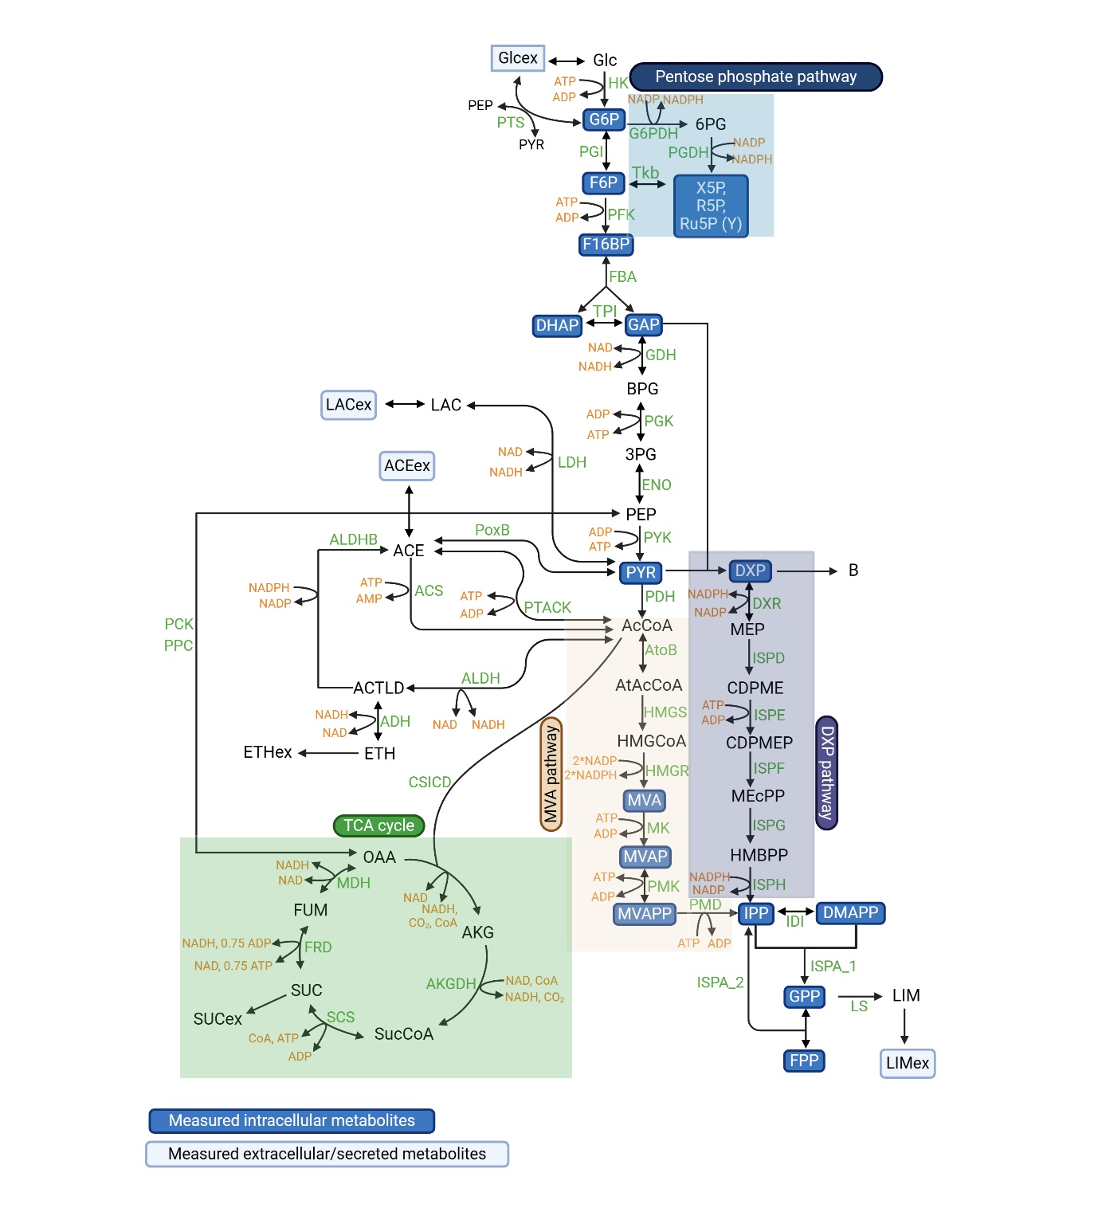

Figure S1. Metabolic network used for the initial development of the dynamic model (Models A and B). The illustration was created using Biorender.com.
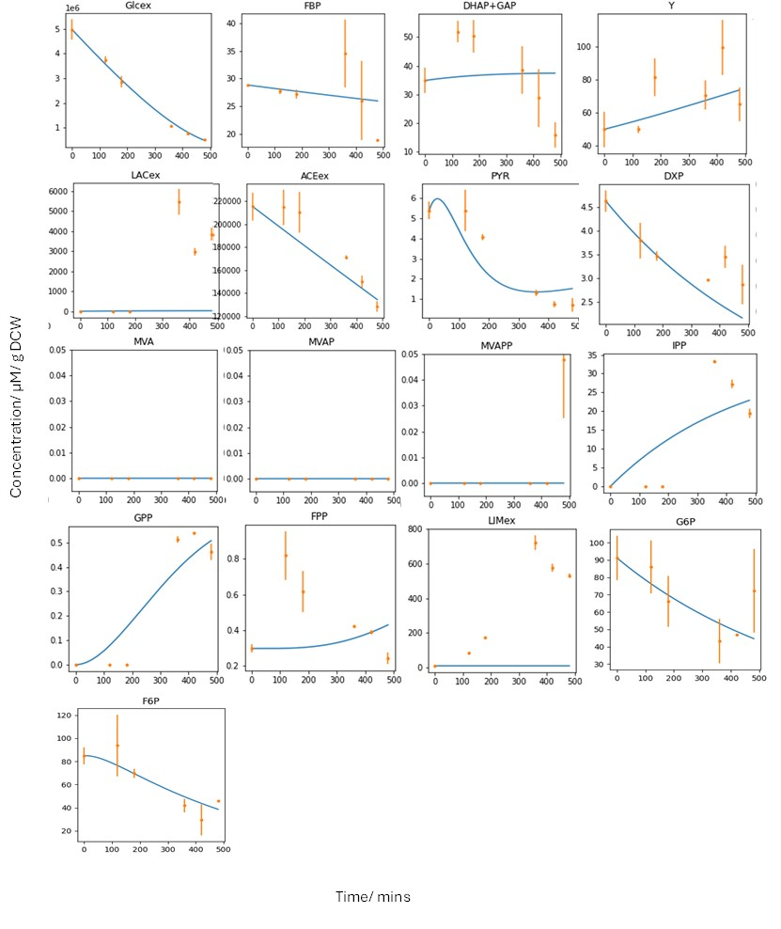
Figure S2. Simulations of extracellular and intracellular metabolites from Model A with the experimental data.

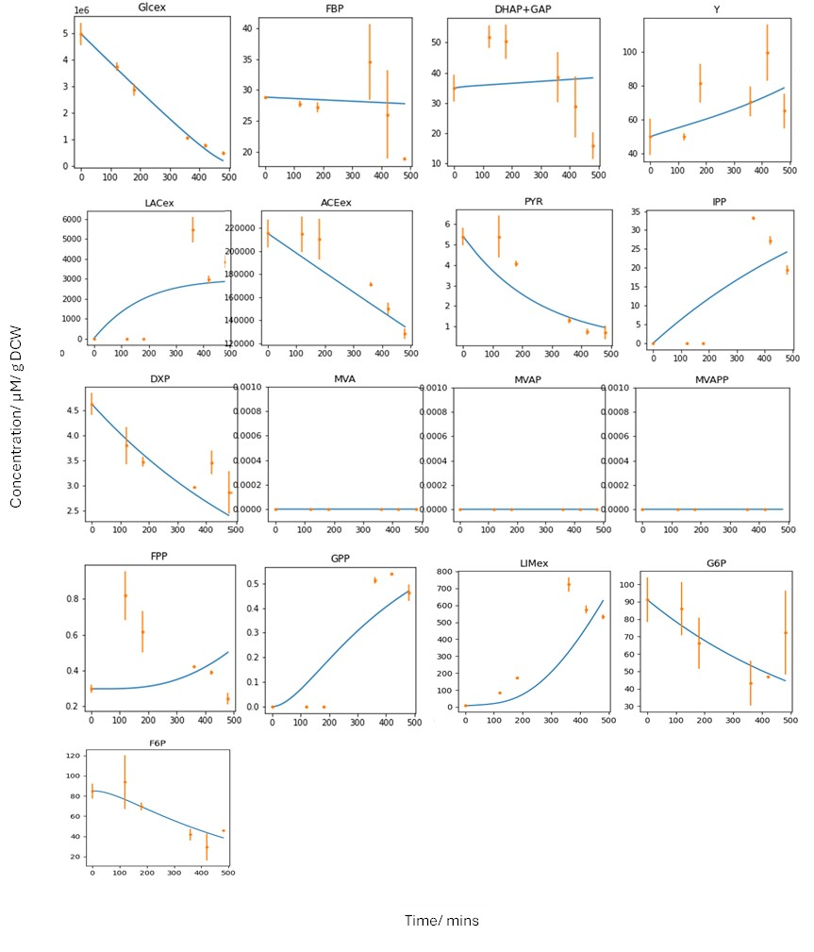
Figure S3. Simulations of extracellular and intracellular metabolites from Model B with experimental data.

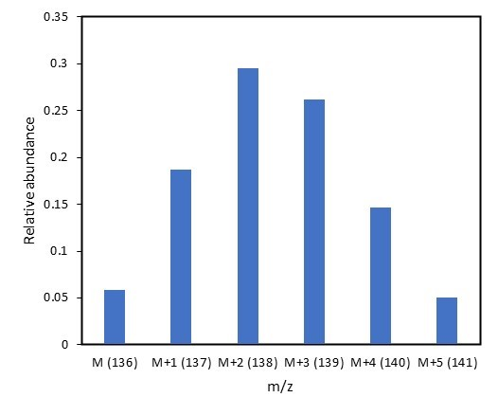
Figure S4. Mass distribution vector of limonene after cultivation on [1-¹³C]-glucose obtained from GC-MS analysis of spectral data with correction for naturally occurring isotopes (MDV*).

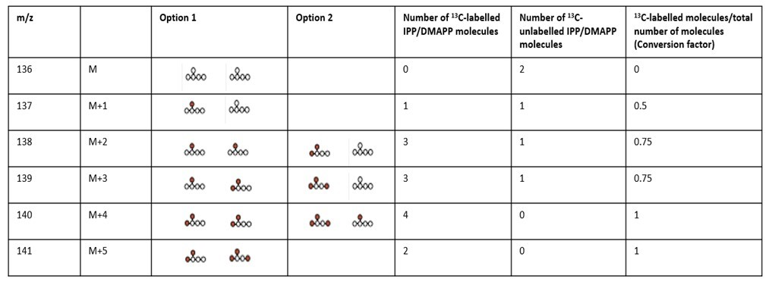
Figure S5. Summary of the predicted incorporation of ¹³C atoms due to the uptake of the positional tracer [1-¹³C]-glucose into IPP/ DMAPP (isopentenyl pyrophosphate/ dimethylallyl pyrophosphate) from cell culture. When the m/z increase in limonene is M+2 or more, there would be more than one option for ¹³C incorporation into IPP/DMAPP. Consequently, the conversion of the corrected mass distribution vector (MDV*) into labelled IPP/DMAPP fractions were executed using the determined conversion factor. These factors are also presented in Table S1.

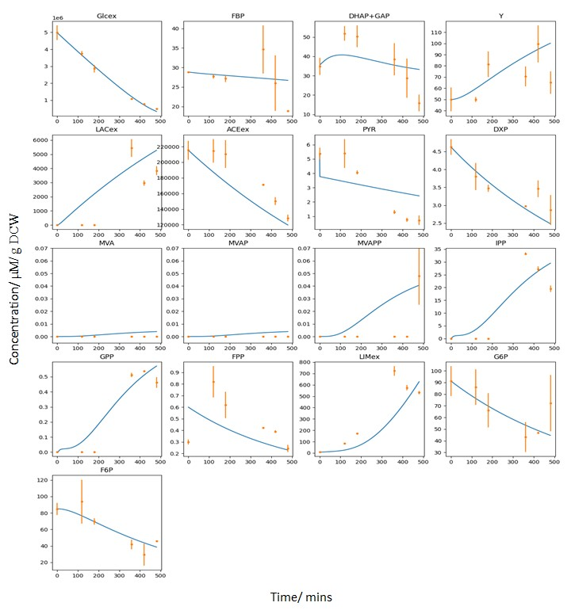
Figure S6. Simulations of the intracellular and extracellular metabolites from the final developed dynamic model (Model C) with the measured time-series metabolomics data

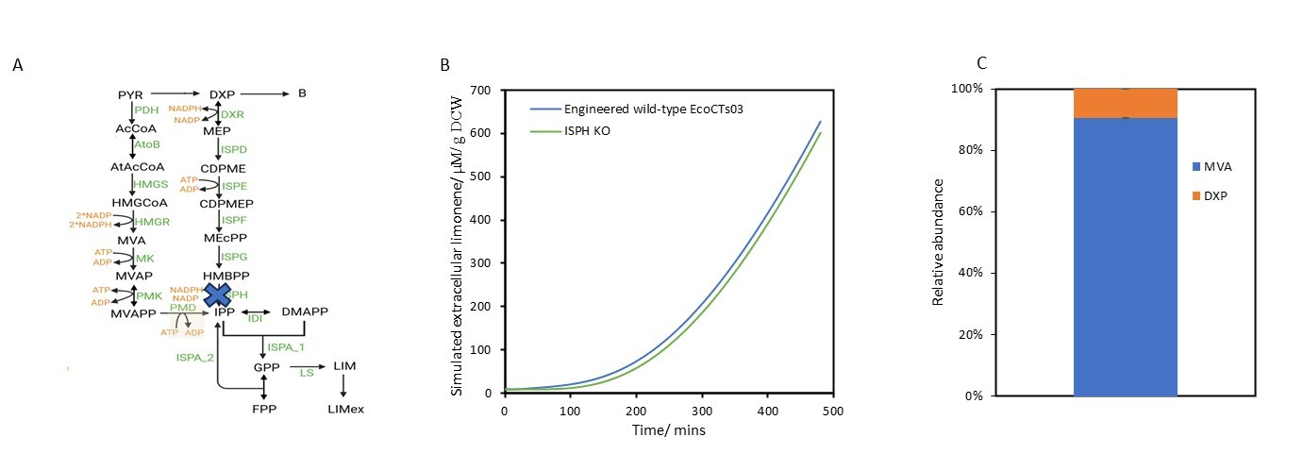
Figure S7. Illustration of the in silico knockout of enzyme ISPH (hydroxymethylbutenyl 4-diphosphate reductase) from the developed dynamic model (Model C) and the experimental proportion of carbon flux entering the MVA and DXP pathways. Figure S7A shows the topology of the ISPH knockout while Figure S7B displays the simulations of extracellular limonene from the developed dynamic model (Model C) using engineered wild-type EcoCTs03 and after ISPH knockout (ISPH KO). Figure S7C portrays the proportion of limonene produced experimentally through the DXP pathway using [4-¹³C]-glucose tracer is about 9.4% similar to the drop in limonene observed with the in silico ISPH KO.

Tables

Table S1. Conversion factors for the transformation of corrected mass distribution vectors (MDV*) fractions into amount of labelled IPP/ DMAPP (isopentenyl pyrophosphate/ dimethylallyl pyrophosphate) for parallel cell cultures grown with [1-¹³C]-glucose and [4-¹³C]-glucose.

MDV fraction | ¹³C-labelled IPP or DMAPP molecules/total number of IPP or DMAPP molecules
MDV fraction | [1-¹³C]-glucose tracer | [4-¹³C]-glucose tracer
M (m/z = 136) | 0 | 0
M+1 (m/z = 137) | 0.5 | 0.5
M+2 (m/z = 138) | 0.75
M+3 (m/z = 139) | 0.75
M+4 (m/z = 140) | 1
M+5 (m/z = 141) | 1

Table S2: Reaction, rate laws and parameter values of the dynamic model.
No. | Reaction | Rate law equation | Parameter | Value | Unit
1 | A (glucose uptake)  Glcex ↔ Glc | $$\frac{Vf∙\frac{Glcex}{Km_Glcex}-Vr∙\frac{Glc}{Km_Glc}}{1+\frac{Glcex}{Km_Glcex}+\frac{Glc}{Km_Glc}}$$ | $$Vf$$ | 11283 | µmol/(l*min)/g DCW
1 | A (glucose uptake)  Glcex ↔ Glc |  | $$Km_Glcex$$ | 14311.2 | µmol/l/g DCW
1 | A (glucose uptake)  Glcex ↔ Glc |  | $$Vr$$ | 916.759 | µmol/(l*min)/g DCW
1 | A (glucose uptake)  Glcex ↔ Glc |  | $$Km_Glc$$ | 189662 | µmol/l/g DCW
2 | HK  Glc + ATP → G6P + ADP; G6P | $$\frac{Vmax∙\frac{Glc}{Km_Glc}∙\frac{ATP}{Km_ATP}}{1+\frac{Glc}{Km_Glc}+\frac{ATP}{Km_ATP}+\frac{G6P}{Ki_G6P}}$$ | $$Vmax$$ | 22.0722 | µmol/(l*min)/g DCW
2 | HK  Glc + ATP → G6P + ADP; G6P |  | $$Km_Glc$$ | 97038.7 | µmol/l/g DCW
2 | HK  Glc + ATP → G6P + ADP; G6P |  | $$Km_ATP$$ | 142201 | µmol/l/g DCW
2 | HK  Glc + ATP → G6P + ADP; G6P |  | $$Ki_G6P$$ | 140634 | µmol/l/g DCW
3 | PGI  G6P ↔ F6P; PEP PG6 | $$\frac{Vf∙\frac{G6P}{Km_G6P}-Vr∙\frac{F6P}{Km_F6P}}{1+\frac{G6P}{Km_G6P}+\frac{F6P}{Km_F6P}+\frac{PEP}{Ki_PEP}+\frac{PG6}{Ki_PG6}}$$ | $$Vf$$ | 81.0943 | µmol/(l*min)/g DCW
3 | PGI  G6P ↔ F6P; PEP PG6 |  | $$Km_G6P$$ | 398841 | µmol/l/g DCW
3 | PGI  G6P ↔ F6P; PEP PG6 |  | $$Vr$$ | 1.8879 | µmol/(l*min)/g DCW
3 | PGI  G6P ↔ F6P; PEP PG6 |  | $$Km_F6P$$ | 23355 | µmol/l/g DCW
3 | PGI  G6P ↔ F6P; PEP PG6 |  | $$Ki_PEP$$ | 8195.44 | µmol/l/g DCW
3 | PGI  G6P ↔ F6P; PEP PG6 |  | $$Ki_PG6$$ | 160354 | µmol/l/g DCW
4 | PFK  F6P + ATP → FBP + ADP; ADP PEP | $$\frac{Vmax∙\frac{F6P}{Km_F6P}∙\frac{ATP}{Km_ATP}∙\frac{ADP}{Ka_ADP}}{1+\frac{F6P}{Km_F6P}+\frac{ATP}{Km_ATP}+\frac{PEP}{Ki_PEP}}$$ | $$Vmax$$ | 1 | µmol/(l*min)/g DCW
4 | PFK  F6P + ATP → FBP + ADP; ADP PEP |  | $$Km_F6P$$ | 12362.6 | µmol/l/g DCW
4 | PFK  F6P + ATP → FBP + ADP; ADP PEP |  | $$Km_ATP$$ | 2679.07 | µmol/l/g DCW
4 | PFK  F6P + ATP → FBP + ADP; ADP PEP |  | $$Ka_ADP$$ | 4115.15 | µmol/l/g DCW
4 | PFK  F6P + ATP → FBP + ADP; ADP PEP |  | $$Ki_PEP$$ | 1000 | µmol/l/g DCW
5 | FBA  FBP ↔ GAP + DHAP; PEP | $$\frac{Vf∙\frac{FBP}{Km_FBP}-Vr∙\frac{GAP}{Km_GAP}∙\frac{DHAP}{Km_DHAP}}{1+\frac{FBP}{Km_FBP}+\frac{GAP}{Km_GAP}+\frac{DHAP}{Km_DHAP}+\frac{PEP}{Ki_PEP}}$$ | $$Vf$$ | 7.13104 | µmol/(l*min)/g DCW
5 | FBA  FBP ↔ GAP + DHAP; PEP |  | $$Km_FBP$$ | 28441.4 | µmol/l/g DCW
5 | FBA  FBP ↔ GAP + DHAP; PEP |  | $$Vr$$ | 1143.05 | µmol/(l*min)/g DCW
5 | FBA  FBP ↔ GAP + DHAP; PEP |  | $$Km_GAP$$ | 17388.1 | µmol/l/g DCW
5 | FBA  FBP ↔ GAP + DHAP; PEP |  | $$Km_DHAP$$ | 8078.8 | µmol/l/g DCW
5 | FBA  FBP ↔ GAP + DHAP; PEP |  | $$Ki_PEP$$ | 2795.05 | µmol/l/g DCW
6 | TPI  DHAP ↔ GAP | $$\frac{Vf∙\frac{DHAP}{Km_DHAP}-Vr∙\frac{GAP}{Km_GAP}}{1+\frac{DHAP}{Km_DHAP}+\frac{GAP}{Km_GAP}}$$ | $$Vf$$ | 3.42989 | µmol/(l*min)/g DCW
6 | TPI  DHAP ↔ GAP |  | $$Km_DHAP$$ | 1781.75 | µmol/l/g DCW
6 | TPI  DHAP ↔ GAP |  | $$Vr$$ | 4.52873 | µmol/(l*min)/g DCW
6 | TPI  DHAP ↔ GAP |  | $$Km_GAP$$ | 108238 | µmol/l/g DCW
7 | GDH  GAP + NAD ↔ BPG + NADH | $$\frac{Vf∙\frac{GAP}{Km_GAP}∙\frac{NAD}{Km_NAD}-Vr∙\frac{BPG}{Km_BPG}∙\frac{NADH}{Km_NADH}}{1+\frac{GAP}{Km_GAP}+\frac{NAD}{Km_NAD}+\frac{BPG}{Km_BPG}+\frac{NADH}{Km_NADH}}$$ | $$Vf$$ | 2.28865 | µmol/(l*min)/g DCW
7 | GDH  GAP + NAD ↔ BPG + NADH |  | $$Km_GAP$$ | 16182.8 | µmol/l/g DCW
7 | GDH  GAP + NAD ↔ BPG + NADH |  | $$Km_NAD$$ | 2346.41 | µmol/l/g DCW
7 | GDH  GAP + NAD ↔ BPG + NADH |  | $$Vr$$ | 24690 | µmol/(l*min)/g DCW
7 | GDH  GAP + NAD ↔ BPG + NADH |  | $$Km_BPG$$ | 350855 | µmol/l/g DCW
7 | GDH  GAP + NAD ↔ BPG + NADH |  | $$Km_NADH$$ | 2445 | µmol/l/g DCW
8 | PGK  BPG + ADP ↔ PG3 + ATP | $$\frac{Vf∙\frac{BPG}{Km_BPG}∙\frac{ADP}{Km_ADP}-Vr∙\frac{PG3}{Km_PG3}∙\frac{ATP}{Km_ATP}}{1+\frac{BPG}{Km_BPG}+\frac{ADP}{Km_ADP}+\frac{PG3}{Km_PG3}\frac{ATP}{Km_ATP}}$$ | $$Vf$$ | 3.26222 | µmol/(l*min)/g DCW
8 | PGK  BPG + ADP ↔ PG3 + ATP |  | $$Km_BPG$$ | 210711 | µmol/l/g DCW
8 | PGK  BPG + ADP ↔ PG3 + ATP |  | $$Km_ADP$$ | 1191.55 | µmol/l/g DCW
8 | PGK  BPG + ADP ↔ PG3 + ATP |  | $$Vr$$ | 166.707 | µmol/(l*min)/g DCW
8 | PGK  BPG + ADP ↔ PG3 + ATP |  | $$Km_PG3$$ | 2161.21 | µmol/l/g DCW
8 | PGK  BPG + ADP ↔ PG3 + ATP |  | $$Km_ATP$$ | 1000 | µmol/l/g DCW
9 | ENO  PG3 ↔ PEP | $$\frac{Vf∙\frac{PG3}{Km_PG3}-Vr∙\frac{PEP}{Km_PEP}}{1+\frac{PG3}{Km_PG3}+\frac{PEP}{Km_PEP}}$$ | $$Vf$$ | 1.66703 | µmol/(l*min)/g DCW
9 | ENO  PG3 ↔ PEP |  | $$Km_PG3$$ | 175019 | µmol/l/g DCW
9 | ENO  PG3 ↔ PEP |  | $$Vr$$ | 3519.95 | µmol/(l*min)/g DCW
9 | ENO  PG3 ↔ PEP |  | $$Km_PEP$$ | 25530.3 | µmol/l/g DCW
10 | PYK  PEP + ADP → PYR + ATP; FBP ATP SucCoA | $$\frac{Vmax∙\frac{PEP}{Km_PEP}∙\frac{ADP}{Km_ADP}∙\frac{FBP}{Ka_FBP}}{1+\frac{PEP}{Km_PEP}+\frac{ADP}{Km_ADP}+\frac{ATP}{Ki_ATP}+\frac{SucCoA}{Ki_SucCoA}}$$ | $$Vmax$$ | 23.8976 | µmol/(l*min)/g DCW
10 | PYK  PEP + ADP → PYR + ATP; FBP ATP SucCoA |  | $$Km_PEP$$ | 1611.62 | µmol/l/g DCW
10 | PYK  PEP + ADP → PYR + ATP; FBP ATP SucCoA |  | $$Km_ADP$$ | 10901.5 | µmol/l/g DCW
10 | PYK  PEP + ADP → PYR + ATP; FBP ATP SucCoA |  | $$Ka_FBP$$ | 17739.9 | µmol/l/g DCW
10 | PYK  PEP + ADP → PYR + ATP; FBP ATP SucCoA |  | $$Ki_ATP$$ | 91671.1 | µmol/l/g DCW
10 | PYK  PEP + ADP → PYR + ATP; FBP ATP SucCoA |  | $$Ki_SucCoA$$ | 546468 | µmol/l/g DCW
11 | PDH  PYR + CoA + NAD → AcCoA + NADH + CO2 | $$k_f∙PYR∙CoA∙NAD$$ | $$k_f$$ | 1555.21 | µmol/l/g DCW
12 | AtoB  2 * AcCoA ↔ AtAcCoA + CoA | $$\frac{Vf∙{\left(\frac{AcCoA}{Km_AcCoA}\right)}^{2}-Vr∙\frac{AtAcCoA}{Km_AtAcCoA}∙\frac{CoA}{Km_CoA}}{1+\frac{2∙AcCoA}{Km_AcCoA}+\frac{AtAcCoA}{Km_AtAcCoA}+\frac{CoA}{Km_CoA}}$$ | $$Vf$$ | 37.9786 | µmol/(l*min)/g DCW
12 | AtoB  2 * AcCoA ↔ AtAcCoA + CoA |  | $$Km_AcCoA$$ | 1506.05 | µmol/l/g DCW
12 | AtoB  2 * AcCoA ↔ AtAcCoA + CoA |  | $$Vr$$ | 22.7725 | µmol/(l*min)/g DCW
12 | AtoB  2 * AcCoA ↔ AtAcCoA + CoA |  | $$Km_AtAcCoA$$ | 1913.16 | µmol/l/g DCW
12 | AtoB  2 * AcCoA ↔ AtAcCoA + CoA |  | $$Km_CoA$$ | 469243 | µmol/l/g DCW
13 | HMGS  AcCoA + AtAcCoA → HMGCoA + CoA | $$\frac{Vmax∙\frac{AcCoA}{Km_AcCoA}∙\frac{AtAcCoA}{Km_AtAcCoA}}{1+\frac{AcCoA}{Km_AcCoA}+\frac{AtAcCoA}{Km_AtAcCoA}}$$ | $$Vmax$$ | 43.6724 | µmol/(l*min)/g DCW
13 | HMGS  AcCoA + AtAcCoA → HMGCoA + CoA |  | $$Km_AcCoA$$ | 4071.74 | µmol/l/g DCW
13 | HMGS  AcCoA + AtAcCoA → HMGCoA + CoA |  | $$Km_AtAcCoA$$ | 5394.92 | µmol/l/g DCW
14 | HMGR  HMGCoA + 2 * NADPH → MVA + 2 * NADP + CoA | $$\frac{Vmax∙\frac{HMGCoA}{Km_HMGCoA}∙{\left(\frac{NADPH}{Km_NADPH}\right)}^{2}}{1+\frac{HMGCoA}{Km_HMGCoA}+\frac{2∙NADPH}{Km_NADPH}}$$ | $$Vmax$$ | 95375.1 | µmol/(l*min)/g DCW
14 | HMGR  HMGCoA + 2 * NADPH → MVA + 2 * NADP + CoA |  | $$Km_HMGCoA$$ | 1250 | µmol/l/g DCW
14 | HMGR  HMGCoA + 2 * NADPH → MVA + 2 * NADP + CoA |  | $$Km_NADPH$$ | 1250 | µmol/l/g DCW
15 | MK  MVA + ATP → MVAP + ADP; DMAPP GPP FPP | $$\frac{Vmax∙\frac{MVA}{Km_MVA}∙\frac{ATP}{Km_ATP}}{1+\frac{MVA}{Km_MVA}+\frac{ATP}{Km_ATP}+\frac{DMAPP}{Ki_DMAPP}+\frac{GPP}{Ki_GPP}+\frac{FPP}{Ki_FPP}}$$ | $$Vmax$$ | 1.00E+06 | µmol/(l*min)/g DCW
15 | MK  MVA + ATP → MVAP + ADP; DMAPP GPP FPP |  | $$Km_MVA$$ | 100 | µmol/l/g DCW
15 | MK  MVA + ATP → MVAP + ADP; DMAPP GPP FPP |  | $$Km_ATP$$ | 100 | µmol/l/g DCW
15 | MK  MVA + ATP → MVAP + ADP; DMAPP GPP FPP |  | $$Ki_DMAPP$$ | 1.00E+06 | µmol/l/g DCW
15 | MK  MVA + ATP → MVAP + ADP; DMAPP GPP FPP |  | $$Ki_GPP$$ | 1.00E+06 | µmol/l/g DCW
15 | MK  MVA + ATP → MVAP + ADP; DMAPP GPP FPP |  | $$Ki_FPP$$ | 1.00E+06 | µmol/l/g DCW
16 | PMK  MVAP + ATP ↔ MVAPP + ADP | $$\frac{Vf∙\frac{MVAP}{Km_MVAP}∙\frac{ATP}{Km_ATP}-Vr∙\frac{MVAPP}{Km_MVAPP}∙\frac{ADP}{Km_ADP}}{1+\frac{MVAP}{Km_MVAP}+\frac{ATP}{Km_ATP}+\frac{MVAPP}{Km_MVAPP}+\frac{ADP}{Km_ADP}}$$ | $$Vf$$ | 1.00E+06 | µmol/(l*min)/g DCW
16 | PMK  MVAP + ATP ↔ MVAPP + ADP |  | $$Km_MVAP$$ | 100 | µmol/l/g DCW
16 | PMK  MVAP + ATP ↔ MVAPP + ADP |  | $$Km_ATP$$ | 100 | µmol/l/g DCW
16 | PMK  MVAP + ATP ↔ MVAPP + ADP |  | $$Vr$$ | 0 | µmol/(l*min)/g DCW
16 | PMK  MVAP + ATP ↔ MVAPP + ADP |  | $$Km_MVAPP$$ | 10000 | µmol/l/g DCW
16 | PMK  MVAP + ATP ↔ MVAPP + ADP |  | $$Km_ADP$$ | 5783.1 | µmol/l/g DCW
17 | PMD  MVAPP + ATP → IPP + ADP + CO2 | $$\frac{Vmax∙\frac{MVAPP}{Km_MVAPP}∙\frac{ATP}{Km_ATP}}{1+\frac{MVAPP}{Km_MVAPP}+\frac{ATP}{Km_ATP}}$$ | $$Vmax$$ | 300000 | µmol/(l*min)/g DCW
17 | PMD  MVAPP + ATP → IPP + ADP + CO2 |  | $$Km_MVAPP$$ | 189.24 | µmol/l/g DCW
17 | PMD  MVAPP + ATP → IPP + ADP + CO2 |  | $$Km_ATP$$ | 174.726 | µmol/l/g DCW
18 | DXS  PYR + GAP → DXP + CO2; IPP DMAPP | $$\frac{Vmax∙\frac{PYR}{Km_PYR}∙\frac{GAP}{Km_GAP}}{1+\frac{PYR}{Km_PYR}+\frac{GAP}{Km_GAP}+\frac{IPP}{Ki_IPP}+\frac{DMAPP}{Ki_DMAPP}}$$ | $$Vmax$$ | 1904.83 | µmol/(l*min)/g DCW
18 | DXS  PYR + GAP → DXP + CO2; IPP DMAPP |  | $$Km_PYR$$ | 18536.9 | µmol/l/g DCW
18 | DXS  PYR + GAP → DXP + CO2; IPP DMAPP |  | $$Km_GAP$$ | 28453.3 | µmol/l/g DCW
18 | DXS  PYR + GAP → DXP + CO2; IPP DMAPP |  | $$Ki_IPP$$ | 1000 | µmol/l/g DCW
18 | DXS  PYR + GAP → DXP + CO2; IPP DMAPP |  | $$Ki_DMAPP$$ | 1141.73 | µmol/l/g DCW
19 | DXR  DXP + NADPH ↔ MEP + NADP | $$\frac{Vf∙\frac{DXP}{Km_DXP}∙\frac{NADPH}{Km_NADPH}-Vr∙\frac{MEP}{Km_MEP}∙\frac{NADP}{Km_NADP}}{1+\frac{DXP}{Km_DXP}+\frac{NADPH}{Km_NADPH}+\frac{MEP}{Km_MEP}+\frac{NADP}{Km_NADP}}$$ | $$Vf$$ | 3206.16 | µmol/(l*min)/g DCW
19 | DXR  DXP + NADPH ↔ MEP + NADP |  | $$Km_DXP$$ | 4655.26 | µmol/l/g DCW
19 | DXR  DXP + NADPH ↔ MEP + NADP |  | $$Km_NADPH$$ | 20713.9 | µmol/l/g DCW
19 | DXR  DXP + NADPH ↔ MEP + NADP |  | $$Vr$$ | 22.2757 | µmol/(l*min)/g DCW
19 | DXR  DXP + NADPH ↔ MEP + NADP |  | $$Km_MEP$$ | 300332 | µmol/l/g DCW
19 | DXR  DXP + NADPH ↔ MEP + NADP |  | $$Km_NADP$$ | 4872.81 | µmol/l/g DCW
20 | ISPD  MEP → CDPME | $$\frac{Vmax∙\frac{MEP}{Km_MEP}}{1+\frac{MEP}{Km_MEP}}$$ | $$Vmax$$ | 50 | µmol/(l*min)/g DCW
20 | ISPD  MEP → CDPME | $$\frac{Vmax∙\frac{MEP}{Km_MEP}}{1+\frac{MEP}{Km_MEP}}$$ | $$Km_MEP$$ | 15185.9 | µmol/l/g DCW
21 | ISPE  CDPME + ATP → CDPMEP + ADP | $$\frac{Vmax∙\frac{CDPME}{Km_CDPME}∙\frac{ATP}{Km_ATP}}{1+\frac{CDPME}{Km_CDPME}+\frac{ATP}{Km_ATP}}$$ | $$Vmax$$ | 3345.35 | µmol/(l*min)/g DCW
21 | ISPE  CDPME + ATP → CDPMEP + ADP |  | $$Km_CDPME$$ | 1000 | µmol/l/g DCW
21 | ISPE  CDPME + ATP → CDPMEP + ADP |  | $$Km_ATP$$ | 3726.99 | µmol/l/g DCW
22 | ISPF  CDPMEP → MEcPP; MEP FPP | $$\frac{Vmax∙\frac{CDPMEP}{Km_CDPMEP}∙\frac{MEP}{Ka_MEP}}{1+\frac{CDPMEP}{Km_CDPMEP}+\frac{FPP}{Ki_FPP}}$$ | $$Vmax$$ | 18773 | µmol/(l*min)/g DCW
22 | ISPF  CDPMEP → MEcPP; MEP FPP |  | $$Km_CDPMEP$$ | 1000 | µmol/l/g DCW
22 | ISPF  CDPMEP → MEcPP; MEP FPP |  | $$Ka_MEP$$ | 1000 | µmol/l/g DCW
22 | ISPF  CDPMEP → MEcPP; MEP FPP |  | $$Ki_FPP$$ | 159542 | µmol/l/g DCW
23 | ISPG  MEcPP + NADPH → HMBPP + NADP | $$\frac{Vmax∙\frac{MEcPP}{Km_MEcPP}∙\frac{NADPH}{Km_NADPH}}{1+\frac{MEcPP}{Km_MEcPP}+\frac{NADPH}{Km_NADPH}}$$ | $$Vmax$$ | 15346.8 | µmol/(l*min)/g DCW
23 | ISPG  MEcPP + NADPH → HMBPP + NADP |  | $$Km_MEcPP$$ | 1000 | µmol/l/g DCW
23 | ISPG  MEcPP + NADPH → HMBPP + NADP |  | $$Km_NADPH$$ | 1247.88 | µmol/l/g DCW
24 | ISPH  HMBPP + NADPH → IPP + NADP | $$\frac{Vmax∙\frac{HMBPP}{Km_HMBPP}∙\frac{NADPH}{Km_NADPH}}{1+\frac{HMBPP}{Km_HMBPP}+\frac{NADPH}{Km_NADPH}}$$ | $$Vmax$$ | 5000 | µmol/(l*min)/g DCW
24 | ISPH  HMBPP + NADPH → IPP + NADP |  | $$Km_HMBPP$$ | 8104.21 | µmol/l/g DCW
24 | ISPH  HMBPP + NADPH → IPP + NADP |  | $$Km_NADPH$$ | 1597.5 | µmol/l/g DCW
25 | IDI  IPP ↔ DMAPP | $$\frac{Vf∙\frac{IPP}{Km_IPP}-Vr∙\frac{DMAPP}{Km_DMAPP}}{1+\frac{IPP}{Km_IPP}+\frac{DMAPP}{Km_DMAPP}}$$ | $$Vf$$ | 100 | µmol/(l*min)/g DCW
25 | IDI  IPP ↔ DMAPP |  | $$Km_IPP$$ | 1000 | µmol/l/g DCW
25 | IDI  IPP ↔ DMAPP |  | $$Vr$$ | 50 | µmol/(l*min)/g DCW
25 | IDI  IPP ↔ DMAPP |  | $$Km_DMAPP$$ | 1000 | µmol/l/g DCW
26 | ISPA_1  DMAPP + IPP → GPP | $$\frac{Vmax∙\frac{DMAPP}{Km_DMAPP}∙\frac{IPP}{Km_IPP}}{1+\frac{DMAPP}{Km_DMAPP}+\frac{IPP}{Km_IPP}}$$ | $$Vmax$$ | 101932 | µmol/(l*min)/g DCW
26 | ISPA_1  DMAPP + IPP → GPP |  | $$Km_DMAPP$$ | 500 | µmol/l/g DCW
26 | ISPA_1  DMAPP + IPP → GPP |  | $$Km_IPP$$ | 500 | µmol/l/g DCW
27 | ISPA_2  GPP + IPP ↔ FPP | $$\frac{Vf∙\frac{GPP}{Km_GPP}∙\frac{IPP}{Km_IPP}-Vr∙\frac{FPP}{Km_FPP}}{1+\frac{GPP}{Km_GPP}+\frac{IPP}{Km_IPP}+\frac{FPP}{Km_FPP}}$$ | $$Vf$$ | 541.808 | µmol/(l*min)/g DCW
27 | ISPA_2  GPP + IPP ↔ FPP |  | $$Km_GPP$$ | 102904 | µmol/l/g DCW
27 | ISPA_2  GPP + IPP ↔ FPP |  | $$Km_IPP$$ | 292262 | µmol/l/g DCW
27 | ISPA_2  GPP + IPP ↔ FPP |  | $$Vr$$ | 200 | µmol/(l*min)/g DCW
27 | ISPA_2  GPP + IPP ↔ FPP |  | $$Km_FPP$$ | 100000 | µmol/l/g DCW
28 | LS  GPP → LIM | $$\frac{Vmax∙\frac{GPP}{Km_GPP}}{1+\frac{GPP}{Km_GPP}}$$ | $$Vmax$$ | 8210.7 | µmol/(l*min)/g DCW
28 | LS  GPP → LIM | $$\frac{Vmax∙\frac{GPP}{Km_GPP}}{1+\frac{GPP}{Km_GPP}}$$ | $$Km_GPP$$ | 1643.31 | µmol/l/g DCW
29 | LDH  PYR + NADH ↔ LAC + NAD | $$k_f∙PYR∙NADH-k_r∙LAC∙NAD$$ | $$k_f$$ | 2.23902 | µmol/l/g DCW
29 | LDH  PYR + NADH ↔ LAC + NAD | $$k_f∙PYR∙NADH-k_r∙LAC∙NAD$$ | $$k_r$$ | 8.47E-06 | µmol/l/g DCW
30 | PPC  PEP + CO2 → OAA; AcCoA FBP FUM SUC | $$\frac{Vmax∙\frac{PEP}{Km_PEP}∙\frac{CO2}{Km_CO2}∙\frac{AcCoA}{Ka_AcCoA}∙\frac{FBP}{Ka_FBP}}{1+\frac{PEP}{Km_PEP}+\frac{CO2}{Km_CO2}+\frac{FUM}{Ki_FUM}+\frac{SUC}{Ki_SUC}}$$ | $$Vmax$$ | 25.9766 | µmol/(l*min)/g DCW
30 | PPC  PEP + CO2 → OAA; AcCoA FBP FUM SUC |  | $$Km_PEP$$ | 2716.98 | µmol/l/g DCW
30 | PPC  PEP + CO2 → OAA; AcCoA FBP FUM SUC |  | $$Km_CO2$$ | 40471.7 | µmol/l/g DCW
30 | PPC  PEP + CO2 → OAA; AcCoA FBP FUM SUC |  | $$Ka_AcCoA$$ | 388963 | µmol/l/g DCW
30 | PPC  PEP + CO2 → OAA; AcCoA FBP FUM SUC |  | $$Ka_FBP$$ | 179882 | µmol/l/g DCW
30 | PPC  PEP + CO2 → OAA; AcCoA FBP FUM SUC |  | $$Ki_FUM$$ | 4203.01 | µmol/l/g DCW
30 | PPC  PEP + CO2 → OAA; AcCoA FBP FUM SUC |  | $$Ki_SUC$$ | 7726.24 | µmol/l/g DCW
31 | PCK  OAA + ATP ↔ PEP + ADP + CO2 | $$\frac{Vf∙\frac{OAA}{Km_OAA}∙\frac{ATP}{Km_ATP}-Vr∙\frac{PEP}{Km_PEP}∙\frac{ADP}{Km_ADP}∙\frac{CO2}{Km_CO2}}{1+\frac{OAA}{Km_OAA}+\frac{ATP}{Km_ATP}+\frac{PEP}{Km_PEP}+\frac{ADP}{Km_ADP}+\frac{CO2}{Km_CO2}}$$ | $$Vf$$ | 6.64861 | µmol/(l*min)/g DCW
31 | PCK  OAA + ATP ↔ PEP + ADP + CO2 |  | $$Km_OAA$$ | 1757.7 | µmol/l/g DCW
31 | PCK  OAA + ATP ↔ PEP + ADP + CO2 |  | $$Km_ATP$$ | 1000 | µmol/l/g DCW
31 | PCK  OAA + ATP ↔ PEP + ADP + CO2 |  | $$Vr$$ | 92.9095 | µmol/(l*min)/g DCW
31 | PCK  OAA + ATP ↔ PEP + ADP + CO2 |  | $$Km_PEP$$ | 17031.3 | µmol/l/g DCW
31 | PCK  OAA + ATP ↔ PEP + ADP + CO2 |  | $$Km_ADP$$ | 172064 | µmol/l/g DCW
31 | PCK  OAA + ATP ↔ PEP + ADP + CO2 |  | $$Km_CO2$$ | 385787 | µmol/l/g DCW
32 | PoxB  PYR ↔ ACE | $$k_f∙PYR-k_r∙ACE$$ | $$k_f$$ | 0.001997 | µmol/l/g DCW
32 | PoxB  PYR ↔ ACE | $$k_f∙PYR-k_r∙ACE$$ | $$k_r$$ | 339.361 | µmol/l/g DCW
33 | ACS  ACE + ATP + CoA → AcCoA + AMP | $$\frac{Vmax∙\frac{ACE}{Km_ACE}∙\frac{ATP}{Km_ATP}∙\frac{CoA}{Km_CoA}}{1+\frac{ACE}{Km_ACE}+\frac{ATP}{Km_ATP}+\frac{CoA}{Km_CoA}}$$ | $$Vmax$$ | 22596.5 | µmol/(l*min)/g DCW
33 | ACS  ACE + ATP + CoA → AcCoA + AMP |  | $$Km_ACE$$ | 31960.1 | µmol/l/g DCW
33 | ACS  ACE + ATP + CoA → AcCoA + AMP |  | $$Km_ATP$$ | 13420 | µmol/l/g DCW
33 | ACS  ACE + ATP + CoA → AcCoA + AMP |  | $$Km_CoA$$ | 41071.7 | µmol/l/g DCW
34 | PTACK  AcCoA + ADP ↔ ACE + ATP + CoA; PEP PYR NADH | $$\frac{Vf∙\frac{AcCoA}{Km_AcCoA}∙\frac{ADP}{Km_ADP}∙\frac{PEP}{Ka_PEP}∙\frac{PYR}{Ka_PYR}-Vr∙\frac{ACE}{Km_ACE}∙\frac{ATP}{Km_ATP}∙\frac{CoA}{Km_CoA}}{1+\frac{AcCoA}{Km_AcCoA}+\frac{ADP}{Km_ADP}+\frac{ACE}{Km_ACE}+\frac{ATP}{Km_ATP}+\frac{CoA}{Km_CoA}+\frac{NADH}{Ki_NADH}}$$ | $$Vf$$ | 26.4958 | µmol/(l*min)/g DCW
34 | PTACK  AcCoA + ADP ↔ ACE + ATP + CoA; PEP PYR NADH |  | $$Km_AcCoA$$ | 37591.8 | µmol/l/g DCW
34 | PTACK  AcCoA + ADP ↔ ACE + ATP + CoA; PEP PYR NADH |  | $$Km_ADP$$ | 1660.61 | µmol/l/g DCW
34 | PTACK  AcCoA + ADP ↔ ACE + ATP + CoA; PEP PYR NADH |  | $$Ka_PEP$$ | 310301 | µmol/l/g DCW
34 | PTACK  AcCoA + ADP ↔ ACE + ATP + CoA; PEP PYR NADH |  | $$Ka_PYR$$ | 44082.2 | µmol/l/g DCW
34 | PTACK  AcCoA + ADP ↔ ACE + ATP + CoA; PEP PYR NADH |  | $$Vr$$ | 1.18498 | µmol/(l*min)/g DCW
34 | PTACK  AcCoA + ADP ↔ ACE + ATP + CoA; PEP PYR NADH |  | $$Km_ACE$$ | 174489 | µmol/l/g DCW
34 | PTACK  AcCoA + ADP ↔ ACE + ATP + CoA; PEP PYR NADH |  | $$Km_ATP$$ | 11661.8 | µmol/l/g DCW
34 | PTACK  AcCoA + ADP ↔ ACE + ATP + CoA; PEP PYR NADH |  | $$Km_CoA$$ | 4355.81 | µmol/l/g DCW
34 | PTACK  AcCoA + ADP ↔ ACE + ATP + CoA; PEP PYR NADH |  | $$Ki_NADH$$ | 10510.9 | µmol/l/g DCW
35 | ACE transport  ACE ↔ ACEex | $$\frac{Vf∙\frac{ACE}{Km_ACE}-Vr∙\frac{ACEex}{Km_ACEex}}{1+\frac{ACE}{Km_ACE}+\frac{ACEex}{Km_ACEex}}$$ | $$Vf$$ | 9.64742 | µmol/(l*min)/g DCW
35 | ACE transport  ACE ↔ ACEex |  | $$Km_ACE$$ | 4735.42 | µmol/l/g DCW
35 | ACE transport  ACE ↔ ACEex |  | $$Vr$$ | 1062.22 | µmol/(l*min)/g DCW
35 | ACE transport  ACE ↔ ACEex |  | $$Km_ACEex$$ | 500000 | µmol/l/g DCW
36 | ADH  ACTLD + NADH ↔ ETH + NAD | $$\frac{Vf∙\frac{ACTLD}{Km_ACTLD}∙\frac{NADH}{Km_NADH}-Vr∙\frac{ETH}{Km_ETH}∙\frac{NAD}{Km_NAD}}{1+\frac{ACTLD}{Km_ACTLD}+\frac{NADH}{Km_NADH}+\frac{ETH}{Km_ETH}+\frac{NAD}{Km_NAD}}$$ | $$Vf$$ | 71135.7 | µmol/(l*min)/g DCW
36 | ADH  ACTLD + NADH ↔ ETH + NAD |  | $$Km_ACTLD$$ | 2947.93 | µmol/l/g DCW
36 | ADH  ACTLD + NADH ↔ ETH + NAD |  | $$Km_NADH$$ | 1000 | µmol/l/g DCW
36 | ADH  ACTLD + NADH ↔ ETH + NAD |  | $$Vr$$ | 1.5811 | µmol/(l*min)/g DCW
36 | ADH  ACTLD + NADH ↔ ETH + NAD |  | $$Km_ETH$$ | 100000 | µmol/l/g DCW
36 | ADH  ACTLD + NADH ↔ ETH + NAD |  | $$Km_NAD$$ | 108286 | µmol/l/g DCW
37 | ALDH  AcCoA + NADH ↔ ACTLD + NAD + CoA | $$\frac{Vf∙\frac{AcCoA}{Km_AcCoA}∙\frac{NADH}{Km_NADH}-Vr∙\frac{ACTLD}{Km_ACTLD}∙\frac{NAD}{Km_NAD}∙\frac{CoA}{Km_CoA}}{1+\frac{AcCoA}{Km_AcCoA}+\frac{NADH}{Km_NADH}+\frac{ACTLD}{Km_ACTLD}+\frac{NAD}{Km_NAD}+\frac{CoA}{Km_CoA}}$$ | $$Vf$$ | 537712 | µmol/(l*min)/g DCW
37 | ALDH  AcCoA + NADH ↔ ACTLD + NAD + CoA |  | $$Km_AcCoA$$ | 709.653 | µmol/l/g DCW
37 | ALDH  AcCoA + NADH ↔ ACTLD + NAD + CoA |  | $$Km_NADH$$ | 547.927 | µmol/l/g DCW
37 | ALDH  AcCoA + NADH ↔ ACTLD + NAD + CoA |  | $$Vr$$ | 521277 | µmol/(l*min)/g DCW
37 | ALDH  AcCoA + NADH ↔ ACTLD + NAD + CoA |  | $$Km_ACTLD$$ | 1643.89 | µmol/l/g DCW
37 | ALDH  AcCoA + NADH ↔ ACTLD + NAD + CoA |  | $$Km_NAD$$ | 542.68 | µmol/l/g DCW
37 | ALDH  AcCoA + NADH ↔ ACTLD + NAD + CoA |  | $$Km_CoA$$ | 558.236 | µmol/l/g DCW
38 | ALDHB  ACTLD + NADP → ACE + NADPH | $$\frac{Vmax∙\frac{ACTLD}{Km_ACTLD}∙\frac{NADP}{Km_NADP}}{1+\frac{ACTLD}{Km_ACTLD}+\frac{NADP}{Km_NADP}}$$ | $$Vmax$$ | 1.8111 | µmol/(l*min)/g DCW
38 | ALDHB  ACTLD + NADP → ACE + NADPH |  | $$Km_ATCLD$$ | 19351 | µmol/l/g DCW
38 | ALDHB  ACTLD + NADP → ACE + NADPH |  | $$Km_NADP$$ | 18281.9 | µmol/l/g DCW
39 | ETH transport  ETH → ETHex | $$\frac{Vmax∙\frac{ETH}{Km_ETH}}{1+\frac{ETH}{Km_ETH}}$$ | $$Vmax$$ | 3.27458 | µmol/(l*min)/g DCW
39 | ETH transport  ETH → ETHex | $$\frac{Vmax∙\frac{ETH}{Km_ETH}}{1+\frac{ETH}{Km_ETH}}$$ | $$Km_ETH$$ | 15275.8 | µmol/l/g DCW
40 | CSICD  AcCoA + OAA + NAD → AKG + NADH + CoA + CO2; AKG NADH | $$\frac{Vmax∙\frac{AcCoA}{Km_AcCoA}∙\frac{OAA}{Km_OAA}∙\frac{NAD}{Km_NAD}}{1+\frac{AcCoA}{Km_AcCoA}+\frac{OAA}{Km_OAA}+\frac{NAD}{Km_NAD}+\frac{AKG}{Ki_AKG}+\frac{NADH}{Ki_NADH}}$$ | $$Vmax$$ | 3.9575 | µmol/(l*min)/ g DCW
40 | CSICD  AcCoA + OAA + NAD → AKG + NADH + CoA + CO2; AKG NADH |  | $$Km_AcCoA$$ | 14739.9 | µmol/l/g DCW
40 | CSICD  AcCoA + OAA + NAD → AKG + NADH + CoA + CO2; AKG NADH |  | $$Km_OAA$$ | 9656.43 | µmol/l/g DCW
40 | CSICD  AcCoA + OAA + NAD → AKG + NADH + CoA + CO2; AKG NADH |  | $$Km_NAD$$ | 67324.4 | µmol/l/g DCW
40 | CSICD  AcCoA + OAA + NAD → AKG + NADH + CoA + CO2; AKG NADH |  | $$Ki_AKG$$ | 254162 | µmol/l/g DCW
40 | CSICD  AcCoA + OAA + NAD → AKG + NADH + CoA + CO2; AKG NADH |  | $$Ki_NADH$$ | 159499 | µmol/l/g DCW
41 | AKGDH  AKG + NAD + CoA → SucCoA + NADH + CO2 | $$\frac{Vmax∙\frac{AKG}{Km_AKG}∙\frac{NAD}{Km_NAD}∙\frac{CoA}{Km_CoA}}{1+\frac{AKG}{Km_AKG}+\frac{NAD}{Km_NAD}+\frac{CoA}{Km_CoA}}$$ | $$Vmax$$ | 1.89161 | µmol/(l*min)/ g DCW
41 | AKGDH  AKG + NAD + CoA → SucCoA + NADH + CO2 |  | $$Km_AKG$$ | 27153.5 | µmol/l/g DCW
41 | AKGDH  AKG + NAD + CoA → SucCoA + NADH + CO2 |  | $$Km_NAD$$ | 10750.2 | µmol/l/g DCW
41 | AKGDH  AKG + NAD + CoA → SucCoA + NADH + CO2 |  | $$Km_CoA$$ | 3940.68 | µmol/l/g DCW
42 | SCS  SucCoA + ADP ↔ SUC + ATP + CoA | $$\frac{Vf∙\frac{SucCoA}{Km_SucCoA}∙\frac{ADP}{Km_ADP}-Vr∙\frac{SUC}{Km_SUC}∙\frac{ATP}{Km_ATP}∙\frac{CoA}{Km_CoA}}{1+\frac{SucCoA}{Km_SucCoA}+\frac{ADP}{Km_ADP}+\frac{SUC}{Km_SUC}+\frac{ATP}{Km_ATP}+\frac{CoA}{Km_CoA}}$$ | $$Vf$$ | 13.1672 | µmol/(l*min)/ g DCW
42 | SCS  SucCoA + ADP ↔ SUC + ATP + CoA |  | $$Km_SucCoA$$ | 9111.67 | µmol/l/g DCW
42 | SCS  SucCoA + ADP ↔ SUC + ATP + CoA |  | $$Km_ADP$$ | 49517 | µmol/l/g DCW
42 | SCS  SucCoA + ADP ↔ SUC + ATP + CoA |  | $$Vr$$ | 347.439 | µmol/(l*min)/ g DCW
42 | SCS  SucCoA + ADP ↔ SUC + ATP + CoA |  | $$Km_SUC$$ | 23166.5 | µmol/l/g DCW
42 | SCS  SucCoA + ADP ↔ SUC + ATP + CoA |  | $$Km_ATP$$ | 7554.76 | µmol/l/g DCW
42 | SCS  SucCoA + ADP ↔ SUC + ATP + CoA |  | $$Km_CoA$$ | 274256 | µmol/l/g DCW
43 | SUC transport  SUC -> SUCex | $$\frac{Vmax∙\frac{SUC}{Km_SUC}}{1+\frac{SUC}{Km_SUC}}$$ | $$Vmax$$ | 49.9909 | µmol/(l*min)/ g DCW
43 | SUC transport  SUC -> SUCex | $$\frac{Vmax∙\frac{SUC}{Km_SUC}}{1+\frac{SUC}{Km_SUC}}$$ | $$Km_SUC$$ | 1199.57 | µmol/l/g DCW
44 | FRD  FUM + NADH + 0.75 * ADP ↔ SUC + NAD + 0.75 * ATP; OAA | $$\frac{Vf∙\frac{FUM}{Km_FUM}∙\frac{NADH}{Km_NADH}∙{\left(\frac{ADP}{Km_ADP}\right)}^{0.75}-Vr∙\frac{SUC}{Km_SUC}∙\frac{NAD}{Km_NAD}∙{\left(\frac{ATP}{Km_ATP}\right)}^{0.75}}{1+\frac{FUM}{Km_FUM}+\frac{NADH}{Km_NADH}+\frac{0.75∙ADP}{Km_ADP}+\frac{SUC}{Km_SUC}∙\frac{NAD}{Km_NAD}+\frac{0.75∙ATP}{Km_ATP}+\frac{OAA}{Ki_OAA}}$$ | $$Vf$$ | 252.349 | µmol/(l*min)/g DCW
44 | FRD  FUM + NADH + 0.75 * ADP ↔ SUC + NAD + 0.75 * ATP; OAA |  | $$Km_FUM$$ | 254036 | µmol/l/g DCW
44 | FRD  FUM + NADH + 0.75 * ADP ↔ SUC + NAD + 0.75 * ATP; OAA |  | $$Km_NADH$$ | 74064.8 | µmol/l/g DCW
44 | FRD  FUM + NADH + 0.75 * ADP ↔ SUC + NAD + 0.75 * ATP; OAA |  | $$Km_ADP$$ | 396763 | µmol/l/g DCW
44 | FRD  FUM + NADH + 0.75 * ADP ↔ SUC + NAD + 0.75 * ATP; OAA |  | $$Vr$$ | 2.67232 | µmol/(l*min)/g DCW
44 | FRD  FUM + NADH + 0.75 * ADP ↔ SUC + NAD + 0.75 * ATP; OAA |  | $$Km_SUC$$ | 643183 | µmol/l/g DCW
44 | FRD  FUM + NADH + 0.75 * ADP ↔ SUC + NAD + 0.75 * ATP; OAA |  | $$Km_NAD$$ | 33882.8 | µmol/l/g DCW
44 | FRD  FUM + NADH + 0.75 * ADP ↔ SUC + NAD + 0.75 * ATP; OAA |  | $$Km_ATP$$ | 807176 | µmol/l/g DCW
44 | FRD  FUM + NADH + 0.75 * ADP ↔ SUC + NAD + 0.75 * ATP; OAA |  | $$Ki_OAA$$ | 160548 | µmol/l/g DCW
45 | MDH  FUM + NAD ↔ OAA + NADH | $$\frac{Vf∙\frac{FUM}{Km_FUM}∙\frac{NAD}{Km_NAD}-Vr∙\frac{OAA}{Km_OAA}∙\frac{NADH}{Km_NADH}}{1+\frac{FUM}{Km_FUM}+\frac{NAD}{Km_NAD}+\frac{OAA}{Km_OAA}+\frac{NADH}{Km_NADH}}$$ | $$Vf$$ | 7156.65 | µmol/(l*min)/g DCW
45 | MDH  FUM + NAD ↔ OAA + NADH |  | $$Km_FUM$$ | 7499.4 | µmol/l/g DCW
45 | MDH  FUM + NAD ↔ OAA + NADH |  | $$Km_NAD$$ | 423139 | µmol/l/g DCW
45 | MDH  FUM + NAD ↔ OAA + NADH |  | $$Vr$$ | 2.80486 | µmol/(l*min)/g DCW
45 | MDH  FUM + NAD ↔ OAA + NADH |  | $$Km_OAA$$ | 115924 | µmol/l/g DCW
45 | MDH  FUM + NAD ↔ OAA + NADH |  | $$Km_NADH$$ | 98267.7 | µmol/l/g DCW
46 | B (vitamin B6 synthesis)  DXP -> B | $$\frac{Vmax∙\frac{DXP}{Km_DXP}}{1+\frac{DXP}{Km_DXP}}$$ | $$Vmax$$ | 1.52353 | µmol/(l*min)/g DCW
46 | B (vitamin B6 synthesis)  DXP -> B | $$\frac{Vmax∙\frac{DXP}{Km_DXP}}{1+\frac{DXP}{Km_DXP}}$$ | $$Km_DXP$$ | 1770.77 | µmol/l/g DCW
47 | G6PDH  G6P + NADP → PG6 + NADPH; NADPH | $$\frac{Vmax∙\frac{G6P}{Km_G6P}∙\frac{NADP}{Km_NADP}}{1+\frac{G6P}{Km_G6P}∙\frac{NADP}{Km_NADP}+\frac{NADPH}{Ki_NADPH}+\frac{G6P}{Ki_G6P}}$$ | $$Vmax$$ | 48512.1 | µmol/(l*min)/g DCW
47 | G6PDH  G6P + NADP → PG6 + NADPH; NADPH |  | $$Km_G6P$$ | 7797.16 | µmol/l/g DCW
47 | G6PDH  G6P + NADP → PG6 + NADPH; NADPH |  | $$Km_NADP$$ | 1332.17 | µmol/l/g DCW
47 | G6PDH  G6P + NADP → PG6 + NADPH; NADPH |  | $$Ki_NADPH$$ | 263829 | µmol/l/g DCW
47 | G6PDH  G6P + NADP → PG6 + NADPH; NADPH |  | $$Ki_G6P$$ | 41750.2 | µmol/l/g DCW
48 | PGDH  PG6 + NADP → NADPH + Y; FBP ATP NADPH | $$\frac{Vmax∙\frac{PG6}{Km_PG6}∙\frac{NADP}{Km_NADP}}{1+\frac{PG6}{Km_PG6}+\frac{NADP}{Km_NADP}+\frac{FBP}{Ki_FBP}+\frac{ATP}{Ki_ATP}+\frac{NADPH}{Ki_NADPH}}$$ | $$Vmax$$ | 62.2647 | µmol/(l*min)/g DCW
48 | PGDH  PG6 + NADP → NADPH + Y; FBP ATP NADPH |  | $$Km_PG6$$ | 22421.5 | µmol/l/g DCW
48 | PGDH  PG6 + NADP → NADPH + Y; FBP ATP NADPH |  | $$Km_NADP$$ | 662493 | µmol/l/g DCW
48 | PGDH  PG6 + NADP → NADPH + Y; FBP ATP NADPH |  | $$Ki_FBP$$ | 17462.3 | µmol/l/g DCW
48 | PGDH  PG6 + NADP → NADPH + Y; FBP ATP NADPH |  | $$Ki_ATP$$ | 196487 | µmol/l/g DCW
48 | PGDH  PG6 + NADP → NADPH + Y; FBP ATP NADPH |  | $$Ki_NADPH$$ | 9947.46 | µmol/l/g DCW
49 | Tkb  Y ↔ GAP + F6P | $$\frac{Vf∙\frac{Y}{Km_Y}-Vr∙\frac{GAP}{Km_GAP}∙\frac{F6P}{Km_F6P}}{1+\frac{Y}{Km_Y}+\frac{GAP}{Km_GAP}∙\frac{F6P}{Km_F6P}}$$ | $$Vf$$ | 44.2569 | µmol/(l*min)/g DCW
49 | Tkb  Y ↔ GAP + F6P |  | $$Km_Y$$ | 957442 | µmol/l/g DCW
49 | Tkb  Y ↔ GAP + F6P |  | $$Vr$$ | 5761.94 | µmol/(l*min)/g DCW
49 | Tkb  Y ↔ GAP + F6P |  | $$Km_GAP$$ | 19792.6 | µmol/l/g DCW
49 | Tkb  Y ↔ GAP + F6P |  | $$Km_F6P$$ | 2116.63 | µmol/l/g DCW
50 | NGAM  ATP → ADP | $$\frac{Vmax∙\frac{ATP}{Km_ATP}}{1+\frac{ATP}{Km_ATP}}$$ | $$Vmax$$ | 4.95185 | µmol/(l*min)/g DCW
50 | NGAM  ATP → ADP | $$\frac{Vmax∙\frac{ATP}{Km_ATP}}{1+\frac{ATP}{Km_ATP}}$$ | $$Km_ATP$$ | 151617 | µmol/l/g DCW
51 | ADK  AMP + ATP ↔ 2 * ADP | $$\frac{Vf∙\frac{AMP}{Km_AMP}∙\frac{ATP}{Km_ATP}-Vr∙{\left(\frac{ADP}{Km_ADP}\right)}^{2}}{1+\frac{AMP}{Km_AMP}+\frac{ATP}{Km_{ATP}}+\frac{2∙ADP}{Km_ADP}}$$ | $$Vf$$ | 3940.7 | µmol/(l*min)/g DCW
51 | ADK  AMP + ATP ↔ 2 * ADP |  | $$Km_AMP$$ | 1376.48 | µmol/l/g DCW
51 | ADK  AMP + ATP ↔ 2 * ADP |  | $$Km_ATP$$ | 443497 | µmol/l/g DCW
51 | ADK  AMP + ATP ↔ 2 * ADP |  | $$Vr$$ | 127.426 | µmol/(l*min)/g DCW
51 | ADK  AMP + ATP ↔ 2 * ADP |  | $$Km_ADP$$ | 22419.2 | µmol/l/g DCW
52 | PTS  Glcex + PEP ↔ G6P + PYR | $$\frac{Vf∙\frac{Glcex}{Km_Glcex}∙\frac{PEP}{Km_PEP}-Vr∙\frac{G6P}{Km_G6P}∙\frac{PYR}{Km_PYR}}{1+\frac{Glcex}{Km_Glcex}+\frac{PEP}{Km_PEP}+\frac{G6P}{Km_G6P}+\frac{PYR}{Km_PYR}}$$ | $$Vf$$ | 3.54601 | µmol/(l*min)/g DCW
52 | PTS  Glcex + PEP ↔ G6P + PYR |  | $$Km_Glcex$$ | 129820 | µmol/l/g DCW
52 | PTS  Glcex + PEP ↔ G6P + PYR |  | $$Km_PEP$$ | 636260 | µmol/l/g DCW
52 | PTS  Glcex + PEP ↔ G6P + PYR |  | $$Vr$$ | 20923.9 | µmol/(l*min)/g DCW
52 | PTS  Glcex + PEP ↔ G6P + PYR |  | $$Km_G6P$$ | 33743.5 | µmol/l/g DCW
52 | PTS  Glcex + PEP ↔ G6P + PYR |  | $$Km_PYR$$ | 43152.2 | µmol/l/g DCW
53 | LIM transport  LIM → LIMex | $$\frac{Vmax∙\frac{LIM}{Km_LIM}}{1+\frac{LIM}{Km_LIM}}$$ | $$Vmax$$ | 19.175 | µmol/(l*min)/g DCW
53 | LIM transport  LIM → LIMex | $$\frac{Vmax∙\frac{LIM}{Km_LIM}}{1+\frac{LIM}{Km_LIM}}$$ | $$Km_LIM$$ | 36.2854 | µmol/l/g DCW
54 | LAC transport  LAC ↔ LACex | $$k_f∙LAC-k_r∙LACex$$ | $$k_f$$ | 0.97 | µmol/l/g DCW
54 | LAC transport  LAC ↔ LACex | $$k_f∙LAC-k_r∙LACex$$ | $$k_r$$ | 0.1 | µmol/l/g DCW
55 | KDPGA  KDPG ↔ GAP + PYR | $$\frac{Vf∙\frac{KDPG}{Km_KDPG}-Vr∙\frac{GAP}{Km_GAP}∙\frac{PYR}{Km_PYR}}{1+\frac{KDPG}{Km_KDPG}+\frac{GAP}{Km_GAP}∙\frac{PYR}{Km_PYR}}$$ | $$Vf$$ | 20496.1 | µmol/(l*min)/g DCW
55 | KDPGA  KDPG ↔ GAP + PYR |  | $$Km_KDPG$$ | 40217.9 | µmol/l/g DCW
55 | KDPGA  KDPG ↔ GAP + PYR |  | $$Vr$$ | 2167.25 | µmol/(l*min)/g DCW
55 | KDPGA  KDPG ↔ GAP + PYR |  | $$Km_GAP$$ | 40066.1 | µmol/l/g DCW
55 | KDPGA  KDPG ↔ GAP + PYR |  | $$Km_PYR$$ | 1867.62 | µmol/l/g DCW
56 | PG6D  PG6 ↔ KDPG | $$\frac{Vf∙\frac{PG6}{Km_PG6}-Vr∙\frac{KDPG}{Km_KDPG}}{1+\frac{PG6}{Km_PG6}+\frac{KDPG}{Km_KDPG}}$$ | $$Vf$$ | 8078.72 | µmol/(l*min)/g DCW
56 | PG6D  PG6 ↔ KDPG |  | $$Km_PG6$$ | 42636.1 | µmol/l/g DCW
56 | PG6D  PG6 ↔ KDPG |  | $$Vr$$ | 27.1009 | µmol/(l*min)/g DCW
56 | PG6D  PG6 ↔ KDPG |  | $$Km_KDPG$$ | 27446.5 | µmol/l/g DCW

