Table 5 Physico-chemical properties of flatbreads depending on the oat and barley bran US-pretreatment compared to the control wheat bread
Appearance | Sample | Dry matter (%) | Total β-glucans (g/100 g d.w.) | Specific volume (mL/g) | Spread ratio | Lightness L* | Yellowness b* | TCD
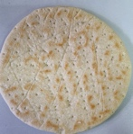 | FB-C | 60.63 ± 4.42ª | 0.60 ± 0.01^{d} | 2.34 ± 0.20^{b} | 18.27 ± 0.72^{bc} | 47.06 ± 0.35^{bc} | 7.54 ± 0.41^{b} | n.a.
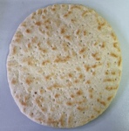 | FB-OB | 60.70 ± 3.20ª | 1.35 ± 0.06^{b} | 2.60 ± 0.10^{ab} | 20.68 ± 0.23^{ab} | 46.69 ± 0.44^{c} | 7.13 ± 0.25^{bc} | 0.44
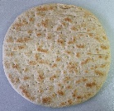 | FB-OB-US | 61.67 ± 5.80ª | 1.69 ± 0.04ª | 2.39 ± 0.26^{b} | 16.66 ± 0.73^{c} | 49.86 ± 2.15^{b} | 16.13 ± 0.79ª | 7.09
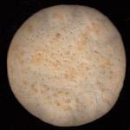 | FB-OB-SD | 63.31 ± 4.56ª | 1.22 ± 0.06^{b} | 2.75 ± 0.19ª | 19.31 ± 0.97^{b} | 53.54 ± 0.66ª | 3.10 ± 0.47^{c} | 7.88
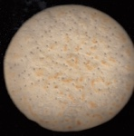 | FB-OB-US-SD | 65.36 ± 7.32ª | 1.65 ± 0.06ª | 2.62 ± 0.06^{ab} | 22.13 ± 1.34ª | 55.22 ± 1.42ª | 3.98 ± 0.84^{c} | 8.94
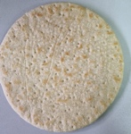 | FB-BB | 62.96 ± 7.41ª | 0.94 ± 0.03^{c} | 2.55 ± 0.10^{ab} | 20.98 ± 0.57^{ab} | 44.95 ± 0.1^{c} | 6.22 ± 0.12^{b} | 2.38
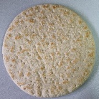 | FB-BB-US | 60.34 ± 6.12ª | 1.38 ± 0.03^{b} | 2.53 ± 0.08^{ab} | 16.73 ± 0.59^{c} | 46.43 ± 0.92^{c} | 14.47 ± 1.22ª | 9.41
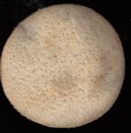 | FB-BB-SD | 63.02 ± 6.18ª | 0.77 ± 0.01^{c} | 2.87 ± 0.06ª | 20.74 ± 0.71^{ab} | 54.72 ± 0.14ª | 3.65 ± 0.03^{c} | 8.64
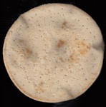 | FB-BB-US-SD | 60.87 ± 6.18ª | 1.27 ± 0.07^{b} | 2.85 ± 0.10ª | 20.18 ± 0.44^{ab} | 56.19 ± 1.72ª | 4.62 ± 1.22^{c} | 9.64
FB – flatbread; C – control wheat; BB – barley bran; OB – oat bran; SD – sourdough; US – ultrasound treated; TCD – total color difference
n.a – not applicable
a–b Values within the same column marked with different letters differ significantly according to Tukey’s test (p < 0.05)

