Appendix A
The KM curves for all variables
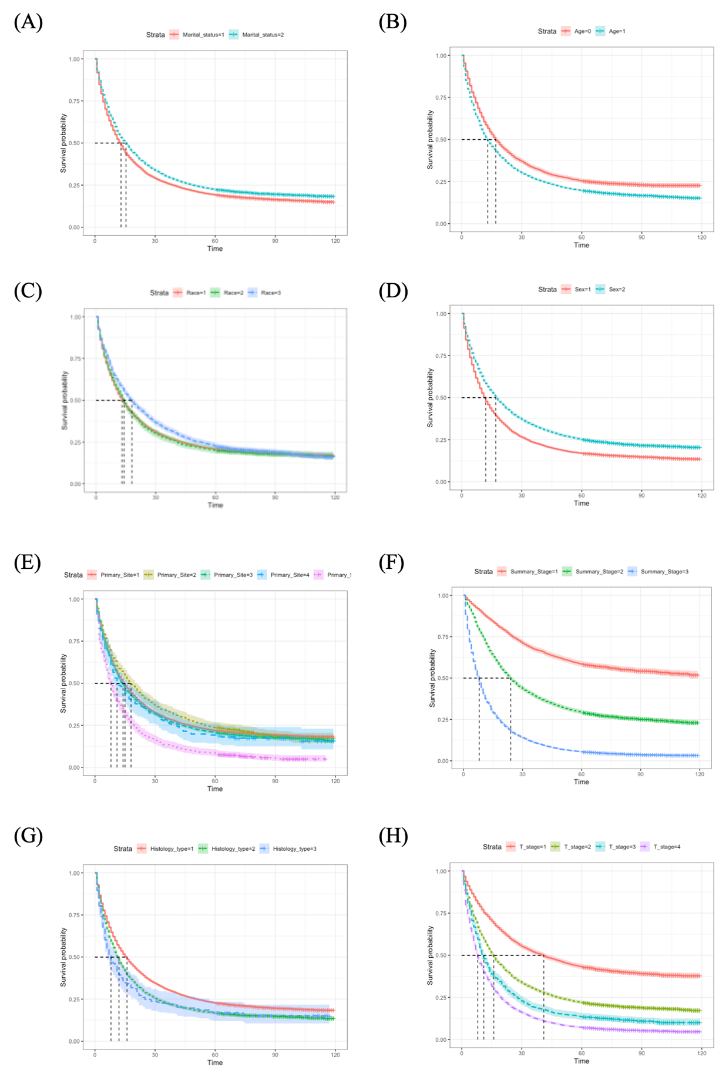
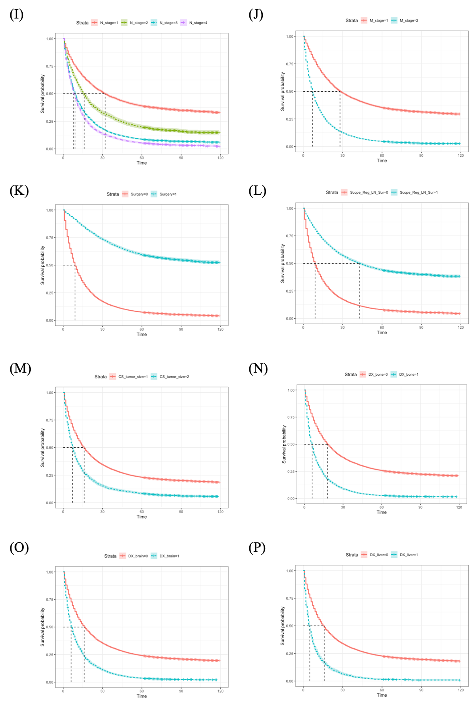
Figure A.1 The KM curves for all variables.
(A) Marital status. (B) Age. (C) race. (D) sex. (E) primary site. (F) summary stage. (G) histologic type. (H) T stage. (I) N stage. (J) M stage. (K) surgery. (L)lymph node examination. (M) tumor size. (N) bone metastasis. (O) brain metastasis. (P) liver metastasis.

Appendix B
The results before the crossing point
First, we tested the PH assumption using the time-dependent coefficient method, and more than half of the coefficients of the variables had P<0.001 (Table B.1), so the Cox model could no longer be used. Although the AFT model for both distributions was also poor (Figure B.1), the AFT model under LLD was still constructed in order to be comparable with the results after the crossing point. Similarly, we also showed the goodness-of-fit of the three models used to construct the prognostic analysis models for chemotherapy and radiotherapy through the AIC and residual plot (Table B.2 and Figure B.2), and it can be seen that it was the AFT model under LLD the best model after modeling both chemotherapy and radiotherapy. Then, targeting the IPW for chemotherapy and radiotherapy separately, it can be seen based on the results of intergroup SMD that after weighting for chemotherapy, the T stage remained unbalanced. After weighting for radiotherapy, there was still imbalance between the summary stage, T stage, and N stage (Figure B.3). Therefore, these covariates were included in the prognostic analysis model for chemotherapy and radiotherapy, respectively. Survival time for radiotherapy was longer than non-radiotherapy ($γ$=1.228, 95%CI: 1.183-1.272), survival time for chemotherapy was longer than non-chemotherapy ($γ$=3.364, 95%CI: 3.294-3.434) (Table B.3).
Table B.1 Results of the time-dependent coefficient test before the crossing point
Time dependent variable | P | Time dependent variable | P
Primary site*T | 0.005 | lymph node examination * T | 0.114
Summary stage* T | <0.001 | Radiotherapy * T | 0.001
Histological type * T | <0.001 | Chemotherapy * T | <0.001
T stage* T | <0.001 | Tumor size* T | <0.001
N stage * T | <0.001 | Bone metastasis * T | <0.001
M stage * T | 0.013 | Brain metastasis * T | <0.001
Surgery * T | <0.001 | Liver metastasis * T | <0.001
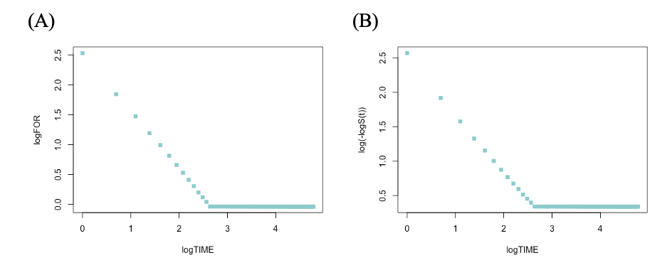
Figure B.1 Test the fitting requirement of the AFT model.
(A) $\log\left(t\right)\sim log⁡(FOR)$ curve for LLD. (B) $\log\left(t\right)\sim log\left[-logS(t)\right]$ curve for the AFT model under Weibull distribution

Table B.2 The AIC of prognostic analysis models before the crossing point
 | model for chemotherapy |  |  | model for radiotherapy
 | Cox model | AFT model under LLD | AFT model under Weibull distribution | Cox model | AFT model under LLD | AFT model under Weibull distribution
AIC | 379620.34 | 156301.73 | 160455.54 | 379405.94 | 156440.95 | 160468.08

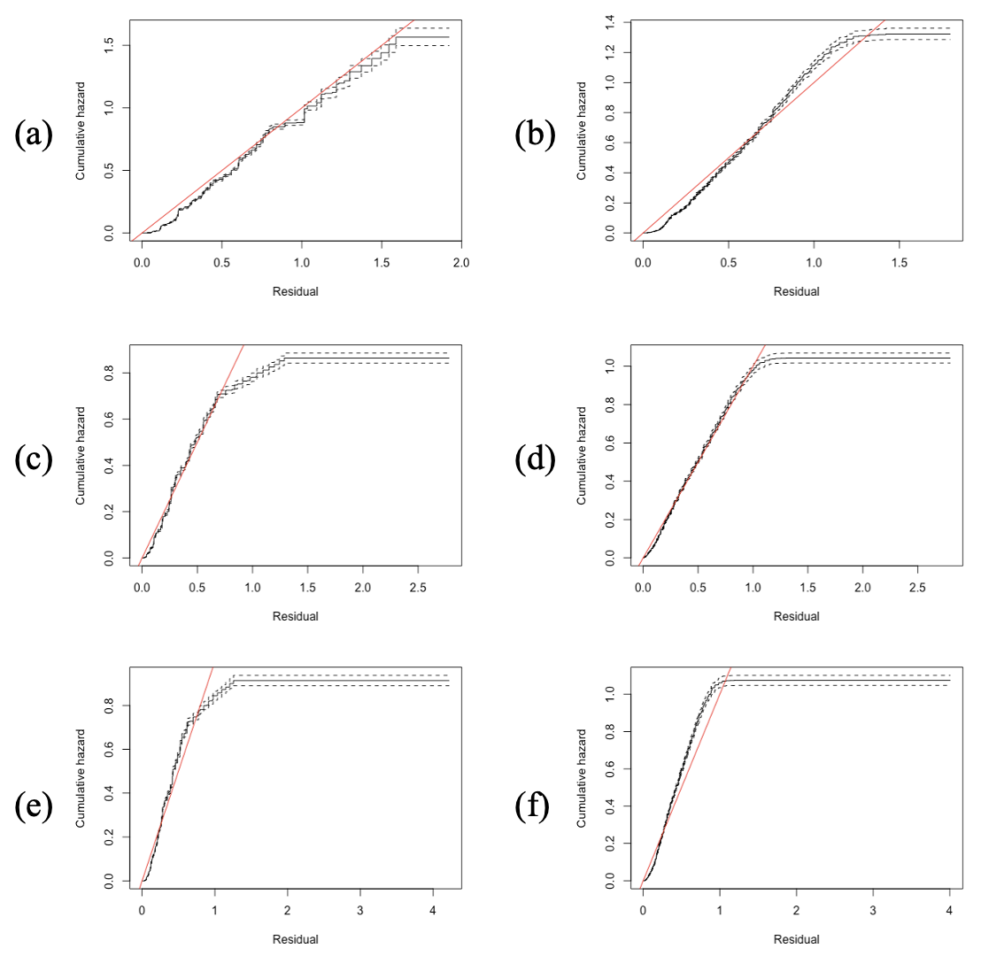
Figure B.2 The results of Cox-Snell Residuals of prognostic analysis models before the crossing point. (a) The Cox model without segmentation. (b) The Cox model with segmentation. (c) The AFT model under LLD without segmentation. (d) The AFT model under LLD with segmentation. (e) The AFT model under Weibull distribution without segmentation. (f) The AFT model under Weibull distribution with segmentation.

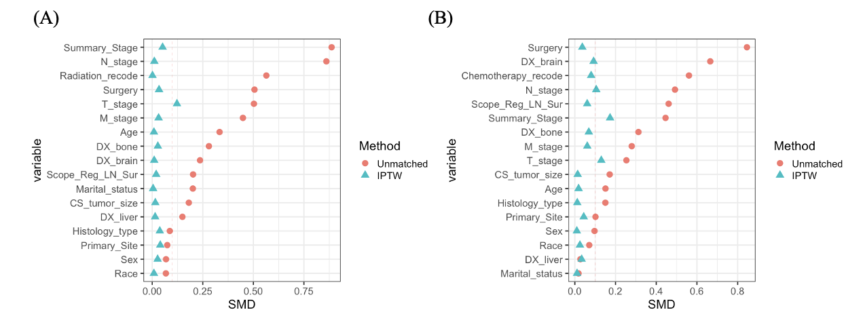
Figure B.3 The results of inter-group SMD before the crossing point.
(A) IPW for Chemotherapy. (B) IPW for Radiotherapy.

Table B.3 Results of the AFT model under LDD before the crossing point
Variable | $$γ$$ | 95%CI lower bound | 95%CI upper bound | P
Radiotherapy (No for reference)
Yes | 1.228 | 1.183 | 1.272 | <0.05
Chemotherapy (No for reference)
Yes | 3.364 | 3.294 | 3.434 | <0.05

Appendix C
The results of inter-group SMD
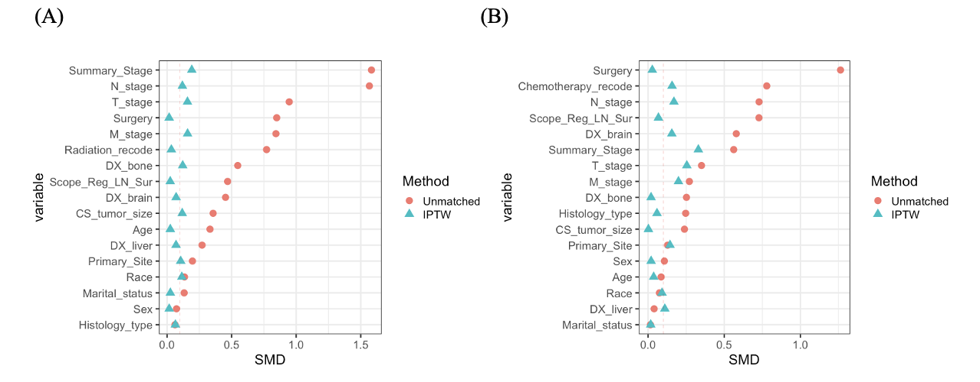
Figure C.1 The results of inter-group SMD after the crossing point.
(A) IPW for Chemotherapy. (B) IPW for Radiotherapy.
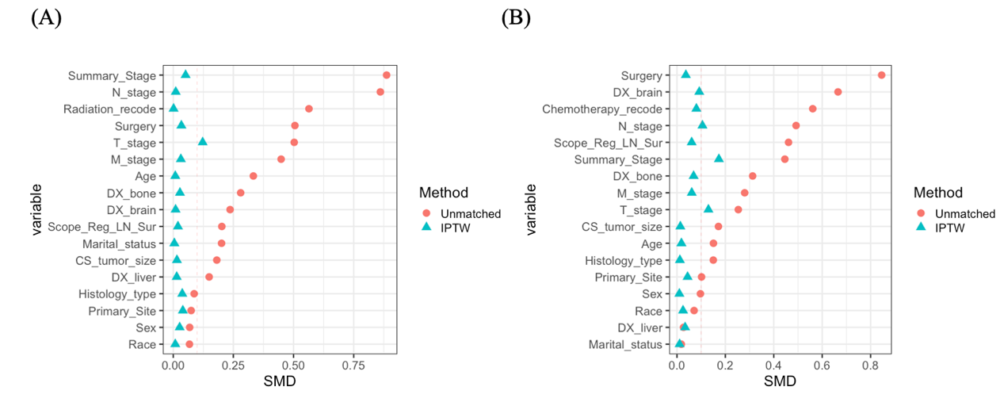
Figure C.2 The results of inter-group SMD in the non-segmentation analysis.
(A) IPW for Chemotherapy. (B) IPW for Radiotherapy.

