Supplementary data

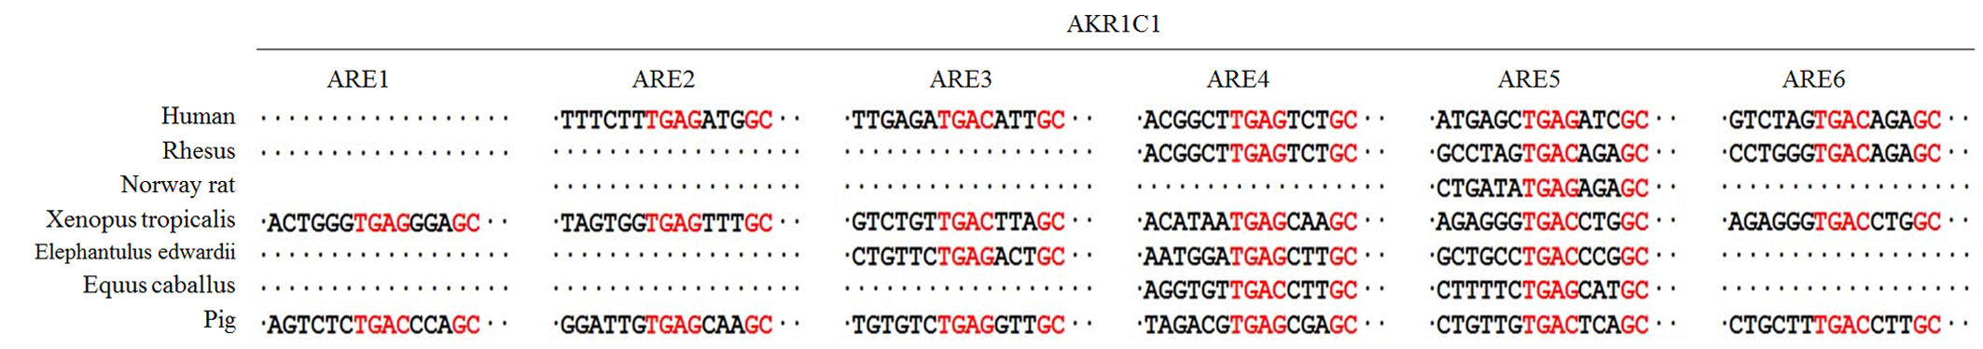
Supplementary figure 1. Sequence analysis of AKR1C1 AREs.

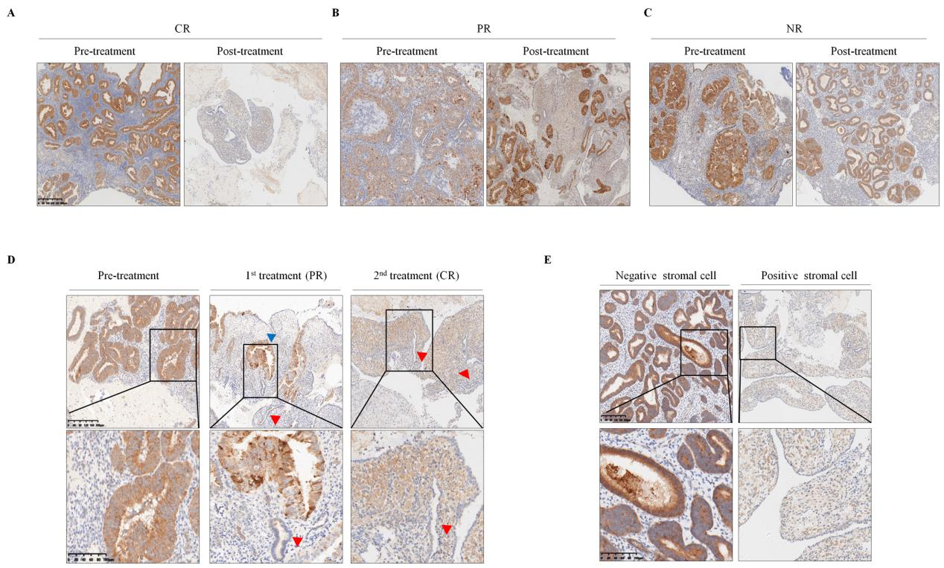
Supplementary figure 2. Aberrant expression of AKR1C1 in endometrial tissues before and after progestin treatment. An IHC assay was used to determine AKR1C1 expression in the patients with different responses to progestin as follows: CR, complete response (A); PR, partial response (B); NR, no response (C). Original magnification in the upper panel: 40×. D, Representative samples from patients who underwent two progestin treatments cycles and the corresponding PR and CR results. Original magnification in the upper panel: 100×, lower panel: 200×. E, Inverse expression patterns of AKR1C1 in stromal cells and glands. Red triangle, atrophic gland after progestin treatment with a good response; Blue triangle, hyperplasia gland after progestin treatment with poor response; Purple triangle, normal gland.

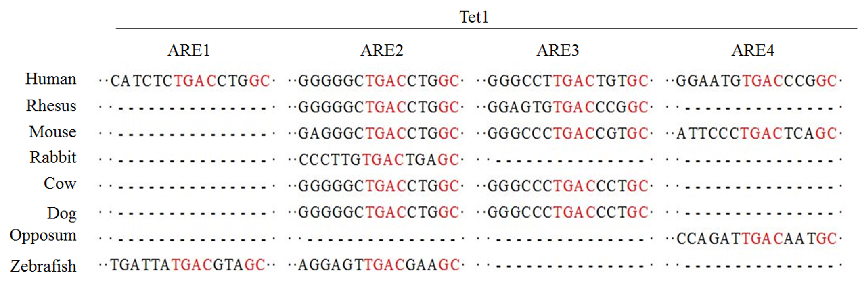
Supplementary figure 3. Sequence analysis of Tet1 AREs.

