Supplementary Materials
Effects of Photo-biomodulation on Gut Microbiota: A Meta-analysis Based on 16S rRNA Sequencing Data
Letian Chen^{1, 2, 3#}, Shijing Wang^{1, 2, 3#}, Yueying Lu^{1, 2, 3}, Jingjing Cui^{1, 2, 3}, Yuming Fu^{1, 2, 3} *, Hong Liu ^{1, 2, 3}
¹Key Laboratory for Biomechanics and Mechanobiology of the Ministry of Education, Beijing Advanced Innovation Centre for Biomedical Engineering,
²International Joint Research Center of Aerospace Biotechnology & Medical Engineering, Beihang University, Beijing 100191, China
³State Key Laboratory of Virtual Reality Technology and Systems, School of Computer Science and Engineering, Beihang University, Beijing, 100083, China

E-mail: Letian Chen: lt_chen@buaa.edu.cn; Yuming Fu: fuyuming@buaa.edu.cn

#These authors contributed equally to this work.
*Corresponding author：
Yuming Fu Tel: +86 18310088840; E-mail: fuyuming@buaa.edu.cn

Supplementary Figure 1 Comparison of alpha (Chao1 and Shannon) diversity among: A, B species; C, D Authors; and E, F physique as described in studies.

Supplementary Figure 2 Principal Coordinate Analysis (PCoA) of weighted UniFrac distances on A wave bands, B authors, C species and D physique.

Supplementary Figure 3 Effect of authors and species as random effects on alpha diversity: A, B Chao1 richness; C, D Shannon’s diversity.

Supplementary Figure 4 Effect of authors and species as random effects on the relative abundance of A, B Saccharibacteria and C, D Verrucomicrobia.

Supplementary Figure 5 Cross-validation error curve.
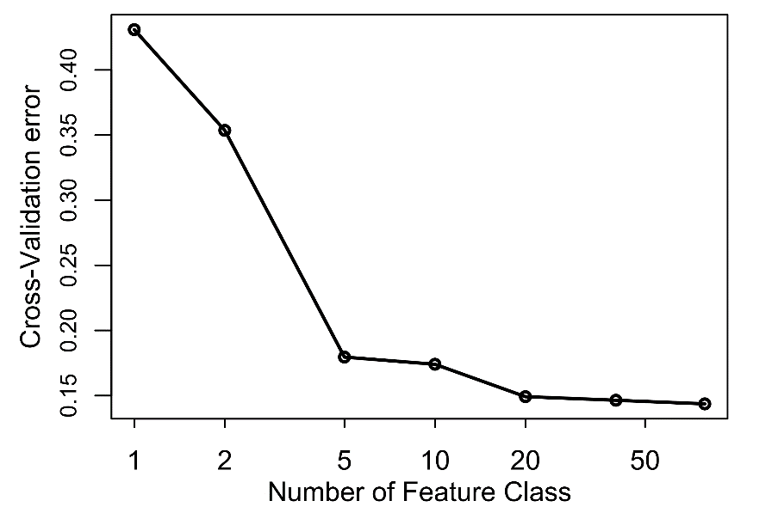

Supplementary Figure 6 Comparison of the effects on Akkermensia of wave bands, according to GLMM, with the control group as the baseline (*P < 0.05, **P < 0.01, ***P < 0.001).
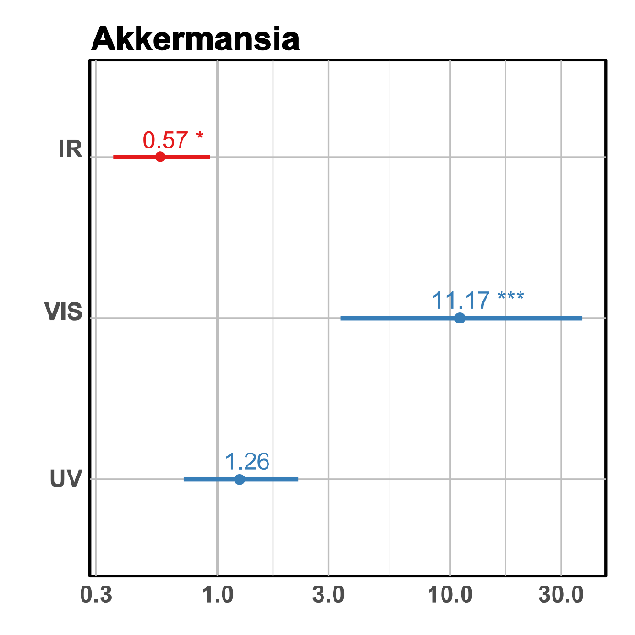

Study | Target Region | Study Design |  |  | Biological Samples |  | Sample (n=) | Accessions
Study | Target Region | Wave  Band | Wave Length(nm) | Disease | Specie | Type | Sample (n=) | Accessions
Chen et al.[1]  (2021) | V4 | VIS | 400-760 | OVX,  Food allergy | Mouse | BALB/c | 9 | PRJNA690991
Chen et al.[2] (2021) | V3-V4 | VIS/IR | 630, 730, 830 | Alzheimer's disease | Mouse | C57BL/6 | 25 | PRJNA514213
Ding et al.[3] (2021) | V3-V4 | VIS | 425-475 | jaundice | Human | Infants | 246 | PRJNA665920  PRJNA680178
Khan et al.[4] (2020) | V3-V4 | IR | 4000-20000 | None | Mouse | C57BL/6 | 21 | None
Lu et al.[5]  (2021) | V3-V4 | IR | 830 | OVX | Rat | SD | 24 | PRJNA634023
Bicknell et al.[6] (2022) | V3-V4 | IR | 904 | Parkinson's disease | Human | Elder | 12 | PRJNA790457
Bosman et al.[7] (2019) | V6-V8 | UV | 311 | Vitamin-D deficiency | Human | Youth | 81 | PRJNA539987
Cui et al.[8] (2021) | V3-V4 | UV | 280-320 | OVX | Rat | SD | 24 | PRJNA671564

Supplementary Table 1 Summary of studies and datasets collected.

References
1. Chen P, Nakano T, Lai C-Y, et al (2021) Daily full spectrum light exposure prevents food allergy-like allergic diarrhea by modulating vitamin D3 and microbiota composition. npj Biofilms Microbiomes 7:1–13. https://doi.org/10.1038/s41522-021-00213-8
2. Chen Q, Wu J, Dong X, et al (2021) Gut flora-targeted photobiomodulation therapy improves senile dementia in an Aß-induced Alzheimer’s disease animal model. Journal of Photochemistry and Photobiology B: Biology 216:112152. https://doi.org/10.1016/j.jphotobiol.2021.112152
3. Ding J, Ma X, Han L, et al (2021) Gut microbial alterations in neonatal jaundice pre- and post-treatment. Biosci Rep 41:. https://doi.org/10.1042/BSR20210362
4. Khan I, Pathan S, Li XA, et al (2020) Far infrared radiation induces changes in gut microbiota and activates GPCRs in mice. Journal of Advanced Research 22:145–152. https://doi.org/10.1016/j.jare.2019.12.003
5. Lu Y, Yang J, Dong C, et al (2021) Gut microbiome-mediated changes in bone metabolism upon infrared light exposure in rats. Journal of Photochemistry and Photobiology B: Biology 217:112156. https://doi.org/10.1016/j.jphotobiol.2021.112156
6. Bicknell B, Liebert A, McLachlan CS, Kiat H (2022) Microbiome Changes in Humans with Parkinson’s Disease after Photobiomodulation Therapy: A Retrospective Study. Journal of Personalized Medicine 12:49. https://doi.org/10.3390/jpm12010049
7. Bosman ES, Albert AY, Lui H, et al (2019) Skin Exposure to Narrow Band Ultraviolet (UVB) Light Modulates the Human Intestinal Microbiome. Front Microbiol 10:2410. https://doi.org/10.3389/fmicb.2019.02410
8. Cui J, Fu Y, Yi Z, et al (2021) The beneficial effects of ultraviolet light supplementation on bone density are associated with the intestinal flora in rats. Appl Microbiol Biotechnol 105:3705–3715. https://doi.org/10.1007/s00253-021-11282-2

