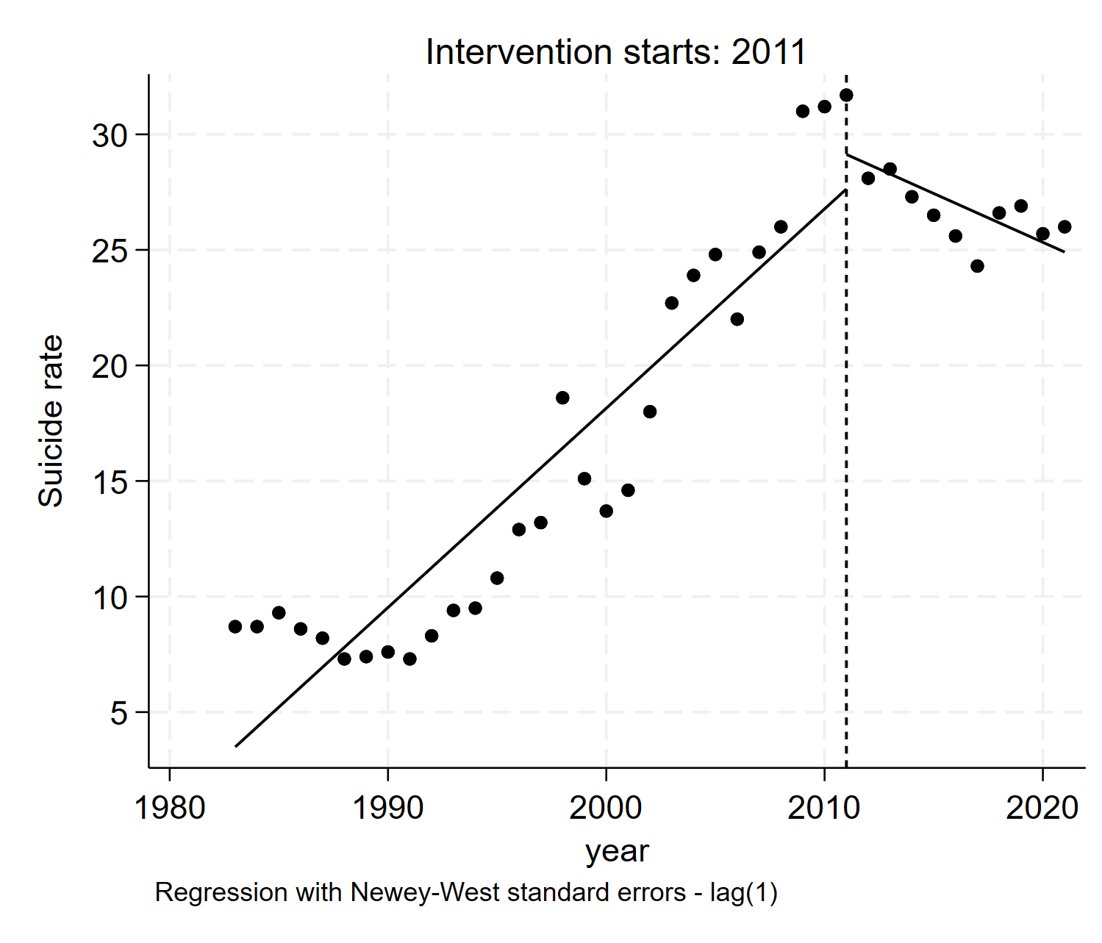 | 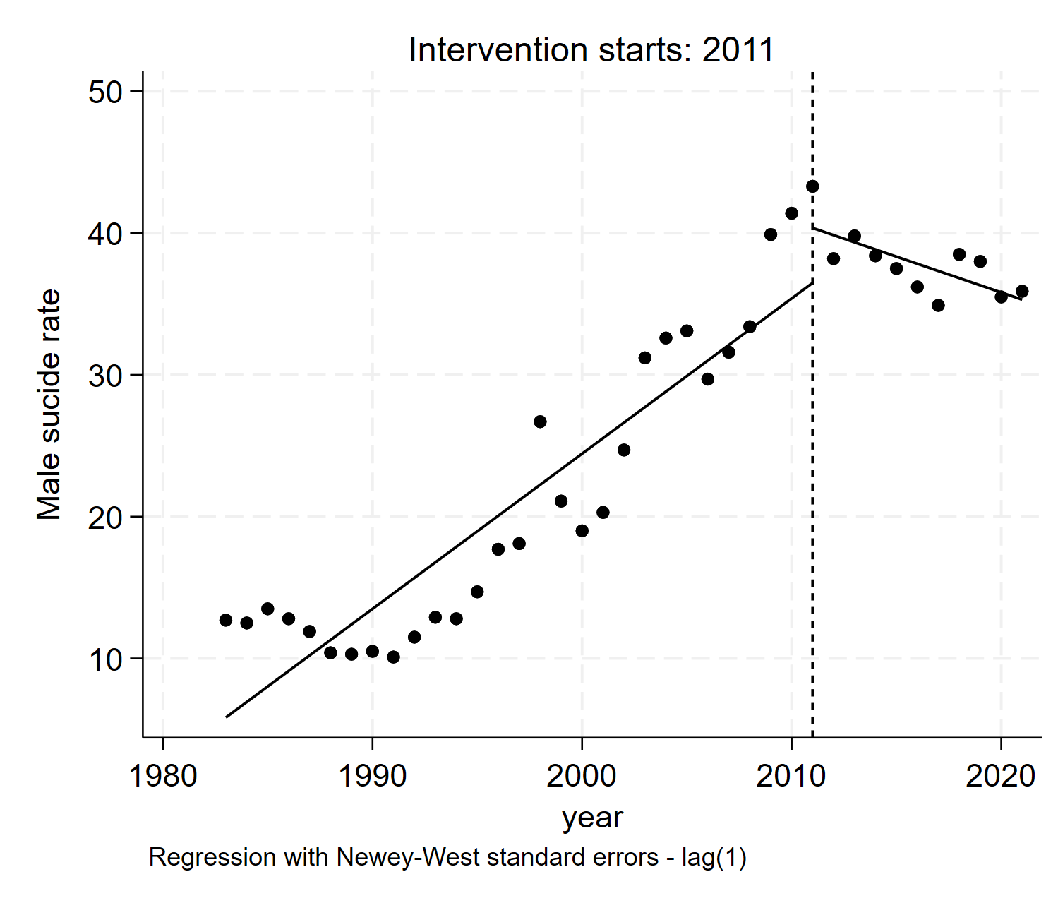 | 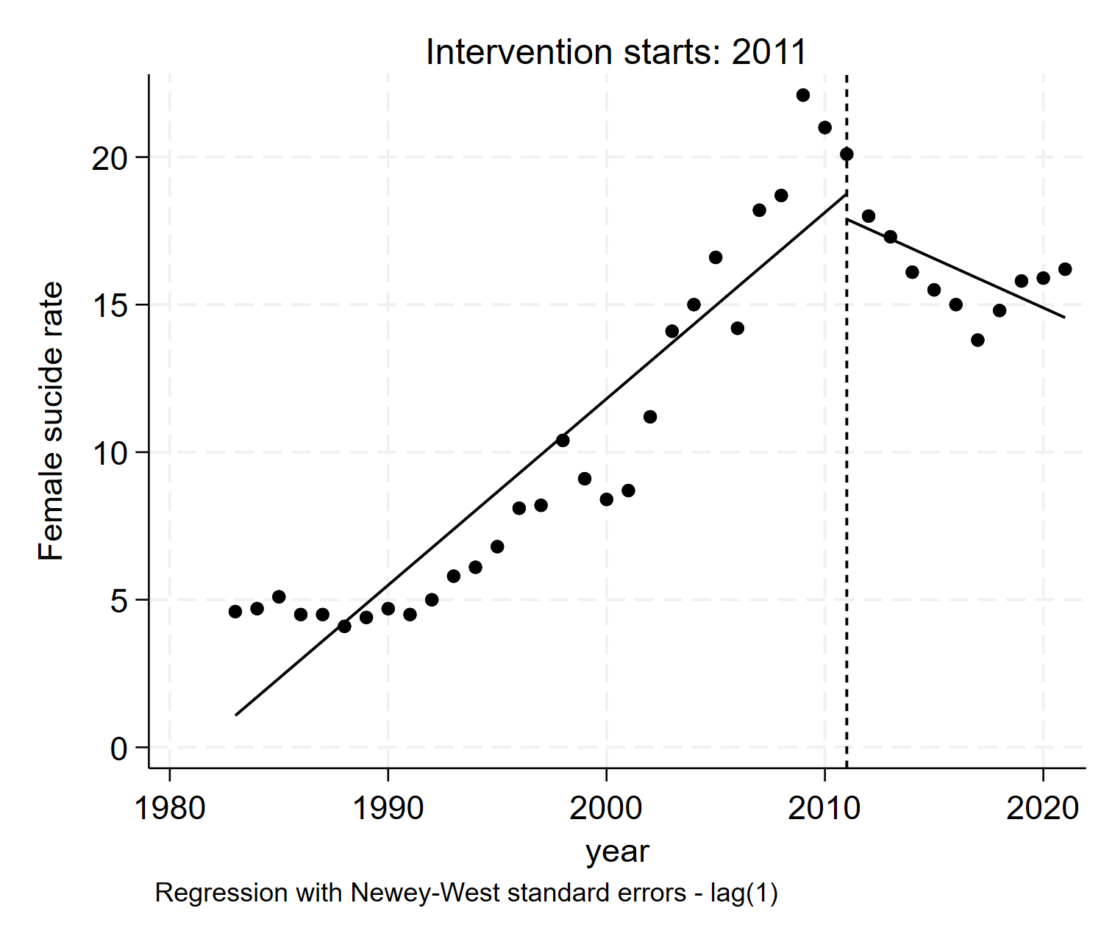
Suicide rate (overall) | Suicide rate (male) | Suicide rate (female)

Figure S1. Changes in suicide rate (per 100,000 population) regarding the Suicide Prevention Act (1983-2021 by Gender)

Table S1. Changes in suicide rate (per 100,000 population) before and after the implementation of the Suicide Prevention Act by age
Suicide rates | Coefficient |  | SE | t-statistics | P value
10-19 years old | β₀ | 3.811 | 0.220 | 17.31 | 0.000
10-19 years old | β₁ | 0.397 | 0.018 | 2.16 | 0.037
10-19 years old | β₂ | -0.444 | 0.635 | -0.70 | 0.479
10-19 years old | β₃ | 0.139 | 0.825 | 1.69 | 0.100
20-29 years old | β₀ | 9.868 | 0.412 | -0.64 | 0.525
20-29 years old | β₁ | 0.337 | 0.128 | 2.63 | 0.013
20-29 years old | β₂ | -0.505 | 2.862 | -0.18 | 0.861
20-29 years old | β₃ | -0.264 | 0.412 | -0.64 | 0.525
30-39 years old | β₀ | 7.241 | 1.363 | 5.31 | 0.000
30-39 years old | β₁ | 0.661 | 0.103 | 6.43 | 0.000
30-39 years old | β₂ | 2.284 | 1.896 | 1.21 | 0.236
30-39 years old | β₃ | -0.868 | 0.190 | -4.57 | 0.000
40-49 years old | β₀ | 7.848 | 2.043 | 3.84 | 0.000
40-49 years old | β₁ | 0.836 | 0.114 | 0.000 | 0.000
40-49 years old | β₂ | 1.429 | 1.586 | 0.90 | 0.374
40-49 years old | β₃ | -1.243 | 0.152 | -8.17 | 0.000
50-59 years old | β₀ | 6.800 | 2.531 | 2.69 | 0.011
50-59 years old | β₁ | 1.139 | 0.144 | 7.91 | 0.000
50-59 years old | β₂ | -0.041 | 2.068 | -0.02 | 0.984
50-59 years old | β₃ | -2.035 | 0.195 | -10.42 | 0.000
60-69 years old | β₀ | 5.040 | 3.576 | 1.41 | 0.168
60-69 years old | β₁ | 1.719 | 0.208 | 8.23 | 0.000
60-69 years old | β₂ | -8.190 | 3.562 | -2.30 | 0.028
60-69 years old | β₃ | -3.488 | 0.350 | -9.97 | 0.000
70-79 years old | β₀ | 0.231 | 4.972 | 0.05 | 0.963
70-79 years old | β₁ | 2.995 | 0.298 | 10.04 | 0.000
70-79 years old | β₂ | -7.294 | 5.603 | -1.30 | 0.201
70-79 years old | β₃ | -7.026 | 0.559 | -12.56 | 0.000
Over 80 years old | β₀ | 18.077 | 4.541 | 3.98 | 0.001
Over 80 years old | β₁ | 7.226 | 0.606 | 11.93 | 0.000
Over 80 years old | β₂ | -42.058 | 11.188 | -3.76 | 0.001
Over 80 years old | β₃ | -12.306 | 0.762 | -14.11 | 0.000

β₀ intercept; β₁ baseline trend before Suicide Prevention Act are introduced; β₂ intercept change after Suicide Prevention Act are introduced; β₃ trend change after Suicide Prevention Act are introduced.

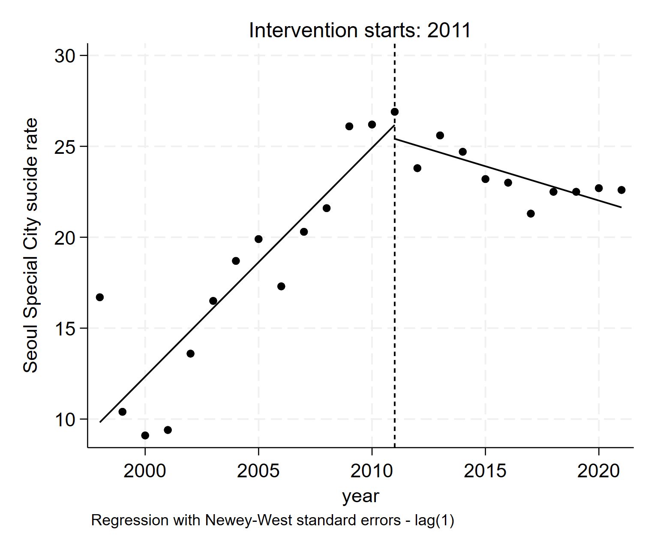 | 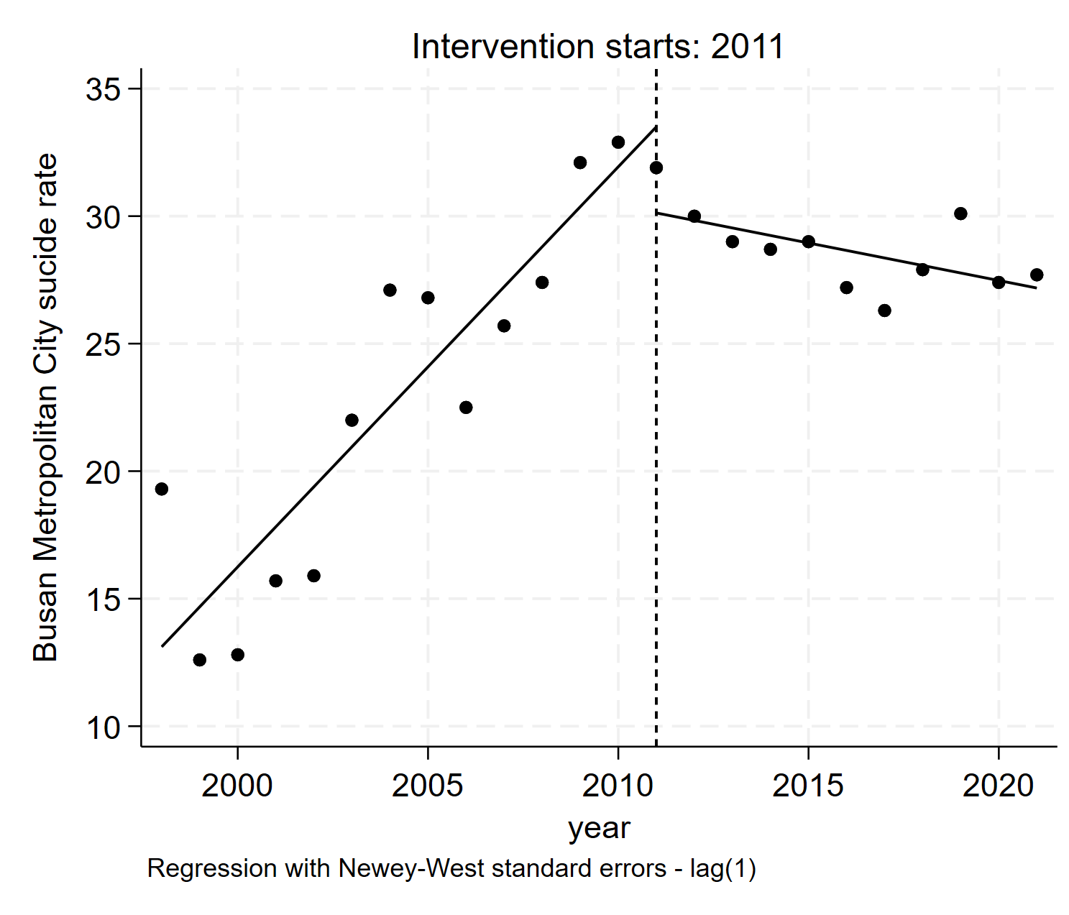 | 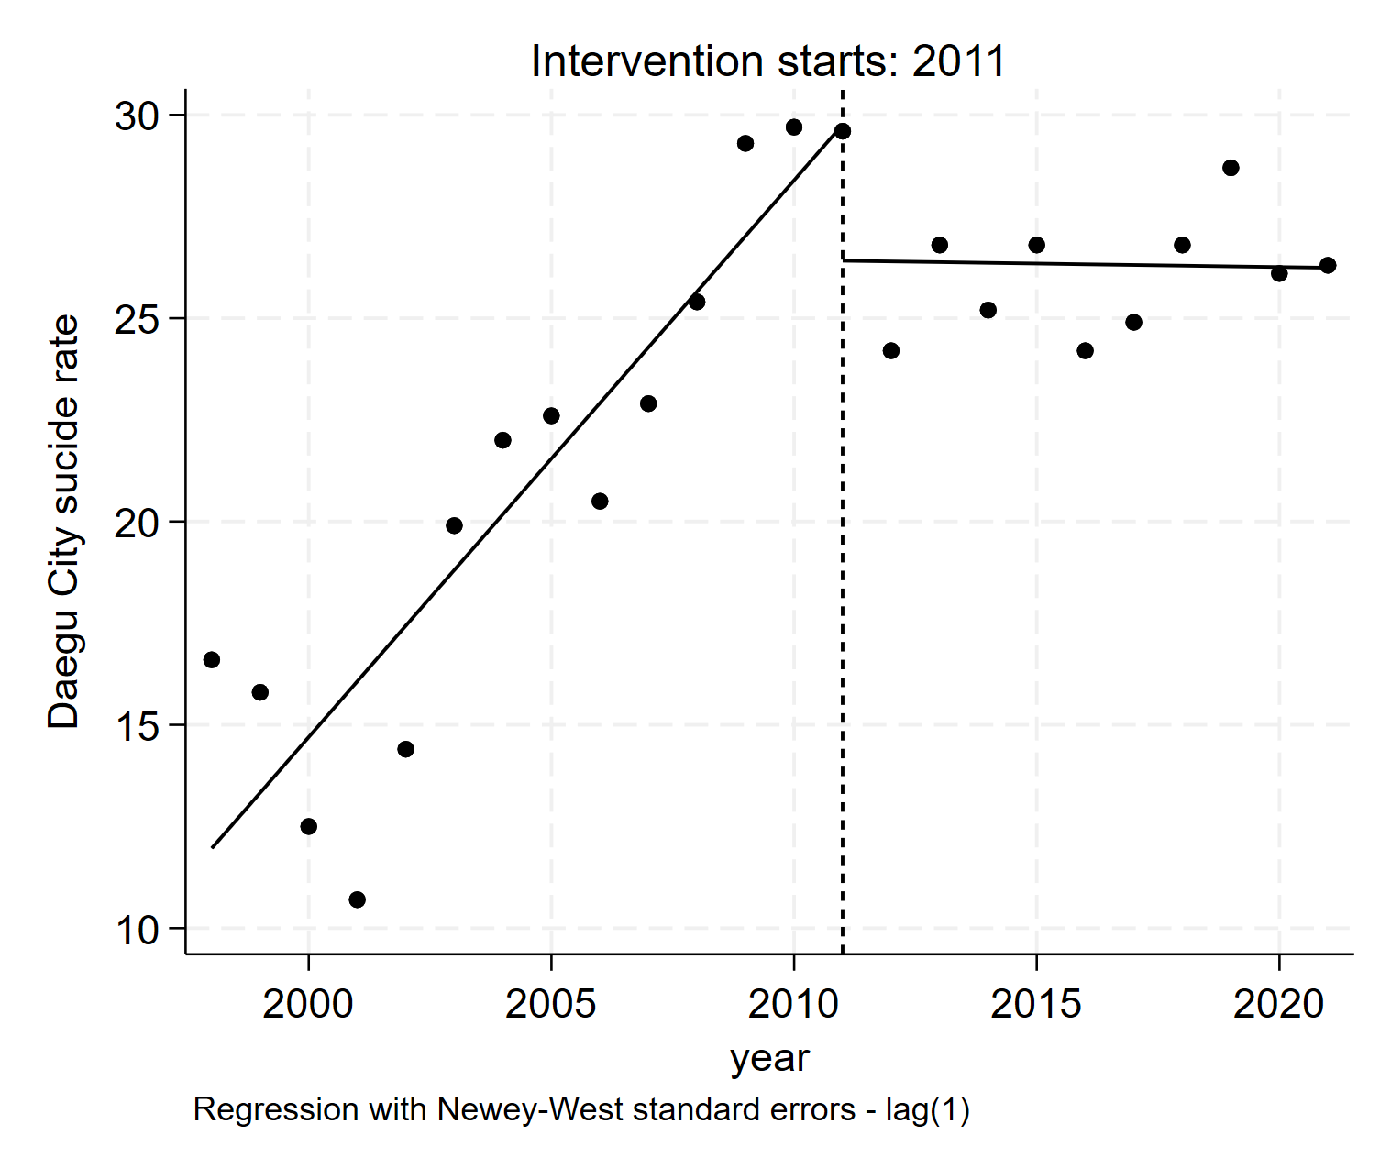
Seoul Special City | Busan Metropolitan City | Daegu City
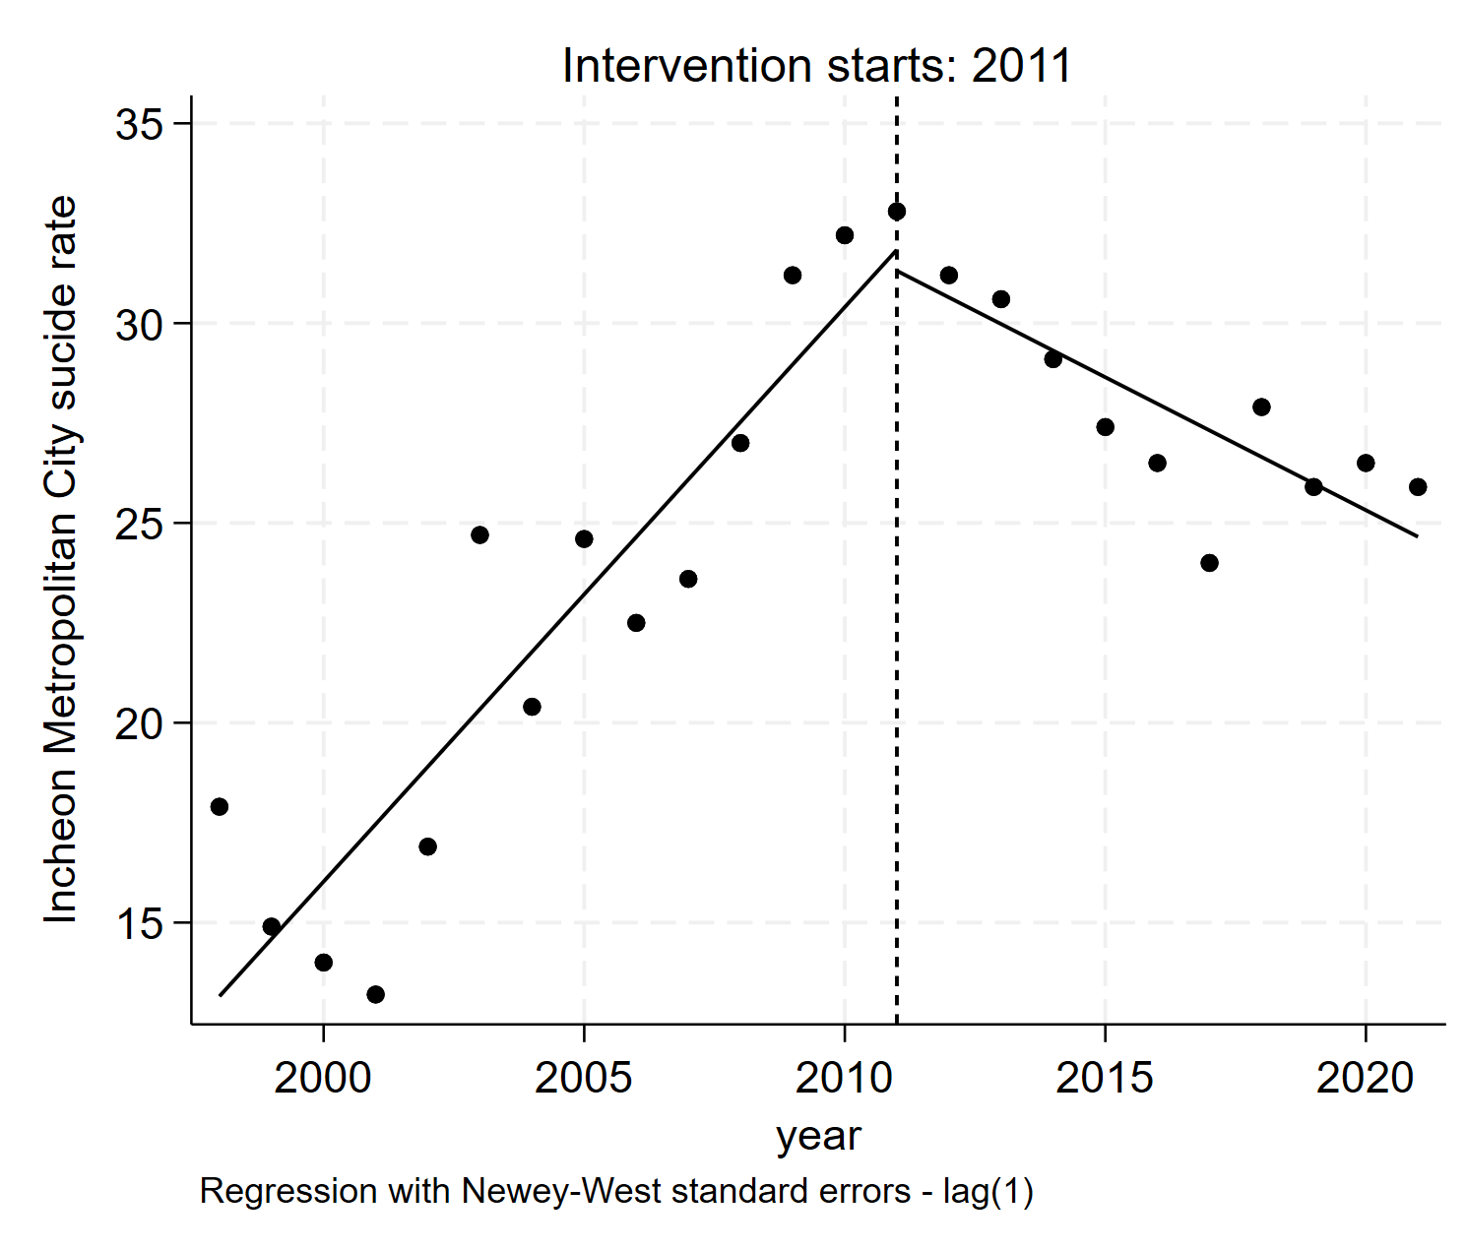 | 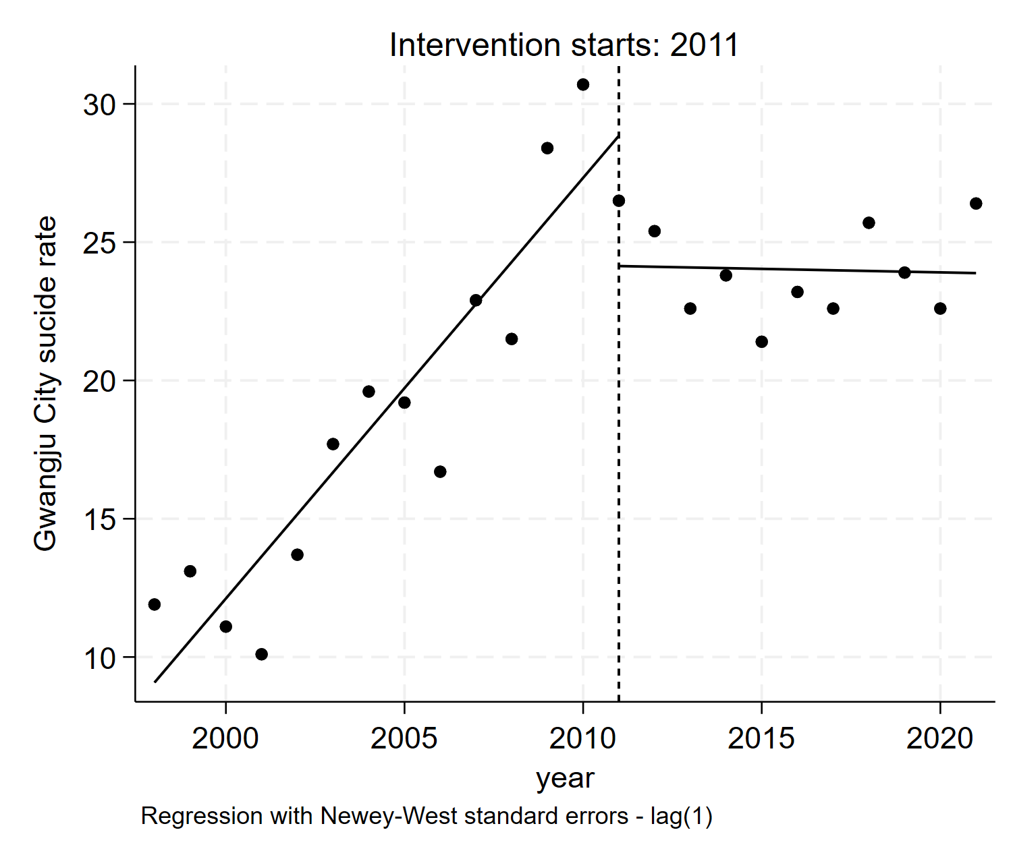 | 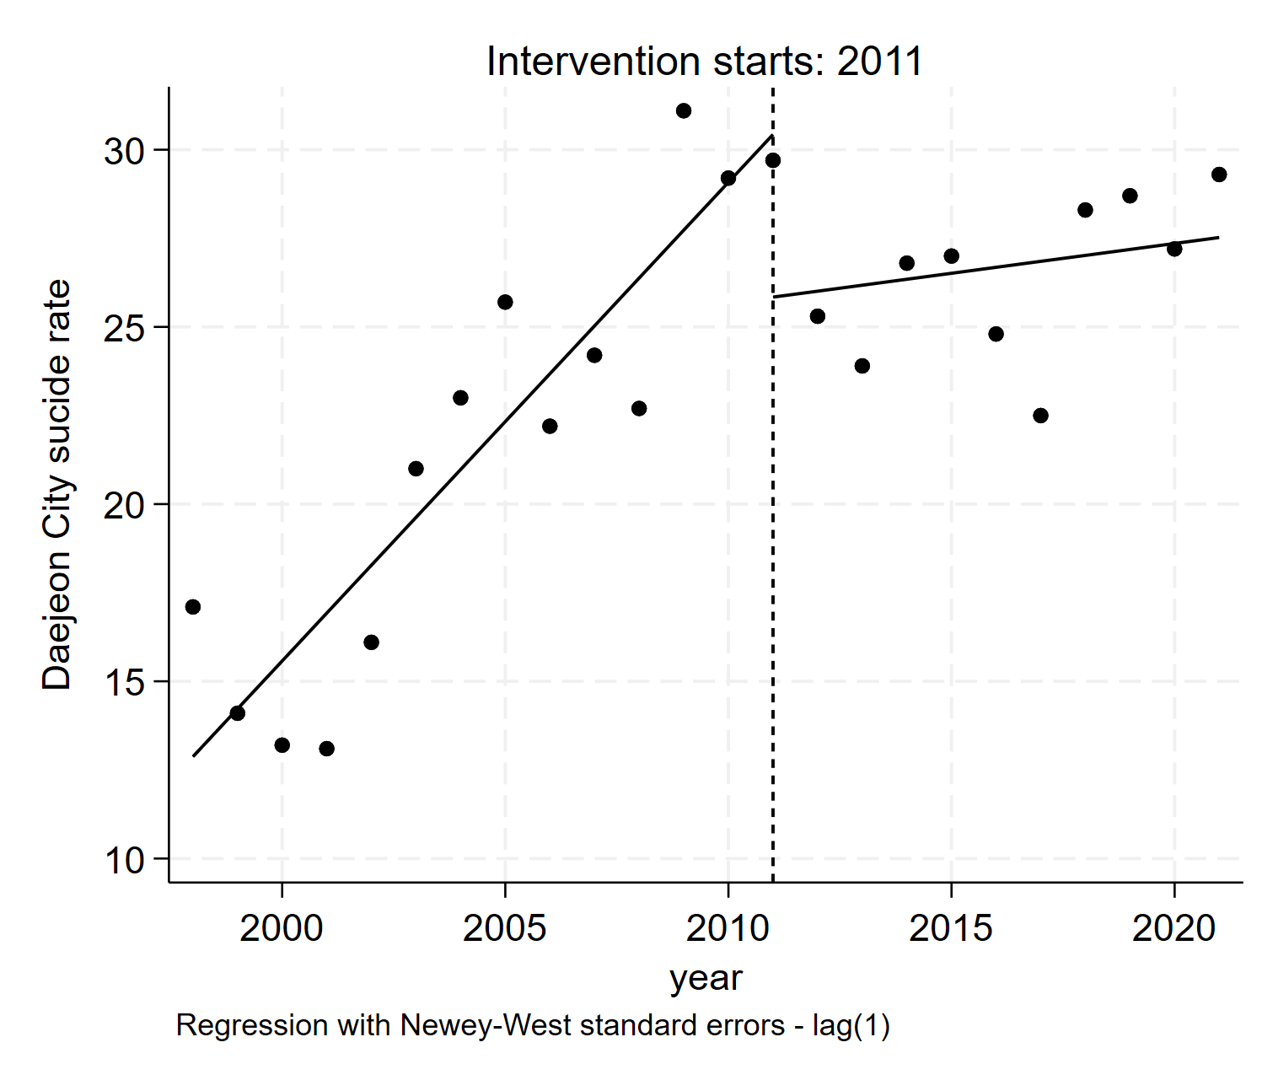
Incheon Metropolitan City | Gwangju City | Daejeon City
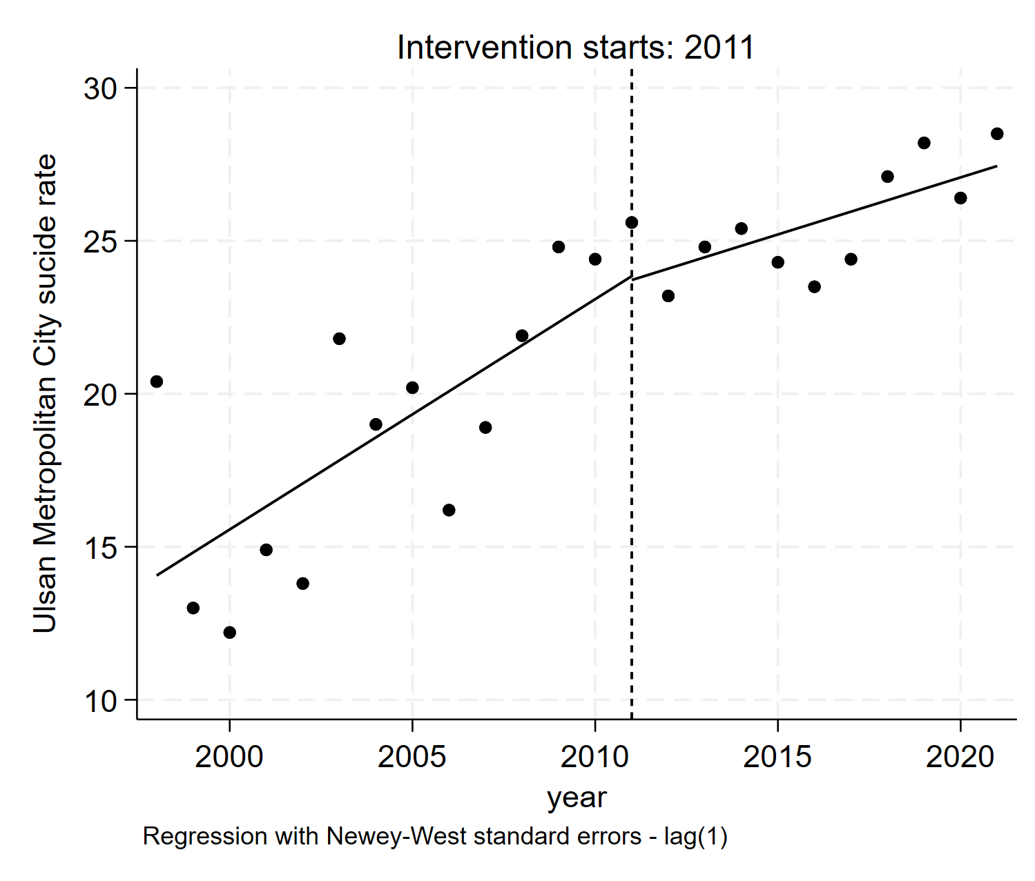 | 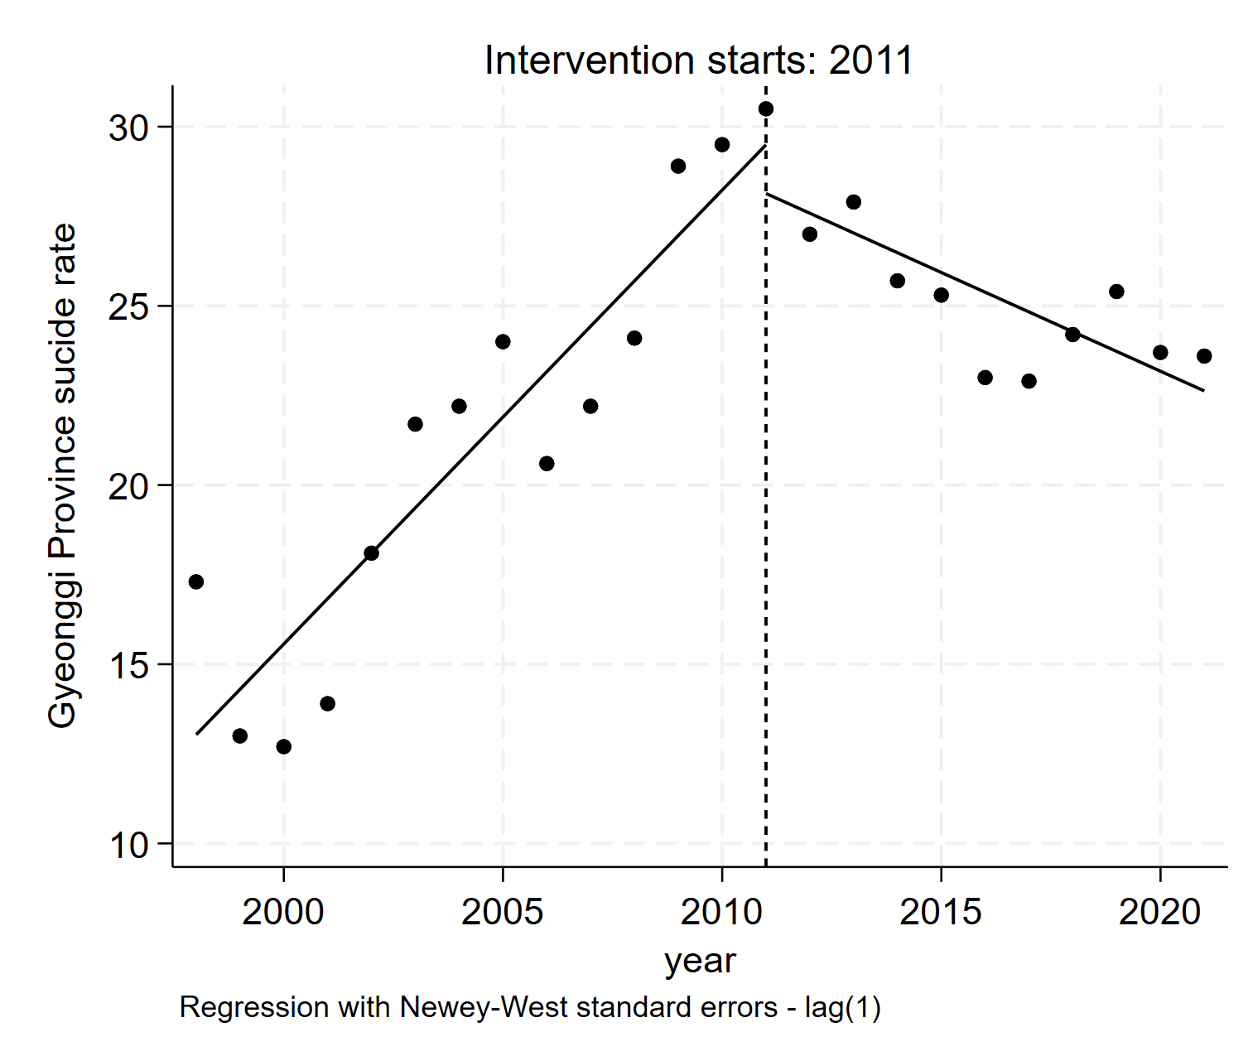 | 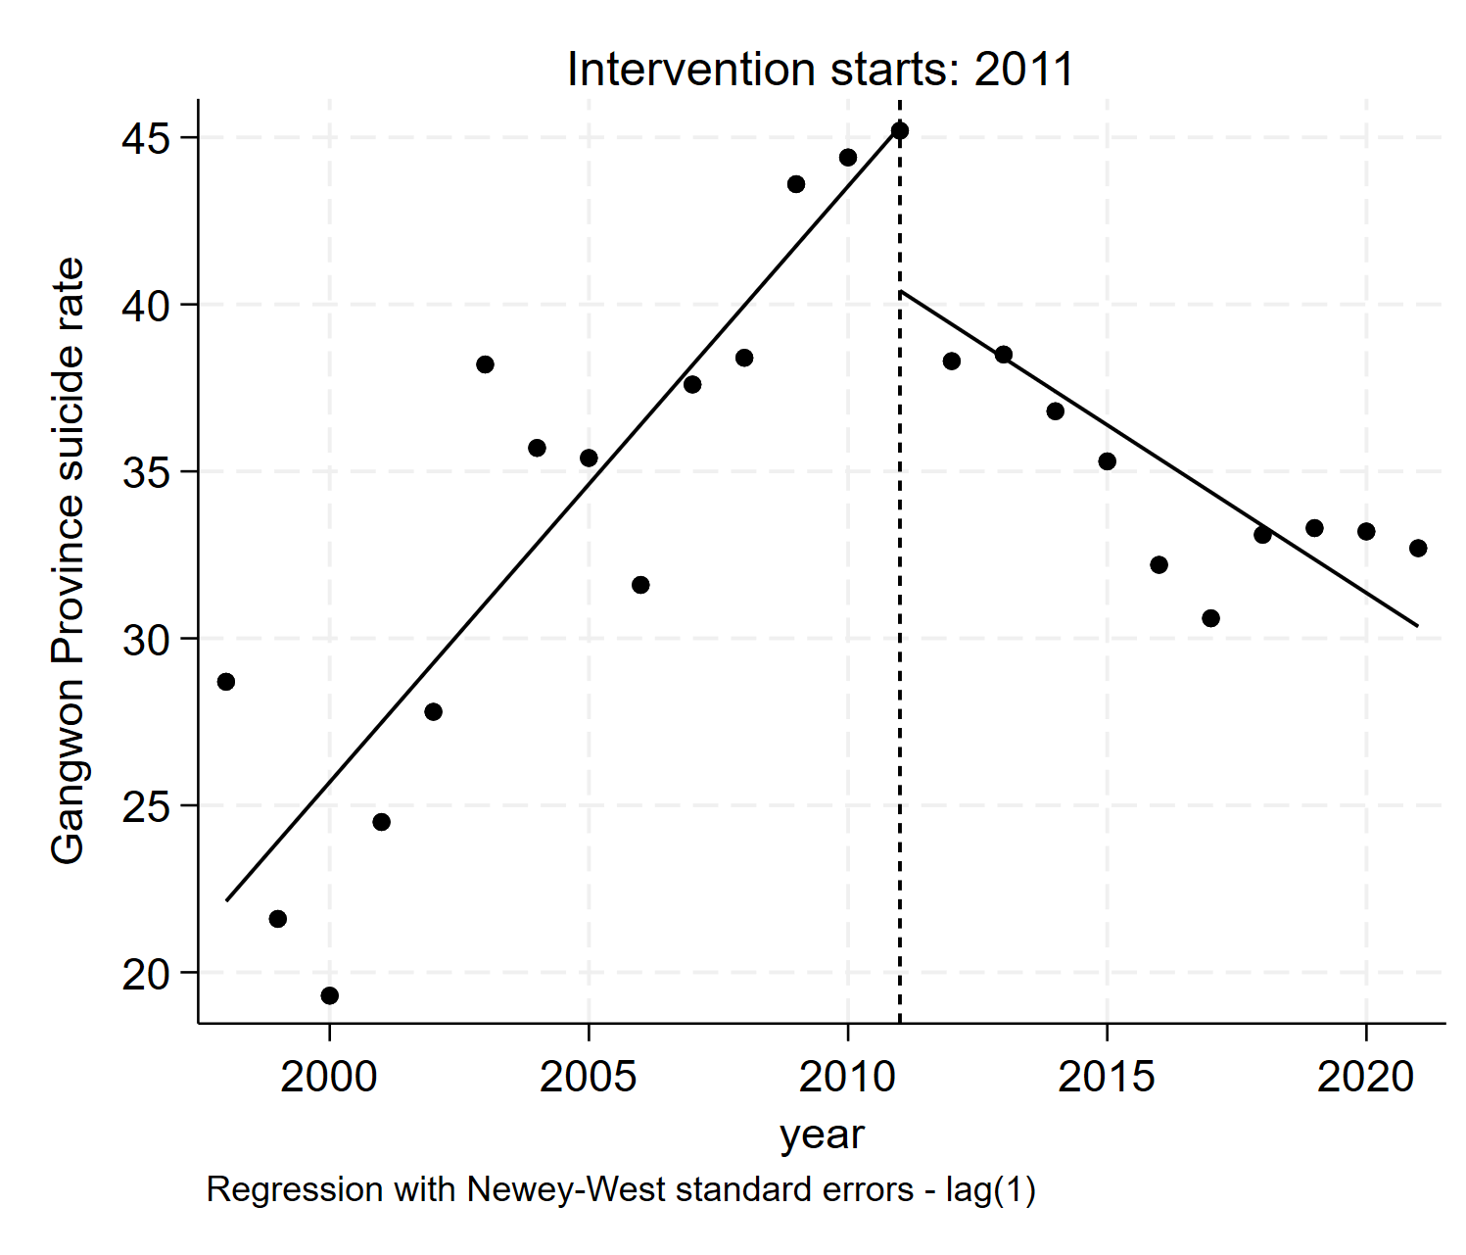
Ulsan Metropolitan City | Gyeonggi Province | Gangwon Province
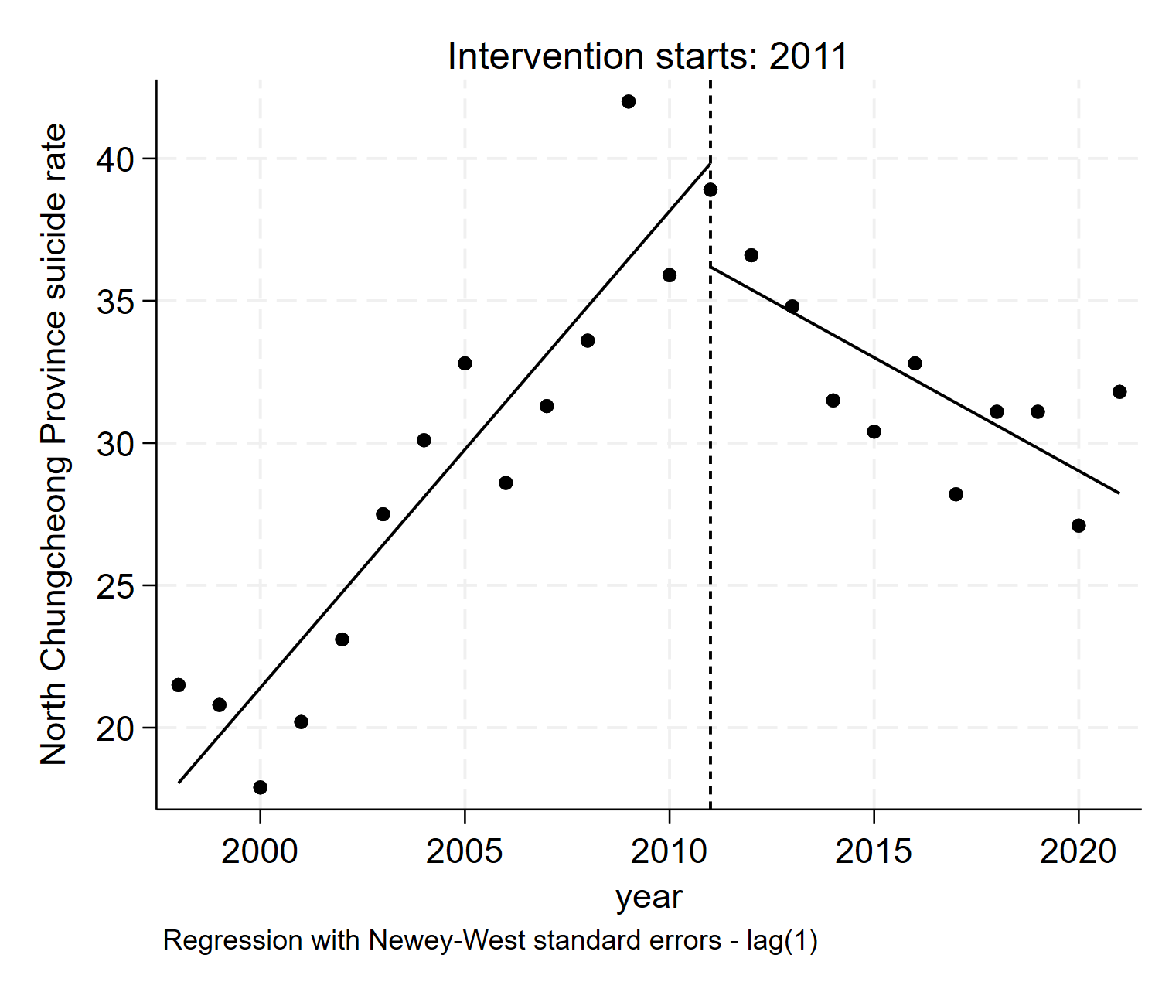 | 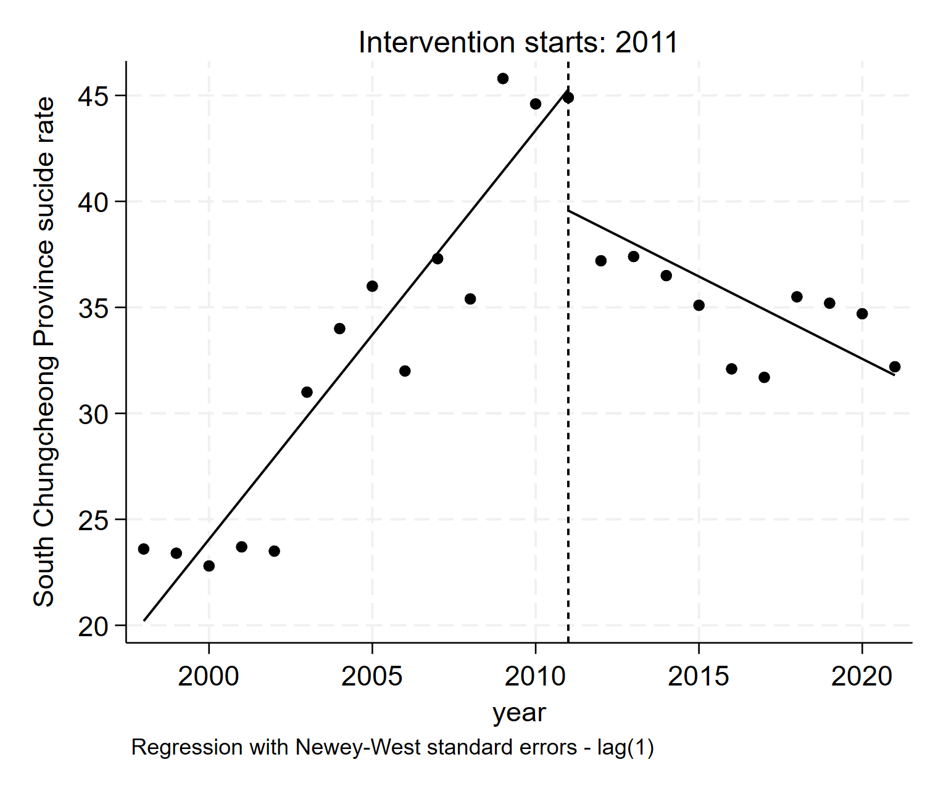 | 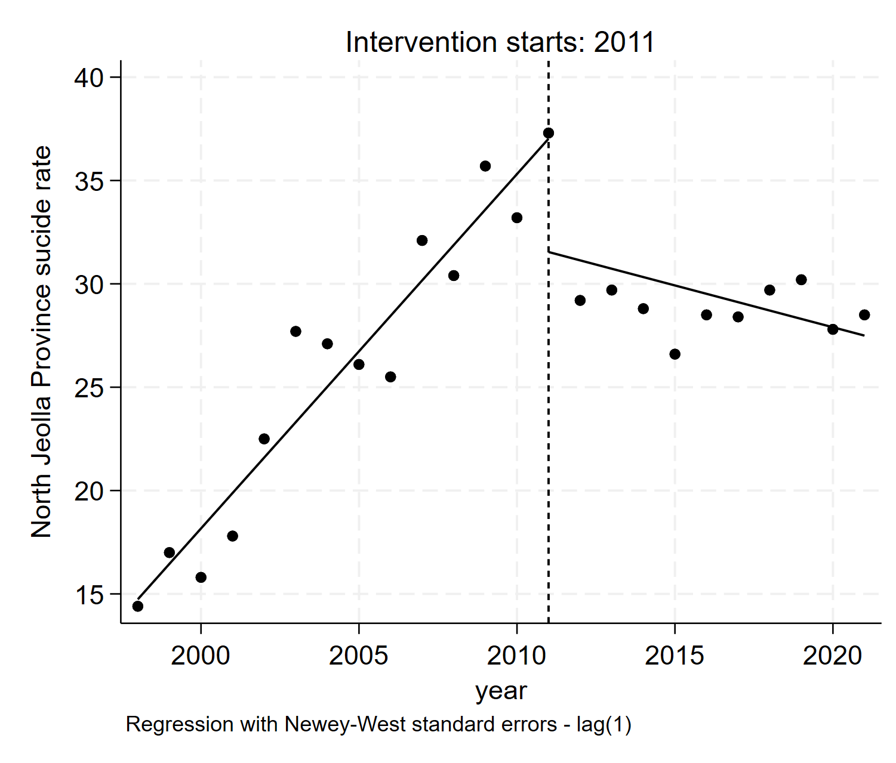
North Chungcheong Province  (Chungcheongbuk-do) | South Chungcheong Province  (Chungcheongnam-do) | North Jeolla Province (Jeollabuk-do)
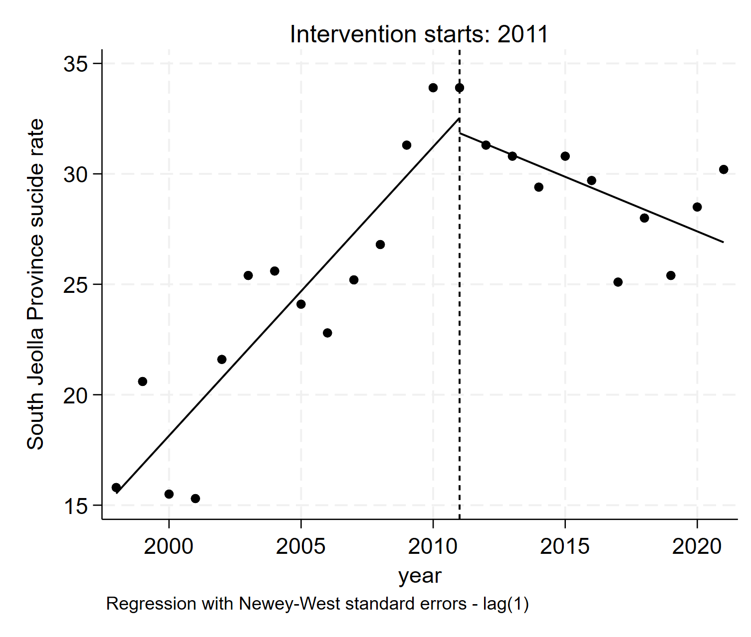 | 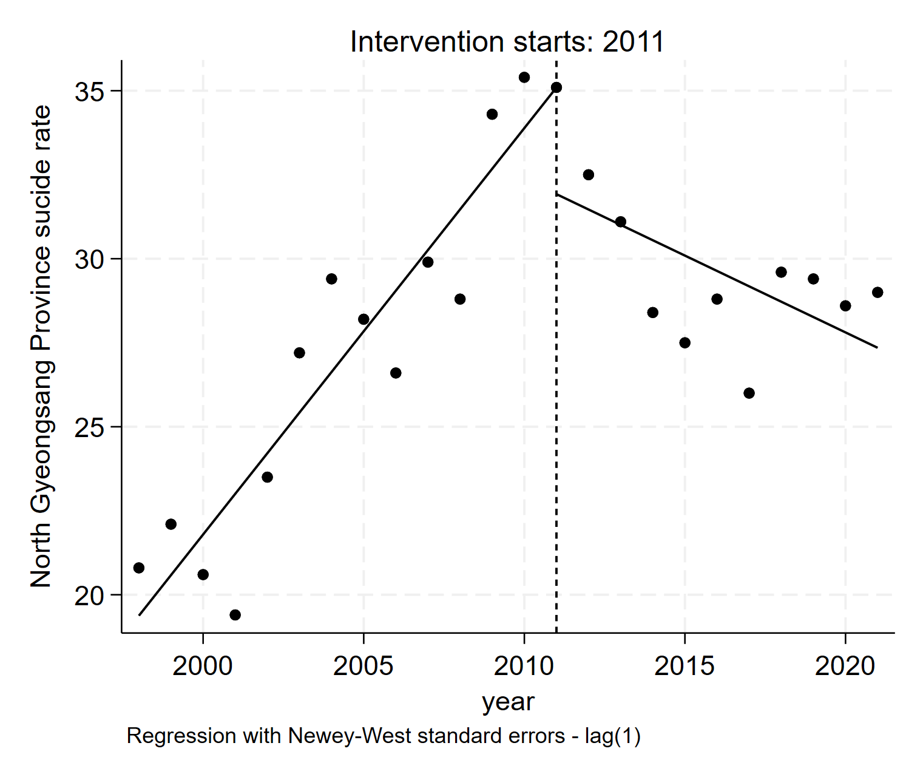 | 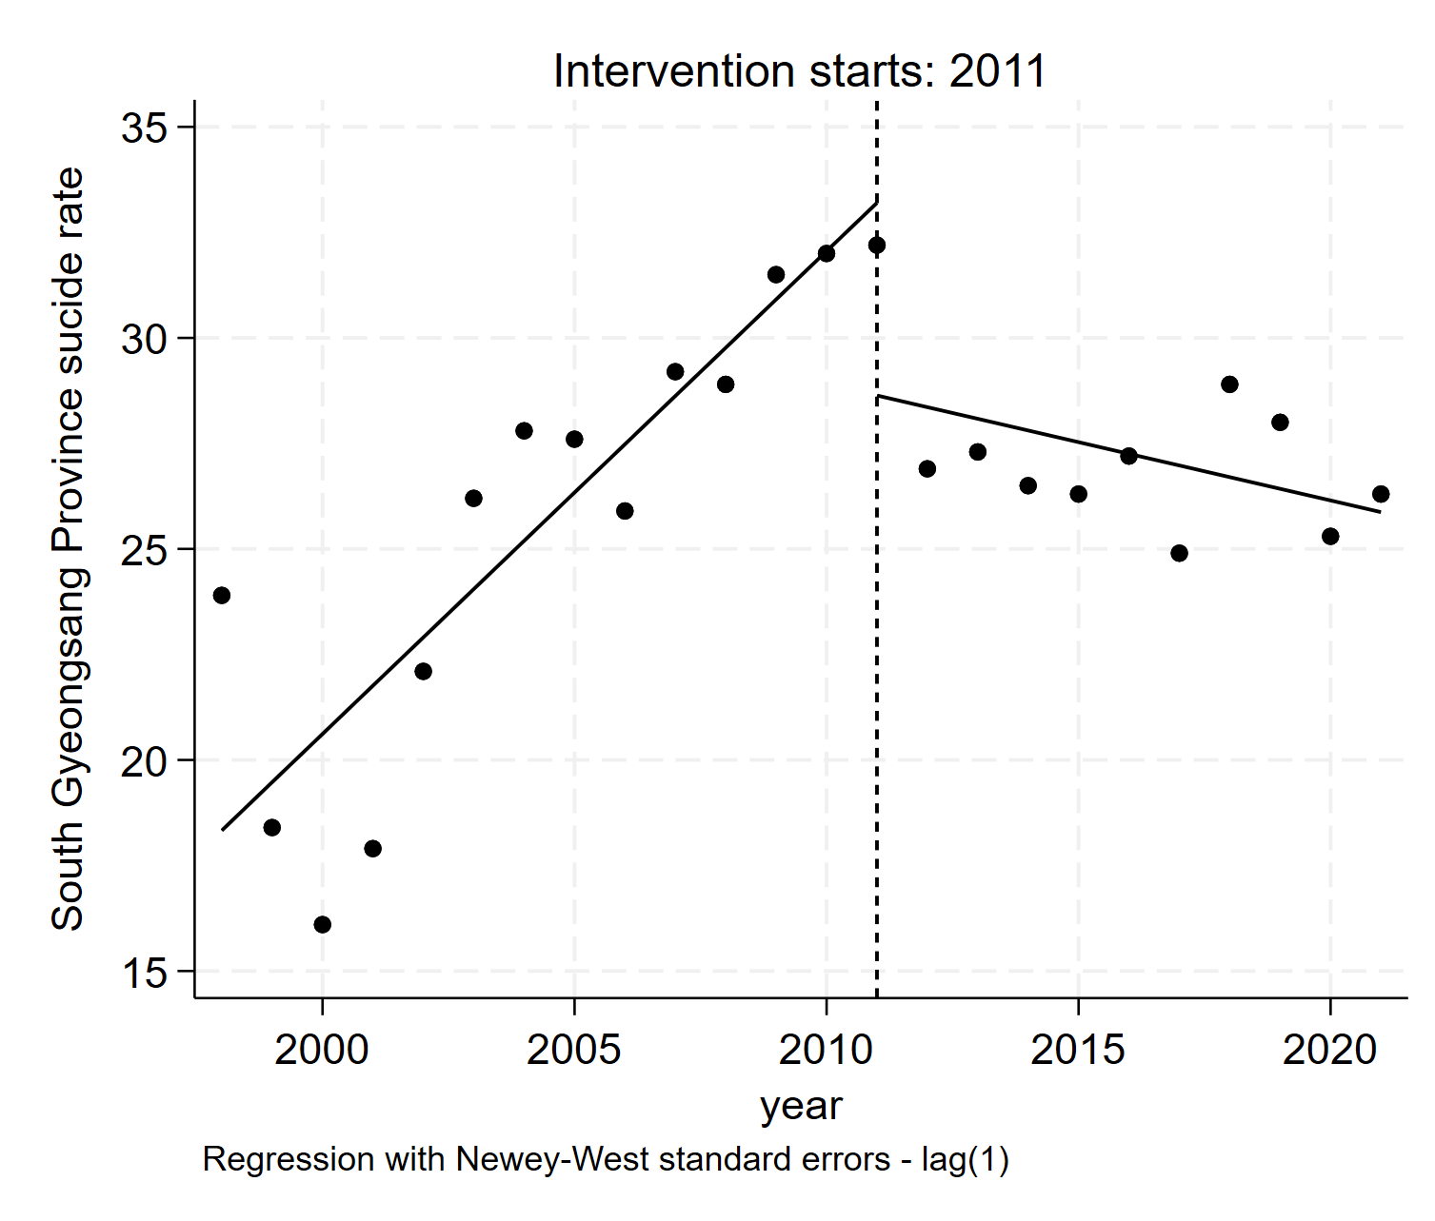
South Jeolla Province (Jeollanam-do) | North Gyeongsang Province (Gyeongsanbuk-do) | South Gyeongsang Province (Gyeongsannam-do)
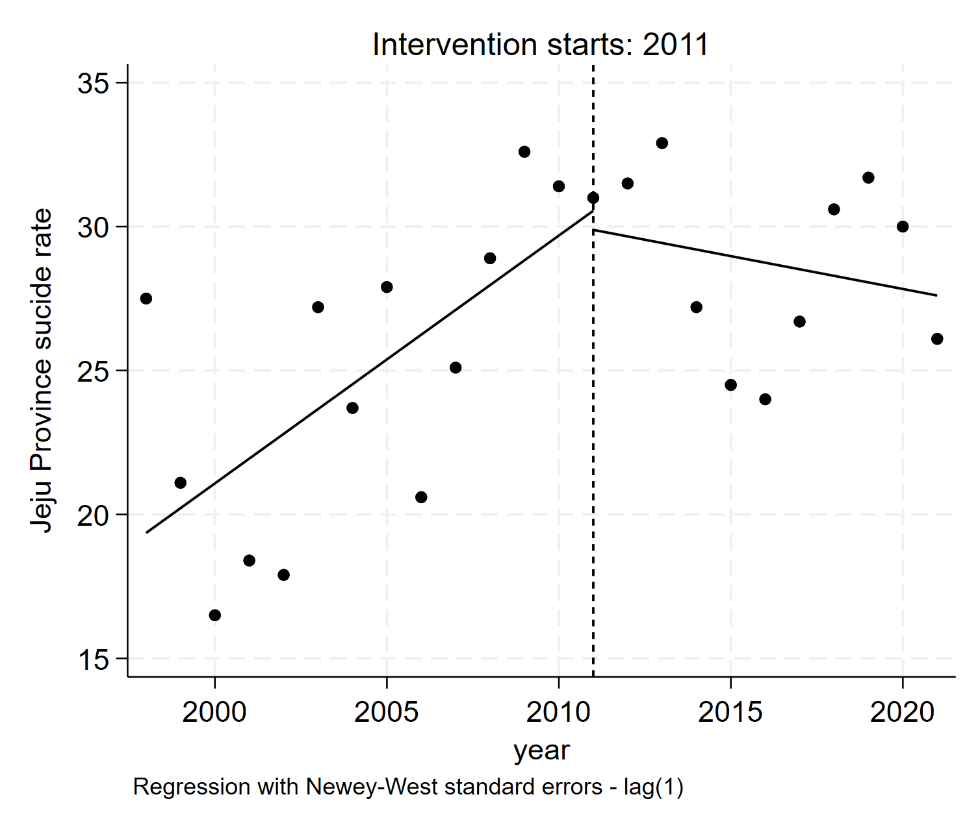
Jeju Province (Jeju-do)
Figure S2. Changes in suicide rate (per 100,000 population) regarding the Suicide Prevention Act (1998-2021) by region
Figure S3. Difference in employment rate and unemployment rate trend between the whole country and Ulsan Province
Employment rate - Percentage of employed persons among the population aged 15 and over, Unemployment rate - The ratio of the unemployed to the economically active population (employees + unemployed)

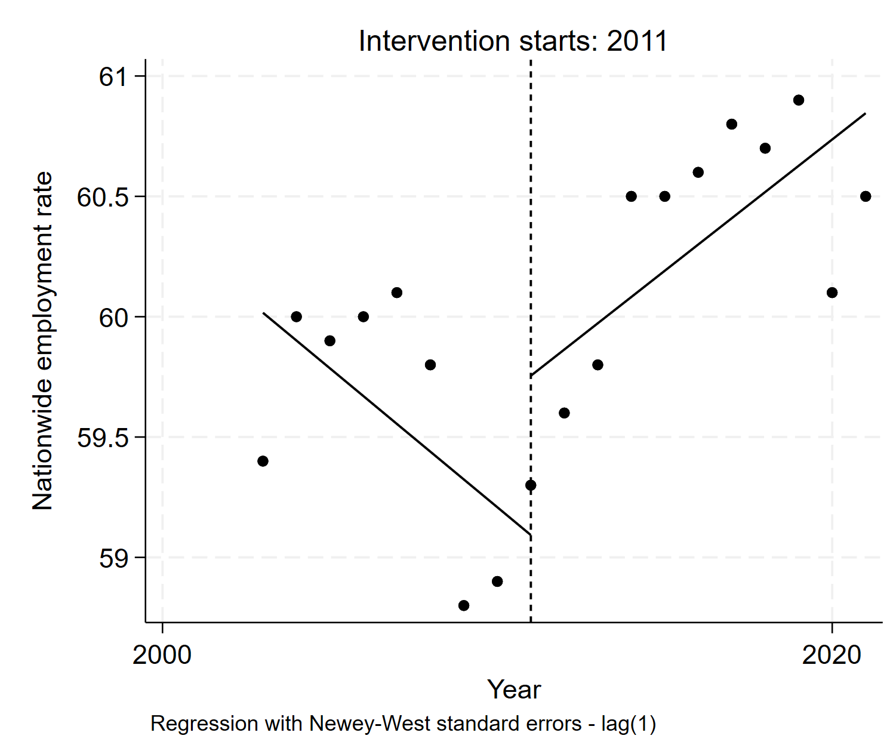 | 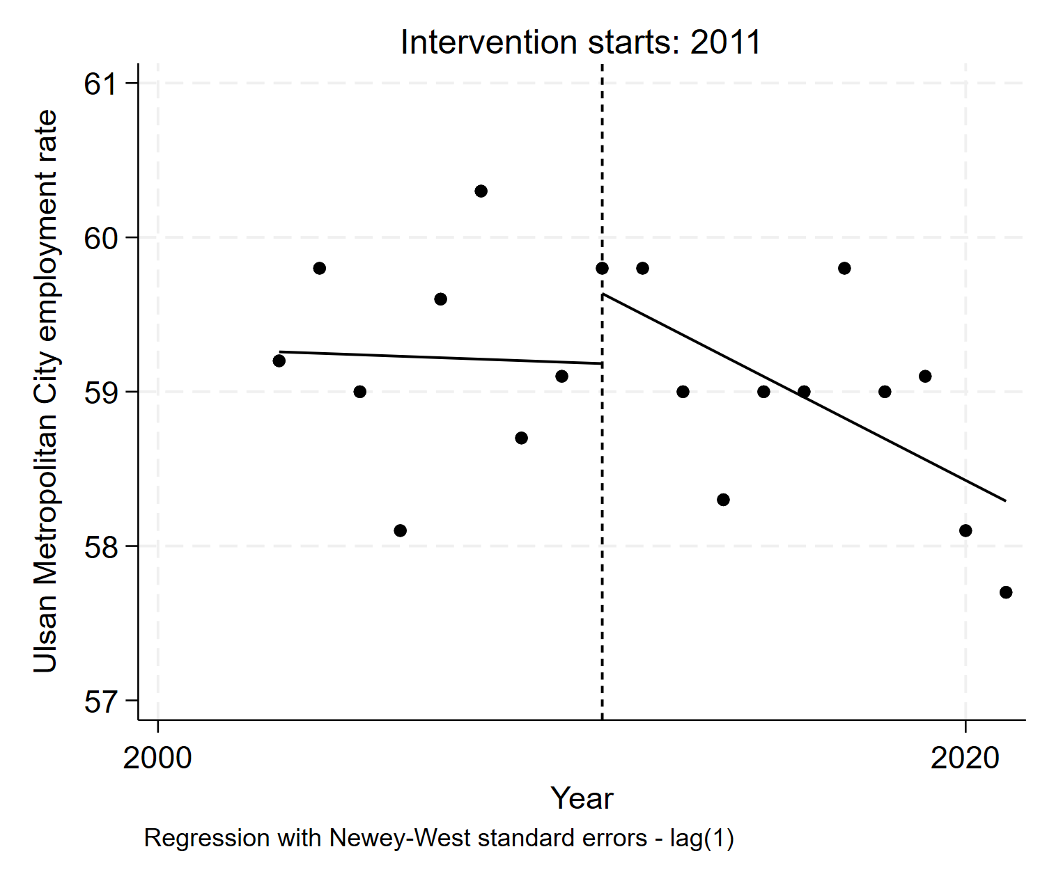
Employment rates in nationwide (2003-2021)  β₂ = 0.662 (P-value=0.172), β₃= 0.225 (P-value=0.033) | Employment rates in Ulsan Province (2003-2021)  β₂ = -0.135 (P-value=0.368), β₃=-0.125 (P-value=0.135)
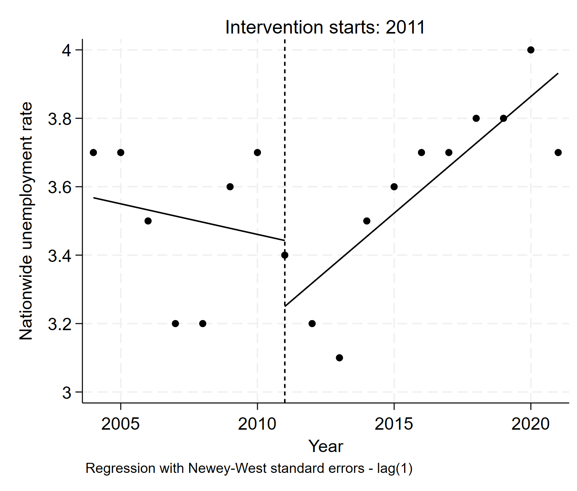 | 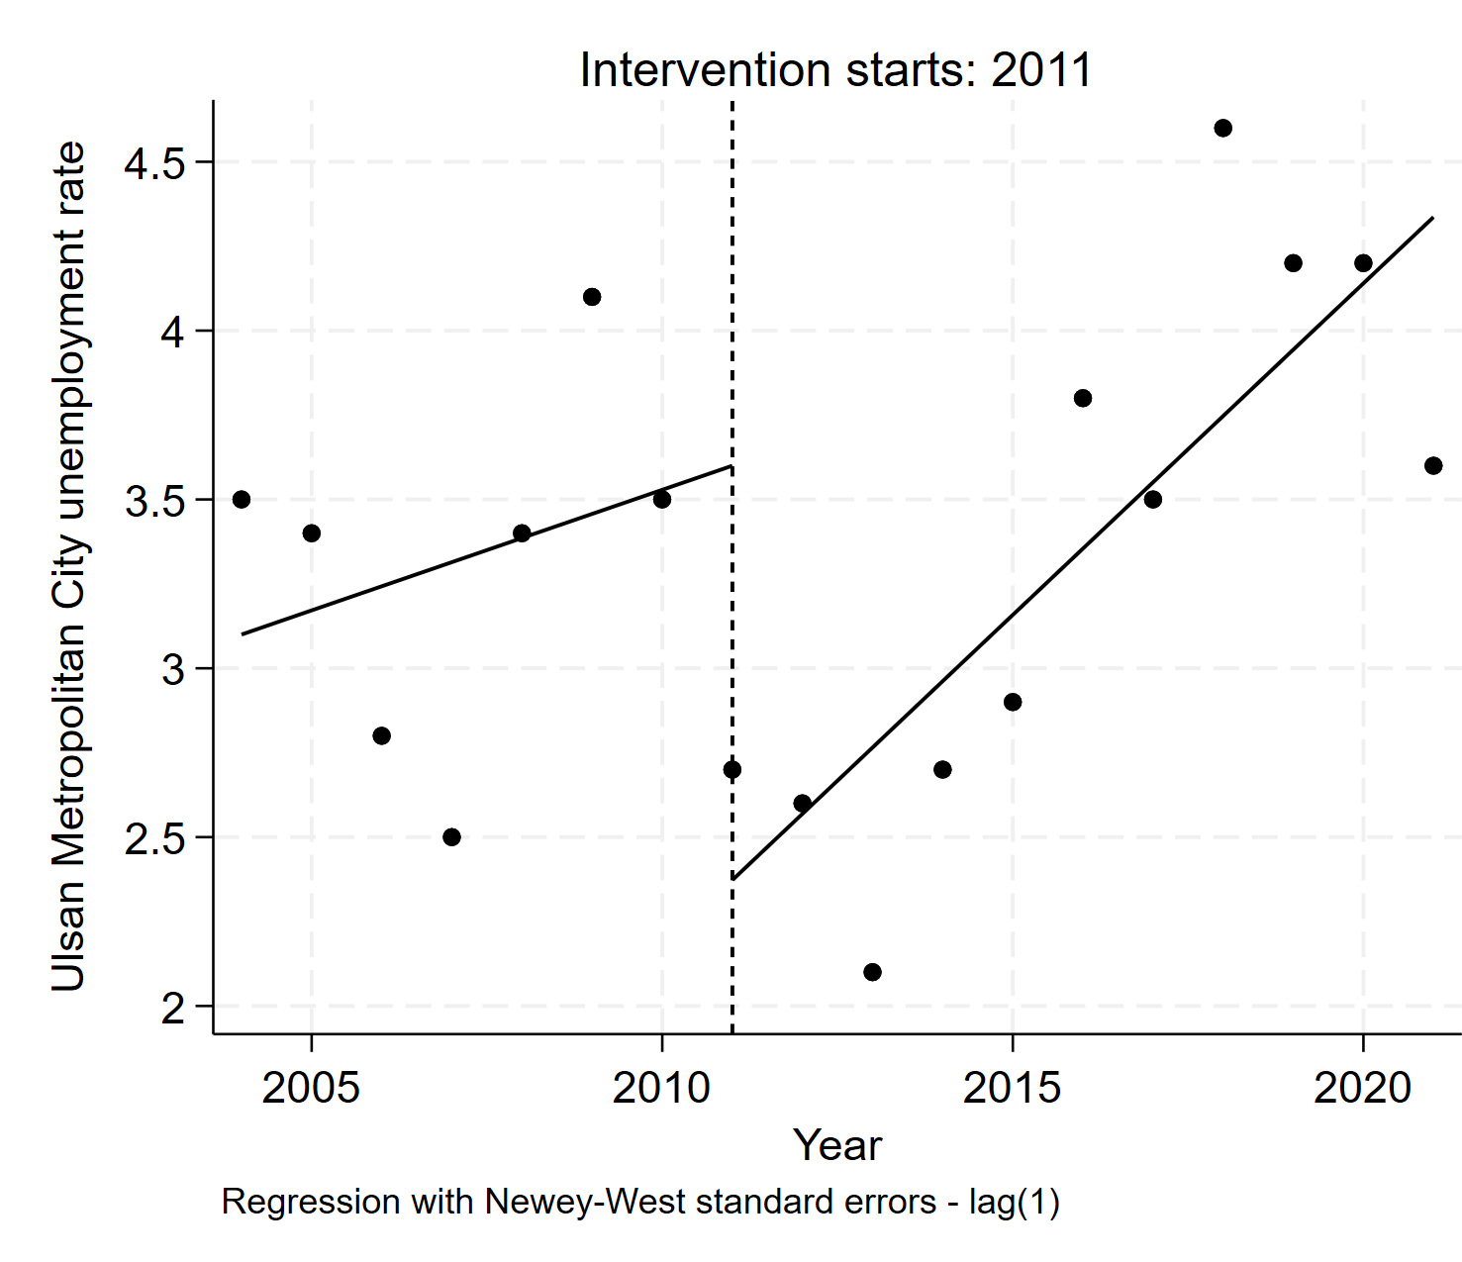
Unemployment rates in nationwide (2004-2021)  β₂ = -0.193 (P-value=0.421), β₃= 0.086 (P-value=0.097) | Unemployment rates in Ulsan Province (2004-2021)  β₂ = -1.227 (P-value=0.017), β₃= 0.125 (P-value=0.205)

Figure S4. Changes in employment rate and unemployment rate regarding the Suicide Prevention Act in nationwide and Ulsan Province

