Chart 1: graphical representation showing the distribution of the sample according to the gender of the participants.

Chart 2: A graphical representation of patients suffering from chronic diseases.

Chart 3: A graphical representation showing the educational level of the participants’ parents.

Chart 4: A graphical representation showing the weights of participants in the sample.

Chart 5: A graphical representation of sports practice in days per week in the sample.

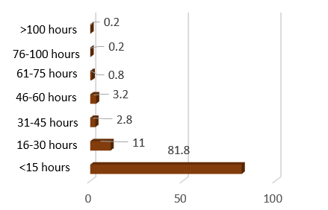

Chart 6: A graphical representation showing the number of hours of computer use and television watch per week.

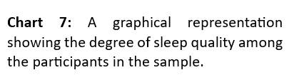

Chart 8: A graphical representation showing the sleep disorders among the participants in the sample

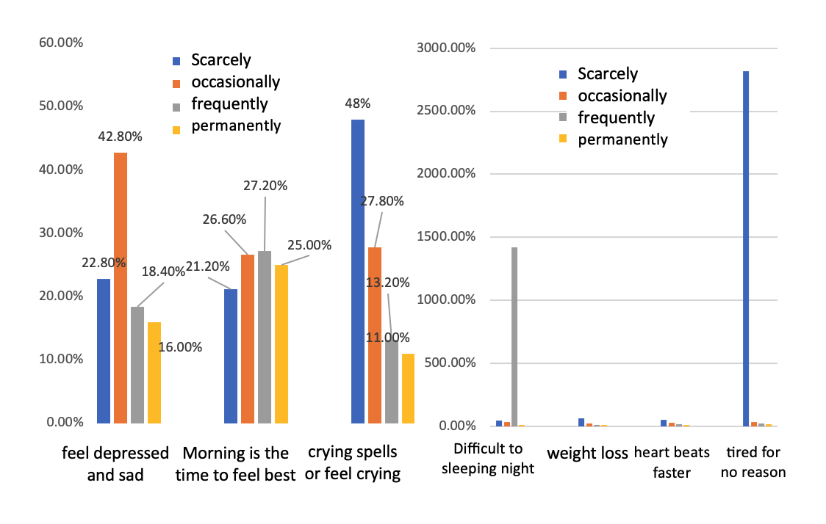

Chart 10: A graphical representation of the extent of difficulties resulting from depression.

